
mARKETING Report
Marketing report promoting Swansea Arena House Party

Name- Josephine Ayres
Date:12/12/2025
Module Name- Niche Marketing and Social Media
Date:12/12/2025
Word Count-1634

AI Acknowledgement
I acknowledge the use of SparkToro and SimilarWeb (https://pro.similarweb.com/?sourcepage=home&action=lite-redirect) (https://sparktoro.com/product/dashboard) on 10/12/2025 to aid in research and statistics. I used the prompt(s):
1)Swansea Arena
2)Swansea Arena House party
I confirm that I have not presented any AI generated text as my own work. I confirm I have copies of my drafts, notes, and other resources I used before, and after the use of AI tools which I may be asked to provide in evidence.
Introduction - 123
This report will be exploring Swansea Arena’s House Party event and how well they market themselves to their customers as well as how they could promote this more effectively. It will consider the ideal customer for the Arenas house party and how they can better market themselves to retain these customers. The report will include various types of marketing frameworks like Ansoff’s Matrix which helps businesses identify four areas of growth based on their product using SOSTAC model, The four P’s of marketing (Product, Price, Place, and Promotion). It will also investigate the RACE model and how the Arena can utilise this effectively. Of the three customer profiles made this report will look at the customer that they want to retain (profile 1).

Situational Analysis

5 C’s
  - Company
(3.1) It shows that the event is centred around these artists as well as raising money to support them in future projects. It also looks at areas that can be improved upon as well as competition that they may face through other arenas/ venues nearby like, Cardiff, Bristol and London as these are bigger and have more capacity than Swansea.
  - Customers
Customer segmentation allows businesses to section their customers into different areas so that they can easily target different types of people. The Arena should investigate for the house party would be the demographics (age, gender etc); the house party is an event that would focus on the ages of 23-33.
- The location it would focus on is Swansea and surrounding areas, as the artists are local throes from areas like Carmarthen up to Neath, Port Talbot as they will be more likely to travel in for this event.
- A customer they want to retain they would cater to her lifestyle as she enjoys these types of events, they do this by setting up a loyalty scheme to keep her returning. Also, targeted ads to keep her attention and appeal to her emotions. This relates to Aristotle’s modes of persuasion and the use of Ethos-credibility, Pathos-emotions and Logos- logic (table 6.1). As connecting to a persons’ emotions can appeal to them and make them feel more connected. Another area is the credibility as showing visitors that they are reliable will make them want to return.

  - Competitor
Some competitors include:
- Silent Disco- Museum Cardiff
- Back in the days party- Cardiff
- Wave Rave Bristol
These events can become competitors for the house party like nearby arenas that are bigger and hold more people, the house party will have to differentiate themselves to keep and attract new people. To do this they would want to evaluate things like pricing, what they offer during their event, gaps in the market and their own strengths and weaknesses. They make themselves stand out through supporting local musicians creating a community focus. They also work closely with university students which not many other venues take part in.
  - Collaborators
Some companies that they work closely with include:
- Delta Hotels
- UWTSD
- Music Venue Trust
- ATG Entertainment
These help with the running of the House Party. They can expand sales, well-known brands allow for reliability and credibility, learning experiences for the students at the university. They can all contribute to the overall visitor experience.
  - Climate
Technology plays role in the House Party event as they use LED’s both inside and outside of the building as well as other lighting during the event itself. However, it can impact locals late at night causing a negative effect. Similarly, crowds of people will impact the event through a higher demand of public transport.

SMART Objectives
The chosen profile enjoys events like the house party so the objective would be to increase repeat attendance to the house party over 12 months. The profile regularly attends events similar so targeting their demographic directly can get them to return based on positive experiences from previous visits.

Strategy
  - Ansoff’s Matrix
This model is a planning tool that allows businesses to identify areas that can allow them to expand through new and existing markets. It has four strategies:
- Market Penetration
- Market Development
- Product Development
- Diversification
For the House Party to keep existing customers like the chosen profile through different ways like a loyalty scheme for their events, more of a social media presence highlighting the party and their collaborators. Another area is targeting new audiences in surrounding areas or providing different types of packages offered to new people. For them to develop what they already have they could provide VIP options for visitors before the event starts, Merchandise for visitors to remember the event by. They also provide workshops with some local businesses and musicians before the event which can allow them to be different to other arenas and events.
  - Marketing Mix
The Marketing Mix is described as ‘a set of the marketing tools that the firm uses to pursue its marketing objectives in the target market’ (Goi, 1970). It can also be known as the 4 P’s:
- Product
- Price
- Place
- Promotion
The house party is a day for visitors to watch and listen to music from local acts, it allows for creative workshops, there are also various stalls from grassroot venues and a charity donation. The house party’s main objective is to showcase local artists and give them an opportunity to perform in a larger venue on a larger stage as well as raising money for the Music Venue Trust to support these artists further. To differentiate themselves from others they bring exposure for local bands, the venues they work alongside for the house party also host after-parties to join in with, since they partner with UWTSD it allows them to take part and for an educational aspect of the house party. The ticket prices start from £10 so they keep them lower so that it can be kept affordable and with a community focus. Swansea Arena is a modern building with a capacity of 3,500 so it provides a good experience for the artists to show off their talent. The MVT states ‘’support the creative music scene in Swansea’’ Music Venue Trust (2023a), this will appeal to the emotions of their viewers and gives it more of a community feel. Working with the students allows word-of-mouth from them through them socially. The venue also uses social media platforms to promote the house party like Instagram, Reddit, X and Facebook. On the other hand, there can be challenges with this as the use of a larger venue may make it feel less intimate than the venues that are used by the artists normally, the use of the LEDs can disrupt normal life outside of the venue as the Arena is in central Swansea.

Tactics
  - RACE Framework
This is a digital marketing strategy used businesses to help market themselves better for their audiences it stands for:
- Reach
- Act
- Convert
- Engage
For the customer chosen as she is already a customer, they want to keep her returning. This can be done through engage, this means it will build loyalty among visitors. They should keep contact with those that have previously visited the house party, interacting with posts and reviews that have been left by visitors through Tripadvisor is a good way to do this as it shows areas for improvements and interest, engaging with reviews allows for trust to build leaving a positive impression. Based on the results from Sparktoro (graph 9.1-9.4) it shows that the most visited social media app for this is Facebook, so producing regular posts showing the house party throughout the year to keep memories of it in visitors’ mind creating nostalgia, promoting discounts or special offers can help increase sales, making people want to return. Using the communications mix is also another aspect that they can utilise. This is the use of different platforms to market themselves effectively. The Arena uses social media platforms like Facebook, Instagram and X to communicate with visitors. To improve they could provide videos of behind the scenes, visitor polls, showing local collaborations that they have, creating a hashtag is also another way to get guests interacting with them. Each of these allows the arena to relate themselves and the house party event to appeal and build excitement among visitors.

  - Action
Some of the chosen channels have been used due to the results from Sparktoto and SimilarWeb. Some social media channels are Facebook, Instagram and X as they were the most popular among visitors. As the House Party Event is In March a lot of the marketing will need to be in the lead up to the event and reviewing will have to be after the event itself has taken place. (Chart 10.1)
  - Control
To monitor the success of these promotions they should monitor the amount of new visitors that they gain for the event and ask how they heard about the event when they book their tickets, tracking the number of visits/ searches that they have on different search engines to see the attention they are getting from it. Even though all profits are donated they should compare the amount that they made compared to the year before. Another important area would be looking at and responding to online reviews that are left for them after the event.

Conclusion
Overall, Swansea Arenas House Party is an event that contributes to the local artists and venues. Their marketing channels suit all types of customers, but the report specified on a customer that they wanted to retain, applying these frameworks like Ansoff’s Matrix will give them a deeper insight into their marketing channels and how effective they are. It suggests ways that they can improve their promotions through various ways with social media, websites and reviews, as well as coming up with new ways to attract and keep their visitors like with merch sales, more interacting with their customers online and promotions like sales and discounts.

References

Amos, C., Zhang, L., King, S., & Allred, A. (2022). Aristotle’s modes of persuasion and valence effects on online review trustworthiness and usefulness. Journal of Marketing Communications, 28(4), 360–391. https://doi.org/10.1080/13527266.2021.1881806
ATG Entertainment (2022). Partners | Swansea Arena. [online] Swansea-arena.co.uk. Available at: https://www.swansea-arena.co.uk/about-us/partners#Corporate [Accessed 8 Dec. 2025].
ATG Entertainment (n.d.). Safety & Security | Your Visit | Swansea Arena. [online] www.swansea-arena.co.uk. Available at: https://www.swansea-arena.co.uk/visitors/your-visit-to-swansea-arena/safety-security [Accessed 8 Dec. 2025].
ATG Entertainment (2024). Swansea Arena | The Swansea Arena House Party. [online] www.swansea-arena.co.uk. Available at: https://www.swansea-arena.co.uk/shows/the-swansea-arena-house-party [Accessed 8 Dec. 2025].
ATG Entertainment (2025a). Swansea Arena | House Party 2026. [online] Swansea-arena.co.uk. Available at: https://www.swansea-arena.co.uk/shows/house-party-2026 [Accessed 8 Dec. 2025].
ATG Entertainment (2025b). Swansea Arena | Swansea Arena House Party 2025. [online] Swansea-arena.co.uk. Available at: https://www.swansea-arena.co.uk/shows/swansea-arena-house-party-2025 [Accessed 8 Dec. 2025].
ATG Entertainment (2025c). Swansea Arena | Swansea Arena House Party 2025. [online] Swansea-arena.co.uk. Available at: https://www.swansea-arena.co.uk/shows/swansea-arena-house-party-2025 [Accessed 8 Dec. 2025].
Chaffey, D. and Ellis-Chadwick, F. (2022). Digital Marketing. 8th ed. Harlow: Pearson Education.
Christy, A. J., Umamakeswari, A., Priyatharsini, L., & Neyaa, A. (2021). RFM ranking – An effective approach to customer segmentation. Journal of King Saud University. Computer and Information Sciences, 33(10), 1251–1257. https://doi.org/10.1016/j.jksuci.2018.09.004
Dalling, R. (2022). People have been raving about the new Swansea Arena but one big issue leaves audience sweating. [online] Wales Online. Available at: https://www.walesonline.co.uk/whats-on/whats-on-news/first-impressions-of-swansea-arena-23405825 [Accessed 8 Dec. 2025].

Goi, C.L. (1970). Marketing Mix: A Review of ‘P’. The Journal of Internet Banking and Commerce, [online] 10(2), pp.1–11. Available at: https://www.icommercecentral.com/open-access/marketing-mix-a-review-of.php?aid=38598 [Accessed 12 Dec. 2025].
Google Trends (2015). Google Trends. [online] Google Trends. Available at: https://trends.google.com/trends/explore?date=today%205-y&geo=GB&q=Swansea%20Arena%20House%20Party&hl=en-GB [Accessed 8 Dec. 2025].
Music Venue Trust (n.d.). Music Venue Trust: Wales. [online] MVT Wales Briefing.pdf. Available at: https://business.senedd.wales/documents/s150686/MVT%20Wales%20Briefing.pdf.
Music Venue Trust (2023a). The Swansea Arena House Party: Uniting For Music With Music Venue Trust. [online] Music Venue Trust. Available at: https://www.musicvenuetrust.com/2023/10/the-swansea-arena-house-party-uniting-for-music-with-music-venue-trust/ [Accessed 10 Dec. 2025].
Pereira Ferraz Soares Ferreira, A. P., & Marques, M. B. P. de S. M. (2024). The Importance of the Ansoff Matrix for the Study of the Information Services Market. Canadian Journal of Information and Library Science, 47(2), 78–84. https://doi.org/10.5206/cjils-rcsib.v47i2.17432
Rautela, S. (2021) “Social Media for New Product Launch: A Study of Social Media Platforms Across the RACE Planning Framework”, International Journal of Interactive Mobile Technologies (iJIM), 15(05), pp. pp. 187–204. doi: 10.3991/ijim.v15i05.18147.
Sparktoro.com. (2025). SparkToro Login. [online] Available at: https://sparktoro.com/product/search/overview?keyword=swansea%20arena%20house%20party&type=keyword&location=uk [Accessed 8 Dec. 2025].
Swansea (2025). Swansea Arena’s 2025 Big House Party to Support the Region’s Grassroots Music Venues. [online] Business News Wales. Available at: https://businessnewswales.com/swansea-arenas-2025-big-house-party-to-support-the-regions-grassroots-music-venues/ [Accessed 8 Dec. 2025].
TFW (2020). Swansea railway station | Transport for Wales. [online] Tfw.wales. Available at: https://tfw.wales/places/stations/swansea [Accessed 8 Dec. 2025].
Trust, M.V. (2023). The Swansea Arena House Party: Uniting For Music With Music Venue Trust. [online] Music Venue Trust. Available at: https://www.musicvenuetrust.com/2023/10/the-swansea-arena-house-party-uniting-for-music-with-music-venue-trust/ [Accessed 8 Dec. 2025].
Ubersuggest. (2025). AnswerThePublic by Neil Patel: Keyword Research & Content Ideas. [online] Available at: https://answerthepublic.com/en/dashboard/reports/60ef8962-68a0-42e6-afff-fcf8b8146bcf [Accessed 8 Dec. 2025].
Utilita arena (2023). Utilita Arena Cardiff | Meet in Wales. [online] Meetinwales.com. Available at: https://www.meetinwales.com/venue/attraction-venue/utilita-arena-cardiff-578851 [Accessed 8 Dec. 2025].
UWTSD (2024). UWTSD students host ground-breaking House Party at Swansea Arena. [online] University of Wales Trinity Saint David. Available at: https://www.uwtsd.ac.uk/news/uwtsd-students-host-ground-breaking-house-party-swansea-arena [Accessed 8 Dec. 2025].
www.swansea-arena.co.uk. (n.d.). Community | Swansea Arena. [online] Available at: https://www.swansea-arena.co.uk/about-us/community [Accessed 8 Dec. 2025].
Youle, R. (2021). ‘It was like Barons at 3am’: Residents near new Swansea Arena fear it will keep them awake at night after lights test. [online] Wales Online. Available at: https://www.walesonline.co.uk/news/wales-news/swansea-arena-licence-marina-jobs-21695308 [Accessed 8 Dec. 2025].

Appendix

  - 1.1
A PESTLE Analysis of Swansea Arena’s House Party
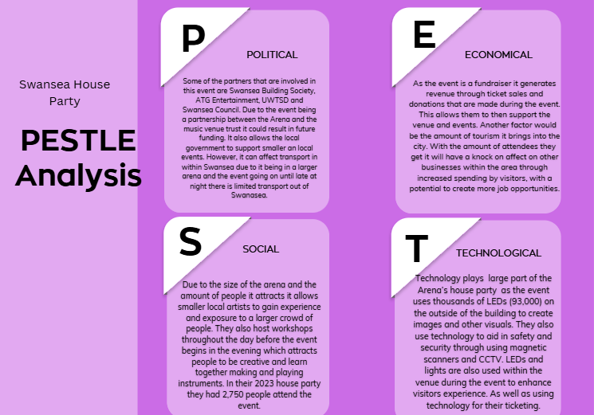
2.1 A table showing one of three customer profiles
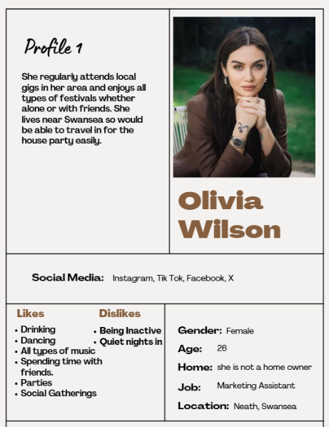
The Ideal customer

2.2 The Mid-Range customer
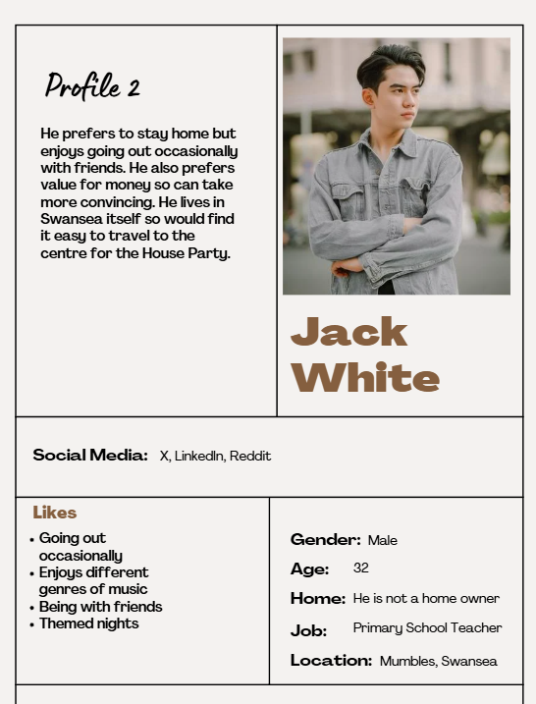

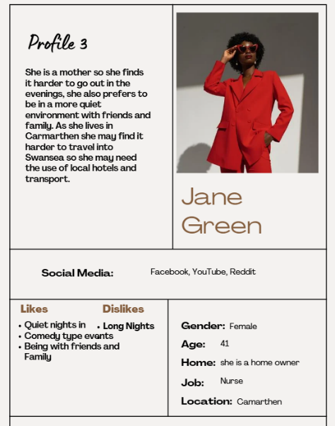
2.3 The customer that needs exploring

3.1 A SWOT analysis of Swansea arena and the House Party event, This demonstrates that the house party hosts smaller musicians to perform on a bigger stage in a bigger venue.

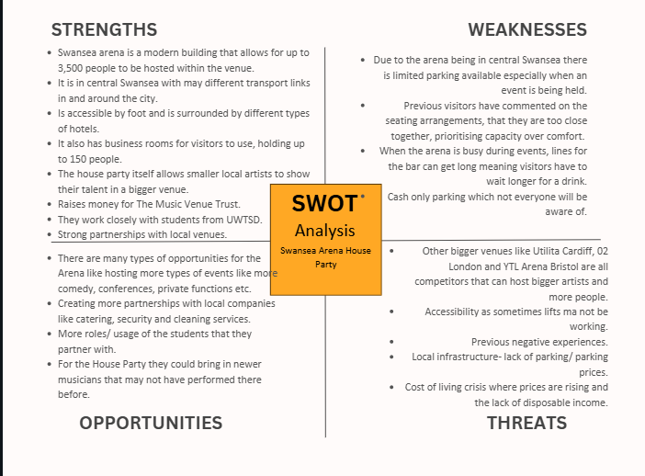

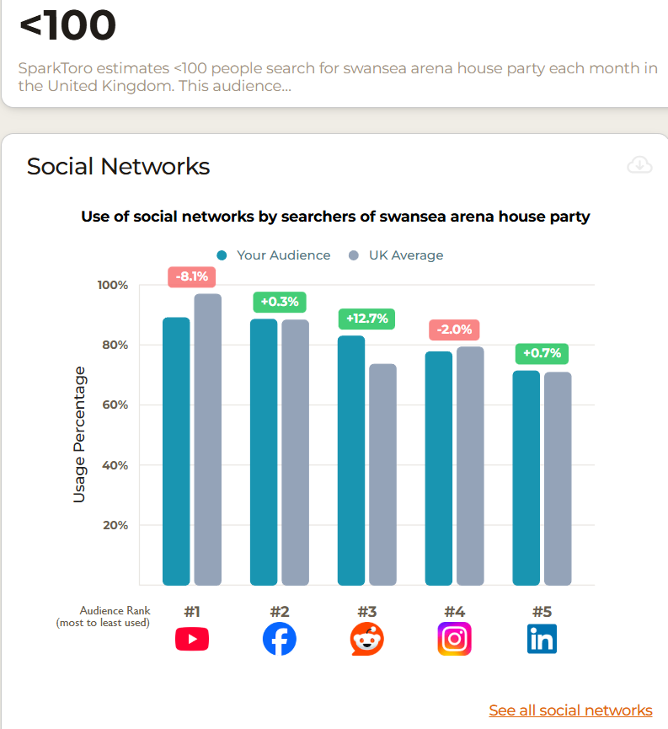
4.1 Results using SparkToro showing the social media used for Swansea Arena House Party.

5.1 A graph showing the interest rates in Swansea Arena over the last 12 months.
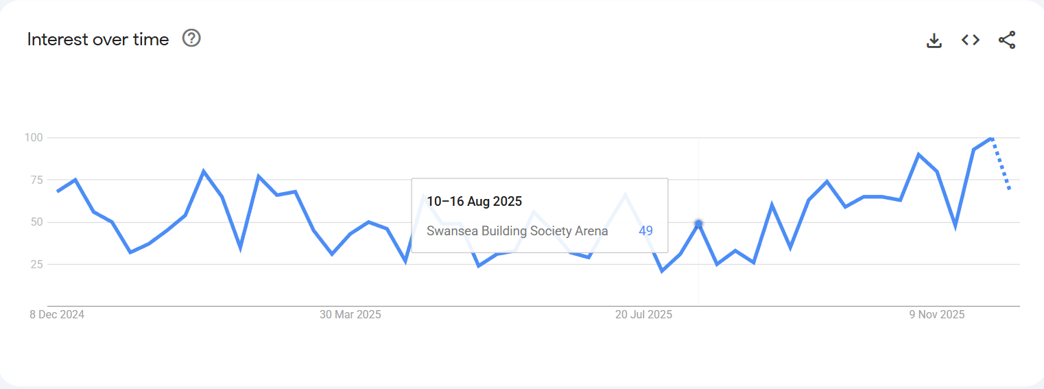
5.2 A list showing most recent searches in relation to Swansea Arena.
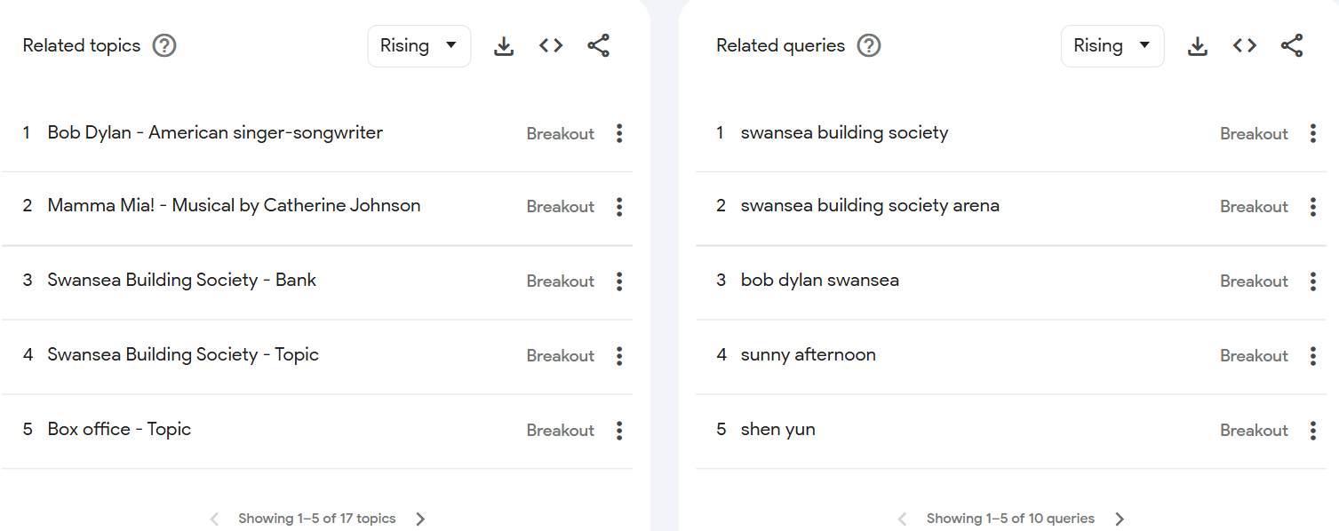
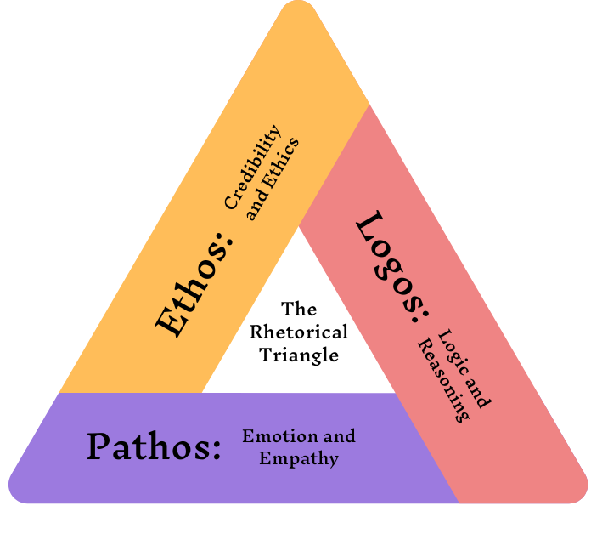
6.1 An image showing Aristotle’s methods of persuasion

7.1 A perceptual positioning map showing competitors to Swansea arena and their total capacity
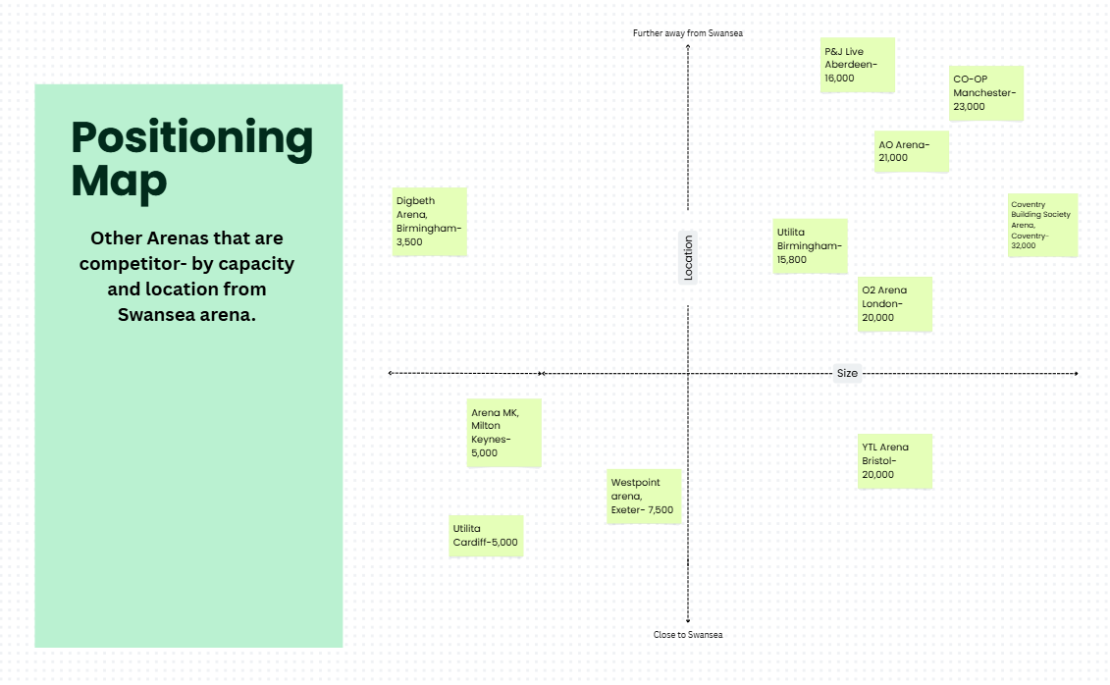
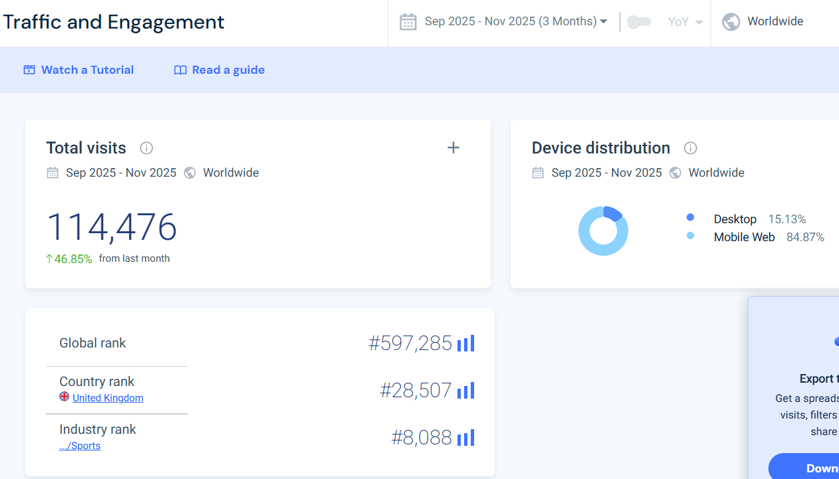
8.1 Results from SimilarWeb on Swansea Arena- https://pro.similarweb.com/#/digitalsuite/websiteanalysis/overview/website-performance/*/999/3m?webSource=Total&key=swansea-arena.co.uk

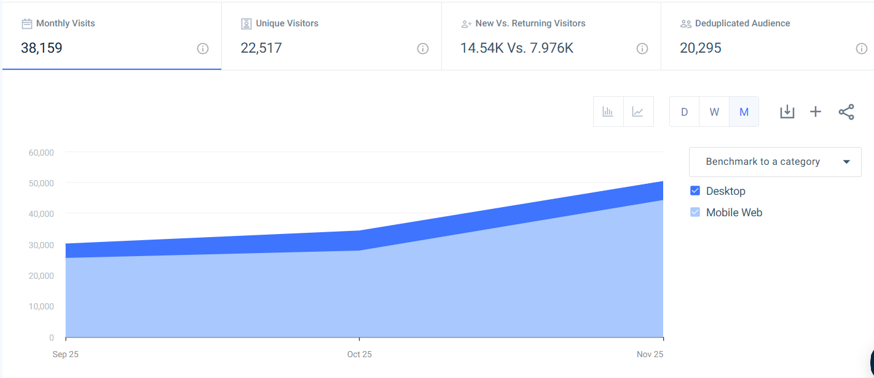
  - 8.2

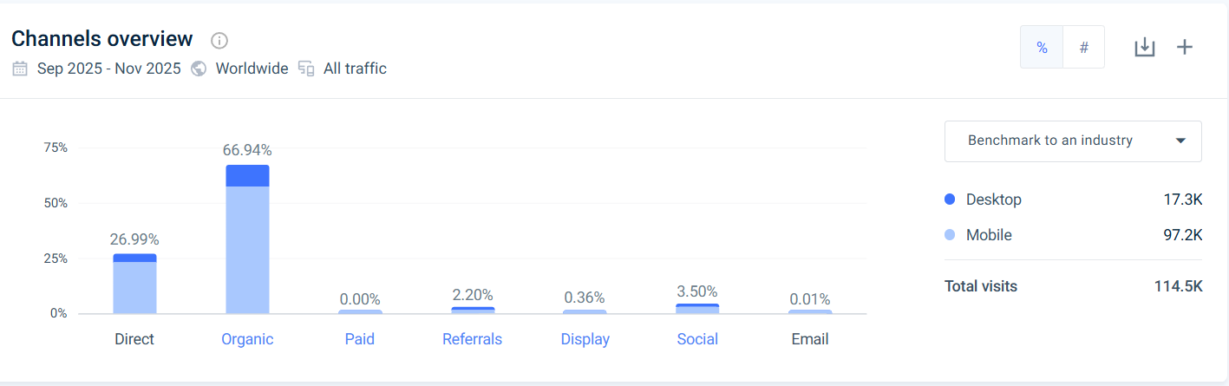
  - 8.2

  - 8.3
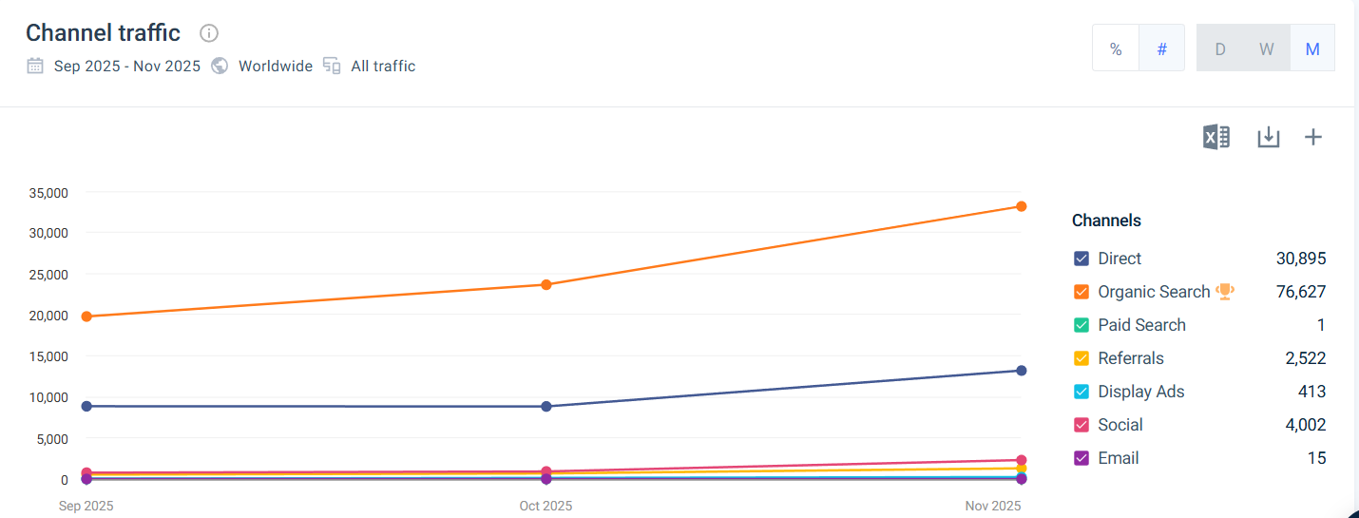

  - 8.4
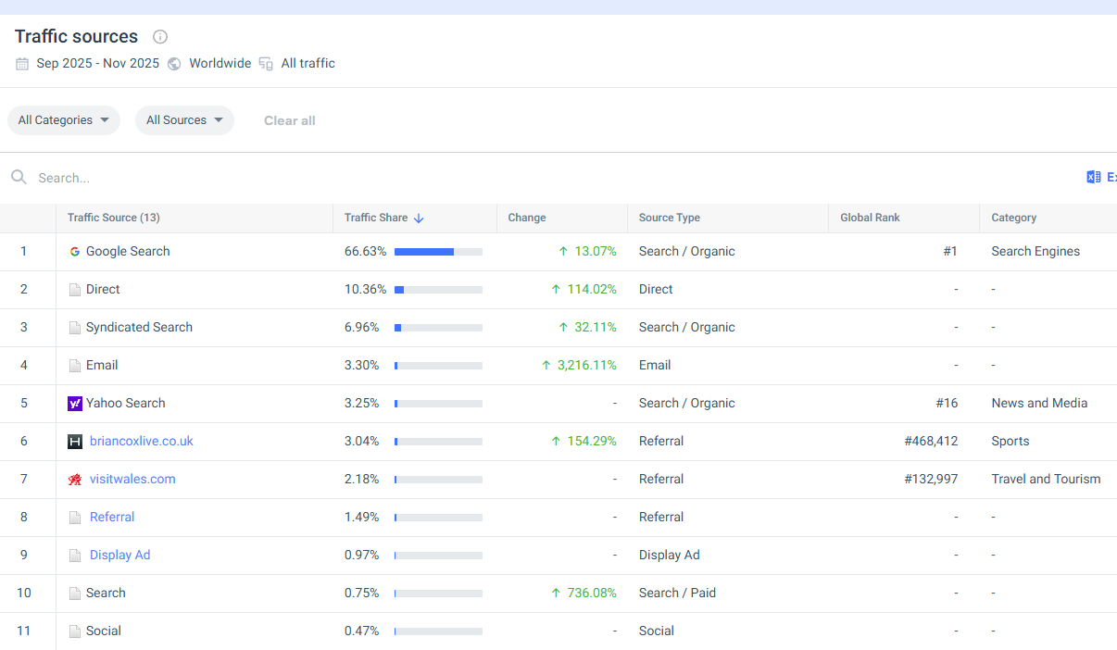

  - 8.5
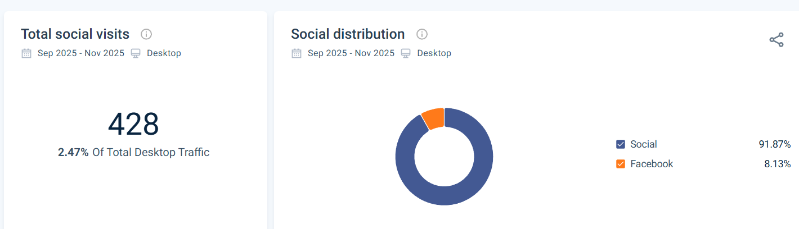
9.1 A table with results showing the social media usage for Swansea Arena from SparkToro- https://sparktoro.com/product/search/overview?keyword=www.swansea-arena.co.uk%2Fshows%2Fswansea-arena-house-party-2025&type=keyword&location=uk

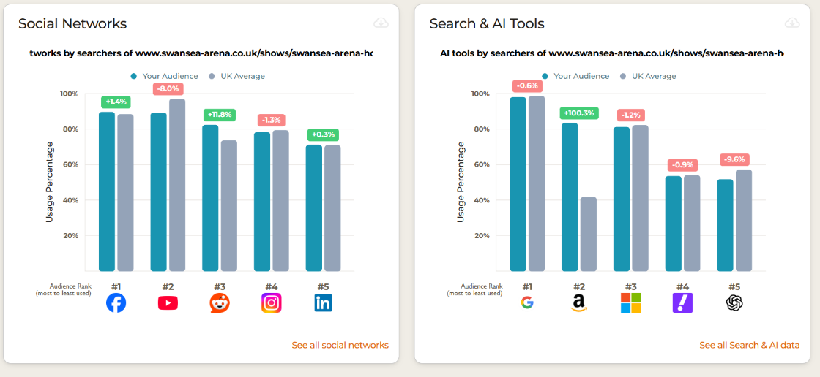

  - 9.2
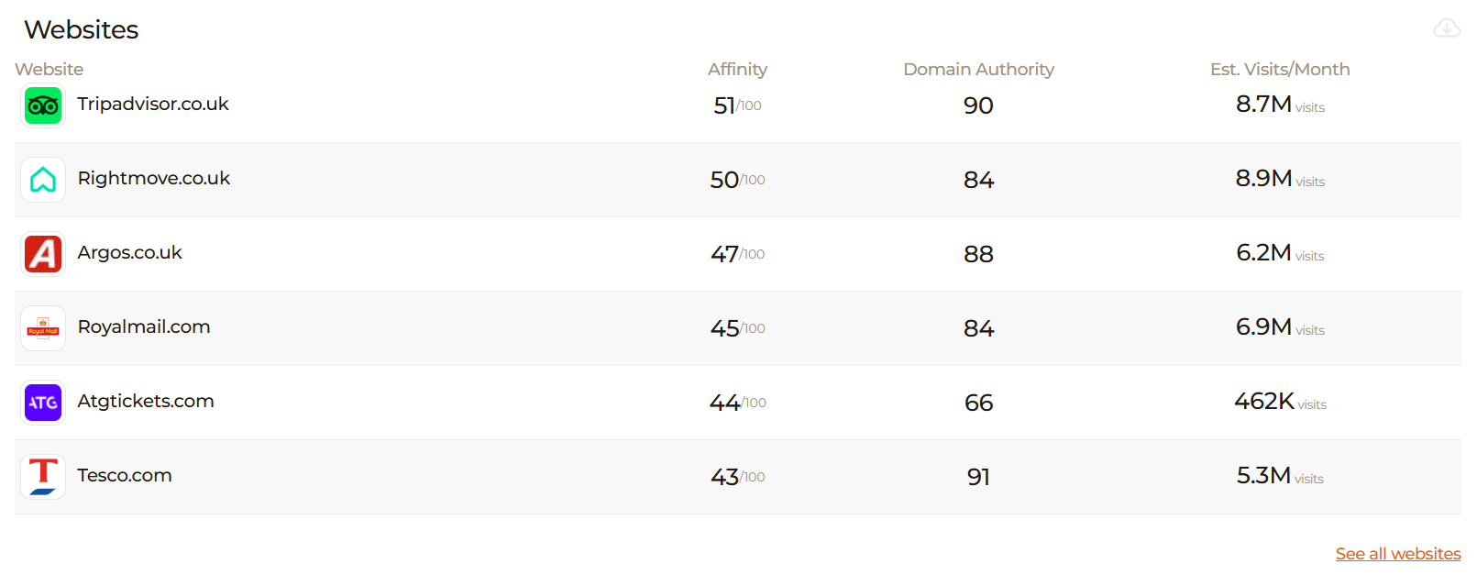

  - 9.3
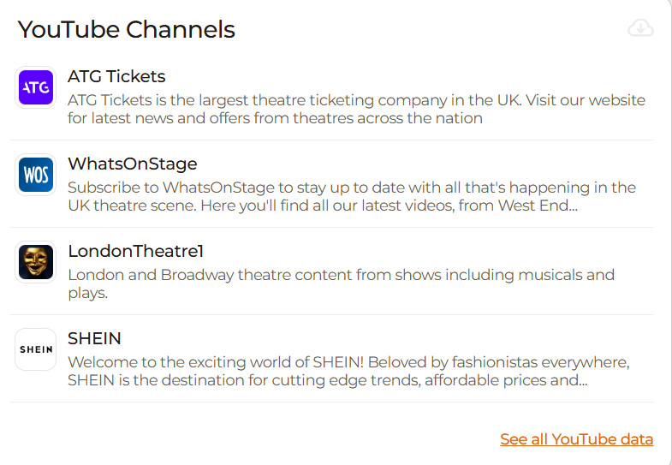

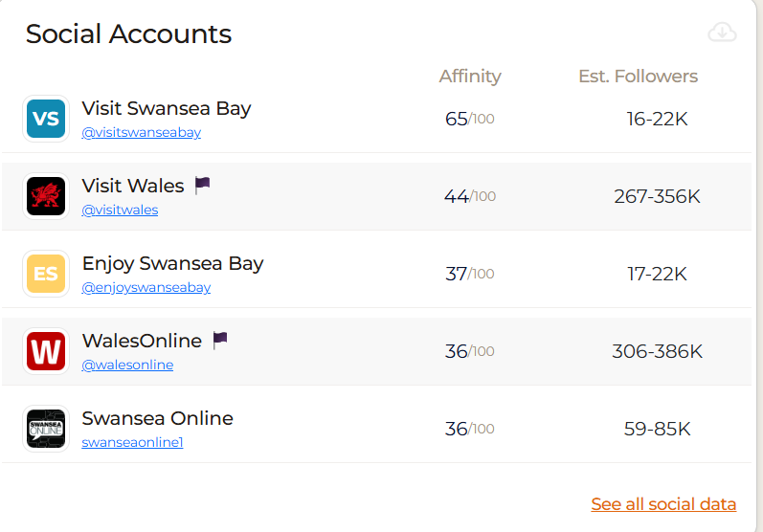
  - 9.4

10.1 Gannt Chart- Marketing report.xlsx A Gannt Chart showing marketing production and promotions.
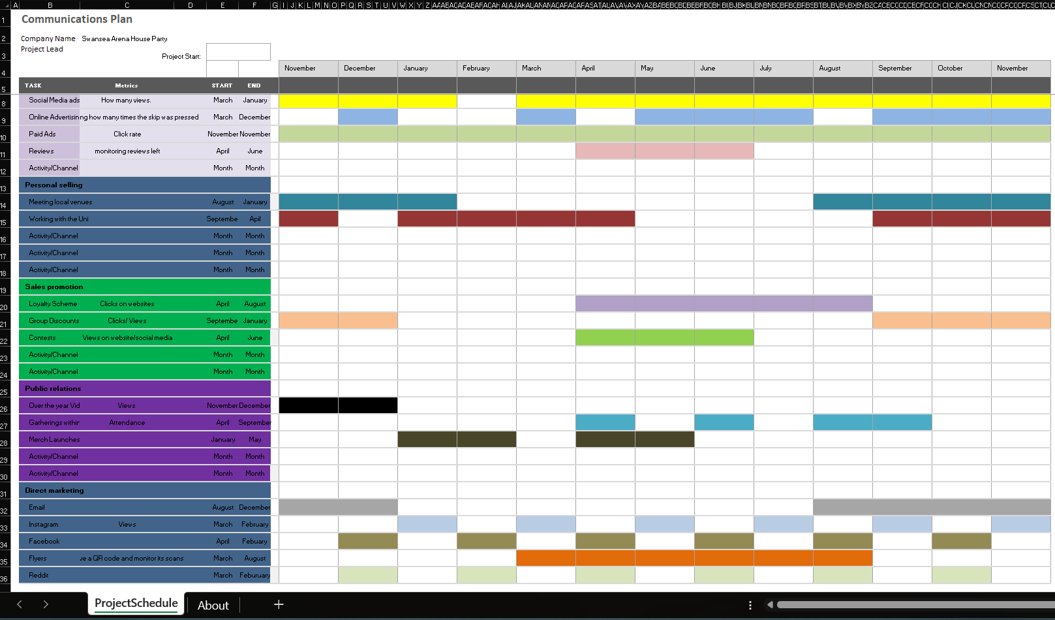

Table of contents
Table of Contents
AI Acknowledgement 1
Situational Analysis 3
5 C’s 3
SMART Objectives 5
Strategy 5
Tactics 7
Conclusion 8
References 9
Appendix 12

