Lists in Python

In most languages, there is an array structure.

Python does not have an array structure. But it does have a list structure (a list can actually be used as if it was an array)

A list in Python is a collection of ordered items, separated with a comma.

For example:

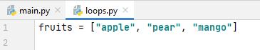

In lists, each item is called an element. There are 3 elements in this list (apple, pear and mango)

Additionally, the list is counted from 0.

element 0 element 1 element 2

Printing list contents - singly

To print out one of the elements of your list, simply specify the one you want in a square bracket.

For example:

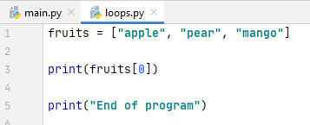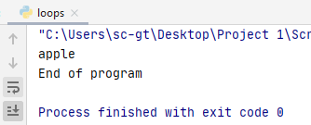

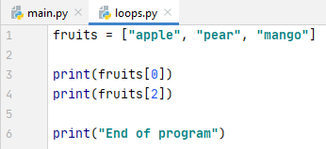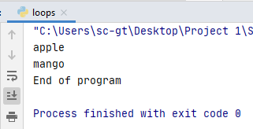

Printing list contents – loops

If we want to print out the list or part of a list, we can use a for loop to help. Remember, a for loop counts from 0 by default. So it is quite handy to use with a list.

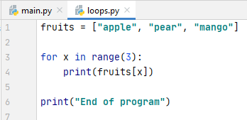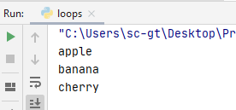

Note: We can simply write print(fruits) However, we should learn how to use a for loop with a list as it will be helpful with more complex calculations.

for x in range (len(fruits))

Overflow

We must be careful not to overflow our list:

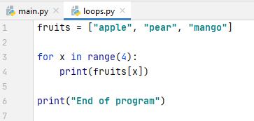

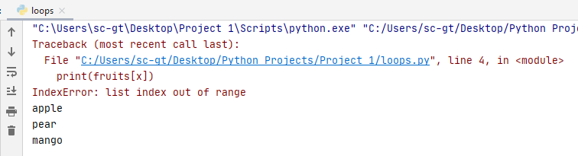

Overflow – there is no element 3 (only 0, 1 and 2)

We must be careful to set our loop range to avoid overflow.

If you are printing out the whole list, rather than part of it, it is easier to use an iterator loop. This is a variant on the for loop, sometimes known as a for…each loops. Here is an example:

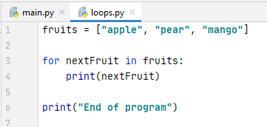

In this case, we don't need to know how big the list is or set a range. Python will sort it out and automatically stop when it gets to the end of the list:

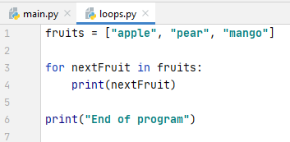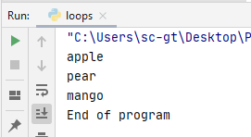

Lists do not have to hold a set strings, they can hold a set integers:

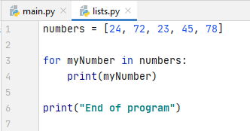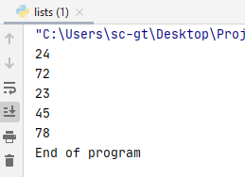

Or a set of floats:

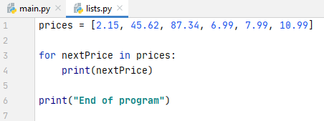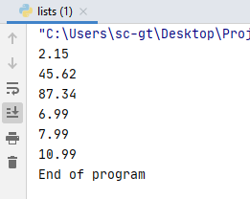

Or even a mixture:

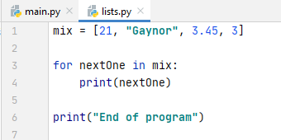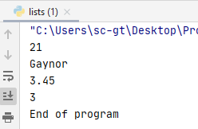

(Note: arrays in many languages are not allowed to hold mixed types, so it is probably best to keep to one type per list until you are more experienced in using them)

Changing values in a list

Let's go back to our original fruit example (a list with 3 elements).

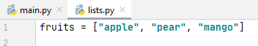

Suppose we want to change "pear" to something else.

This is easily possible by referencing the element we want to change. Remember, lists in Python start from 0, so "pear" is element 1:

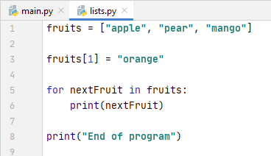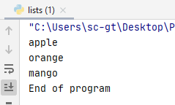
changed!

Adding to a list

We might want to add some extra values to the end of a list.

There are two ways we can do this:

append()

If we want to add to the end of a list, the append() function can be used:

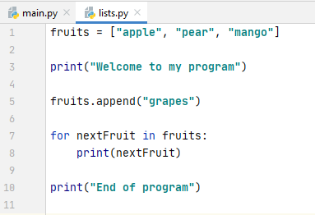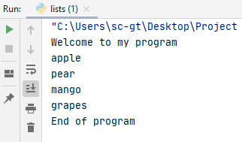
Appended to list

insert()

If we want to add an item somewhere else in the list, we can use insert() and the index required.

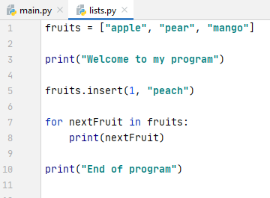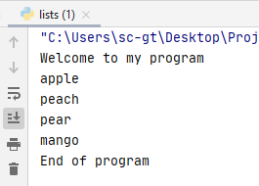
Inserted into list

As we can see, Python has inserted "peach" at element 1. It has automatically shuffled "pear" up to element 2 and "mango" up to element 3 to make room for it (ie pear has not been overwritten!)

extend()

You can also merge two lists together. Here, I am adding my fruits list to my groceries list:

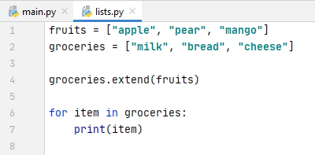

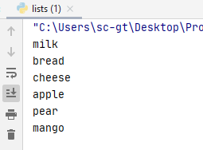
The fruits list has
been added to the
groceries list

Removing items from lists

There are a few ways we can remove items from lists in Python.

Let us go back to our fruits example.

pop()

We can remove using the index – for example if I want to remove "mango" (element 2, counting from 0)

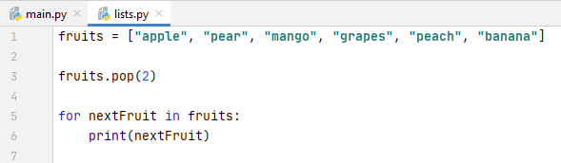

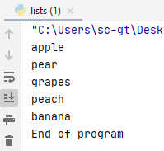

Mango has gone – grapes, peach and banana have been shuffled down to elements 2, 3 and 4 respectively.

(Del is also possible – del fruits[2])

Note that if you us pop() without an index, it will remove the last value in the list:

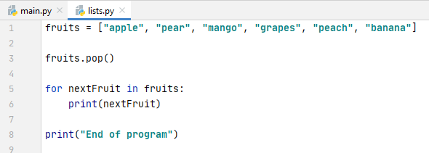
no index specified

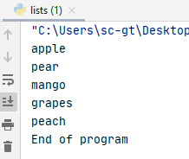
banana has been deleted!

remove()

remove() allows you to remove an element from a list using a value.

For example:

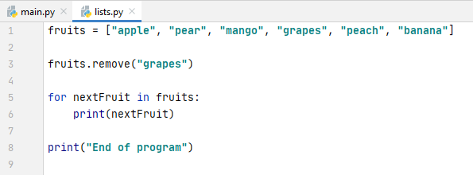

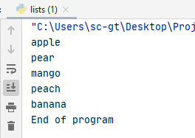
grapes has been deleted

Note that if there is more than one "grapes" in the list, Python will only remove the first one it finds:

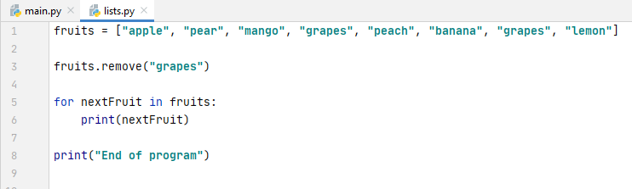
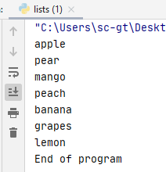
only the first grapes
has been deleted

(To remove both grapes you could write a second fruits.remove("grapes") into your program)

Side note: removing the last element in the list could be done in many different ways!

fruits.pop()
fruits.pop(5)
del fruits[5]
fruits.remove("banana")

clear()

To clear the entire list, you can use the clear() function.

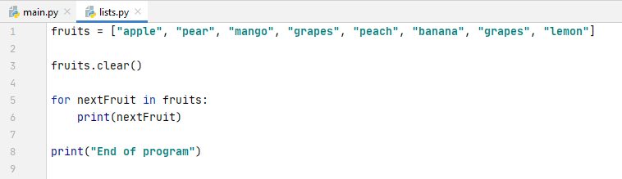

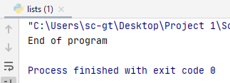
Checking if an item exists in a list

If we want to double check whether a list item is in there, we can use an if statement:

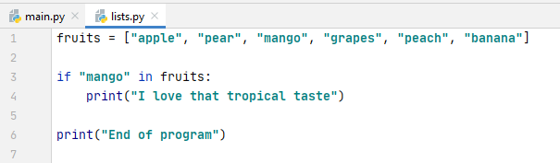

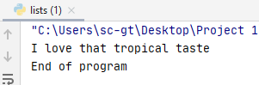

User input and lists

Let's take an example with user input. Via a for loop, the user is invited to enter 5 breakfast cereals:



