 APPENDIX GA36b

LEVEL 4 ASSESSMENT SPECIFICATION

Student name: | Josh Jenkins | Student ID number: | 17835588
Programme: | HNC/HND in Electrical and Mechanical Engineering.
Module | Engineering Applications and Study Skills
Module code: | GOEN 4000 | Contribution to Overall  Module Assessment (%): | 40%
Lecturer: | Calvin Williams | Internal Verifier: | Coral Planas
Assignment Title: | Academic and Employability Skills for Engineers. | Word count (or equivalent); | 2000
Submission deadline: | 11/01/2022 | Return date of provisional marks & written feedback: | 01/02/2022
Submission method: | All written assessments, where practical and possible, must be submitted via Turnitin unless otherwise instructed by the Lecturer. (Please DO NOT put this assessment specification into Turnitin or it will match many similarities with other students’ submissions.)  Alternative submission method (if applicable):  Late submission of the assessment will result in a late penalty mark. Penalties for late submission: Up to one week late, maximum mark of 40%. Over one week late, 0%. Only the Extenuating Circumstances Panel may approve a change to submission dates.
Academic honesty/ referencing: | Academic honesty is required. In the main body of your submission you must give credit to authors on whose research and ideas your work is based. Append to your submission a reference list that indicates the books, articles, etc. that you have used, cited or quoted in order to complete this assessment.

Module Learning Outcomes (from module syllabus)
Demonstrate transferable skills in a learning environment. Apply an academic, positive and professional approach to their studies. Identify suitable and relevant sources of information to meet a research topic of your choice

TASK DESCRIPTION

Task 1

Self Assessment Questionnaire.

Carefully read each question below and circle your chosen answer.

When you have answered the questions, check your answers against the results on the answer sheet.
If you are unsure of any answers do not be tempted to look at the answer sheet but assess your current knowledge and skills.

Reflect on the results from your answers and make a short list of any areas that you feel you need to improve.

GUIDANCE FOR STUDENTS IN THE COMPLETION OF TASKS

Choose the best answer for each of the following questions:

- A research paper is different from an essay because:
- An essay contains fewer facts than a research paper.
- An essay is more opinion dominated.
- A research paper is an extended analysis based on data and evidence.
- A research paper is always shorter than an essay.

- An introductory paragraph should always contain:
  - The thesis statement.
  - As many facts as possible.
  - A summary of the subject matter.
  - A table of contents.

- To proofread any document—including your research paper—means to thoroughly:
- Rewrite any sections that need work.
- Restate the thesis argument.
- Check for any spelling or grammatical errors and correct them.
- Change the pagination and footnotes.

- A bibliography is an essential component of any research paper because it:
  - Demonstrates to the reader the full knowledge of the writer.
  - Officially lists all the sources the writer has consulted.
  - Makes a final statement at the end of the paper.
  - Helps the reader understand the content of the paper.

- A primary source:
- Is the first source the writer has consulted.
- Always includes electronic material taken directly from the web.
- Is a better source of information than any other.
- Includes eyewitness accounts or firsthand information about the event or topic discussed in the paper.
- To plagiarise someone else's work means to:
  - Use too many quotations.
  - Take someone else's point of view.
  - List too many facts or statistics.
  - Copy and neglect to credit work that is not your own.
- An annotated bibliography provides important information to the reader because:
  - It states more sources than a regular bibliography.
  - It describes precisely how each book was useful and what material it contained.
  - It is more professional than a regular bibliography.
  - All professors prefer an annotated bibliography.

- In order to avoid plagiarising a source, every note card needs to have:
  - Your thesis statement in its final form.
  - The title, author, publisher, date/place of publication, and page number of the book you are using.
  - An introductory paragraph from the book you are using.
  - A conclusion from the book you are using.

- Non-fiction material refers to any material that:
  - The writer has reviewed before writing the paper.
  - Comes from a variety of different sources.
  - Contains strictly factual information.
  - Refers to secondary sources in the bibliography.

- When citing electronic information, it is important to be as accurate as possible because:
  - Most websites contain more information than books.
  - Electronic websites and information are constantly being updated.
  - Too many people use the web for research.
  - Electronic information is never reliable.

- Any factual material that is quoted directly or paraphrased from a text must:
  - Appear in the introductory paragraph.
  - Express the opinion of the writer only.
  - Have an accompanying footnote, endnote, or parenthetical citation.
  - Sufficiently get the attention of the reader.

- Internet or electronic sources of information can be tricky to document and include in footnotes or citations if they:
  - Do not come from an established website with an official electronic address.
  - Come from an international website.
  - Are not available in hard copy.
  - Do not provide accompanying web links.

- The problem with relying completely on your computer's spell check to proofread your paper for spelling errors is that:
  - A computer program corrects words too quickly.
  - Computers are unreliable machines.
  - A computer can spell words correctly but cannot always verify their spelling by the way they are used in context.
  - The grammar check on a computer is more effective than the spell check.

- The best way to remember the correct spelling of a word and its proper usage is to:
- Use a dictionary, look it up, and see the word in context.
- Rely on the spell check on your computer.
- Ask a friend to proofread your paper for you.
- Use the grammar check on your computer program.
- When you revise your rough draft, the best thing to check first is:
  - That every single word is spelled perfectly.
  - That there is a sense of logic and order in your research paper.
  - That the evidence presented is perfect and beyond any dispute whatsoever.
  - That your tone is important and official.Answers
Question No. | Answer | Question No. | Answer
1 | c | 8 | b
2 | b | 9 | c
3 | c | 10 | b
4 | b | 11 | c
5 | d | 12 | a
6 | d | 13 | c
7 | b | 14 | a
 |  | 15 | b

Having completed the above questionnaire, what areas of weakness have you identified? What areas could you improve on, in relation to research and report writing?
(Minimum 500 Words)
In reference to understanding research and written submissions, I feel that there are several areas in which I can improve on for a successful outcome in my studies.

The first area I think I can improve on is introductory paragraphs. When answering the question, I thought that an introductory paragraph was to write a summary of the subject of the matter, when really you should try to contain as many facts as possible. Whilst I still believe that in an introductory paragraph you should write a summary of the subject you are going to discuss, I will in the future try to include as many facts related to the topic as possible.

Another area of which I could improve on is citing electronic information. Although I am aware of the risks that come with using electronic information, I believe I don’t go into enough research into whether the source is 100% factual or not. To improve on this topic, I think I should check whatever sources I use for research and essay writing in more depth before I use them as false information could potentially damage the reliability of my work as well as harming the overall grade. I will also use more reliable sites when researching for subjects electronically that do have a good reputation.

As well as this, I do think it’s important for me to improve on my referencing when it comes to research and written submission tasks. When it comes to essay writing, I know it’s crucial to reference any sources that I used for the task as well as being extremely careful not to plagiarize anyone’s work. So to improve on this I will try to practice referencing more using the Harvard referencing method to make sure I don’t plagiarize anyone’s work by accident and that I am referencing the correct sources properly.

Also, I do believe I need to improve on proof-reading my assignments and written submissions before I send them off for marking. There have been past assignments in which I’ve handed in without checking over my work which has been shown as I have lost marks as a result of this. So for any future assignments I submit, I’m going to make sure I personally proofread any work that is being submitted. This includes a spelling and grammar check, as well as making sure my referencing is within the guidelines. I will also ask a friend to proofread my work for me as well to make sure I haven’t missed anything out. This also is referenced to making sure I am using the correct proofreading software for checking my work, for example when using a word publishing software, it could be using american english to proofread my work when it should be correcting my work in british english as some words or phrases are sometimes spelt or used differently.

Finally, the last area in which I feel I need to improve on is remembering the best way to spell a word and its proper usage. In most cases I rely on the spell check on my computer to correct any spelling mistakes or the wrong use of phrases to autocorrect it for me. In reality, I should instead use a dictionary to check for correct spelling and meaning behind the word so that the reader of my work can easily understand what I am saying.

Task 2
Understanding Learning Styles

We all learn in different ways. It is important that we recognise how we learn so that we can adapt and develop strategies to help us as we learn and to develop our communication skills. Some say that, once we recognise our learning styles we can adapt the way we take notes, carry out research, revise and even take an exam.

To assess your learning style, access https://www.hfe.co.uk/learning-styles-questionnaire/there you will find a simple online Questionnaire that will assess your current preferred learning. Complete the Questionnaire as accurately as possible.

Once completed, the website will identify your preferred learning style. Reflect on the outcome; how do you feel this compared to how you thought you learnt?

Use the website to find out more about your preferred learning style. Reflect on this by give a few examples of how you could take lecture notes or revise for class tests to help you in the coming year.

Preferred Learning Styles | Your Scores
Visual | 16
Aural | 7
Read/Write
Kinaesthetic | 11
Multimodal
What is identified as your preferred Learning Style | Visual

- Critically evaluate the use of VARK, by examining some evidence of its value.
To a certain extent, I do believe that VARK can be very useful when understanding your learning styles. Personally, I believe that VARK can be used very effectively to aid you in your studies because it helps you identify your key learning styles, as well as skills you can potentially improve on. Research conducted by VARK shows that VARK is ‘moving in the right direction’ with the questionnaire ‘point learners in the direction of strategies that might help with their learning, and to encourage them to actively think about how they learn best’. The page also shows that the new version of VARK has increased the percentage of people who believe the results matched their learning style from 69% to 74%. VARK is in general is widely accepted as an effective way to find your unique learning style with only 2.6% of people who take the test don’t expect it to be useful. A study conducted by Imran Hussain, Department of English Linguistics, University of Lahore, Pakistan, on point that backed the use of VARK states that these ‘cultivating styles have lent to have a genuine impact on the accomplishments of students (Cassidy, 2004)’ which shows that VARK is again effective in the learning managements and techniques of students.

However, despite a lot of praise for VARK itself, there is also a long list of critics that consider VARK to be very ineffective in the aid of learning which does alter my opinion on the topic. One of the main criticisms that has been accepted widely is that there’s no concrete evidence to suggest that VARK learning styles are actually effective and help students in their studies. A quote from a report carried out by Lafferty and Burely (2009) stated that ‘learning styles are independent’ and goes on to say the same about teaching techniques and dependence on emotion. The point that is trying to be made here is that there are other factors that come into play when talking about your learning style, and some of these environmental factors are beyond your control. For example, when the author mentioned emotion, it can be that one bad day could put you off your learning and your mind can drift elsewhere, which of course can massively hinder your learning, especially if you don’t understand the work. This research is repeated across a vast variety of books and websites which does show that VARK is widely unaccepted by society.

In conclusion, when looking at both points of the argument, I do believe that VARK can be used effectively in the right places but it shouldn’t be pushed forward as revolutionary technique. Due to every learner being different, a different style works for each person and if I believe that VARK should be used as a way to help students who are struggling in their learning techniques, rather than also enforce into onto people who don’t require VARK for help.

- With this knowledge, list some factors that influence learning.

How can you use what you have learned to aid you in your studies?
Taking information in | Flashcards – Flashcards are an effective technique that can be used to remember key words or phrases that’s very helpful for report writing. This involves writing a word on one side of the card and writing the definition of that word on the other side of it. According to recent studies, ‘Some research has found that this kind of active recall retrieval practice leads to 150% better retention than passive studying’.  Highlighting – Highlighting a common technique used that has been known to be effective in taking in information. This involves using a highlighter to underline key words and phrases from a textbook or paragraph of information and only look over those words/phrases that have been highlighted so you don’t need to take in as much information. However it is important that you don’t highlight too much as it could have a negative impact on taking in information. Research from Fowler and Baker (1974) states that ‘the more text subjects highlighted the worse their test performance’  Abbreviate words – Abbreviating words is another form of taking in information by shortening words or phrases to make it easier for you to remember or understand better. This can sometimes be confused with using acronyms, however an acronym is shortened using individual letters of the initial letters of the phrase. For example, an abbreviation could be Dr for Doctor or CA for California, whilst an acronym could be BBC for British Broadcasting Corporation, or HSBC for Hongkong and Shanghai Banking Corporation.  Teach someone what you learnt – teaching can be a good way to retain information as well as getting feedback that can help you aid you in taking in information. When doing a presentation, you try to explain a topic to people in a way that everyone in a room can easily understand, and by simplifying it down and revising the lines for the presentation, you will eventually be able to know the information off by heart.  Play and learn - this technique involves playing games in order to help students take information. One game that is commonly used involves one person (usually a teacher) holding a ball and asks a question to the class on a topic. The teacher then throws the ball to someone and they answer the question, then they throw the ball to someone else and they answer the question, and this is repeated and is supposed to be a way to get your brain to think on how to answer the question. This game should then help you remember as you are put on the spot to answer a question.
Studying & Revising | Structuring - When studying, it’s very important that you add structure to your revision. If you have multiple exams, you should organise your work into different topics so that it’s easier to find the notes you are looking for. Adding a structure to your learning plan as well, such as planning the time you’re going to revise each topic and plan what days you are going to study each topic will help boost confidence and provide less stress in preparation leading to the exams.  Past questions - Looking at and completing past paper questions is widely accepted to be an extremely effective way to revise. By familiarising yourself with the structure of exam questions and how many marks are up for grabs and how you earn those marks, it will prepare yourself for anything the exam might throw at you. As well as this, by completing past papers and marking yourself you can clearly see where you need to improve on in preparation for the exam, and if you keep passing these exams, it will certainly boost your confidence.  Research/reading - doing your own notes and research can be a key way to revise for an exam. Particularly if you’re in university, there’s a lot of independent study you are required to do if you want to have the chance to pass the exam.  Colour coding - Colour coding is another type of structuring method that can aid you for your studies. This involves either using different coloured sticky notes or different coloured highlighters to categorise different topics, phrases equations etc. so that it is easier to find or study the thing you are looking for.  Record yourself explaining information and notes - If you record yourself describing the information back to you, you can look back at this information wherever you go without the need to take your notes if you record with your phone.  Pomodoro technique - This technique is one that many people do but might not realise they’re doing it. This is a time management technique where you structure your work and break times. It encourages you to try to do as much work as you can for 20/25 minutes, and then you take a 5 minute break, and repeat this process throughout your revision session.  Mind maps - Mind maps are used as a brainstorming technique to help you in revision. This involves writing the topic in the middle of the page, and then draw branches of side topics that come off the main topic, and then writing down any key words that associate with those side topics. When looking back at this mind map, you can then associate these keywords with the different topics.
In exams or class test situation | Pre-exam technique - To avoid as much stress as possible on the day of or before the exam, it helps some people to have a pre exam technique that can give them confidence or help them feel at ease. This normally varies from person to person, but there are several examples out there that are quite common. Some people like to study in groups of friends the night before an exam to help test each other, go over notes and to make sure everything is correct. Some people also like to study the morning before the exam to help them feel more prepared, or to eat some brain food that keeps them mentally ready such as eating a banana.  Highlight key notes - to achieve your full potential in the exam, you should read the questions thoroughly. This should be done by reading the question twice and highlighting the key words, this should help you fully understand what the question is telling you. This method could be the difference between a grade.

Task 3

Skills Self-Assessment Audit

Please answer all questions in this self-assessment. There are 48 questions, split into 8 groups. Read each question and tick the value which you feel is most appropriate to you. Each answer has a point value:

- disagree strongly 1
- tend to disagree 2
- tend to agree 3
- strongly agree 4

Add up your scores for each section and then add these together. There is an indication of your skill level in the scoring system at the end of the exercise. This will give you an idea of how confident you feel about your skills. Please be as honest as you can with your answers.

COMMUNICATION: READING |  |  | 1 | 2 | 3 | 4
1 | I feel confident about my reading, especially for study |  | □ | □ | □ | □
2 | I can find information from a wide variety of sources (books, journals, CD-ROMS, Internet) |  | □ | □ | □ | □
3 | I can select information relevant to the topic from these sources |  | □ | □ | □ | □
4 | I am able to use different reading strategies (skim, scan, read in-depth) |  | □ | □ | □ | □
5 | I can make useful notes while I am researching for an assignment or a project |  | □ | □ | □ | □
6 | I can summarise a section of text to convey the author’s main arguments |  | □ | □ | □ | □
 | TOTAL: |  |  |  | 22

COMMUNICATION: WRITING |  |  | 1 | 2 | 3 | 4
7 | I am confident that I can reproduce my ideas effectively in writing |  | □ | □ | □ | □
8 | I am confident that I can write substantial reports and essays as well as shorter pieces such as formal letters |  | □ | □ | □ | □
9 | I always plan my essays and other assignments before writing anything |  | □ | □ | □ | □
10 | I always check my work for spelling and grammatical errors before submitting it |  | □ | □ | □ | □
11 | I always check that my work is presented according to my department’s requirements |  | □ | □ | □ | □
12 | I can make useful and meaningful notes from a lecture, presentation or demonstration |  | □ | □ | □ | □
 | TOTAL: |  |  |  | 20

COMMUNICATION: ORAL |  |  | 1 | 2 | 3 | 4
13 | I am confident explaining new concepts to other people |  | □ | □ | □ | □
14 | I would be able to give a presentation on a subject new to me |  | □ | □ | □ | □
15 | I can produce visual aids (including slides with charts, diagrams, tables and photographs) to illustrate points in a presentation |  | □ | □ | □ | □
16 | In group discussions, I listen to others and am sensitive to their points of view |  | □ | □ | □ | □
17 | I can take the discussion forward at appropriate points |  | □ | □ | □ | □
18 | I can adapt my presentations according to my audience |  | □ | □ | □ | □
 | TOTAL: |  |  |  | 23

TEAMWORK |  |  | 1 | 2 | 3 | 4
19 | I have often worked with others as part of a team |  | □ | □ | □ | □
20 | I make sure that I understand the goals the team is trying to achieve |  | □ | □ | □ | □
21 | I agree my own responsibilities in working towards the team’s goals |  | □ | □ | □ | □
22 | I am sensitive to the roles of other team members |  | □ | □ | □ | □
23 | I can monitor the team’s progress and report any difficulties |  | □ | □ | □ | □
24 | I am happy to lead the team if the opportunity presents itself |  | □ | □ | □ | □
 | TOTAL: |  |  |  | 24

PROBLEM-SOLVING |  |  | 1 | 2 | 3 | 4
25 | When faced with a task I can break it down into manageable parts |  | □ | □ | □ | □
26 | If at first I do not understand a problem, I can find help |  | □ | □ | □ | □
27 | I enjoy the challenge of solving problems |  | □ | □ | □ | □
28 | When I am given a new task, I always ‘brainstorm’ ideas (involving the team if part of a team) |  | □ | □ | □ | □
29 | I consider the likely outcomes of my solutions to problems before I carry them out |  | □ | □ | □ | □
30 | I consider alternative solutions depending on the problem in question |  | □ | □ | □ | □
 | TOTAL: |  |  |  | 21

PERSONAL EFFECTIVENESS |  |  | 1 | 2 | 3 | 4
31 | I can organise my tasks in order to meet deadlines |  | □ | □ | □ | □
32 | I reflect on my progress towards my targets |  | □ | □ | □ | □
33 | I know my own strengths and weaknesses when it comes to planning and meeting targets |  | □ | □ | □ | □
34 | I can find support where necessary in order to help complete a task |  | □ | □ | □ | □
35 | I have future targets in mind regarding my career and education |  | □ | □ | □ | □
36 | I discuss my future targets with others (e.g. tutor) |  | □ | □ | □ | □
 | TOTAL: |  |  |  | 20

NUMERACY |  |  | 1 | 2 | 3 | 4
37 | I am confident about making simple calculations |  | □ | □ | □ | □
38 | I use a calculator competently in my studies/work |  | □ | □ | □ | □
39 | I am confident in working with fractions, decimals, percentages and ratios |  | □ | □ | □ | □
40 | I can interpret graphs, charts, tables and diagrams where necessary |  | □ | □ | □ | □
41 | I can construct graphs, charts and diagrams when I need to convey information this way |  | □ | □ | □ | □
42 | I am confident in my ability to handle statistical data as part of my course/my job |  | □ | □ | □ | □
 | TOTAL: |  |  |  | 24

INFORMATION TECHNOLOGY |  |  | 1 | 2 | 3 | 4
43 | I use a word-processing package to produce all my submitted work |  | □ | □ | □ | □
44 | I can use a spreadsheet package to record and manage data |  | □ | □ | □ | □
45 | I can use a database package to establish and use a database |  | □ | □ | □ | □
46 | I am confident in researching topics of study using the Internet |  | □ | □ | □ | □
47 | I can produce transparencies or visual aids for a presentation using presentation software |  | □ | □ | □ | □
48 | I am aware of health and safety issues around the use of computers |  | □ | □ | □ | □
 | TOTAL: |  |  |  | 24
178
Grand Total:

How did you do?

You can check your score against the scoring system below. PLEASE REMEMBER that this is not scientific! It is not devised as a ‘perfect’ self-assessment test, and these scores give only an indication of your level in any of the skills mentioned.
48-69
You’re not feeling particularly confident about your skills and abilities – perhaps you weren’t giving yourself due credit for your talents? By using this pack, you should be able to work on areas which you feel could do with improving. You might even find it useful to talk through your self-assessment with a friend or a tutor whom you trust. They may see your strengths more clearly than you have in this exercise.
70-95
You consider yourself to be ‘average’ – this means that you have firm foundations on which to improve your skills! Using the list below, identify some of the areas which are stronger than others. This will help you to plan your improvement, and prioritise the areas which need attention. Focus on activities which can develop these particular skills. If you refer to this Skills Audit again during the semester you’ll see how your weaker skills are gradually strengthening.

96-139
Congratulations! You’ve rated yourself well. You may have some areas which could be developed further, but you are confident and competent in a wide range of skills. If you are particularly strong in one skill, such as written communication, now might be the time to focus on something else. For example, you might start working on your numeracy – can you work out how much you’ve spent on your food shopping before you reach the till at the supermarket?
140-192
You are highly confident in all these skill areas – well done. You find it easy to apply your skills in a variety of situations. However, you can make good use of this pack to reflect on your skills further and bring them to a higher level. Think about the next stages of your academic and professional life – would you know how to demonstrate your skills to an employer?

From your Personal Skills Audit, Strengths and Weakness discussions in class and your group session develop your own personal SWOT analysis, identify your strengths and weaknesses and also to look at how you can develop those areas.

Use the internet to research different templates and use the one that suits your needs.
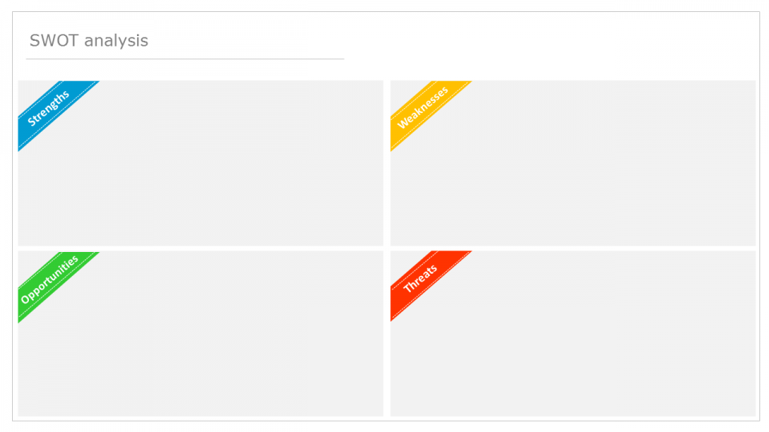
Practical Skills
Listening Skills
Work Ethic
Motivation
Self-Reflection
Timekeeping
Efficiency
Retaining Information
Getting something wrong
Distractions

Support
Job progression
Qualifications
Profession opportunities
Increased wages

Exams
Removed from job position
Environmental Factors
Mental Health
Physical Threats

Strengths

Practical skills – One of my key strengths in the workplace is my practical skills. When working with tools and equipment I can use them quite effectively and efficiently and I’m quite quick on learning on tools and equipment I haven’t been previously trained on. I also know when presented with a task, I know what tools and equipment are needed for the job and how to use them to full effect.
Listening skills – I would say I’m very good at being able to listen to instructions carefully and being fully focused on someone talking to me. There are very few times when I need to ask someone to repeat themselves and I’m also very aware of my surroundings when listening for anything unusual (e.g. a machine might have a fault as indicated by a siren or by the sound it is making).
Work Ethic – I have always had a strong work effort whether I’m at work, college or any task I undertake. I take pride in my work and I always try to complete the job to the best of my ability. Sometimes I might come across a job that I don’t really like but I always get on with it without any complaining or moaning.
Motivation – When working my job, I always feel motivated when it comes to tackling jobs no matter the size or difficulty. I feel that if you keep yourself motivated you will enjoy the task more and you will complete it more effectively, which ultimately pays off for myself in both the short and long term.
Self-reflection – When it comes to reviewing my work, I handle both the positives and negatives very well. I’ve always been praised on how well I handle criticism and how I use it to my advantage. This has helped me develop my skills for the better as I use the criticism to improve my abilities.

Weaknesses

Timekeeping – I will say at times I can be quite poor when it comes to time keeping for my work. When meeting a deadline I can sometimes leave my work to the last minute which causes the quality of the work to be tampered compared to what it would be like if I completed it earlier and spend more time on it. This normally happens when I prioritise other work over sooner deadlines, so to improve on this I plan on creating a log sheet to plan what days and times to use to do work.
Efficiency – Another weakness of mine is how efficient I can be in my work. When introduced to new jobs and new things they aren’t always quite as efficient as they could be. Also, compared to someone with years of experience, I am unable to do the job as effectively as him which can go noticed.
Retaining information – I can sometimes find it difficult to retain information within the short term. Over time and a little revision does help this but in the short term I need to improve on being able to retain important information that is given to me there and then.
Getting Something Wrong - One of my biggest weaknesses has always been being afraid of getting something wrong. When I do get something wrong, I do tend to panic quite quickly which ultimately tampers my work due to not being fully concentrated. This has always been something I feel like I need to improve on. This normally tends to happen in a workplace situation due to past experiences, and other tense situations so it’s for the best that I should learn to calm down and don’t take the failures to heart in the future.
Distractions - Despite being a person who likes to stay concentrated, I do tend to get distracted very easily. Whenever I am studying or in class, I can sometimes get distracted by the slightest thing which obviously stops me from concentrating and doing my work. This is sometimes avoided when I switch my phone off or if I’m not near a social situation.

Opportunities

Support - What is good about the position I’m currently in is that there’s a lot of support if I need it. Whether it is to do with my job or with college work, there’s always someone there for help. For example, if i need help with a project with my apprenticeship, I’ve got engineers there to help me with any questions I need or to guide me in the right direction if things go wrong. Or in college I’ve always got support from my lecturers or my classmates to help me with work that I don’t understand.
Job Progression - I’m very lucky to be in a job where I can progress far if I want to. For example, once I complete my HNC my company will allow me to go to study a HND alongside work if I want to, and a further degree after that if I wish to do so. As well as this, there's encouragement in the workplace to strive for better opportunities and lots of training available. With all this in mind, this will allow me to progress further into my job and eventually be an electrical engineer.
Qualifications - On top of completing my HNC, completing this apprenticeship will bring me loads of qualifications that will give me plenty of job opportunities in the future. On completion of the apprenticeship, I will be given an NVQ, a HNC in electrical and electronic engineering as well as being a fully qualified electrical craftsman.
Profession Opportunities - With the qualifications I will be having at the end of this HNC and apprenticeship, these qualifications will allow me to apply for a number of different jobs within engineering.
Increased wages - Whilst I am currently on apprenticeship wages which is lower than the average salary, once I am fully qualified I will be able to receive a big increase in my wages. These wages can only continue to go up as my qualifications will help me be considered for promotions.

Threats

Exams - Exams throughout the whole qualification could prevent me from passing this course as well as the apprenticeship. Of course if I fail my exams I won’t be able to receive the qualification and I will not be able to pass my apprenticeship as a result, which can lead to me losing my job.
Removed from job position - For whatever reason in the future, I could be removed from my job permission whether it’s due to personal or company issues there would be nothing I could do about it. This would obviously mean I would lose my apprenticeship and some of my qualifications.
Mental Health - One’s mental health could cause huge damage to results and performance within a HNC course. Whether this is to do with stress or an incident that happens out of college, the mental health effects from it might contribute to failing exams, missing details and not attending class.
Physical Threats - There are some threats that can be seen as a factor to failing exams and assignments. For example, if you are injured or fall ill, this will have to mean missing class in some cases and makes you miss out on learning.

Task 4

As a core learning process, you are to develop a personal development plan for the next five to ten years of your career. Think of the following points as you develop your personal development plan.

- What you want to achieve in the long term, identify short-term objectives to help you get there
- Use an action plan to track and manage your professional development.
- Be aware of factors that could affect your sector, perhaps read specialist magazines.
- Take on new challenges, either at work or in your leisure time.
- Continue to learn, either formally or informally - develop your skills, knowledge and abilities can be life-changing, whatever stage of your career.

Use the template below to complete the personal development plan.

Short and medium term | Action required | Constraints | Resources – who or what can help me? | Target dates for action
Complete my current electrical apprenticeship with my current employer. | Keep a track log of what work I have completed in my NVQ and HNC.  Use time within work to get work done instead of sitting down. | Time management - when working during a busy period it can sometimes be hard to find time to complete paperwork.  Commitments outside of work such as trying to maintain a social life and hobbies can make it difficult to fit everything in. | Lecturers in college  Work colleagues  Other apprentices within the company.  Engineers in the workplace | To be completed by 31/08/2023 at the latest
Pass my HNC course in electrical engineering and aim for a HND once the course in complete | Keep up to date with work in class  Meet any deadlines for assignments. Any work should nor be left until the last minute and should be submitted with time to spare.  Revise for any upcoming exams and make sure enough revision has been put in prior to the exam | Commitments with a working full time job as well as college.  Other qualifications such as an NVQ also need to meet deadlines along with the HNC deadlines.  Some colleges might require a certain mark in order to study a HND | Lecturers in college  Friends from the class  Internet resources for information | Must be completed by the summer of 2023.  HND must be applied for by the summer of 2023
Buy my first house | Save a certain percentage of my monthly wages into a savings account and make sure I’m financially stable to keep the house. | Failure to complete my apprenticeship or the inability to get a job at the end of it.  Other ways I want to spend my money such as travelling, moving abroad, buying a new car etc. | Financial adviser  Parents and family members  Housing companies to arrange a mortgage | 31/12/2026
Be financially stable by this time in five years | Complete my HNC and apprenticeship to have the best possible chance of being hired as an electrician. | Not getting the job after my apprenticeship.  Environmental factors that can tamper with my wages. | Financial advisor  Parents and family members | 31/12/2026
Continue my learning within my current job and progress to be promoted into an electrical engineer. | Getting accepted to study a HND and go on to study a degree afterwards.  Job opportunities within the company and working hard. | Other people applying for the same job.  Failure to pass the HNC  Not having the academic ability to reach this within five years | Work colleagues and management  Family and friends  College lecturers | 31/12/2026

Task 5. The report.

Identify relevant sources of information in order to undertake an investigation into an engineering subject. You should produce a professional report and PowerPoint presentation with a clear structure, aims, objectives and outcomes based on your research. This can then be used as a vehicle to inform your peers or other interested parties of your findings. Any quotations or citations within the report must also be referenced using the correct method as detailed in the ‘Harvard’ referencing system.

The report document must contain:

- A cover page or document title page
- A contents page
- Sections or paragraph headings related to each aspect of the report
- Headers on each page with the title of your report
- Footers on each page with the author’s name on the right hand side
- Page numbers
- An introduction into the report that outlines who it is intended for and provides a brief background to your research
- A structured summary or conclusion that draws together the findings of your research and any recommendations you are making
- A maximum word count of 2000 words

The Power Point presentation must contain:
- A maximum of six slides
- A maximum of four bullet points to a page
- Visual objects, graphs, images to enhance communication
- Hyperlinks where appropriate
- All graphics, quotations to be fully referenced
- A 5 minute presentation.

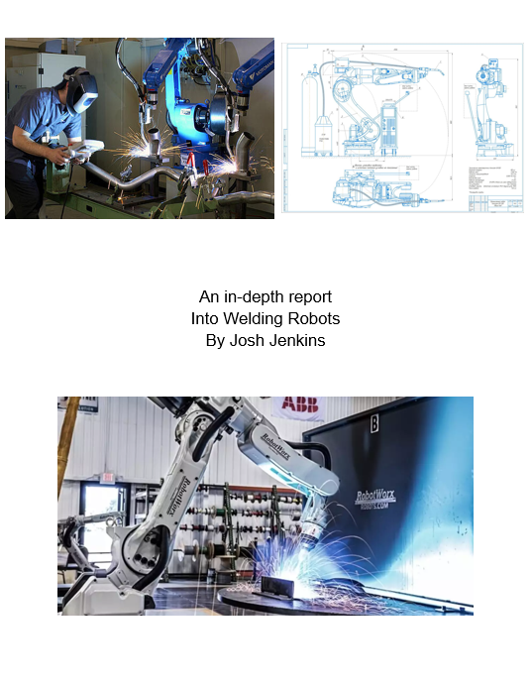

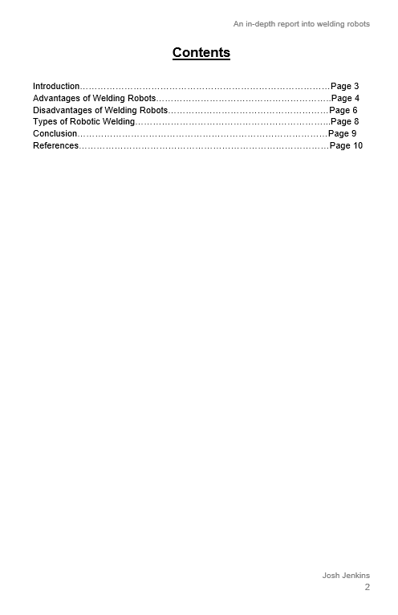

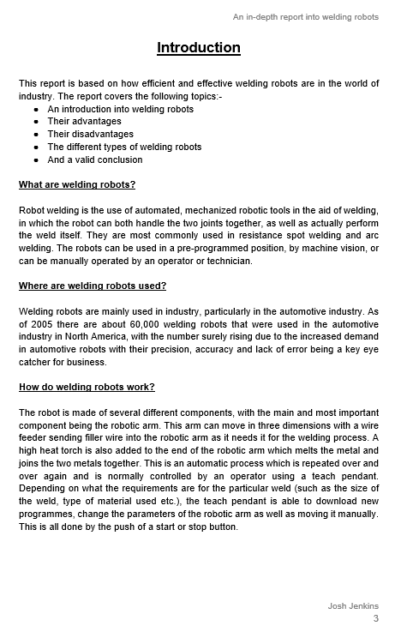

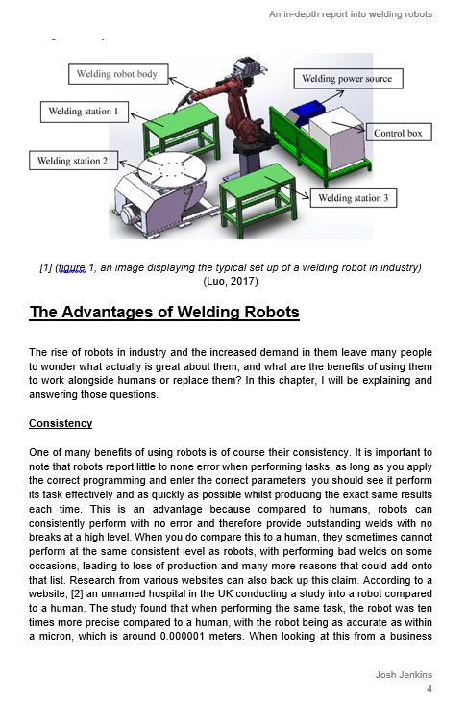

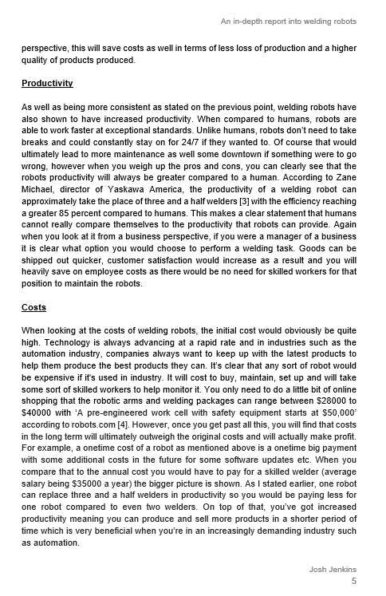

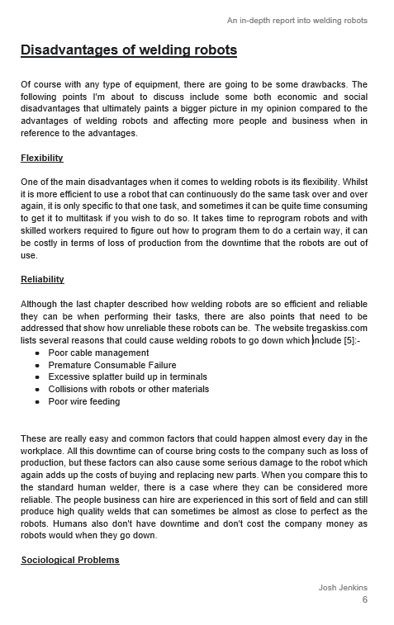

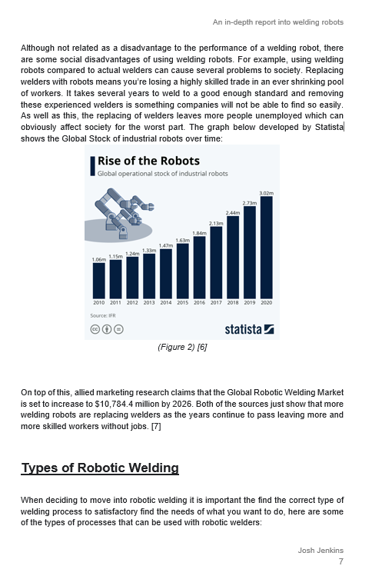

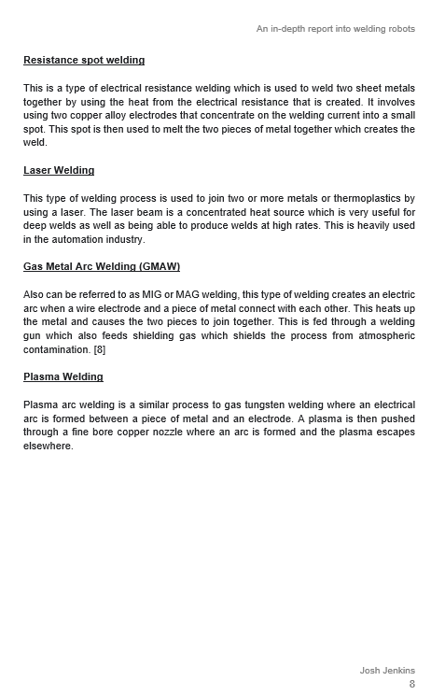

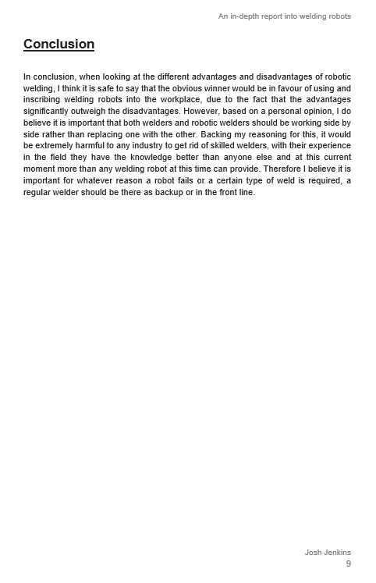

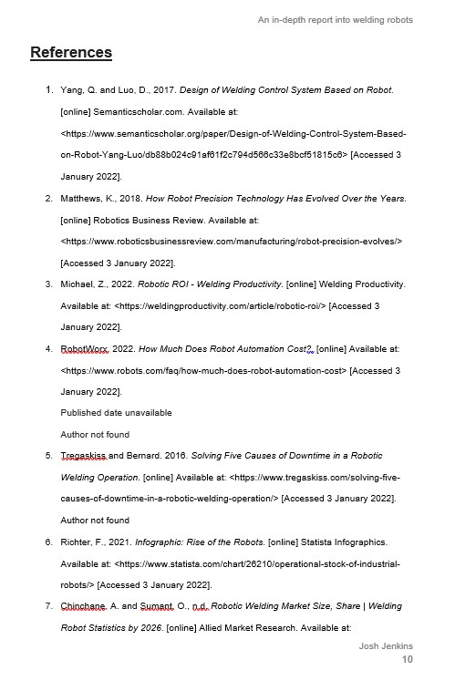

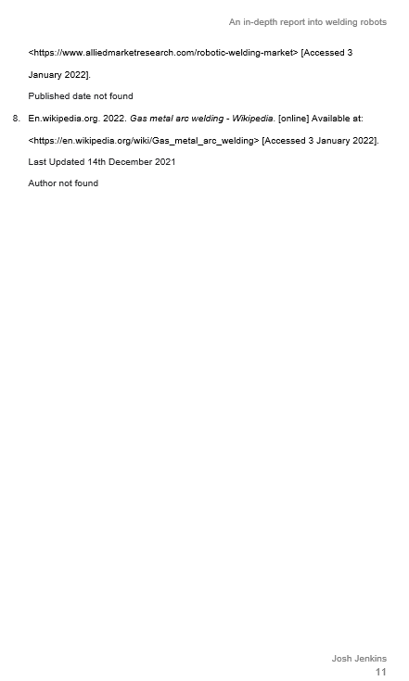

GUIDANCE FOR STUDENTS IN THE COMPLETION OF TASKS

NOTE: The guidance offered below is linked to the five generic assessment criteria overleaf.

1. Engagement with Literature Skills
Your work must be informed and supported by scholarly material that is relevant to and focused on the task(s) set. You should provide evidence that you have accessed an appropriate range of sources, which may be academic, governmental and industrial; these sources may include academic journal articles, textbooks, current news articles, organisational documents, and websites. You should consider the credibility of your sources; academic journals are normally highly credible sources while websites require careful consideration/selection and should be used sparingly. Any sources you use should be current and up-to-date, mostly published within the last five years or so, though seminal/important works in the field may be older. You must provide evidence of your research/own reading throughout your work, using a suitable referencing system, including in-text citations in the main body of your work and a reference list at the end of your work.

Guidance specific to this assessment:
This section will be assessed by your response to Task 1. This specifically relates to referencing and engagement with literature.

2. Knowledge and Understanding Skills
At level 4, you should be able to demonstrate knowledge of the underlying concepts and principles associated with your area(s) of study. Knowledge relates to the facts, information and skills you have acquired through your learning. You demonstrate your understanding by interpreting the meaning of the facts and information (knowledge). This means that you need to select and include in your work the concepts, techniques, models, theories, etc. appropriate to the task(s) set. You should be able to explain the theories, concepts, etc. to show your understanding. Your mark/grade will also depend upon the extent to which you demonstrate your knowledge and understanding.

Guidance specific to this assessment:
In Task 2 you will have the opportunity to show a sound knowledge of learning styles. You will need to show a good level of knowledge and analysis of theories and techniques.

3. Cognitive and Intellectual Skills
You should be able to present, evaluate and interpret qualitative and quantitative data, in order to develop lines of argument and make sound judgements in accordance with basic theories and concepts of your subject(s) of study. You should be able to evaluate the appropriateness of different approaches to solving problems related to your area(s) of study and/or work. Your work must contain evidence of logical, analytical thinking. For example, to examine and break information down into parts, make inferences, compile, compare and contrast information. This means not just describing what! But also justifying: Why? How? When? Who? Where? At what cost? You should provide justification for your arguments and judgements using evidence that you have reflected upon the ideas of others within the subject area and that you are able to make sound judgements and arguments using data and concepts. Where relevant, alternative solutions and recommendations may be proposed.

Guidance specific to this assessment:
The Self-assessment Audit carried out in task 3 will give you the opportunity to evidence your cognitive and intellectual skills. Critical evaluation and analysis of your findings need to be shown.

4. Practical Skills
At level 4, you should be able to apply the basic underlying concepts and principles to evaluate and interpret these within the context of your area of study. You should be able to demonstrate how the subject-related concepts and ideas relate to real world situations and/or a particular context. How do they work in practice? You will deploy models, methods, techniques, and/or theories, in that context, to assess current situations, perhaps to formulate plans or solutions to solve problems, or to create artefacts. This is likely to involve, for instance, the use of real world artefacts, examples and cases, the application of a model within an organisation and/or benchmarking one theory or organisation against others based on stated criteria.

Guidance specific to this assessment:
This will be assessed in Task 4.
You will need to produce a well-structured and self evaluative action plan that accurately reflects your needs and goals. This applying knowledge gained to real world situations will provide evidence for this area.

5. Transferable Skills for Life and Professional Practice
Your work must provide evidence of the qualities and transferable skills necessary for employment requiring the exercise of some personal responsibility. This includes demonstrating: that you can communicate the results of your study/work accurately and reliably, and with structured and coherent arguments; that you can initiate and complete tasks and procedures, whether individually and/or collaboratively; fluency of expression; clarity and effectiveness in presentation and organisation. Work should be coherent and well-structured in presentation and organisation.

Guidance specific to this assessment:
This will be assessed in Task 5.
A 2000 word report incorporating, diagrams, spreadsheets, and photographs is required. You will be required to make a 10 minute presentation to your class-mates and faculty staff, thus covering the relevant criteria for this unit.

STUDENT FEEDBACK FORM

This section details the extent to which the assessment criteria are demonstrated by you, which in turn determines your mark. The marks available for each category of skill are shown. Lecturers will use the space provided to comment on the achievement of the task(s), including those areas in which you have performed well and areas that would benefit from development/improvement.

Generic Assessment Criteria | Marks available | Marks  awarded
1. Engagement with Literature Skills

Task 1
Questionnaire completed
Reflections of areas of improvement

5
10

2. Knowledge and Understanding Skills

Task 2 | 10
3. Cognitive and Intellectual Skills

Task 3 | 10
4. Practical Application Skills

Task 4  Skills Self-Assessment Audit  Developed the personal development plan | 15  10
5. Transferable Skills for Life and Professional Practice

Task 5  A report satisfying the criteria in the student guidelines.  A presentation | 25
 | 15

Assessment Mark (Assessment marks are subject to ratification at the Exam Board. These comments and marks are to give feedback on module work and are for guidance only until they are confirmed. ) | Late Submission Penalties (tick if appropriate) |  | %
 | Up to 1 week late (40% Max) |  | %
 | Over 1 week late (0%) |  | %

GENERIC ASSESSMENT CRITERIA

Level 4
In accordance with the Framework for Higher Education Qualifications, at the end of Level 4 students will be expected to have demonstrated knowledge of the basic underlying concepts and principles of a subject, and an ability to evaluate and interpret these within the context of that area of study. They should be able to present, evaluate and interpret qualitative and quantitative data in order to develop lines of argument and make sound judgements in accordance with basic theories and concepts of their subject(s) of study. They will have learned how to evaluate different approaches to solving problems, and will be able to communicate the results of their study/work accurately and reliably, and with structured and coherent arguments. They will be able to undertake further training and develop new skills within a structured and managed environment and will have the qualities and transferable skills necessary for employment requiring the exercise of some personal responsibility.

Level 4 | FAIL | MARGINAL FAIL | SATISFACTORY  (3rd / Pass) | GOOD  (2.2 / Pass) | VERY GOOD  (2.1 / Merit) | EXCELLENT  (1st / Distinction) | EXCEPTIONAL  (1st / Distinction)
Category | 0-29% | 30-39% | 40-49% | 50-59% | 60-69% | 70-84% | 85-100%
Engagement with literature (including reading, referencing,  academic conventions and  academic honesty) | Little or no evidence of reading and/or reliance on inappropriate sources.  Views and findings mostly unsupported and non-authoritative.  Referencing conventions used incoherently or largely absent. | Poor engagement with essential reading. No evidence of wider reading. Reliance on inappropriate sources, and/or indiscriminate use of sources. Heavily reliant on information gained through class contact. Inconsistent and weak use of referencing. | Engagement with a limited range of mostly relevant and credible sources but with some reliance on information gained through class contact. Some omissions and minor errors.  Referencing conventions evident though not always applied accurately or consistently. | Engagement with an appropriate range of literature, including sources retrieved independently. Some over-reliance on texts rather than other sources. Referencing may show minor inaccuracies or inconsistencies. | Engagement with a wide range of literature, including sources retrieved independently.  Selection of relevant and credible sources. Generally sound referencing, with no/very few inaccuracies or inconsistencies. | Engagement with an extensive range of relevant and credible literature. Consistently accurate application of referencing. | Exceptional engagement with an extensive range of relevant and credible literature. High-level referencing skills consistently applied.
Knowledge and understanding (Knowledge of the basic underlying concepts and principles of a subject.) | Major gaps in knowledge and understanding of the basic underlying concepts and principles of the subject matter. Inclusion of irrelevant material. Substantial inaccuracies. | Gaps in knowledge of the basic underlying concepts and principles, with flawed or superficial understanding. Some significant inaccuracies and/or irrelevant material. | Limited knowledge and understanding of the basic underlying concepts and principles within the subject area. Some elements may be missing. | Knowledge of the basic underlying concepts and principles is accurate with a good understanding of the field of study but lacks depth and/or breadth. | Competent knowledge of the basic underlying concepts and principles. Exhibits very good understanding. | Excellent knowledge and understanding of the basic underlying concepts and principles of the subject. | Exceptional, detailed knowledge and understanding of the basic underlying concepts and principles
Cognitive and intellectual skills  (Evaluate underlying concepts and principles of a subject and interpret qualitative and quantitative data in order to develop lines of argument and make sound judgements.) | Wholly or almost wholly descriptive work. Little or no evaluation of the underlying concepts and principles.  Failure to develop arguments, leading to illogical or invalid judgements. Minimal or no use of  evidence to back up views. | Largely descriptive work, with superficial evaluation of the underlying concepts and principles. Weak interpretation of data, flawed development of arguments and judgements. Information accepted uncritically, uses generalised statements made with scant evidence and unsubstantiated opinions. Ideas sometimes illogical and contradictory. | Limited attempt at evaluation of the underlying concepts and principles, tending towards description.  Can interpret qualitative and quantitative data but with some errors. Some evidence to support emerging arguments and judgements but these may be underdeveloped or with a little inconsistency / mis-interpretation. | Good evaluation of the underlying concepts and principles. Can interpret qualitative and quantitative data, with minor errors.  An emerging ability to use evidence to support the argument.  Mostly valid arguments and logical judgements. | Sound evaluation of the underlying concepts and principles. Can interpret qualitative and quantitative data accurately. Ability to devise arguments using evidence to make mostly appropriate and valid judgements. | Excellent evaluation of the underlying concepts and principles. Can interpret qualitative and quantitative data accurately and with some insight. Excellent ability to devise arguments using evidence and make appropriate and valid judgements. | Exceptional evaluation of the underlying concepts and principles based evidence. Outstanding interpretation of qualitative and quantitative data.  Exceptional ability to devise arguments using evidence and make wholly appropriate and valid judgements.
Practical skills  (Different approaches to solving problems in particular contexts.) | Limited or no use of taught, basic methods, materials, tools and/or techniques.  Little or no appreciation of the context of the application.  Very weak evidence of different approaches to problem-solving in particular contexts. | Rudimentary application of taught, basic methods, materials, tools and/or techniques but without consideration and competence. Flawed appreciation of the context of the application.  Weak evidence of different approaches to problem-solving in particular contexts. | An adequate awareness and mostly appropriate application of basic methods, materials, tools and/or techniques.  Basic appreciation of the context of the application.  Can identify problems in particular contexts and propose basic alternative approaches or solutions though there may be errors. | A good and appropriate application of basic methods, materials, tools and/or techniques.  Clear appreciation of the context of the application.  Good evidence of different approaches to problem-solving in particular contexts and proposes mostly appropriate solutions. | A very good application of a range of basic methods, materials, tools and/or techniques.  Very good consideration of the context of the application. Very good evidence of different approaches to problem-solving in particular contexts and proposes appropriate solutions. | An advanced application of a range of taught, basic methods, materials, tools and/or techniques.  The context of the application is well considered, and insightful.  Excellent evidence of different approaches to problem-solving in particular contexts and proposes appropriate solutions. | Exceptional levels of application and deployment skills in particular practical contexts. Outstanding identification of problems in particular contexts and formulation of wholly appropriate, thoughtful solutions / different approaches.
Transferable skills for life and professional practice  (Communicate the results of their study/work accurately and reliably, and with structured and coherent arguments; the qualities needed for employment requiring the exercise of some personal responsibility within a structured and managed environment.) | Work is poorly structured, disorganised, inaccurate and/or confusingly expressed. Very weak use of language and/or very inappropriate style. Failure to work effectively individual or as part of a group. Little or no evidence of the skills for employment requiring the exercise of some personal responsibility. | Work is poorly presented in a disjointed manner. It is loosely, and at times incoherently, structured, with information and ideas often poorly expressed. Weak use of language and/or inappropriate style. Flawed approach to individual or group work, meeting only partial obligations to others. Limited evidence of the skills for employment requiring the exercise of some personal responsibility. | Mostly ordered presentation and structure in which relevant ideas / concepts are reasonably expressed. Work may lack coherence and/or accuracy in places. Can work as part of a group, meeting most obligations to others but perhaps with limited involvement in group activities.  Demonstrates the basic skills for employment requiring the exercise of some personal responsibility, with some areas of minor weakness. | Mostly coherent, organised and accurate work, in a suitable structure and is for the most part clearly expressed. Can work effectively independently and/or as part of a team, with clear contribution to group activities.  Demonstrates the skills for employment requiring the exercise of some personal responsibility, with some areas of strength and some of minor weakness. | Work is accurate, coherent, fluent, well-structured and organised.  Can work effectively independently and/or as part of a team, with very good contribution to group activities. Demonstrates very good skills for employment requiring the exercise of some personal responsibility, with just occasional minor weakness. | Work is coherent, very fluent and is presented professionally. Can work effectively independently and/or as part of a team, with an excellent contribution to group activities. Demonstrates excellent skills for employment requiring the exercise of some personal responsibility with an appetite for further development. | Work is accurate, exceptionally coherent, very fluent and presented well. Can work effectively independently and/or as part of a team, with an exceptional contribution to group activities. Demonstrates exceptional skills for employment requiring the exercise of some personal responsibility with an appetite for further development.

References

      - VARK - A Guide to Learning Styles. n.d. Research Statistics. [online] Available at: <https://vark-learn.com/research-statistics/> [Accessed 3 January 2022].
Publisher and author not found
Publisher date not found
      - Hussain, I., 2017. (PDF) Pedagogical Implications of VARK Model of Learning. [online] ResearchGate. Available at: <https://www.researchgate.net/publication/337274707_Pedagogical_Implications_of_VARK_Model_of_Learning> [Accessed 3 January 2022].
      - glowscotland. n.d. To VARK or not to VARK that is the question. [online] Available at: <https://blogs.glowscotland.org.uk/glowblogs/uodeportfoliommackie/2016/02/25-to-vark-or-not-to-vark-that-is-the-question> [Accessed 3 January 2022].
Author, Publisher and publisher date not found
      - Brainscape Academy. n.d. Are flashcards effective? The top 3 ways they can boost your grades. [online] Available at: <https://www.brainscape.com/academy/are-flashcards-effective/> [Accessed 3 January 2022].
Author and date not found
      - Cui, L., 2018. MythBusters: Highlighting helps me study — Psychology In Action. [online] Psychology In Action. Available at: <https://www.psychologyinaction.org/psychology-in-action-1/2018/1/8/mythbusters-highlighting-helps-me-study#:~:text=Fowler%20and%20Barker%20(1974)%20found,the%20worse%20their%20test%20performance.&text=Final%20verdict%3A%20Highlighting%20text%20is,students%2C%20but%20not%20by%20much> [Accessed 3 January 2022].

THIS DOCUMENT IS ALSO AVAILABLE IN WELSH

