Module name: Managing Projects in the Workplace
Module code: BMSW5104
Student name: Nelea Sargarovschi
Student Id: 2021300
Lecture name: Sujeewa Herath

Table of Contents
2.1 Project outline and scope 3
2.2 Stakeholder analysis 4
2.3 Stakeholder engagement 5
2.4 Work breakdown structure 6
2.5 Resource consideration 7
2.6 Project schedule 7
2.7 Risk assessment 9
3.0 Conclusion 10
Reference List 11

Managing projects in some businesses are very important to draw the gap emerging in the working structure. Systematic project management is all set to commence the growth of the project with the new product launch in the pharmaceutical company. Project is a vital process of commencing the business plan into a systematic and disciplined way of launching some products in the market. The whole process can be constructed with some strategic ideas for presenting the product to the market trend and meeting the demand. For this planning, a project management procedure can be extracted with the cost, structure, stakeholder, and catching presentation planning. In this area of pharmaceutical companies, the launch of a new brand of multivitamins is the project managing area this report focuses on. This is the report on managing the project with the strategies and implementation process of the marketing ideas in the business of multivitamin products.

2.1 Project outline and scope
The project here views the overall concept of launching a product in medicine by the pharmaceutical company. In the situation of the pandemic, the requirements for multivitamins are quite progressive and in demand. In previous times, the launch of the product in a pharmaceutical company is not satisfactory and didn’t meet the target of sales and growth. So, the new launch going to be specific and in planning to the project management team. The product of this project management process is the multivitamin. This multivitamin is consisting of a series of vitamins relevant to the situation of Covid-19. The ingredients are very important to increase the immunity power of a person and can fight against the diseases easily after Covid-19. In the country UK, there are so many disastrous situations with the death rates in the pandemic, so people are trying to increase the strength of their bodies to prevent diseases and grow their health.
The scope of the project is to increase the market demand for the new product to have in the form of side support to the vitamins. A body upliftment can be enhanced by the multivitamin, and it is the most required part of the body to intake when a person is weak in immunity. The demand is high in the market, but there is competition too, so project management can be a helpful area to launch and market a new product. The scope of this project is to dominate the market with the high competition with the other multivitamin brands. The marketing techniques need to be highlighted if the focus is to follow the multivitamin branding to the people in high demand. This project is aiming to form a strategic idea to perform the work attending the structure and analysis of the marketing techniques for the multivitamin product launch.

2.2 Stakeholder analysis
The stakeholder analysis is very important for the project because their presence is always helpful or influential to the business or marketing planning and implementation. A new product launch has the responsibility to manage the situation and sights of the business and market. So the project management requires support from the stakeholders and engages them in the project procedure. The plot of the stakeholder grid of influence and impact is the new and effective planning in the project management process. The growth and their mapping of discussing the stakeholder analysis are very helpful for the marketing of the new product and its launching process (Barbalho, 2022). The attraction to the customer and the changing elements of the products are very tactical to present in the business area for success and for this, the ideas and involvement of the stakeholders are very important to draw the analysis to the project managers.
Impact- There are some good and bad impacts of having the stakeholder involvement in analysis and change. The lab workers and market analyzers are bringing impact to the area of business because sometimes they have another explanation regarding the products. After the launch of the new product of multivitamins, the lab tests are very important and sometimes it has been seen that the medicine is not as effective for people as it thinks previously. They can restrict the production after analyzing it. Here the product is passed the lab test and is ready to serve the people. Also, the market analyzer is preparing the product by choosing the best diagrams for the costing and planning. Previously the costing planning was not good, and a shortage was observed in bindings. The market analyzer involvement helps to improve the area of analysis and cost of the newly launched item and create an impact for the better presence of mind in the marketing segment. Also, the change process tackles time and for this, the product will be launched some late in time.
Influence- The influential grid of the stakeholders is consisting of the biochemist, marketing head, delivery chain, etc. They are influenced to do the work in a positive and energetic manner for the project management and in new product launches (Soltész, 2022). Biochemists are the personnel who are attached to the medicine preparation and the production team which is influential to the project for better demarcation. The delivery chain of the project management is very influential in the project of the new launch of this product because the work process of them can speed up the process and any mitigation factor of the team can bring success in sales and marketing.

2.3 Stakeholder engagement
In this project management area, the engagement of the stakeholders is far more effective to get the idea of the proper marketing process for sales growth. Stakeholders who are very important for this project are-
Bio-chemist- They are the most influential stakeholders in the business because the product is prepared by them with the elements analyzing the impact on the person. This person is very important for this project and needs to assist with the rest of the project completion. His concerns are very significant as the multivitamin is in great competition and the market has many of these, so the composition of this medicine needs to be clear and safe, and a biochemist can do a better analysis of this for the project aim in the market.
Doctors- In this project, the engagement of some doctors is required to verify the product with their knowledge and can recommend it to the patient (Chuah, 2022). After passing the lab test, the verification of these products has been completed, so the doctor’s prescription can be the best way to enhance the project operation regarding the product launch. A new product in medicine is always tested and analyzed first, then recommended by the doctor to the patient which can be the first step of marketing.

Figure 1: Stakeholder management
(Source: Self-created in MS-Word)
Medical representatives- They are part of the project, because, in the medicine line, they are the business holders for marketing and sales. A medical representative is trained and knowledgeable about the new product and can sell those items for marketing. They can bring the sales back to the collaboration with doctors.
Marketing analyzer- This personnel is getting on the right track with the marketing segmentation and analysis because, throughout the business of this product, management and planning are important which can be done by the clever concept of this market analyzer. If they cannot strategically plan for the marketing and budget, the new launch will get into a disaster.
Retailers- Retailers are the major stakeholders for the new launch of the products because they can sell products with estimated costs and promotion of this new item (Salerno, et al, 2022). Their concerns are very important to get the idea of the marketing and retail marketing factors and are very useful for the project management planning with the delivery and selling team.

2.4 Work breakdown structure
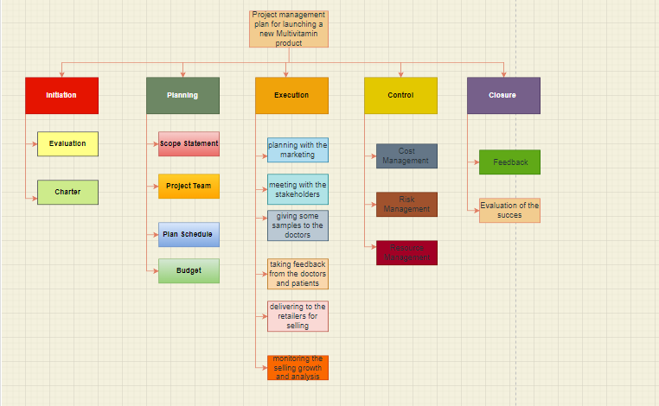
Figure 2: Work Breakdown Structure
(Source: Draw.io)
Work breakdown means systematically drawing an outline of works going to do in the project planning, process of production, costing, and the initiation and closure schedule of the project. This work breakdown structure presents the new launch of the item- “Multivitamin” and plans to settle the product into a highly competitive market. There are some steps ahead to bring the project down- initiation, planning, execution, control, and closure. In these steps, the series of actions are presented through the structure which outlines the clear presentation of the work done day by day with major and minor planning. Thinking of the project launch, cost budgeting, and the execution to the launching of the product is very properly structured with the drawings and framework. The execution part of this project undergoes planning with the marketing> meeting with the stakeholders> giving some samples to the doctors> taking feedback from the doctors and patients> delivering to the retailers for selling> and monitoring the selling growth and analysis.

2.5 Resource consideration
To consider the area of resources in time and cost planning, the project management strategies are completed with the handling teams. Costing planning considers a huge area with the medical power, unique features of the medicine, competition to the market, etc helps to plan for the price in the project planning. As the product is a drug, it requires huge money to complete the project. In the process of involving the stakeholders, in testing and promoting the area of medicine, the cost can be approx. 5500 pounds. The time planning the project of a product launch is estimated to be 2-3 months from the starting date, the planning, initiatives, and executions need to be very subjective for the project management (Croft, 2022). The resources collected for the project management are also considered part of the project with the time and cost planning, meetings, promotional planning, strategic process to enhance the marketing, the sell growth strategies, etc. in the situation of this pandemic, the UK needs to have the best multivitamin brand for the health of the people, and this is the chance to dedicate the drug into the business. One-time projection of the drug can be enough cause of gaining resources and the proper planning need to be done quickly with analysis. A marketing analysis requires many things such as internet access, team binding, knowledge, and training to analyze the market properly. The estimation of time and cost is very important to complete the project properly because the starting of the project needs to deal with a lot of planning and measuring area to the breaking down of works into the teams. With the money and time, the project is going to perfectly handle the product launch process of the multivitamin drug.

2.6 Project schedule
This project was scheduled with time planning with different things of doing and planning. In this process, the structure is presented through the time allocation chart and graph for a better distribution of work. A project is engaged with some valuable structure breakdown starting from the initiation of the project, cost and time planning, resource gathering, execution, control gestures with strategies, etc. the time outlines are distributed to work efficiently and with the different zone of people in the team. A project involves the time planning to complete within a time span which is more important than the project planning in cost. This helps to speed up the task that is going to access the aim thoroughly.
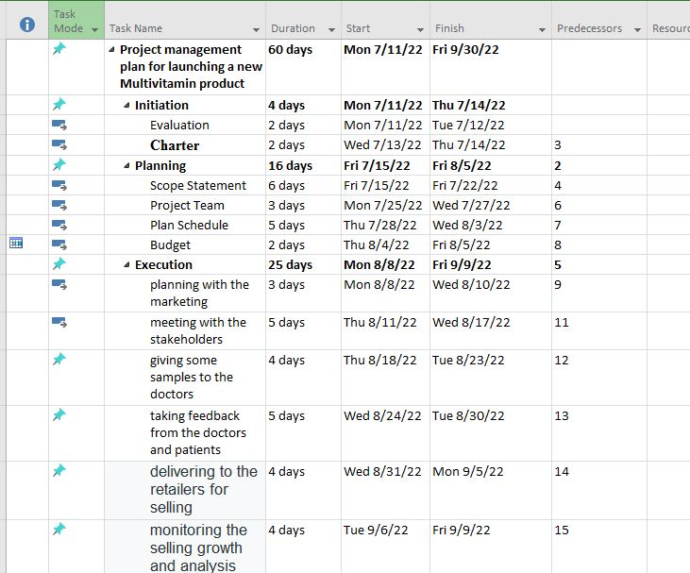
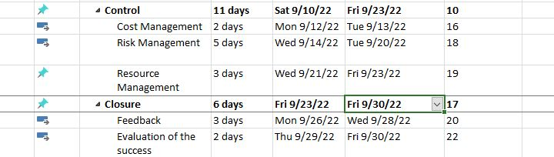
Figure 3: Time scheduling chart
(Source: Self-Created in MS-project)
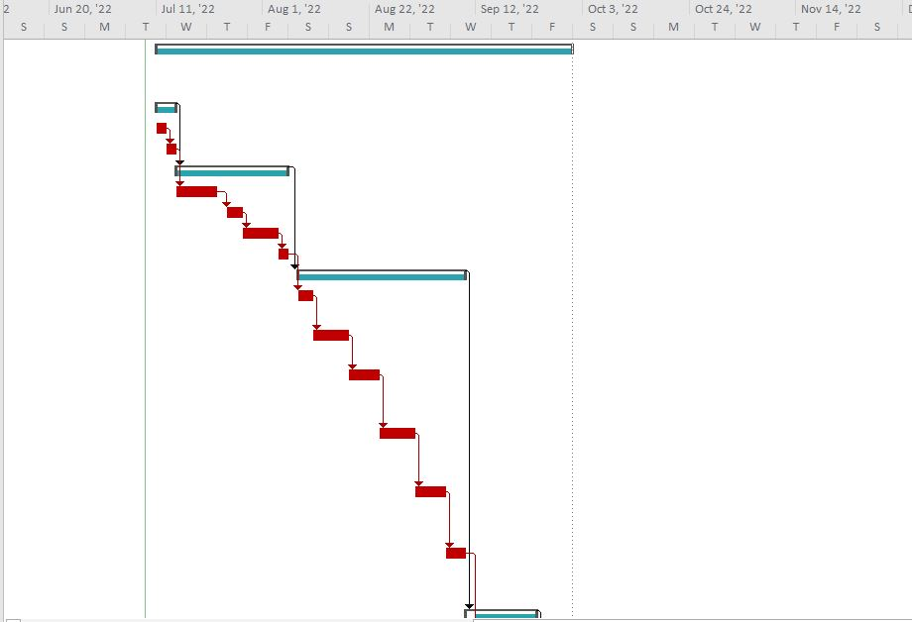
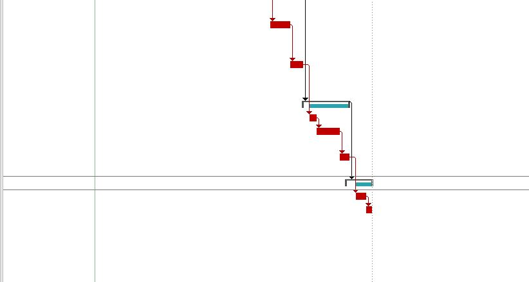
Figure 4: Time scheduling graph
(Source: Self-Created in MS-project)

2.7 Risk assessment
Risk assessment guidelines are an important part of this project as it is the most important project with the medicine launch (Juutinen, 2022). Risks are everywhere and they can harm the project structure and culture and restrict to delivery of the projected goals in the end. There may be some risk in getting the project work done by the team and engaging the stakeholders.
- This project can be failed if any side effects are grown in anyone’s body, in spite of the lab tests. Sometimes, the tests don’t show results properly and take time, so if the project to launch a new multivitamin will impact the body negatively, the project will be gain failed as previous.
- The costing planning with the help of market and competitor analysis has the risk because the market trend is not stable and people ‘s demand can move the way from taking those medicines from the brand.
- The project has the time estimation, but in any retailing or analysis market segmentation issues, the sudden time expansion can take the attraction of people in getting the drugs.
- The project failures can have the risk of getting badly affected due to many losses, as the pharmaceutical company had already a loss in the product launch with their sales.
- In doing, the project of a new product launch, the financial support to the doctors, retailers can take a high risk of failure of the product testing to the people. It can take casualties for the medicine that is not responding to the human body.

3.0 Conclusion
To conclude, project management is the most important guideline and task to make a product business properly done in a planned schedule. The multivitamin of the pharmaceutical company is the focus of this project management for the scope of spreading the drug to immune and healthy diagnostic order to people. This report presents the project order of managing process with the new product launch and the area of business and marketing. The market analyzer cost planning and execution of the projects are very important to enhance the business with the product launch. The UK has seen many multivitamin brands, but the composition to the immune building with fewer side effects on the body by taking daily is the new way to attract people. The project scope is to schedule the timeline for the product with the sales and demand met by the customers in a strategic way of aching the market position.

Reference List
Barbalho, S.C.M., 2022. Functions of project management offices and the satisfaction of project personnel in new product development. International Journal of Business Innovation and Research, 27(3), pp.281-296.
Berényi, L. and Soltész, L., 2022. Evaluation of Product Development Success: A Student Perspective. Administrative Sciences, 12(2), p.49.
Croft, C., 2022. Project Management QuickStart Guide: The Simplified Beginner’s Guide to Precise Planning, Strategic Resource Management, and Delivering World Class Results. ClydeBank Media LLC.
Day, M.Y., 2022. Software Products and Project Management: Software product management and prototyping.
de Vasconcelos Gomes, L.A., Seixas Reis de Paula, R.A., Figueiredo Facin, A.L., Chagas Brasil, V. and Sergio Salerno, M., 2022. Design principles of hybrid approaches in new product development: a systematic literature review. R&D Management, 52(1), pp.79-92.
Hartel, D.H., 2022. Agile Project Management in Logistics and Supply Chain Management. In Project Management in Logistics and Supply Chain Management (pp. 125-143). Springer Gabler, Wiesbaden.
Ho, S.C. and Chuah, K.B., 2022. Application of MSTAM Methodology in Project Management: A Case Study of ITF Robotic Automation R&D Project. In Research Anthology on Cross-Disciplinary Designs and Applications of Automation (pp. 135-160). IGI Global.
İncekara, M., 2022. The impact of global sourcing in new product development processes. European Journal of International Management, 17(4), pp.632-658.
Juutinen, K., 2022. Sourcing a strategic partner in new product development process.
Kartiko, B.M., Pratama, N.R. and Nurcahyo, R., The Evaluation of Technology Implementation to Support Product Development Agility in FMCG Industry in Indonesia.
Kerzner, H., 2022. Project management case studies. John Wiley & Sons.
Lei, Y., Wu, X. and Jiang, J., 2022. Shared Mental Models and Boundary Management Activities in New Product Development: A Perspective on Multiteam Systems. IEEE Transactions on Engineering Management.
Lyu, C., Zhang, F., Ji, J., Teo, T.S., Wang, T. and Liu, Z., 2022. Competitive intensity and new product development outcomes: The roles of knowledge integration and organizational unlearning. Journal of Business Research, 139, pp.121-133.
Madureira, R.C., Silva, C.S., Amorim, M., Ferreira Dias, M., Lins, B. and Mello, G., 2022. Think Twice to Achieve a Sustainable Project Management: From Ecological Sustainability towards the Sustainable Project Management Cube Model. Sustainability, 14(6), p.3436.

