ASSESSMENT 1:INDIVIDUAL BLOG MARKETING FUNDAMENTALS ANALYSIS AND EVALUATION
NAME:BIANCA FLORENTINA MIRICA
STUDENT ID:2030299
LECTURER: Piyumika Gamage
MODULE CODE :LCBB4004

Table of Contents
Individual Blog: 3
Individual report: 5
Introduction 5
The segmentation, targeting, and positioning strategies of Vodafone 5
The current marketing mix strategies of Vodafone 7
Conclusion 10
Reference list 11

Individual Blog:
In previous times mass marketing was one of the major forms of performing marketing activities in a business. Mass marketing was preferable due to the nature of consumers being different at that time. Consumers were comparably less smart and informative than today's society. In mass marketing, an organization provides an offer that is not based on segmentation. The organization provides this offer to the entire audience it has. Various sectors are present in the current business world which still uses mass marketing. Auto mobile organizations and personal computer organizations use mass marketing (Kotler, 1989).

Figure: Mass marketing
Source: (Kotler, 1989)
In daily use products such as soap, shampoo, etc organizations use mass marketing. Dove has its shampoo and soap also. While promoting these products Dove does not focus on any particular consumer segment. Rather the organization promotes the product to its entire consumer base.

Figure: Different brands that use mass marketing
Source: (Kotler, 1989)
The need for segmentation or the necessity of segmentation has increased due to the dynamic nature of the business environment. The contemporary business environment has the nature of changing habits rapidly. Consumers are nowadays very smart, more educated, and more informed from previous times. Specific information and information about various facts help consumers to understand different things which helps them to understand their personal needs (Shava, 2021).
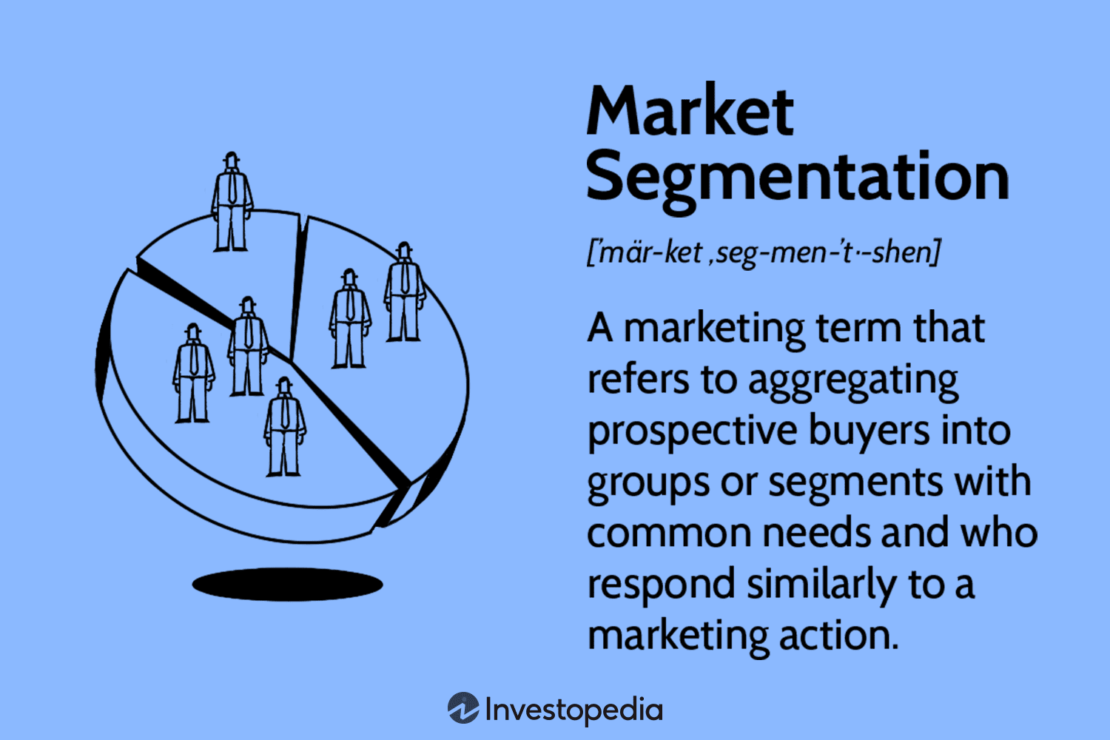
Figure: Market segmentation
Source: (Shava, 2021)
Organizations use market segments to differentiate consumers with different characteristics. Vodafone uses demographic segmentation where the organization uses age, and income to identify its consumers. Based on these dimensions the organization offers service to its consumers. Also, in today's business world, consumers expect various things from organizations. As consumers are exploring different things, therefore they are asking for various options and choices. Consumers want increased efficiency, and speed in the services they use or the product they use. For example, the telecommunication industry has initiated to establishment 5G network which has great speed and efficiency. The demand of consumers has insisted organizations innovate these new domains of an existing industry. The competitive nature of industries also insisting organizations explore new areas. If an organization fails to remain competitive then other organizations will take over and also consumers will shift due to the backdated nature of the business. All these factors are assisting organizations to perform segmentation to identify them, fulfill their needs, and ensure profitable outcomes for their businesses (Zhou et al., 2020)

Individual report:

Introduction
This report will include various things which are marketing fundamentals. The purpose of this report will be to understand the importance of these factors. Also, understanding how using these factors can offer various benefits to an organization will be the purpose of this report. In this report, the segmentation, targeting, and positioning strategies of Vodafone will be determined and explained. Further, the marketing mix strategy of Vodafone will be outlined and critically evaluated in this report.
Vodafone is a multinational British telecommunication organization that operates worldwide.

The segmentation, targeting, and positioning strategies of Vodafone
Market segmentation:
Marketing is an essential part of any business organization in today's contemporary business world. In the contemporary business environment, consumers are dynamic and can quickly shift from one priority to another. Due to these reasons, an organization uses different marketing strategies to identify consumers, their tastes, nature, etc. Market segmentation is one of those marketing strategies. In this strategy, an organization uses well-defined criteria to divide the organization's entire market share into small groups. Every segment has different and distinct nature which helps the organization to make an offer on products, experience, etc. Through using market segmentation an organization tries to find out the different kinds of needs of consumers. Well-defined criteria help to understand needs, demands, etc. There are four kinds of market segmentation. Demographic, behavioral, psychographic, and geographic are the four kinds of segmentation (Shava, 2021).
Vodafone is a globally based organization that has consumers in different markets and every consumer is different from any other one. Therefore, it is important for the organization to ensure proper identification of the needs of consumers. Due to this reason, the organization uses market segmentation. The organization uses two kinds of market segments. The organization uses a demographic segment and also uses psychographic segments. In demographic the organization targets 13-65 years of age. The organization includes small, high, and middle-income groups. The organization includes both B2B and B2C. Also, it has included rural areas, semi-urban areas, and urban areas. In the psychographic segment, the organization prefers young people in semi-urban and in urban areas (Zhou et al., 2020)
Target market:
The target market is the identified group of people who can be the most potential consumers for a particular product due to their similarity in characteristics such as income, age, etc. The target market is a part of business decision-making. During the time of designing, packaging, and advertising the product. The contemporary business environment increases the importance of the target market. As the market includes various kinds of consumers, also the nature of consumers is not stable, therefore organizations try to identify the set of consumers to create a potential consumer base. The target market also includes four different forms. Demographic, psychographic, geographic, and behavioral are four kinds of target markets (Hosseini et al., 2022).
The organization has targeted both the B2B market and the B2C market. In the B2B market, the organization has initiated plans for small and large organizations. Those plans are based on the demand of the business organization. In the B2C market, the organization has arranged several plans for its consumers depending on their age, demand, needs, etc. Recharge plans of Vodafone start from cheap prices and end in the premium range. Therefore, the organization has tried to ensure the fulfillment of the demands of various kinds of consumers (Soto et al., 2022).
Market positioning:
Market positioning is about how a brand position itself in the mind of consumers. Various organizations use various dimensions to ensure the proper positioning of the brand. The contemporary business environment includes high competition, therefore, it's necessary for organizations to position themselves rightly, otherwise, the organization might fail to encounter the competition in the industry (Iyer et al., 2019).
Vodafone uses product, price, and distribution for positioning the brand rightly. The organization uses both premium and basic products. The organization offers voice and messaging services. Also, it offers mobile transfer and IT solutions for businesses. In price, the organization has priced its services according to the nature of the market. Small, medium, and premium pricing is included in the business. In distribution, the organization has its own outlets, uses other small outlets, and also uses the online store to sell and distribute its products. These dimensions are used by Vodafone to position the brand in the consumer's mind (Fahy and Jobber, 2019).

The current marketing mix strategies of Vodafone
The marketing mix is an essential part of a marketing plan. The marketing mix includes various components that are required for creating an effective marketing plan. In the contemporary business environment marketing mix is a necessity for an organization. An organization by using various components of the marketing mix can achieve better outcomes from previous times.
Marketing mix of Vodafone:
Vodafone is a globally established organization that operates in various markets. Different markets have different natures, tastes, cultures, etc. Vodafone uses different elements of the marketing mix to achieve suitable business outcomes in the global business environment. Here, the marketing mix strategy of Vodafone will be outlined (Fahy and Jobber, 2019).
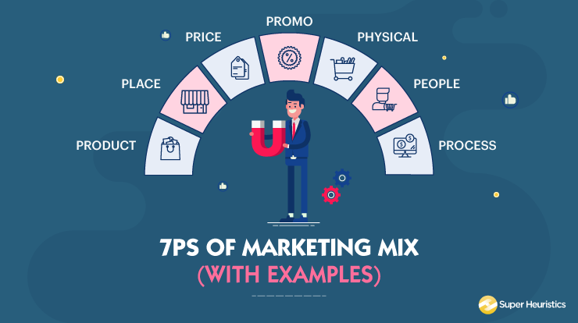
Figure: 7ps marketing mix
Source: (Asamoah, 2021)
Product:
Product is one of the components of a marketing mix strategy. The product or service is the main factor that helps an organization to be successful. Vodafone has included a range of services in the business. As the organization uses different marketing segments, target markets, and positioning, therefore it offers services according to the demand of various consumers. The organization has offered high-quality service to its consumers. In various entities such as Asia and Africa it operates in a dominant way. The organization offers fixed telephony, broadband service, voice and messaging services, etc to its consumers. Different consumers have different needs and the organization has tried to fulfill these demands of consumers by offering a range of products to them. These services are high in quality and the availability of service is also high in different parts of the world (Jain and Jain, 2022).
Price:
Pricing is a major factor in today's contemporary business environment. Especially it is a crucial factor for Vodafone as the organization operates in a highly competitive market. There are various regional organizations that pose threat to Vodafone. The organization has used competitive methods to ensure proper pricing of its services. The organization has different kinds of consumers and the capacity of different consumers is variable. Vodafone use competitive pricing to ensure proper pricing of its services. In this method, the organization looks into the quality of service offered by the organization, the price that competitors have set, and the thoughts of consumers also considered in this method. All these factors collectively help the organization to ensure the proper pricing of its services. Competitive pricing helps the organization stay competitive in the market and gain profit (Saidani and Saudiarditha, 2019).
Place:
Place refers to the distribution and the place in which the organization operates. Vodafone is a globally established business and it operates in various parts of the world. It operates in the UK, USA, Australia, India, and in other nations also. The geographical presence of the organization has helped the organization to ensure better consequences for the organization. These markets have offered good business returns also the organization has gained loyal consumers in these regions. The organization has outlets in all the different places it operates. In those outlets, consumers can avail of customer service, various kinds of services offered by the organization, etc. The presence on the internet is also an essential activity for an organization. Vodafone has its official website where consumers can avail of customer service and various services. The online presence has helped the organization to ensure greater reach for the organization as the organization is able to communicate with tons of internet users around the world (Fahy and Jobber, 2019).
Promotion:
Promotion helps an organization to create brand awareness among its customers and audience. As Vodafone operates in a highly competitive environment, therefore promotion has its value in the organization. The organization uses a range of promotional methods, campaigns, and channels to ensure the proper promotion of the brand. The organization uses unique animated characters to promote the band. The organization uses social media, and the internet to promote the brand. Also, the organization uses traditional marketing channels such as television channels, and radio stations to ensure proper promotional activities for the organization.
People:
People refer to employees of an organization. Vodafone has been able to create an effective workforce which has offered great outcomes to the organization. The organization has been able to generate great outcomes due to the efficiency of the workforce. The organization selectively recruits and selects employees from different sources. Also, the organization trains and develop its employees in the workplace to ensure diversity in the workplace. All these factors have contributed to the success of the organization (Asamoah, 2021).
Process:
Process refers to different processes that take place in an organization. Vodafone uses both offline and online processes to ensure proper results for the organization. The organization uses traditional processes in various parts of the business. Also, the organization uses online processes to ensure greater efficiency and effectiveness in the business.
Physical evidence:
Physical evidence refers to multiple things which help an organization to remain distinct and identifiable. Vodafone has successfully used its physical evidence. The organization has a distinct logo, the organization uses color very uniquely. The organization has introduced unique animated characters which help consumers to identify the brand. All these factors have helped the organization to create its own identity in the industry (Jain and Jain, 2022).

Conclusion
Conclusively it can be stated that market segmentation, targeting, and positioning have their own importance in an organization. It has been determined that Vodafone uses demographic and psychographic segments, uses these segments to target both B2B and B2C markets. Also, the organization uses its products, price, and distribution to position itself. Further, the critical evaluation of the marketing mix has outlined that Vodafone uses competitive pricing to cope with the competition and to ensure the effective pricing of its products. Various components such as promotion on the internet, etc have helped the organization to ensure better outcomes in the business.

Reference list
Asamoah, E.S., 2021. The Effect of the Marketing Mix on Customer Purchase Decision in the Mobile Telecommunication Industry in Sub-Sahara Africa. Journal of Applied Business & Economics, 23(7).
Fahy, J. and Jobber, D., 2019. EBOOK: Foundations of Marketing, 6e. McGraw Hill.
Hosseini, M., Tammimy, Z. and Galavi, E., 2022. Social media target marketing: Use of social networks data to target marketing. Journal of Industrial Engineering and Management Studies, 9(1), pp.28-37.
Iyer, P., Davari, A., Zolfagharian, M. and Paswan, A., 2019. Market orientation, positioning strategy and brand performance. Industrial Marketing Management, 81, pp.16-29.
Jain, R. and Jain, S., 2022. Analyzing and Exploring the Effectiveness of Each Element of 7Ps of Marketing Mix. International Journal of All Research Education and Scientific Methods, 10(1), pp.243-251.
Kotler, P., 1989. From mass marketing to mass customization. Planning review, 17(5), pp.10-47.
Saidani, B. and Sudiarditha, I.K.R., 2019. Marketing mix-7Ps: The effect on customer satisfaction. Jurnal Pendidikan Ekonomi Dan Bisnis (JPEB), 7(1), pp.72-86.
Shava, H., 2021. The relationship between service quality and customer satisfaction in the South African mobile network telecommunications industry. Journal of International Studies, 14(2), pp.70-83.
Soto, E.A., Arakawa, K. and Bosman, L.B., 2022. Identification of target market transformation efforts for solar energy adoption. Energy Reports, 8, pp.3306-3322.
Zhou, J., Zhai, L. and Pantelous, A.A., 2020. Market segmentation using high-dimensional sparse consumers data. Expert Systems with Applications, 145, p.113136.

