Student Name: Robert Nzeyimana
Student ID: 2329949
Module Code: BMHP5015
Lecturer Name: Tsiwani Khumalo
Module: Changemakers: Building your Personal Brand for Sustainable Employment
Assignment Title: Component 1: Online Portfolio of Set Exercises
Submission Deadline: 25th March 2026

Table of Contents
Task 1: Personal Brand 3
Task 2: Network Map and Rationale 4
Task 3: Blog 5
Task 4: NHS Equality, Diversity and Inclusion Quiz 7
Task 5: A letter to yourself 9
Task 6: Gantt chart 10
Task 7: Making Changes- Report 12
Task 8: Self-Reflection 14
Reference list 16

Task 1: Personal Brand
Introduction
Personal branding refers to projecting skills, values and professional identity to others (Hedeshian et al., 2024). Personal branding exhibits competence and credibility to achieve the career goals of becoming a Clinical Governance Officer in Bupa.
Main Body
I have demonstrated strong personal communication, attention to detail, and quality improvement in healthcare. Strong communication ability is necessary for maintaining policy compliance and service improvement as a Clinical Governance Officer (Fothergill et al., 2022). I show empathy, and I have strong information analysis abilities, which are essential for governance procedures.
I have a lack of self-confidence in leading a team. Therefore, I need to take governance-related training, have internships, and achieve digital literacy regarding healthcare quality systems. Teamwork activities and reflective practise are essential for empowering leadership ability (Bhati et al., 2023). These practices will help me to aid quality monitoring and evidence-based decision-making necessary in the Clinical Governance Officer position.
Actions to improve personal branding

Career goals | Actions | Success criteria
Improving leadership ability | Participating in the group project and performing volunteer roles. | Increasing self-confidence to perform governance initiatives.
Developing clinical governance knowledge. | Taking governance training and reading governance policy. | Strong ability to support compliance and patient safety.

Conclusion
I will be able to prove my professionalism, knowledge of governance, and prepare to be a leader through personal branding. These capabilities will allow me to reach my desired position of becoming a Clinical Governance Officer.

Task 2: Network Map and Rationale
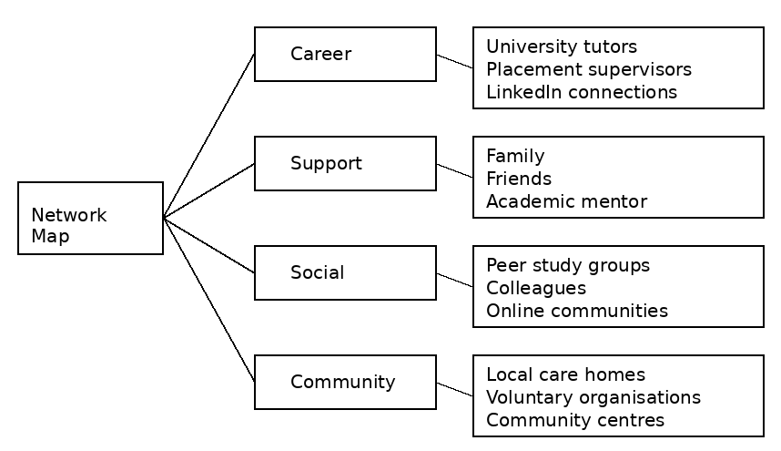
Figure 1: Network Map
(Source: Author)
The network map shows all the main relationships which contribute to my professional development. The career network is made up of university tutors, placement supervisors, and LinkedIn professional contacts who give advice, critique, and industry knowledge. These networks are critical towards building knowledge, employability skills and opportunity awareness in health and social care (Healy et al., 2022).
The support network includes the family, friends, and academic mentors who partake in emotional well-being, motivation and academic success. The difference in emotions is valuable since resilience and confidence have effects on the work of the professional (Courchesne et al., 2024). The social network encompasses peer study groups, colleagues and online communities that facilitate collaborative learning and sharing of knowledge and acquisition of communication skills.
The community network also touches on the local care homes, voluntary organisations and community centres, which include the aspects of volunteering, practising, and learning about person-centred care. These networks increase resilience and professional identity formation among healthcare students. Importantly, my networking has been effective in academics and peer networks, but I need more contacts in the professional industry.

Task 3: Blog
Title: Digital Inclusion in UK Healthcare: Supporting Older Adults in the Digital Era
Introduction
Online GP appointments, e-prescriptions and distant monitoring are becoming widespread in the UK in the field of digital healthcare. Nevertheless, older adults are not able to access such services because of a low level of digital skills. The problem is relevant to family caregivers and older adults since digital exclusion may decrease access to prompt care and become a contributor to the higher levels of health disparities.
Main Body
Digital exclusion amongst the elderly is associated with low digital literacy levels, inability to use the internet, affordability, among other factors and slow confidence in using technology. As more medical services move to the internet, elderly people face a risk of not being able to make appointments, get medical data, and maintain communication with the healthcare facility. It was found that 4.7 million older adults in the UK have a poor digital literacy rate (Age UK, 2024).
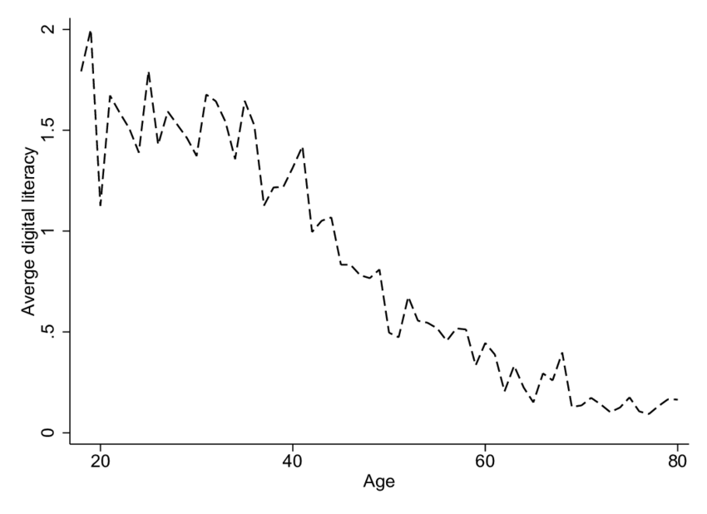
Figure 2: Digital literacy rate in the UK by age group
(Source: Wang et al., 2024)
The effect of being digitally marginalised is huge. The older adults who do not access digital services could be under delayed care, under diminished independence and over-dependence on their care givers. According to NHS England evidence, digital inequality is one of the contributing factors to increased health inequalities and constrains the success of remote healthcare efforts (NHS England, 2023).

This problem needs special attention to the training of digital skills, the availability of technologies in their designs, and the provision of alternative non-digital forms of care. The caregivers may assist older adults by helping them acquire the skills in digital literacy, as well as searching through the community training programmes.
Conclusion
The inclusion of the digital world is critical to secure equitable access to healthcare among older adults in the UK. Patient outcomes and inequalities can be reduced in favour of developing digital skills and keeping alternative service options. Caregivers and the community have an important part to play in bridging the digital divide.

Task 4: NHS Equality, Diversity and Inclusion Quiz
1. The primary goal of the NHS Equality, Diversity, and Inclusion Improvement Plan is to foster inclusion of all staff, minimise cases of discrimination, and encourage equal opportunities throughout the NHS (NHS England, 2023).

2. The NHS EDI Improvement Plan propose to tackle the gender pay gap by reporting on transparent pay, recruiting towards an inclusive society, providing women with development as leaders, and providing focused career advancement support to minimise the pay disparities (NHS, 2025).

3. Intersectionality means the ability to understand that a person can have multiple faces of inequality due to his or her gender, ethnicity, disability, or age (Day et al., 2023).

4. A psychologically safe environment in the NHS allows staff to speak up, report on concerns and errors, and better patient safety and staff wellbeing are enhanced (Hallam et al., 2023).

5. The NHS EDI Improvement Plan supports formal orientation, mentorship programmes, equitable career growth, and enhanced pastoral care among the recruits internationally (NHS England, 2023).

6. Leaders have a role of leading by example and practising inclusive behaviour, keeping track of performance, handling inequalities and institutionalising EDI in organisational culture and decision making.

7. Among the factors of the NHS EDI Improvement Plan, one should note that the opportunities to be trained, developed, and promoted should be equal to the staff of less-represented groups (NHS England, 2023).

8. The NHS EDI Improvement Plan involves the collection and analysis of workforce data, helps to identify discrepancies, monitor the progress, and design targeted interventions to achieve better inclusion (NHS England, 2023).

9. Flexible working policies of NHS contributes to work-life balance, greater accessibility to varied staff needs, and retention of employees with varied backgrounds are supported by the flexible working policies.

10. One strategy mentioned in the NHS EDI Improvement Plan is the adoption of good reporting mechanisms, a zero-tolerance policy, and accountability of its leaders to establish a respectful culture at the workplace (NHS England, 2023).

Task 5: A letter to yourself

Robert Nzeyimana
20 Rosengrave ST
DE11TS

Dear younger self,
I recall when you had been overwhelmed handling academic pressure, personal responsibility, and not being sure of your future career. You tend to think of your skills and get stressed out when confronting a new problem. At that point, you were not entirely aware of the significance of emotional state and strong suits.
I have now gained that emotional intelligence is used to understand emotions, to deal with stress, and to communicate effectively with people. Being aware of how you feel would have enabled you to act wisely as opposed to using frustration and self-doubt as a reaction to such a situation.
I believe that any challenge that came your way, whether it was failure, fear of missing the deadline, or insecurity, was also an opportunity to develop. You would have believed in yourself, and it was the difficult moments that kept you going if you viewed challenges as learning experiences.
I would like you to keep in mind that failures are not a reflective behaviour of being weak but a stage of development. Self-reflection, requesting assistance, and having a positive attitude are practices that will assist in overcoming challenges. Such little steps like time management, mindfulness, and achievement celebration will make your resilience stronger over time.
You are improving, in the process of learning, and getting stronger with each experience. It will take perseverance and self-knowledge to get the confidence that you seek.
Sincerely,
Your Future Self

Task 6: Gantt chart
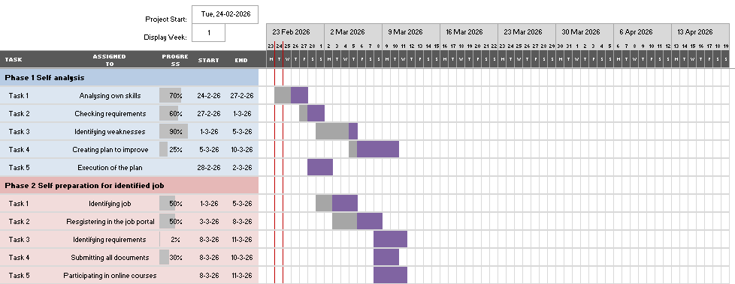
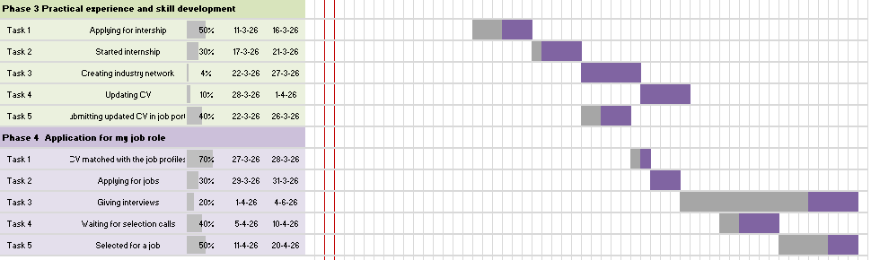
Figure 3: Gantt chart
(Source: Author)
This Gantt chart explained my activities to achieve my employment goal as a Clinical Governance Officer. It outlines the main steps, such as career exploration, skill development, practical experience, and job application, which show a definite transition to the level of professional preparedness.
The initial stage is to know the job position where people investigate roles, skills necessary and what is expected of me in the industry (Jackson and Tomlinson, 2022). This level helps me in developing achievable career objectives and defining development requirements. The second stage entails academic and professional expertise building, such as quality improvement, digital healthcare systems, and data analysis.
The third stage focuses on practise, including placements, volunteering and involvement in group projects. This level is necessary to transfer theoretical knowledge into practise in real healthcare facilities and enhance employability skills. The fourth step involves professional networking and career preparation, an activity that involves connecting with others, refining my CV and practising interviewing. The last stage is the job application and long-term professional evidence, which will provide one with the ability to join the job market and, at the same time, continue education.

Task 7: Making Changes- Report
Introduction
I want to introduce a digital resident monitoring system as the manager of the Avery Park Care Home to enhance real-time monitoring of health and increase the safety of residents. Digital innovation is becoming relevant in enhancing the quality and efficiency of care homes in the UK.
Planning the Change
The change will be done by following Lewin’s Change Management Model. This change management model has three aspects that allow for establishing the change successfully (Agazu et al., 2022).
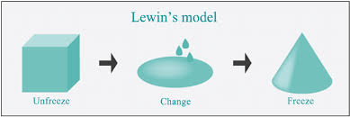
Figure 4: Traits of Lewin’s Change Management Model
(Source: Agazu et al., 2022)
The unfreeze step will involve awareness of the staff, training, and execution of the existing limitations in documentation. The process of change will entail pilot testing the system, training of the staff and making the technology part of the everyday routine. The stage of refreeze will entrench the system in the practice using policies, continued training, and performance monitoring. A digital monitoring system is helpful in the early identification of risks and in minimising unnecessary hospital readmissions by older adults (Miotti et al., 2024).
Skills Required
The required skills are leadership, digital literacy, and communication and change management skills to implement successfully (Krishna and Koustuv, 2024). The ability to train the staff and analytical skills are also needed to understand the monitoring data and assist with evidence-based planning of care and risk prevention.
Barriers and Solutions
The potential hurdles include the resistance of the technology by the staff, insufficient digital confidence, money, and technical challenges. These obstacles could be organised through instructional training and constant technical support. Digital monitoring improves quality care facilities through early detection (Suganthi and Kalaiselvi, 2024). Involvement of staff during the decision-making process and constant encouragement will enhance its acceptability and permanence.

Conclusion
A digital resident monitoring system can solve safety issues, the quality of care provided will be enhanced, and the proactive management of risks will be supported. The application of the Lewin’s model will provide a systematic long-term change in accordance with the priorities of the digital transformation in care homes.

Task 8: Self-Reflection
The learning experience is described in this section by using Gibbs’ Reflective Cycle. This model helps to share personal experiences through six stages (Ocampo et al., 2025).
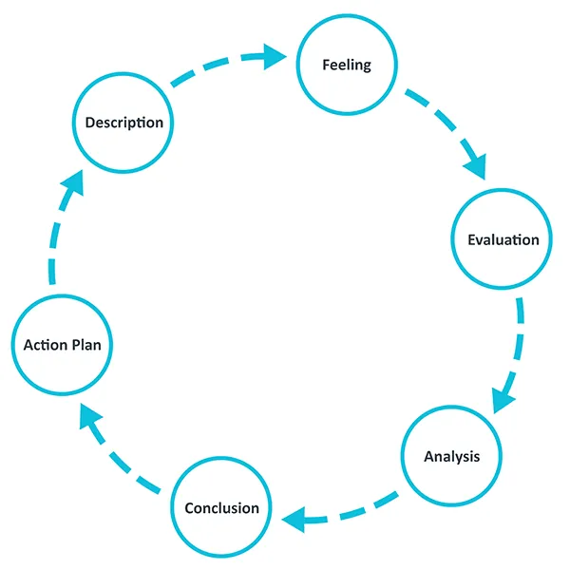
Figure 5: Aspects of Gibbs’ Reflective Cycle
(Source: Ocampo et al., 2025)
Description
In this module, I understood personal branding, networking, change management, and professional growth in the area of health and social care. These activities made me realise the ways my skills are aligned with my career objective, which is to work within the field of clinical governance.
Feelings
Initially, I used to be very unwilling to demonstrate my personal strengths and accept my weaknesses to work on them. Gradually, I participated in different reflective practises, and improved my skills and professional opportunities. Wouldn’t need self-confidence to fulfil any critical tasks (Maczulskij and Viinikainen, 2023).
Evaluation
One of the things that was found to be positive was my strengths in communication, attention to detail and willingness to learn. One of the challenges was the identification of gaps in leadership confidence, digital skills, and governance knowledge, which are also necessary in the future professional place.
Analysis
The reflection prompted me to understand that lifelong learning and self-knowledge are the two advantages necessary to achieve professional development. Emotional intelligence and resilience help to deal with pressure, receive feedback and embrace changes (Enstroem and Benson, 2024). The concept of learning change management also enabled me to learn how systematised methodologies can facilitate better practise in healthcare.
Conclusions
This module allowed me to learn more about my strengths, developmental requirements, and career orientation. The reflection helped me relate the theoretical information with practical skills development that are applicable in promoting the quality of health care.
Action Plan
I will participate in the clinical governance training to understand the ethics, policy and principles of the health and social care sector. I will improve my digital literacy and leadership ability by participating in different group activities effectively.

Reference list
- Agazu, B.G., Birbirsa, Z.A. and Werke, S.Z. (2022) ‘Leadership Models and Change Management: a Systematic Review’, Research Square, 56(5), pp. 67–87. Available at: https://doi.org/10.21203/rs.3.rs-2075522/v1.
- Age UK (2024) More than 1 in 3 over 65s (4.7 million) Lack the Basic Skills to Use the Internet Successfully, Age UK. Available at: https://www.ageuk.org.uk/latest-press/articles/2024/more-than-1-in-3-over-65s-4.7-million-lack-the-basic-skills-to-use-the-internet-successfully/ (Accessed: 26 February 2026).
- Bhati, D., Deogade, M.S. and Kanyal, D. (2023) 'Improving Patient Outcomes through Effective Hospital Administration: a Comprehensive Review', Cureus, 15(10), pp. 1–12. Available at: https://doi.org/10.7759/cureus.47731.
- Courchesne, S.A., Stynen, D., Semeijn, J.H. and Caniëls, M.C.J. (2024) 'New ways of fostering sustainable employability in inter-organisational networks: an explorative study to understand the factors and mechanisms for their success', Employee Relations, 46(9), pp. 115–140. Available at: https://doi.org/10.1108/er-09-2023-0462.
- Day, G.L., Havranek, E.P., Campbell, E.G. and Mehta, A.B. (2023) 'Applying Intersectionality to Better Characterise Healthcare Disparities for Critically Ill Adults', American Journal of Respiratory and Critical Care Medicine, 207(12), pp. 1639–1641. Available at: https://doi.org/10.1164/rccm.202301-0153LE.
- Enstroem, R. and Benson, L. (2024) ‘Enterprise education in undergraduate business programmes advances students’ negotiating competence and self-confidence’, Education + training, 66(1), pp. 54–69. Available at: https://doi.org/10.1108/et-01-2022-0009.
- Fothergill, L.J., Al-Oraibi, A., Houdmont, J., Conway, J., Evans, C., Timmons, S., Pearce, R. and Blake, H. (2022) ‘Nationwide Evaluation of the Advanced Clinical Practitioner Role in England: a cross-sectional Survey’, BMJ Open, 12(1), pp. 55–47. Available at: https://doi.org/10.1136/bmjopen-2021-055475.
- Hallam, K.T., Popovic, N. and Karimi, L. (2023) ‘Identifying the Key Elements of Psychologically Safe Workplaces in Healthcare Settings’, Brain Sciences, 13(10), pp. 14–50. Available at: https://doi.org/10.3390/brainsci13101450.
- Healy, M., Hammer, S. and McIlveen, P. (2022) ‘Mapping graduate employability and career development in higher education research: a citation network analysis’, Studies in Higher Education, 47(4), pp. 1–13. Available at: https://doi.org/10.1080/03075079.2020.1804851.
- Hedeshian, H., Dastgheib, S.A.R. and Rasekh, K.A. (2024) ‘Strategies for Using Instagram to Develop Personal Branding and Career Success’, News Science Quarterly (NS), 43(4), pp. 23–98. Available at: https://doi.org/http//doi.org/10.22034/lrsi.2024.469023.1213.
- Jackson, D. and Tomlinson, M. (2022) ‘The relative importance of work experience, extra-curricular and university-based activities on student employability’, Higher Education Research & Development, 41(4), pp. 1–17. Available at: https://doi.org/10.1080/07294360.2021.1901663.
- Krishna, S. and Koustuv, S. (2024) ‘A digital healthcare monitoring system with real-time analysis’, i-manager’s Journal on Electrical Engineering, 18(1), pp. 26–87. Available at: https://doi.org/10.26634/jee.18.1.21233.
- Maczulskij, T. and Viinikainen, J. (2023) ‘Self-confidence Predicts Entrepreneurship and Entrepreneurial Success’, Journal of Business Venturing Insights, 19(1), pp. 39–82. Available at: https://doi.org/10.1016/j.jbvi.2023.e00382.
- Miotti, A.M., Tikvina, S., Calzavara, A., Nesoti, M. and Zilli, E. (2024) ‘The importance of healthcare monitoring systems’, The European Journal of Public Health, 34(Supplement_3), pp. 65–89. Available at: https://doi.org/10.1093/eurpub/ckae144.2130.
- NHS (2025) Bridging the gender pay gap, NHS Employers.org. Available at: https://www.nhsemployers.org/system/files/2025-05/bridging-the-gender-pay-gap-2962.pdf (Accessed: 24 February 2026).
- NHS England (2023) Inclusive digital healthcare: a framework for NHS action on digital inclusion, NHS England. Available at: https://www.england.nhs.uk/long-read/inclusive-digital-healthcare-a-framework-for-nhs-action-on-digital-inclusion/ (Accessed: 26 February 2026).
- NHS England (2023) NHS England» NHS equality, diversity and inclusion (EDI) improvement plan, www.england.nhs.uk. Available at: https://www.england.nhs.uk/publication/nhs-edi-improvement-plan/ (Accessed: 24 February 2026).
- Ocampo, F.A., McIntyre, B.G., Massey, D. and Saunders, R. (2025) ‘Nursing Student Reflections on a Research internship: a Reflective Discussion following the Gibbs’ Reflective Cycle’, Nurse Education Today, 145(1), pp. 106–481. Available at: https://doi.org/10.1016/j.nedt.2024.106481.
- Suganthi, V. and Kalaiselvi, K. (2024) ‘Decision Support System in Healthcare Monitoring’, Artificial Intelligence‐Based System Models in Healthcare, 56(5), pp. 55–78. Available at: https://doi.org/10.1002/9781394242528.ch3.
- Wang, Q., Liu, C. and Lan, S. (2024) ‘Digital literacy and financial market participation of middle-aged and elderly adults in China’, Economic and Political Studies, 56(9), pp. 1–28. Available at: https://doi.org/10.1080/20954816.2022.2115191.

