Tutor: Julie Hayward

Subject: Project Organisation and Personal Development

Title: Assignment 2 Professional Development Plan
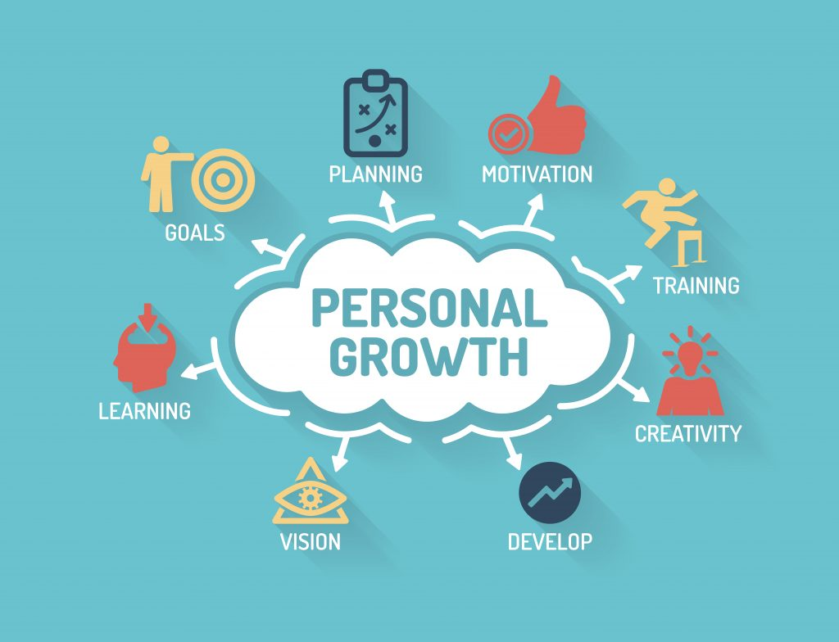  Development plan  An in detail professional development plan for Krzysztof Rutkowski. | Krzysztof Rutkowski (1907930)  Project Organisation and Personal Development

Table of contests:

- Introduction 3.
- Development Plan 4.
- References 7.
- Video References 8.

Introduction

What exactly is professional development plan, and why everyone should do it?

Professional Development Plan (PDP) is a variety of ideas, techniques and different approaches that will help an individual manage its learning and growth by focusing on an honest reflection of one self, to benefit and improve the skills that might be vital in the future career. Simply it’s a tool to help you manage you own development on an ongoing basis. Its function is to help you record, review and reflect on the skills you have or the skills that you might want to develop. (CIPD, 2020)

Why is it important to have a Professional Development Plan?

Every single one of us wants to be the best version of themselves, however there are many things that will stand in our way to become them. Professional development Plan can be used to keep a track of all these things that you might have to do, skills you might want to improve or develop, strengthen your professional credibility, help you reach your full potential. (Sangster, 2017)

According to Allen and Adair (1999) the self-development and learning are the things we all should do throughout our life’s and I would fully agree with this statement, but in order for it to work perfectly, the person doing it should be 100% honest with itself and use SMART techniques (Doran G. T. 1981) and that’s what I’m planning on doing.

Development Plan

NAME: | Krzysztof Rutkowski | STUDENT NUMBER: | 1907930
COVERING THE PERIOD FROM: | 28 January 2020 | TO: | 1 June 2020

Planned outcome

Where do I want to be by the end of this period? What do I want to be doing?

What do I want/need to learn?  (Specific & Relevant) | What will I do to achieve this?  (Specific) | What resources or support will I need?  (Achievable) | What will my success criteria be?  (Measurable) | Target dates for review and completion  (Timebound)
By the next assessment point I want to score full marks on Harvard Referencing. | In order to achieve this, I will read the feedback that I had from previous assessments, see what I have done wrong.  While writing my next assessment I will have Harvard Referencing Guide by my side as I do it. | I will need the Harvard Referencing Guide at all times and I think Ill ask our librarian to double check it for me when I’m done, which will take place at least a week before my work is due. | I will have to wait for my lecturer to finish marking everyone’s work and then see how many marks out of 15 I got. | By next assessment.
Create my LinkedIn profile and make it look professional, to increase my chances of getting a better paid job. | According to Ted Prodromou (2015) I should invest in my own brand in order to stand out from the crowd.  In order to achieve this, I will attend the Employability Event at UWTSD in order to talk to people who, know about LinkedIn and they could give me tips on how to improve my profile.  I will also have a look at other people’s profiles to see what they got that I haven’t.  I will also post and update my LinkedIn profile on regular basis. | Of course, I’m going to need a computer with internet access to find out how to improve my profile and then apply those changes.  I will also rely on the People at the event to help me. | I will regard my profile as a ‘Success’ after I complete all the necessary steps in order to finish my profile and get 100% completion on the website.  I will also try to add at least 100 people in order to make my network bigger. | I want to achieve all this by the end of February, however I won’t stop right there because in order to make it truly successful I will have to keep visiting and posting on my profile on the regular basis.
To gain confidence about talking/presenting my own work to others, especially large groups of people | I will take part in showcases and presentations that will be done as a part of a group and also individually.  I will watch couple of videos that might help me and give me some tips about public speaking.  According to Amy Cuddy, a public speaking is not so much about what you say but how you say it. | I will need a computer with internet access and help from my friends who might be more comfortable with it. | I will consider this a success when I’ll get the feeling that when I’m giving a presentation I won’t feel uncomfortable | I would like to achieve this by the end of my first year at UWTSD.
Develop A Growth Mindset by doing and anticipating in activities that are out of my comfort zone. | According to Dweck (2006) I should push myself to get out of my comfort zone as a result I decided to participate in an activity that I have never done before, at least once a month. | I will need a help from my friends and family so in times of need I know I can fall back onto them and have someone to share the experience with, access to computer with internet so I can research any events or activities that I might want to participate in. | I will consider this a success after taking part in a few activities that I haven’t done before and never would have thought about doing them. | I will reflect back on this in September and see how many new things I have experienced.
Take full control over my finances and save up £2000 by the end of the 1st year of studying in order to go around Europe during the summer holidays. This will be just a small fraction of me taking control over my finance. | Tammy Lally is arguing that in order to take control of you finances, you should plan out your spending, spent less, go for a cheaper alternative to the products/services you desire. | In order to achieve this, I will need to create a budget plan for myself and stick with it until I reach my goal. For this I will use Elizabeth Warren method called ‘50/30/20’ | I will consider this a full success after I save up the initial amount of £2,000. | I will try to achieve this goal by May 2020.
Learn how to use the Microsoft Office programs such as Word, Excel and PowerPoint, to be considered a very good, professional user of those programs. | I will watch and learn from the YouTube videos that are available on ‘Technology for teachers and students’ channel. | In order to do it I will need a computer with internet access. | I will consider it a success after I will find out how to do all the things that I want such as making graphs in Excel or how to set up orientation of the pages in Word. | I would like to achieve this at the end of May.

References.

- Adair and Allen (1999) Time management and personal development, Thorogood Publishing Ltd.
- Chartered Institute of Personnel and Development (2020) Available at: https://www.cipd.co.uk/learn/employers/people-development-partner
- Cuddy A. (2012) ‘Your body language may shape who you are’ [video]. Available at: https://www.ted.com/talks/amy_cuddy_your_body_language_may_shape_who_you_are?language=en

Doran, G. T. (1981) ‘There’s a S.M.A.R.T. Way to Write Management’s Goals and Objectives. Management Review’ , ‘Management Review’ November
- Dweck C. (2006) ‘Mindset: the new technology of success, Random House
- Lally T. (2018) ‘Money Detox: Your invitation to liberation’ Little Lindsey Press
- Prodromou T. (2015) ‘Ultimate Guide to LinkedIn for Business’, Entrepreneurial Media Inc.
- Sangster, 2017 ‘Planning and Organizing Personal and Professional Development’, Routledge 1st. edition
- Technology for Teachers and Students (2020) Available at: https://www.youtube.com/channel/UCYUPLUCkMiUgiyVuluCc7tQ
- Warren E. (2005) ‘All your worth: The ultimate lifetime money plan’ Free Press

Video Link and References.

Link: https://www.youtube.com/watch?v=n7bg3xi5Hfs

References:

- Adair and Allen (1999) ‘Time management and personal development’, Thorogood Publishing Ltd.
- Belbin, M.R. (2010) ‘Team Roles at Work’, Oxford: Elsevier Ltd.
- Drucker, P.F. (2007) ‘The Practice of Managemen’t, Oxford: Elsevier Ltd.
- Gibbs, G. (2001) ‘Learning by Doing: A Guide to Teaching and Learning Methods’, Geography Discipline Network
- Mills, D. Q. and Friesen, G. B. (2001), ‘Empowerment, second edition’, Financial Times Prentice Hall.
- Radcliffe, S. (2012) ‘Leadership Plain and Simple’ Financial Times Prentice Hall
- Rotter, J. (1966) ‘Generalized expectancies for internal versus external control of reinforcement’, Periodicals Service Company
- Tannenbaum, R. and Schmidt, W.H. (1973) How to choose a leadership style, Harvard Business Review
- Wilson, F. M. (2004), ‘Organisational Behavior and Work: A Critical Introduction’, second edition, Oxford University Press

