Fundamentals of Construction Technology

Name – Emyr Walters

Student ID -1910881

Lecturer – Juan A Ferriz-Papi

Module Code – ACBA4001


Contents

1.Introduction.

2.Existing plans.

3. The ground floor- Construction, detailing and junctions with external walls.

4. The first floor- Construction, detailing, junctions with external walls and restraints.

5. Openings- Solutions for lintels, sills and jambs.

6. Eaves detailing and roof covering – indicating appropriate weathering, fixing and laps.

7. The main roof structure- Construction, detailing and fixing.

8. References.

1.Introduction.

We have received planning consent for a single, two storey detached domestic building with a loft room.
It is to be built on a level, greenfield site that has 450mm of topsoil above a firm subsoil with a low clay content that is above the water table.

The building is of standard cavity wall construction; block and block with partial fill cavity insulation and a smooth render externally. Plinths, soldier courses over all openings and porch pillars are to be natural sandstone.

There is a suspended timber ground floor and upper floors are to be traditional solid timber with tongue and groove softwood flooring.

Windows and external doors are to be light oak wood effect uPVC with sealed Double-glazed units.
Roof structure is to be trussed rafters at a 400 pitch with a natural slate covering and closed eaves. The roof covering is to be natural slates.

I will provide detailed sketches, will ensure that your construction method shows how the design will meet the current Building Regulations for a domestic new build,

2.Existing plans.

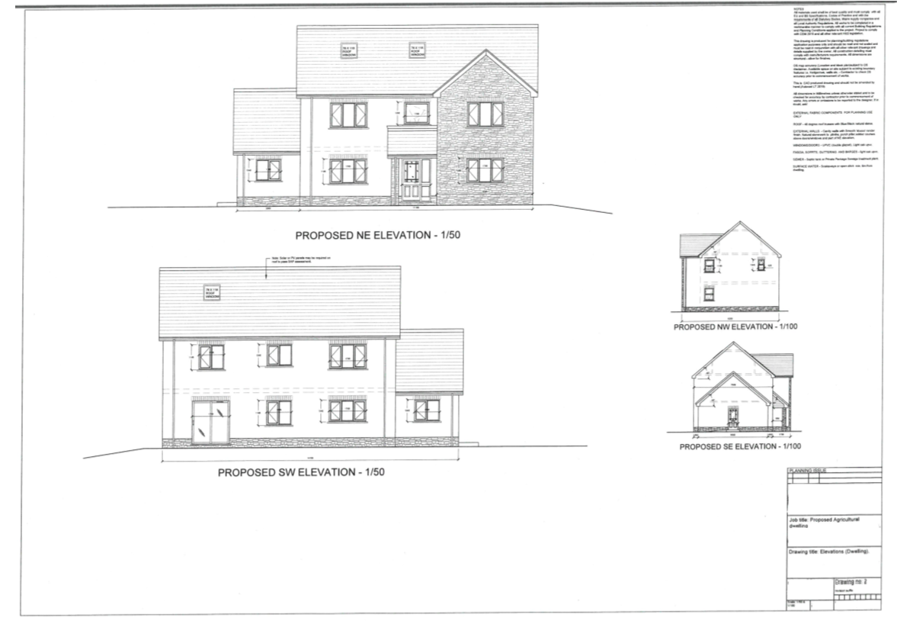

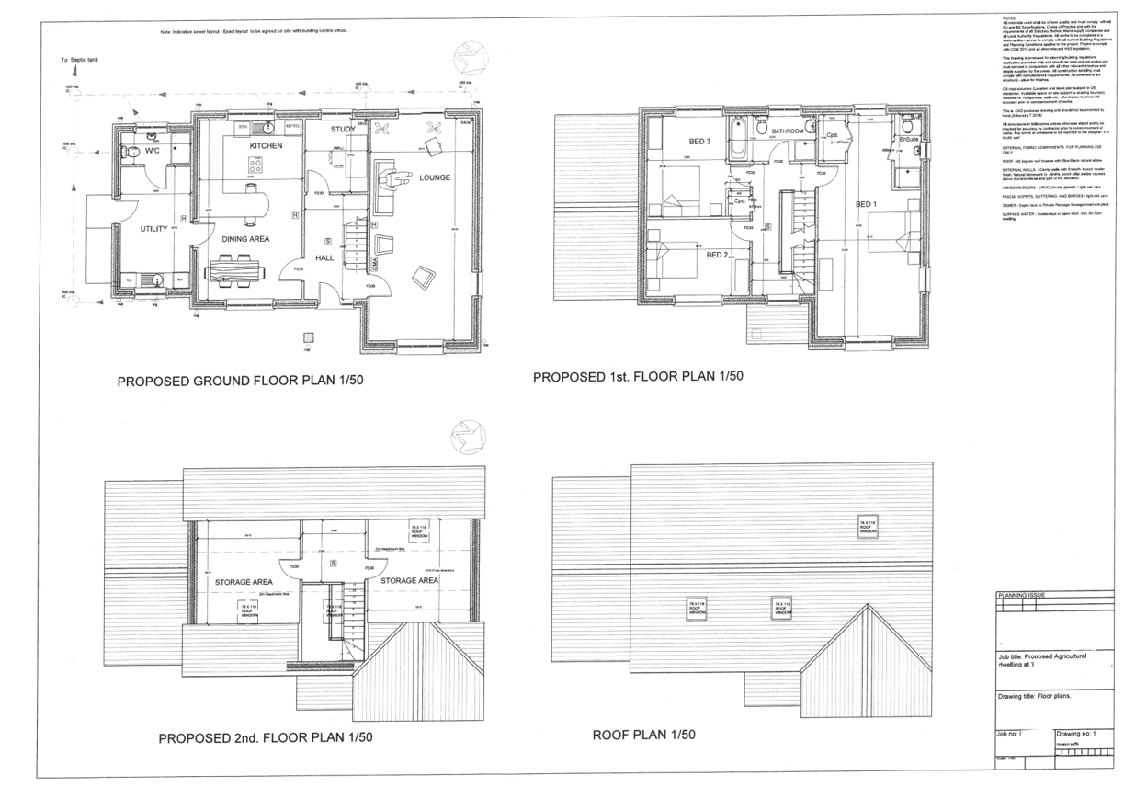
3. The ground floor. Construction, detailing and junctions with external walls.

- Given that it’s a greenfield site, unless advised otherwise by a site investigation report, 600 x 300 Concrete strip foundations should be sufficient for a domestic dwelling. The excavations will be inspected by Building Control and any Warranty Provider and will need to meet Part A of the Building Regulations: Structural Safety
Ref-(Structure: Approved Document A, 2020)

- Maintain a clear cavity of at least 225mm below damp proof course level (dpc). This is to ensure that the cavity drains freely.

- 100mm Concrete Blocks 7N

- 75mm Lean mix concrete oversite laid on geotextile root barrier. If radon is present, then protective measures should be installed to prevent the passage of radon gas into the house. Part C of the Building Regulations: resistance to contaminants and moisture.

Ref-(Site preparation and resistance to contaminates and moisture: Approved Document C, 2020)

- 225mm Clear void between oversite and underside of timber joists. This space is ventilated using brick vents at opposite ends of the dwelling. Part F of the Building Regulations: ventilation

Ref-(Ventilation: Approved Document F, 2020)

- Timber treated joists which will be sized and spaced in accordance with the architects or engineers recommendation, e.g. 600mm centres, but never greater than 600mm centres. These joists will be sized using the TRADA Span table and will be either C16 or C24 Class and will comply with BS 8103-3 - Part A of the Building Regulations: Structural Safety

Ref-(Structure: Approved Document A, 2020)
Ref-(Span Tables | TRADA, 2020)

- 100mm Celotex rigid board insulation fixed between joists. Use 25mm x 50mm battens to hold the insulation in place. Use 25mm rigid board insulation on the abutment between the joists and the external wall to maintain thermal continuity. Insulation is used in the floor, walls and roof space. This is to ensure compliance with Part L of the Building Regulations: conservation of fuel and power. Given that this is a domestic new build, this will also need to comply with SAP Calculations. SAP is a Building Regulations requirement for all new residential dwellings. The Standard Assessment Procedure (SAP) is a measure of the energy efficiency of a property and is the calculation from which an Energy Performance Certificate (EPC) is generated.

Ref-(SAP calculations explained, 2020)

- 22mm T&G Flooring screwed through to joists

- Softwood skirtings. Air seal at junctions.

- 12.5mm Plasterboard on dabs (Dot and Dab) with Skim finish

- 100mm Concrete block inside leaf

- 100mm Celotex rigid board insulation taped at joints to maintain thermal envelope - Part L of the Building Regulations.

Ref-(Conservation of fuel and power: Approved Document L, 2020)

- 50mm Clear cavity. A cavity is designed to prevent any penetrating water entering the dwelling. Any water ingress will filter down the cavity and leave via weep holes or via the lean mix fill.

- 100mm Concrete block outside leaf

- Natural sandstone plinth up to 450mm above finished floor level – Plain render thereon

- Wall ties fixed at 450mm staggered spacing

Plan below, numbers on plan coincide with detail above.

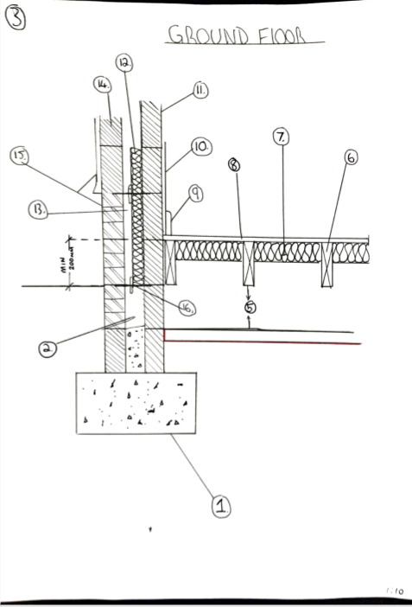

4. The first floor. Construction, detailing, junctions with external walls and restraints.

- 22mm T&G Flooring screwed through to joists

- Timber joists which will be sized and spaced in accordance with the architects or engineer’s recommendation. These joists will be sized using the TRADA Span table and will be either C16 or C24 Class and will comply with BS 8103-3. These joists will be fitted inside the inside leaf of the external wall. Joists should not be spaced at centres greater than 600mm. When planning joist spacings, a clearance of 25mm to 75mm between the first joist and the wall face should be allowed. This helps when installing services and fixing floorboards. – Part A Building Regulations

Ref-(Span Tables | TRADA, 2020)
Ref-(Structure: Approved Document A, 2020)

- Restraint straps and/or joist hangers suitable for taking tensile forces may be required to tie the walls and upper floors together. Restraint straps at not more than 2m centres should be provided along the walls that run parallel to the joists.

- 100mm Mineral wool insulation to be laid in between the joists to prevent the passage of sound between floors – Part E of the Building Regulations: Resistance to the passage of sound

Ref-(Resistance to sound: Approved Document E, 2020)

- 15mm Plasterboard fixed to the underside of the joists finished with skim

- Softwood skirtings. Air seal at junctions

- 12.5mm Plasterboard on dabs (Dot and Dab) with Skim finish

- 100mm Concrete block inside leaf

- 100mm Celotex rigid board insulation taped at joints to maintain thermal envelope - Part L of the Building Regulations: conservation of fuel and power.

Ref-(Conservation of fuel and power: Approved Document L, 2020)

- 50mm Clear cavity. A cavity is designed to prevent any penetrating water entering the dwelling. Any water ingress will filter down the cavity and leave via weep holes or via the lean mix fill

- 100mm Concrete block outside leaf

- Plain render fixed to external leaf of block

- Wall ties fixed at 450mm staggered spacing

Plan below, numbers on plan coincide with detail above.

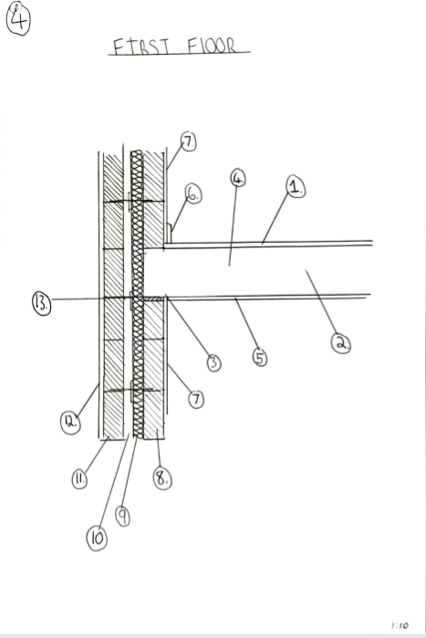

5. Openings. Solutions for lintels, sills and jambs.

- Given that there is a requirement for soldier courses as window and door heads, stainless steel Catnic Type Lintels will be required. These lintels are designed so that you can build masonry work on the outside skin and withhold the loading above - Part A & Part C of the Building Regulations.

Ref-(Structure: Approved Document A, 2020)
Ref-(Site preparation and resistance to contaminates and moisture: Approved Document C, 2020)

- A layer of damp proof membrane will be fixed above the lintel and will lead to a weep hole in the soldier course. Any water that enters the cavity will filter down and across the DPM and exit the wall through the weep hole.

- The sills will be fitted beneath the window itself and will be laid on a slight slope so that any water will filter away from the window.

- There will be a DPM fitted behind underneath and lapped behind the DPM again to ensure that any water will filter out of the junction.

- All window and door jambs will be fitted with proprietary cavity closers such as Kingspan Thermabate. These will be fitted within the cavity and maintain the thermal insulation around windows and doors - Part L of the Building Regulations: conservation of fuel and power.

Ref-(Conservation of fuel and power: Approved Document L, 2020)

- Inside leaf, will be reinforced concrete lintel.

Plan below, numbers on plan coincide with detail above.

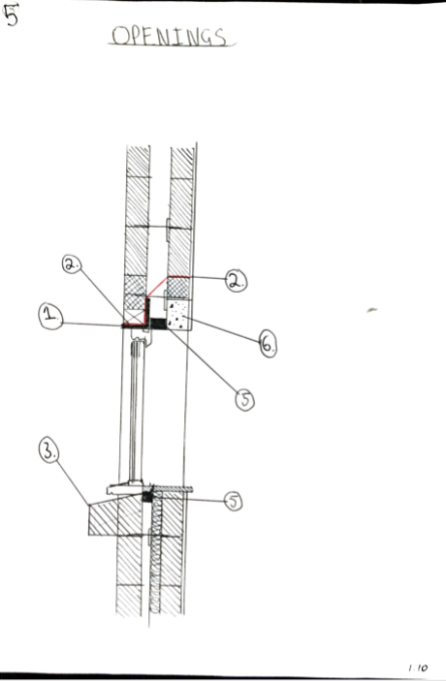

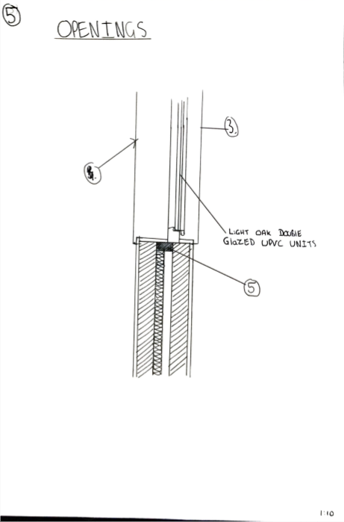

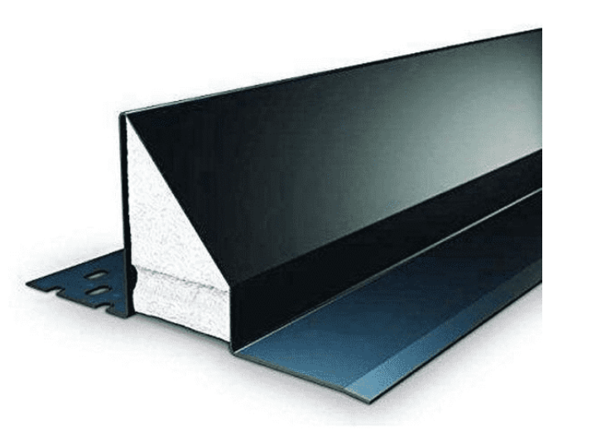Catnic style lintel.
(image taken from)- (Selector, 2020)

6. Eaves detailing and roof covering – indicating appropriate weathering, fixing and laps.

- 12.5mm Plasterboard on dabs (Dot and Dab) with Skim finish

- 100mm Concrete block inside leaf

- 100mm Celotex rigid board insulation taped at joints to maintain thermal envelope -Part L of the Building Regulations: conservation of fuel and power.

(Conservation of fuel and power: Approved Document L, 2020)

- 50mm Clear cavity. A cavity is designed to prevent any penetrating water entering the dwelling. Any water ingress will filter down the cavity and leave via weep holes or via the lean mix fill

- 100mm Concrete block outside leaf

- Plain render fixed to external leaf of block

- Wall ties fixed at 450mm staggered spacing

- 100 x 50 Sawn timber wall plate. The wall plate is used to fix the attic truss to the external wall. The wall plate is strapped to the external walls using wall plate straps at 1200 centres

- Upvc fascia and soffit fixed to sawn timber treated 150mm x 25mm backing boards and 50mm x 50mm formwork which is fixed to the external walls. The gutters are fixed to the Fascias using proper clips which are supplied with the guttering.

- Natural slates roof, nailed twice using copper roofing nails, hammered through the slate into the battens beneath

- 25mm x 50mm battens, fixed to the attic trusses beneath

- Breathable roofing membrane. This layer also provides a secondary barrier to the ingress of rain, wind and snow. It has a low vapour resistance and is air – permeable, additionally, it eliminates the incidence of interstitial condensation in pitched roofs. – Part F of the Building Regulations: Ventilation.

Ref-(Ventilation: Approved Document F, 2020)

- Over fascia vent. This is fitted between the trusses at eaves level and allows air to enter the ventilated air gap which will exist above the insulation - Part F of the Building Regulations: Ventilation

Ref-(Ventilation: Approved Document F, 2020)

- 50mm Minimum air gap. This is a continuous gap which allows the passage of air through the roof. The 50mm path of ventilation is to reduce the risk of interstitial condensation forming on the underside of the impermeable felt membrane and settling on the timber rafters. - Part F of the Building Regulations: Ventilation

Ref-(Ventilation: Approved Document F, 2020)

- Celotex rigid insulation board. This is fitted between the rafters and is there to provide thermal insulation within the roof - Part L of the Building Regulations: conservation of fuel and power.

Ref-(Conservation of fuel and power: Approved Document L, 2020)

- Insulated plasterboard with integral vapour control layer. This is fitted to the underside of the rafter and is used to further insulate the roof space. The reason for having to insulate beneath as well as between is that the depth of the rafter is not always enough to provide enough insulation to achieve Pat L compliance with the Building Regulations. The insulation depth is reduced due to the need to provide a 50mm air gap.

Ref-(Conservation of fuel and power: Approved Document L, 2020)

- Skim finish

Plan below, numbers on plan coincide with detail above.

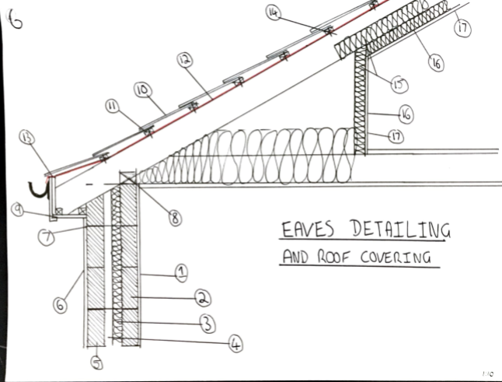

7. The main roof structure. Construction, detailing and fixing.

- The use of attic trusses is common where rooms are to be provided within the roof space.

- Trussed rafters should be designed in accordance with BS 5268-3. Truss manufacturers may have their own computer programs for calculating truss designs in accordance with the British Standard. - Part A of the Building Regulations: structural safety

Ref-(Structure: Approved Document A, 2020)

- The attic truss is fixed to the wall plate at the top of the external wall and strapped to the walls using wall plate straps.

- The building designer should specify all bracing. Trussed rafter roofs should be braced in accordance with Table 1 in Appendix 7.2-C unless the roof is designed and braced in accordance with BS 5268-3.

Ref-(NHBC Standards 2011, 2020)

- All timber bracing to trussed rafters should be at least 100mm x 25mm in section and twice nailed to each trussed rafter and to the wall plate. Nailing should be 3.35mm x 65mm long galvanized round wire nails.

- Trussed rafters should not be spaced at centres greater than 600mm

Plan below, numbers on plan coincide with detail above.

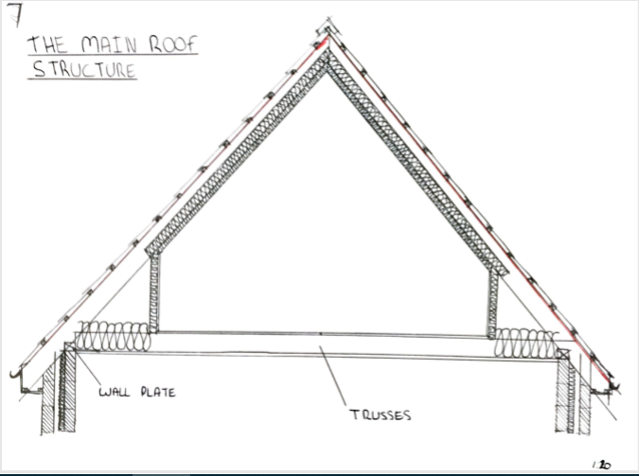

8.Referencess.

(Structure: Approved Document A, 2020)
GOV.UK. 2020. Structure: Approved Document A. [online] Available at: <https://www.gov.uk/government/publications/structure-approved-document-a> [Accessed 28 April 2020].
(Site preparation and resistance to contaminates and moisture: Approved Document C, 2020)
GOV.UK. 2020. Site Preparation And Resistance To Contaminates And Moisture: Approved Document C. [online] Available at: <https://www.gov.uk/government/publications/site-preparation-and-resistance-to-contaminates-and-moisture-approved-document-c> [Accessed 28 April 2020].
(Resistance to sound: Approved Document E, 2020)
GOV.UK. 2020. Resistance To Sound: Approved Document E. [online] Available at: <https://www.gov.uk/government/publications/resistance-to-sound-approved-document-e> [Accessed 28 April 2020].
(Ventilation: Approved Document F, 2020)
GOV.UK. 2020. Ventilation: Approved Document F. [online] Available at: <https://www.gov.uk/government/publications/ventilation-approved-document-f> [Accessed 28 April 2020].
(Conservation of fuel and power: Approved Document L, 2020)
GOV.UK. 2020. Conservation Of Fuel And Power: Approved Document L. [online] Available at: <https://www.gov.uk/government/publications/conservation-of-fuel-and-power-approved-document-l> [Accessed 28 April 2020].
(Span Tables | TRADA, 2020)
Trada.co.uk. 2020. Span Tables | TRADA. [online] Available at: <http://www.trada.co.uk/ad-hoc/span-tables/> [Accessed 28 April 2020]
(Home and Efficiency, 2020)
Home and Efficiency, 2020. Energy Performance Certificates. [online] Energy Saving Trust. Available at: <https://energysavingtrust.org.uk/home-energy-efficiency/energy-performance-certificates> [Accessed 28 April 2020]
(NHBC Standards 2011, 2020)
Nhbccampaigns.co.uk. 2020. NHBC Standards 2011. [online] Available at: <http://nhbccampaigns.co.uk/landingpages/techzone/previous_versions/2011/Part7/section2/appendix.htm> [Accessed 28 April 2020].
(Selector, 2020)
Selector, L., 2020. Catnic. [online] Catnic. Available at: <https://catnic.com/products/lintels/lintel-product-selector> [Accessed 28 April 2020].
(SAP calculations explained, 2020)
Eden.gov.uk. 2020. SAP Calculations Explained. [online] Available at: <https://www.eden.gov.uk/planning-and-building/building-control/building-control-guidance-notes/sap-calculations-explained/> [Accessed 28 April 2020].

