

Module: Research Methods for Business
Module code: LCLM6004

Component 1 – Business Research Proposal

Title: The Impact of Social Media Marketing on Customer Engagement and Brand Loyalty: A Case Study of Gymshark in the UK.

Student name: Junior Ngimbi
Student number: 2314796
Lecturer’s Name: Dr. Ashikul Alam

Table of Contents
1. Introduction 3
1.1 Research Background 3
1.2 Research/Business Problem 4
1.3 Research Rationale and Significance 4
1.4 Research Aims and objectives 5
1.5 Research Questions 5
2. Critical Literature Review 6
2.1 Social Media Marketing Activities 6
2.2 Customer Engagement 6
2.3 Brand Loyalty 6
2.4 Relationship Between Social Media Marketing and Brand Loyalty 7
2.5 Customer Engagement as a Driver of Brand Loyalty 7
2.6 Theoretical Framework: Relationship Marketing Theory 7
2.7 Research Gap 7
3. Research Methodology and Design 9
3.1 Research Approach 9
3.2 Data Collection Methods 9
3.3 Sampling Strategies 10
3.4 Ethical Considerations 10
3.5 Gantt chart 10
4. Business Relevance and Practical Implications 12
4.1 Potential Impact on Business Practices 12
4.2 Implications for Decision-Making and Industry Developments 12
5. Conclusion 13
References 14

1. Introduction

1.1 Research Background
Social media marketing has now become a crucial component of marketing, and organisations can now relate directly to the consumers and can build a long-term relationship. Brands might use Instagram, Facebook, TikTok, and X to have engaging content, get a conversation with the customer and develop brand awareness (Abdullah and Faisal, 2022). Social media marketing is becoming a trend that is gaining a lot of popularity among companies in light of digital communication and awakening the interest of the customers and creating brand loyalty. Li, Larimo and Leonisou (2021) pay attention to social media marketing as a valuable resource to create value and sustain a competitive advantage. Additionally, the evolution of the use of social media has transformed how brands establish long-term relationships with the customers (Li et al., 2021).
The relevance of social media marketing lies in its ability to enhance customer engagement, which is increasingly recognised as a key determinant of marketing effectiveness. Customer engagement refers to the emotional, cognitive, and behavioural interaction between consumers and a brand. Through actions such as liking, commenting, sharing content, and participating in online communities, customers become active contributors rather than passive recipients of marketing messages. This interaction strengthens the relationship between consumers and brands by fostering a sense of involvement, trust, and emotional attachment.
In addition, social media platforms enable brands to deliver personalised and interactive content, which significantly increases engagement levels. Features such as influencer marketing, live streaming, user-generated content, and interactive campaigns allow organisations to create meaningful connections with their audience. These digital interactions not only increase visibility but also encourage consumers to develop stronger psychological bonds with the brand.
Customer engagement is closely linked to brand loyalty, which refers to a customer’s consistent preference and commitment to repurchase or support a specific brand over time. High levels of engagement often lead to increased trust, satisfaction, and emotional connection, which are key drivers of loyalty. When consumers feel valued and engaged through continuous interaction, they are more likely to develop long-term relationships with the brand and resist switching to competitors. Conversely, low engagement may weaken emotional attachment and reduce repeat purchase intention.
In this context, social media marketing plays a critical role in shaping both engagement and loyalty by providing a platform for continuous interaction between brands and consumers. For example, brands that actively respond to customer feedback, maintain consistent messaging, and build online communities are more likely to strengthen consumer trust and loyalty. This is particularly evident in digitally native brands such as Gymshark, which has built its success largely through influencer collaborations, community-driven content, and strong social media presence.
The level of social media marketing activities suffices to enhance the level of interaction among consumers, building brand confidence and eventually brand commitment, thereby making it a significant strategic objective of the companies that operate within the highly competitive online market segments (Fetais et al., 2023).

1.2 Research/Business Problem
Business companies are also on the run to gain and maintain customers, and they are spending colossal sums of money on advertisements on social media (Wulandari et al., 2022). Nonetheless, with this kind of investment, the majority of organisations are unable to establish whether their investment in social media is causing effective customer engagement and brand loyalty in the long run (Salsabila and Indrawati, 2022). The customers' tastes and preferences and their online behaviour have been evolving at a very rapid rate; hence, it has been difficult to establish the most effective marketing strategies that work. According to Ibrahim (2022), the strength of the social media marketing efforts to foster brand loyalty is positive; however, the strength and nature of such associations might vary in other scenarios and sectors, which constitutes a major area of study.

1.3 Research Rationale and Significance
The significance of this research is that understanding the development of the relationship between social media marketing, customer engagement and brand loyalty will be able to assist organisations in creating an even more effective digital marketing plan (Li et al., 2021). With the heightened competition in the online arena, it is important that businesses should have evidence-based information that will see them streamline the customer interaction and build loyalty (Ibrahim, 2022). Dwivedi et al. (2021) explain that social media has changed the manner in which organisations communicate with consumers, and as such, it is imperative to comprehend its effects on customer behaviour. The results of this research could be used to make managerial decisions, and it could be added to the existing literature on digital marketing practices.

1.4 Research Aims and objectives
Research Aim
To investigate the effect of social media marketing on customer interaction and brand loyalty among customers.
Research Objectives
- To analyse how social media marketing activities can affect customer engagement.
- To investigate the correlation between customer engagement and brand loyalty.
- To determine whether social media marketing has an influence on brand loyalty.
- To identify the social media marketing activities that strongly influence customer engagement and brand loyalty among Gymshark customers.
- To recommend strategies that Gymshark can adopt to improve customer engagement and strengthen brand loyalty through social media marketing.

1.5 Research Questions
- What impact do social media marketing activities have on customer engagement?
- How is there a connection between customer engagement and brand loyalty?
- How does social media marketing influence brand loyalty?
- Which kinds of social media marketing prove to be the most successful in reaching customers and generating brand loyalty among customers of Gymshark?
- What is the best way of how Gymshark can use social media marketing to enhance customer engagement and brand loyalty?

2. Critical Literature Review

2.1 Social Media Marketing Activities
The strategic utilisation of social networking platforms to promote brands, products and services, and creating communication with customers, is known as 'social media marketing activities'. These activities are those of entertainment, interactivity, trendiness, personalisation and electronic word of mouth. Li, Larimo and Leonisou (2021) argue that currently social media marketing is a strategic capacity, rather than a means of communication. Moreover, Dwivedi et al. (2021) suggest that social media have revolutionised the conventional marketing medium, with the current ability to conduct direct and continuous interaction between the organisations and consumers.

2.2 Customer Engagement
Customer engagement refers to the level of cognitive, emotional and behavioural interest that the customers will have towards a brand. Social media provides the customers with an opportunity to engage with the content, express their opinion, and become members of brand communities. The article on the studies by Aljuhmani et al. (2022) provides evidence that the marketing activities of social media have a favourable effect on customer brand engagement, as they mobilise the customers to participate in the marketing. The engaged customers will have increased opportunities to interact with brand-based content and get involved in online discussions. Meruvishnu and Sudaryanto (2022) underline that customer engagement is an important process with the assistance of which the social media activity changes the customer attitudes and behaviours.

2.3 Brand Loyalty
Brand loyalty refers to the loyalty of customers towards a brand to purchase and visit a particular brand repeatedly. Highly loyal customers are likely to exhibit positive attitudes and repeat buying behaviour and refer to the brand. In a meta-analysis, Ibrahim (2022) has come to the conclusion that brand loyalty has a positive and strong correlation with the social media marketing activities. There should also be the development of devotion because in most cases, it is always cheap to retain a customer as compared to acquiring one. Kumari (2022) found out that brand awareness and brand identity could be used to improve social media marketing to result in loyalty.

2.4 Relationship Between Social Media Marketing and Brand Loyalty
The literature indicates that social media marketing could have a direct effect on brand loyalty, as it can positively impact customer experiences and improve brand-consumer relationships. Individuated communication and interactive content will assist the businesses in bringing in more value to the customers. According to Fetais et al. (2023), social media marketing activities have a positive impact on brand loyalty, especially where consumers feel that they have got value in their interactions with the brand. Social media is also useful in ensuring that organisations ensure that there is constant communication with the customers. Althuwaini (2022) found out that trust plays an important mediating role in the relationship between the activities of social media and customer loyalty.

2.5 Customer Engagement as a Driver of Brand Loyalty
Customer engagement, according to most scholars, is the connection between social media marketing and brand loyalty. The higher the engagement of customers in brands, the more emotionally attached and positive towards the brand will be. The revelation by Wulandari, Suryawardani and Marcelino (2022) revealed that the extent of customer engagement plays a major role in influencing brand loyalty. Interaction encourages customers to be part of brand communities and interact with other individuals. The customers can be made loyal in case of increased interaction and engagement, as was found out by Salsabila and Indrawati (2022), and the social media marketing activities can assist in doing so.

2.6 Theoretical Framework: Relationship Marketing Theory
According to the Relationship Marketing Theory, organisations cannot risk their eyes establishing long-run relationships with the customers but on individual transactions. The theory involves loyalty of trust in commitment, communication and customer satisfaction. Regarding the significance of loyalty in the case of social media, Althuwaini (2022) explains that trust is crucial to enhance its results. Social media channel advertising provides organisations with a chance to create a process of constant interaction and building relationships.

2.7 Research Gap
The existing results are in industries and countries that are far apart, though the previous studies that have been conducted have covered the aspects of social media marketing, customer engagement and brand loyalty. Ibrahim (2022) stresses that the effectiveness of the relationship between social media marketing activities and brand loyalty varies. The studies above are based on direct relationships, and the studies do not have an in-depth exploration of customer engagement as a mechanism. Abdullah and Faisal (2022) state that more research is required to know how engagement can develop loyalty.

3. Research Methodology and Design

3.1 Research Approach
It will be a quantitative research study which will focus on exploring the connection between social media marketing and customer engagement and brand loyalty. The quantitative approach is suitable as it allows the gathering of numerical data, which can be statistically analysed to establish a relationship amongst variables. Quantitative research would be convenient to test the theories and analyse tendencies in a large population, as Saunders, Lewis and Thornhill (2023) explain. It will also be deductive in nature since the questions of the research will be informed by the theories and findings of past literature which will be used in the gathering of the data. Bell, Bryman and Harley (2022) remark that deductive research will be appropriate in those instances when the researchers are curious about confirming the current concepts and correlations between theories.
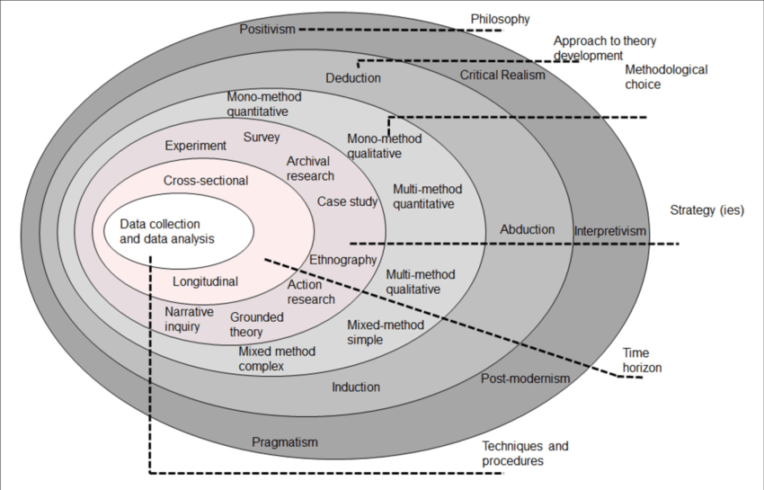
Figure 1: Research onion ring model (Saunders, Lewis and Thornhill, 2019)

3.2 Data Collection Methods
An online questionnaire designed to be used to gather primary data by sending it to all users of social media. The five-point Likert scale will also be included in the questionnaire, and the closed-ended, as a measure of their perception of social media marketing, customer engagement and brand loyalty. Online surveys are regarded as effective since they enable the researcher to get information from a relatively high number of respondents within a restricted time period. Easterby-Smith et al. (2021) also confirm that a questionnaire is one of the most common methods of carrying out business research, as it may lead to some standardised and measurable information. This survey method will also bring about consistency in responses and also statistical analysis. The answers that will be obtained after interviewing the respondents will provide a hint of the interrelations of the key variables that will be discussed in this research.

3.3 Sampling Strategies
The research will employ a convenience sampling method which is non-probability. Their willingness to take part in the survey and the time will be used to sample them. The target market will be comprised of active social media users with experience with the brands using digital platforms. Business studies typically use the convenience sample, as the researcher can get the needed information in a limited period of time when the researchers do not have access to a complete sampling frame. The arguments by Saunders, Lewis and Thornhill (2023) focus on convenience sampling in an exploratory study and where there is a feasibility constraint to the study. About 100 respondents will be targeted, and this will mean that sufficient data will be collected to analyse. Such an approach will allow the researcher to gather pertinent information under the time- and resource-limited conditions.

3.4 Ethical Considerations
The use of ethical considerations is also important as a way of guaranteeing the integrity and credibility of the research process. The participants will be well informed of the purpose of the study by filling in the questionnaire. This will be voluntary-based, and the respondents will be free to withdraw anytime without being reprimanded. According to Aityan (2022), one of the obligatory terms of business research involving a human subject is informed consent. Privacy and anonymity will be respected, taking care not to request any personally identifiable information. Data collected via the respondents would be stored securely, and no other intentions would be used on the information other than scholarly. Bryman, Bell and Hirschsohn (2021) suggest that the privacy of participants is needed in order to make sure that ethical requirements are observed and participants gain trust in the research activities.

3.5 Gantt chart
The project time planning is attached following:
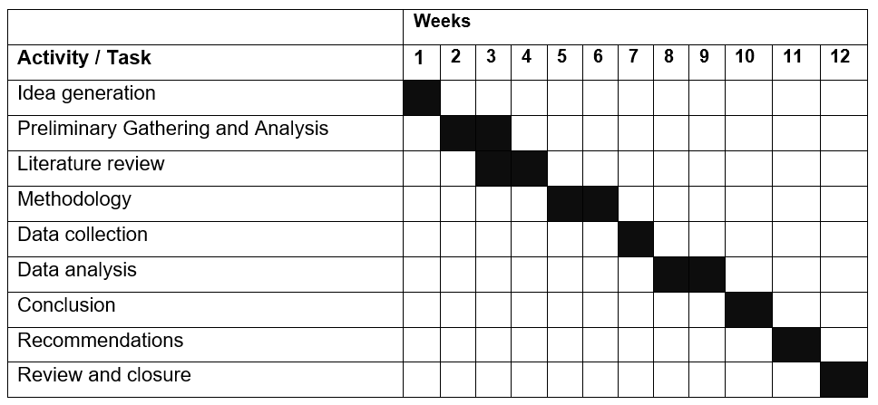

4. Business Relevance and Practical Implications

4.1 Potential Impact on Business Practices
The results of this study may assist the companies in being more effective in their social media marketing campaigns, as the activities that may contribute to increasing customer engagement and brand loyalty will be revealed. These insights can help organisations to create more focused content, enhance customer relationships and enhance brand communications. Li, Larimo and Leonisou (2021) point out that successful social media marketing helps in achieving competitive advantage in the long run due to enhanced customer engagement. Knowing how social media affects customer behaviour, businesses will be in a more advantageous position to make use of whatever they have to offer in marketing and enhance retention of customers.

4.2 Implications for Decision-Making and Industry Developments
The implications of the study for the managers and marketing practitioners in their strategic decision-making with regard to investing in digital marketing would be enormous. Understanding of the relationship between social media marketing and customer engagement and brand loyalty of customers can be used to assist organisations in coming up with evidence-based marketing campaigns. Dwivedi et al. (2021) confirm that the marketing in any industry and relationship with consumers are still being redefined by social media. The results can also be used to build industry developments due to customer-centred digital strategies focus.

5. Conclusion
Social media marketing is one of the key tools in the modern business environment as a way of engaging customers in brand loyalty. This study suggests a study of how these variables relate to each other to bring a better insight into consumer behaviour in cyberspace. The findings can assist organisations to improve both the marketing strategies, customer relationships and competitive advantages in the long term by effectively using social media and customer loyalty programmes.

References
Abdullah, M.H.S. and Faisal, A. (2022). The Role of Social Media Marketing Activities in Increasing Brand Loyalty. Jurnal Ekonomi, 27(3), pp. 478–499.
Aityan, S.K. (2022) Business Research Methodology: Research Process and Methods. Cham: Springer.
Aljuhmani, H.Y., Elrehail, H., Bayram, P. and Samarah, T. (2022). Linking social media marketing efforts with customer brand engagement in driving brand loyalty. Asia Pacific Journal of Marketing and Logistics, 34(7), pp. 1719–1738.
Althuwaini, S. (2022). The Effect of Social Media Activities on Brand Loyalty for Banks: The Role of Brand Trust. Administrative Sciences, 12(4), 148.
Bell, E., Bryman, A. and Harley, B. (2022) Business Research Methods. 6th edn. Oxford: Oxford University Press.
Bryman, A., Bell, E. and Hirschsohn, P. (2021) Research Methodology: Business and Management Contexts. 2nd edn. Cape Town: Oxford University Press Southern Africa.
Daya, M., Siagian, Y.M. and Kurniawati (2022). Influence Social Media Marketing Activities Against Brand Loyalty Directly or Through Consumer Satisfaction and Brand Equity on the Largest E-Commerce in Indonesia. Jurnal Aplikasi Manajemen, 20(4).
Dwivedi, Y.K., Ismagilova, E., Hughes, D.L., Carlson, J., Filieri, R., Jacobson, J., Jain, V., Karjaluoto, H., Kefi, H., Krishen, A.S., Kumar, V., Rahman, M.M., Raman, R., Rauschnabel, P.A., Rowley, J. and Wang, Y. (2021). Setting the Future of Digital and Social Media Marketing Research: Perspectives and Research Propositions. International Journal of Information Management, 59, 102168.
Easterby-Smith, M., Jaspersen, L.J., Thorpe, R. and Valizade, D. (2021) Management and Business Research. 7th edn. London: Sage Publications.
Fetais, A.H., Algharabat, R.S., Aljafari, A. and Rana, N.P. (2023). Do Social Media Marketing Activities Improve Brand Loyalty? An Empirical Study on Luxury Fashion Brands. Information Systems Frontiers, 25(2), pp. 795–817.
Ibrahim, B. (2022). Social Media Marketing Activities and Brand Loyalty: A Meta-Analysis Examination. Journal of Promotion Management, 28(1), pp. 60–90.
Kumari, K.W.S.N. (2022). How Social Media Marketing Activities Influence Brand Loyalty through Brand Identity and Brand Awareness during COVID-19. Studies of Applied Economics, 40(3).
Li, F., Larimo, J. and Leonidou, L.C. (2021). Social media marketing strategy: Definition, conceptualization, taxonomy, validation, and future agenda. Journal of the Academy of Marketing Science, 49(1), pp. 51–70.
Meruvishnu, J.R. and Sudaryanto, B. (2022). Analisis Pengaruh Social Media Marketing Instagram Shopee terhadap Brand Loyalty dengan Customer Engagement sebagai Variabel Intervening. Diponegoro Journal of Management, 11(3).
Salsabila, N.S. and Indrawati, I. (2022). Pengaruh Social Media Marketing Activities terhadap Loyalitas Pelanggan pada Produk Lokal UMKM di Aplikasi Shopee. Jurnal Inspirasi Bisnis dan Manajemen, 6(1), pp. 83–100.
Saunders, M., Lewis, P. and Thornhill, A. (2023) Research Methods for Business Students. 9th edn. Harlow: Pearson.
Wulandari, A., Suryawardani, B. and Marcelino, D. (2022). Create Brand Loyalty of Indonesian Facebook User Through Brand Engagement: Utilization the Role of Social Media Marketing Elements. Asia Pacific Management and Business Application, 10(3), pp. 251–266.

