

Was the Guggenheim Designed for its Intended Purpose?
School of Architecture, Built and Natural Environment
Course: BSc Architecture

Lucia Batters (2403918)

Name: Lucia Batters

Student Number: 2403918
Module Code: ACAA50003
Word Count: 2331
Date: 19/03/2026

Guggenheim

Introduction 3
Main Body 3
Location and Architect 3
Design Philosophy 4
Landscape in Context to the Building 7
Issues in Design and Construction 10
Atmosphere 12
Comparison to the Tate Modern 16
Conclusion 19
References 20

Figure List
Figure 1 - section through the Guggenheim (Solomon R. Guggenheim Foundation, 1960) 6
Figure 2 - interior sketch of Guggenheim (Betsky, 1939) 7
Figure 3- Sketch of the Guggenheim Museum, 1956 (Solomon R. Guggenheim Foundation, 1960) 7
Figure 4 - exterior view of Guggenheim New York (Solomon R. Guggenheim Foundation, 1960) 9
Figure 5 - view of the Guggenheim in context to the landscape (Solomon R. Guggenheim Foundation, 1960) 10
Figure 6 - Skylight with concrete ribs (Solomon R. Guggenheim Foundation, 1960) 12
Figure 7 - Skylight details (Crosbie, 1995) 14
Figure 8 - Guggenheim being used for an exhibition (Solomon R. Guggenheim Foundation, 1960) 15
Figure 9 - internal birds-eye view (Etlin, 1994) 16
Figure 10 - section through Tate Modern (Jones, 2000) 17
Figure 11 - shows the Turbine Hall (Jones, 2000) 18

Introduction
This essay explores the practicalities of Frank Lloyd Wright's design for the Guggenheim Museum in New York. The key analysis is based on whether the building serves its purpose to show off the artwork, which is what Frank Lloyd Wright was commissioned to achieve, making sure to let the artwork be shown off in modern surroundings, or if it is designed to be the artwork itself, to show off Frank Lloyd Wright's artistic flair and architectural capabilities. Topics such as artists' opinions, construction and design philosophy are explored to gain an understanding of what Frank Lloyd Wright aimed to achieve. This essay will discuss the findings and reach a conclusion as to whether Frank Lloyd Wright's architectural work is truly fit for purpose when it comes to the New York Guggenheim.

Main Body

Location and Architect
The Guggenheim, originally called Hillas Museum, sits on Fifth Avenue in New York, on a plot bounded by Fifth Avenue, 88th Street, and 89th Street overlooking Central Park (Merkel, 2010; Angel & William, 2011; Dal Co., 2017). It was designed by Frank Lloyd Wright, born in 1867, and is known as his last major project and potentially one of his most popular (Perez, 2010; Dal Co., 2017; Tafel, 1979). Frank Lloyd Wright practised for 72 years and was mainly known for his residential projects, and did very few public pieces (Merkel, 2010). In the final weeks of 1943, Wright began to draw up his ideas, most of which pushed the limits of technology and sometimes exceeded them (Dal Co., 2017; Hart, 2007). This can be seen in the final design, such as how he designed the building without expansion joints to achieve a monolithic form (Hart, 2007). Wright's focus on the building's aesthetics and technology highlights the idea that the building's image comes before the function, however it could be argued that the technology may be in place to showcase the artwork displays in a new light. After the initial architectural proposals, construction began on the 16th august 1956, with 17 years passing from initial sketches to the museums inauguration, for which neither Frank Lloyd Wright, who died in 1959 at the age of 91, or Solomon R Guggenheim, the sponsor for the museum who died in 1949, where alive to see (Dal Co., 2017; Tafel, 1979; Solomon R. Guggenheim Foundation, 1960). Perhaps if it had not been for Wright's death, he may have noted his errors in design methodology and the building might have been adapted during construction in order for the intended purpose to be better fulfilled. The Guggenheim is a key piece of organic architecture, which is shown by its flowing forms and eggshell-like exterior (Tafel, 1979; Solomon R. Guggenheim Foundation, 1960). Organic architecture can be seen throughout Wright's work, including Fallingwater (Tafel, 1979).

Design Philosophy
The Guggenheim you see now took lots of development with 700 sketches and 6 sets of working drawings required to bring the vision to life (Perez, 2010). Throughout these many revisions, the constant element was the main design feature of the museum's more than a quarter-mile-long ramp, which can be seen in figure 1 (Solomon R. Guggenheim Museum, 1993; McLaughlin & Waldek, 2023). When Wright was challenged on his spiral design he reasoned that he felt the museum goer would find it more convenient to enter, take the lift to the top and slowly descend the spiral form whilst being immersed in the art, as shown in figure 2, that takes you on a journey to the exit, rather than the conventual museum form where you have to retrace your steps and confuse the experience (Pfeiffer, 2002). The slope was designed to be only 1% steeper than the kerb requirements in New York City, to create this gentle spiral to walk up or walk down (Solomon R. Guggenheim Foundation, 1960; Dal Co., 2017). This architectural idea does compromise the building's function as it has made it famously awkward to display any art, forcing creators to hang work at angles or build secondary structures on the ramp (Betsky, 1939). This, and the curved walls, force the architectural mind to question whether Wright truly designed The Guggenheim to fulfil the function required or whether he was more focused on the public's perceptions of his work. It also forces the question as to whether the surrounding landscape was a driving factor in his inspiration for key features such as the exterior, which can be seen in Figure 3, rather than the intended function of the building. Wright’s original design also included a glass elevator and spherical observation deck, and showed the exterior as being a brown-yellow even though Wright would have preferred it to be red (McLaughlin & Waldek, 2023). These colour choices lean towards the building being a statement in itself, maybe more so than the artwork it was intended to house, which raises the question of whether Wright was designing a museum or a piece of artwork itself and whether he was hoping for this to be his statement piece rather than an accomplished museum. This can be backed by how some experts say that the building competes with the artwork, backed by the letter the director and trustees of the museum were sent from a long list of artists explaining that the sloped walls and iconic ramp would make it unusable for the exhibition of paintings (Perez, 2010; Pfeiffer, 2002). This letter clearly shows that the designs carried a disregard for the function of the building and the suitability for the display of artwork, perhaps indicating that Wright did not equip himself with enough knowledge on the matter.

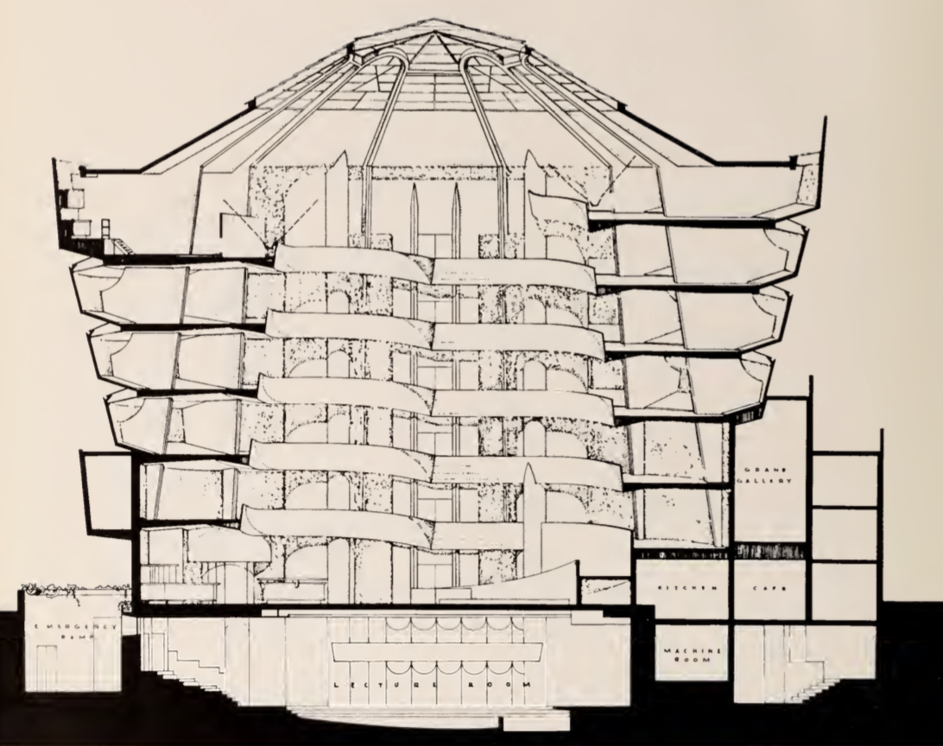
Figure 1 - section through the Guggenheim (Solomon R. Guggenheim Foundation, 1960)
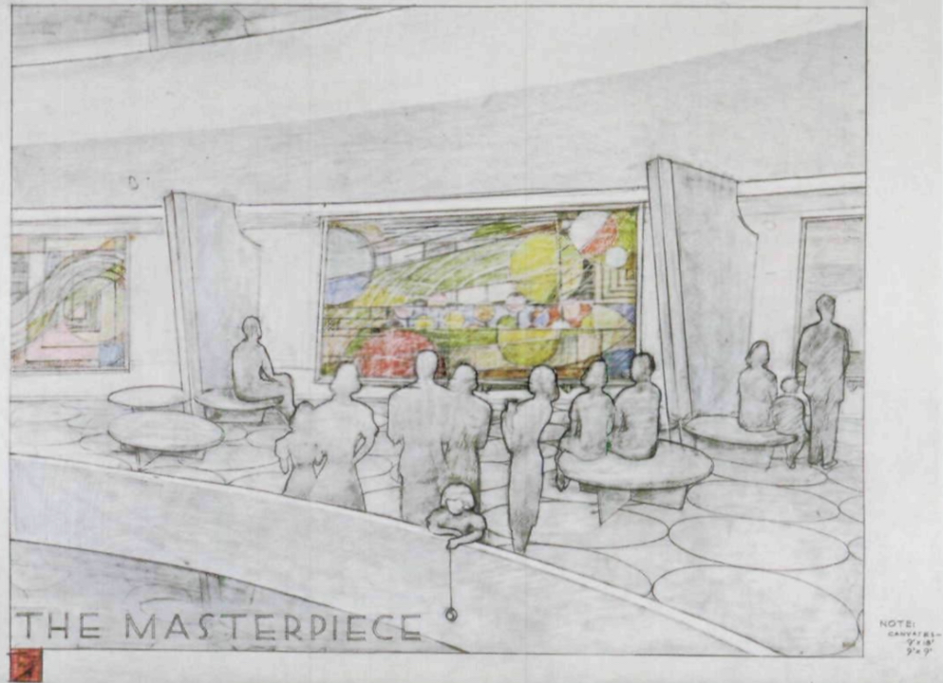
Figure 2 - interior sketch of Guggenheim (Betsky, 1939)
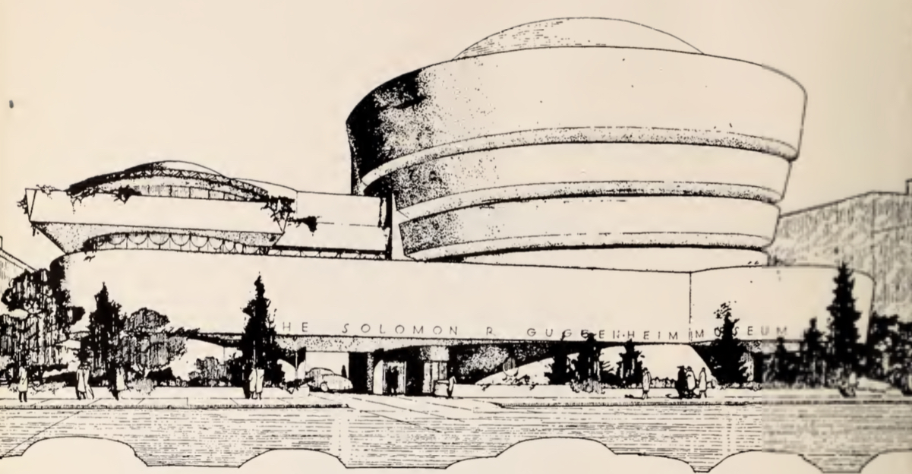
Figure 3- Sketch of the Guggenheim Museum, 1956 (Solomon R. Guggenheim Foundation, 1960)

Landscape in Context to the Building
The Guggenheim is sometimes seen as an odd artefact, perhaps because of its obvious contrast to the Manhattan city grid, which can be seen in figure 4, and its controversial way of presenting art (Betsky, 1939; Perez, 2010). Wright's design forced the building to swell from the neat line of apartments, as shown in figure 5, forcing some critics to call it “an oversized and indigestible hot cross bun” (Betsky, 1939; McLaughlin & Waldek, 2023). While the critics slandered it, calling it other derogatory names such as inverted oatmeal bowl, others saw it as a building to mark the first step towards organic architecture for New York City (McLaughlin & Waldek, 2023; Solomon R. Guggenheim Foundation, 1960). All these comments push the idea that Wright wanted the structure itself to make a statement; perhaps drawing the focus away from the artwork itself. The idea of it swelling reinforces this notion of a need for his work to be a statement in itself, rather than letting the artwork inside do the talking. This lack of consideration for the artwork can be seen by how the structure of the museum allowed for seasonal condensation, which rendered sections of the gallery unfit for exhibition during cold seasons, and perhaps Wright's approach to his choice of a prominent location also showed where his priorities were (Hart, 2007; Tafel, 1979). This prominent location and the exterior design may be one of the reasons that compared to the museums in Bilbao, Las Vegas, Venice and Berlin, this New York museum is the most popular of the Guggenheim collections, even after 30 years, with as many as a third of visitors coming to see the building itself, rather than the artwork (Merkel, 2010; Ulam, 2005). This statistic indicates that the public may view the building as the main attraction rather than the canvas on which the art it to be displayed. This is a concerning idea as it shows a lack in the architectural approach from Wright. This is due to the goal of Architecture being to achieve the client's vision, which in this case was a museum to show off modern artwork, which it does not seem Wright was able to achieve.
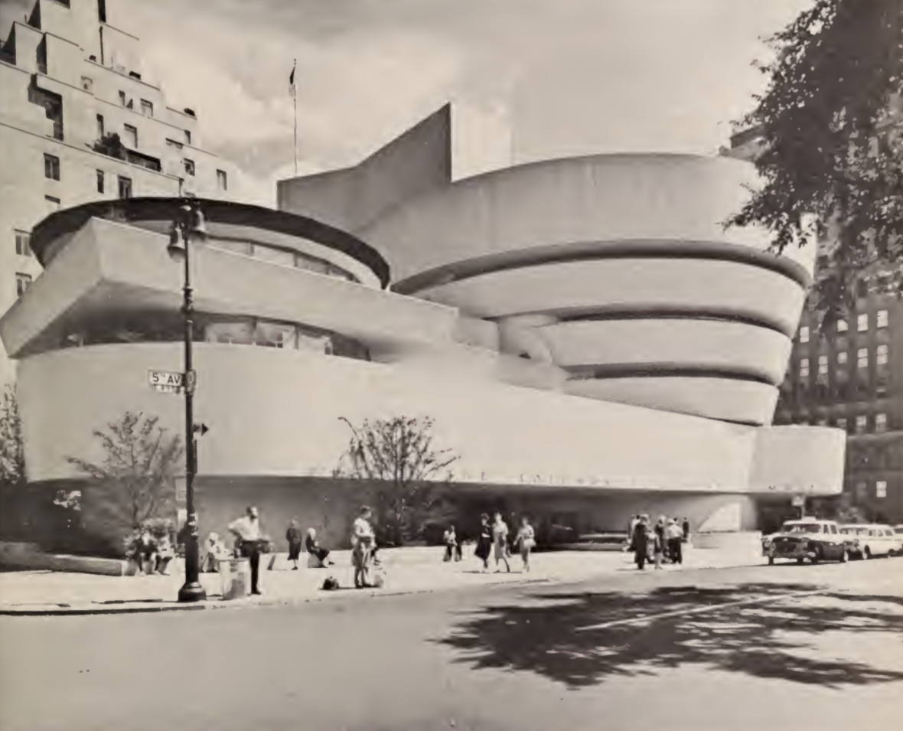
Figure 4 - exterior view of Guggenheim New York (Solomon R. Guggenheim Foundation, 1960)
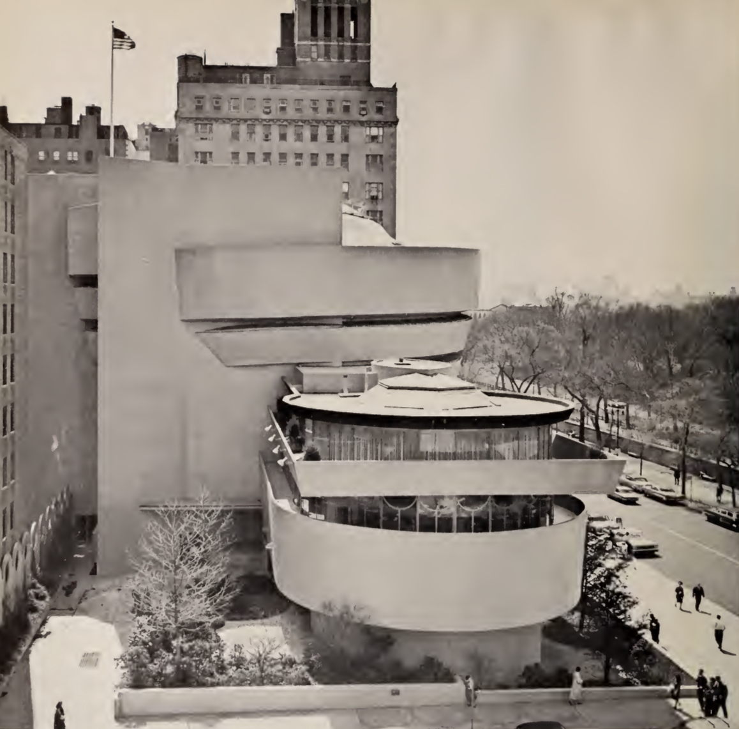
Figure 5 - view of the Guggenheim in context to the landscape (Solomon R. Guggenheim Foundation, 1960)

Issues in Design and Construction
The museum had many delays before its completion in 1959 (Angel & William, 2011). The main issues occurred between 1943 and 1956 due to building codes, changes in site conditions, the rising costs of materials and construction and the changes that happened to the museum's own programme (Pfeiffer, 2002). Issues that occurred with the building codes administrators were around the subject of structural issues for the glass dome that caused Wright to reduce its size and redesign it so that concrete ribs extended from the structural pillars located in the exterior wall up into the skylight itself, which is shown in figure 6 (Perez, 2010). This lack of structural consideration may be due to Wright's focus on the aesthetics of the building and the need for a statement. Another issue was how it took four years from the trustees approving the plans for the board of standards and appeals to grant the construction permit for the museum in March 1956 (Dal Co., 2017). After navigating these delays, Guggenheim then delayed the project himself due to post-war inflation, with the delay then being further extended due to his death, forcing a new administration to be formed before the project could be continued (Solomon R. Guggenheim Museum, 1993). By the time ground was broken, Wright was 89, and it was then, finally, on the 21st October 1959, that the museum opened up to the public, 6 months after Wright's death and 10 years after Guggenheim's (Pfeiffer, 2002; Dal Co., 2017; Solomon R. Guggenheim Foundation, 1960). Within the first 9 months, more than 750,000 people visited (Solomon R. Guggenheim Foundation, 1960). If we pair this with the earlier statistic as to how many people came to see the architecture, we can calculate that only 250,000 of these people actually came for the artwork.
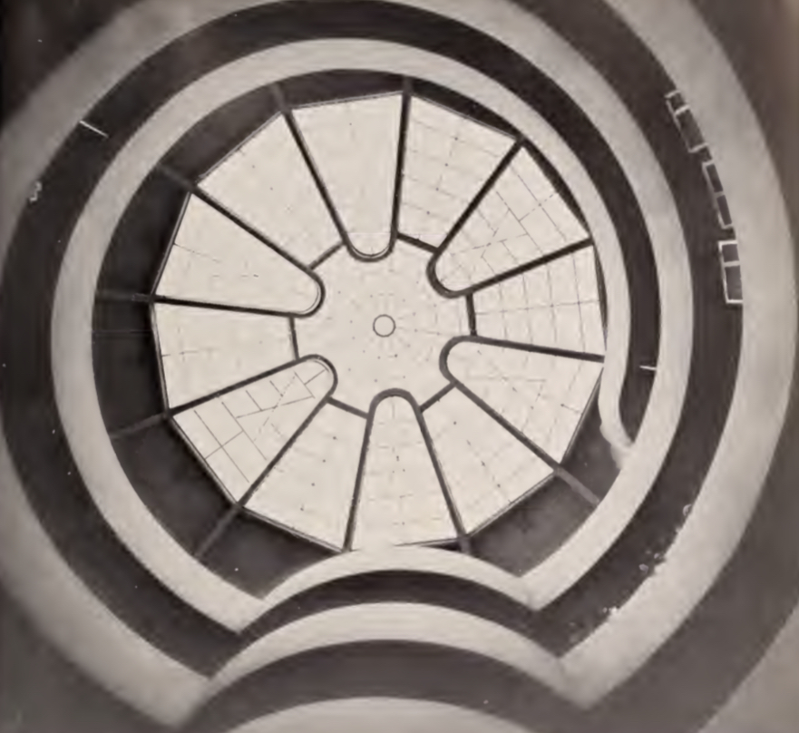
Figure 6 - Skylight with concrete ribs (Solomon R. Guggenheim Foundation, 1960)

Atmosphere
The exterior of the museum is a stacked white cylinder of reinforced concrete, which, whilst still having a minimal appearance, still creates a significant impact on the public, more so by its unique futuristic form (Perez, 2010). This form is quite unique and to some it resembles an eggshell (Solomon R. Guggenheim Foundation, 1960). On the interior, a ramp provides a sense of progression due to its continuous form, which, paired with its circular swirling form around the structure, creates a dramatic view and a unique experience for the viewer, perhaps being a new era of displaying artwork (Perez, 2010; Solomon R. Guggenheim Foundation, 1960). This ramp is not only dramatic but also makes the building almost feel more subtle compared to the harsh linear forms most other museums take. Another dramatic feature is provided by the expansive glass dome that Wright has used to link the interior with the natural exterior (Perez, 2010). This dramatic feature caused issues, those being its off-the-shelf system that is not watertight, air-tight or thermally tight, therefore failing on its functionality (Crosbie, 1995). The detailing of this system can be seen in Figure 7. Wright also specified it to be single-paned glass, which had no filtering for ultraviolet or infrared light, therefore furthering this idea that the function was an afterthought of Wright's compared to his and the Guggenheim’s image (Crosbie, 1995). This skylight not only takes attention away from the artwork that is supposed to be the star within this museum, but also over time damages the artwork due to the exposure to the ultraviolet light, which is slowly bleaching the artwork. This was a significant lack of consideration on Wright's side, as the implementation of an ultraviolet filtration system would have made a huge difference in the building's functionality by providing a much safer space for the artwork. The atmosphere of the space can be seen within figures 8 and 9, with visitors exploring the building as well as the artwork.
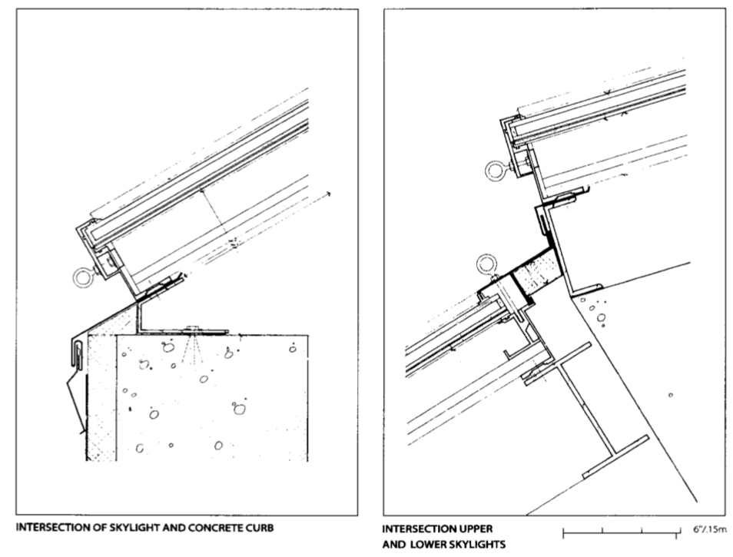
Figure 7 - Skylight details (Crosbie, 1995)
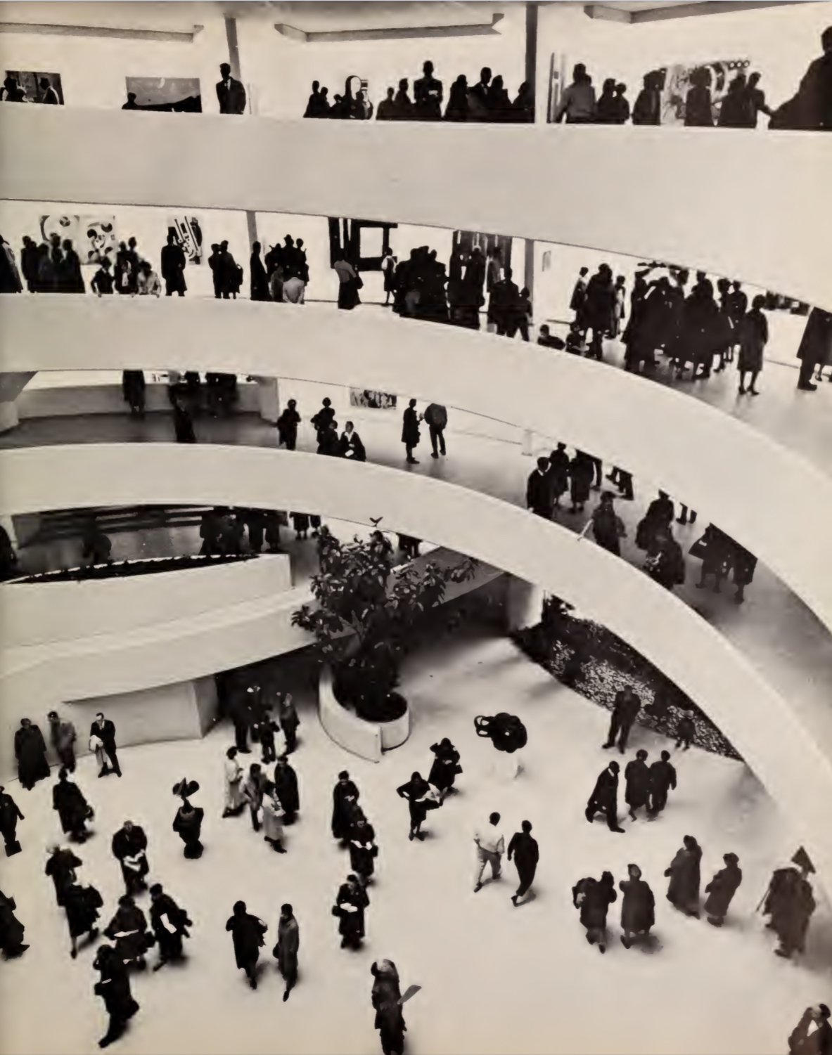
Figure 8 - Guggenheim being used for an exhibition (Solomon R. Guggenheim Foundation, 1960)
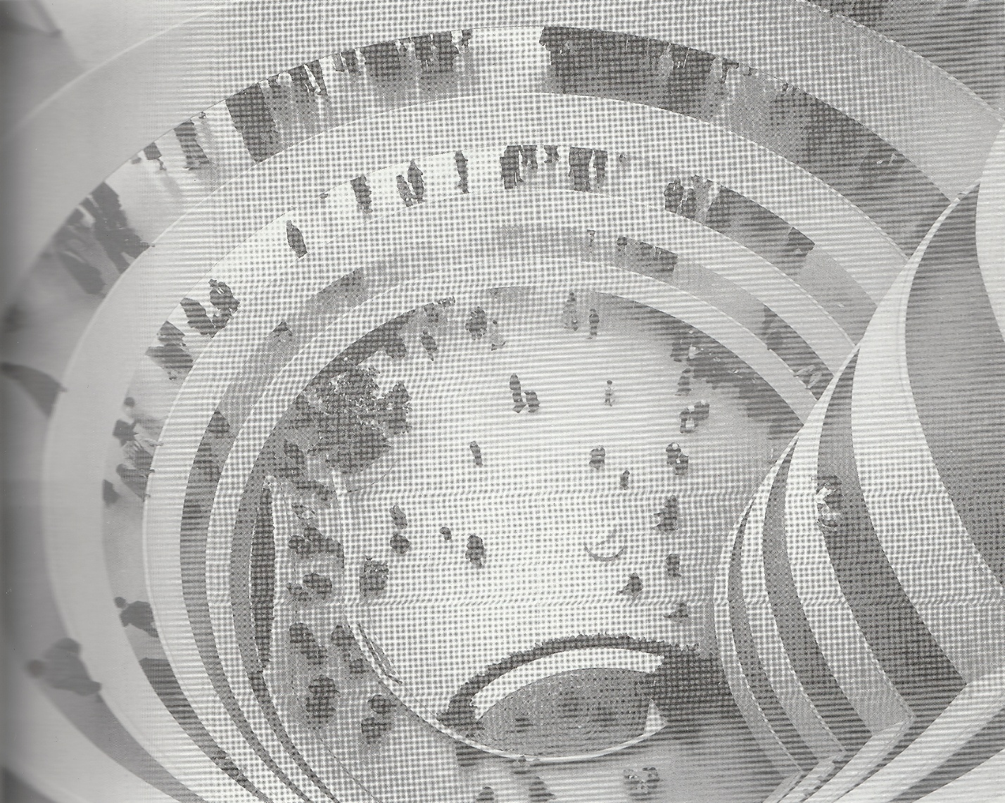
Figure 9 - internal birds-eye view (Etlin, 1994)

Comparison to the Tate Modern
The Tate Modern was designed by Herzog & De Meuron as a contemporary public space for an art gallery (Jones, 2000). Their “design involved few but powerful interventions, with the aim of retaining the industrial character of the building as much as possible," said De Meuron (Ravenscroft, 2025). From Figure 10, it is clear to see that Hertzog & De Meuron took a much more gentle and thoughtful approach to their design, therefore leading to a better approach to displaying artwork. Whilst Herzog & De Meuron’s interventions allowed the building to be an experience and a visual exhibition itself, it did have a more understated aesthetic approach in the gallery areas, therefore still respecting the artwork and allowing it to speak for itself (Jones, 2000). This delicate and thought-out approach allows the Tate Modern to have a much more sensitive approach towards a balance between the artwork being shown off and the building being allowed to stay true to itself. One of the main features of the Tate Modern is its former turbine hall, shown in figure 11, which is 150 metres long, which forms a dramatic new space within the building yet allows for a great space to show off artwork giving people a new perspective on the pieces themselves (Ravenscroft, 2025). Annual visitor figures are an average of 2 million, with more than 5 million in the first year; which is substantially more than the Guggenheim, therefore suggesting that the Tate Modern is a more successful piece of architecture both on its own and regarding its sensitivity and thought about how it successfully displays the art (Ravenscroft, 2025). Also, the fact that it has this sensitive approach to the exterior means that the Tate Modern does not draw away from the artwork as soon as the museum goer sees it and instead subtly guides them into seeing the artwork being shown off and the history of the building being preserved (Jones, 2000). This is drastically different to the Guggenheim, where the building quite obviously stands out both in its physical shape and in its stark eggshell colour, which contradicts the landscape. It is clear to see that the Guggenheim is a bold and outgoing approach to architecture, with the Tate Modern being a lot more minimalistic and thought through.
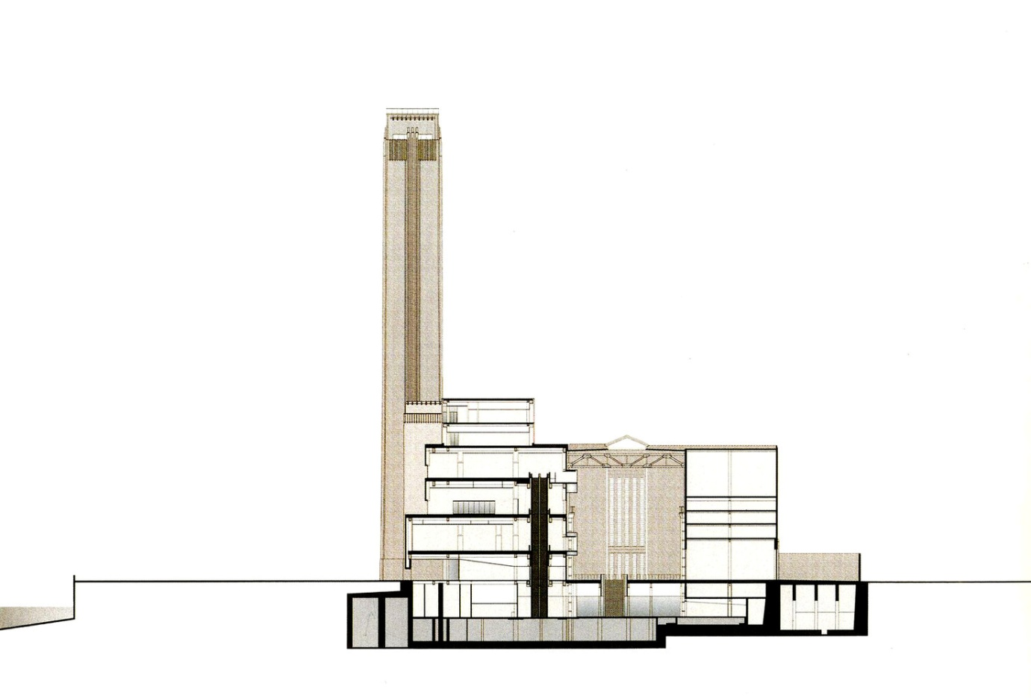
Figure 10 - section through Tate Modern (Jones, 2000)

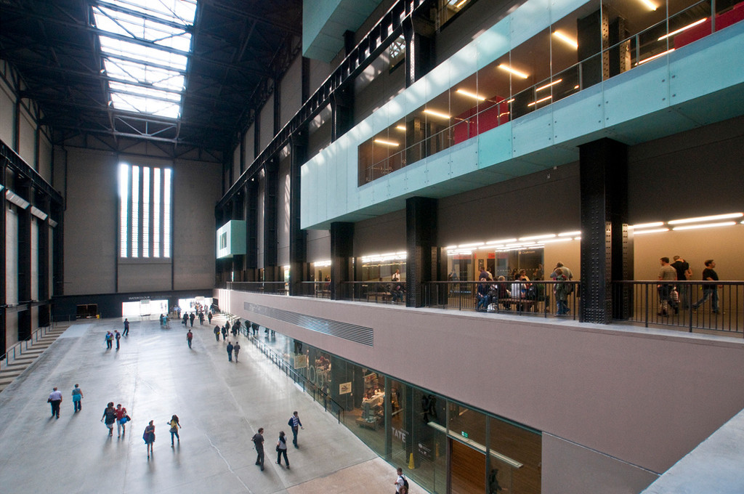
Figure 11 - shows the Turbine Hall (Jones, 2000)

Conclusion
Overall, the building was supposed to be designed as a museum, which did not seem to be a key factor within Wright's approach to design, as shown by some calling it precisely what a museum should not be (Dal Co., 2017). This is shown by how Frank Lloyd Wright prioritised things such as his drive to design as though the building is a piece of artwork, and his lack of consideration when it comes to structural aspects of the building (Tafel, 1979). Despite the building having an unsuccessful function due to the concavity of the walls, some still believe it has an indescribable individuality, which may be why it is one of the youngest buildings to be designated a national historic landmark at both the local, state, and national levels, due to it being a significant example of modernism (Perez, 2010; Dal Co., 2017; McLaughlin & Waldek, 2023; Hart, 2007). This building may have been a leap in modernism and organic architecture yet that does not take away from the lack of consideration for the functionality. Therefore, the building is a success as a piece of artwork, but not when it comes to its functionality and intended purpose, leading to the conclusion that it was not designed for its purpose.

References
Angel, A. & William, R., 2011. Reglazing FrankLloyd Wright's Solomon R. Guggenheim Museum in New York City. APT Bulletin, 42(2/3), pp. 59-66.
Betsky, A., 1939. Wrong Wright: FrankLloyd Wright Buried in the Guggenheim. Art in America, 97(8), p. 128.
Crosbie, M. J., 1995. Giggenheim Skylight. Progressive Architecture, 76(3), p. 95.
Dal Co., F., 2017. The Guggenheim, Frank Lloyd Wright's Iconoclastic Masterpiece. New Haven: Yale University Press.
Etlin, R. A., 1994. Frank Lloyd Wright and Le Corbusier: the romantic legacy. Manchester and New York: Manchester University Press.
Hart, S., 2007. Guggenheim restoration has Wright stuff. Architectural Record, 195(11), p. 42.
Jones, R., 2000. AD Classics: The Tate Modern / Herzog and De Meuron. [Online]
Available at: https://www.archdaily.com/429700/ad-classics-the-tate-modern-herzog-and-de-meuron
[Accessed 19 March 2026].
McLaughlin, K. & Waldek, S., 2023. 9 Things You Didn't Know About New York City's Guggenheim Museum. [Online]
Available at: https://www.architecturaldigest.com/story/you-didnt-know-new-york-city-guggenheim-museum
[Accessed 5 March 2026].
Merkel, J., 2010. The Museum is the Exhibit. Architectural Design, 80(1), pp. 140-141.
Perez, A., 2010. AD Classics: Solomon R. Guggenheim Museum / Frank Lloyd Wright. [Online]
Available at: https://www.archdaily.com/60392/ad-classics-solomon-r-guggenheim-museum-frank-lloyd-wright
[Accessed 3 February 2026].
Pfeiffer, B. B., 2002. Frank Lloyd Wright. 2nd ed. Cologne: Taschen.
Ravenscroft, T., 2025. Herzog & de Meuron's Tate Modern was the most significant building of 2000. [Online]
Available at: https://www.dezeen.com/2025/01/06/tate-modern-herzog-de-meuron-21-century-most-significant-buildings-2000/
[Accessed 19 March 2026].
Solomon R. Guggenheim Foundation, 1960. The Solomon R. Guggenheim Museum. Architect, Frank Lloyd Wright. 1 ed. New York: Solomon R. Guggenheim Foundation and Horizon Press.
Solomon R. Guggenheim Museum, 1993. Art of this century: the Guggenheim Museum and its collection. 1 ed. New York: Solomon R. Guggenheim Foundation.
Tafel, E., 1979. Aprentice to Genius: Years with Frank Lloyd Wright. New York: McGraw-Hill.
Ulam, A., 2005. Guggenheim, Eyeing Expansion, Names New York Chief. Architectural Record, 193(11), p. 36.

