Title: Case Study
Student ID: 2232117
Student Name: Shivani Jasvanthbhai
Module code: BMMB700
Module Name: Change and Stability Management
Professor name: Marie pitson

Table of Contents
Contribution to Overall Module Assessment (%): 1
Introduction 4
Introduction to the organization for change 4
Key change models – Planned and emergent 6
How the models can be utilized when considering incremental (small-scale) or a large-scale change program 11
Driver factors for change 12
Resistance factors to the change 13
Change Program and its effectiveness 15
Conclusion 16
References 16

Introduction
Apple Inc. is a multinational firm with international operations headquartered in Cupertino, California. As of June 2022, iPhone had become the most valuable business in the world, with a capitalization of US$365.8 trillion.

The company was also the world's fourth-largest personal computer supplier in unit sales and the top mobile phone supplier, with revenues of US$359.8 trillion in 2021. It is one of the Big Five American IT giants alongside Microsoft, Alphabet (Google), Amazon (Amazon Prime), Facebook (Meta), and Facebook. Apple became the first publicly traded U.S. company in October 2018 when its share price topped $trillion dollars, and again in Fall 2020 and January 2022 when it exceeded $trillion dollars and $3 hundred billion. It was estimated to be worth up to $2.2 trillion in early 2023.

Introduction to the organization for change
Apple's ongoing commitment to adapting to the ever-shifting demands of the market underlies many of the most notable parts of the company's recent history. For a complete and efficient organizational change, this should be the sole (though most important) rationale. Apple sees agile methodologies as crucial since the world of marketing as well as customers ’ expectations are always shifting (Blum, 2017).
Management of change, in fact, refers to a systematic and quite well approach to reshaping the activities of many a person, a group, a department, or an organization at large. As a result, Apple Firm's transactional leader is not only practicing responding to changes in the climate, in addition, actively promoting them. Such changes are uncommon, but they might be identified by looking at how the company normally operates.
Several aspects of an organization's internal processes for change can be assessed with the help of change scales. All four aspects of a transition—management, technology, structure, and people—are dealt with separately. Therefore, launching a new product necessitates introducing cutting-edge technologies and modernizing the company's manufacturing infrastructure. When the company started selling iPods to the general public, a change like this was immediately apparent.
Leaders in the corporation oversaw the introduction of cutting-edge tech throughout all operational departments, from research and development to human resources to marketing and public relations. Steve Jobs was a visionary leader who sparked the changes that eventually resulted in a flexible management philosophy. This activity is more important than simply advertising a new product since it positions the company to compete for its target demographic in the future.
Apple needed to make significant changes to its approach in order to reposition itself away from the stigma associated with making computers and software. Therefore, the company needed a fresh image that was commonly correlated with content production and also the possibility of reaching a larger audience than only apple users. While Apple's method for change management was undoubtedly unique, it was implemented in accordance with Coombe's tenets all the same.
Management of the organization capacity of adjusting necessitates not only familiarity with leadership styles and group dynamics, but also a marketing savvy that makes it easier for change customers to communicate with one another. Organizational change is a well-defined process inside strategic initiatives that helps keep everyone on the same page, encourages collaboration, and ensures that everyone associated with the project has the training and support they need to succeed. It employs measures like leader dedication, communication efficacy, and the acknowledged are in need for transformation to build precise tactics, which can be used to avert failed change projects or to resolve problematic ones.
The company is going through changes right now that are necessary prior to the introduction of new products. Because of this, Apple is actively promoting the launch of the iPhone 4G and working to boost iPad sales. There is a lot of extra work involved in implementing these measures on top of standard change management practices. Due to the significance of analyzing the required changes with an employer's decision, it is important to stress that Innovation and cooperation are the primary aspects of organizational transformation.
Techniques for getting along well with people. This post may have been held by one of the earliest leaders to understand the need of brief and clear communication. Therefore, it is crucial that all parties involved keep the channels of communication open. In order to effectively implement changes to existing products and projects, managers need a reliable and quick way to communicate with one another.
The CEO and department heads need the same reliable feedback mechanism. In this way, the company can monitor the unfavorable outcomes of the changes and respond rapidly to problems at any level of the organizational hierarchy. The company takes great pains to hire only the most competent candidates. Since the goods are innovative, the transfer to them should be handled by professionals who are flexible in their approach to management.

Key change models – Planned and emergent
Human resources, financial resources, and cutting-edge technology are just a few of Apple's internal drivers of change. Apple's business culture, vision and mission, rules of the company, vision and mission statements, as well as personnel education and development, all play a role in propelling the company forward through human resource administration. One way by which the company's goals might be altered is by altering its mission, vision, and purpose statement (CEPEDA M et al., 2017). Alterations to the business, such as wage increases, new hires, and product development, are also prompted by access to sufficient financial resources. A shift in the company's savings culture is also influenced by the advent of new technologies. For instance, the corporation can save a significant amount of money on transportation and lodging expenses for employees by allowing them to participate in conferences from home utilizing technology like video conferencing and mobile devices.
The effects of change on companies are multifaceted. Altering how things are done may lead to the discovery of new, more profitable strategies, as well as new methods for people to shine. Similarly, if Apple were to implement a new or more efficient method of shipping, it might drastically cut the time it takes to get products to customers' doors. However, unfavorable shifts may lower morale, strain relationships among employees, and increase absenteeism (Paini et al., 2021).
Understanding the change, making a strategy for the change, putting the change into action, and communicating the change are the four pillars of the change process. In order for stakeholders to accept the change, it is important to emphasize the positive outcomes of the transition. In order to effectively manage the transition, it is necessary to plan for it in advance. Implementing a change requires gathering support and getting everyone involved. Getting people on board with the change requires communicating it effectively so that it may gain widespread backing at the appropriate moment.
Stages in the change management process
- Managers play an important role in preparing their organizations for change by providing details to staff about just the reasons behind the shift, as well as the potential benefits and drawbacks of the transition.
- The person in charge of both the change creates a vision and a strategy for it, taking into account potential obstacles that may arise throughout execution. This includes identifying and defining the anthropogenic climate strategic objectives, KPIs, users, and scale.
- Putting the plan into action entails making the necessary moves to bring about the transformation. Empowering workers and maintaining their awareness of the transformation process through frequent communication are also crucial to this phase.
- Incorporating adjustments into daily operations to stop a reversal in progress
- Leaders can assess the success of the change endeavor and prepare for the future by looking back on the process and the outcomes.
Change models
- Swot analysis
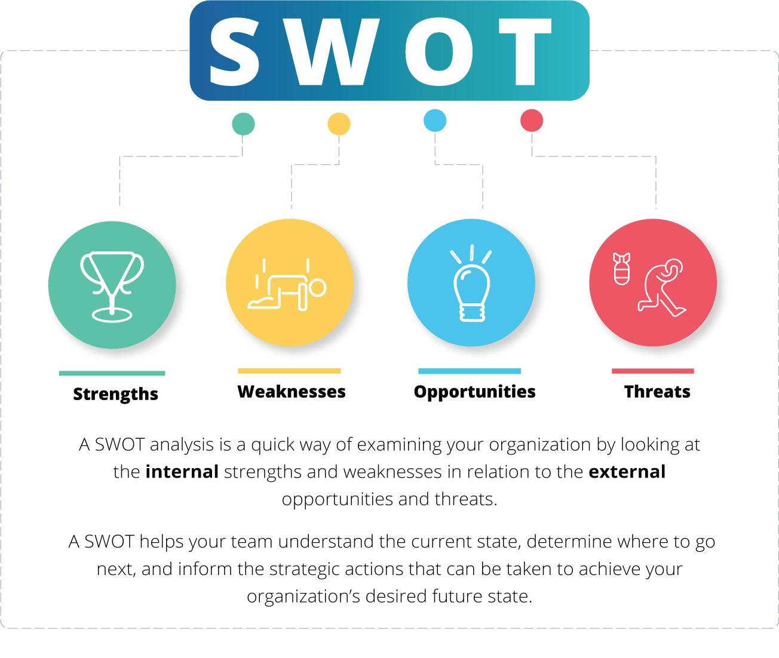
(Figure 1: Swot analysis)
Strength | Weaknesses
- Valuable brand  - Iconic  - Super technology  - Brand of choice  - Proficient research | - High pricing  - Limited promotions  - Non competent  - Incompatibility  - Unfair practices
Opportunities | Threats
- Customer growth  - Qualified professional  - Need to expand distribution channels  - Green technology | - Supply chain disruption  - Bulled by counterfeit  - Competition  - Market penetration  - Tariffs

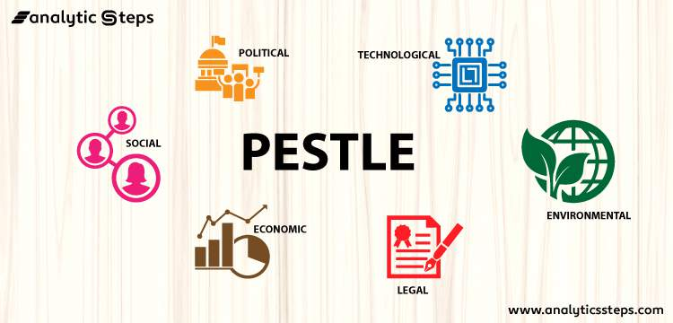
- Pestle analysis

(Figure 2: pestle analysis)
Political factors | Economics factor
- Tax  - Import restrictions | - Stagnation growth
Social political | Technological political
- Shifting consumer behavior | - Increasing competition from competitors like google and Samsung
Legal factors | Environmental factors
- New regulations  - Intellectual property | - Pollution from manufacturing


- Kotter's model, ADKAR, and Lewin's change management
(Figure 3: change models)
Kotter's model, ADKAR, and Lewin's change management approach are the three most widely used change management models (approaches). When comparing the three change management frameworks, it is important to note the distinctions in approach and emphasis between each. For instance, Kotter's approach prioritizes the thoughts of upper-level management, ADKAR looks inward, and Lewin's model considers everyone who might oppose the change. Nonetheless, each of the three perspectives contributes valuable knowledge on how to handle change successfully. Lewin's methodology for implementing change has been used effectively by Apple to establish new policies and procedures. The three phases that the company went through to implement the change were as follows:
- The management defrost the company by selling the advantages of the change in order to get rid of any opposition that could be present.
- A company's culture, beliefs, behaviors, and attitudes can undergo a dramatic shift throughout the change phase, and this transformation is facilitated by strong leadership and clear, consistent communication.
- To prevent thawing and returning to old habits, the company "refreezes" the new modification.
When change comes in an organization, people typically react in three distinct ways:
- Employees' psychological detachment from the change is referred to as "disengagement." Lack of employee motivation or dedication to implementing change is a major contributor to disengagement, which in turn undermines the success of the change process.
- The fear that comes with transformation is known as disidentification. Such a reaction would add resistance to the change process, as affected workers would cling to familiar practices out of fear for their jobs or personal identities.
- Negativity and rage are common manifestations of disenchantment among workers going through the transformation process. During the transition, it's more challenging to motivate and persuade disgruntled workers to buy into the new plan.

How the models can be utilized when considering incremental (small-scale) or a large-scale change program
In order to align personal responsibility and regulate and to even the overcrowding that happens when innumerable decisions naturally abundance the organizational chart to the very top, financial history and organizational theory argue that as entrepreneurship companies expand larger and more complex, they must transition from an integral to a bicameral system. When executives delegate authority to the heads of business units, those heads may focus on doing what's best for their specific clients and for the unit's bottom line, all while being evaluated by their superiors. DuPont and GM, among other American corporations, reorganized their operations in the early 20th century from a functional to a multidivisional structure, as noted by Harvard Business School historian Alfred Chandler (Sundararajan et al., 2017).
By the middle of the 20th century, most major corporations had joined in as well. For companies facing tremendous technological advancement and industrial change, Apple explains why organizational organization is preferable. Apple's commitment to a functional department isn't necessarily reflected in the company's willingness to maintain a static management structure.
In light of the increasing significance of AI and related developing sectors, this structure has developed. In this article, we take a close look at Apple's unconventional and ever-changing organizational design, showcasing its technology benefits and board leadership, with the goal of providing useful information to individuals and companies that are trying to succeed in uncertain and volatile environments.
Apple Computer was established on the concept of creating goods that enhance people's daily lives. This necessitates both the development of whole new categories for goods like the Apple Watch and iPhone as well as the maintenance of a perpetual state of development inside the categories. The iPhone's camera is an excellent illustration of Apple's commitment to ongoing development. During the inaugural event where new products were presented in 2007, Steve Jobs spent a whopping total of six seconds describing the device's camera.
So, the photographic business has benefited from the constant upgrades to the iPhone's picture. High-dynamic-range (HDR) photography was introduced in 2010, panorama pictures in 2012, Pure Color flash in 2013, zoom lens stabilization in 2015, a dual-lens camera in 2016, a panorama in 2016, a photo illumination mode in 2017, and a night mode in 2018. (2019).
Apple's revolutionary innovations stem from the company's functional knowledge-based management structure. At its heart, it is based on the idea that individuals who have the greatest knowledge and expertise in a given area should be the ones making important decisions. This is rooted in the following two perspectives in particular: To begin, Apple works in sectors where technical change and disruption occur at a breakneck pace, so the company must rely on the knowledge and instincts of those who are closest to the cutting-edge technology that is destroying its rivals. Long in order to obtain market feedback and reliable market estimates, the company must make bets on which technologies and concepts are most likely to succeed in cellphones, computers, etc. Trusting those wagers to scientific experts rather than program management increases the likelihood of success.

Driver factors for change
Apple achieved a $2 trillion market valuation in August 2020, surpassing Microsoft and Google in the process. The strength of the Apple brand and its position in the market was bolstered as a result. However, despite Apple's record-breaking sales and ascendance to the top of the market, the business was dealing with serious problems (Dolata, 2017). What, exactly, is Tim Cook doing to de-risk circumstances like the decrease in iPhone sales since 2014 or the sequence of crackdowns by large players like Epic Games and Facebook?
In the beginning, Apple planned to offer three distinct categories of goods: hardware, subscriptions, and premium upgrades. The first is the hardware, which is the entry-level product (e.g iPhone). The customer than would be retained through retainers like iMessage as well as the App Store. The retainer products would boost interoperability between devices, making upsell items like the MacBook more desirable (Clarke and Boersma, 2017). There are three pathways by which the shift to software could occur.
The first is through Apple's aggregation capability, which is the company's ability to leverage information about consumers' app usage and in-app purchases. Apple has the ability to identify market niches and fill them with services and apps that directly compete with those already on the market (Dafermos et al., 2018). But there's a caveat: Apple still would make money off of your purchases and sales through the App Store in the form of commissions. This has resulted in commercial dealings in the EU as rival Apple app developers are forced to raise prices or reduce margins (Goossens et al., 2017).
Apple has already created a solid basis with Apple Card with Apple Watch, with Apple Watch will become the nation's biggest watch producer, knocking out renowned names such as Rolex, and it appears eager to enter the healthcare and FinTech industry despite having already met its 2020 goal. In addition, goods like Apple Cards contain a lot of purchasing information, that can be leveraged to market banking services and also promote products via advertisement, much like the App Store.
The success of Apple's shift exemplifies the importance of firm management. Though helpful, trading quantities and value measures only provide a piece of the puzzle when deciding whether or not to invest in a stock. It's also important to consider the company's overall outlook and the agility and market awareness of the company's management. An organization's management is a key factor in its performance, yet it is difficult to measure and cannot be studied in a controlled environment.

Resistance factors to the change
Do change the right first time
Although resistance to alteration is a typical human response, much of it may be avoided or mitigated with well-executed organizational change first from outset of a project or endeavor. It's not enough to think of change management as a reactive instrument for dealing with resistance. Most useful when used to get workers excited about and invested in a transformation. Reluctance to adapt to change can be avoided if you can harness the excitement and enthusiasm people feel about the new approach. In the Prosci 2019 benchmarking research, respondents reported that 47 percent of employees’ resistance might have been prevented with better change management. The takeaway here is that most pushback can be avoided with proper change management from the beginning (Chen et al., 2019).
Expect resistance to change
The power of being content with the way things are. Even if the current condition is painful, transitioning into an uncertain future state causes anxiety, fear, and tension. Teams working on a project or implementing a change in organizational culture should anticipate and take steps to counteract any pushback they might receive. Studies of the brain's structure and function have revealed that resistance to change is a physiological response as well as a psychological one. More mental energy is needed to take a different course of action. The human body's natural response to learning something new is to fall back on tried-and-true methods (Puschmann, 2017). Changing one's behavior is possible for humans, but it's neither easy nor painless, not even for the brain.
Identify the root cause for reasons for change
Treating resistance by ignoring its causes is useless. Complaining, missing important meetings, failing to supply needed information or resources, or simply refusing to adopt a new procedure or practice are all obvious signs of resistance (Podolny and Hansen, 2020). They may be more noticeable, but concentrating on them will not help. You need to get to the bottom of what's producing the resistance if you want to overcome it. In order to effectively handle resistance, it is necessary to first understand the underlying reasons behind the resistance.
One good place to begin unraveling the knots of resistance is in Prosci's Best Practices in Change Management study. Important recurring motifs in the leading causes of resistance were discovered by the 2019 study, validating the findings of earlier investigations. To convince senior officials to push for change, change teams need an understanding of these major causes. A large amount of pushback on a project or an endeavor can be avoided with this easy exercise by addressing the leading reason for opposition (i.e., a lack of awareness). Your list of possible root causes and activities to address and mitigate each can be tailored using additional benchmark results and you personal experience with change in your business (Novac et al., 2017).

Change Program and its effectiveness
Picking the right change management metrics is crucial for accurately assessing the results of a digital transformation. These metrics can be used to evaluate the effectiveness of an organization as a whole, an individual employee, or a new method of managing change. To acquire a reliable outcome, it's important to take into account not only individual performance but also the performance of the organization as a whole. Determine if the new change management actions were successful by measuring their impact. Keep tabs on how well your plans are working out. Check the percentage of persons who take the tests and see how well the training is received (Lio et al., 2018).
Business key performance indicators can also be used to assess how well your company is doing. Then, determine if the project was profitable by calculating the return on investment (ROI). Expecting your project team to keep track of several KPIs in order to optimize their use is an ambitious goal. Luckily, there are a variety of tools and methods available in the field of change management that can help you get precise results. Choices that we particularly like include:
One of the more conventional yet reliable management tools is the balanced scorecard. Organizations employ it as a tool for gauging employee performance and providing constructive criticism. This technique examines the project's strategic objectives in relation to its periodic outcomes. The results are compared to the initial objectives. The scorecard serves as a simple, straightforward evaluation instrument. Use it for any number of digital transformation side projects. The impact is evaluated across four key dimensions (customer, financial, process, and human) on the scorecard.
These aids are great for demonstrating the interconnected nature of a process's individual steps (Wang et al., 2018). With this, everyone in the firm can see the big picture of where they've been. They illustrate the process involved and the way in which one event can have repercussions for subsequent steps. Change management activities can be monitored and recorded to ensure they are proceeding as planned with the help of a basic flowchart of the project's performance. In addition, you may pinpoint problem areas and checkpoints in the process.
Numerous recent research confirms the widespread failure of reform programs. According to research published in Deloitte and MIT Sloan Management Review, resistance to change is the primary cause of failure. A culture mapping tool is useful for illustrating the culture of an organization. You can use it to learn what you need to know to successfully implement your initiative for change and how to lessen the likelihood that anything bad will go wrong (Gvili, 2020).

Conclusion
The takeaways from this situation are straightforward. Teams need to be staffed by competent people who care about doing a good job for the group and the firm as a whole. Departments need to be led by innovative and astute managers who can implement changes without halting daily operations. For the field of change management as a whole, Apple's recent past serves as reassurance that transitions need not be fatal to a business; rather, if changes are handled with care and the team buys into the changes' core ideas, the organization can essentially be reborn. A leader, as seen by Steve Jobs's illustrious career, must also be able to deviate from canonical directives and adapt their methods to the specifics of the present moment in order to achieve success.

References
Blum, J., 2017. Contribution of ecosystem services to air quality and climate change mitigation policies: the case of urban forests in Barcelona, Spain. In Urban Forests (pp. 21-54). Apple Academic Press.
CEPEDA M, A.N.D.R.E.A., Vélez-Sánchez, J.E. and Balaguera-López, H.E., 2021. Analysis of growth and physicochemical changes in apple cv. Anna in a high-altitude tropical climate. Revista Colombiana de Ciencias Hortícolas, 15(2).
Chen, C., Lu, Y., Yu, H., Chen, Z. and Tian, H., 2019. Influence of 4 lactic acid bacteria on the flavor profile of fermented apple juice. Food Bioscience, 27, pp.30-36.
Clarke, T. and Boersma, M., 2017. The governance of global value chains: Unresolved human rights, environmental and ethical dilemmas in the apple supply chain. Journal of business ethics, 143, pp.111-131.
Dafermos, Y., Nikolaidi, M. and Galanis, G., 2018. Climate change, financial stability and monetary policy. Ecological Economics, 152, pp.219-234.
Dolata, U., 2017. Apple, Amazon, Google, Facebook, Microsoft: market concentration-competition-innovation strategies (No. 2017-01). SOI Discussion Paper.
Goossens, Y., Annaert, B., De Tavernier, J., Mathijs, E., Keulemans, W. and Geeraerd, A., 2017. Life cycle assessment (LCA) for apple orchard production systems including low and high productive years in conventional, integrated and organic farms. Agricultural Systems, 153, pp.81-93.
Gvili, Y., 2020. Security analysis of the COVID-19 contact tracing specifications by Apple Inc. and Google Inc. Cryptology ePrint Archive.
Liao, X., Li, J., Muhammad, A.I., Suo, Y., Chen, S., Ye, X., Liu, D. and Ding, T., 2018. Application of a dielectric barrier discharge atmospheric cold plasma (Dbd‐Acp) for Eshcerichia coli inactivation in apple juice. Journal of food science, 83(2), pp.401-408.
Novac, O.C., Novac, M., Gordan, C., Berczes, T. and Bujdosó, G., 2017, June. Comparative study of Google Android, Apple iOS and Microsoft Windows phone mobile operating systems. In 2017 14th international conference on engineering of modern electric systems (EMES) (pp. 154-159). IEEE.
Paini, J., Benedetti, V., Ferrentino, G., Baratieri, M. and Patuzzi, F., 2021. Thermochemical conversion of apple seeds before and after supercritical CO 2 extraction: an assessment through evolved gas analysis. Biomass Conversion and Biorefinery, 11, pp.473-488.
Podolny, J.M. and Hansen, M.T., 2020. How Apple is organized for innovation. Harvard Business Review, 98(6), pp.86-95.
Puschmann, T., 2017. Fintech. Business & Information Systems Engineering, 59, pp.69-76.
Sundararajan, S., Samui, A.B. and Kulkarni, P.S., 2017. Versatility of polyethylene glycol (PEG) in designing solid–solid phase change materials (PCMs) for thermal management and their application to innovative technologies. Journal of Materials Chemistry A, 5(35), pp.18379-18396.
Wang, Z., Li, G., Sun, H., Ma, L., Guo, Y., Zhao, Z., Gao, H. and Mei, L., 2018. Effects of drought stress on photosynthesis and photosynthetic electron transport chain in young apple tree leaves. Biology open, 7(11), p.bio035279.

