In this body of work an exploration of two historic and significant sites in Wales shall be critically discussed in the form of a reflective fieldwork journal. Paying close attention to the landscape of each location, this reflective account shall refer to personal experiences, high quality academic and policy related literature as well as providing suggestions for sustainable approaches to recreational development at each site. With a particular focus on the character, quality and designations of the landscape, it is firstly important to define and understand these key terms. ‘Landscape character’ refers to ‘a distinct and recognizable pattern of elements that occurs consistently in a particular type of landscape’ (Heritage Council, 2006; Swanwick, 2002; Turner, 2005). The landscape character ‘often reflects the state and quality of the landscape and informs planners on how to manage and maintain the landscape’ (Atik et al, 2014, p.90). Examples of the characteristics within the landscape can be seen as forests, mountain ranges, meadows and water features. Landscape quality on the other hand refers to and ‘can encompass many elements including environmental pollution and cleanliness, visual and aesthetic quality and perception of personal security’ (Forest Research, 2022). Perhaps a crucial part of an individual’s perception of a specific landscape, the landscape quality can determine the attraction and enjoyment of an area. Within the UK, there are many cultural and historic landscapes that are under the protection of conservation designations. These designations vary in regards to the amount of protection they receive and ‘play a central role in helping to convey the importance of the natural environment and its protection, informing visitors both about the natural features they encounter and broader conservation issues’ (Booth et al, 2009, p.3196). The two sites that this paper shall cover include Dinefwr (A historic estate encapsulated by a National Nature Reserve and 18th Century deer park) and Blaenavon Big Pit National Coal Museum (an industrial heritage museum representing industrialisation through iron and coal production). Upon each visit, the mode of locomotion for surveying the landscape was through the use of guided walking tours facilitated by local staff situated at each site.

Dinefwr

Dinefwr is situated in the heart of South West Wales nestled within the county of Carmarthenshire just to the north-west of the market town Llandeilo. Now owned and protected by the National trust, the Dinefwr estate boasts an 800 acre National Nature Reserve, a ruined hilltop castle, ancient woodland, flower-rich meadows, utilitarian structures and an 18th century mansion. Designated as a grade 1 historic park and a Site of Special Scientific Interest, Dinefwr holds a significant position within Welsh and national History. Formally occupied by members of the Rice family whom were ‘largely responsible for designing the landscape’ (National Trust Collections, 2022), the estate has evolved over time adapting to significant cultural trends throughout it’s existence. It incorporates both the historic and the contemporary (The National Trust, 2022). The place name Dinefwr has received many representations in its time, however, the exact meaning has been lost throughout history. ‘Dinefwr could relate to a defended settlement, fort or defensive hill but there are a number of alternative interpretations’ (Coflein, 2002, p.2). At present, Dinefwr Estate is open for members of the public to visit for a small fee courtesy of the National Trust. With a variety of exhibitions, exclusive events and opportunities for educational visits, Dinefwr is a place worth experiencing.
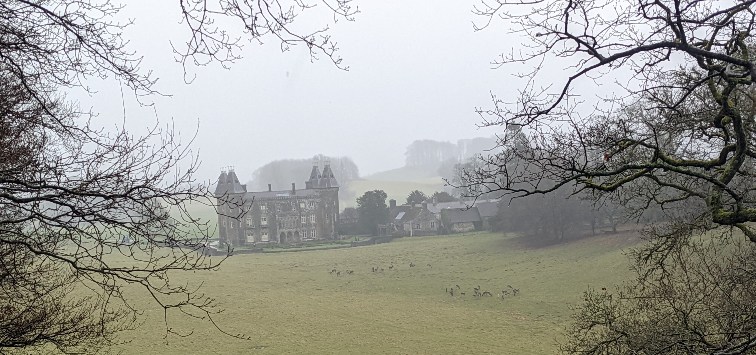
Fig.1. Photograph taken on the north western side of the Dinefwr estate (OS Grid Ref: SN61099 22578) showing Newton house and local deer grazing in the park.

Fieldwork Visit to Dinefwr – 28/02/2022

It was late February when the students of the University of Wales Trinity Saint David visited Dinefwr Estate. The forecast was predicted as overcast sky conditions with consistent rainfall throughout the day. To many people these conditions would likely encourage a day spent indoors, however, in regards to the purpose of the visit the forecast provided the opportunity to experience the landscape with freedom from public interference. Upon the arrival to the estate, we were greeted by National Trust staff members including an experienced ranger who would be facilitating the guided experience. The estate itself made for great first impressions as the character of the landscape depicted an abundance of both veteran trees, newly planted saplings, areas of rich meadow pastures and of course the 17th century mansion of Newton House. The image of the landscape reflected what Gilpin (2013) described as an example of all that was best about the Picturesque in his essay ‘Observations of the River Wye’ (2013). The bedrock geology of the Dinefwr area has been recorded as Llanvirin rock, a form of sandstone that is estimated to be of approximately 464-467 million years old (British Geological Survey, 2017). As we made our way around the grounds clockwise via the western designated footpath, the quality of the landscape demonstrated destructive impacts of weathering caused by the recent storm Eunice. Met Office (2022) had issued red weather warnings the week before the visit to Dinefwr describing ‘the most severe and damaging storm to affect England and Wales since February 2014’ (Met Office, 2022). Examples of the impacts were seen through newly fallen trees, a scattering of debris and damage to various parts of estates infrastructure. The destruction did not only create a sense of sadness within the ranger who had an evident relationship with the landscape she had cared for during her time at the estate, but it also made a huge impact on the history of the estate itself. Many of the mature trees found within the surrounding landscape were already 100 years old when the estate was first occupied in the 1400’s and had been referred to as ‘one of Britains finest collections of mature trees’ (National Trust, 2022). However, as with the circle of life, these fallen trees still serve a great purpose within the grounds of Dinefwr. As bio-diversity is at the forefront of the National Trust’s mission, the trees ‘stay where they fall to provide habitat for Dinefwr plant, wildlife and fungi species’ (National Trust, 2022). This is a representation of the constant evolution of Dinefwr’s landscape character and quality and represents an ever changing perspective towards our national heritage.

As we progressed along the designated path, the landscape continued to present examples of the sustained impacts caused by both human and natural forces. The wooden bridge that circled what is known as ‘the lake of reflections’ was shown to be in a horrid state with ongoing repair works marked along its structure. Paths that led into the woodland on the estate also showed signs of human impact with many sections of the path increasing in width thus altering the aesthetic beauty of the landscape (please see appendices for example). Although these signs of human impact demonstrate an inherent attraction and recreational appeal to Dinefwr Estate, it leaves the landscape in a sense of limbo. As explained by Zee (1990), when recreationists visit a natural landscape, they do not display behavior that is deemed as destructive, however, as paths and tracks start to present areas of bare soil a process starts in which a change occurs in the vegetation composition thus resulting in a general degeneration of vegetation (Zee, 1990, p.231). It is because of examples like this that have led to various introductions of legislations and policies to help protect and maintain UK natural landscapes. The National Trust and Natural Resource Wales recognise this and note that ‘access needs to be studied carefully and periodic route changes may be necessary to limit negative impacts on some features’ (Natural Resource Wales, 2022). As previously mentioned, the Dinefwr estate has been listed as a Special Site of Scientific Interest (SSSI) due to its high conservation value and the particular interest towards the local fauna and flora. SSSI’s ‘are the cornerstones of conservation work, protecting the core of our natural heritage’ (Natural Resource Wales, 2021).

Although the natural landscape of Dinefwr is met with numerous challenges and set backs such as damages caused from weather events, human impact and invasive species such as the ever-present Grey Squirrel, there remains huge future potential for development and opportunity for both the estate and it’s surrounding communities. With its rich history, this location has great potential for place based educational visits. As illustrated by Stewart (2008), locations that are rich in history hold potential for a greater connection to the natural world. If the story of Dinefwr and it’s surrounding landscapes are told effectively, the legacy of Dinefwr shall live on encouraging sustainable practice and stewards for the future.

Blaaenavon Big Pit National Coal Museum

Situated in the county of Torfaen, Blaenavon Big Pit National Coal Museum is an industrial heritage museum that represents the importance to the ‘process of industrialisation through iron and coal production’ (National Museum wales, 2022). Designated as a World Heritage Site by UNESCO in 2000, the site presents evidence ‘of the pre-eminence of South Wales as the world's major producer of iron and coal in the 19th century’ (UNESCO, 2022). The coal mine itself opened in 1880 providing the main impetus for mineral workings and settlement (UNESCO, 2022) to the people of South Wales and beyond. With a depth of 300ft, the coal earned itself the name ‘Big Pit’ ‘because of its unusually large elliptical shaft’ (Visit Blaenavon, 2022). The mine itself closed in 1980 as a result of fierce completion from around the globe. At a time when Thatcher was in power of the British Government, she believed that cheaper sources of energy such as gas and oil would provide greater efficiency and would subsequently allow the economy to grow. These decisions ultimately left many citizens who built their careers around the mining industry jobless resulting in various miners strikes. One strike in particular was in 1984 in which the British Academy describe as ‘the last great battle of the organised industrial class, of which the miners were the heroic vanguard’ (British Academy, 2021). The site of Big Pit has since reimagined itself as National Coal Museum and is open to the public for a small fee. Visitors can now walk around the former facilities used by the miners as well as experiencing a guided tour of the shaft itself.
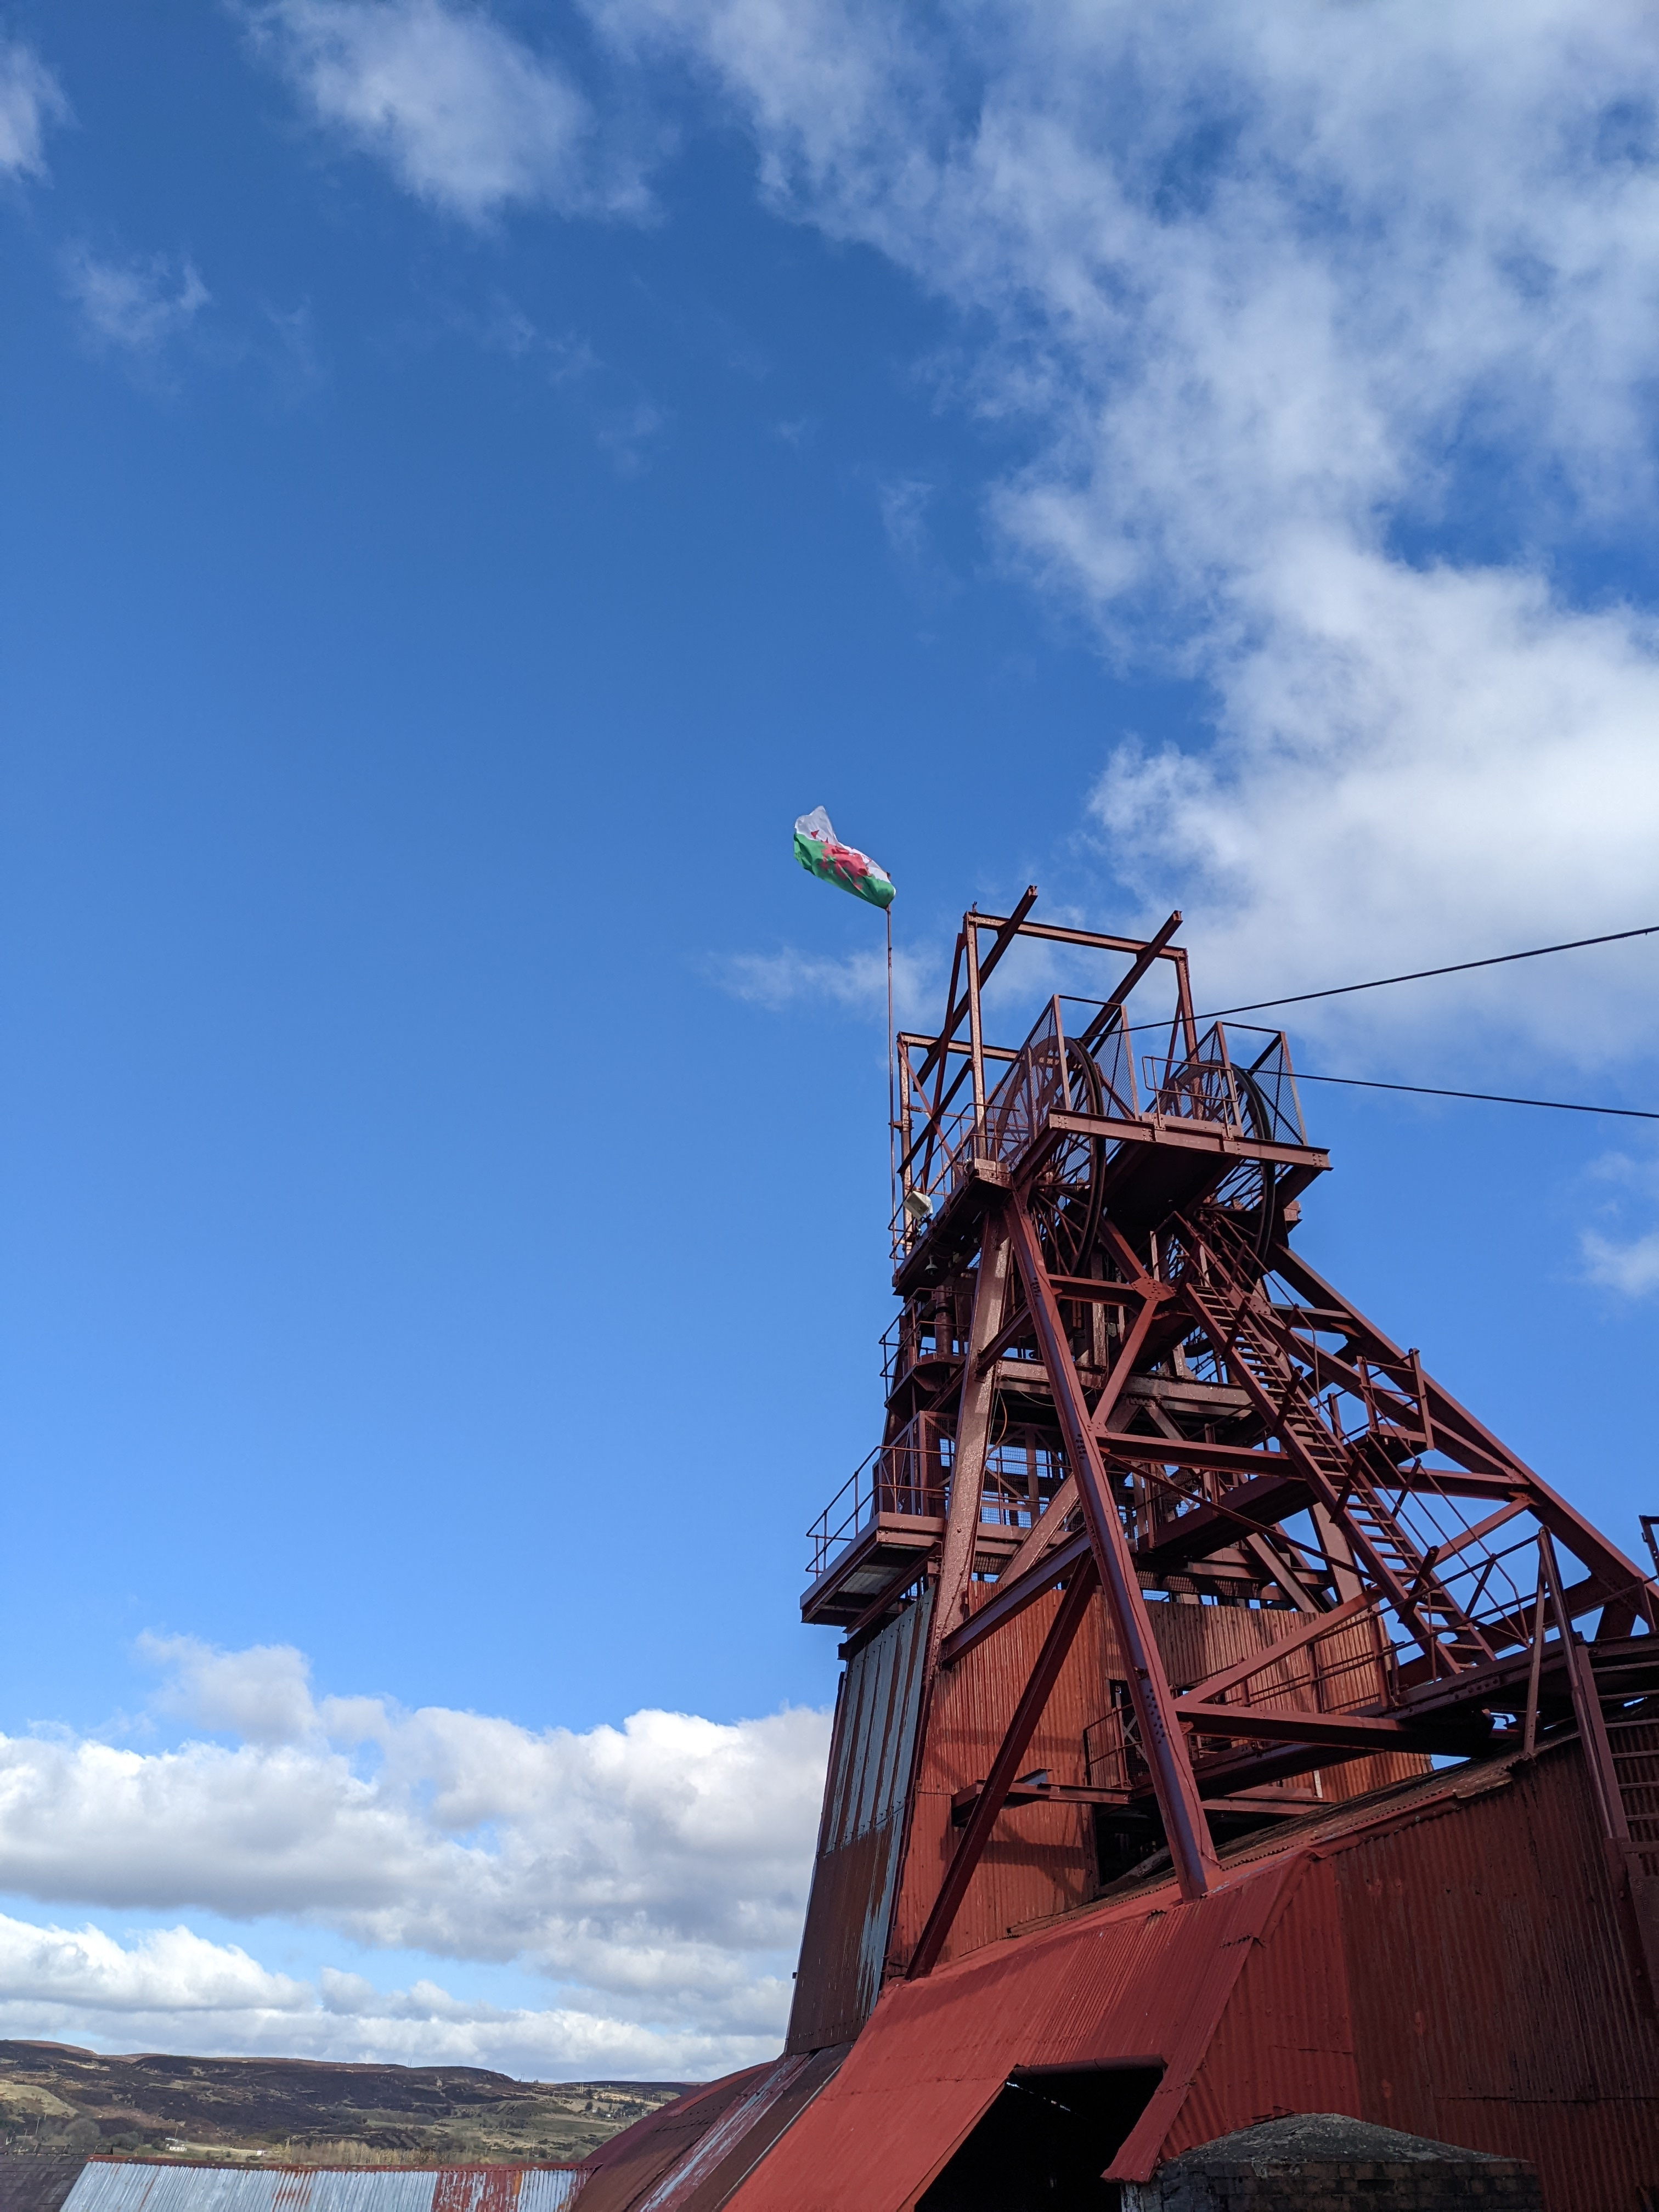
Fig. 2. Blaenavon Coal and Iron Works Museum.

Fieldwork Visit to Blaenavon National Coal Museum – 07/03/2022

When stepping of the coach at Blaenavon it was difficult to feel the excitement and sense of awe towards the landscape. The landscape character of the surrounding valleys was baron and bleak, the rolling hills lacked colour and vegetation whilst the town of Blaenavon itself gave off a sense of melancholy as a result of its industrial architecture and design. Perhaps a place to visit to feel a sense of nostalgia and reminiscence towards Welsh History instead of a place that captures one’s attention through it’s picturesque beauty, the landscape of Blaenavon did not feel very inviting. Infact, Blaenavon and its surrounding landscape could be seen as one that is a cultural landscape, a ‘combined work of nature and man’ (Wakelin, 2016, p.41). Although there is not much that attracts the eye from above, what makes the landscape nationally significant is the value of what’s excavated from the ground. Blaenavon’s geology consists of ‘carboniferous sandstone characterized by thick massive feldspathic and micaceous sandstones and grits’ (Glamorgan-Gwent Archaeological Trust Ltd, 2022). The landscape also consists of coal measures, millstone grit and carboniferous limestone, thus making the quality of the landscape so valuable. As we made our way into the site of the National Coal Museum, we were greeted by an experienced guide, stripped of our belongings and given a hard hat, head torch and safety belt that would be worn when exploring the 300ft deep mine. The guides enthusiasm and excitement when speaking about the mine and it’s legacy made the experience feel like we were actually a part of landscape and it’s history. When spending time down in the mine, the quality of the landscape really presented itself, however, this quality could now be seen as irrelevant due to the fact that the value of what’s beneath the surface is no longer in transition. Nonetheless, to gain a sense of what it may felt like working in the mines brought a real sense of place to the experience.

In regards to the potential of the Blaenavon Big Pit National Coal Museum, the landscape can be used for both recreational purposes and education. Although there has been reports of illegal activities taken place upon the landscape such as motorcycling and vandalism, there remains opportunity for organized field studies, place based education and even adventurous activities such as the potential for climbing, camping, hiking and even trail running. As previously mentioned in this paper, the history of this landscape allows for stories to be told and intimate connections to the landscape. These experiences ‘offer a significant opportunity to engage both physically with [the] landscape and cognitively with those who have played a role in shaping a place’ (Stewart, 2008, p.88).

Conclusion

This paper looked to provide a reflective account of the experiences at both Dinefwr Estate and Blaenavon Big Pit National Coal Museum. Upon reflection of both experiences, a greater connection to Wales’s landscapes, heritage, past, present and potential future has been cemented. For someone who is originally from England, experiencing Welsh culture and landscapes is always new and exciting with so much to learn and take back. I believe that experiences such as the visits to heritage sites can allow both the individual and the community to gain a greater sense of place to the surrounding landscape whilst encouraging pro environmental behaviors and sustainable attitudes towards our future actions.

Word Count - 2274

References

Atik, M. et al (2014) ‘Definition of Landscape Character Areas and Types in Side Region, Antalya-Turkey with Regard to Land Use Planning’, Land Use Policy, 44, pp. 90-100.

Booth, J. et al (2009) ‘Public Understanding of Protected Area Designation’, Biological Conservation, 142(12), pp. 3196–3200.

British Academy (2021) ’10-Minute Talks: The Miners Strike of 1984-85’. Available at: https://www.thebritishacademy.ac.uk/podcasts/10-minute-talks-miners-strike-1984-85/ (Accessed: 20 April 2022).

British Geological Survey. (2017) South Wales (Glyncorrwg Ponds and Dinefwr, Llandeilo) (1:625,000). United Kingdom: Ordnance Survey; Garmin; Esri (Geological Survey of Great Britain [England and Wales]). Available at:
http://mapapps.bgs.ac.uk/geologyofbritain3d/ (accessed: 20th April 2022).

Coflein (2002) ‘Register of Parks & Gardens of Special Historic Interest in Wales’. Available at: https://coflein.gov.uk/media/18/995/cpg131.pdf?fbclid=IwAR0X3e63e7X_v7zKTW2HHFKRn3k0rKZIpdDJ382h8KXWQNmGXpYQIXSnBlo (Accessed: 20 April 2022).

Forest Research (2022) ‘Landscape Quality’. Available at: https://www.forestresearch.gov.uk/tools-and-resources/fthr/urban-regeneration-and-greenspace-partnership/greenspace-in-practice/planning-integrated-landscapes/landscape-quality/#:~:text=Landscape%20quality%20can%20encompass%20many,a%20town%20or%20city's%20image. (Accessed: 20 April 2022).

Gilpin, W. (2013) ‘Observations on the River Wye, and Several Parts of South Wales’. Cambridge: Cambridge University Press.

Glamorgan-Gwent Archaeological Trust Ltd (2022) ‘Blaenavon: Historical Processes, Themes and Background’. Available at: http://www.ggat.org.uk/cadw/historic_landscape/blaenavon/english/Blaenavon_Features.htm#:~:text=The%20solid%20geology%20of%20the,Millstone%20Grit%20and%20Carboniferous%20Limestone. (Accessed: 20 April 2022).

Heritage Council (2006) ‘Landscape Character Assessment (LCA) in Ireland: Baseline Audit and Evaluation’. Available at: https://www.heritagecouncil.ie/content/files/landscape_character_assessment_final_report_2006_1mb.pdf (Accessed: 20 April 2022).

Met Office (2022) ‘Storms Dudley, Eunice and Franklin, February 2022’. Available at: https://www.metoffice.gov.uk/binaries/content/assets/metofficegovuk/pdf/weather/learn-about/uk-past-events/interesting/2022/2022_01_storms_dudley_eunice_franklin_r1.pdf (Accessed: 20 April 2022).

National Museum Wales (2022) ‘Big Pit National Coal Museum’. Available at: https://museum.wales/bigpit/about/ (Accessed: 25 April 2022).

National Trust (2022) ‘Dinefwr’. Available at: https://www.nationaltrust.org.uk/Dinefwr (Accessed: 20 April 2022).

National Trust (2022) ‘Dinefwr’s Designed Landscape Inspired by Capability Brown’. Available at: https://www.metoffice.gov.uk/binaries/content/assets/metofficegovuk/pdf/weather/learn-about/uk-past-events/interesting/2022/2022_01_storms_dudley_eunice_franklin_r1.pdf (Accessed: 20 April 2022).

National Trust (2022) ‘Parkland Walks at Dinefwr’. Available at: https://www.nationaltrust.org.uk/dinefwr/features/dinefwr-park (Accessed: 20 April 2022).

National Trust Collections (2022) ‘Dinefwr’. Available at: https://www.nationaltrustcollections.org.uk/place/Dinefwr (Accessed: 18 April 2022).

Natural Resource wales (2021) ‘Types of Protected Areas of Land and Sea’. Available at: https://naturalresources.wales/guidance-and-advice/environmental-topics/wildlife-and-biodiversity/protected-areas-of-land-and-seas/types-of-protected-areas-of-land-and-sea/?lang=en (Accessed: 20 April 2022).

Natural Resource Wales (2022) ‘Dinefwr Estate Site Of Special Scientific Interest’. Available at: https://naturalresources.wales/media/647946/SSSI_0629_SMS_EN0012759.pdf (Accessed: 20 April 2022).

Stewart, A. (2008) ‘Whose Place, Whose History? Outdoor Environmental Education Pedagogy as Reading the Landscape’. Journal of Adventure Education & Outdoor Learning, 8(2), pp.79–99.

Swanwick, C. (2002) ‘Landscape Character Assessment Guidence for England and Scotland’. Available at: https://www.nature.scot/sites/default/files/2018-02/Publication%202002%20-%20Landscape%20Character%20Assessment%20guidance%20for%20England%20and%20Scotland.pdf (Accessed: 20 April 2022).

Turner, S. (2005) ‘Historic Landscape Characterisation’. Available at: https://www.devon.gov.uk/historicenvironment/the-devon-historic-environment-record/historic-landscape-characterisation/ (Accessed: 20 April 2022).

UNESCO (2022) ‘Blaenavon Industrial Landscape’. Available at: https://whc.unesco.org/en/list/984/ (Accessed: 25 April 2022).

Wakelin, P. (2016) ‘Conceptualisation, Content and Boundaries: Defining World Heritage Landscapes in Wales’, ICOMOS–Hefte des Deutschen Nationalkomitees, 62, pp.40-47

Zee, D. (1990) ‘The Complex Relationship Between Landscape and Recreation’. Landscape Ecology, 4(4). pp. 225-236.

