May 8, 2020
Digital skills and research method
- Module code: BMSW4003 Lecturer’s name: Yajesh Kumar Certificate of Higher Education in Skills for Workplace (Health and Social Care) Level 4
Adriana IvanovA-1909640
University of wales trinity saint david
London

CONTENTS

Introduction………………………………………………………………2
Background3
- What is Virtual Learning Environment……………………………………….2
- Abbreviation Moodle…………………………………………………………..3
- Advantages and Disadvantages of VLE……………………………….3
Aims and objectives
- Researching what is the impact of VLE on students?...............................3
- Collect data by Survey Research…………………………………………….3
- Presentation results……………………………………………………………3
- Analyse collected data. ……………………..…………….…………………..3
Research method
- Primary and Secondary data collection……………………………………...4
- Sample and Population………………………………………………………..4
- Qualitative and Quantitative collection data……………………………4
Results…………………………………………………………………….5
Discussion
- Q1 Moodle Use (chart 1)………………………………………………………5
- Q2-Q3 Moodle access (chart 2,3)……………………………………………6
- Q4 Moodle organised (charts 4,)……………………………………………..7
- Q5 Moodle organised (charts 5)……………………………………………...8
- Q6 Moodle Satisfaction (charts 6)……………………………………………8
- Q7 Moodle Satisfaction (charts 7)……………………………………………9
- Q8 Moodle-impact (chart 8)…………………………………………………..9
- Q9 Moodle-assignment support (chart 9)………………………………….10
- Q10 Opinions and recommendations (table 1)…………………………….11
Conclusion………………………………………………………………11
Appendices
- Survey Questionnaire………………………………………………………..12
- Sample of National Student Survey for UWTSD………………………….12
References………………………………………………………………13

Introduction
This report will focus on the Impact of Virtual Learning Environment (VLE) – Moodle on students' learning experience. The Collected date based on quantitative research at University does not include every student, only on the part of all, who have the same interests. I will do primary research questioning 20 students of my course group of education at the University of Wales Trinity Saint David.
The survey will base on my need what I want to understand of the respondent, their expectation; accessing; organisation of lessons and information; satisfaction and if this type of Virtual learning is essential in Higher Education. The results will analyse and show in Column-Chart and Table. That will help to understand better of my investigation the other opinions of the impact in this virtual learning doing conclusion. Do the students feeling more confident and ready for employment.
Background
What is a virtual learning environment (VLE)? That is interactive learning. In addition to face-to-face communication, this type of virtual studying complements the teaching very successfully. The main idea is to make it easier for students to find more information such as what the program is, upcoming lecturer and events—online access to materials that are up-to-date and relevant to studying course and module. There is a link to resources.other students and lecturers for work-based study (Stella Cottrell,2008).
At Moodle is beneficial the area of storage. We can store our assignments. Learning resources have a gathering, study or growth plans, reflective writing, CV and so on. Items in these various storage areas can be collated for different purposes. Furthermore, this storage point may be private. Further components may be handy by the tutor or other learners who are working together. This easy of an entrance – not only for one and for other users - can be a great advantage (Sheila Cameron,2009).
According to the University of Wales Trinity Saint David's website (2020), online learning is learning without face-to-face contact with a tutor in a physical classroom – flexible and supporting with academic rigour. It is a prerequisite for reaching full potential. My opinion about the disadvantages of VLE-Moodle is internet addiction. From my personal experience and observation on my colleagues, I came to that conclusion. If the mobile device and operating system are the old versions, the connection is very hard and slowly. They are not compatible with most of the new software and mobile apps. Sometimes losing network and need to joint to Wi-Fi if it is possible.
Modular Object-Oriented Dynamic Learning Environment is the acronym of the Moodle. This educational platform provides a custom learning environment for students (TechTerms,2020).
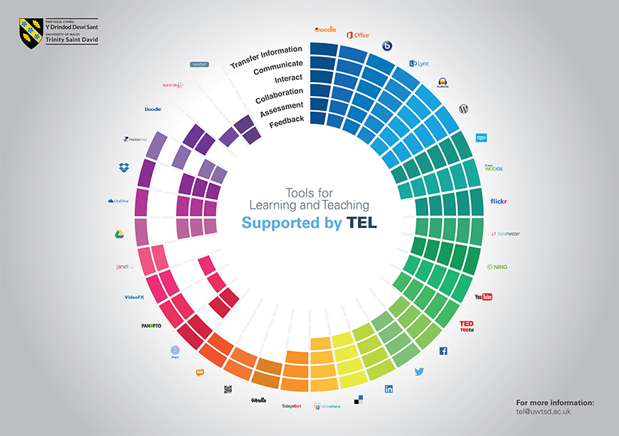
Figure 1 Supported products at Moodle (UWTSD,2020)

The platform Moodle at UWTSD besides has a broad range of services from audio and visual effects, web and graphic design through to teaching and researching technology-enhanced learning (uwtsd, 2020). It is an area of assessing course information; communication with lecturers and fellow students; submitting assignments; interactive study activities (uwtsd, 2020). The installing University hub software on devices allows access to Moodle and learning modules. Further to a lot of useful section like Mail; My Taimtable; Microsoft Office apps; OneDrive; Library; Academic support.

Aims and objectives
The primary purpose is I to do a research survey and collect and analyse data on what is the impact of Moodle Virtual Learning environment on students learning experience. I have no experience whit doing a survey questionnaire, and my first objective is to back again to my lecture and explanations of my lecturer. The other objectives are to prepare my questions. Developing my survey questionnaire, I will look at some secondary sources of a similar topic, to compare the results. I will analyse my data and evaluate based on the respondent's answers.

Research method
- Primary and Secondary Data
The primary and secondary data is the deferent types of the research process. The primary information is collecting oneself like an interview( face-to-face, or by phone), direct observation, questionnaire, experiments or other means. The secondary data included results of surveys does out by other people or organisation (Cameron,2009). With the informed consent of my colleagues- students, I collected the first data by directly observing about which devices they used. That would help me with the next step-preparing the survey questionnaire. Must to follow the highest ethical standards.
- Differences between Sample and Population
A sample is the group of individuals who participate in the study, and the population is the broader group of people to whom y results applying (statisticssolutions,2020). All students at UWTSD are population, and a sample was my course group. The geographical area when I have done researched was the University of Wales Trinity Saint David London campus.
- Differences between Qualitative data and Quantitative data
Qualitative data- It is investigative research. It is using to gain amity of underlying reasons, thoughts, and motivations. It offers ideas into the problem or helps to develop concepts or hypotheses for possible quantitative research (snapsurvey,2020).
Quantitative data- used to quantify the issue by mode of producing numerical data or information that can be changing within current statistics. It is second-hand to quantify relation, view, behaviours, and other defined changeable – and generalise outcomes from a significant sample population -including chart, graphs, table, online and paper survey, telephone survey (snapsurvey,2020). Using this method for my research, I have used Paper Survey (Appendix 1). I designed the writing survey, including a checkbox multiple-choice question, when had a variety of more than one answer. Closed-ended the question, based on familiarity with Moodle. Open-ended question expected opinions about improving Moodle. With other items, I have focused on the levels of satisfaction, importance, organisation and academic support through Moodle.
I did not include inquiries related to the age and gender of students because it was not a pre-set standard - Quota Sampling. They were not determining factor in my research about virtual learning. I expected the responses of my fellow students. My strategy was to do a survey and receive answers to the end of class. No more than 10 minutes needed per person.

Results
This my first survey is to gathering information about what is the impact of Virtual learning Environment (VLE) -Moodle on student's learning at University. I had 20 respondent and received a high percentage response rate. I get answers all question of all respondents. The results show that most of the undergraduates use more than one device to access Moodle (50%). Desktop (0%). The level of satisfaction -the quality of learning sources (45%), academic support (30%). Moodle expectations are justified by 70% of learners. One of the criteria for getting grade marks is plagiarism, and a high percentage can be seen here (65%). The positive effect of VLE is noted at 70%. Low rate (30%) when giving an opinion or recommendation. The reason can be in the type of Survey research.

Discussion

chart 1 Moodle Use
Q1. Chart 1 shows two definite answers, yes/no. Of this closed-ended question, we can see that the majority (80%) are aware of how to use Moodle and what its function is. A small number of respondents (20%) encountered difficulties.

chart 2 Moodle access
The answers to Q2 in the chart show how often students use Moodle. The chart shows that only 10% are used Moodle once a month, and the other 10% are on another extreme-every day. 20% are open Moodle once a week. The higher percentage (60%) log-in to Moodle a few time a week, which can mean a two, three, four times a week.

chart 3 Moodle access
Q3 The first thing to note in this chart is that no one is using Desktop. The reason is that they are not mobile like other devices. This question is with a multiple choice answer, and some of the respondents give more than one option. Most of the students use a smartphone (55%). At University, for example, it is the best way, easily portable. This response does not exclude the use of a Laptop (20%) and Tablet (25%). In addition to these results, the answers show that half of the students use more than one device (50%). They use Tablet(20%) and Laptop (30%) as a second option. Their advantage lies in a larger screen, which makes it easy to work whit.

chart 4 Moodle Organised
Q4. Chart 4 shows that only 10% of the polls do not think Moodle organised well. The information contained it is beneficial, according to the majority. Comparing with the data of National Studen Survey (NSS) for 2019 about an organisation (85 %) here the results are lowest (55% )extremely and very helpful, (35 %) helpful. This NSS survey is done annually, and results are accessible to all. Our University (UWTSD) is a registered provider (OfficeforStudent, 2020) I am using semple of this data to comparing when is possible(Appendix 2).

chart 5 Moodle Organised
Q5. This chart shows that (85%) of students have said that very easy and easy navigate Moodle and find what they need. The percentages are similar to results of NSS (85% ). For the rest(15%) is rather not easy. Generally, it is mean the learning resources are organising well for easy finding and access.

chart 6 Satisfaction-academic support
Q6. Overall satisfaction (65%) shows a decrease comparing to two indicators from last year, academic support (88%) and contact staff (90%). 5% is not satisfied.

chart 7 Satisfaction -Quality of learning
Q7. The answers in chart 7 show a high level of overall satisfaction (90%) about the quality of the course and learning resources. This percentage is very little over last year (89%). 5% can not judge and have no opinion and prefer to be neutral. The rest (5%) are low satisfied, which is closer to not satisfied.

chart 8 Impact of VLE-Moodle
Q8. The dominant percentage in this chart (88%) shows how Virtual Learning Environment is essential for all students, with a little exception (10%). That increase student to be more activity, motivated and helps to develop the independent study. This response is significantly closer to the results of NSS (90%).

chart 9: Assignment support

Q9. An essential part of education is assignments. One of the mark criteria is a fair practice, and the student has to avoid plagiarism, and in this chart can see that 90 % of students rate this opportunity. Comparing by criteria assessment and feedback (84) the overall result of this survey increase by 6% from last year. Two respondents (10%) are neutral.

Q10. Do you have some opinion or recommendation about Moodle?
1 | To be more clearly
2 | To be more organised
3 | To be easier finding links for assessment brief and uploading assignment, and I am confused
4 | There are too much unnecessary links for other groups
5 | Moodle is beneficial
6 | Too many useful sections in one place, it is great
 | Total responses: 6 of 20 respondents - 30 % rate
Table1: Opinion and Recommendation
Q10. That is an open-ended question and respondent to give an opinion if they like. They do not provide more attention to this question, because it will spend more time and for them, it is unnecessary after they have done the others. If the survey was by interview face-to-face (qualitative data collection), the response is higher. Here are two an opinion and four a recommendation (30%). The half think that Moodle is not well organised, and have to be more clear to navigate to be much more comfortable.
Unnecessary information, the links for other groups is links to very slowly and hard find. It slows and confusing users. Two is very thankful by using Moodle because of functions, organised an opportunity to access to many learning resources.

Conclusion
Virtual learning is now a beneficial and essential part of student learning. It successfully complements the standard face-to-face mode. The Moodle platform, which is a vital part of this type of education, increases student activity. Thanks to it, they have the opportunity to develop and improve the many skills they need in an academic and professional aspect. Looking for learning resources uploaded to a Moodle, students improve their research skills.
On the other hand, sifting through the available information, shows critical thinking. Writing emails, submitting assignments online, using charts and tables, making presentations as course projects - all these skills are further enhancing during virtual training. Easy navigation in the mullet, good organisation and information sources has a very positive impact on students. Everything needed is gathering in one place, which is a critical argument for the positive feedback from students about virtual learning – Moodle.

Appendices

- Survey Questionaire

- Sample of National Student Survey -link to UWTSD provider

References

Cameron, S (2009) Business Student's Handbook, Skills for Study and Employment. 5th edn. Ashford Colour Press: Gosport
Cottrell, S. (2008) Palgrave Study Skills, The Study Skills Handbook 3rd edn. Palgrave Macmillan, Basingstoke
OfficeforStudents (2020) National Student Survey – NSS, National Student Survey results 2019, Health and social care 2019 NSS results by registering provider [online] Available at: https://www.officeforstudents.org.uk/advice-and-guidance/student-information-and-data/national-student-survey-nss/get-the-nss-data/ (Accessed 1 May 2020)
SnapSurveys (2020) Difference between qualitative and quantitative research. [online] Available at: https://www.snapsurveys.com/blog/qualitative-vs-quantitative-research/ (Accessed 29 April 2020)
StatisticSolution (2020) What is the Difference Between Population and Sample? - Statistics Solutions [online] Available at: https://www.statisticssolutions.com/what-is-the-difference-between-population-and-sample/ (Accessed 28April 2020)
TechtTerms (2020) Moodle definition, Moodle [online] Available at: https://techterms.com/definition/moodle (Accessed 27 April 2020)
UWTSD (2020) Online and distance learning [online] Available at: https://www.uwtsd.ac.uk/online/ (Accessed 29 April 2020)
UWTSD (2020) Technology Enhanced Learning, Moodle [online] Available at: https://www.uwtsd.ac.uk/tel/technology-enhanced-learning/ (Accessed 28 April 2020)

