
Module Name: Professional Career Development

Module Code: BMBS4005

Student Name:Karleigh osbourne

Student Number:2537013

Lecturer:jemma

Deadline: Monday 26th October 2026 23.59PM

Contents
Element 1: Career Sector Investigation 3
1.1 My Chosen Sector or Business Area 3
1.2 Sector / Business Area Research 3
1.3 Skills, Qualities and Attributes Valued by Employers 3
1.4 Current Trends Affecting the Sector 3
1.5 Personal Career Fit 4
Element 2: Skills Audit and Professional Development Plan 5
2.1 Personal SWOT Analysis 5
2.2 Emotional Intelligence and Professional Behaviour 5
2.3 Applying Theories or Models 5
2.4 SMART Development Goal 6
Element 3: Recruitment Application Pack 7
3.1 Selected Job Role 7
3.2 Tailored Curriculum Vitae (CV) 7
3.3 Cover Letter 8
3.4 LinkedIn Profile 8
3.5 Application Rationale 8
Reference List 8

Element 1: Career Sector Investigation.

1.1 My Chosen Sector or Business Area
The business I have chosen to establish is a cleaning service business, which falls within the service sector. The business would provide cleaning services to homes offices shops and other workplaces. I selected this business because there is a constant demand for cleaning services from both individuals and businesses. I also chose this business because it can be started on a relatively small budget and has the potential to grow by gaining more customers and employing additional staff.

1.2 Sector / Business Area Research
The cleaning industry is part of the service sector it involves providing cleaning and hygiene services to homes offices schools hospitals shops hotels and other organisations. Common things we do include vacuuming mopping dusting window cleaning carpet cleaning and deep cleaning common jobs include cleaners, cleaning supervisors and cleaning managers. The uk national careers service confirms that cleaners can work in places such as offices school hospitals hotels and private homes. The British cleaning council reports that the uk cleaning hygiene and waste industry employs around 1.5 million people showing that it is a larger and important business sector. Sources; cleaning council uk careers service and google.

1.3 Skills, Qualities and Attributes Valued by Employers.
. Attention to detail-important because cleaners must achieve a high standard and make sure no areas are missed.
. Reliability and punctuality-important because customers depend on cleaners arriving on time and completing their work.
. Good communication and customer service- important when working with customers colleagues and supervisors.
. Time management and organisation-cleaners often have several tasks to complete within a set amount of time.
. Health and safety awareness-cleaners must use chemicals and equipment safely and follow hygiene procedures.

1.4 Current Trends Affecting the Sector
One major trend is the increased use of technology cleaning companies are using robots’ smart application and digital systems to improve efficacy and reduce costs. The British cleaning council reports that robots are increasingly being used to support cleaning teams. This can make it harder for cleaning businesses to expand. Sustainability is also becoming more important customers and organisations increasing expects cleaning companies to use environmentally friendly products and equipment such as low water systems and products that can break down naturally.

1.5 Personal Career Fit
The cleaning sector suits me because I currently work as a cleaner, so I already have experience in this area. I enjoy keeping places clean organised and hygienic and I have developed skills such as attention to detail time management reliability and working independently. I am attracted to this business because I understand the work and the needs of customers in the future, I would like to use my experience to start up and grow my own cleaning business. To achieve this I would need to improve my communication skills so I can manage customers and employees effectively.

Element 2: Skills Audit and Professional Development Plan
.

2.1 Personal SWOT Analysis
STRENGTHS  • time management  • organization skills  • reliability and responsibility | WEAKNESSES / AREAS FOR DEVELOPMENT  • limited marketing skills  • attendance  • lack of business experience
OPPORTUNITIES  • training courses  • social media advertising  • networking opportunities | THREATS / CHALLENGES  • competition  • increasing costs  • changes in customer demand

One of my most important strengths is communication skill. Communication is essential in my cleaning business because I need to understand customers need explain my services and deal with any questions or complaints professionally. Good communication helps me build trust with customers maintain positive relationships and encourage repeat businesses. This is important for my career because a good reputation can help my business grow.

2.2 Emotional Intelligence and Professional Behaviour
I manage my emotions by staying calm when dealing with stressful situations such as handling customers complaints when im working or meeting university deadlines. I communicate with others by listening carefully respecting different opinions and explaining my ideas clearly during group activities. I aim to behave professionally by being reliable respectful and reasonable.

2.3 Applying Theories or Models
Gibbs model has six stages that help me learn from experiences and identify areas for improvement. For example, when dealing with a difficult customer in my cleaning job I can reflect on how I managed my emotions how I communicated and what I could do differently next time. Maslow’s hierarchy needs explains how peoples need influence their motivation. I can apply this to my development by building my confidence developing my skills and working towards achieving my goals. These models help me recognise my strengths improve my communication and behave more professionally in my cleaning job and at uni.

2.4 SMART Development Goal
Specific | My active listening ability I would like to improve so I can understand better
Measurable | Because hopefully I will understand things better
Achievable | I will practice at uni and in my cleaning job
Relevant | Because I will understand better what clients want and understand better what I need to do in uni
Time-bound | 10 weeks I will look back and hopefully see progress and build more confidence as I will have a better understanding.

Element 3: Recruitment Application Pac

3.1 Selected Job Role
Job Title | Housekeep manager
Organisation | Cleaner
Location | Bristol
Where the vacancy was found | Indeed
Job Role URL | Housekeep manger

3.2 Tailored Curriculum Vitae (CV).
]
KARLEIGH

OSBOURNE
SKILLS
Sanitisation techniques
•
Hygiene standards
•
Safety awareness
•
time management
•
Organisational reliability
•
independent working
•
teamwork and communication
•
attention to detail
•
LANGUAGES
C1
English
:
Advanced
Detail-oriented House Cleaner with proven expertise in maintaining
cleanliness and hygiene across all areas of the home. Skilled in
organising cleaning tasks, using appropriate products and equipment,
and ensuring a tidy environment. Committed to high standards and
client satisfaction through thorough cleaning and sanitising practices.
Reliable and punctual, effectively managing time and responsibilities
to contribute to a welcoming atmosphere.
EXPERIENCE
August 2023
-
Current
House Cleaner

CLEANER
,
CARDIFF
,
CARDIFF
January 2018
-
March 2020
Cleaning Assistant

new look
,
CARDIFF
,
CARDIFF
Sanitised kitchen surfaces and organised items for optimal
cleanliness and functionality., Clean bathroom fixtures and surfaces
to maintain hygiene standards., Organised and cleaned bedrooms to
enhance comfort and create inviting spaces. and Clean and organise
living areas to enhance comfort and aesthetics.
•
maintain high standards of cleanliness and hygiene.
•
organise cleaning tasks and manage time effectively.
•
use cleaning products and equipment safely.
•
Maintained cleanliness and tidiness of homes to ensure presentable
living environments.
•
work independently and take responsibility for completing duties.
•
Executed established cleaning routines to ensure a hygienic
environment. and completed assigned duties.
•
ensured store cleanliness and presentation for optimal customer and
staff experience.
•
operated cleaning equipment safely to support overall operational
efficiency.
•
cleaned shop floors to create a tidy shopping environment for
customers.
•
EDUCATION
2017
SVQ Level 3

hospitality supervision
Cardiff University
,
Cardiff
2017
GCSEs

health and safety
Cardiff University
,
Cardiff
2016
A-Levels

cleaning and support services
Cardiff Metropolitan University
,
Cardiff
a level 3 qualification in hospitality supervision and leadership.
•
health and safety and cosh training
•
a level 2 qualification in cleaning and support services
•
CONTACT
CARDIFF, WALES CF143B B
07149281369
2537013
@STUDENT.UWTSD.AC.U
K
2013
GCSEs English Cathays high school, Cardiff

HOBBIES AND INTERESTS
- keeping things organised I enjoy keeping spaces clean, tidy and organised
- teamwork I enjoy working with others and helping people when needed
- learning new skills, I am interested in developing my skills in hospitality and housekeeping management

DRIVING LICENCE
• I have a full uk driving licence

3 Cover Letter
KARLEIGH OSBOURNE
2537013@STUDENT.UWTSD.AC.UK
housekeeper
KARLEIGH OSBOURNE
CARDIFF
16 October 2026
Re: Application for Housekeeping Manager
Dear Hiring Manager,
I was delighted to see that bespoke hotels are currently recruiting for a Housekeeping Manager. My skills and experience are well aligned with the job criteria, and I would like you to consider my suitability for the role.
I have always had a passion for working in the cleaning industry during my previous position as Cleaner, I quickly developed skills in leadership and feedback from my managers backs this up. In addition, the work experience I gained has enabled me to build and practice skills in essential areas such as customer service and communication.
I have an excellent work ethic, am attentive to detail and am a consummate professional. I believe my skills and experience will allow me to contribute substantially to your team and goals.

I completed cleaning tasks on time while working as a self-employee cleaner. I communicated with customers to understand their needs and expectations. I made sure areas were thoroughly cleaned and presented to a high standard organized my work and managed my oppoiments and task independently. I listened to customers and sure they were happy with the service I provided.
I have enclosed my CV for your review and can be reached at your convenience. Please do not hesitate to call or email me with any follow-up questions or arrange a suitable interview time.

Sincerely,
KARLEIGH OSBOURNE
KARLEIGH OSBOURNE

3.4 LinkedIn Profile
LinkedIn Profile URL | https://www.linkedin.com/in/karleigh-osbourne-4829ba41a
Professional Headline | Cleaner self emplyed
Evidence / Screenshot | 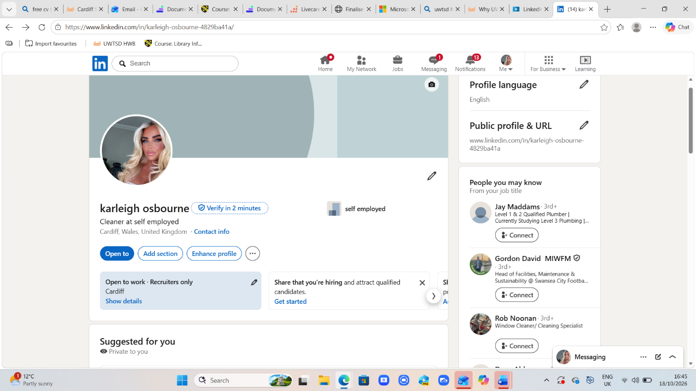

3.5 Application Rationale
I tailored my cv and cover letter for the housekeeping manager role at bespoke hotels by identifying the skills and experience most relevant to the position. I focused on cleaning experience communication organisation time management attention to detail and maintaining high hygiene standards. One of the main requirements I prioritised was cleaning experience and attention to detail. In my cv I included my current experience as a house cleaner where I sanitise kitchen surfaces clean bathrooms and bedrooms and maintain high standards of cleanliness and hygiene, I also included my previous role as a cleaning assistant at new look where I maintained shop cleanliness and presentation. These experiences show my understanding of hygiene standards and my ability to create clean, welcoming environments which are important in hotels housekeeping. I also prioritised organisation and time management because a housekeeping manager needs to ensure that cleaning duties are completed efficiently and to the required standard. My cv highlights my ability to organise cleaning tasks, manage my time effectively and work independently. In my cover letter, I explained how I manage appointments and complete tasks on time. These examples demonstrate that I can take responsibility and organise my workload. Another important requirement was communication and customer service. In my cover letter I explained how I communicate with customers to understand their needs and expectations and listen to feedback to ensure they are satisfied. I included these skills because professional communication helps maintain customer satisfaction and positive working relationships. Finally I highlighted my reliability profession and leadership potential. These qualities are relevant to manging housekeeping responsibilities although I recognise that I need to develop further experience in supervising staff. Overall tailoring my application helped me connect my previous experience to the requirements of the housekeeping manager role and identify areas for further professional development.
Reference List
BRITISH INSTITUTE OF CLEANING SCIENCE (BICSC) (N.D. CLEANING SERVICES MANAGER AVAILABLE AT BICSC OFFICIAL WEBSITE (ACCESSED 19 OCTOBER)

GOV.UK(N.D.) HEALTH AND SAFETY AT WORK.AVAILABLE AT GOV.UK OFFICIAL WEBSITE (ACCESSED 19TH OCTOBER 2026

HEALTH AND SAFETY EXECUTIVE (HSE) (N.D.) COSHH AND CLEANERS KEY MESSAGES AVAILABLE AT HSE OFFICIAL WEBSITE ACCESSED 19TH OCTOBER 2026

NATIONAL CAREERS SERVICE (N.D.) HOTEL HOUSEKEEPER JOB PROFILE AVAILABLE AT NATIONAL CAREERS SERVICE OFFICIAL WEBSITE ACCESSED 19TH OCTOBER 2026

PEOPLE 1ST (2022) SUPERVISE HOUSEKEEPING SERVICES NATIONAL OCCUPATIONAL STANDARD PPLHSL17 AVAILABLE AT UK STANDARDS OFFICIAL WEBSITE (ACCESSED 19TH OCTOBER

