Research
Proposal

Assignment 1

Steffan Dancey

2014079

Table of Contents
1. Chapter 1 – Introduction 3
1.1 Research title 3
1.2 Abstract 3
1.3 Introduction and background 3
1.4 Aims and objectives 3
2. Chapter 2 – Literature Review 4
2.1 Welsh Government 4
2.2 Specification considerations for blue roof SuDS attenuation systems 4
2.3 Sustainable Drainage Systems 5
2.4 Advantages of Sustainable drainage 6
3. Chapter 3 –Research Methodology 7
4. Chapter 4 – Timetable 8
5. Chapter 5 – Data analysis 9
6. Chapter 6 – Results 9
6.1 Introduction 9
6.2. Primary research 10
6.2.1 Response rates 10
6.2.2 Profession of respondents 10
6.2.3 Experience in the roofing industry 11
6.2.4 Area of employment 11
6.3 Secondary research 12
7 Bibliography 12

Chapter 1 – Introduction

Research title

Are Green and Blue roofs effective methods to meet the Statutory SuDS Standards published by the Welsh Government?

Abstract

This research will aim to gain further knowledge on the effectiveness of roofing systems proposed by manufacturers to meet Statutory SuDS Standards.

Introduction and background

The research will be carried out by a person involved with roofing schemes since 2018, It will look to find if the current sustainable roofing methods are sufficient to meet Statutory SuDS Standards published by the Welsh Government.

This research will be beneficial to contractors and manufacturers within the roofing industry. In order to meet the regulations brought out in 2019 by the welsh government, roofing manufacturers introduced new sustainable methods of roofing systems as an option for the Sustainable Drainage Systems. This research will look into effectiveness of these systems since being first introduced.

Aims and objectives

The objective of researching this topic is to gain an understanding of the effectiveness of the roofing systems proposed by roofing manufacturers and evaluate their success. I will also look for other means of achieving the Sustainable Drainage Systems, to evaluate whether the roofing systems proposed are viable.

Chapter 2 – Literature Review

Welsh Government

From 7th January 2019, all new developments of more than 1 dwelling house or where the construction area is 100 square meters or more, will require sustainable drainage systems (SuDS) for surface water. The SuDS must be designed and built-in accordance with Statutory SuDS Standards1 published by the Welsh Ministers and SuDS Schemes must be approved by the local authority acting in its SuDS Approving Body (SAB) role, before construction work begins. Welsh Government accessed 06/12/21.

In Wales, surface water flooding was identified as one of the main causes for home flooding. Surface water flooding is on the rise due to climate change and increased amounts of water is being pushed through the drainage systems, this is mainly due to urban development.

Due to the increased pressure on drainage systems the welsh government released regulations to promote effective SuDS in new development that will remain effective for the life of the building.

Specification considerations for blue roof SuDS attenuation systems

“The Met Office projects significant temperature rises in the decades ahead, with extreme weather and flooding events becoming more frequent. Summer rain is forecast to become more intense, leading to a greater risk of flash flooding, and trending wetter winters is also likely to continue, placing greater pressure on existing sewers and flood defences.” RCI – accessed 05/12/21.

As a result of climate change, efficient water management and SUDS designs within developments are becoming a lot more significant. Blue roofs systems provide a solution to problems, reducing flood risks and pollution while encouraging wildlife ecosystems when partnered with sedum.

When designing the roofing systems there are multiple consideration such as, Local rainfall/flood data, Structural and loading considerations, and Thermal performance.

Sustainable Drainage Systems

Sustainable drainage systems and methods are not limited to applications in roofing. SuDS can be applied in areas such as Ponds, Filter Strips, Permeable surfaces and Tanked Systems.
Please see image attached below of a SuDS hierarchy, this indicates the sustainability and benefits of each SuDS system.
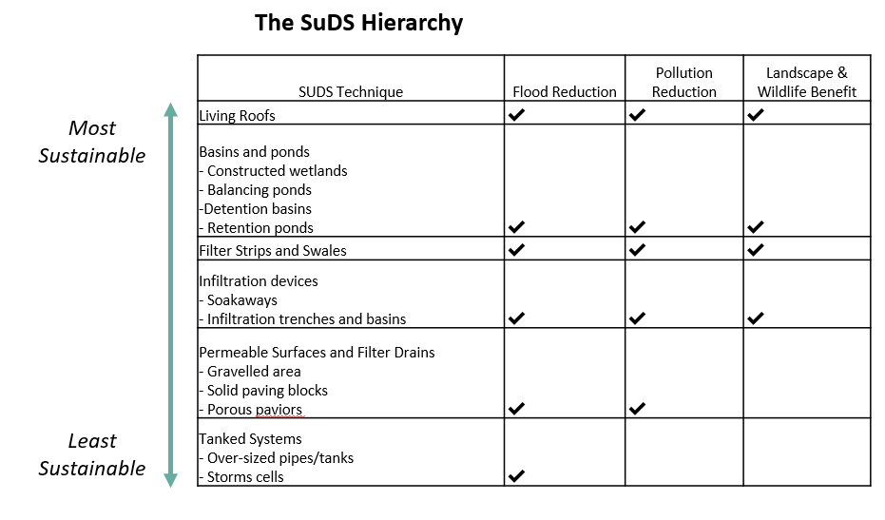
Image from Ambiental, accessed 20/01/2021.

Retention ponds – These ponds are designed for water treatment and attenuation; they also support growth of aquatic vegetation. Rainwater run-off is collected and treated in the pond, providing relief for drainage systems and sewers. However due to requirement of high embankments, this method of SuDS may not be suitable for development on steep sites.

Roofing Systems – Roofing systems are recent development of SuDs technologies; they created a solution for urban areas where ground-based systems are limited. Blue roofs are designed to hold rainwater over a 24-hour period, this allows a slow release of rainwater to avoid drainage surge.

Filter Strips – These are areas land that are gently sloped which allow a slow filtration of rainwater run-off, they are a relatively cheap and easy way of introducing SuDs and can be easily integrated into proposed development to provide SuDS.

Permeable surfaces – Permeable surfaces allows water to penetrate through the surface and the pattern of voids. This system allows water to temporarily be stored before either being absorbed through the ground beneath or discharged to a drainage system or watercourse. This system will require maintenance, as poor maintenance will cause growth of weeds etc.

Tanked Systems - Tanked systems such as water attenuation tanks are used in modern construction developments to reduce the risk of floods. Attenuation tanks are typically used on sites where a high water table is present and sites where building on clay.

Advantages of Sustainable drainage

Sustainable drainage systems are a relatively modern and environmentally friendly method of water management. They are used to both manage flood and pollution risks from drainage run off. Benefits of introducing Sustainable drainage systems include:

Water Quality – Sustainable drainage systems filter any contaminates from drainage run off and reduce the amount of water entering sewers, this reducing drainage overflow.

Flood Risk Management – Sustainable drainage systems store rainwater and reduce the flow in sewers etc, they also reduce the amount of rainwater run off reducing flood risk and drainage overflow.

Biodiversity – Through introducing sustainable drainage systems, existing habitats are maintained, and new habitats are also created. The increased Biodiversity improves the quality of ecosystems.

Planning – Proposing an effective sustainable drainage scheme encourages a faster planning process as it encourages a green and sustainable development.

Chapter 3 –Research Methodology

The initial research conducted will look into the effectiveness of the roofing systems proposed in the industry, to achieve this we will need to carry out research through undertaking Primary and Secondary research.

By conducting primary exploratory research, it increases the researcher’s knowledge on the topic, but should not be used solely to draw a conclusive answer, although it can greatly assist in establishing a foundation for further research. Exploratory research is also very flexible and easy to adapt and enables the researcher to understand at an early stage whether the topic is worth researching in depth.

An example of exploratory research would be undertaking a survey, all results and data will be gathered from the survey and be assessed to study opinions and trends. This research will aim to gain further knowledge on the effectiveness of roofing systems proposed by manufacturers to meet Statutory SuDS Standards published by the welsh government.

Research of Secondary data will also be carried out as there are many resources for information on the subject of sustainable drainage within roofing systems. Benefits of conducting secondary research include ease of access to a wide variety of information and it saves considerable time. Although, secondary data may not answer the specific question I’m asking, and the information could potentially be biased.

A combination of primary and secondary data will be collected as primary or secondary research alone will not provide enough information. Each method has their benefits and drawbacks e.g. Not all surveys may be answered therefore, a good secondary source of information will then be required.

The researcher will contact numerous reliable individuals who are involved in sustainable drainage systems and roofing design to complete a survey.

This research will study the following:

- Sustainability – life span.
- Cost – are the systems financially liable?
- Effectiveness – are the systems successful?

Chapter 4 – Timetable

This research will take place post January 2022, 2 years from when the new regulations on sustainable drainage in Wales was released.

Survey

- Sample surveys will be issued to approximately 5 individuals, with a 10-day return request.
- From the 5 returns, the data will be studied, and the survey will be altered if required.
- The survey will then be issued to approximately 30 individuals with a 10-day return request, delivered in person.
- Data will be collected in person to try and increase the number of responses.
- Data will then be entered into a spreadsheet and analysed.

Secondary research

- Conduct research using existing articles/online resources.
- Evaluate relevance of data.
- Access credibility of data.

Both approaches of collecting data will be studied in order to establish a fair overall understanding on the effectiveness of systems proposed.

Chapter 5 – Data analysis

All data collected from the different methods of research will be examined, using different techniques.

quantitative data collected from the survey will be imputed into a programme named Microsoft Excel to create a database. The researcher can then use Pivot tables within Excel to process this data, this allows us to summarise data and provide a detailed breakdown on the responses received.

Qualitive data analysis will make sense of large amounts of data by decreasing the amount of raw information and identifying patterns to draw a meaning from the data.
Categorising and Coding the data is the critical stage in the process of this data analysis. Coding includes splitting large volumes of raw information down and assigning them into categories. The researcher must create categories and codes to choose what to collect, to identify the patterns and draw meaning from the data.

To ensure the information gathered is valid and reliable the researcher has developed each question in a way that only relevant responses can be provided. Sample surveys will be issued to approximately 5 individuals, with a 10-day return request to ensure validity of data collection, and that all questions are suitable.

Chapter 6 – Results

Introduction

the main aim of conducting the research was to gain an understanding of the effectiveness of the roofing systems proposed by roofing manufacturers and evaluate their success. The results collected from the research will be analysed in the form of charts and tables.

6.2. Primary research

Response rates

The survey was hand delivered to exactly 30 individuals, and of the 30 possible respondents only 23 responses were completed and taken into account, which is a response rate of approximately 76.7%. As the surveys were delivered and collected by hand, I believe this encouraged the respondents to respond within the 10-day return request.

Profession of respondents

Within the survey the respondents had the option of choosing they’re relevant profession. As some respondents had more than one profession an overlap was evident within the results, as the total number of professions exceeded the 23 respondents.
Figure 1.

Experience in the roofing industry

The table listed above presents how many years’ experience the respondents have within the roofing industry. It’s observed that the majority of the respondents have been involved in the roofing industry for 5-10 years (39%), followed by 3-5 years (30%), then 1-2 years (17%) and finally 10+ years (13%). The results from this indicate that the majority of the selected audience have a large amount of experience within the roofing industry.

Figure 2.

Area of employment

The table above represents the comparison between the respondent’s department of employment. As seen above, the majority of the respondents (78%) were contractor based and the remainder were Manufacturer based (22%). Of the contractor-based responses (28%) were installers, and (78%) of respondents were office-based Project Managers and Quantity Surveyors. The results from this will provide an unbiased opinion towards the effectiveness of SuDS within roofing.

Figure 3.

Secondary research

Through conducting secondary research, it allowed access to research and re use a large amount of existing information regarding the research topic. The limited chances and costs associated with conducting primary research have encouraged the use of secondary research, as this method can be very easily accessible and a cost-effective way to gather information. The literature review has provided significant evidence regarding this topic and allowed me to further gain understanding of the effectiveness of the roofing systems and evaluate their success. It also allowed me to gain access to other methods of SuDS and evaluate the roofing systems effectiveness.

Bibliography

Welsh Government – 2019 Sustainable Drainage (SuDS) Statutory Guidance, accessed 06/12/21. https://gov.wales/sites/default/files/publications/2019-06/statutory-guidance.pdf

Bauder - Planning for the future: rooftop SuDS, accessed 28/01/21 https://www.bauder.co.uk/technical-centre/standards-and-knowledge/planning-for-the-future-rooftop-suds

RCI Mag – Specification considerations for blue roof SuDS attenuation systems. published 12/03/2021, accessed 05/12/21. https://rcimag.co.uk/green-roofs/specification-considerations-for-blue-roof-suds-attenuation-systems

Ambiental – What are SuDS? Sustainable Drainage Systems Guide, accessed 20/01/2021. https://www.ambiental.co.uk/what-are-suds-sustainable-drainage-systems-guide/

