Problem Solving and Decision Making

Reducing Long Term Absenteeism-Task 2

Student : Ana Maria Dogaru Professor : MD Nazmul Hasan

Table of Contents
Introduction 3
Analyzing the nature and impact of absenteeism on stakeholders. 4
Pestle analysis of the problem 6
Cause and effect analysis of the problem 8
The alternative solution to absenteeism 11
A plan has been implemented to solve the problem and the success indicators 12
Conclusion 12
References 13

Introduction
Employee absenteeism is described as an employee's habitual absence from the workplace. This pattern of nonattendance is generally referred to as a habitual one (Aniyan, 2021). When an employee fails to show up for work, it has been seen as a sign of bad performance on the job, as well as a failure of an implied contract between the employee and the company. It is impossible to provide high-quality health care when there are fewer people available to work, and this leads to overwork or interruptions in service delivery. In this report, a detailed analysis has been given on the impact of absenteeism on both organizations and employees. A pestle analysis has been done to see how external factors contribute to the increased absenteeism in MCHT. Some alternative solutions to absenteeism have been evaluated.

Analyzing the nature and impact of absenteeism on stakeholders.
The nature and scope of the absenteeism problem:
There has been an increase in the number of people who miss work in the healthcare industry. According to data from the National Health Service, illness absence rates have increased from 4.41 percent in 2010/11 to 4.66 percent in 2020/21 (Mashta, 2021). In addition, the absence rates in the NHS are greater than in the other sectors. The Covid-19 epidemic has exacerbated this tendency, and it is unlikely to alter in the near future. More than a quarter of all NHS personnel are absent from work as a result of the virus, which has also taken a toll on their mental well-being, which is already the most common reason for absence among healthcare workers.
The impact of absenteeism:
There are various stakeholders are affected by absenteeism. It includes the whole healthcare system, healthcare organizations like Mid Cheshire Hospitals NHS Foundation, NHS workers, and the general public or patients (GAUDINE and GREGORY, 2020).
The whole healthcare industry is affected by increased absenteeism. Because when hospitals like MCHT have a higher staff absence rate, they fail to maintain the usual service quality. They have to provide services with a limited number of health workers which sometimes falls short of the usual demand. So the staff has to overwork which causes burnout and demotivation. Lack of sleep and disorganization of medical staff in MCHT can be potentially harmful. Due to extreme workload demands, this might result in longer waiting times for medical attention as well as higher expenditures for the hospital or healthcare provider. Emotional exhaustion is common among professionals who are subjected to an unpredictable work environment and a heavy workload.
Absenteeism also affects patients and the general public. An organization like MCHT's internal affairs will eventually be observed by its customers (Mashta, 2021). Having to make impromptu judgments because of a lack of staff has a negative impact on the quality of the service. Customer perceptions of the company's professionalism and honesty may be tainted by these sudden shifts. In the healthcare profession, trust is hard to establish an extremely harder to regain once it is gone.

Fishbone analysis of the problem:
Rather than concentrating on symptoms, a fishbone diagram allows an organization to visualize the underlying causes of a problem or situation. A fishbone analysis of absenteeism in MCHT has been provided below:
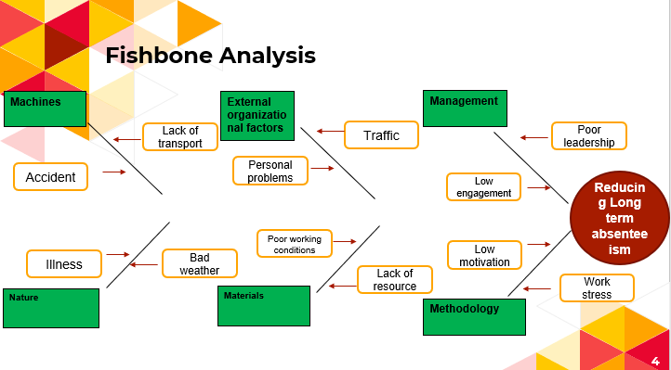
Figure 1: Fishbone analysis of healthcare absenteeism (Mashta, 2021).
Machines: Health care workers at MCHT are afraid of getting into an accident, even though the industry now provides numerous advantages to those who work there. In addition, they have a problem with transportation which can cause absenteeism (Aniyan, 2021).
Nature: The nature of work in healthcare is stressful. Sometimes healthcare workers in hospitals like MCHT can get frightened while handling patients. They can feel mental trauma by seeing the death of patients. So the nature of work is assumed to cause absenteeism in healthcare (Izadi, 2020).
External Organizational Factors: There are various external factors that can contribute to absenteeism in healthcare organizations like MCHT. These factors include political, economic, technological, socio-economic, legal, and environmental. The impact of these factors has been thoroughly discussed in the next section.
Materials: Healthcare provider MCHT may not have sufficient resources which can cause healthcare absenteeism (Aniyan, 2021).
Management: Ineffective management planning can cause employee absenteeism. For example, if the management of MCHT doesn’t have a good compensation system for the employees, they will feel undervalued. Their commitment will reduce. As a result, they become irregular in their duty (Aniyan, 2021).
Methodology: Health care providers in MCHT are under a lot of stress, which leads to a lot of discontent among their employees. The underlying methodology of providing service may not be convenient to staff.

Pestle analysis of the problem
For every healthcare business, PESTEL analysis is an essential aspect of strategic management. In addition, it provides a cost-effective method of scanning the environment. Useful for identifying elements that influence an industry or company's actions. To see how external factors affect MCHT, a pestle analysis has been used below:

Political factors: The National Health Service (NHS) in the United Kingdom, like all other institutions in the country, is expected to be adversely impacted by Brexit. Healthcare organizations like MCHT will suffer greatly if it is forced to leave. Even though it is impossible to predict how Brexit would affect the NHS, a number of political and economic specialists have expressed concerns (Iacobucci, 2021).
Resource deficiency is one of the most pressing challenges. From throughout the EU, they export a large number of pharmaceuticals and medical supplies to the UK. Once Brexit happens, the markets will be thrown into a loop, and people will be forced to struggle with a severe shortage of life-saving medications (Iacobucci, 2021). Another problem that might harm MCHT is a shortage of staff. The NHS employs a large number of people from countries other than the United Kingdom. There will be a reduction in the supply of skilled people following Brexit. There will be a shortage of workers in the NHS as a result of this. So when organizations like MCHT have a shortage of medical staff, the existing staff has to overwork which may increase absenteeism.
Economic factors: Throughout Britain, businesses have been harmed by the economic downturn, with many unable to maintain their quality standards. The recent outbreak of coronavirus has worsened the situation. Due to a shortage of resources and a variety of economic laws, organization like MCHT was forced to lower the compensation of their employees (Mahase, 2021). NHS staff resigned as a result, and less competent workers were brought in to replace them. Even though the financial crisis occurred a decade ago, the NHS is still feeling its impacts, since it is no longer performing at its previous level.
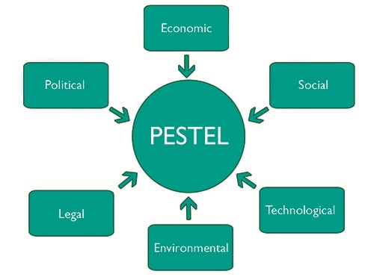
Figure 2: PESTLE analysis of absenteeism in the UK (Cowper, 2020).
This economic crisis due to the pandemic has also prompted the UK government to implement austerity measures (Cowper, 2020). Many hospitals like MCHT saw their funding slashed as a result of these initiatives. As a result, austerity measures by the government had an indirect impact on the NHS's budget. In addition to the financial pressures imposed by the financial crisis and pandemic, an organization like MCHT has been also forced to cut salaries which have resulted in increased absenteeism.
Social factors: Average life expectancy in the United Kingdom is rapidly growing. This is a worldwide occurrence because of the differences in the populations of the different generations. As people become older, their health issues also get worse. Diabetic and cancer-related deaths are on the rise, in part because of the aging population (Peila and Rohan, 2020). As a result, the NHS is under even more burden, making it nearly impossible for an organization like MCHT to keep up with the rising demand for healthcare services as a whole. As a result, they have seen an increase in absenteeism.
Technological factors: technological advancement in the medical field has benefited NHS and the organization alike. One of the external factors that have contributed massively to the NHS is technological advancement (Walley and Davies, 2021). Scanners, x-ray machines, and other high-tech equipment are now standard in most UK hospitals like in MCHT. Because of these technological improvements, the NHS can now give high-quality and fast healthcare to every patient. This helps organizations reduce absenteeism.
Legal factors: Patients who are dissatisfied with the quality of treatment they receive from the NHS are increasingly lodging legal complaints. A patient's family member may file a lawsuit because they think an organization like MCHT has treated the patient unfairly (Hoxsey, 2021). Unhappy patients have brought several lawsuits against the NHS in the past. New and costly challenges await the organization like MCHT as a result of this new development. Healthcare staff fears that they may face a lawsuit if they fail to handle the patient’s situation which may prompt them to be absent from work.
Environmental factor: The medical business is a major source of hazardous waste piling up throughout the globe. In addition to the present problem that our climate is suffering, all medical organizations like MCHT are under a lot of criticism. They have a lot riding on their ability to handle trash and resources with the utmost care. This increased pressure on healthcare staff in the organization like MCHT cause absenteeism.

Cause and effect analysis of the problem
Grid analysis:
As can be seen from the absence rate grid, a staff absence rate of 7% is deemed Medium. An annual rise of 3% is not insignificant, but a 3% increase from the previous year is. Using the grid, medium and higher performance levels appear to intersect at the orange level.
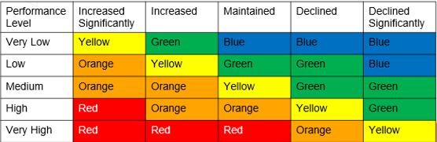
Figure 3: Grid analysis (Source: Author)
Cause and effect analysis:
The main causes of absenteeism in healthcare organizations like MCHT are as follows-
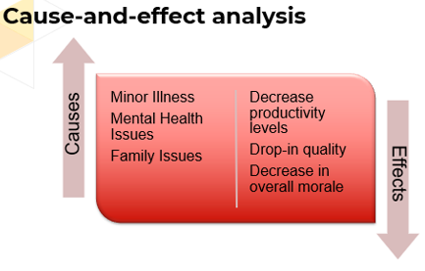
Figure 4: Cause and effect of absenteeism (Izadi, 2020).
Illness: A typical excuse for leaving work is an illness, however, this is not usually the real cause behind it. During the cold and flu season, both full and part-time staff at MCHT see a significant increase in the absence (Izadi, 2020).
Family issues: Taking care of an elderly family member may necessitate an unplanned leave from work on occasion. If the plans go through or a family member becomes sick, this might be the reason for staff absenteeism in the MCHT. To balance work and family life, it is usual for healthcare staff with children, especially those in high-demand professions like medicine, to seek time off for child-rearing obligations. This might cause to increase in absenteeism in the MCHT (Hoxsey, 2021).
Mental health issues: Depression is the most common reason for employee absences in the United Kingdom. Using drugs or alcohol can lead to substance dependence in those suffering from depression. As a result of the epidemic, healthcare workers have had to put in long hours. This is based on their personal experiences when they have witnessed companies like MCHT devolve into chaos and disgruntled consumers. Healthcare workers at MCHT might suffer from anxiety, sleeplessness, and even depression if they don't have any safety nets in place at work. It increases absenteeism (Hoxsey, 2021).
There are the various effect of these causes which are as follows-
Decrease productivity: As performance deteriorates, so does the necessary productivity in terms of job quality and work quantity. In addition, managers at MCHT must strive to reorganize projects or shift deadlines while employees are absent. Absenteeism increases pressure on other employees. If it happens regularly, other employees at MCHT may need to take more responsibility which can burn out them. This can eventually demotivate them to work and lead to decreased productivity (Donovan, Moore and VanDenKerkhof, 2019).
Drop-in quality: An employee who frequently misses work will not perform as well as others who do not. So patients will be affected. In the eyes of the patients, these sudden adjustments might be seen as unprofessionalism and dishonesty. In the healthcare profession, trust is tough to earn and much more difficult to regain after it has been lost. So increased absenteeism in the MCHT can lead to dropping their overall service quality (Halpern, 2019).
Decreased morale: Emotional exhaustion from working in an insecure setting with a large workload may quickly demotivate any professional. Dissatisfaction and hopelessness can set in when employees believe that circumstances beyond their control prohibit them from accomplishing their best work. Absenteeism in an organization like MCHT can put pressure on employees who don’t miss work. But their enduring capability can diminish if the absence rate is not implored. As a result, their work ethics and morale can be affected.

The alternative solution to absenteeism
Employee recognition and rewards: To avoid absences, employees should be properly recognized by MCHT for their efforts. Rewards should be provided when they are needed.
Policy refinement: Employees must be encouraged by MCHT to come to work on a regular basis by a change in the institution's policies (Halpern, 2019).
Feedback and communication: Employees' concerns should be handled seriously and addressed in a timely manner by MCHT using appropriate channels of communication.

Identifying the best solution by using a decision-making matrix:
Solutions | Time  (5) | Money/budget  (5) | Effort  (5) | Complications  (5) | Support from the government  (5) | Total
- Employee recognition and rewards | 4 | 3 | 5 | 4 | 5 | 21
- Policy refinement | 4 | 4 | 4 | 3 | 3 | 19
- Feedback and communication | 3 | 4 | 4 | 3 | 4 | 18
Figure 5: Decision-making for the best solution (Source: Author).
Employee recognition and awards will be the most effective option from the above matrix, based on the solutions outlined above. The MCHT healthcare team will be more supportive of this plan despite its greater complexity and larger expenditure.

A plan has been implemented to solve the problem and the success indicators
Employee rewards and recognition plan:
The employee rewards and recognition plan can be adopted by MCHT is “Payment based on productivity”. This is a great method to recognize and reward those that go above and beyond in MCHT. Its primary objective is to raise productivity and inspire people to strive for greater heights which will eventually reduce absenteeism in MCHT (Gunawardena, 2022).
Measuring success indicators:
Performing roles and responsibilities: How Employees at MCHT manage to complete their roles and responsibilities will be evaluated every week. Those who perform better will be scored between one to five. The final measurement of their performance will be evaluated monthly. Those who will score more will be rewarded (Gunawardena, 2022).

Conclusion
The causes and consequences of employee absenteeism can be uncovered via solid research. A variety of analyses have been performed in this presentation, allowing for a complete examination of the absence of employees. With the help of these methods, this issue may be resolved quickly and easily. The best solution for reducing absenteeism is rewarding and recognizing employees for their work.

References
Aniyan, A., 2021. Absenteeism and Factors Affecting Absenteeism. International Journal of Nursing &amp; Midwifery Research, 05(01), pp.27-31.
Cowper, A., 2020. Emerging tensions will affect how the NHS uses its new money. BMJ, p.m767.
Donovan, T., Moore, K. and VanDenKerkhof, E., 2019. Employee Absenteeism Based on Occupational Health Visits in an Urban Tertiary Care Canadian Hospital. Public Health Nursing, 25(6), pp.565-575.
GAUDINE, A. and GREGORY, C., 2020. The accuracy of nurses' estimates of their absenteeism. Journal of Nursing Management, 18(5), pp.599-605.
Gunawardena, I., 2022. Reward management in healthcare. British Journal of Healthcare Management, 17(11), pp.527-530.
Halpern, M., 2019. Impact of smoking status on workplace absenteeism and productivity. Tobacco Control, 10(3), pp.233-238.
Hoxsey, D., 2021. Are happy employees healthy employees? Researching the effects of employee engagement on absenteeism. Canadian Public Administration, 53(4), pp.551-571.
Iacobucci, G., 2021. No deal Brexit will have a “catastrophic” impact on the NHS, BMA warns. BMJ, p.l5343.
Izadi, N., 2020. The Trend of Sickness Absenteeism among Health Care Workers. Public Health Open Access, 4(1).
Mahase, E., 2021. NHS reorganisation must not be rushed through during pandemic, leaders warn. BMJ, p.n431.
Mashta, O., 2021. NHS absenteeism is a “festering sore,” study says. BMJ, p.d5327.
Peila, R. and Rohan, T., 2020. Diabetes, Glycated Hemoglobin, and Risk of Cancer in the UK Biobank Study. Cancer Epidemiology Biomarkers &amp; Prevention, 29(6), pp.1107-1119.
Walley, P. and Davies, C., 2021. Implementing IT in NHS hospitals - internal barriers to technological advancement. International Journal of Healthcare Technology and Management, 4(3/4), p.259.

