An Analysis: Academic Skills and Their Importance

Students:
Mihai Tilea (2124071)
George Chiras (2120095)
Ionel Golovatii (2228604)
Roman Grigoriev (2229684)

University Of Wales Trinity Saint Davis
Module: LCBB4006_LON
Lecturer: Lizeta Demitroiu
Date: 28.04.2023

Contents
Introduction by George Chiras 3
Time Management by Roman Grigoriev 3
Definition 3
Techniques of time management 4
Benefits of time management 4
Teamwork by Mihai Tilea 5
Definition of Teamwork 5
Importance of teamwork in Academic Success 6
Importance of teamwork in Professional Success 7
Tuckman Model of Team Development 7
Example of Teamwork 7
Paraphrasing and Summarizing by George Chiras 8
Definition of paraphrasing and summarizing 8
Importance of paraphrasing and summarizing skills in academic writing 8
Paraphrasing and summarising examples 9
Final tips for improving paraphrasing and summarizing abilities. 9
Referencing by Ionel Golovatii 10
What is referencing 11
How to do academic referencing 11
Importance of referencing in the academic community 12
Conclusion by Ionel Golovatii 12
References 13

Introduction by George Chiras
In today's academic environment, possessing strong academic skills has become increasingly essential. Academic skills are a set of abilities that help individuals to succeed in higher education and beyond. These skills enable individuals to manage their time effectively, collaborate with others, avoid plagiarism, and accurately represent the ideas of others (Cottrell, 2019). While each of these skills is vital, the ability to communicate and present ideas effectively is especially important. In this written work, we will explore the importance of academic skills and how they can be developed and utilized to achieve success in academic and professional settings. We will also discuss the ways in which individuals can enhance their academic skills through practice, training, and continuous learning (Cottrell, 2019). By the end of this report, readers will have a greater understanding of the significance of academic skills and the strategies for acquiring and improving them (Cottrell, 2019).

Time Management by Roman Grigoriev

Definition
According to Cottrell ( 2019), time management is the process of planning, organizing, and controlling how much time you spend on various activities to achieve your goals and maximize productivity. It also involves setting objectives, prioritizing tasks, and employing time management strategies. The objective of using time effectively is to utilize your time productively and successfully, so you can achieve more significantly quicker and diminish pressure and burnout. Due to the fact that it assists individuals in managing their workload, meeting deadlines, and achieving their goals, time management is an essential skill in both personal and professional settings.

Techniques of time management
Prioritization: The process of identifying and concentrating on the most pressing tasks is known as prioritization. To-do lists and task managers can occasionally assist individuals in prioritizing tasks (Covey, 1989).
Time Blocking: Time blocking includes booking explicit blocks of time for various assignments. Staying focused and avoiding distractions can be made easier with this strategy (Newport, 2016).
Method of the Pomodoro: The Pomodoro method involves working for 25 minutes at a time before taking a brief break. According to Cirillo (2006), this method can help you maintain focus and avoid burnout.
Elimination of time-wasting activities: Distinguish exercises that burn through your time and dispose of them. For instance, limit your virtual entertainment utilization or keep away from multitasking (Newport, 2016).
Delegation: Delegating responsibilities to others who are better equipped to them is known as delegation. You can make more time for more important tasks by using this method (Cottrell, 2019).
Tracking time: Time tracking is the process of recording how much time you spend doing different things. Using this method, you can figure out where you might be wasting time and make changes to increase productivity (Cottrell, 2019).
Goal setting: You can stay focused and motivated by setting goals that are specific and measurable. Set attainable goals with the help of tools like SMART goals (Doran, 1981).

Benefits of time management
The benefits of time management are numerous and can have a positive impact on your personal and professional life. The key benefits are:
- Increased productivity: by managing your time effectively.
- Reduced stress: when you have clear plan for how you will spend your time.
- Improved focus: time management helps you prioritize your tasks and focus on the most important ones.
- Better decision-making: when you have a clear understanding of how much time you have available and what tasks you need to complete.
- Increased motivation: when you see progress towards your goals, it can be motivating and help you stay on track.
- Improved work-life balance: By managing your time effectively, you can create more time for the things that are important to you outside of work.

Teamwork by Mihai Tilea

Definition of Teamwork
Working in a team improves the quality of the work as the implementation of thoughts and ideas of every member of the team provides a better quality of the work. Not only that teamwork allows for completing the work at a faster rate increasing the productivity of the team which will be beneficial for the growth of the company (Schmutz, Meier and Manser, 2019). The term teamwork not only defines working in a group of people but also enhances the potential of every member of the team. This not only allows the completion of work at a faster rate but also completes it with new and innovative ideas allowing better quality results. Every employee seeks this skill of teamwork for representing better performance in the workplace (Kerrissey, Satterstrom and Edmondson, 2020). This allows for an increase in the productivity of the employee and creates a collaborative and motivated environment in the workplace of the organisation. This allows the organisation to achieve their targeted goals and be in a profitable stage easily.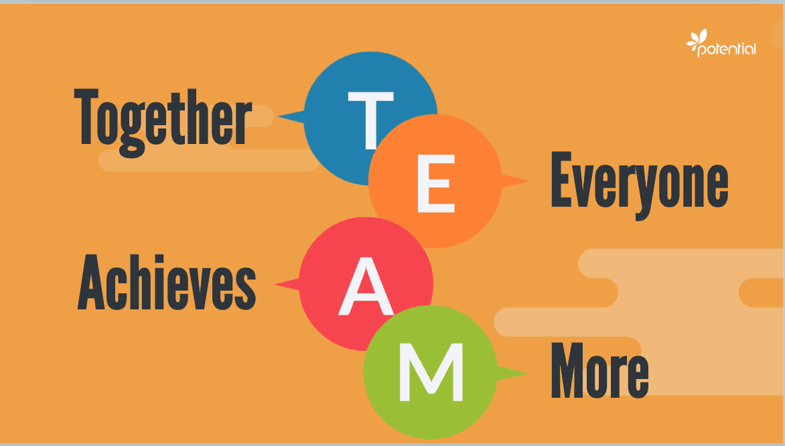
Figure 1: Teamwork
(Source: Potential, 2021)

Importance of teamwork in Academic Success
Collaborative work allows students to complete their projects at a faster rate. This allows them to represent a better quality of the project allowing each other to build strengths which will be beneficial for the growth of the career. The collaborative projects allow the student to share their knowledge with the members of the team allowing them to understand the topic properly and show a better performance in completing the project (Rydenfält, Borell and Erlingsdottir, 2019). This improves the quality of the projects as well as allows the student to learn new things which will increase their knowledge capacity and make them eligible for future projects. However, every institute and college should make their students understand the importance of teamwork and allow them to practice the same. Allocating them to collaborative projects will improve their communication skills and make them understand the importance of teamwork. This will not only build their communication skill but also their social skill allowing them to know the thoughts and ideas of different students coming from different cultures. Therefore, the confidence of each student will increase and will be eligible to express their thoughts and ideas without any fluctuation. However, this will make them practice working in a team before getting employed.

Importance of teamwork in Professional Success
The ability to blend in a team and work cooperatively increases the work capacity of a person. A person needs to understand the importance of teamwork during his academic career so that he can perfect the skill before reaching his professional field. Within a team, a person will know how to gather knowledge from his teammates. Apart from that, it motivates a person to work beyond his capabilities as he becomes a part of a group where some people exceed his capability or skill. This helps to boost the current skill level of a person and makes it easy to represent collaborative work as they hold the practice of working in a team creating a better opportunity for their future. Working in a team also allows us to reduce stress during pressured hours (Holmes, Vifladt and Ballangrud, 2020). The sharing of ideas between the members of the team allows the sharing of knowledge and innovative ideas allowing the employees to represent a better quality of the work. However, the skills of an individual working in a team get improved which allows the employee to get better opportunities which will be beneficial for the growth of the career.

Tuckman Model of Team Development
The Tuckman model of team development is a widely recognized model that explains the stages of team development. The model consists of four stages: forming, storming, norming, and performing (Alex Jones, 2019). During the forming stage, team members get to know one another and begin to establish their roles within the team. In the storming stage, conflict and tension can be observed as team members begin to present themselves and their ideas. During the norming stage, team members begin to connect with one another, reach agreements and have expectations as a group. Finally, during the performing stage, the team should be fully functional, with team members working together effectively to achieve their goals and objectives.

Example of Teamwork
In a hospital environment, for example, upon the patient's arrival with a serious illness, a group of people with different skills and expertise will collaborate to provide the necessary treatment. The nurse will administrate medication and take the vital signs of the patient, while the physician will prescribe medication based on medical records and current condition, and the carers will provide support and personal care. In essence, the carers, the physicians and the nurses will work together as a team to bring the best treatment for the patient during the stay.

Paraphrasing and Summarizing by George Chiras

Definition of paraphrasing and summarizing
Paraphrasing and summarizing are techniques used to restate information from a source in one's own words, without changing the original meaning of the text. According to Cottrell (2019), paraphrasing involves rewording a passage of text so that it conveys the same meaning as the original, but with different words and sentence structures. This technique is useful for incorporating information from sources into one's own writing while avoiding plagiarism. Summarizing, on the other hand, involves condensing a larger piece of text, such as an article or book, into a shorter summary that highlights the main points or ideas (Cottrell, 2019). This technique is useful for providing an overview of a text or for helping readers to quickly grasp the key concepts. Both paraphrasing and summarizing require a good understanding of the original text, and the ability to communicate the ideas effectively in one's own words. These techniques are commonly used in academic writing, as they help to avoid plagiarism and demonstrate an understanding of the subject matter.

Importance of paraphrasing and summarizing skills in academic writing
In her book "Skills for Success: The Personal Development Planning Handbook", Cottrell (2019) emphasizes the importance of paraphrasing to show that one has engaged with the material and can explain it in their own words. She notes that paraphrasing requires a thorough understanding of the original text and the ability to rephrase it without changing the meaning, however, by summarizing, writers are forced to analyse the material and identify the most important information, which helps to deepen their understanding of the material and to develop stronger arguments and ideas. This is particularly useful when discussing lengthy or complex texts, as it allows the writer to highlight the most important information for the reader.

Paraphrasing and summarising examples
Is important to comprehend differences between paraphrasing and summarising in academic writing, in view of this topic, examples are provided to make a refine understanding of the text.
Original text:
"Many people enjoy watching movies in their free time."
Paraphrased text:
A lot of individuals find pleasure in watching movies during their spare moments.
Original text:
"The book provides a comprehensive overview of the history of art, from ancient cave paintings to contemporary works. It discusses the different styles and techniques used by artists throughout history and includes numerous examples of famous artworks."
Summarised text:
The book offers a complete overview of art history, covering the various styles and techniques used by artists from ancient cave paintings to modern works. It includes examples of well-known artworks.

Final tips for improving paraphrasing and summarizing abilities.
Improving your paraphrasing and summarizing skills is a continuous process that requires practice and dedication. Final tips to enhance academical literature abilities in university are provided. To rewrite or shorten a written piece, must be focused to understand what it is about and what it means by reading and understanding the original text. Try using different words and phrase patterns. A good advice is to avoid replace words with synonyms. Instead, try to rewrite the text using different sentence forms and word choices. Ensure that the core of the important notion is not lost. When you are providing a summary of a piece of writing, the key argument and the most essential points are the aspects of the writing that need the greatest focus and attention from you.
Consistent practise is essential in improving one's ability to paraphrase and summarise effectively. The frequency of practise correlates with the level of proficiency attained in these skills. By following these tips, it can improve the paraphrasing and summarizing abilities and avoid unintentional plagiarism. Remember that developing these skills takes time and effort, but the benefits are worth it, as they will help to communicate more effectively and succeed in academic and professional environments (Cottrell, 2019).
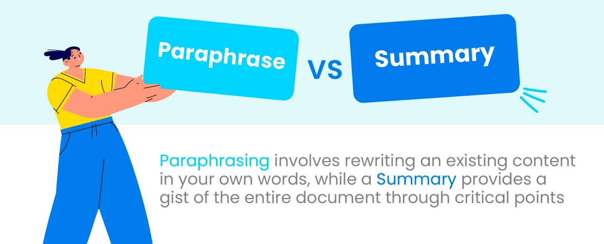
Figure 1: Paraphrasing and summarising
(Source: Paraphrase Vs. Summary: What is The Difference And How to Use Them?)

Referencing by Ionel Golovatii
In a modern world where information is easily accessible, the protection of the intellectual property is regulated by law. In the academic community, one of the most important tools to avoid breaching intellectual property rights is referencing. Referencing is acknowledging the source of information you have used in your writings to provide the reader with an accurate idea of how you have used others work to develop your own arguments and ideas. By citing the ideas of a source, we respect the intellectual property rights of that source and give credit to the work done. Accurate and diversified sources referencing gives more credibility to your writings and allows the reader to dive deeper into the various aspects of the discussed matter (Newcastle University, Academic Skills Kit, 2023).
It is imperative to create a habit of disciplined and precise referencing as this skill will allow you to succeed in your academic and professional activity. In order to create an effortless habit, it is necessary to understand what is referencing; how to do academic referencing; the importance of referencing in the academic community.

What is referencing
As stated above, referencing is a method of acknowledging someone’s ideas used in your research. Whether you are representing a point with a picture, quoting or summarising an idea from a book, or paraphrasing an opinion from a journal, you must give credit to the original author of the work. The following types of sources can be used as references for your academic works: books, journal articles, magazines, newspapers, websites, online discussion forums, interviews, brochures, documentaries, printed pictures, diagrams, etc (Smith, 2023).
There are many referencing styles and an appropriate selection of a particular one depends on the academic discipline involved. For example:
APA (American Psychological Association) is used by sciences, psychology, and education.
MLA (Modern Language Association) style is used by the humanities.
Chicago/Turabian style is used by business, history, and the fine arts.
Harvard style is used for humanities, natural, history, behavioural, and social sciences.
In this writing, the reference will be made to Harvard style book referencing.

How to do academic referencing
Harvard style referencing consists of two parts: in-text citation and referencing list.
In-text citations are brief indications of the source in the text of your work that are inserted immediately after quoted or summarised paragraph and contain the surname of the authors followed by the date of publication and the page if referred to direct quotations or to a particular section of a source. For example: (Kennedy, 2003, p. 17). Note that the full stop is located after the citation (Royal Literary Fund, Resources, 2023).
The reference list is a complete list of all the cited references used with full bibliographic details, to facilitate the reader to find the primary source. For example: Kennedy, D. (1996) New Relations: The Refashioning of British Poetry 1980-1994. Bridgend: Seren.
The referencing list appears in alphabetical order by the author’s surname and is located at the end of your work, after the conclusion (Royal Literary Fund, Resources, 2023).

Importance of referencing in the academic community
One of the first skills learned within an academic environment is referencing. As a beginner in the academic community, it is important to cultivate a respectful attitude toward someone else work as this will lay out a solid path to a social environment based on fairness and equality.
Apart from giving credit to the author of the research and original text, thus allowing to avoid plagiarism and all the consequences that may arise from legal actions, referencing also create the opportunity for the reader to verify the validity of the work by allowing them to locate the sources that were used. Consequently, this opportunity facilitates the enrichment of the reader's knowledge and lay a foundation for future research and the promotion of knowledge sharing (Nyadzi, 2023).
Referencing demonstrates an understanding of the topic you are working on. You will be recognised as a good author only if you write academic content in the correct referencing way.
Referencing is a critical aspect of the academic environment as the correct use of this tool can lead to personal development not just for the writer but for the reader as well, consequently creating the path for a society based on intellectual correctitude.

Conclusion by Ionel Golovatii
As a final thought, it is important to remind the reader that the purpose of academic skills is to enable the learner to develop cognitive abilities and behavioural patterns that will facilitate development in academic, professional, and personal environments by making a habit of discipline, collaboration with others to achieve a common goal and thinking from different perspectives. In an increasingly complex world, academic skills can provide the solution to keep pace with the development of all aspects of modern society.

References
Cirillo, F. (2018) The Pomodoro Technique: The Acclaimed Time-Management System That Has Transformed How We Work. Crown
Cottrell, S. (2019), Skills for Success: The Personal Development Planning Handbook, Palgrave Study Skills, ed 3, pp. 68-101.
Covey, S.R. (1989) The Seven Habits of Highly Effective People. New York: Simon and Schuster
Doran, G. T. (1981). There’s a S.M.A.R.T. Way to Write Management’s Goals and Objectives. Management Review"
Holmes, T., Vifladt, A. and Ballangrud, R., (2020) ‘A qualitative study of how inter‐professional teamwork influences perioperative nursing’, Nursing Open, 7(2), pp.571-580. Available at: link
Jones, Alex. (2019). THE TUCKMAN'S MODEL IMPLEMENTATION, EFFECT, AND ANALYSIS & THE NEW DEVELOPMENT OF JONES LSI MODEL ON A SMALL GROUP, Journal of Management, 6. p23-28. Available at: link
Kerrissey, M.J., Satterstrom, P. and Edmondson, A.C., (2020) ‘Into the fray: Adaptive approaches to studying novel teamwork forms’, Organizational Psychology Review, 10(2), pp.62-86. Available at: link
Newcastle University, Academic Skills Kit. (2023) 'Good Academic Practice', Referencing: What is referencing?. Available at: https://www.ncl.ac.uk/academic-skills-kit/good-academic-practice/referencing/ (Accessed: 25 March 2023).
Newport, C. (2016) Deep Work: Rules for Focused Success in a Distracted World. London: Piatkus
Priya, J. (2022), Paraphrase Vs. Summary: What is The Difference And How to Use Them? Available at: https://www.scalenut.com/blogs/paraphrase-vs-summary (Accessed: 28 April 2023)
Potential (2021). Available at: link
Rydenfält, C., Borell, J. and Erlingsdottir, G., (2019). ‘What do doctors mean when they talk about teamwork? Possible implications for interprofessional care’, Journal of interprofessional care, 33(6), pp.714-723. Available at: link
Royal Literary Fund, Resources (2023) 'Essay Guide', Quotes and references: MLA, APA, Harvard or MHRA?. Available at: https://www.rlf.org.uk/resources/mla-apa-harvard-or-mhra/ (Accessed: 25 March 2023).
Schmutz, J.B., Meier, L.L. and Manser, T., (2019). ‘How effective is teamwork really? The relationship between teamwork and performance in healthcare teams: a systematic review and meta-analysis’, BMJ open, 9(9), p.e028280. Available at: link
Smith, J. (2023) 'Understand the Importance of Referencing in Academic Writing', Assignment HELP PRO, 9 March. Available at: https://www.assignmenthelppro.com/blog/importance-of-referencing-in-academic-writing/ (Accessed: 25 March 2023).

