Lego spike prime project
Integrating Project – ACHA4008
30/04/24
2317483@student.uwtsd.ac.uk
Daniel Leone (2317483)

Table of Contents
1. Introduction 2
2. Background Research: Robotics in education 2
3. Project Planning & Research 3
3.1 Following a defined line 3
3.2 Overcoming / Avoiding an obstacle 4
3.3 Navigating a maze 5
4. Robot Design 7
7
5. Final Solution: Programming the robot 7
5.1 Main Code block 8
5.2 Following Line code block 9
5.3 Obstacle Code block 10
5.4 Maze Code block 11
7. Evaluation 12
6. References 13

1. Introduction
The aim of this report is to demonstrate the process of developing a complete solution to a maze solving robot, Using Lego Spike Prime. This project will be undertaken as a group of four. The author of this report will detail their own knowledge and understanding of all the requirements involved, and the implementations used within the groups’ final solution. The objectives are to build a robot which is capable of the following; autonomously moving within a defined path, overcoming an obstacle, re-joining the course, and finally solving a physical maze. The robot will require the use of appropriate sensors for navigation and to solve the maze autonomously. An example of a possible course layout has been provided as part of the assignment brief; this can be seen in Figure 1 below.
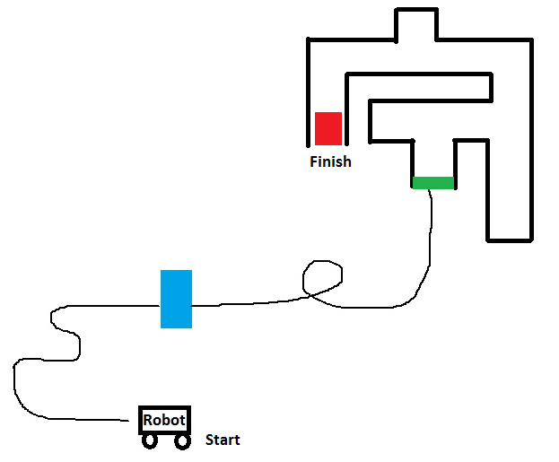
Figure 1 Example route layout

2. Background Research: Robotics in education
Educational robotics have become an invaluable tool within schools, colleges, and universities alike, supporting students of all ages to gain hands-on experience in applying technology to solve real world problems. It is believed that the engaging and hands-on nature of robotics can enhance students’ abilities, both academically and personally. In a journal article written by E. Afari and M.S. Khine [1], It is noted that studies have shown that educational robotics can have a meaningful impact in the following subjects: Physics, Mathematics, Engineering. These studies have also shown that robotics in education can support students’ personal development. This includes cognitive, meta-cognitive and social skills. It is also noted that students can gain important life skills, which become particularly beneficial when entering a workplace. These skills include research skills, creative thinking, decision making, problem solving, communication and teamwork. Additionally, As written in a LinkedIn article published by ‘Nextup Community’ [2], With Artificial Intelligence and Automation becoming increasingly prevalent, those who have previously been exposed to robotics, are likely to be better equipped when entering the job market.

3. Project Planning & Research
The robots’ course can be deconstructed into the following three elements:

- Following a defined line
- Overcoming / Avoiding an obstacle
- Navigating a maze

The research will need to be relevant to each of these elements and should aim to provide foundational knowledge, understanding, and potential techniques that can be implemented when planning the final solution.

3.1 Following a defined line
As written on a Lego Education webpage [3], A simple driving base can follow a line by using the colour sensor. It is suggested that the line should be thick and coloured black. The line should also be on a white, or light-coloured surface. This contrast will ensure that the sensor will perform as accurately as possible, reducing the potential for false inputs. It is stated that the sensor can be used in either ‘Colour Mode’ or ‘Reflected light intensity mode’. A possible programmable solution, provided in the same webpage can be seen in Figure 2 below.
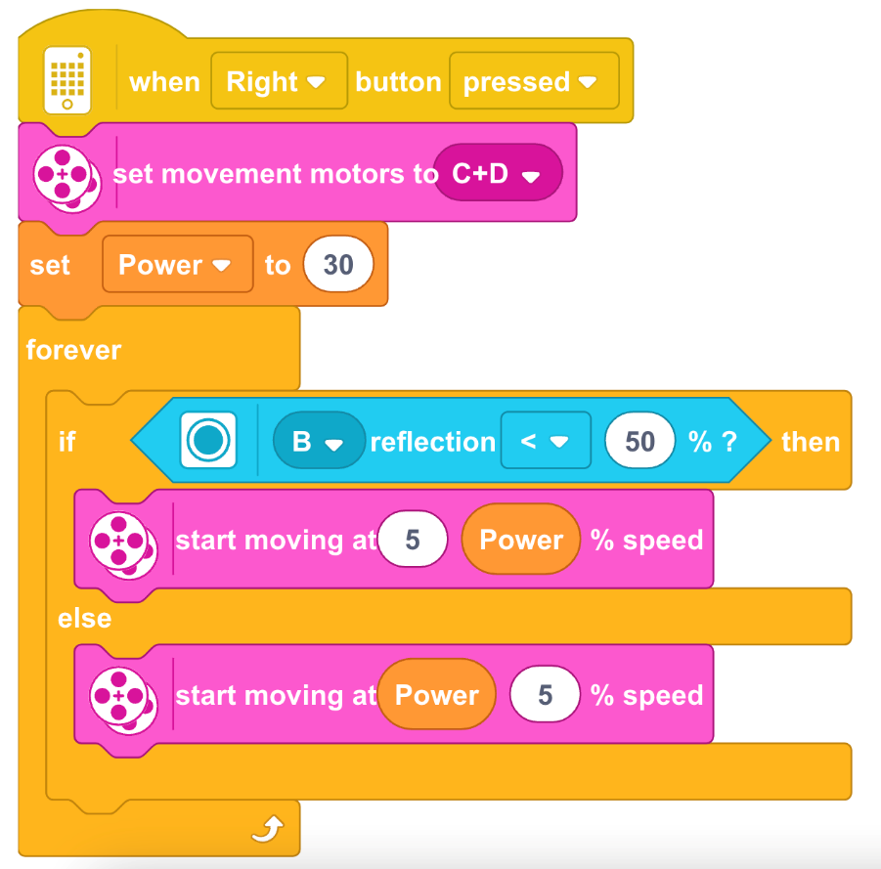
Figure 2 Possible solution: Following a line

The simple driving base makes use of two motors, one on either side of the robot, which are used to drive the wheels.

An image of a simple driving base can be seen in Figure 3, below.
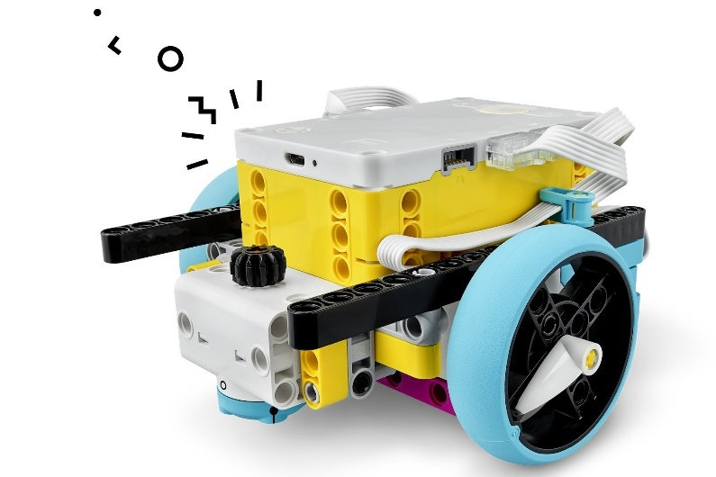
Figure 3: Simple Driving base

An image of the colour sensor can be seen in Figure 4, below.

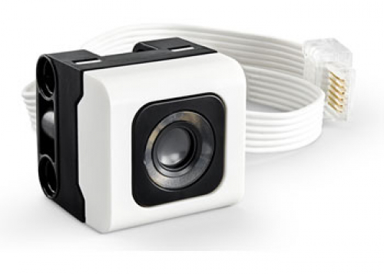
Figure 4 Colour Sensor

Overcoming / Avoiding an obstacle
Another Lego Education webpage​ [4]​ suggests that turning does not require any additional sensors, only the driving base itself is required. Turning movements can be made by using the hubs’ built-in gyro sensor. An example of code has been provided on the Lego webpage, seen in figure 5, below.

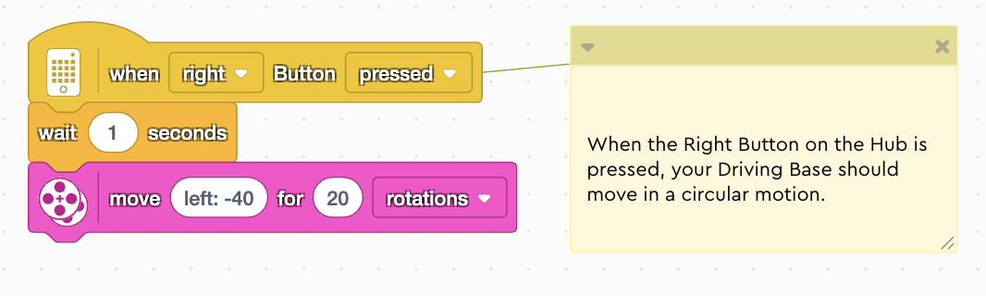
Figure 5 Possible solution: Turning

The robot will need a sensory input to ‘know’ when it needs to execute an alternative branch of code, instructing it to move around the obstacle. In a blog post on the Lego education website [5], Rob Torok describes the force sensor as giving “…your robot a sense of touch”. This force sensor could be used to provide the robot with the necessary input when meeting an obstacle. An image of the force sensor can be seen in figure 6, below.

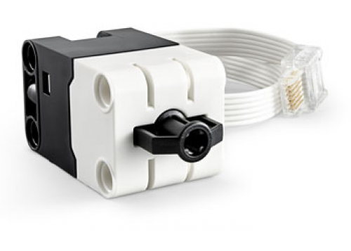
Figure 6: Force sensor

3.3 Navigating a maze
In a post made by ‘Zargos Robotics’ on Instructables.com [6], A simple solution to maze solving is a method known as the “Left hand rule”. This is expanded into the following set of four rules, Figure 7 below:

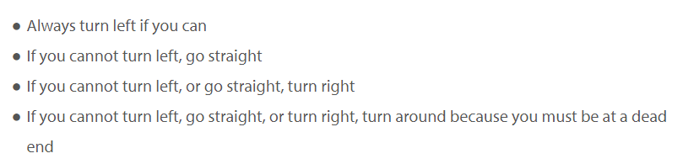
Figure 7: Left Hand Rule [6]
Considering the application of this ruleset, it can be determined that the robot would require the use of two sensors when solving a maze. One sensor should provide the robot with an input from its left-hand side – allowing it to determine whether a wall is present to the left. Another sensor will need to be utilised on the front of the robot – allowing it to determine whether there is a wall in front of the robot.

The force sensor can be utilised at the front of the robot, in the same manner as described in the prior section: overcoming / avoiding an obstacle. The remaining sensor, being the Distance sensor, can be utilised to fulfil the requirement of sensing whether a wall is to the left of the robot. Rob Torok [5] claims that it “works by sending out high frequency sound waves that bounce off any object in range”. Rob Torok also suggests that it can be used for object avoidance whilst moving. An image of the Distance sensor can be seen in the image below, Figure 8.

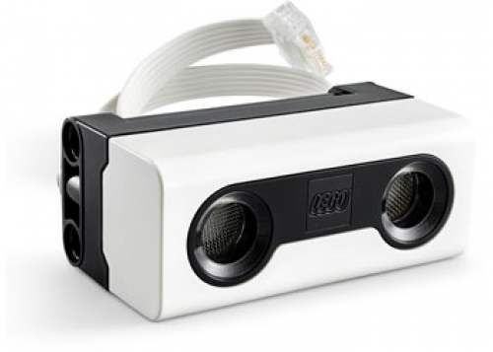
Figure 8 Distance Sensor

4. Robot Design
The robot design was largely influenced by the research undertaken when determining the requirements of solving the overall course. The simple driving base has been adapted and built upon to attach the necessary sensors. The author of this report took a lead in the robots’ initial design and made further adjustments when it was determined that the robot needed to be physically smaller during the testing phase. An image of the robot initial design, with its’ sensors labelled can be seen in figure 9, below.
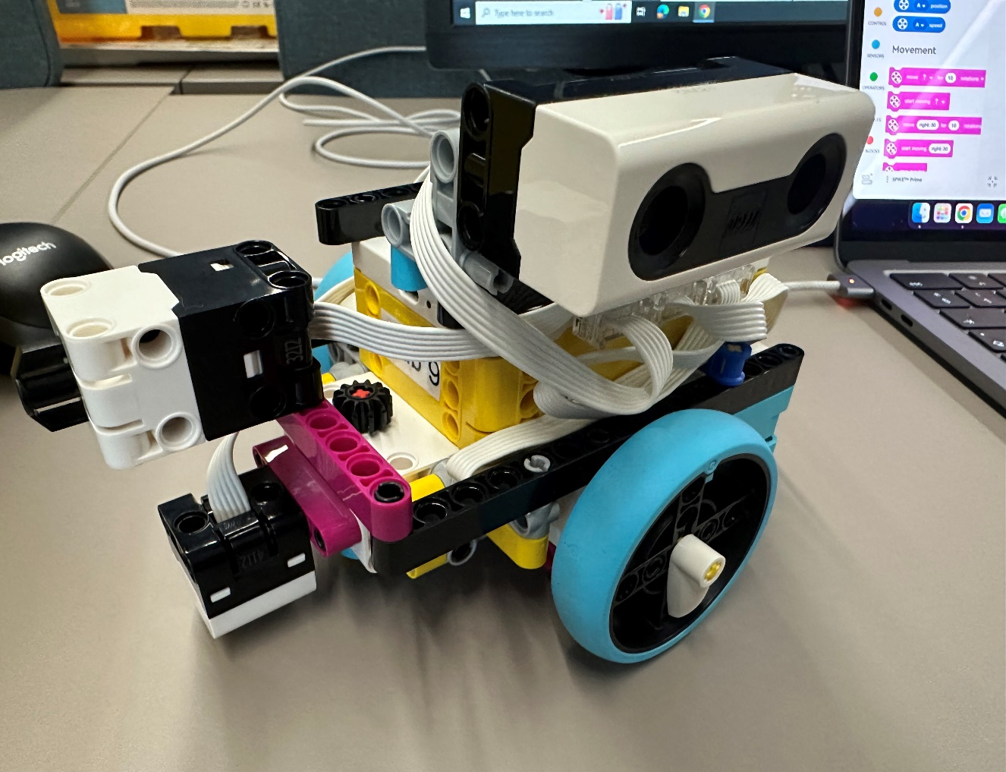
Force Sensor
Colour Sensor
Distance Sensor

Figure 9 Robot Design

5. Final Solution: Programming the robot
As previously noted during in the planning and research stage, the overall problem can be broken down into three separate challenges; Following a line, Overcoming/ Avoiding an obstacle, and navigating a maze. The created progam uses this same decomposition approach within the overall final solution.

5.1 Main Code block
A main block of code has been built which is responsible for firstly setting the variables for the two motors, which drive the wheels. It then has an ordered set of functions to execute.

The main program block can be seen in figure 10, below.

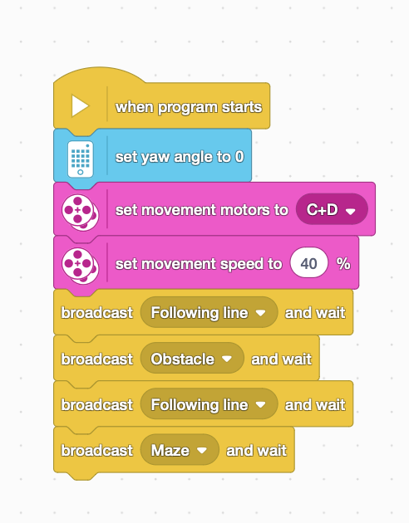
Figure 10 Main Code block

5.2 Following Line code block
The “Following line” block is responsible for moving the robot along the defined line on the ground. The block is a made up of a ‘forever’ loop.

The “Following line” block can be seen in figure 11, below.
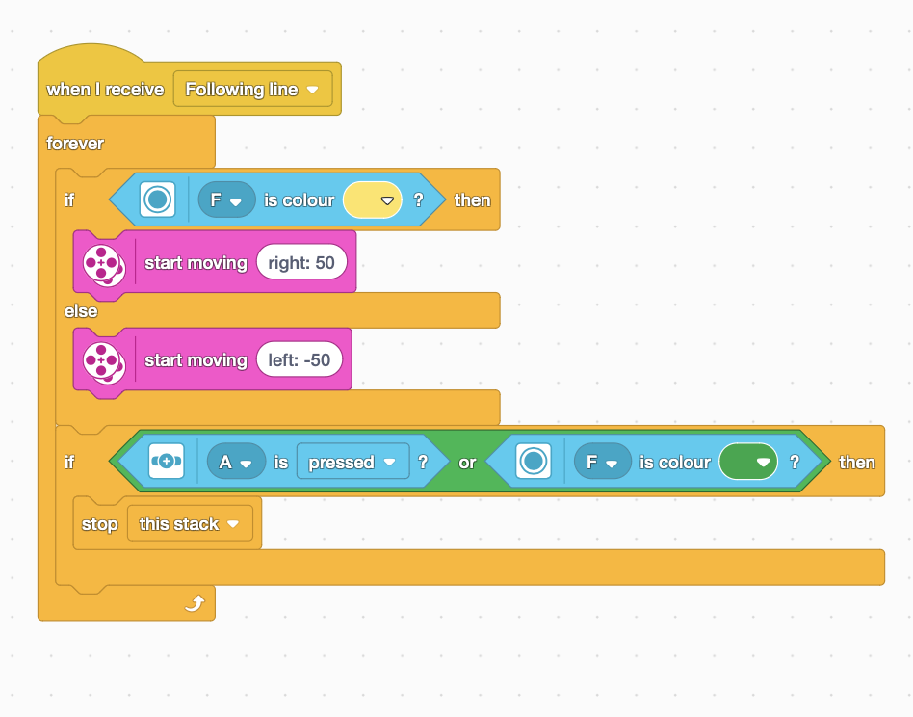
Figure 11 Following Line Code block

5.3 Obstacle Code block
This block of code is responsible for overcoming the obstacle.

An image of the code block can be seen in figure 12, below.

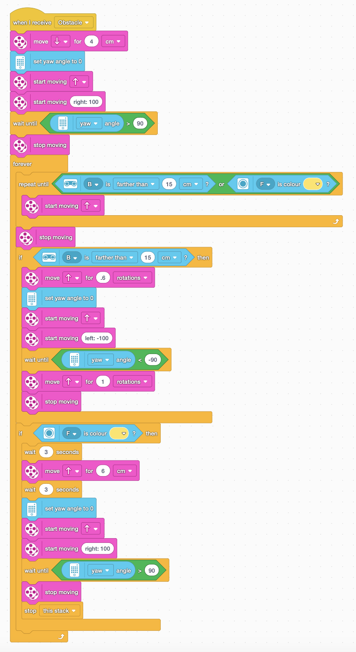
Figure 12 Obstacle Code block

5.4 Maze Code block
This block of code is responsible for solving the maze.
An image of the code block can be seen in figure 13, below.

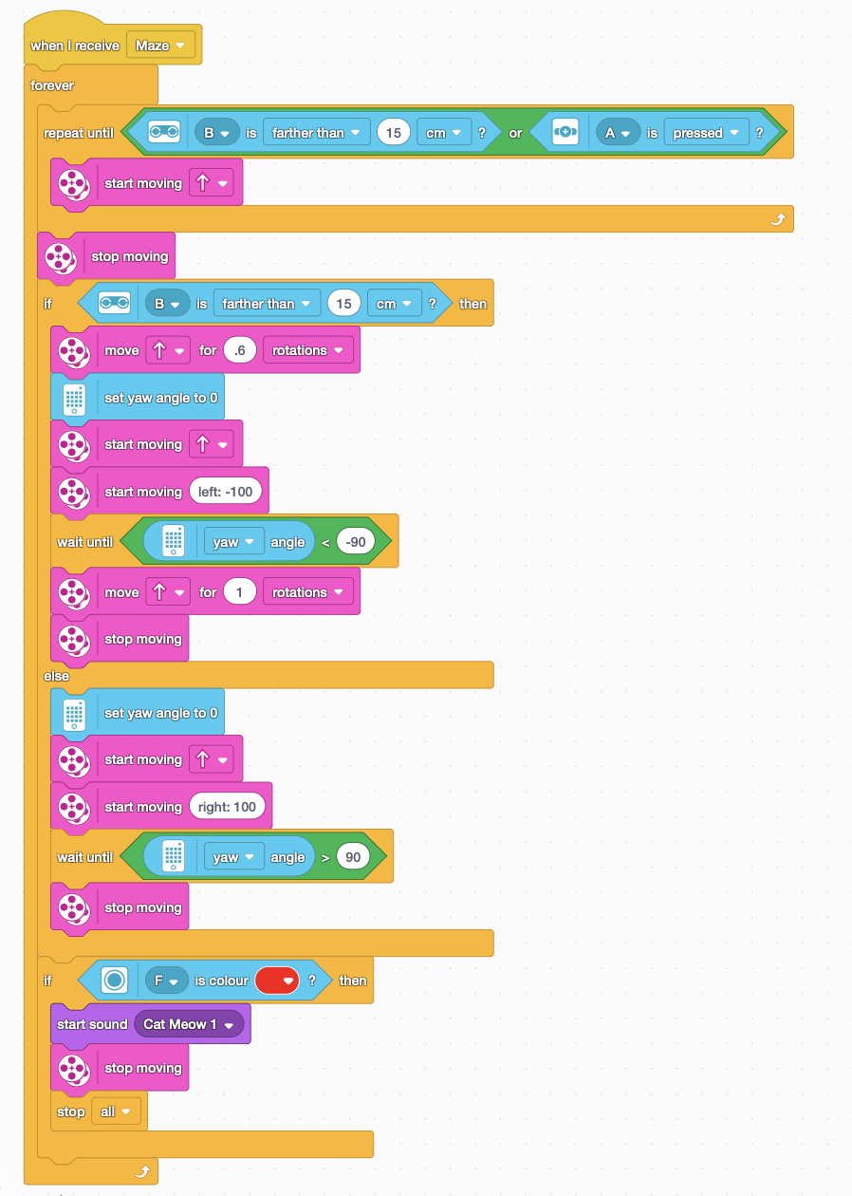
Figure 13 Maze Code block

7. Evaluation
The initial stages of development were straight forward, with the group taking time to share ideas, and collaborate in all aspects of early experimentation. As the project developed further, each team member naturally found their own area of focus, with the author of this report becoming particularly involved in leading the initial design and subsequent modifications of the robot.

One of the most noteworthy challenges faced, was having lost a large amount of code block work, and having to recreate the blocks again from scratch. This occured due to a technical problem with the Lego Spike software. The software had become buggy, and the connection to the robot had stopped working. The software needed rebooting. The data was saved and backed up at this point; however, it turned out that the saved file did not save in its current state, instead it was in a much earlier state, thus a lot of progress had been lost. This technical issue was unavoidable; however, steps could have been taken to make recovery easier. Such as, saving regular screenshots of the code blocks throughout the development.

The second notable challenge came with testing the robot within the maze. The maze was much narrower than originally anticipated, which caused the robot to oftentimes get caught on the edges or corners. This would significantly throw off robots’ alignment, greatly reducing its ability to complete the maze successfully.

During trial runs, the robot did prove to be capable of achieving the overall objective, and can be considered a success in this respect. However, the results were inconsistent, this is largely due to the factor of the robot often becoming misaligned. On reflection, in order to have overcome this issue, the robot would need to be coded in such a way which allows for continuous readjustment of its yaw positioning whilst navigating the maze.

6. References

[1] | M. S. K. E. Afari, “Robotics as an Educational Tool: Impact of Lego,” International Journal of Information and Education Technology, vol. 7, no. 6, pp. 437-442, 2017.
[2] | Nextup Community, “Revolutionizing Education: The Impact of Robotics in the Classroom,” 02 11 2023. [Online]. [Accessed 2027 04 2024].
[3] | L. Education, “Training Camp 3: Reacting to Lines,” [Online]. Available: https://education.lego.com/en-gb/lessons/prime-competition-ready/training-camp-3-react-to-lines/. [Accessed 10 April 2024].
[4] | Lego Education, “Training Camp 1: Driving Around,” [Online]. Available: https://education.lego.com/en-gb/lessons/prime-competition-ready/training-camp-1-driving-around/. [Accessed 27 04 2024].
[5] | R. Torok, “Exploring SPIKE™ Prime Sensors,” Think Like An Engineer, 11 07 2022. [Online]. Available: https://community.legoeducation.com/blogs/31/220. [Accessed 27 04 2024].
[6] | Zargos Robotics, “Robot Maze Solver,” [Online]. Available: https://www.instructables.com/Robot-Maze-Solver/. [Accessed 27 04 2024].

