Module Assignment Submission
Cover Page

Student Name: | Antony Swistun
Student Number: | 1604713
Module No: | BMSP7001
Module Title: | The Challenge of Sustainability

Date submitted: | 08/11/2020
Time submitted: | 13:10

Statement of Confirmation of Authenticity
By the act of making this submission, the student declares that this is the work of the student named above. Where materials have been used from other sources it has been properly acknowledged. If this statement is untrue, the student acknowledges that an assessment offence has been committed. Proven incidents of plagiarism, collusion or cheating can result in a learner being withdrawn from a
qualification.
Attention is drawn to the Plagiarism and Unfair Practice policies of the University and ILM.
Permission for ILM to use this script
ILM uses learners’ submissions – on an anonymous basis – for assessment standardisation. By submitting, both the centre and the learner agree that ILM may use this script on condition that identifying information is removed. However, if you are unwilling to allow ILM use this script, please refuse by ticking the box: □

Contents
Introduction 2
BMSP7001 Magazine Article 2
Conclusion 7
Works Cited 7
Bibliography 8

Introduction
For this assignment, the author shall be looking at how logistics industry can become a zero-carbon industry, in a magazine article format, the author will be looking at the advancements of the logistics company DPD, and others, as part of the research.

BMSP7001 Magazine Article

Green logistics in today’s world.
We are at a time where warehouses are becoming increasingly more efficient, reducing electricity usage through LED lighting systems, using electric powered fork trucks in the warehouses, compared to the diesel, or LPG variants, they are much quieter and produce no fumes or smoke. The recycling of waste products, and ensuring everyone is working smarter, more efficiently, and with a greater sense of empowerment towards sustainability, helping keep costs down.
The effects that have a harmful effect on the environment are being reduced, what can distribution companies now do to help them get to a zero-carbon footprint by 2030, as set out as the target date in the United Nations set of Sustainable Development Goals (SDGs). The Sustainable Development Goals or Global Goals are a collection of 17 interlinked goals designed to be a "blueprint to achieve a better and more sustainable future for all" (United Nations, 2019)
The only remaining large scale pollutants in these scenarios are the continuously used transportation vehicles, the heavy goods vehicles, and the light goods vehicles. Unfortunately, both forms of the vehicles are not very good for the environment, the emissions they produce have a harmful effect on people, wildlife, and the environments around where they operate, also creating noise pollution, especially in villages, and built up areas.
(United Nations, 2019)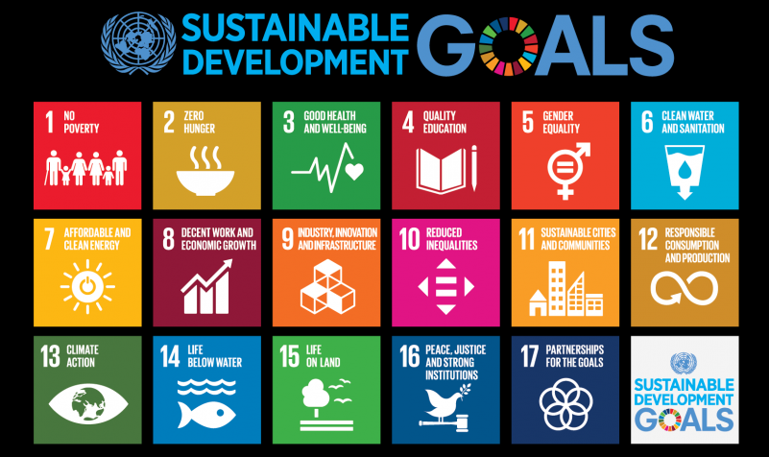
This SDG would be SDG 9, Build resilient infrastructure, promote inclusive and sustainable industrialization and foster innovation.
If we look at these vehicles from a logistics viewpoint, we see that they play an essential role. If we wish to transport goods from a shipping port, airport, railway freight terminal, warehouse, or supermarkets, the quickest, safest, and most cost effective choice is the HGV, due to its range, volume of stock they can transport, and their ability to drop off, and pick up, another trailer, enabling them to be back on the road within minutes. For similar journeys, with a lighter overall weight, the LGVs are preferred, as they are lighter, and better on fuel economy and emissions.
Its undeniable that the logistics industry can have a high impact on the environment. From habitat fragmentation of transport infrastructure development to accidental oil spillages and plastic refuse in the marine world. Add to this pollution from air and road freight. Transport accounts for around a quarter of UK green-house-gas emissions. The good news is that the logistics industry has a greater awareness of these issues than ever before, and in almost every sector, steps are being taken to mitigate against their effects through leading edge technology or best practice.

To address this issue, many companies have decided to introduce several smaller EVs, such as cars, and vans, into their fleet. Swansea City Council’s current fleet of 800 vehicles, has only 41 EVs, as of July 2020, (Swansea City Council Authority, 2020). Whilst these are made up of manly electric cars and vans, the council also operate several electric refuse collection trucks, these can be charged overnight for work the next day. Image from (DALTON, 2018)
Logistics company DPD, have gone a large step further. At the beginning of the year, DPD had only one hundred and thirty EVs within their fleet, now, as the year comes to an end, they have smashed their target of five hundred EVs, by introducing seven hundred EVs into their daily operations fleet. Image of the EVs currently being used in Switzerland. Image from (Kane, 2020)

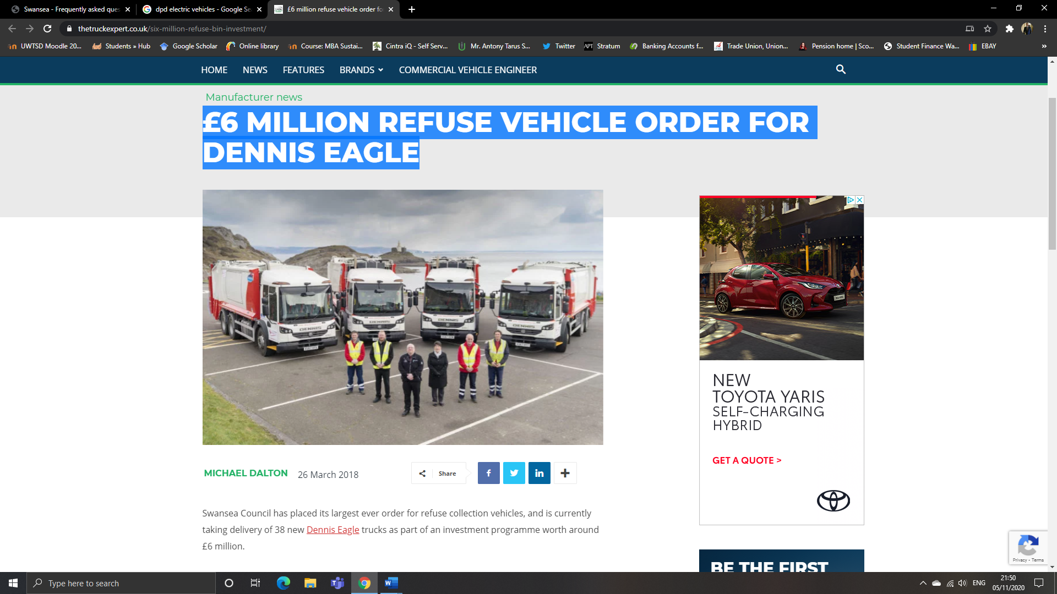 (DALTON, 2018) 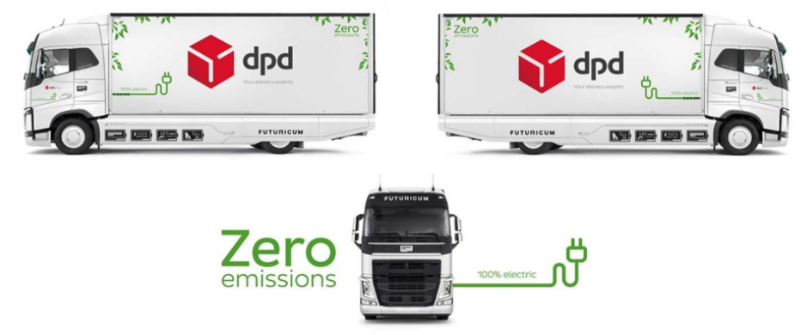 (Kane, 2020)

Dwain McDonald, DPD's CEO commented, "Despite everything that is going on, we've been really focused on getting EVs on the road and delivering for us this year. Yes, you need to be trialling new technology and looking at future concepts, but you have to start making a difference now, and that's what we are doing”. (DPDgroup, 2020)
(Yaw Agyabeng-Mensah, 2020)claim that while green warehousing and logistics optimization negatively influences economic performance, it will improve economic performance through supply chain sustainability.
There are many benefits to running all-electric, or hybrid vehicles in the UK, the operators, and members of the public can apply for funding grants to help ease the burden of purchasing the vehicles and the installation of the charging stations. Grants, and information on the requirements to be approved can be found at (https://www.claim-chargepoint-grants.service.gov.uk).
While the UK government supports and welcomes the use of electric vehicles (EVs), the infrastructure to enable the effective charging of them is still far from complete, the infrastructure of the national grid is still unequipped to deal with the large scale usage of EVs country wide. Other issues are charging times, battery life, range of the vehicles, and access (while expanding greatly), are still insufficient for these larger vehicles.

Map 1 from (Department for Transport, 2020), identifies the number of charging units, in the UK, per 100, 000 residents. Map 2 identifies how many of those units are fast chargers, however, these would only be suitable for cars, vans, and motorcycles. Due to the time it takes to charge, they would be unsuitable for electric variants of the HGVs, and LGVs. Those chargers would be based at the companies that operate the trucks, and motorway service stations.

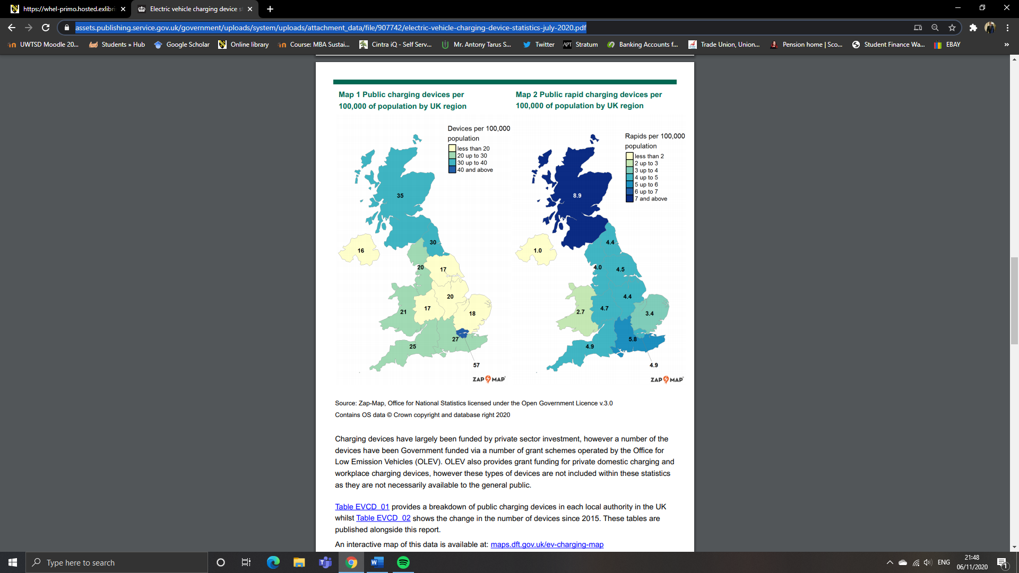

While there are numerous benefits to EVs, what are some of the disadvantages to the environment? While mainly traditional methods of electricity production are being used, there will always be an argument as to “how green can they be?” (Bogdan Varga, 2018), as they need to be powered by electricity from power stations. Thankfully, with the increase in technology advancements, the green alternatives are becoming ever more efficient, producing more, costing less to produce and maintain. The increase in personal electricity generation from people’s homes is also having a positive effect as they can use the electricity generated to power their homes, their vehicles, and sell some back to the national grid.
(RAC Motoring Services, 2020)state that in a survey by the (The European Environment Agency (EEA), 2016), CO2 emissions from electric-only vehicles is 59% higher that combustion vehicles, mainly through the production processes, and the mining and extraction of the materials for the batteries , such as, lithium, cobalt, graphite and nickel. However, once the EV has been produced, that is where their emissions end, unlike traditional combustion vehicles, where this is the start of their emission story. The costs of recycling or replacing the vehicles batteries could also be much higher than the value of the vehicle at that time. The same study claims that EV batteries should (if well maintained) see 150,000 miles before replacement is needed. Due to the costs involved, Volkswagen have in 2019 introduced a scheme which it believes will see 97% of all the raw materials used in new EV batteries reused by 2040.
The socio-cultural changes that are happening indicate that the general public are starting to embrace the concept of the EVs, it is believed that a number of customers to distribution centres such as DPD, are in favour of their efforts, as such, DPD have won numerous awards for their contributions to a greener future. This is also a contributing factor in the large scale expansion of DPDs distribution centres around the UK, the number of employees they have, and keep employed, with a low turnover of staff indicating a high morale within the workforce, a willingness of local people willing to work at the sites, the economic contributions made by those employees to local business, such as local shops, café’s, fuel stations, as they fill their own vehicles on their way to and from work, and go out for lunch on their breaks.
With this year's competition attracting more entries than ever before, DPD topped the following categories:

- Customer Care (for the fourth time in five years).
- Home Delivery Operator (for the fourth time in five years).
- Best use of Technology.
- Clean Fleet Van Operator.
- Urban Delivery Operator
(DPDGroup, 2020)

Due to the culture change commitments DPD has made, companies such as Macmillan Distribution Ltd, a storage and distribution centre for over forty well known publishers, has made DPD there preferred third party logistics courier, as they stand for similar values as their own, which are;
COMMITTING TO SUSTAINABILITY AND ENVIRONMENTAL STEWARDSHIP
We believe by changing our corporate behaviour we can influence other companies to take responsibility for their use of resources and energy and together we can lessen any harm we do. Macmillan is committed to minimising our environmental impact and engaging in practices that will improve our stewardship of natural resources. At a minimum, we aim to comply with the laws, rules and regulations that pertain to the environment, but we expect that we will often exceed legally mandated standards. Our goal as a company is to reduce our carbon usage significantly, which will require active participation by all employees. This means using existing resources wisely and looking for ways to lessen our usage or find sustainable alternatives. We will evaluate vendors based on cost, services offered and their commitment to sustainable business practices. If you believe that any company practice is not in keeping with these goals or have any suggestions on how we can improve our use of resources, let your manager, department head or the Human Resources Department know. (Macmillan Distribution Ltd, 2020)
While these are steps forward towards reaching the companies sustainability goals, what else can be done? With the current reliance on power stations to charge these EVs, a suggested approach would be to install, and utilise, wind turbines, and/or solar panels at the company (gov.uk, 2019) have a feed-in scheme that offers a grant for the purchase and installation of solar panels, and wind turbines, and allows you to sell some back to the National grid at 5.42p per unit generated. There are now many different types of solar panel systems, as well as the traditional large panels on the roof tops, or surrounding the warehouses, there are now special coatings that can be applied to windows, panels that now look like roofing tiles, and even a strip system that can be laid over rooftops, and potentially, in future, on the tops of the EVs themselves, the trailers that they use, constantly recharging the batteries.
No matter how soon a company would like to be sustainable, they will not achieve these goals with the current technology alone, there is always an environmental impact of some sort, governmental policy, company budgets, or just individuals opposed to change, slowing down these processes. All the innovations made to make a greener, more sustainable workforce, will inevitably come at a price to others. We already see manufacturing of combustion engines in decline, while some employees may retrain, others may be made redundant. The business around those sites would see increased losses of income, potentially forcing them to close, also having a knock-on impact on those that supply them.

Conclusion
EVs are a necessity to achieve the goals of becoming a Zero-carbon business, while the impact of the emissions caused during production is high, the zero emissions produced while in operation counteracts those before, (until the batteries need recycling or replacing). While they produce benefits at the moment, they may create longer term issues in terms of battery leakages from accidents on the road, there are also other alternatives that can help this process which bring with them their own sets of benefits and disadvantages, this is the rise of the Hydrogen fuel cell vehicles.

Works Cited
Bogdan Varga, F. M. (2018, 07). Indirect environment-related effects of electric car vehicles use. Environmental engineering and management journal, 17(7), 1591-1597. doi:10.30638/eemj.2018.158
DALTON, M. (2018, 03 26). £6 MILLION REFUSE VEHICLE ORDER FOR DENNIS EAGLE. Retrieved 11 05, 2020, from https://www.thetruckexpert.co.uk/six-million-refuse-bin-investment/
Department for Transport. (2020). Electric vehicle charging device statistics July 220. Retrieved 11 06, 2020, from https://assets.publishing.service.gov.uk/government/uploads/system/uploads/attachment_data/file/907742/electric-vehicle-charging-device-statistics-july-2020.pdf
DPDGroup. (2020). DPD make history with five road transport 'Oscars'. Retrieved 11 07, 2020, from https://www.dpd.co.uk/content/about_dpd/dpd-make-history-with-five-road-transport-oscars.jsp
DPDgroup. (2020). DPD smashes EV target five months early with over 700 electric vehicles. Retrieved 11 04, 2020, from https://www.dpd.co.uk/content/about_dpd/press_centre/dpd-smashes-ev-target-five-months-early-with-over-700-electric-vehicles.jsp
gov.uk. (2019). Feed-in tariffs: get money for generating your own electricity. Retrieved 11 03, 2020, from https://www.gov.uk/feed-in-tariffs
Kane, M. (2020, 07 16). Switzerland: DPD To Use Electric Truck With Largest Battery Available. Retrieved 11 05, 2020, from Inside EVs: https://insideevs.com/news/429066/switzerland-dpd-electric-truck-largest-battery-available/
Macmillan Distribution Ltd. (2020, 10). MACMILLAN CODE OF CONDUCT. Retrieved 11 04, 2020, from http://www.macmillandistribution.co.uk/documentdownload.axd?documentresourceid=29
RAC Motoring Services. (2020). Are electric cars really better for the environment? Retrieved 11 07, 2020, from https://www.rac.co.uk/drive/advice/emissions/are-electric-cars-actually-worse-for-the-environment/
Swansea City Council Authority. (2020). Frequently asked questions about council vehicles. Retrieved 11 05, 2020, from https://www.swansea.gov.uk/councilvehicleFAQs
The European Environment Agency (EEA). (2016). Monitoring CO2 emissions from new passenger cars and vans in 2015. Luxembourg: Publications Office of the European Union. doi:10.2800/85593
United Nations. (2019). Sustainable Development Goals. Retrieved 11 04, 2020, from https://www.un.org/development/desa/disabilities/about-us/sustainable-development-goals-sdgs-and-disability.html
Yaw Agyabeng-Mensah, E. A. (2020, 08 21). Green warehousing, logistics optimization, social values and ethics and economic performance: the role of supply chain sustainability. The International Journal of Logistics Management, 31(3), 549-574. doi:https://doi.org/10.1108/IJLM-10-2019-0275

Bibliography
Forum for the Future. (2020). Sustainability and system change. Retrieved 09 06, 2020, from https://www.forumforthefuture.org/Sustainability and system change
Alke Electric Vehicles. (2019, 04 23). Eco-friendly logistics: discover the Alke' electric vans! Retrieved 11 04, 2020, from Youtube.com: https://www.youtube.com/watch?v=nO39MFUzp5g
Anne Owen, J. B. (2020). Reducing inequality resulting from UK low-carbon policy. Climate Policy, 20(10), 1193–1208. doi:10.1080/14693062.2020.1773754
Bakker, P. (2016). The role of business in climate change. Retrieved 10 18, 2020, from https://www.wbcsd.org/Overview/News-Insights/Insights-from-the-CEO/The-role-of-business-in-climate-change
Beaumont, P. (2013, 6 5). 5 Definitions of Sustainability. (University of Rochester) Retrieved 10 6, 2020, from https://blogs.rochester.edu/thegreendandelion/2013/06/5-definitions-of-sustainability/
Bogdan Varga, F. M. (2018, 07). Indirect environment-related effects of electric car vehicles use. Environmental engineering and management journal, 17(7), 1591-1597. doi:10.30638/eemj.2018.158
Bradley J.Flamm, A. W. (2012, 03). Constraints to green vehicle ownership: A focus group study. Transportation Research Part D: Transport and Environment, 17(2), 108-115. doi:10.1016/j.trd.2011.09.013
Center for Strategic & International Studies. (2019, 12 09). Electric Vehicles: The Future of Development and Deployment. Retrieved 11 06, 2020, from Youtube.com: https://www.youtube.com/watch?v=JYyMBFB39Jo
DALTON, M. (2018, 03 26). £6 MILLION REFUSE VEHICLE ORDER FOR DENNIS EAGLE. Retrieved 11 05, 2020, from https://www.thetruckexpert.co.uk/six-million-refuse-bin-investment/
David M. Herold, K.-H. L. (2017, 10 26). Carbon Disclosure Strategies in the Global Logistics Industry: Similarities and Differences in Carbon Measurement and Reporting. (R. H. Moazzem Hossain, Ed.) Brisbane: Springer, Cham. doi:978-3-319-67702-6
Department for Environmnety, Food and Rural Affairs. (2019). Government introduces ground-breaking Environment Bill. Retrieved 11 04, 2020, from https://www.gov.uk/government/news/government-introduces-ground-breaking-environment-bill
Department for Transport. (2020). Electric vehicle charging device statistics July 220. Retrieved 11 06, 2020, from https://assets.publishing.service.gov.uk/government/uploads/system/uploads/attachment_data/file/907742/electric-vehicle-charging-device-statistics-july-2020.pdf
DPDGroup. (2020). DPD make history with five road transport 'Oscars'. Retrieved 11 07, 2020, from https://www.dpd.co.uk/content/about_dpd/dpd-make-history-with-five-road-transport-oscars.jsp
DPDgroup. (2020). DPD smashes EV target five months early with over 700 electric vehicles. Retrieved 11 04, 2020, from https://www.dpd.co.uk/content/about_dpd/press_centre/dpd-smashes-ev-target-five-months-early-with-over-700-electric-vehicles.jsp
gov.uk. (2019). Feed-in tariffs: get money for generating your own electricity. Retrieved 11 03, 2020, from https://www.gov.uk/feed-in-tariffs
Government Digital Service. (2018, 07 24). Workplace Charging Scheme: grant claim portal for installing charging equipment. Retrieved 11 05, 2020, from https://www.gov.uk/government/publications/workplace-charging-scheme-grant-claim-form-for-installing-charging-equipment
Happonen, A. (2020, 03 23). Decarbonizing warehousing activities through digitalization and automatization with WMS integration for sustainability supporting operations. 2019 7th International Conference on Environment Pollution and Prevention (ICEPP 2019), 158. doi:10.1051/e3sconf/202015803002
International Maritime Organization. (2019). International Maritime Organization. Retrieved 11 04, 2020, from https://www.imo.org/en/About/Pages/Default.aspx#:~:text=As%20a%20specialized%20agency%20of,environmental%20performance%20of%20international%20shipping.&text=And%20IMO%20is%20the%20forum%20at%20which%20this%20process%20takes%20place.
Ivan A. BLAGOJEVIĆ, S. R. (2019). THE FUTURE (AND THE PRESENT) OF MOTOR VEHICLE PROPULSION SYSTEMS. Society of Thermal Engineers of Serbia, 23, 1727. doi:10.2298/TSCI180307177B
Jamal El Baz, I. L. (2017, 10 02). Third-party logistics providers (TPLs) and environmental sustainability practices in developing countries: The case of Morocco. International Journal of Operations & Production Management, 37(10), 1451-1474. doi:10.1108/IJOPM-07-2015-0405
Jonathan Woetzel, R. S. (2017). How technology is reshaping supply and demand for natural resources. Houston: McKinsey Global Institute. Retrieved 11 01, 2020, from https://www.mckinsey.com/business-functions/sustainability/our-insights/how-technology-is-reshaping-supply-and-demand-for-natural-resources#
Jonathan Woetzel, S. N. (2017, 06 02). How the Natural Resources Business Is Turning into a Technology Industry. Retrieved 11 01, 2020, from https://hbr.org/2017/06/how-the-natural-resources-business-is-turning-into-a-technology-industry
Jonn Axsen, S. G. (2016, 08). How might potential future plug-in electric vehicle buyers differ from current “Pioneer” owners? Transportation Research Part D: Transport and Environment, 47, 357-370. doi:10.1016/j.trd.2016.05.015
Jorg M. Ries, E. H. (2017). Environmental impact of warehousing: a scenario analysis for the United States. International Journal or Production Research, 55(21), 6485-6499. doi:10.1080/00207543.2016.1211342
Joshua S.Graff Zivin, M. J. (2014, 11). Spatial and temporal heterogeneity of marginal emissions: Implications for electric cars and other electricity-shifting policies. Journal of Economic Behavior & Organization, 107(PART A), 248-268. doi:10.1016/j.jebo.2014.03.010
Kane, M. (2020, 07 16). Switzerland: DPD To Use Electric Truck With Largest Battery Available. Retrieved 11 05, 2020, from Inside EVs: https://insideevs.com/news/429066/switzerland-dpd-electric-truck-largest-battery-available/
Kelly Sims Gallaghera, E. M. (2011, 01). Giving green to get green? Incentives and consumer adoption of hybrid vehicle technology. Journal of Environmental Economics and Management, 6(1), 1-15. doi:10.1016/j.jeem.2010.05.004
Liu, J. (2020). Studying environmental pollutants and bioavailability for reaching sustainable developement goals. Environmental Pollutants and Bioavailability, 32(1), 68-68. doi: 10.1080/26395940.2020.1751452
LogisticsUK. (2017). Logistics UK and the environment. Retrieved 11 04, 2020, from https://logistics.org.uk/environment
Low Carbon Vehicle Report For The Minister for Economy, Science and Transport. (2015). Retrieved 11 01, 2020, from https://gov.wales/sites/default/files/publications/2019-05/low-carbon-vehicle-steering-group-final-report.pdf
Macmillan Distribution Ltd. (2020, 10). MACMILLAN CODE OF CONDUCT. Retrieved 11 04, 2020, from http://www.macmillandistribution.co.uk/documentdownload.axd?documentresourceid=29
Mahmoud A. Hammad, B. J. (2020, 02). Methods and Models for Electric Load Forecasting: A Comprehensive Review. Logistics & Sustainable Transport, 11(1), 51-76. doi:10.2478/jlst-2020-0004
Maja Izabela. Piecyk, M. B. (2015). Logistics service providers and corporate social responsibility: sustainability reporting in the logistics industry. International journal of physical distribution & logistics management, 45(5), 459-485. doi:10.1108/ijpdlm-08-2013-0228
Manning, J. (2019, 06 26). Power cut – what happens when EVs break down? Retrieved 11 08, 2020, from https://www.fleeteurope.com/en/new-energies/europe/features/power-cut-what-happens-when-evs-break-down?a=JMA06&t%5B0%5D=RAC&t%5B1%5D=AA&t%5B2%5D=Arc%20Europe&t%5B3%5D=electric%20vehicle&curl=1
Martijn Groenleer, M. K. (2010, 11 09). Regulatory governance through agencies of the European Union? The role of the European agencies for maritime and aviation safety in the implementation of European transport legislation. Journal of European Public Policy, 17(8), 1212-1230. Retrieved 11 04, 2020, from https://www.tandfonline.com/doi/abs/10.1080/13501763.2010.513577
Muhammad Khalid Anser, Z. Y. (2020, 08 25). Green Technology Acceptance Model and Green Logistics Operations: “To See Which Way the Wind Is Blowing”. doi:10.3389/frsus.2020.00003
Na Tian, S. T. (2019, 09 01). Measuring regional transport sustainability using super-efficiency SBM-DEA with weighting preference. Journal of Cleaner Production, 242. doi:10.1016/j.jclepro.2019.118474
NewsRx. (2020, 05 01). Sustainability Research; Researchers from Dalian Maritime University Report on Findings in Sustainability Research (The Whole Lifecycle Management Efficiency of the Public Sector in PPP Infrastructure Projects). Ecology, Environment & Conservation; Atlanta, 651. Atlanta. Retrieved 11 02, 2020, from https://www-proquest-com.ezproxy.uwtsd.ac.uk/docview/2395795729/fulltext/A952EBD8B9BD4711PQ/2?accountid=130472
OFFICE OF ENERGY EFFICIENCY & RENEWABLE ENERGY. (2019). Reducing Pollution with Electric Vehicles. Retrieved 06 11, 2020, from https://www.energy.gov/eere/electricvehicles/reducing-pollution-electric-vehicles
R. Mehta, D. S. (2016). "Optimal charging scheduling of plug-in electric vehicles for maximizing penetration within a workplace car park,". (pp. 3646-3653). Vancouver, B.C.: IEEE. doi:10.1109/CEC.2016.7744251.
RAC Motoring Services. (2020). Are electric cars really better for the environment? Retrieved 11 07, 2020, from https://www.rac.co.uk/drive/advice/emissions/are-electric-cars-actually-worse-for-the-environment/
Swansea City Council Authority. (2020). Frequently asked questions about council vehicles. Retrieved 11 05, 2020, from https://www.swansea.gov.uk/councilvehicleFAQs
The European Environment Agency (EEA). (2016). Monitoring CO2 emissions from new passenger cars and vans in 2015. Luxembourg: Publications Office of the European Union. doi:10.2800/85593
United Nations. (2019). SDG9 Build resilient infrastructure, promote inclusive and sustainable industrialization and foster innovation. Retrieved 11 03, 2020, from https://sdgs.un.org/goals/goal9
United Nations. (2019). Sustainable Development Goals. Retrieved 11 04, 2020, from https://www.un.org/development/desa/disabilities/about-us/sustainable-development-goals-sdgs-and-disability.html
Wikimedia Foundation, Inc. (2020). Sustainable Development Goals. Retrieved 11 02, 2020, from https://en.wikipedia.org/wiki/Sustainable_Development_Goals
Yaw Agyabeng-Mensah, E. A. (2020, 08 21). Green warehousing, logistics optimization, social values and ethics and economic performance: the role of supply chain sustainability. The International Journal of Logistics Management, 31(3), 549-574. doi:https://doi.org/10.1108/IJLM-10-2019-0275

