University of Wales Trinity Saint David

Wales Institute of Science and Art


Technical Report Writing

Introduction to Automotive Engineering (ACHA4009)

Chloe Rees
2218480
January 2023
Table of Contents
Chapter 1 2
1.1 Introduction 2
1.2 Aims and Objectives 2
Chapter 2 2
2.1 Materials 2
2.1.1 Carbon Fibre 2
2.1.2 Aluminium 3
2.1.4 Titanium 3
2.2 Aerodynamics 4
2.2.1 Active Rear Wing 4
2.2.2 Air Intake 4
2.2.3 Heat Shield Brake Cooling 5
2.3 Emissions 5
2.4 Electric Motors 6
2.5 Computer Design 6
2.6 Probability of Failure 7
Chapter 3 7
3.1 The Automotive Industry 7
3.1.1 The Past Challenges 7
3.1.2 Changes 7
3.1.3 The Future challenges 8
Chapter 4 8
4.1 Conclusion 8
References 9
Table of Figures 10

Chapter 1

Introduction
This report will be focusing on the Bugatti Chiron. The Bugatti Chiron was first produced in 2016, and it features a quad-turbocharged 8-litre W16 engine giving it an output of 1,479 horsepower and 1,600Nm of torque. The Chiron was designed by Achim Anscheidt who was the head of design on the Chiron, Frank Heyl, Sasha Selipanov and Etienne Salome. Bugatti limited its production of the Chiron to 500 units, which were priced at £1.9 million. The Bugatti Chiron can reach speeds of 261mph and an acceleration from 0 to 60mph in 2.5 seconds. (Kable, 2016)

Aims and Objectives
The Aims and objectives of this report are to look at the Bugatti Chiron in depth to understand what materials were used in its production, the aerodynamic features that aid it to have maximum downforce at a given time, the emissions that it produces and how that can be mitigated by the use of electric motors, how different CAD software function help understand the Chiron and any issues with the Chiron including recalls and how it has been resolved. All these topics will show the different focuses, process, and the impact of the Chiron. The report will finish by looking at how the automotive industry has changed in the last 30 years and what challenges it has had to overcome during the last century. This will be done through thorough research about each topic and how it can be applied to the Chiron.

Chapter 2

2.1 Materials
2.1.1 Carbon Fibre
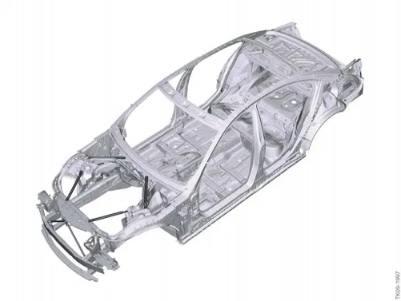
Bugatti first used the monocoque carbon fibre chassis design on the EB110, it was the first development of new advanced technology that was seen in the automotive industry. They later decided to keep the same chassis design for the Chiron as it was strong and lightweight. The monocoque chassis design can also be seen on many other automotive brands such as Koenigsegg, Ferrari, McLaren, etc. The Bugatti Chiron also featured carbon fibre body panels which were used to help reduce the weight of the car. The materials used were closely looked at to see how they would positively impact the Chiron.
Figure 1- A Monocoque Chassis (Rangam, 2020)

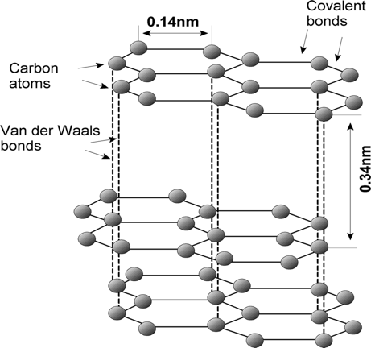
A carbon fibre’s atomic structure is comparable to that of graphite, with layers of carbon atoms arranged in a consistent hexagonal pattern. Carbon fibre layer planes can have a turbostratic, graphitic, or hybrid structure depending on the precursors and manufacturing techniques (Huang, 2009). The most commonly used raw material to create carbon fibre is polyacrylonitrile (PAN). This is produced when PAN is combined with additional chemicals, spun into fibres, cleaned, and stretched. Before being heated to a high temperature and carbonised, the fibres are chemically processed and stabilised. Finally, after being coated and wound onto bobbins, the fibres are twisted into yarns of various sizes by spinning machines. The fibres can also be produced into composite materials by joining them with a plastic polymer under pressure, heat, or vacuum. The process of oxidisation enhances their bonding properties (Johnson, 2020).

Figure 2- Graphite Structure (Lakshmanan, 2023)
The Ultimate Tensile Strength of carbon fibre ranges between 500-1050 MPa. On the Young’s Modulus scale carbon fibre has a GPa of 69-150. Carbon fibre has a high C02 footprint that varies between 45.8 and 50.5kg of C02. The advantages of using carbon fibre on a car are, the material is low in weight which allows the vehicle to consume less fuel, and carbon fibre also offers great stiffness and strength to the vehicle’s chassis. There is also no thermal expansion with carbon fibre, creating it the perfect material to use in a high-end supercar. However, carbon fibre takes a lot of time to produce meaning the material is costly. Carbon fibre can also be fragile and has a tendency to have poor resistance to impacts making it very easy to break when it comes in contact with anything. In addition, carbon fibre is not recyclable meaning it is a material which can damage the environment when thrown away.

2.1.2 Aluminium
Another material Bugatti used on the Chiron is aluminium, which was used to create the wheels, the light strip on the rear of the car and the grille as it coped the best with extreme loads and g-force. Aluminium has an Ultimate Tensile Strength in a range of 90-550 MPa. Aluminium has a Young’s Modulus that equals 60-75 GPa. Aluminium produces around 12.4-13.7kg of C02, which is considerably lower than carbon fibre. Some advantages of using aluminium include its lightweight and flexible meaning automotive manufacturers can easily include this material on their vehicles. It is corrosion resistant and extremely durable in any given situation, this means that the material has a longer lifespan. Aluminium is a good conductor of heat and electricity, creating it a good material to use in the engine block. On the other hand, there are also downsides to using aluminium on a car for example, high energy is required to produce virgin aluminium and it can be a difficult process to weld as it has a high thermal expansion (Sahana, 2022).

2.1.4 Titanium
Titanium was used to create the bolts and the exhaust on the Bugatti Chiron, it has a high tensile strength of 550-1200 MPa. Titanium also has a Young’s Modulus which is equivalent to 100-120 GPa, which is relatively high in contrast to the other materials used on the Bugatti Chiron. The production of titanium roughly releases 33.9-37.4kg of carbon dioxide into the atmosphere. Titanium has an exceptionally good strength-to-weight ratio, low density, good resistance to corrosion and a high melting point creating it a good material to use in the hottest areas of the car. However, the production costs are very high to produce titanium, it is also hard on tooling and the production of titanium is not eco-friendly.

2.2 Aerodynamics
The Bugatti Chiron is designed to be as aerodynamic as possible without having too much drag, it therefore has impacted the design and performance of the Chiron a lot. The Chiron has four major features that help optimises its aerodynamic performance. These features are an intelligent air intake, heat shield brake cooling and an active rear wing.

2.2.1 Active Rear Wing
The main feature of the Chiron is the rear wing, which is also able to act as an air brake when decelerating from high speeds. The extremely efficient rear wing is an example of highly sophisticated technology that makes use of a hydraulic diffuser flap on the front axle with optimised geometry for less drag and better brake cooling, an adaptive chassis that allows for various ground clearance settings, and active air brake (Bugatti, 2016), this can be seen in figure 4. The Chiron also has a hi-tech driving mode system which allows the driver to switch between different modes depending on how you would like to drive the vehicle, this will accordingly change the angle that the rear wing sits at and therefore can produce the right amount of downforce that is needed and reduces the drag. The Chiron has a drag coefficient of 0.39 and a rear wing angle of 10° when driving on the Autobahn. When the Chiron is at its top speed it creates a drag coefficient of 0.36 while the wing would be at an angle of 3°. Finally, when the car is using its rear wing as an air brake it has a drag coefficient of 0.60 and the wing is at a 49° angle, which will reduce the speed and bring the car to a stop quicker (Bugatti, 2016).

2.2.2 Air Intake
The state-of-the-art intelligent air intake system is considered an engineering masterpiece by Bugatti. The effective drag area was greatly reduced to ensure lower drag, and it was intended to prevent turbulence brought on by rotating wheels. In order to direct the approaching air through and around the car, the leftover exposed area at the front of the vehicle is used strategically. The air curtain, the aerodynamic front splitter, the front air intakes for cooling the brakes, water, and air conditioning, the air intakes for the oil cooler and the engine air inlets on the sides, as well as the continuous trailing edge on the back of the vehicle, are elements that are crucial in this situation (Bugatti, 2016). This can be demonstrated well by glancing at figure 5. The air intake makes use of the Chiron’s curves and inlets as it helps guide the air around the through the intakes at the tail of the car, as seen in figure 3.

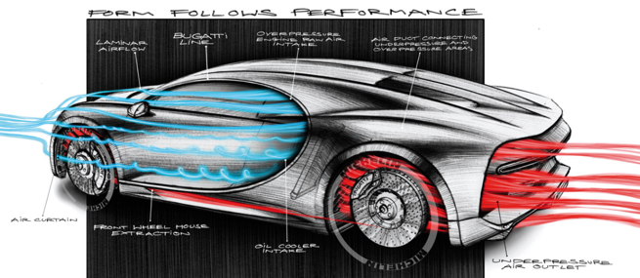
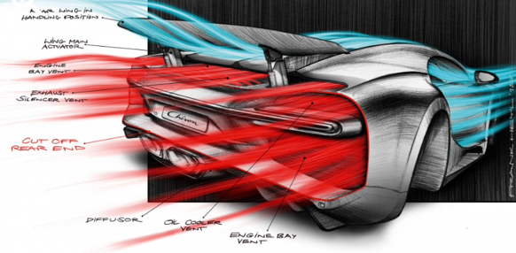

Figure 3- Chiron Air Flow Performance (Gallina, 2016)
Figure 4- Chiron Aerodynamics (Bell, 2016)
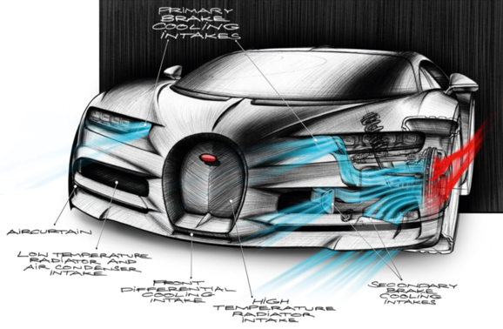

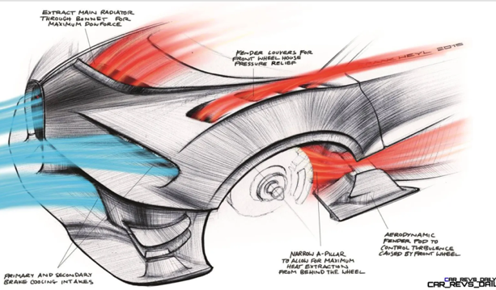

Figure 5- Chiron Aerodynamics from The Front (Wattles, 2016)
Figure 6- Heat Shield Brake Cooling System (Burkart, 2015)

2.2.3 Heat Shield Brake Cooling
Having air vents on top of the bonnets and the wheel arch, therefore, helps the air flow glide more freely and uniformly along the car. This will consequently reduce the amount of drag and turbulent air created by the wheels by pushing it to the underbody and the sides of the Chiron. By examining figure 6 it illustrates how it can help the car become more aerodynamic. A document produced by (Bugatti, 2016) explains that the Chiron has active front diffusers and special air guides in the shape of rails dubbed strakes on the level underbody. The front also has air outlets for the primary radiator. NACA ducts in the centre of the underbody draw air into the cabin to cool the drivetrain, while additional air intakes in the back cool the rear brakes.

2.3 Emissions
As stated above the Bugatti Chiron is equipped with a quad-turbocharged 8-litre W16 engine. As one of the world’s most powerful engines, it therefore must have to produce an extremely high amount of carbon dioxide into the atmosphere. The use of combustion engines releases many life-threatening gases such as carbon monoxide which can affect the respiratory system of many humans and animals, carbon dioxide being the main issue as it is a greenhouse gas that destroys the ozone layer in the stratosphere, this will eventually affect the planet and increase the rate of global warming. Hydrocarbons and nitrogen oxide are both very toxic to the earth as a high amount will start to affect the atmosphere and cause acid rain. Finally, sulphur dioxide is also deadly to the planet as it creates a thick layer of smog, as in 1952 London was effect for 5 days and saw roughly 3,500 lives lost due to the burning of fossil fuels. Today the Bugatti Chiron releases combined CO₂ emissions of 516.64 G/KM and achieves a fuel economy of 12.5 miles to the gallon (Kable, 2016).

2.4 Electric Motors
The future looks to be electric and with recent laws manufacturers must comply by 2030. Due to recent news Bugatti and Rimac announced in 2021 that they would be partnering up together for the future, the merged company would be known as ‘Bugatti Rimac LCC’. The newly formed Rimac group will hold a 55% stake in Bugatti Rimac LCC (Page, 2021). As Rimac is an electric car company from Croatia that has produced the fastest accelerating car in the world the Nevera and Bugatti have some of the most powerful and fastest cars in the world making use of their W16 engines. This deal would be great for Bugatti due to recent emissions laws, Bugatti can start using the Rimac electric motors to create a hybrid or a fully electric vehicle. The impact and influence of this will be major for Bugatti as it would affect both development and performance.
The Rimac motor powertrain consists of four independent surface-mounted, carbon-sleeve, permanent-magnet electric motors, including a four-wheel drive system with a motor positioned at each wheel. The front two motors have 226kW of power each and produce a max torque of 270Nm each. The two rear motors have 450kW of power and produce a max torque of 900Nm each, giving the Nevera 614hp at the front and 1224hp at the rear (Anon., 'no date').

2.5 Computer Design
The use of computer aided softwares such as Solid Works, have allowed manufacturers to see how well their vehicles and parts performance under-pressure of different temperatures and weight. Figure 7 shows the static pressure coefficient of the Bugatti Chiron that has been produced using a CAD software. The red and yellow areas recognise that is where there would be a high amount of static pressure on the car, whereas the blue areas highlight where there would be a low amount of static pressure. Figure 8 shows how computer design can create a mesh model of the vehicle. Both figures 7 and 8 can help designers and engineers figure out what they can extract from the car to improve its performance, aerodynamics, and visual design.
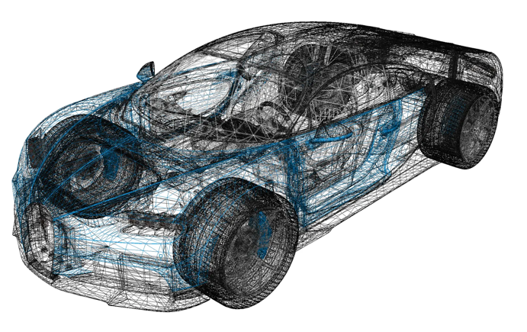
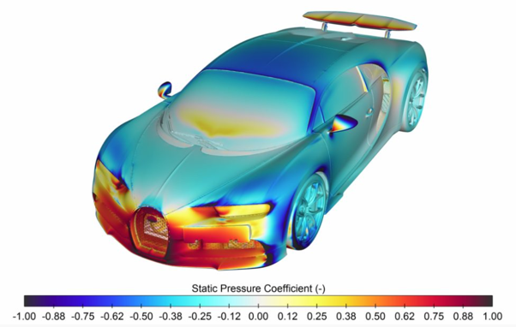

Figure 7-Static Pressure Coefficient (Butcher, 2020)
Figure 8- 3D Mesh Model (Dobre, 2017).

2.6 Probability of Failure
Throughout the production of the Bugatti Chiron there has only been 2 recalls of failures that has had an impact on the car. The first recall affects Chiron’s that were built between the 2nd of February and the 13th of October 2017. The reason for the recall was that the driver and passenger seat backrest frames may have been improperly bonded, causing the backrest to become slack. This could have an effect on the driver’s ability to manage the vehicle may be compromised if the backrest becomes loose, and the driver’s and passenger’s seats may not operate as intended in the case of a collision. To avoid this before an incident Bugatti decided to check the backrest frame welding visually and if the structure is not welded according to the proper specifications the seat will be altered. The second recall was for material resistance of the rear left drive shaft as it may not be withing the acceptable range. This issue would affect Bugatti Chiron models that were built between the 19th of January 2018 and the 23rd of October 2020. In order to mitigate this issue Bugatti would replace the rear left drive shaft on the vehicles affected (Recalls, n.d.).

Chapter 3

3.1 The Automotive Industry
The automotive industry has had its difficulties in the past and will also have complications in the future. There have also been some major and sophisticated changes that have happened in the industry over the last century.

3.1.1 The Past Challenges
The Automotive industry in the 1990s did provide numerous amounts of challenges to manufacturers. One of these challenges is globalisation and increased foreign manufacturing competition, as those from Japan increased their market share in the United States, placing pressure on American manufacturers to raise the quality, effectiveness, and innovation of their products in order to compete. In order to keep up with foreign rivals, American manufacturers started concentrating on lean production, quality improvement and innovation (Abernathy & Clark, 1982). During the 1990s, environmental regulations became increasingly strict, especially regarding air pollution and emissions. The manufacturers’ production expenses increased as a result of having to satisfy stricter emission standards. Automobile manufacturers had to make investments in cutting-edge technologies like catalytic converters fuel injection systems, and computerised engine controls to comply with these rules (Jaffe, et al., 1995). A few other challenges include the changing consumer preferences and trends in the market, labour relations and union contracts and the increasing complexity and the cost of new technologies.

3.1.2 Changes
There have been some significant changes in the automotive industry throughout the years, the main area of change has been technology, cars now include advanced technology including an entertainment system and digital features. Manufacturers can make use of forward-thinking designing software, CFD, CAM and CAD which can aid its performance. mass production has also changed how manufacturers produce vehicles (Murphy, 2020). New use of materials such as carbon fibre and Alcantara have changed vehicles’ performance and interior design. The self-driving car is a great example of sophisticated technology as 30 years ago that was only a dream for manufacturers.

3.1.3 The Future challenges
The future of the automotive industry looks promising however it doesn’t mean that there will not be any challenges facing it. COVID-19 could be considered the epicentre of the majority of these problems. According to (Iyer, 2022) some of these challenges are:
- Production recovery- As there are supply chain and semiconductor issues lead to resource shortages and excess in unwanted production, which can inevitably cause a significant financial loss that would directly impact global GDP.
- Fewer vehicle sales- The pandemic caused many workers to stay at home and to remote work, this took away the need to travel for many people. However, as production started to resume after the pandemic customers would be faced with long waiting and delivery times for newer car models causing them to rethink their decision for a newer car.
- Massive layoffs- workers were made redundant as there was no work to be done due to the lockdown and therefore the company were unable to supply an income for them due to no profits and money being limited.
- Disrupted supply chain- As China is the main leading exporter of raw materials and components for the automotive sector and also the first county to go into lockdown it had an instant effect on all the countries to which it was supplying goods for.
- Liquidity- factory shutdowns and crashing sales quickly saw manufacturers have a huge financial loss and struggle to practically stay alive. Which resulted in companies asking the government for financial support.
- Small or still recovering manufacturers may be finding it difficult to move from combustion to electric due to not having effective R&D techniques.

Chapter 4

4.1 Conclusion
Overall, the Bugatti Chiron is a well production vehicles it has many aspects that it uses to consider it a supercar. It can be considered that Bugatti along with the Chiron has played an important part throughout the automotive industry recently. Bugatti designed unique aerodynamic features on the Chiron that has been adapted by many other manufacturers. The Chiron makes use of its materials well, due to components being hot and keeps the car relatively lightweight, and Bugatti seem to be well prepared for the future of its vehicles. Finally, the automotive industry has had to overcome many challenges, however that doesn’t mean that there are no challenges for the future. To conclude the topics that has been researched about on this report show how each topic has impacted different traits of the Chiron.

References
Abernathy, W. J. & Clark, K., 1982. The Competitive Status of the U.S. Auto Industry: A Study of the Influences of Technology in Determining International Industrial Competitive Advantage National Academies of Sciences, Engineering, and Medicine. 1982. The Competitive Status of the U.S. Aut. Washington: National Academies Press.
Anon., 'no date'. Nevera. [Online]
Available at: https://www.rimac-automobili.com/nevera
Bell, K., 2016. Why the Bugatti Chiron Looks the Way It Does. [Online]
Available at: https://www.motorauthority.com/news/1102923_why-the-bugatti-chiron-looks-the-way-it-does
Bugatti, 2016. [Online]
Available at: https://www.bugatti.com/fileadmin/media/Media/MediaKit/180301_Bugatti_Chiron_en.pdf
Burkart, T., 2015. 2018 Bugatti 'Chiron' Design Analysis. [Online]
Available at: https://www.car-revs-daily.com/tag/2018-bugatti-chiron-design-analysis/
Butcher, L., 2020. Optimizing the Bugatti Chiron’s Climate Control. [Online]
Available at: https://www.automotivetestingtechnologyinternational.com/features/optimizing-the-bugatti-chirons-climate-control.html
Dobre, A., 2017. Bugatti Chiron (2017) 3D Model. [Online]
Available at: https://www.3dcadbrowser.com/3d-model/bugatti-chiron-2017
Gallina, E., 2016. [Online]
Available at: https://autodesignmagazine.com/en/2016/09/bugatti-chiron-forma-performance/
Huang, X., 2009. Fabrication and Properties of Carbon Fibres.
Iyer, S., 2022. Top 6 Challenges Faced by the Automotive Industry: The Post-COVID-19 Era. [Online]
Available at: https://www.gminsights.com/blogs/top-challenges-in-the-automotive-industry-pre-COVID
Jaffe, A. B., Peterson, S. R., Portney, p. R. & Stavins, R. N., 1995. Environmental Regulation and the Competitiveness of U.S. Manufacturing: What Does the Evidence Tell Us?. 33(1).
Johnson, T., 2020. How is Carbon Fiber Made?. [Online]
Available at: https://www.thoughtco.com/how-is-carbon-fiber-made-820391
Kable, G., 2016. 2016 Bugatti Chiron - every detail on the Veyron's 260mph+ successor. [Online]
Available at: https://www.autocar.co.uk/car-news/2016-bugatti-chiron-spec-detail-veyron-260mph-successor
Lakshmanan, R., 2023. [Online]
Available at: https://www.researchgate.net/figure/Molecular-arrangement-of-carbon-in-graphene-and-various-bonding-and-forces-involved_fig3_327193768
Li, A., 2022. The Properties and Advantages and Disadvantages of Magnesium Alloys. [Online]
Available at: https://www.winfredint.com/info/the-properties-and-advantages-and-disadvantage-74542924.html
Molsheim, 2021. 30 Years of The Bugatti EB 110, The First Super Sports Car of The Modern Era. [Online]
Available at: https://newsroom.bugatti.com/press-releases/30-years-of-the-bugatti-eb-110-the-first-super-sports-car-of-the-modern-era
Murphy, G., 2020. [Online]
Available at: https://industryeurope.com/sectors/transportation/how-the-automotive-industry-has-changed-over-the-years/
Page, F., 2021. Bugatti and Rimac hypercar firms complete merger. [Online]
Available at: https://www.autocar.co.uk/car-news/new-cars/bugatti-and-rimac-hypercar-firms-complete-merger
Rangam, K., 2020. [Online]
Available at: https://gomechanic.in/blog/types-of-car-chassis/
Recalls, B. C., n.d. Bugatti Chiron Recalls: Safety and Technical Recalls. [Online]
Available at: https://www.autoinsider.co.uk/recalls/r2020364-bugatti-chiron
[Accessed 22 March 2023].
Sahana, 2022. Advantages and Disadvantages of Aluminum. [Online]
Available at: https://www.techquintal.com/advantages-and-disadvantages-of-aluminum/
Wattles, J., 2016. Bugatti Chiron: Meet The Next 'Worlds Fastest Supercar'. [Online]
Available at: https://edition.cnn.com/style/article/bugatti-chiron-geneva-motor-show/index.html

Table of Figures

Figure 1- A Monocoque Chassis (Rangam, 2020) 2
Figure 2- Graphite Structure (Lakshmanan, 2023) 3
Figure 3- Chiron Air Flow Performance (Gallina, 2016) 5
Figure 4- Chiron Aerodynamics (Bell, 2016) 5
Figure 5- Chiron Aerodynamics from The Front (Wattles, 2016) 5
Figure 6- Heat Shield Brake Cooling System (Burkart, 2015) 5
Figure 7- Static Pressure Coefficient (Butcher, 2020) _____________________________________________ 6
Figure 8- 3D Mesh Model (Dobre, 2017) _______________________________________________________ 6

