
marketing management lcmb7001
Lecturer: Tushara Balendran

[Datum]
BENSON BECHEMAYOR
1909011

Table of Content
- Introduction………………………………………………………………………………………………………………………..2
- Definition of Communication………………………………………………………………………………………………2
2.1. Shannon & Weaver Communication Model………………………………………………………………….4
- Integrated Communication Model……………………………………………………………………………………….5
- New Promotional Strategies for Apple Inc……………………………………………………………………………6
4.1- Online Promotion………………………………………………………………………………………………………….7
4.2 Offline Promotion…………………………………………………………………………………………………………..9
- Branding and Brand Equity…………………………………………………………………………………………………10
5.1- Branding………………………………………………………………………………………………………………………10
5.2- Brand Equity…………………………………………………………………………………………………………………11
- Keller’s Brand Equity Model…………………………………………………………………………………………………11
6.1- Advantages of Keller’s Brand Equity Model…………………………………………………………………..12
6.2- Disadvantages of Keller’s Brand Equity Model………………………………………………………………14
- Customer Touch Points………………………………………………………………………………………………………..14
7.1- Pre-Purchase…………………………………………………………………………………………………………………14
7.2- Purchase……………………………………………………………………………………………………………………….15
7.3- Post-Purchase……………………………………………………………………………………………………………….15
- Customer Journey………………………………………………………………………………………………………………..16
- The Customer Journey Map………………………………………………………………………………………………….17
9.1- Critical Analyses of Apples Inc. Customer Journey Map………………………………………………….17
9.2- Advantages of Apple Inc. Customer Journey Map………………………………………………………….18
9.3- Disadvantages of Apple Inc. Customer Journey Map………………………………………………………18
- Total Engagement Model……………………………………………………………………………………………………..19
- Recommendations for Apple Inc………………………………………………………………………………………….20
- Conclusion……………………………………………………………………………………………………………………………21
- References…………………………………………………………………………………………………………………………..21
- Appendix……………………………………………………………………………………………………………………………..23

- Introduction:
Apple Inc. is a multinational technology company headquartered in Cupertino, California, United States (Apple Inc., 2021). It is one of the largest and most successful technology companies in the world, known for its innovative products, including the iPhone, iPad, Mac, and Apple Watch. Founded by Steve Jobs, Steve Wozniak, and Ronald Wayne in 1976, Apple has since become a major player in the global technology industry, with a market capitalization of over $2 trillion as of 2021 (Goldman, 2021).Apple's success can be attributed to its focus on design, quality, and user experience. The company's products are known for their sleek and elegant designs, high-quality

Fig. 1 Apples’ iPhone 14 Pro-Max
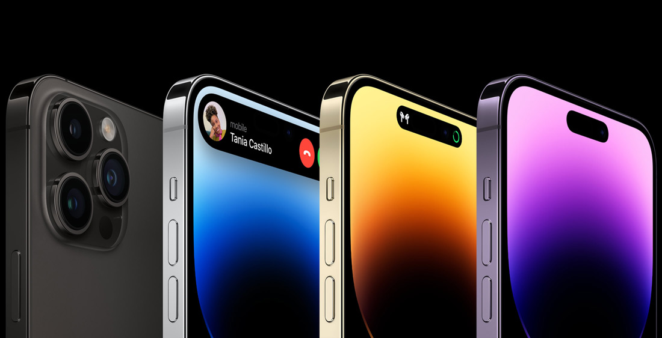
Source: Apple Inc. website.
Materials, and user-friendly interfaces. In addition to its hardware products, Apple also offers a range of software and services, including the App Store, iTunes, and iCloud.
This report is a critical analyses of the Apple Brand and the strategies that are adopted by Apple to maintain its lead in the High-Tech industry. It analyses Apples’ customer’s journey map and the various customers touch point. It examines the strength and the weaknesses of the customer touch points and make recommendations on new promotional strategies that will be advantageous for Apple Inc.

- Definition of Communication.
Communication is the art of exchanging information or ideas between one or more persons. It could be a group or entities. According to Oxford Learners Dictionary, (2023). “It is the activity or process of expressing ideas and feelings or of giving people information.” Communication can be carried out through various channels such as writings, speech, signs, signals, gestures and even technologically. “Communication is the transmission of a message from a source to a receiver over a channel, with the goal of transmitting information and achieving understanding." (Shannon and Weaver, 1949). One of the most recent definition of communication is from Schockley et al., (2010). "Communication is the process of creating shared understanding. This involves the exchange of messages between a sender and a receiver. It could be both verbal and nonverbal elements.” Shockley and his friends argue that Effective communication occurs when the sender's message is accurately received and understood by the receiver."

Fig.2 Communication Diagram.

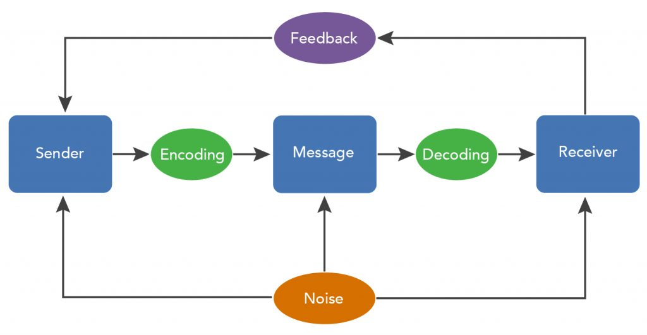
Source: Pdf Education.
Verbal Communication:
Verbal communication is the use of spoken or written words to convey a message from a sender to a receiver. This could be face-to-face conversations, phone or video calls, presentations, speeches, or even written communication such as emails, letters, or memos. “It is human interaction through the use of words, or messages in linguistic form. (Oxford Reference Dictionary, (2023).
Non-Verbal Communication:
Nonverbal communication refers to the ways we transmit information using gestures, facial expressions, emotions, attitude, and body language, without any tone or voice. Knapp and Hall, (2010). Argues that nonverbal communication is a fundamental aspect of human interaction that serves several critical functions.

2.1. Shannon & Weaver Communication Model.
The Shannon model of communication was created by Claude Shannon and Warren Weaver in 1949. It was also known as the mathematical theory of communication. According to Shannon and Weaver, there are key components in communication. These components are as follows:
The Encoder: This is the mechanism that is used to convert a message into its transmittable form. It could be either a language or a symbol.
The Channel: The channel is the medium through which the encoded message is being transmitted to the receiver. This can be cables, airwaves or internet.
The Decoder: This also is another mechanism that transform or convert the encoded message back to its original form when received by the receiver.
The Receiver: This person receiving the decoded message from the sender.
The Shannon and Weaver communication model has two main characteristics or factors. These are noise and the feedback. The noise is the distortion or other factors that interfere with the message when it is being transmitted. And feedback is reaction or response of the receiver of the message.
Fig: 3
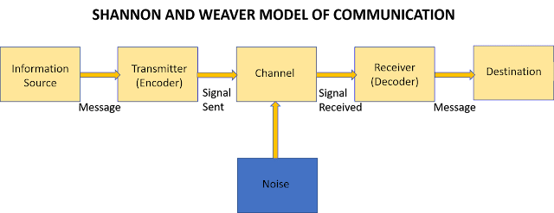
Source: Michelle Mathias Blogspot

- Integrated Marketing Communication :
Definition and Characteristics:
IMC is a strategic marketing approach used in creating brand message across all marketing channels and touchpoints using all marketing communication channels such as advertising, public relation, sales, promotion, direct marketing, digital marketing, and personal selling to reach the targeted audience with the intended message. According to the American Marketing Association, (2019). IMC is “A planning process designed to assure that all brand contacts received by a customer or prospect for a product, service, or organization are relevant to that person and consistent over time.” IMC is the concept of designing marketing activities, advertising, personal selling, sales promotion, public relations, direct marketing, and online marketing to provide a consistent and unified message across all audiences." (Kotler and Armstrong (2016).
IMC requires a consistency in the marketing communication. The messages has to be consistent in terms of branding, tone, and messaging across all marketing channels. It has to be customer focus centered on the needs and preferences of the customer, and should be aimed at delivering a relevant and consistent message to the target audience. It should involves the integration of various marketing communication channels such as advertising, public relations, sales promotion, personal selling, direct marketing, and digital marketing to deliver a consistent and cohesive message. According to Belch and Belch, (2021). “IMC emphasizes the importance of two-way communication between the brand and the target audience, allowing for feedback and dialogue.” Belch and Belch argues that emphasizes on communication is important because it helps in creating a more personal and interactive relationship between the brand and the customer, this can lead to increased engagement, loyalty, and sales. IMC also requires strategic planning and coordination of all marketing activities. This will ensure the alignment of all marketing strategy and objectives.
IMC also allows the tracking and measuring the effectiveness of marketing communication activities. This enables to determine the return on investment. This is in making adjustments to the strategy if the need arises.

- New Promotional Strategies for Apple Inc.
Apple is a worldwide brand with over 1.65 billion Apple devices sold all over the world. (Elma Mrkonjic, 2023). Apple have best marketing strategy team in the High-Tech industry. However Apple can still improve its promotional and marketing strategy to maintain its leadership among its competitors.
Personalized Marketing:
Apple can expand its customer base through personalized marketing. Through its customer browser and shopping history, Apple can monitor and analyze the activities of its customers and know their needs and desires as well as their shopping habit. Apple can create individual marketing campaign based on the customers’ shopping preferences and create targeted advertisement and promotions to offer products that suits the customer’s preferences. This approach will help increase customer engagement and conversions through delivering more relevant and personalized marketing messages. According to Epsilon, (n.d.). “Personalized marketing can increase the effectiveness of marketing campaigns up to 30%.”

Influencer Marketing:
Apple can also collaborate with Influencer like celebrities to promote its products. They can use social media platforms such as Facebook, Instagram, YouTube and Tic Toc to promote selected products. Through partnering with celebrities having large number of followers in their various social media channels will most definitely increase Apples customer base. Especially with products such as the latest iPhone 14 pro and Pro max. This approach can also be effective in promoting future products even before they are introduce into the market. According to Jacinda Santora, (2023). “63% of consumers trust influencers more than they trust brands.” Jacinda argues that influencer marketing is a powerful approach that can help companies grow.

Gamification:
Another promotional marketing strategy that Apple can use is the Gamification. This creating interactive and games and Apps through which customers are engaged with related products, soft wares and services that they like. Apple can create soft wares that assist customers to accomplish task or learn new things that assist customers’ daily activities. According to a study by Joe Pilizzi, (2011) “Gamification can increase customer engagement up to 100%.”

Creating New Partners:
Apple can create new partnership with other companies, organizations, or individuals. Through new partners, Apple can leverage its existing audience and customer base to promote its products and services. They can partner with popular fashion brand to create limited-edition iPhone cases or Apple Smart Watches band. This could help also to increase awareness and generate a buzz around Apple's products within the fashion brand's audiences. Apple can also partner with a nonprofit organization to promote a social cause or issue that aligns with its values. This can also help to increase Apple brand loyalty and positive brand perception among socially-conscious consumers. Apple can partner with other technology companies to integrate its products and services with theirs. For example, Apple could partner with different companies manufacturing home kits to integrate its products with Apple technology thus creating a smart home. This will help increase the value proposition of both Apple and the partner companies' products and services.

4.1- Online Promotion:
Social Media Marketing: This is a form digital marketing which involves the use of social media platforms like Twitter, Facebook, YouTube, Instagram, TicToc, and LinkedIn to promote a product, service, or brand. Apple can use this form of promotional strategy to widen its customer base. Using social media marketing include creating and sharing images of the company’s products, videos, blog posts. Online promotion involves engaging with followers and customers, running targeted advertising campaigns, and the tracking and analyzing of social media metrics to measure the effectiveness of campaigns. Apple has the capabilities and technical know-how to reach out to a wider customer base using these social media metrics. The goal of social media marketing is to increase brand awareness, engaging customers on their various social media platforms and to increase sales and revenue for the company. According to Pamukcu, O. (2021). “Online promotional strategies that Apple could use to increase its online presence and drive sales include social media marketing, influencer marketing, content marketing, email marketing, and search engine optimization.”

Content Marketing: This is a marketing approach that involves the creating and sharing of valuable content consistently in order to attract and retain a clearly defined audience. The goal of content marketing is to build brand awareness and a loyal customer base. To establish the brand as a thought leader in its industry. It is also aimed to increase the profit of the company. It takes the form of blog posts, social media updates, videos, podcasts, white papers and even eBooks. Joe Pulizzi, (2013). Argues that it is important to create high-quality content that adds value for the audience. He further states that content marketing is not just about promoting the brand, but also about providing useful information and building trust with the audience. Through this form of promotion, Apple can engage with that audience and build brand loyalty. Apple is already using other forms of content marketing like “Today at Apple.” Which offers free workshops and events at Apple Stores around the world. (Apple.com). Apple also has a dedicated website and newsroom where the company publishes new and press release about its products. However, apple should still expand its content marketing efforts by creating more valuable and engaging content for its audience and customers. For instance video tutorials, informative blog posts, and interactive social media campaigns. This will increase Apples’ brand awareness, and establish Apples’ leader in the tech industry, and ultimately drive customer action.

Email Marketing: This is a form of digital marketing that involves sending promotional messages or newsletters to a group of people via email. The goal of email marketing is to promote a brand, product, or service and encourage the recipient to take a specific action, such as making a purchase, visiting a website, or signing up for a service. Apple can send promotional and personalized emails to customers announcing the release of new products, highlighting its features and benefits, and encouraging customers to make purchase. Apple can also send post purchase emails to customers providing them with tips and tricks for using the product and for troubleshooting common issues. Apple can also use email marketing to distribute exclusive contents such as behind-the-scenes looks at product development, special offers, discounts, and early access to new features to its customers. They can build brand loyalty and provide promotion valuables thus building stronger relationship with the customers.

Search Engine Optimization (SEO): is the process of optimizing a websites online content in order to improve its ranking and visibility in search engine results pages using specific keywords or phrases. According to Moz (n.d.). "SEO is the practice of increasing the quantity and quality of traffic to your website through organic search engine results.” Apple can optimize its website and online content with relevant keywords and phrases, to improve its online visibility and attract more organic traffic to its website. Apple can rank higher on search engine results pages and attract more potential customers. Apple has the expertise of using analytic tools to analyze its website traffic and performance to make data driven decisions that will optimize its sales.

4.2- Offline Promotion:
Product Launch Events: Apple can hold product launch events to showcase its new products to the media and potential customers. This can generate buzz and excitement around the brand and its products. According to Levinson, J. C., & Gibson, J. (2017). “Argues that strategies like using creativity during product launching events is a low-cost tactics that can achieve maximum impact.”
Apple can use product launch events to create excitement around new product releases, generate media coverage, and increase sales.

Sponsorship: Apple can sponsor events or support organizations that align with its brand values and target audience. Apple can use events like music festivals, film festivals, or technology conferences to showcase its products and increase its brand awareness and build goodwill with potential customers. The can also sponsor sport teams or athletes who align with their brand. For example athletes using Apple smart watch. They can also act as co-sponsors supporting academic innovation or promoting technological education program and campaigns. Sponsorship can benefit Apple in increasing the Apple brand visibility since apple has differentiated itself as a leader in the Tech industry.

Print Advertising: Apple can use print advertising in magazines, newspapers, and billboards to reach potential customers who are not active online. Apple can print high-quality advert posters that showcase its products and services in a compelling way and designs that will stay in the memory of its audiences for a long time. Appel can use printed advert to reinforce its brand value. In regions and countries like in south eastern Asia, Africa and South America where there are problems with electric power supply and internet connections, Apple can create adverts that emphasizes on its innovation designs and users experiences. Apple can use prints adverts to promote its special offers, events, and promotion specials. According to an article on Apples’ print adverts written by Steinberg, B. (2018), he argues that “Apple's print adverts were a masterstroke because they effectively showcased the company's products in a clean, minimalistic manner that resonated with its target audience.” According to Stenberg, the adverts were designed to highlight the simplicity, beauty, and functionality of Apple's products, which were seen as a departure from the cluttered and confusing designs of its competitors.

Direct Mail: Apple can use direct mail campaigns to reach potential customers with targeted offers and promotions. According to the Direct Marketing Association (DMA). “Direct mail has a response rate of 4.4% compared to email's response rate of only 0.12%.” Appel can use direct mail to target a specific geographical or demographical area. The use of this strategy can increase Apples’ audiences.

- Branding and Brand Equity:
5.1- Branding.
Branding can be defined as a process of creating a unique name, design, symbol, or an image that identifies and distinguishes a product, service, or organization from its competition. “Branding is creating a name, term, sign, symbol, design, or a combination of them, with the intention of identifying the goods or services of one seller or group of sellers and to differentiate them from those of the competition." (Aaker, D. A., 1996). According to Aaker’s definition, he argues that a strong brand can provide a competitive advantage, because it creates customer loyalty, command a price premium, and enhances the company's reputation. There are two important emphasis on a brand according to Aaker. There is the Brand Identity and the Brand Image. The brand identity is the unique set of brand associations that a company creates to differentiate its products or services from those of its competition, while brand image is the perception that consumers have about brand based on their experiences with it.

How Does this Apply to Apple Inc.?
Apple has built a strong brand identity since it was created. Apple brand is built on innovation, design, and durable usability. Apple emphasis on simplicity and user experience. Apples marketing technic, product design and customer experience have all contributed to Apple brands’ image. This has played a very essential role for Apple among its competitors in the High-Tech industry.

5.2- Brand Equity:
Brand Equity is the value of the brand. It is more than the brand and the brands financial value, reputation, and the perception of the customer. It is a combination of factors that make up the overall value of the Brand. According to Keller, K. L. (1993). Brand Equity is the differential effect of brand knowledge on consumer response to the marketing of the brand.” “Brand equity is a combination of associations and behaviors of the stakeholders of a brand that enable it to achieve greater value than it would without the name of the brand.” (Leuthesser, 1988). This is the value that the brand provides to its products or services. It is not based only on the attributes of the product but on the perception of the consumer.

How Does this Apply to Apple Inc.?
In the case of Apple, the brand equity is extremely high, because of its strong brand image and reputation for innovation and high-quality products. For this reason Apple charges premium prices for its products and continues maintain a loyal customer base. According to Kantar, M. B., (2021). “The company's brand equity is reflected in its consistently high rankings in brand value.”

- Keller’s Brand Equity Model
The Keller's Brand Equity model is a conceptual framework developed by Professor Kevin Lane Keller, /1997). It discusses how to create a strong brand, and how to measure its value. According to Professor Keller brand equity consists of four key components: Brand Loyalty, Brand Awareness, Brand Associations, and the Perceived Quality of the brand. Professor Keller argues that these components are usually influenced by the internal and external factors, which consist of marketing activities, customer experiences, and brand identity. This model also emphasizes the importance of creating a strong, positive brand image that resonates with consumers and differentiates the brand from other competitors.
Fig:4 4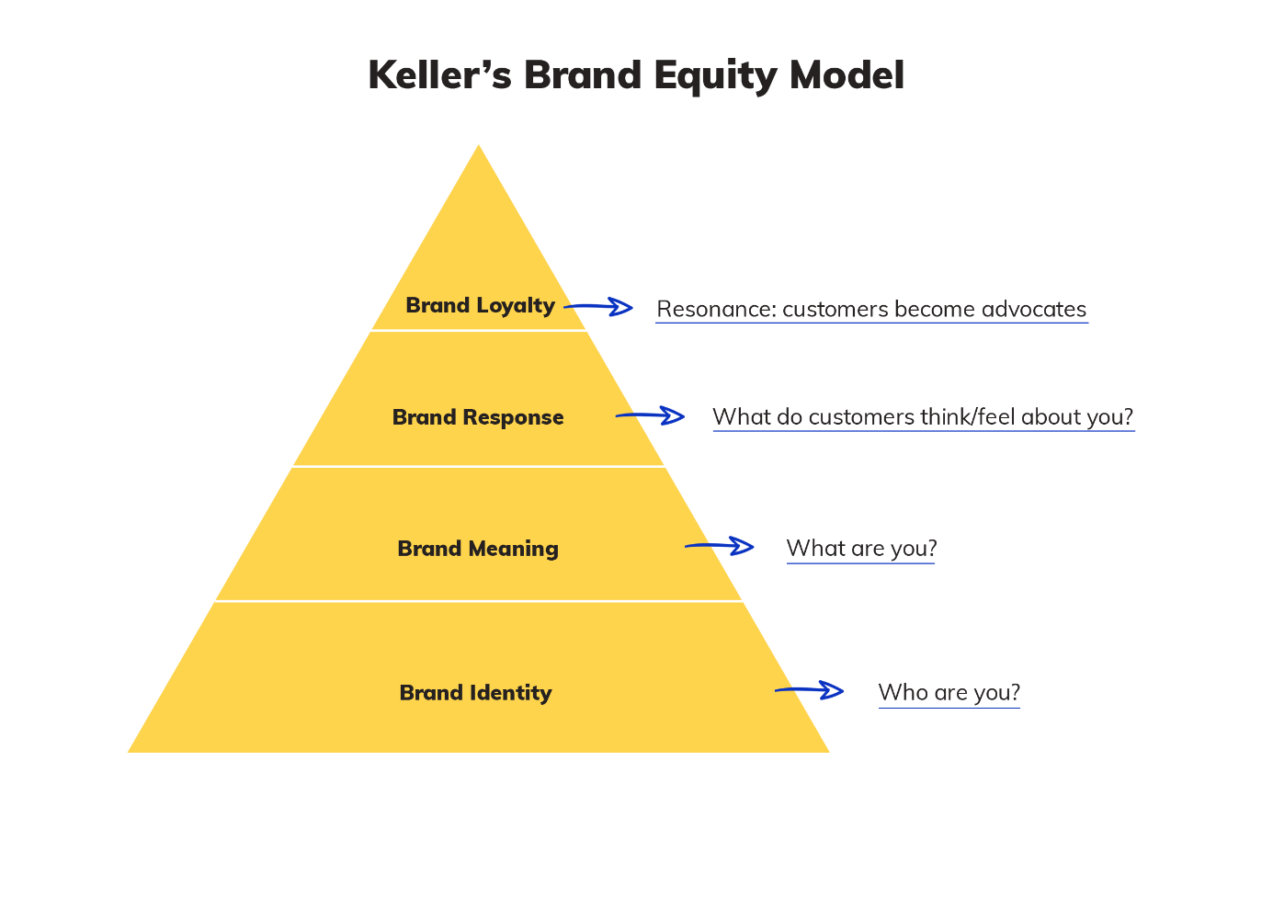
Source: Many pixels.

Brand Identity (Who are you?):
According to Professor Keller, (2003). The brand identity is the unique set of brand associations that the company creates or maintain in the minds of the target audience. It represents what the brand stands for. Its promises to consistently deliver same quality to the consumers. It is a combination of the brand elements, such as the brand name, logo, color, tagline, design, packaging, and the product features, which shape the brand image and create a differentiated and relevant brand identity in the marketplace.
Comparing this with Apple, they have established a strong brand identity that is easy to recognize. Apple Brand identity is associated with innovation, quality and elegance. Through its brand, apple has created a strong emotional connection with its customers and audiences. Because of its strong identity, each time Apple launches a new product, there is always a high anticipation from its customers.

Brand Meaning (What are you?):
According to Keller, Band meaning refers to the set of beliefs and perceptions that customers associate with brand. This includes its attributes, benefits, and overall values. It also includes the functional and emotional aspects of the brand. The functional aspects are things like quality, reliability, and convenience, while the emotional aspects are the excitement, prestige, and authenticity. Ultimately, the goal of brand meaning is to establish a unique and differentiated position in the minds of customers, allowing the brand to stand out and create a unique position in the minds of consumers.
In the case of Apple Inc., Apple's brand meaning is tied to its values of creativity, innovation, and user-centric design, which are evident in Apples’ marketing campaigns and product launches. Apples brand meaning are a set of unique association that it customers hold about the brand. This includes the products functional and emotional benefits, brand personality and the brand value. Apple brand meaning has greatly contributed its success.

Brand Response (What do customers think about you?):
Brand response refers to the customer's overall evaluation of the brand based on their experiences and interactions with the brand. It refers to the customer’s reaction to the brand. The marketing efforts, advertising, promotions, and other forms of communication. It includes the customers’ attitudes, feelings as well as their behavior in response to the brand. It also include their likelihood to purchase or recommend the brand to others.
Apple's brand response can be seen in its successful product launches, with customers often lining up for hours or even days to be one of the first to get their hands on a new Apple product. The brand's focus on simplicity and user experience has also led to a strong brand response, with customers feeling a sense of satisfaction and loyalty when using Apple products.

Brand Loyalty (Resonance: Customers become advocate):
Brand loyalty proof the extent to which customers will repeatedly purchase a product or service from a particular brand rather than its competitors. It measures the strength of a customer's attachment or commitment to a brand. This can be developed through positive experiences with the brand and its products, or through effective marketing and communication strategies. Brand loyalty can lead to repeated purchases, positive word-of-mouth recommendations. This factors gives a competitive advantage for the brand in the marketplace.
Apple has a strong brand loyalty with its customers. This has been built through Apples consistent delivery of high-quality products, innovative designs, and exceptional customer service. Apple's loyal customers do not only continue to purchase its products but has also become advocates for the brand. They recommend it to others and defending it in the face of criticism. The brand loyalty has enabled Apple to maintain a premium pricing strategy, as customers are willing to pay a premium for the perceived value of the Apple brand.

6.1- Advantages of Keller’s Brand Equity Model:

a) - The Keller’s brand equity model provides a structural approach for managing a brand and building brand equity. It helps marketers in creating a roadmap for building a strong brand.
b) - Keller’s brand equity model focuses on the consumer's perspective. It also considers the consumer’s perceptions, attitudes, and behaviors towards the brand.
c) - It provides a comprehensive framework that covers all the important aspects of building and managing a brand, including factors such as brand identity, brand meaning, brand response, and brand relationships.
d) - It provides possibilities to measure the strength of a brand and its equity over time. This makes it easy for companies to track their progress and make adjustments to their branding strategy.
e) - Through focusing on the brand identity and brand meaning, this model helps companies to differentiate their brand from competitors and build a unique identity.
f) – Keller’s model supports brand extension by helping companies identify opportunities for extending their brand into new markets and product categories.

6.2- Disadvantages of Keller’s Brand Equity Model:
a) - According to Keller on his journal article on multidimensionality of brand knowledge, he argues that this model can be quite complex and difficult to be implemented by smaller businesses with limited resources.
b) – According to Kapferer, J. N. (2012). Keller’s brand equity model lacks Limitation. He suggests that companies may need to supplement the model with additional metrics that better reflect their financial goals and objectives. Keller’s model places a heavy emphasis on non-financial metrics, such as brand awareness and associations, which may not be as relevant for companies that prioritize financial performance.
c) – Keller’s brand Equity model does not provide any comprehensive view of the customer journey or factors that may impact customer behavior outside of brand awareness and associations.

- Customer Touchpoints:
According to Verhoef et al, (2009). “Customer touchpoints are the various points of interaction between a customer and a business or product. It is from the initial awareness of the product to post-purchase support. The touchpoints include things like advertising, social media, website visits, customer service interactions, and more. For the Apple the touchpoints are the various points of contact by which the customer have with the company. This includes Apple stores, Apple websites, customer services, Apples’ social media pages, advertising, and its product design.
7.1 – Pre-Purchase:
Apple has several customer touchpoints during pre-purchase. The touchpoints are as follows:
- Advertising: Apple uses various advertising channels such as Televisions, online advertisements, and print media to create awareness for its products.
- Apple website: Apple's website is a critical pre-purchase touchpoint for customers. The website provides detailed information about Apple products, pricing, and availability.
- Apple Retail Stores: The stores provide customers with a hands-on experience with its products before making a purchase decision.
- AppleCare: AppleCare is a service that provides support to customers before and after purchasing Apples’ product. Customers can ask questions about products and receive technical support.
- Online Communities: Apple has several online communities where customers can engage with other customers and experts to ask questions and learn more about Apple products.
- Social media: Apple's social media channels such as Facebook, Instagram, and Twitter provide customers with information about new products, promotions, and events.
- Influencers: Apple uses influencers to reach new customers and create excitement around new products. The influencers’ help customers to understand how Apple products can fit into their lifestyle.

7.2- Purchase:
Apple has the various customer touchpoints during purchase:
- Apple Store: Apple's retail stores are the primary touchpoints for customers during the purchase stage. Customers can visit the store, get a hands-on experience with the products, and purchase them in the store.
- Online: Apple operates online store providing customers with the option to purchase products from the comfort of their homes. The online store offers customers various payment options, including Apple Pay.
- Third-party retailers: Apple customers can also purchase Apple products from third-party retailers like Best Buy, Walmart, and Target.
- Authorized Resellers: Apple has authorized resellers all over the world that provide customers with easy access to their Apple products.
- In-App Purchases: There is also the Apple App Store that allow customers to purchase apps and in-app content for their Apple devices.
- Apple Care: Customers can purchase AppleCare. This is an extended warranty, and technical support service that customer can obtain during the purchase stage to ensure the safety and longevity of their products.

7.3- Post Purchase:
Apple’s customers post purchase touch points are:
- Apple customer services for product registration and activation.
- Apple customer support services, providing telephone, email, and chat support services.
- Apple Store appointments and Genius Bar visits providing assistance for troubleshooting and repairs.
- Apple Online support resources, for knowledge base articles and user forums.
- Apple Software updates and upgrades for improving product performance and adding new features.
- AppleCare and warranty services for extended coverage and protection of customers’ product.
- ITunes and App Store purchases and subscriptions for content and services related to the purchased product.

- Customer Journey.
The customer journey is the process that a customer goes through when they interact with a company, from initial awareness to the final purchase and beyond. It includes all the touchpoints a customer has with a brand, from browsing products to customer support interactions. According to Brodie, R. J. et al. (2013), "The customer journey comprises the sum of experiences that customers go through when interacting with a company and its products or services, which they use in forming their perceptions of the brand." The customer journey comprises of five stages:
- Awareness: This is when the customer become aware of the product or service provided.
- Consideration: This is the stage where the customer begins to make considerations on buying the product or service
- Purchase: This is when the customer make the decision to buy the product or service.
- Experience: This come when after the customer has consume or use the product or service and makes his opinion about the quality of the service or product.
- Loyalty: This is when the customer makes a decision to either remain loyal to the product or services or not.

- The Customer Journey Map:
Customer Journey | Awareness  3 | Consider | Purchase | Experience | Loyalty
Website | Visit website |  | 4  Buy Iphone | 5
Apple Store |  |  |  | Use iPhone
Online Store
Social Media |  | 2  Talk to a iPhone user |  |  | 6
Influencer |  |  |  |  | Share Experience
Emails |  |  |  | 1 22222 11
Print Advert |  |  |  | Receive iPhone Advert in Letter box
Online Communities

9.1- Critical Analyses of the Customer Journey Map
IPhone users are high wage earners. The generally have a higher salary. For Apple customers using the iPhone 14 or 14 Pro-max, they have to go deeper into their pockets. According to a survey by Consumer Intelligence Research Partners, (2019). “Most iPhone uses in the USA have an annual salary of $98, 000.” According to this research, iPhone users have a specific income status. The iPhone customer journey map begins with a customer that does not possess an iPhone. His first touchpoint with the product is through a printed advert in his letter box. After examining the descriptive features of the product, he move to his second touchpoint, contacting a friend who is an iPhone user (influencer). Being influenced by the friend he decided to visit the Apple website which is his touchpoint number 3 for more information about the product. On the fourth touchpoint, he decided to visit the store to have a first-in –hand experience with the product. After considering the product, he made his first purchase. After using the product he is very satisfy and decides to share his experience with others.

9.2 Advantages of Apples’ Customer Journey Map:
a) Printed Advert: Apples printed adverts have a positive effect on the customers’ buying decision. The attractiveness of the product in the advert and the description of the features of the product activated the consumers urge to enquire more about the product.
b) The Influencer: Apple influencers are good at influencing others who are thinking if they should switch to Apple products. Once the customer spoke to the influencer he decided to check the website for more details.
c) Apple website: Apple website is captivating. Everyone that visits the Apple website is willing to own an Apple product.
d) Apple Store: Apple stores are game changer. The touch-in-hand experience brings Apple audiences to immediate decisions to Apple because of the features they get to experience from its products.
e) Using the iPhone 14 Pro-max: This is an amazing experience that the customer immediately starts calling friends and luring them to join and share the experience.

9.3 Disadvantages of Apples’ Customer Journey Map:
a) Each customer has a different experience. All customer cannot have the same experience as their preferences differs.
b) The customer journey map shows only the journey of a particular customer and his touchpoints. Another customer’s journey and touchpoints might be completely different.
c) The map does not take into account the potential impact of external factors on the customer journey.

- Total Engagement Model:
The Total Engagement Model is a marketing framework that is focused on building and strengthening the relationship between a brand and its customers using various touchpoints and channels. This model emphasizes on the importance of engaging customers at every stage of the customer journey, from awareness to advocacy, and it incorporates both the online and the offline interactions.
The total engagement model has four main components: Reach, Acquisition, Conversion, and Loyalty.
  - To Reach: Refers to the applicable methods that are used to make potential customers become aware of the brand.
  - To acquire: This are the tactics that involved in converting potential customers into actual customers.
  - Conversion: Is the process of turning those customers into repeat buyers.
  - Loyalty: Focuses on retaining those customers and turning them into brand advocates.
Applying the total engagement model in Apple will be based on creating a seamless and enjoyable user experience across all of its products and services. This will includes the integration of hardware and software to create a cohesive ecosystem, as well as offering a range of services such as Apple Music, iCloud, and the App Store. Apple also places a strong emphasis on customer support and service, offering resources such as the Genius Bar and online support forums to ensure that customers are able to get the most out of their Apple products. By creating a positive user experience and fostering customer loyalty, Apple aims to maintain a strong market position and grow its customer base over time. Apple also has its Iconic “Think Different” campaign which focuses on Apples’ innovation and design, through this strategy, Apple has built a strong brand loyalty.
Fig: 5 Total Engagement Diagram
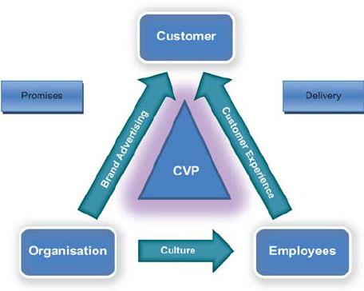
Source: Research Gate
The total engagement model diagram is a demonstration of the circulation of activities within the organization. There is the promise to deliver. We have the customer value proposition, this represents the value that the organization promises to deliver to the customer. The organization has a culture and it is the culture that governs the company it is the company’s value and belief.. The relationship between the employees and the customers is known as the customer experience. Between the organization and the customer is the brand advertising.

- Recommendations for Apple Inc.

- Apple should focus on producing affordable products that can satisfy the desire of those audiences with lower income who desire to own an Apple product.
- Apple should invest in the development of its AI. The Apple Siri is not matching up with most AI from other companies like Google and Tesler.
- Apple should foster a strong customer service culture that prioritizes responsiveness, empathy, and problem-solving. This can help build trust and loyalty among customers.
- Apple should leverage a variety of marketing channels to reach and engage with customers at various touchpoints along their customer journey. This should include social media, email marketing, influencer partnerships, and more.
- Apple should continuously monitor and analyses customer feedback and data to identify areas for improvement and opportunities for innovation.
- Apple should focus on creating a strong brand identity that resonates with specific target audiences within a specific demographic and geographical location. This can involve developing a clear brand purpose, values, and personality that aligns with the need of the people within the geographic region.
- Apple should invest in creating higher-quality products and services that meet or exceed customer expectations. This can help generate positive word-of-mouth and increase customer loyalty.

- Conclusion:
Conclusively, communication plays a vital and critical role in building and maintaining a strong brand. The integrated communication model allows for a cohesive and consistent message across all touchpoints in the customer journey. This enhances brand awareness, meaning, and response. To promote its brand, Apple can implement new strategies such as experiential marketing, social media influencers, and cause-related marketing. These strategies can enhance customer engagement and loyalty, leading to increased brand equity. By understanding the customer journey and implementing effective communication strategies, Apple can continue to thrive and remain a leader in the technology industry.

- References:
Aaker, D. A. (1996). Building strong brands. Simon and Schuster. Assessed 24th April 2023.
American Marketing Association. (2019). Integrated Marketing Communications. Available at https://www.ama.org/resources/Pages/Integrated-Marketing-Communications.aspx. Assessed 24th April 2023.
Apple Inc., (2021)
Belch, G. E., & Belch, M. A. (2021). Advertising and Promotion: An Integrated Marketing Communications Perspective, 12th edition. McGraw-Hill Education. Assessed 24th April 2023.
Elma Mrkonjic, (2023). Apple Customer Demographics: Steve Jobs’ Legacy in 2023. Available at https://serpwatch.io/blog/apple-customer-demographics/. Assessed 25th April 2023.
Epsilon. The Power of Personalization. Available at https://us.epsilon.com/blog/the-power-of-personalization. Assessed 25th April 2023.
Holt, J. (2019). Most iPhone buyers are repeat customers, latest CIRP data shows. MacRumors. Available at https://www.macrumors.com/2019/12/16/cirp-iphone-buyers-are-repeat-customers/. Assessed 25th April 2023.
Kantar Millward Brown. (2021). BrandZ Top 100 Most Valuable Global Brands 2021 Ranking. Available at https://www.brandz.com/articlenew/2021-brandz-tm-top-100-most-valuable-global-brands/. Assessed 25th April 2023.
Keller, K. L. (1993). Conceptualizing, measuring, and managing customer-based brand equity. Journal of marketing, 57(1), 1-22. Assessed 24th April 2023.
Keller, K. L. (2003). Brand synthesis: The multidimensionality of brand knowledge. Journal of consumer research, 29(4), 595-600. Assessed 26th April 2023.
Knapp, M. L., & Hall, J. A. (2010). Nonverbal communication in human interaction. Wadsworth Cengage Learning. Assessed 24th April 2023.
Jacinda Santora, (2023). Key Influencer Marketing Statistics to Drive Your Strategy in 2023. Available at https://influencermarketinghub.com/influencer-marketing-statistics/. Assessed 26th April 2023.
Joe Pulizzi, (2011). Gamification: 4 Examples to Gamify Your Content Marketing. Available at https://contentmarketinginstitute.com/articles/gamification-examples-content-marketing/. Assessed 25th April 2023.
Kotler, P., & Armstrong, G. (2016). Principles of Marketing, 16th edition. Pearson Education, Inc. Assessed 24th April 2023.
Leuthesser, L. (1988). Defining, Measuring, and Managing Brand Equity: A conference summary. Marketing Research, 1(1), 24-27. Assessed 25th April 2023.
Moz. (n.d.). What is SEO? Moz. Available at https://moz.com/learn/seo/what-is-seo. Assessed 25th April 2023.
Oxford Leaners Dictionary, (2023). Definition of Communication. Available at https://www.oxfordlearnersdictionaries.com/definition/english/communication?q=communication. Assessed 24th April 2023.
Oxford Reference, (2023). Verbal Communication. Available at https://www.oxfordreference.com/display/10.1093/oi/authority.20110803115457102;jsessionid=8F2D361F2AD077157B7E68A62761DA19. Assessed 24th April 2023.
Pamukcu, O. (2021). 5 Digital Marketing Strategies for Apple. Vwo.com. Available at https://vwo.com/blog/digital-marketing-strategies-for-apple/. Assessed 25th April 2023.
Shannon, C. E., & Weaver, W. (1949). The mathematical theory of communication. University of Illinois Press. Assessed 24th April 2023.
Shockley-Zalabak, P. S., Ellis, K. S., & Winograd, G. (2010). Fundamentals of organizational communication. Pearson. Assessed 24th April 2023.
Steinberg, B. (2018, June 5). Why Apple's print Ads were a Masterstroke. Advertising Age. Available at https://adage.com/article/opinion/why-apples-print-ads-were-masterstroke/313748. Assessed 25th April 2023.

Appendix:
Figure 1 iPhone Picture. Source https://www.apple.com/uk/iphone-14-pro/.
Figure 2 Communication Diagram. Source. https://pdfeducation.com/stages-of-the-communication-process/.
Figure 3 Shannon And Weaver Communication Diagram. Source https://michellemathiasfsp.blogspot.com/2018/11/shannon-and-weavers-model-of.html.
Figure: 4
Figure. 5

