14/14/2025
Assessment
Portfolio Report on Contemporary Software Applications for Business


Student Name: Mohamed Abdul Karem
Student ID:2510896

Module NaMe: Software solutions for business
Module Code: ACCA 4026
Lecturer: amitave banik
Trinity saint david University of Wales (London Campus)

Table of Contents
Introduction 2
Main Body 2
Task 1 2
e-Commerce Website builders/software solutions 2
Task 2 2
Mind-map of Contemporary Software Applications 2
Task 3 3
Office Applications for Creating, Storing, Presenting, and Analysing Data 3
a. 3
b. 3
Task 4 3
Communication and Collaboration applications 3
a. 3
b. 4
Conclusion 4
References 4
Appendices 4

Introduction

Main Body

Task 1
(10 marks)

e-Commerce Website builders/software solutions
(Approx. 500 words)

Name several e-Commerce website builders/software solutions most popularly used and give a description of 2 contemporary e-Commerce website builders/software solutions based on their major features, benefits and limitations (approx. 2/3 sources).

Many modern businesses rely on e-commerce platforms to easily establish and manage their online stores, without needing complex technical skills. These platforms combine page design, product organization, payment processing, and various marketing tools into a single system. This section presents two of the most popular platforms currently used in e-commerce: Shopify and Wix eCommerce, highlighting their key advantages and disadvantages.
1.Shopify — hosted, all-in-one commerce platform
Shopify is a purpose-built, hosted e-commerce platform that lets merchants launch stores quickly without managing hosting, security, or server configuration. It bundles store management (catalog, checkout, inventory, shipping, taxes), built-in payment processing, multi-channel selling (web, marketplaces, social), and a large app/theme ecosystem so non-technical users can scale fast. Shopify positions itself as a rapidly evolving platform: the company regularly ships major feature updates and has invested heavily in AI tooling to speed store creation and merchandising — for example, in 2025 Shopify introduced an “AI Store Builder” that can generate complete storefronts from simple keywords. Shopify+1
Who it’s for: small-to-medium merchants and brands that want a predictable, managed experience and fast time-to-market. Pros include ease of use, 24/7 support, built-in payments and POS, and a rich marketplace of apps and integrations. Cons are platform fees (or transaction fees if you use external gateways), less low-level control compared with self-hosted solutions, and potential costs from paid apps/themes as stores grow. Shopify’s pricing tiers and commerce features make it simple to get started but also to upgrade into more advanced plans as volume increases. Shopify

2.WooCommerce — WordPress-powered, highly customizable plugin

WooCommerce is an open-source e-commerce plugin for WordPress that turns any WordPress site into a fully functional store. Unlike hosted platforms, WooCommerce is self-hosted: you choose your hosting provider, theme, and extensions, which gives maximum flexibility and ownership over design, data, and custom functionality. Because it’s built on WordPress, merchants benefit from a huge ecosystem of themes, SEO plugins, and developer tools — making WooCommerce especially attractive to merchants who want complete control or have unique technical requirements. WooCommerce

Who it’s for: businesses and developers that need deep customization, full control over data, or want to avoid recurring platform lock-in. Pros include unlimited extensibility (custom code and plugins), tight WordPress integration (content+commerce), and lower entry cost if you can manage hosting and maintenance yourself. Cons include added operational overhead (hosting, security, updates), potential compatibility issues between extensions, and a steeper learning curve for non-technical merchants. WooCommerce has been actively bringing more commerce features into its core to reduce extension complexity and improve the out-of-box experience (a deliberate “more in core” roadmap).

Task 2
(15 marks)

Mind-map of Contemporary Software Applications
(Approx. 500 words)

a. Describe mind mapping and explain the benefits of using mind mapping in business operations (approx. 2/3 sources). 5 marks
A mind map is a visual diagram that starts from a single central idea and radiates connected topics and subtopics as branches. It’s a non-linear, associative way to capture information that mirrors how people think — grouping related concepts, showing hierarchy and relationships, and making large or complex subjects easier to scan and remember. MindMapping
Benefits for business operations (summary):
- Faster idea generation & clearer brainstorming. Mind maps let teams capture many ideas quickly, spot gaps and group concepts for follow-up work. This shortens planning and discovery phases. MeisterTask+1
- Improved information structure & communication. By visually showing hierarchy and links, mind maps help stakeholders see the “big picture” and drill into details without losing context — useful for strategy, process design and knowledge transfer. MeisterTask
- Better memory, prioritisation and time management. Visual layout, colors and associations aid recall; splitting projects into branches helps prioritise tasks and spot bottlenecks. Nulab+1
- Cross-team alignment and documentation. Maps can act as lightweight dashboards or living documents — shared digitally they support collaboration, versioning and presentations. Practitioner surveys and vendor writeups report measurable productivity gains when teams use mind maps for planning and project work
innovative solutions. This method also ensures that no suggestion is lost, as all contributions are compiled into a single, clear diagram. Mind maps also provide significant support for planning and decision-making. They help visually represent all elements related to a topic—such as objectives, risks, options, and resources—making it easier to analyze information and evaluate alternatives. For example, a company can use a mind map to study market opportunities, potential challenges, and different operating strategies. A study published in the International Journal of Management Studies (2022) showed that using visual planning tools like mind maps reduces cognitive strain and helps managers process complex information more quickly. Another benefit is improved communication and collaboration within the team. Mind maps serve as a shared visual reference that all team members can access and contribute to, especially when using digital tools like MindMeister, Miro, and XMind. This enhances coordination, reduces misunderstandings, and provides a clear framework for discussion.Mind maps also contribute to increased productivity and organization. They allow large projects to be broken down into smaller, manageable tasks, with clearly defined responsibilities and deadlines for each part. This makes it easier for employees to prioritize and reduces time wasted on replanning. Furthermore, mind maps are an effective tool for training and knowledge transfer because they present procedures and workflows in an easy-to-understand and remember way.In short, mind maps are a versatile tool for businesses, fostering creativity, supporting decision-making, strengthening team collaboration, simplifying complex information, and increasing productivity. By providing a clear and structured visual representation of ideas, mind maps help organizations operate more efficiently and make more informed decisions.

b. Create a mind map of contemporary software applications that are used to support day-today business/Organisation operations. 10 marks
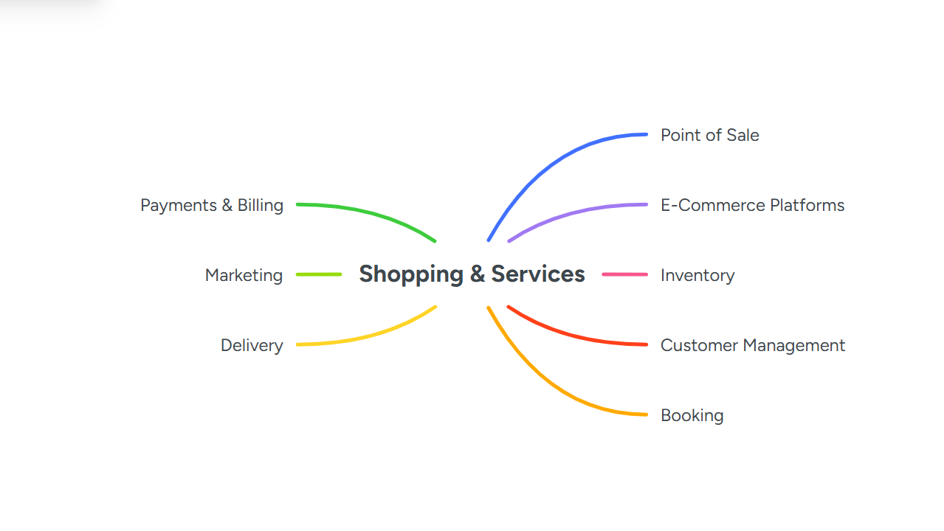

Central node: Contemporary Business Software

Communication & Collaboration Tools: Slack, Microsoft Teams, Zoom .Purpose: real-time chat, channels, video meetings, shared presence for distributed teams. Productivity / Office Suites Tools: Microsoft 365, Google Workspace. Purpose: documents, spreadsheets, email, calendaring and shared drives. Project & Task Management Tools: Asana, Trello, Jira, Monday.com. Purpose: planning, Kanban, sprint tracking, task assignment and timelines. Customer Relationship Management (CRM) Tools: Salesforce, HubSpot, Pipedrive. Purpose: lead tracking, sales pipelines, customer data and reporting. ERP / Core Business Systems Tools: SAP S/4HANA, Oracle NetSuite, Microsoft Dynamics 365. Purpose: integrated finance, inventory, procurement, manufacturing and core workflows.

Accounting & Finance Tools: QuickBooks, Xero, Sage. Purpose: invoicing, bookkeeping, payroll feeds and tax reporting. HR, Payroll & People Ops Tools: Workday, BambooHR, ADP, Rippling. Purpose: hiring, onboarding, time-tracking, payroll and benefits. Marketing, Analytics & Automation Tools: Google Analytics, Mailchimp, Marketo, SEMrush. Purpose: campaigns, web analytics, automation and performance tracking.

Customer Support & Helpdesk Tools: Zendesk, Freshdesk, Intercom. Purpose: ticketing, knowledge bases and customer self-service. Document Management & e Sign Tools: Dropbox, Google Drive, Docu Sign. Purpose: storage, version control, secure signatures. Business Intelligence / Reporting Tools: Tableau, Power BI, Looker .Purpose: dashboards, data visualisation and executive reporting.

Cloud Infrastructure & DevOps Tools: AWS, Azure, Google Cloud, GitHub, GitLab. Purpose: hosting, CI/CD, code repos and platform services. Security & Identity Tools: Okta, CrowdStrike, Palo Alto Networks. Purpose: access control, endpoint protection and threat detection. Automation & AI Assistants

Task 3
(50 marks)

Office Applications for Creating, Storing, Presenting, and Analysing Data
(Approx. 2000 words)

a.
30 marks In the modern digital workplace, office applications play a critical role in creating, storing, presenting, and analysing information and data. These applications are widely used across businesses, educational institutions, governments, and personal environments to improve productivity, accuracy, communication, and decision-making. Office applications, commonly referred to as office productivity software, include word processors, spreadsheets, database management systems, presentation tools, and collaboration platforms. Popular examples include Microsoft Office (Word, Excel, PowerPoint, Access), Google Workspace (Docs, Sheets, Slides), LibreOffice, and other cloud-based solutions. The ability to manage information effectively has become essential in an era where data-driven decision-making dominates organisational strategy. Office applications allow users to handle large volumes of data, transform raw information into meaningful insights, and present results in a clear and professional manner. This assignment explores office applications in detail, focusing on how they are used for creating, storing, presenting, and analysing information and data. The discussion highlights key features, benefits, real-world applications, and challenges associated with office productivity tools. Creating information is one of the primary functions of office applications. Word processing software is the most widely used tool for this purpose. Applications such as Microsoft Word, Google Docs, and LibreOffice Writer allow users to create documents including reports, letters, resumes, manuals, and academic assignments. These tools offer features such as text formatting, spell checking, grammar correction, templates, tables, images, and references, which improve the quality and consistency of documents. Word processors enable users to structure information logically using headings, subheadings, bullet points, and numbering. Advanced features such as track changes and comments allow multiple users to collaborate on the same document, making them especially useful in team environments. Automation tools like mail merge further enhance efficiency by allowing personalised documents to be generated from a single template.In addition to text-based content, office applications also support the creation of numerical and structured information through spreadsheet software. Spreadsheets such as Microsoft Excel and Google Sheets allow users to enter, organise, and calculate data using formulas and functions. They are commonly used to create budgets, financial reports, schedules, inventories, and performance metrics. The ability to create charts and graphs directly from spreadsheet data helps users visualise trends and patterns.Database applications are another category of office tools used for creating structured information. Applications like Microsoft Access allow users to design databases with tables, queries, forms, and reports. These tools are especially useful for organisations that need to manage large datasets, such as customer records, employee details, or product inventories. By enforcing data validation rules and relationships, database systems ensure accuracy and consistency in information creation. Storing information securely and efficiently is essential for both individuals and organisations. Office applications provide various methods for data storage, ranging from local storage on personal devices to cloud-based storage solutions. Traditionally, documents and files were stored on local hard drives or organisational servers. While this method offers control, it also carries risks such as data loss due to hardware failure or limited accessibility. Modern office applications increasingly rely on cloud storage services such as OneDrive, Google Drive, and Dropbox. These platforms allow users to store documents online, making them accessible from any device with an internet connection. Cloud storage enhances collaboration by enabling real-time access and updates while reducing the need for multiple file versions. Automatic backups and version history features further protect data from accidental deletion or corruption. Database management systems within office applications provide structured storage for large volumes of data. These systems allow data to be stored in tables with defined fields, reducing redundancy and improving retrieval efficiency. For example, a student management database can store personal details, academic records, and attendance data in an organised manner. Such structured storage supports quick searches, filtering, and reporting. Security is a major consideration in data storage. Office applications include features such as password protection, file encryption, access controls, and user permissions to safeguard sensitive information. Cloud-based platforms often provide additional security measures such as two-factor authentication and compliance with international data protection standards. These features ensure that information remains confidential, accurate, and available only to authorised users. Presenting information clearly and effectively is essential for communication, decision-making, and knowledge sharing. Presentation software such as Microsoft PowerPoint, Google Slides, and LibreOffice Impress is specifically designed for this purpose. These tools allow users to create slide-based presentations that combine text, images, charts, videos, and animations. Presentation applications support various design templates and themes that help maintain visual consistency and professionalism. Features such as slide transitions, speaker notes, and presenter view assist users in delivering engaging presentations. These tools are widely used in business meetings, classrooms, conferences, and training sessions. addition to presentation software, word processors and spreadsheets also play a role in presenting information. Reports created in word processors can include tables, charts, and images to communicate findings effectively. Spreadsheets offer powerful data visualisation tools, including bar charts, line graphs, pie charts, and dashboards, which present complex data in an easily understandable format. Data visualisation is particularly important in analytical and managerial contexts. Office applications enable users to summarise large datasets into meaningful visuals that highlight key insights. For example, a sales dashboard can show monthly revenue trends, regional performance, and top-selling products at a glance. Such presentations support faster understanding and informed decision-making. Data analysis is one of the most valuable functions of modern office applications. Spreadsheet software is the primary tool used for analysing data due to its flexibility and powerful computational features. Applications like Microsoft Excel provide a wide range of functions for mathematical, statistical, financial, and logical analysis. Users can perform calculations, identify trends, compare datasets, and generate forecasts. Advanced spreadsheet features such as pivot tables, conditional formatting, and data validation enable users to analyse large datasets efficiently. Pivot tables allow users to summarise and reorganise data dynamically, making it easier to identify patterns and relationships. Conditional formatting highlights important values, such as high sales figures or low inventory levels, using colours or icons. Office applications also support basic statistical analysis, including averages, standard deviation, correlation, and regression. These features are commonly used in academic research, business analysis, and performance evaluation. By using built-in functions and charts, users can interpret data without requiring specialised statistical software. Database applications further enhance data analysis by enabling complex queries and reports. Structured Query Language (SQL) and query design tools allow users to extract specific information from large datasets. For example, an organisation can analyse customer purchasing behaviour or employee performance using database queries. The results can then be exported to spreadsheets or reports for further analysis and presentation.One of the key strengths of modern office applications is their ability to integrate and support collaboration. Integration allows different applications to work together seamlessly. For example, data from a spreadsheet can be imported into a word processor or presentation, ensuring consistency across documents. Changes made in the original file can often be updated automatically, reducing duplication and errors. Collaboration features are particularly important in today’s remote and hybrid work environments. Cloud-based office applications enable multiple users to work on the same document simultaneously. Features such as real-time editing, comments, chat, and version control improve teamwork and productivity. Users can track changes, revert to previous versions, and communicate directly within the application. These collaborative capabilities are widely used in education, where students and teachers work together on assignments and projects, and in business, where teams collaborate on reports, budgets, and strategies. The ability to share documents securely with specific permissions enhances both efficiency and data security. Office applications offer numerous advantages that make them indispensable in modern society. They improve efficiency by automating repetitive tasks such as calculations, formatting, and data entry. This allows users to focus on analysis and decision-making rather than manual work. Standardised templates and tools ensure consistency and professionalism across documents and presentations. Accuracy is another significant benefit. Built-in formulas, validation rules, and error-checking features reduce the risk of mistakes in data handling. Secure storage and backup options protect information from loss and unauthorised access. The ability to analyse and visualise data supports evidence-based decision-making and strategic planning. Office applications are also highly adaptable. They can be used by individuals, small businesses, and large organisations across various industries. With the availability of cloud-based and mobile versions, users can access their work anytime and anywhere, increasing flexibility and responsiveness.Despite their benefits, office applications also have certain challenges and limitations. One common issue is the learning curve associated with advanced features. While basic functions are easy to use, mastering complex tools such as pivot tables, macros, or database queries requires training and experience.Compatibility issues can arise when different versions or platforms are used. Files created in one application may not display correctly in another, leading to formatting or data errors. Dependence on technology also introduces risks such as system failures, cyberattacks, and data breaches.Additionally, office applications may not be suitable for extremely large-scale or specialised data analysis, which may require dedicated software such as statistical packages or enterprise-level database systems. However, for most everyday tasks, office applications provide a practical and cost-effective solution.Office applications are essential tools for creating, storing, presenting, and analysing information and data in today’s digital world. Word processors enable the creation of professional documents, spreadsheets support numerical data management and analysis, database systems provide structured data storage, and presentation tools facilitate effective communication. Together, these applications enhance productivity, accuracy, collaboration, and decision-making across various sectors. The integration of cloud technology and collaboration features has further expanded the capabilities of office applications, making them more accessible and efficient than ever before. While challenges such as learning complexity and security risks exist, the benefits far outweigh the limitations. As organisations continue to rely on data-driven approaches, office applications will remain a fundamental component of information management and digital literacy. In conclusion, mastering office applications is a valuable skill that supports academic success, professional growth, and organisational effectiveness. Their role in managing information and data will continue to grow as technology advances and the demand for efficient information processing increases.

b.
20 marks
Test some (Two different functions/tools from two different software applications. Show the process step by step through screenshots) business-related features of Office Applications (e.g., Mail merge, IF Function, VLOOKUP, Pivot Table, Goal Seek, Database concept using MS Access) and document several screenshots with accompanying description to provide evidence of practical use.

Objective:
Use the IF function to classify data based on conditions. In this example, student scores are classified as "Pass" or "Fail".
Procedure:
- Create a table with columns: Student Name, Score, Result.
- Enter the formula in the first cell of the Result column:
• Press Enter and copy the formula down for all rows.
• Observe that the Result column automatically updates based on the condition.
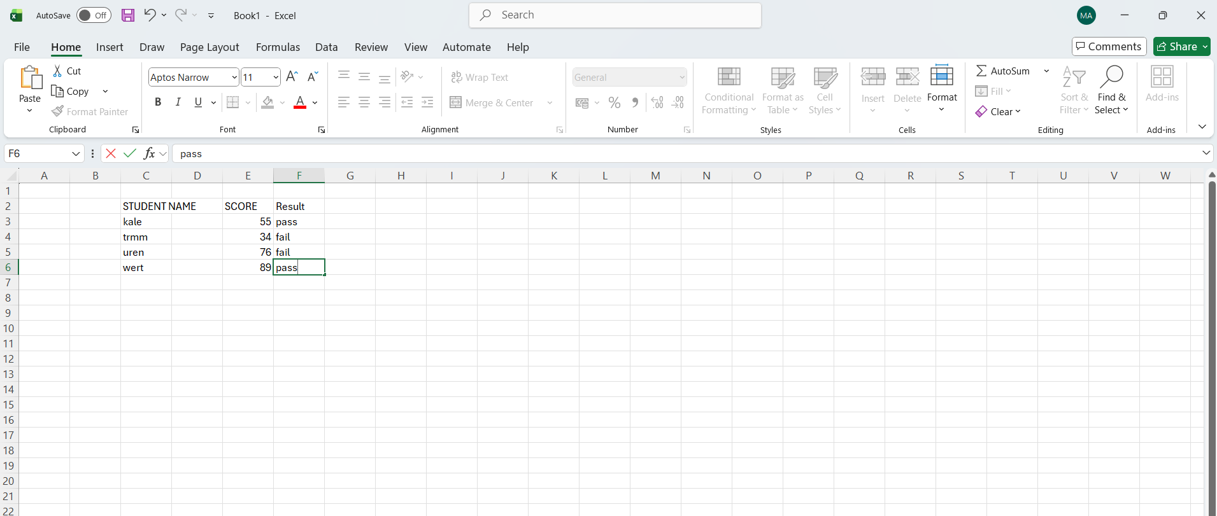
2. VLOOKUP Function
Objective:
Use the VLOOKUP function to retrieve related data from another table. In this example, employee departments are retrieved based on Employee ID.
Procedure:
- Create Table 1 (Employee Data) with columns: Employee ID, Name, Department.
- Create Table 2 (Department Lookup) with Employee IDs and their corresponding departments.
- In the Department column of Table 1, enter:
- 2 = column number in the lookup range that contains the data to retrieve (Department).
- FALSE = ensures an exact match.
- Press Enter and drag the formula down for all rows. The Department column will automatically populate with the correct department for each employee
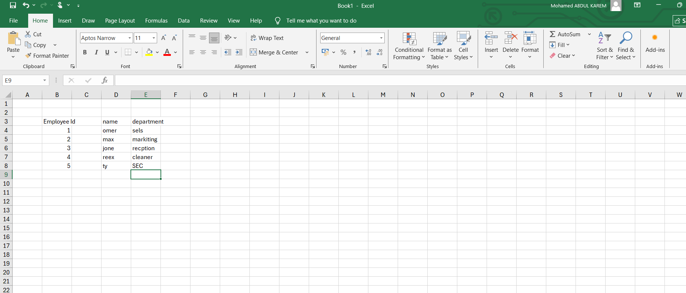

Explanation:
The VLOOKUP function searches for the Employee ID in the lookup table and returns the corresponding Department.

Task 4
(25 marks)

Communication and Collaboration applications
(Approx. 1000 words)

a. 13 marks
In the field of Information Technology (IT), communication and collaboration applications are fundamental tools that support software development, system administration, business operations, and digital services. These applications enable IT professionals to work together efficiently, share technical information, manage projects, and maintain systems across distributed environments. As organizations increasingly adopt remote work, cloud computing, and agile methodologies, communication and collaboration tools have become critical components of modern IT infrastructure.group communication. Teams' integration with Microsoft applications such as Word, Excel, and PowerPoint enables real-time collaboration on documents, including co-authoring in real time[7]. Users can also schedule meetings or host live events using built-in video and audio features. The search history allows for easy retrieval of past messages, files, and discussions, fostering knowledge sharing within the team. Teams also supports integration with external applications, streamlining workflows and improving productivity. Available on desktop, web, and mobile, it ensures continuous communication regardless of location. While Teams improves efficiency and

Communication and collaboration applications in IT are software platforms designed to facilitate interaction, coordination, and shared work among individuals and teams. Communication applications focus on the exchange of information through text, audio, or video, while collaboration applications allow multiple users to work together on tasks such as coding, documentation, troubleshooting, and project management.
In IT environments, these applications support real-time collaboration between developers, network engineers, cybersecurity teams, and stakeholders. They help ensure that systems are developed, deployed, and maintained efficiently while minimizing errors and delays.
can sometimes impact performance.

Microsoft Teams and Miro complement each other in the modern workplace. Teams enhances clarity and speed of communication, providing a structured platform for messaging, meetings, and document collaboration. Miro, on the other hand, supports collaboration and creativity by visualizing ideas and workflows effectively. Using these tools together helps organizations streamline communication, improve project management, and foster a collaborative work culture that supports both synchronous and asynchronous collaboration. By leveraging Teams and Miro, companies can break down barriers, increase transparency, and maintain productivity in increasingly digital and distributed work environments[8].
b. 12 marks
Test some features of a freely available Communication (1) and Collaboration (1) application and document several screenshots with brief accompanying description to provide evidence of practical use.
is a core communication tool in IT organizations. Platforms such as Microsoft Outlook and Gmail are used for formal communication, system notifications, and documentation sharing. Emails are often used to communicate system updates, incident reports, and policy changes, providing a permanent and traceable communication record.Instant messaging tools like Slack, Microsoft Teams, and Discord are widely used in IT teams. These platforms support real-time communication, group channels, and topic-based discussions. For IT professionals, chat applications are essential for quick problem-solving, DevOps coordination, and real-time incident response.

Step 2: Chat and Messaging
Applications such as Zoom, Google Meet, and Microsoft Teams enable virtual meetings, technical discussions, and remote training sessions. In IT, video conferencing is commonly used for sprint planning, system demonstrations, code reviews, and technical interviews.

Step 3: Video Meeting
A meeting is scheduled or started instantly for discussions and presentations.
Business value: Supports remote meetings and reduces travel costs.

Advantages of Microsoft Teams in a Business Environment Provides instant and easy communication between employees Supports remote and hybrid work models Integrates seamlessly with Microsoft applications such as Word, Excel, and PowerPoint
2. Collaboration App
• Tools such as GitHub, GitLab, and Bitbucket are critical collaboration platforms in IT. They allow multiple developers to work on the same codebase, manage versions, track changes, and resolve conflicts. These tools support collaborative software development and are essential for agile and DevOps practices.
IT teams use project management tools like Jira, Trello, and Asana to plan tasks, track progress, and manage workloads. These applications help teams follow structured development

Conclusion

