Component 2 - Research Report
Student Name: Diosnel Cordero Romero
Student Number: 2131587
Lecturer Name: Dr. Nicholas Worthington
BMSW4003_BIRM
Digital Skills and Research Methods.

Contents
1. Introduction 3
2. Research design 3
2.1. Research Question 3
2.2. Method 3
2.3. Ethical Considerations 4
3. Results 5
4. Discussion 5
5. Conclusion 6
6. Reference List 8
7. Appendix A – A blank copy questionnaire. 9

Introduction

In this report I will explain the importance of digital tools and I will talk about how students at UWTSD use digital tools for collaboration.
I will show my findings of my research and what methods I have used to find out which digital tool is mostly used for collaboration by students at UWTSD.
In order to collect data for my report I have used an online survey using Microsoft Forms which was sent to students at UWTSD. Microsoft Forms tool is a very useful tool and it has helped me in gaining knowledge and understanding of what students think.
I will also discuss about the importance of ethical considerations and explain what ethical considerations I have used, while collecting the data from students.
After explaining my result, I will discuss into more details about my findings and compare the result with my initial hypothesis. I will also discuss about new ideas and findings related to my research result.
Last but not least, in the conclusion I will talk about any recommendations to the university, students opinions about digital tools and how digital tools for collaboration can be improved in order to add more value and motivate students to collaborate more using digital tools.

Research design

Research Question

My research was based on an online survey using Microsoft forms, which was sent to students at UWTSD. Students were asked the following questions:
- Which digital tool do you use more at UWTSD to collaborate with other students?
- Moodle Description boards
- Teams
- Outlook
- OneDrive
- Office 365

- How do you prefer to collaborate and study with other students?
- Online
- Face to Face

Method

The primary method which I have used for my research was to create an online survey using Microsoft Forms. I chose to send it to a few students at UWTSD in order to collect information about their opinion on digital tools used at UWTSD.
There are two approaches to learn about people's ideas or behaviours: interviews and surveys. With these techniques, the data you gather is "self-reported," or data gathered in an indirect way, rather than first-hand (like an observation). According to a research made by Lynn Driscoll, humans are fundamentally biased in how they perceive the environment and may overstate the positive aspects of their own behaviour. Despite the problems with self-reported data, surveys and interviews are a great approach to collect information for your main research subject.
The first question I asked was “Which digital tool do you use more at UWTSD to collaborate with other students?”. I asked this question because I wanted to find out individual opinions about the digital tool mostly used at UWTSD for collaboration. The students were given a few options and they had to select one of the following: Moodle Description boards, Teams, Outlook, OneDrive, Office 365. According to the UWTSD website, Digital Learning, these are the digital tools which are available to students at UWTSD for collaboration.
The second question I asked was “How do you prefer to collaborate and study with other students?” and the possible answears were “online” or “face to face”. The reason why I asked this question was to find out if students still prefer to collaborate face to face nowadays, with the developing technology and the variety of digital tools available for collaboration.

Ethical Considerations

A set of guidelines that will direct your research designs and methods are called ethical considerations in research. Informed permission, anonymity, secrecy, the possibility of harm, and the transmission of results are some of these guiding principles.
Nowadays, a number of funders demand proof that projects have undergone independent ethical evaluation. This necessitates the development of a transparent and standardised mechanism for the independent ethical review of research proposals across all fields. A university-wide ethical review mechanism was established to guarantee the continuance of additional research funds and to satisfy the standards for consistency and independence.
During my survey I have applied ethical considerations by asking permission to use the information provided by each student for my research report and I have informed each student that their data is protected and confidential.

- Results

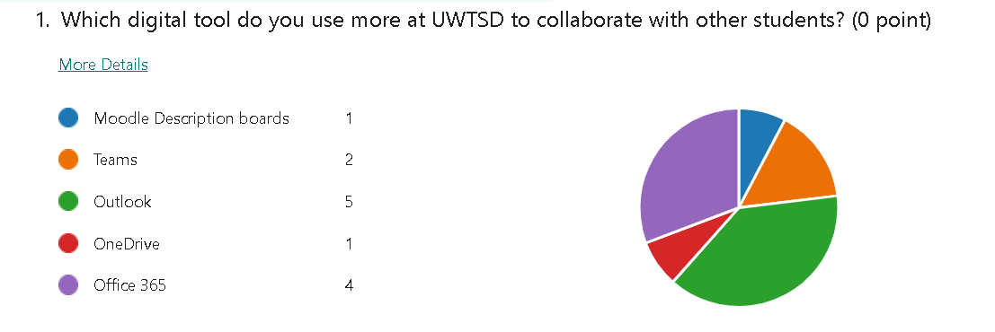
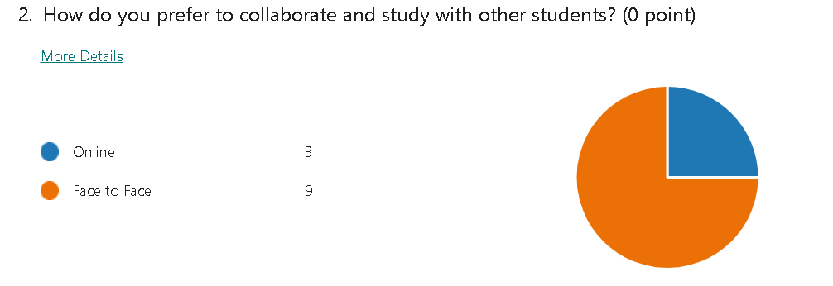
Out of 13 students who completed my online survey, 5 students selected Outlook as the most used digital tool for collaboration at UWTSD, 4 students selected Office 365 as the most digital tool, and 2 students selected Teams.
In regards to the second question, 9 students prefer to collaborate and study with other students face to face, while 3 students prefer to collaborate online.

Discussion

From the results of my survey, it appears that the digital tool mostly used by students for collaboration at UWTSD is Outlook. Most probably this is because most of the information and updates are provided by email.
On the second place of most used digital tool at UWTSD is Office 365. This is because Office 365 includes majority digital tools used for collaboration.
My hypothesis was that the most digital tool used at UWTSD for collaboration is Office 365.
A shared objective agreement between Microsoft and UWTSD aims to make sure that students have the most recent digital abilities.
As one of just three universities in the UK and the first in Wales to do so, UWTSD is now able to use Microsoft's cutting-edge tools and resources to transform the technology at the university.
Students can develop their communication, creativity, critical thinking, and cooperation abilities through the use of Microsoft Office 365.
At UWTSD students use: live sessions, pre-recorded sessions, online activities, group discussions, interactive tutorials.
Having said that, I was surprised to find out that even with all the digital tools available to students for collaboration, majority of students still prefer to collaborate and study with other students face to face, rather than online.
Out of 13 students who completed my survey, 9 students responded that they prefer to collaborate and study with other students face to face and only 3 students responded that they prefer to collaborate online.
As per the result of my study, it appears that students should be encouraged to make more use of the digital tools available for collaboration.
On the other hand, so far we have only looked at the digital tools used for collaboration between students. But could students use the same digital tools to collaborate with their teachers?
According to research, teacher education programmes still do a poor job of integrating digital capability for pedagogical goals. Additionally, creative solutions are required since they contribute significantly to the professional growth of teachers who use ICT in the classroom.
For a deeper grasp of the abilities, dispositions, and knowledge for teaching-learning contexts where information and communication technologies are more important, technology use needs to be taught professionally through tutoring and underpinning educational pedagogy. These skills are crucial as society becomes more digitalized and new media is more seamlessly incorporated into daily life with increased degrees of mobility.
In other words, in order for students to get into the habit of making more use of digital tools for collaboration, teachers must also make use of the available digital tools and encourage the students to do so as well.
According to my research, students could make more use of the digital tools available for collaboration and perhaps the university can encourage more the online collaboration by organizing online workshops and group work.
In my opinion, online collaboration is very important nowadays, with the growing technology around us. Digital tools are designed to help us and make our life easier.
For example, in the case of my research, I was able to collaborate with other students online and collect information via an online survey, which was much easier than if I had to do a face to face interview to ask my questions. This has saved me a lot of time.

- Conclusion

In conclusion, my study was about how students at UWTSD make use of digital tools and what is the most used digital tool used by students for collaboration at UWTSD.
The method used for my research was a primary research method by creating an online survey using Microsoft Forms. I have chosen to create a survey because I wanted to hear from students themselves, which digital tool they use more for collaboration at UWTSD.
The students were asked the questions “Which digital tool do you use more at UWTSD to collaborate with other students?” and “How do you prefer to collaborate and study with other students?”
Most students responded that the digital tool they used the most for collaboration at UWTSD is Outlook, followed by Office 365. In regards to the second question, most students responded that they prefer to collaborate and study with other students face to face, rather than online.
In my research, I have applied ethical considerations by informing the students that the data they provide is protected and confidential.
As part of the discussions, I have explained my opinion about my research result and I have compared it with my initial hypothesis.
I have also talked about the importance of digital tools being used by teachers also, alongside with the students and how the teachers can encourage students to use more the digital tools available to them.
Last but not least, I have talked about how most students prefer to use face to face collaboration, rather than online tools and how it is very important that they are encouraged to make more use of digital tools available to them.
Nowadays technology is developing more and more and it is important that we improve and develop together with the technology. Technology can make our life much more easier if we make good use of it.
It is very important for students to learn how to make the best use of technology and digital tools and stay up to date with the latest tools available. This will help them be more efficient in their jobs and career after they completed their degree, which is the goal of every student.
UWTSD has a multitude of digital tools which were made available to students and it is very important that all students learn how to use these tools and make good use of them. By doing so, students will create a path of making the best use of technology and that will help them be successful in both professional and personal life.

- Reference List
UWTSD, Digital Learning, UK available at URL: https://digitallearning.uwtsd.ac.uk/digital-learning.html
Ahmarg, L. Hallström, L Stigmar, M (2019) Teacher Educators' Use of Digital Tools and Needs for Digital Competence in Higher Education
Driscoll, L (2011) Observations, Surveys, and Interviews
University Ethical Review of Research (birmingham.ac.uk)
Planning a Research Project (uwa.edu.au)

- Appendix A – A blank copy questionnaire.


