CULTURAL AWARENESS
HOTEL HANDBOOK

Iris P. Barreiro Ekoro
ID: 2127100
Foreign Languages & Cultural Awareness (BMIH5003)
Rodrigo Aguilera

EXECUTIVE SUMMARY

This executive summary provides insights into the cultural contrast between Spain and the USA. The report focuses on these preferences' impact on the hospitality industry's guest service experience. By understanding guests' behaviour staff of hotels significantly manage the overall experience of international guests. Key areas the staffs focus on are the communication style of guests, attitudes, personal space management, and punctuality. By acknowledging these cultural adaptations, hotel staff may deliver exceptional experience and service that results in positive guest satisfaction. A culturally sensitive approach implementation ultimately contributes to a successful guest experience.

TABLE OF CONTENTS

Introduction ———— 4

An Understanding of Intercultural Competence ———- 4 & 5

The Importance of Cultural Understanding in the Global Marketplace ——— 5

Analysis of the Two Countries ———— 5

Critical Understanding ———— 5 & 6

Recommendations for the Staff ———— 6

Cultural Awareness Training ———— 7

Customised Service ———— 7

Do’s and Don’t ————- 7 & 8

References ————- 9 & 10

Appendix ————— 11

Introduction
In the modern global era of connectivity, the role of the hospitality industry is significant in accommodating international visitors' diverse needs. For hotel personnel, cultural sensitivity and intelligence are vital in producing exceptional customer service for hotel staff. This report critically evaluates the cultural significance and intelligence in the hotel guest service context, focusing on Spain and USA guest hailing. Relevant cross-cultural theories analysis explore the implication for several hotel sectors and their services. Hotels must emphasise the international customer's necessity that enhances consumer behaviour in guest service experience (Oriade, Osinaike, Aduhene et al. 2021)
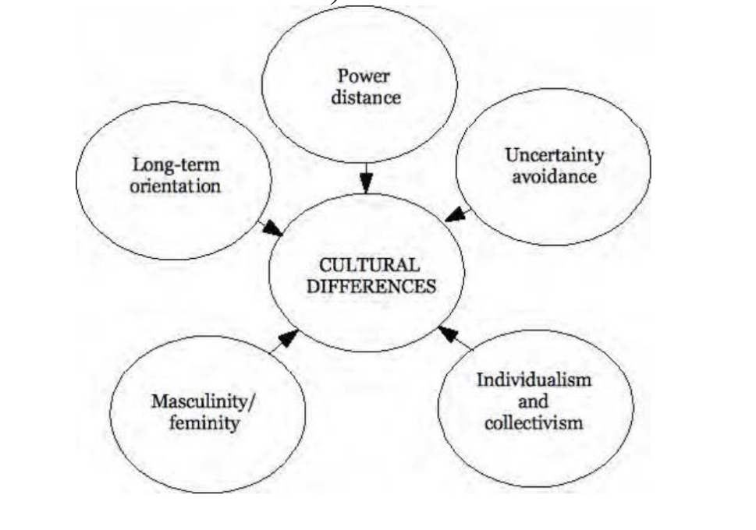
Figure: Hofstede’s five dimensions of culture.
Source: www.futurelearn.com (2022)

An Understanding of Intercultural Competence
Intercultural Competence plays a crucial role in the hospitality industry. It is highly impactful for hotel staff that manage and prepare them to enhance guest experience according to Spain and USA visitors' experiences. For hotel staff, it is essential to understand the cultural difference, customers' expectations and demands to ensure their satisfaction. American guests prioritise professionalism and efficiency, while Spanish guests value a personal and warm approach. Cultural etiquette, dietary choices, and communication styles of these two countries' visitors must be familiarised with hotel staff to provide them a more welcoming environment and personalised service (Jhaiyanuntana and Nomnian 2020).

The Importance of Cultural Understanding in the Global Marketplace
Cultural understanding has effective significance in the global marketplace in the hospitality industry of Spain and the USA. Hotel staff possesses cultural awareness to manage and prepare international visitors' guest experience. Cultural traditions, intricacies and demands of customers from both countries give a complete analysis for hotel staff to deliver top-notch personalised service for the two countries' visitors (Mariani and Predvoditeleva 2019). Cultural understanding gives hotel staff the ability to develop impactful communication skills, optimise misunderstandings, and help them fulfil international customers changing needs, demands, and expectations in the global hospitality market.

Analysis of the Two Countries
Spain and USA possess significant cultural differences that highlight their unique history, geographical, and social backgrounds. Spain is well-known for its rich culture and heritage that place strong traditional family values and festivity (Martinez, Garcia, Veiga, Garcia et al. 2020). The culture of Spain embraces close-knit communities and values time relaxed approach. Additionally, the USA is known for its individualistic social structure that emphasises personal ambition, achievement, and efficiency. In America, people's lifestyles are categorised by dynamic social environments and fast-paced. The cultural diversity of the USA shaped historical immigration and heterogeneous contribution mixed with traditions and customs. In the hospitality industry, the hotel staff must recognise those cultural disparities for effective communication and relationship maintenance with international customers to provide exceptional guest service to both countries.
Critical Understanding
To successfully manage the guest service experiences for international customers of Spain and the USA, hotel staff should analyse a significant understanding of the key cultural differences, behaviour, and customs of Spain and the USA visitors. Spain places the impact on traditional values, family involvement, and community connection. The USA demonstrates ambition, individualism, and personal efficiency. Hotel staff should be aware of customers' communication styles, tie management, and cultural social norms behaviour. This identification of cultural knowledge helps hotel staff to provide culturally sensitive customer service and experience for both countries' international guests (Mariani, Borghi, and Okumus et al., 2020).

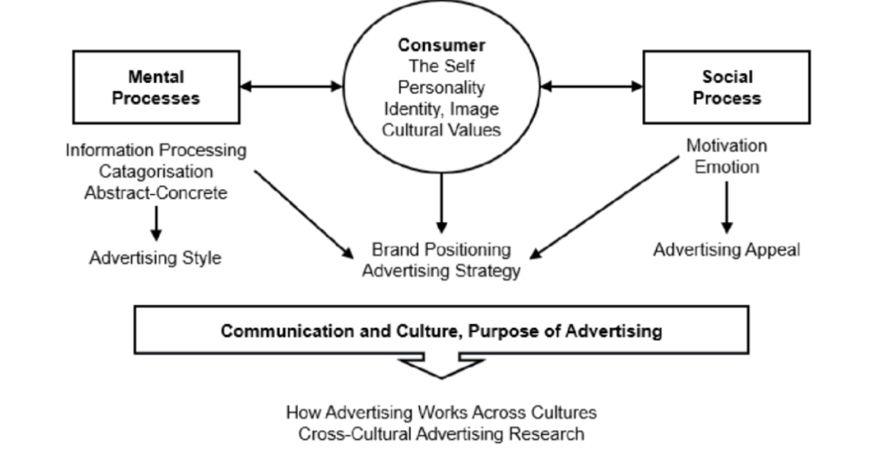
Figure: 3 Organizing for Global Marketing
Source: www.researchgate.net

Recommendations for the Staff
Hotel staff should consider the cultural difference and contradictions of the international visitors of Spain and the USA to manage the proper guest service experience. Here are two recommendations for the hotel staff to identify these aspects in this report.

Cultural Awareness Training
Hotel staff needs to provide them with cultural awareness training that focuses significantly on the cultural disparities between Spain and the USA. This training should address international customers' social norms, communication styles, and hospitality demands. However, Spanish guests appreciate a warm personal approach to customer service, while American guests prefer professional, efficient service from staff. Staff should equip cultural knowledge that will prepare them to adopt unique service styles for guest satisfaction enhancement (Solnet, Subramony, Ford et al. 2019).
Customised Service
Recognise that cultural differences beyond categorisation may vary among individuals by encouraging hotel staff to actively listening engage in personalised interaction with international guests. By understanding customers' preferences and demands, hotel staff may provide customised services (Guan, Hung, and Liu et al. 2022). As an example of customised service, Spanish visitors will enjoy authentic local cuisine and cultural activity, but American customers may prefer popular tourist attraction suggestions and marketing spots. Hotel staff must take the time to understand international guests' cultural backgrounds for customised service.

Do’s and Don’t
Do’s | Don’t
Welcome international guests with friendly gestures and warm smiles. | Avoid making cultural preferences and assumptions based on stereotypes.
Respect guest personal choices and space. | Respect guest’s boundaries and avoid interfering with their personal space.
Offer a guide and assistance about local attractions. | Don’t assume language proficiency.
Be punctual about time commitments. | Avoid making guests wait for reservations and appointments.
Provide various international cousins options. | Don’t confuse communication.
Communicate with clear direction and instruction. | Refrain from making negative comments about guests cultural orientation.

REFERENCES

- Guan, C., Hung, Y.C. and Liu, W., 2022. Cultural differences in hospitality service evaluations: mining insights of user-generated content. Electronic Markets, pp.1-21. Available at: https://www.researchgate.net/profile/Yu-Chen-Hung/publication/361149734_Cultural_differences_in_hospitality_service_evaluations_mining_insights_of_user_generated_content/links/62c7b39fcab7ba7426da0327/Cultural-differences-in-hospitality-service-evaluations-mining-insights-of-user-generated-content.pdf [Acessed: 7 June 2023]
- Jhaiyanuntana, A. and Nomnian, S., 2020. Intercultural communication challenges and strategies for the Thai undergraduate hotel interns. PASAA: Journal of Language Teaching and Learning in Thailand, 59, pp.204-235. Available at: https://files.eric.ed.gov/fulltext/EJ1240001.pdf [Acessed: 7 June 2023]
- Mariani, M. and Predvoditeleva, M., 2019. How do online reviewers' cultural traits and perceived experiences influence online hotel ratings? An empirical analysis of the Muscovite hotel sector. International Journal of Contemporary Hospitality Management. Available at: https://centaur.reading.ac.uk/84917/1/Anon_Manuscript_revised.pdf [Acessed: 7 June 2023]
- Mariani, M.M., Borghi, M. and Okumus, F., 2020. Unravelling the effects of cultural differences in the online appraisal of hospitality and tourism services. International Journal of Hospitality Management, 90, p.102606. Available at: https://centaur.reading.ac.uk/91526/1/Manuscript_Accepted_ok_Final.pdf [Acessed: 7 June 2023
- Martinez, I., Garcia, F., Veiga, F., Garcia, O.F., Rodrigues, Y. and Serra, E., 2020. Parenting styles, internalization of values and self-esteem: A cross-cultural study in Spain, Portugal and Brazil. International Journal of Environmental Research and Public Health, 17(7), p.2370. Available at: https://www.mdpi.com/1660-4601/17/7/2370/pdf [Acessed: 7 June 2023]
- Oriade, A., Osinaike, A., Aduhene, K. and Wang, Y., 2021. Sustainability awareness, management practices and organizational culture in hotels: Evidence from developing countries. International Journal of Hospitality Management, 92, p.102699. Available at: https://wlv.openrepository.com/bitstream/handle/2436/623760/Oriade_et_al_Sustainability_awareness_2020.pdf?sequence=3&isAllowed=y [Acessed: 7 June 2023]
- Solnet, D., Subramony, M., Ford, R.C., Golubovskaya, M., Kang, H.J. and Hancer, M., 2019. Leveraging human touch in service interactions: lessons from hospitality. Journal of Service Management, 30(3), pp.392-409. Available at: https://www.researchgate.net/profile/Mahesh-Subramony/publication/333578664_Leveraging_human_touch_in_service_interactions_lessons_from_hospitality_Leveraging_human_touch_in_service_interactions/links/5dceb4584585156b3515e676/Leveraging-human-touch-in-service-interactions-lessons-from-hospitality-Leveraging-human-touch-in-service-interactions.pdf [Acessed: 7 June 2023]
- www.futurelearn.com (2022) Hofstede’s five dimensions of culture, FutureLearn. Available at: https://www.futurelearn.com/info/courses/managing-company-culture/0/steps/216758 [Accessed: 07 June 2023
- www.researchgate.net (2023) 3 Organizing for Global Marketing | Download Scientific diagram. Available at: https://www.researchgate.net/figure/Organizing-for-global-marketing_fig2_280179031 [Accessed: 07 June 2023]

Appendix
EDUCATION FOR SUSTAINABLE DEVELOPMENT (ESD)

Does the module contribute to ESD? Yes, recognising the importance of respecting culture and language in the industry. When dealing with international customers from Spain or the USA, the hotel staff must navigate cultural differences. Value of understanding help the brand to give a personalise service to the customers. Respecting gusts culture, heritage, sex and some of their traditions. Cultural differences are prioritised to increase the hotel industry with sustainable contribution. Those initiatives heightened guest satisfaction in long term prosperity.

