Assignment 2: Project Management
University of Wails Trinity St David | Swansea
Changemakers: Creativity and Value Creation (ACCA5033)
By: Joseph Gillespie (2214885)
2023
Table of Contents
Introduction 2
1.0 What’s The Verdict? 3
1.1 3
1.2 3
2.0 Project Management 4
3.0 Project Reflection 5
4.0 Screen Captures 6
Bibliography 10

Introduction

This assignment will develop further on the Never Landing Drone project first mentioned in Assignment 1: E-Portfolio. Much like the first assignment, this document will hold screenshots as evidence of the completed tasks, with the whole responses being within the attached E-portfolio linked below:

https://sway.office.com/V4vIFj5f4GFL1FKx?ref=Link

What’s The Verdict?

1.1
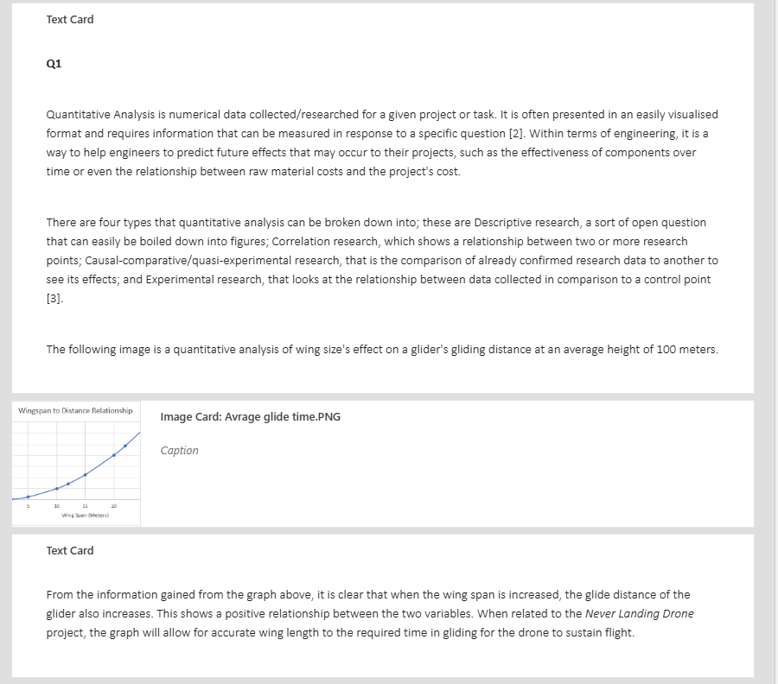

1.2
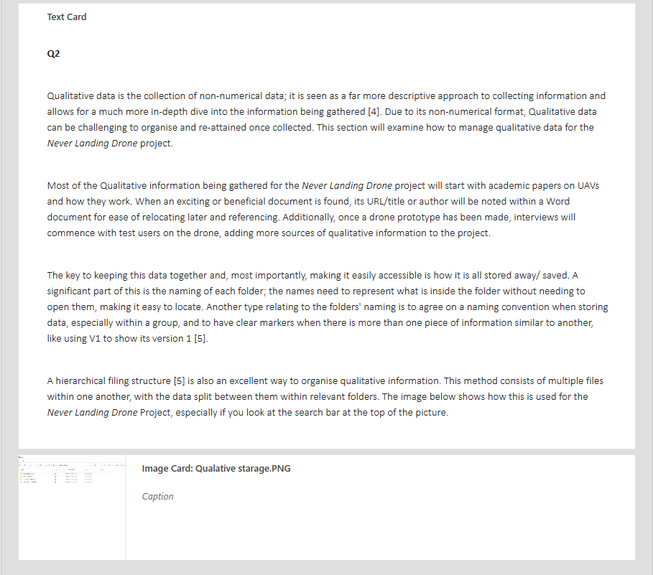

Project Management

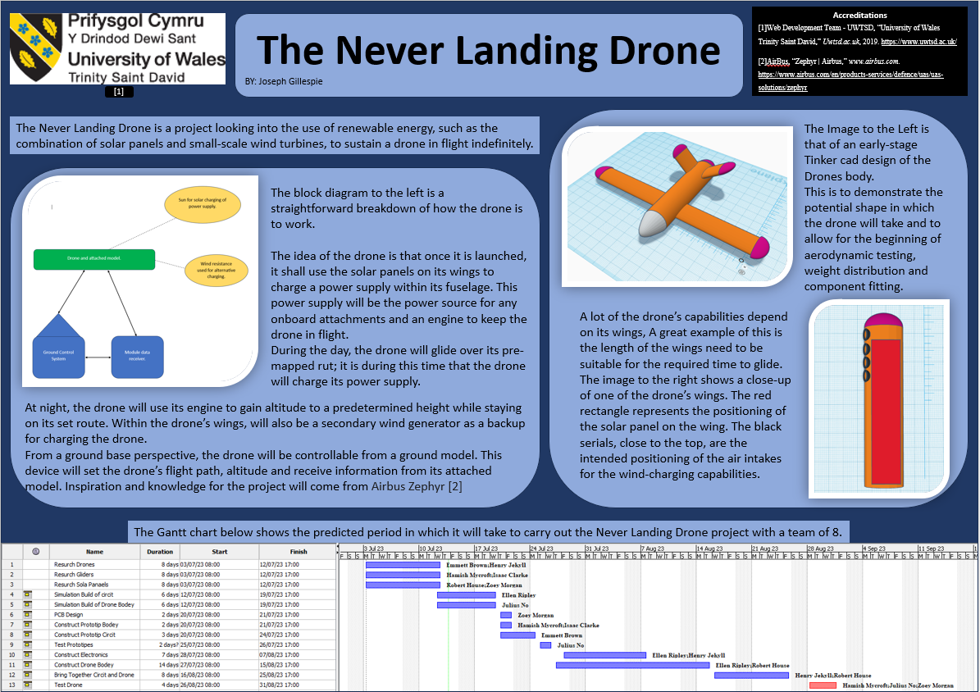

Project Reflection
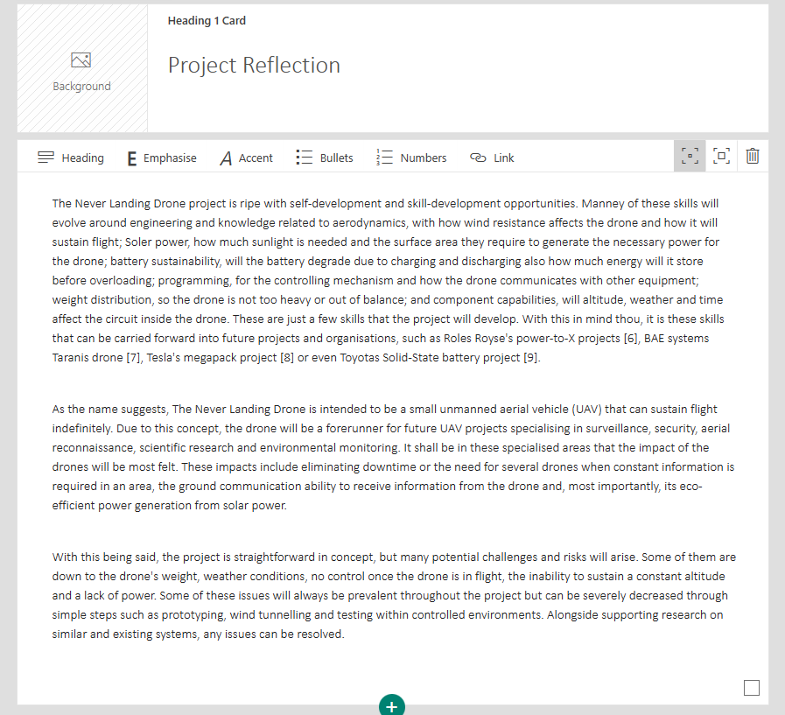

Screen Captures

The Following Screen Captures are to show and prove participation in the presentations found within the change makers module.

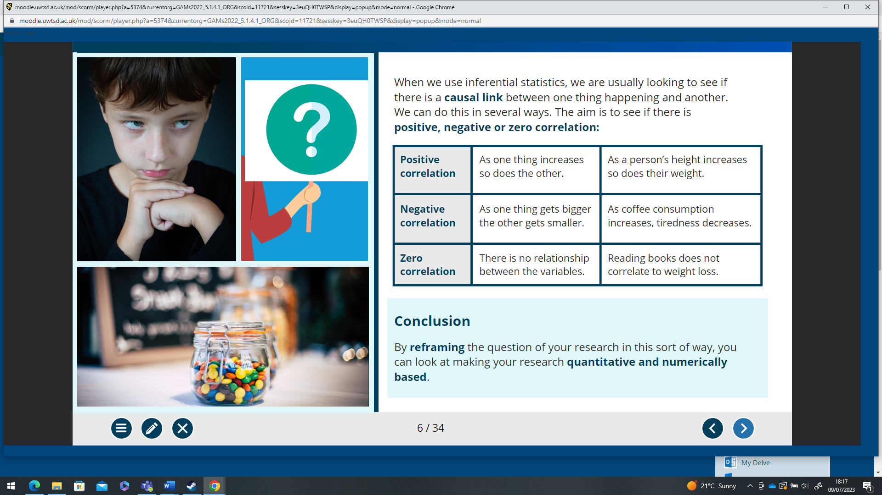
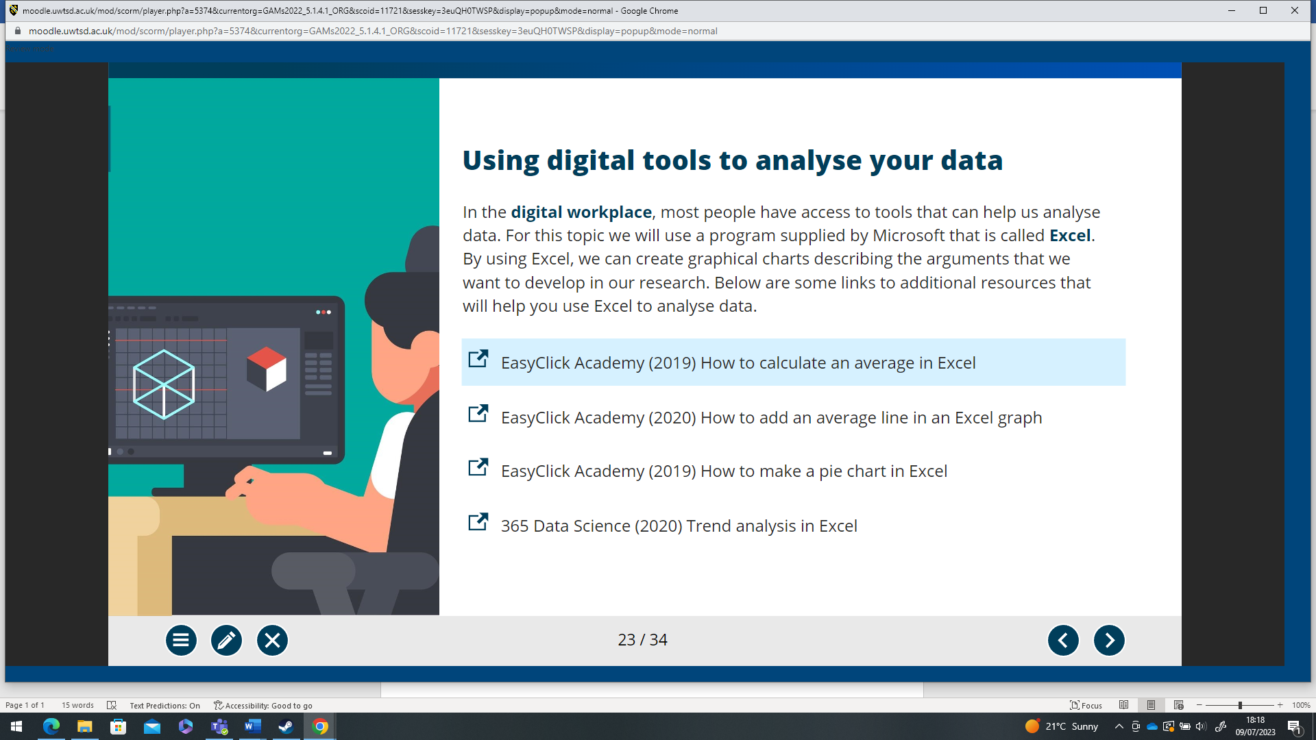
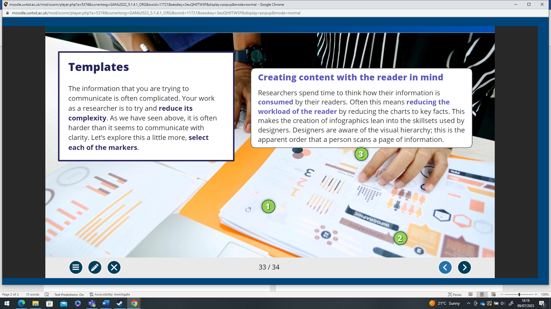
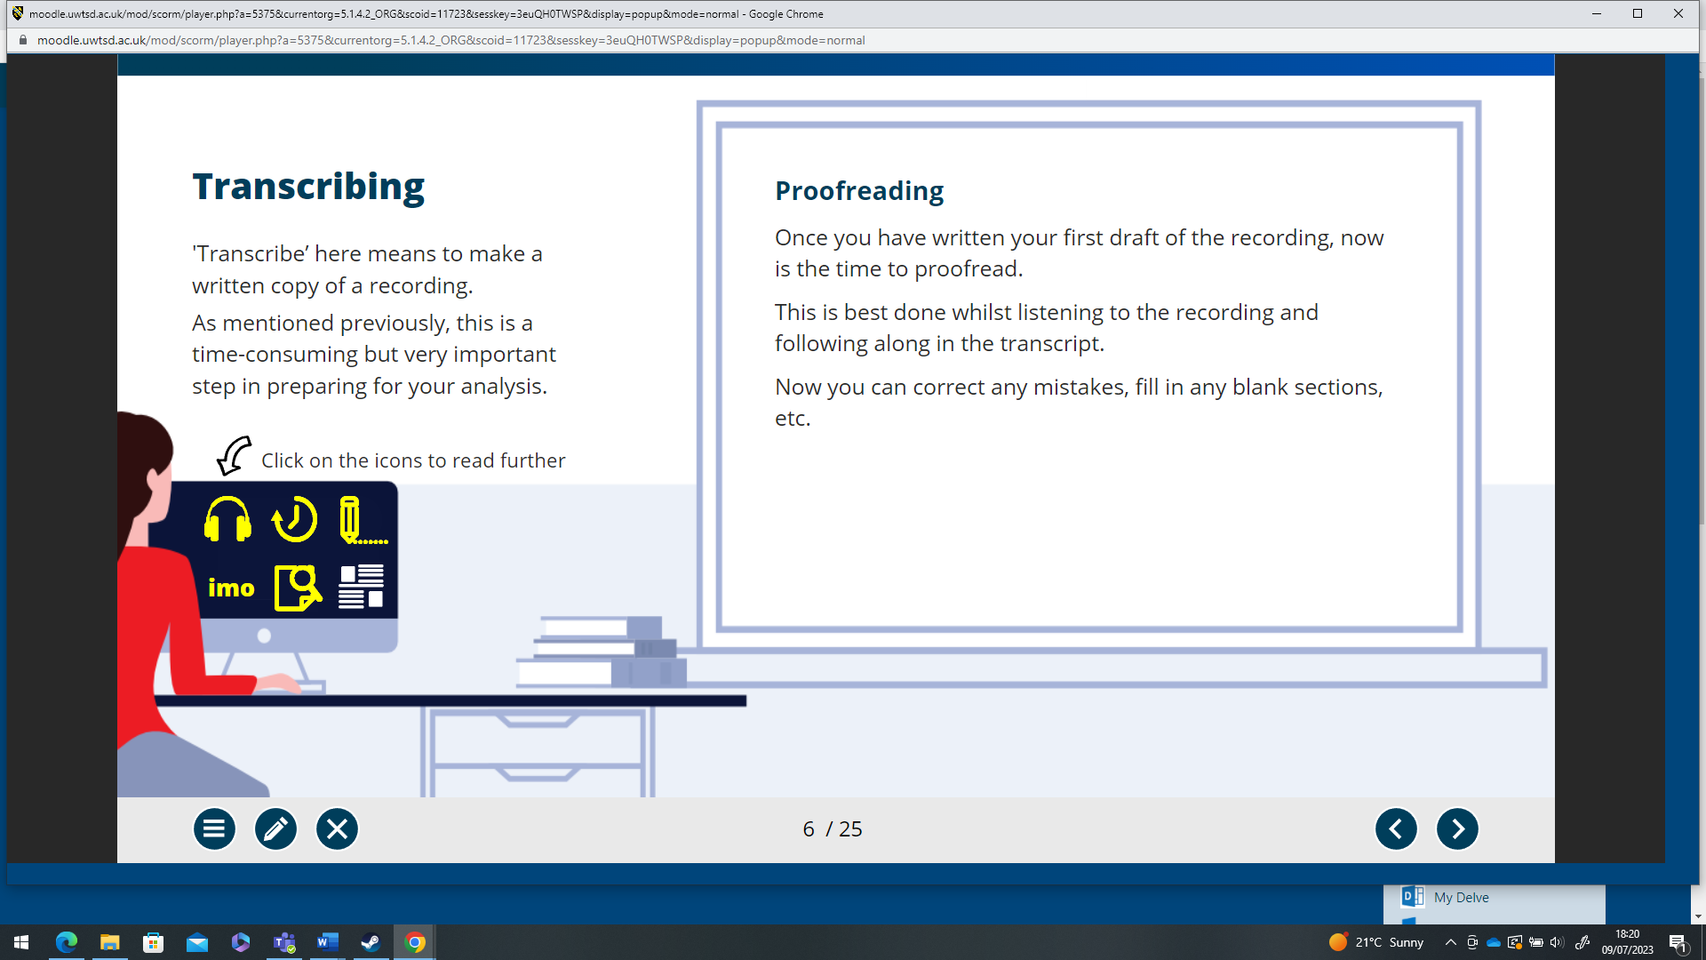
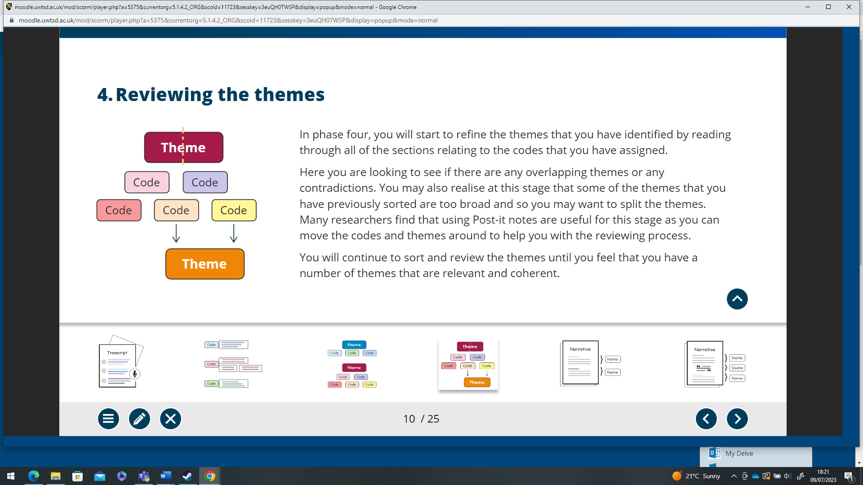
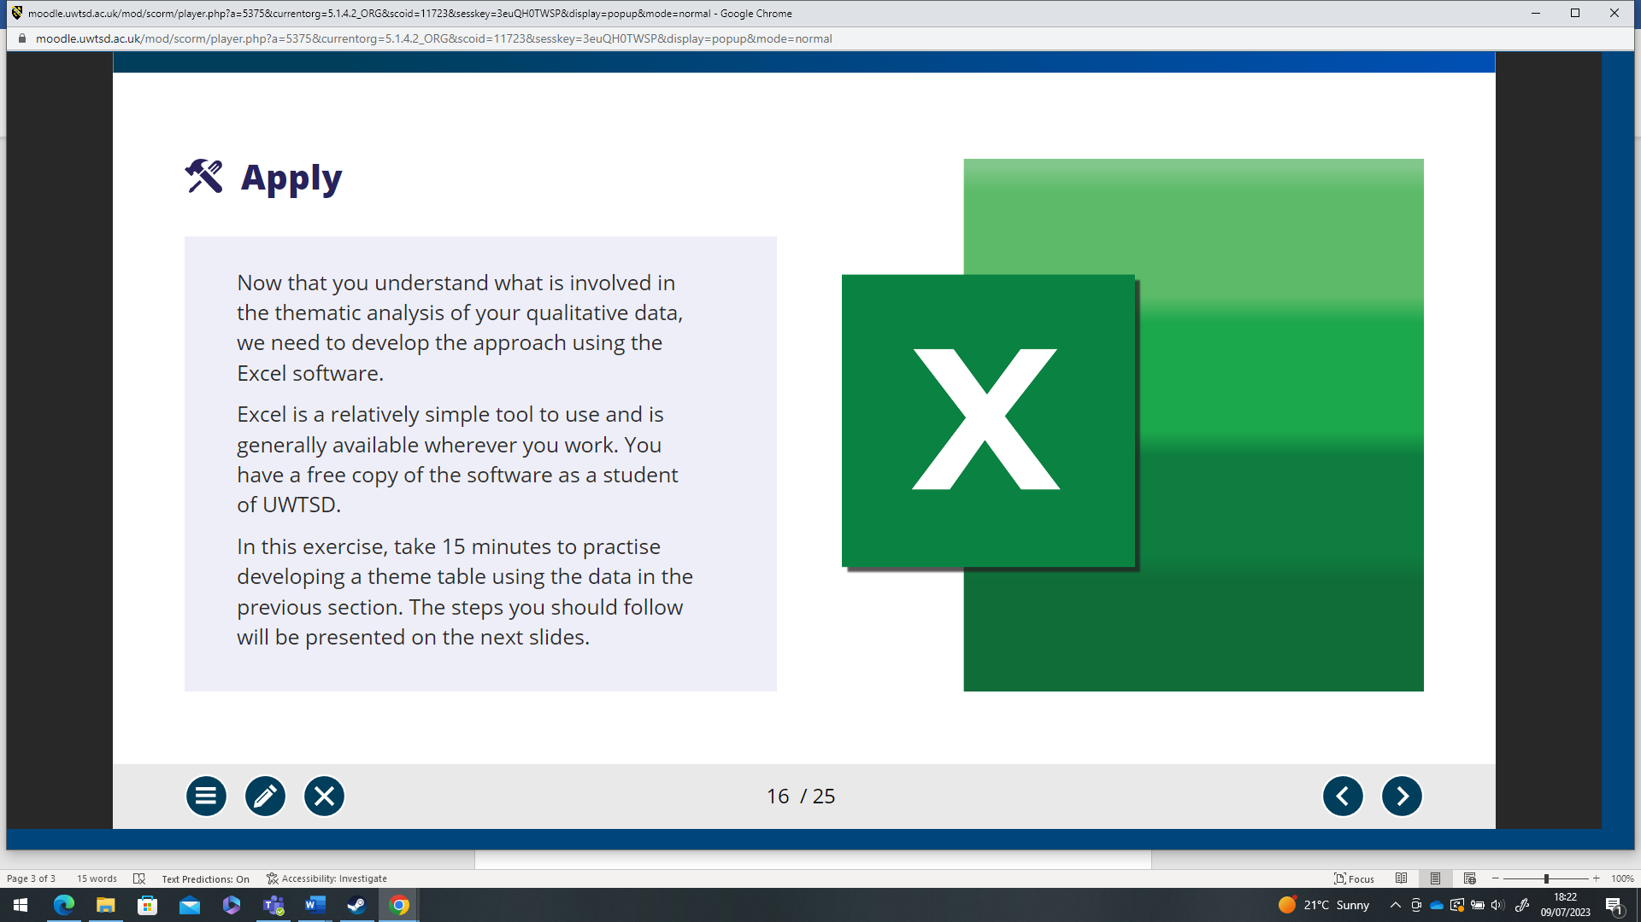

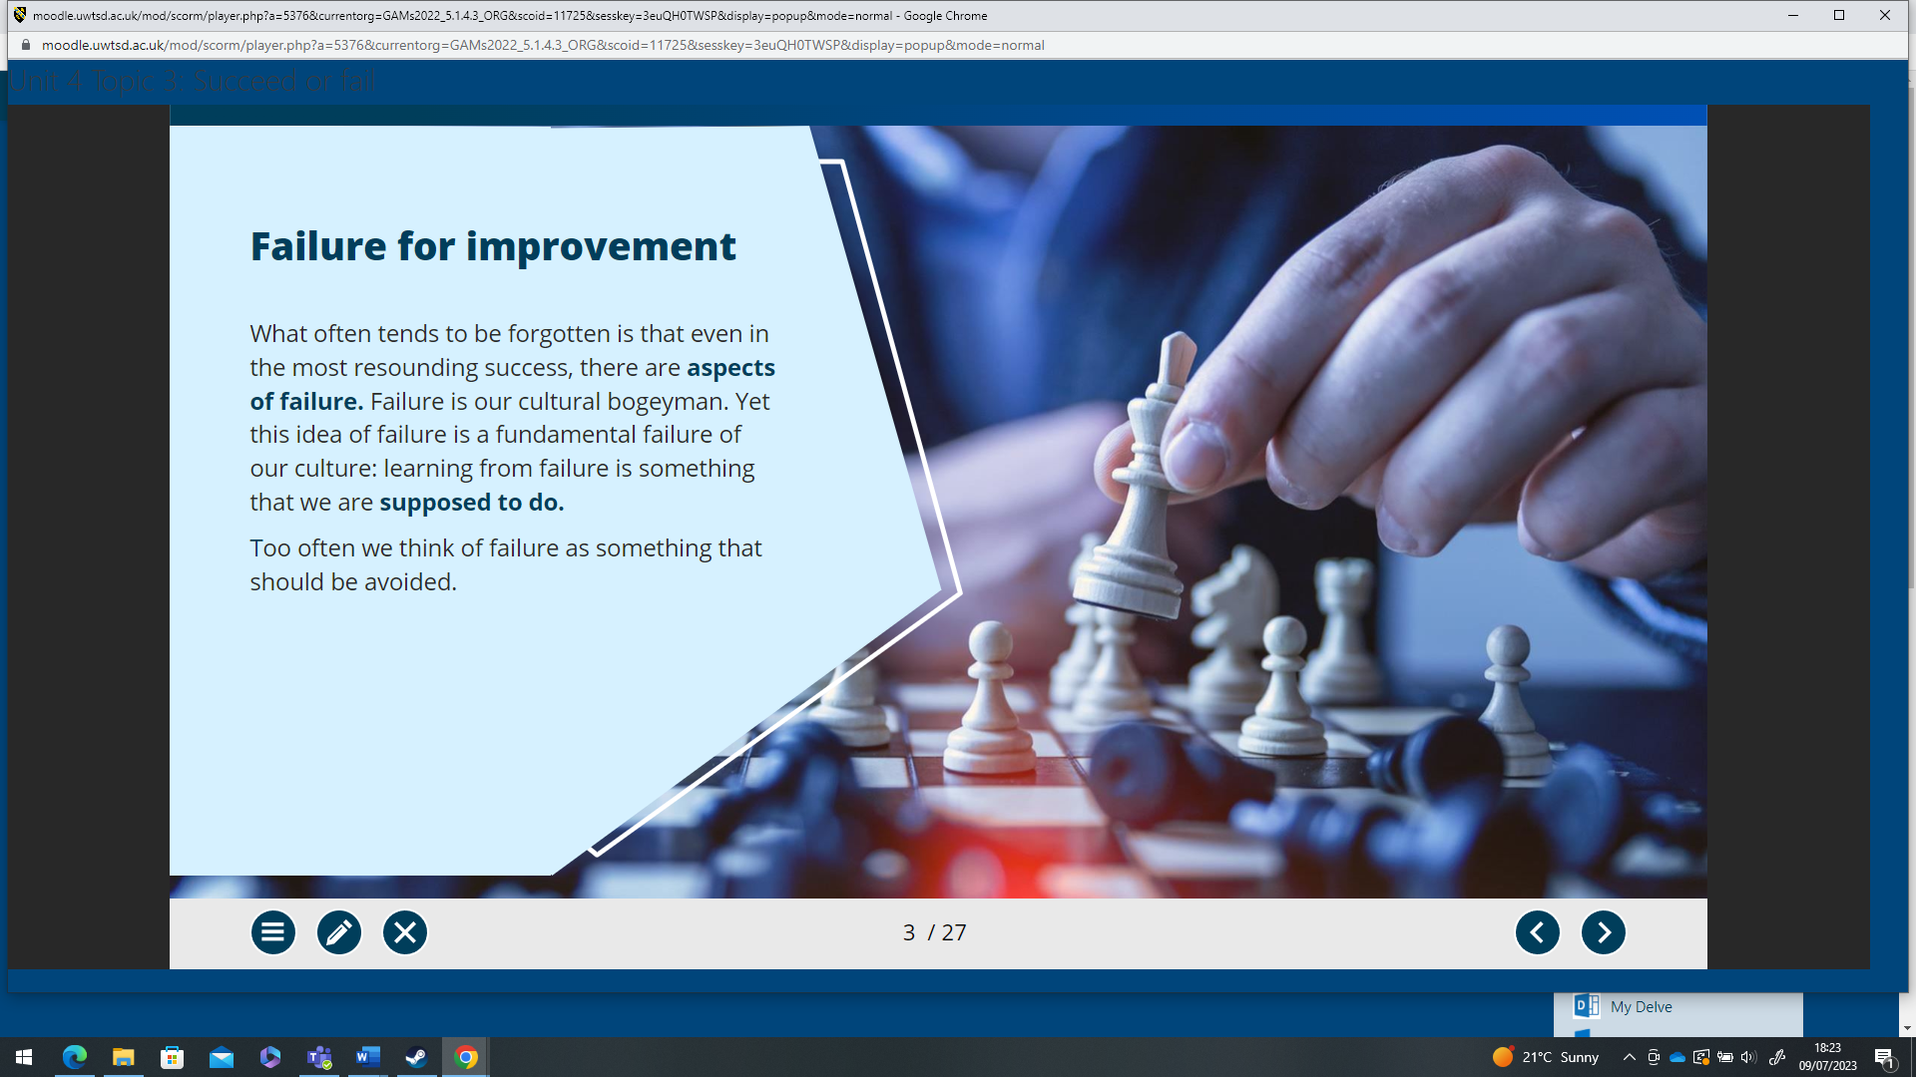

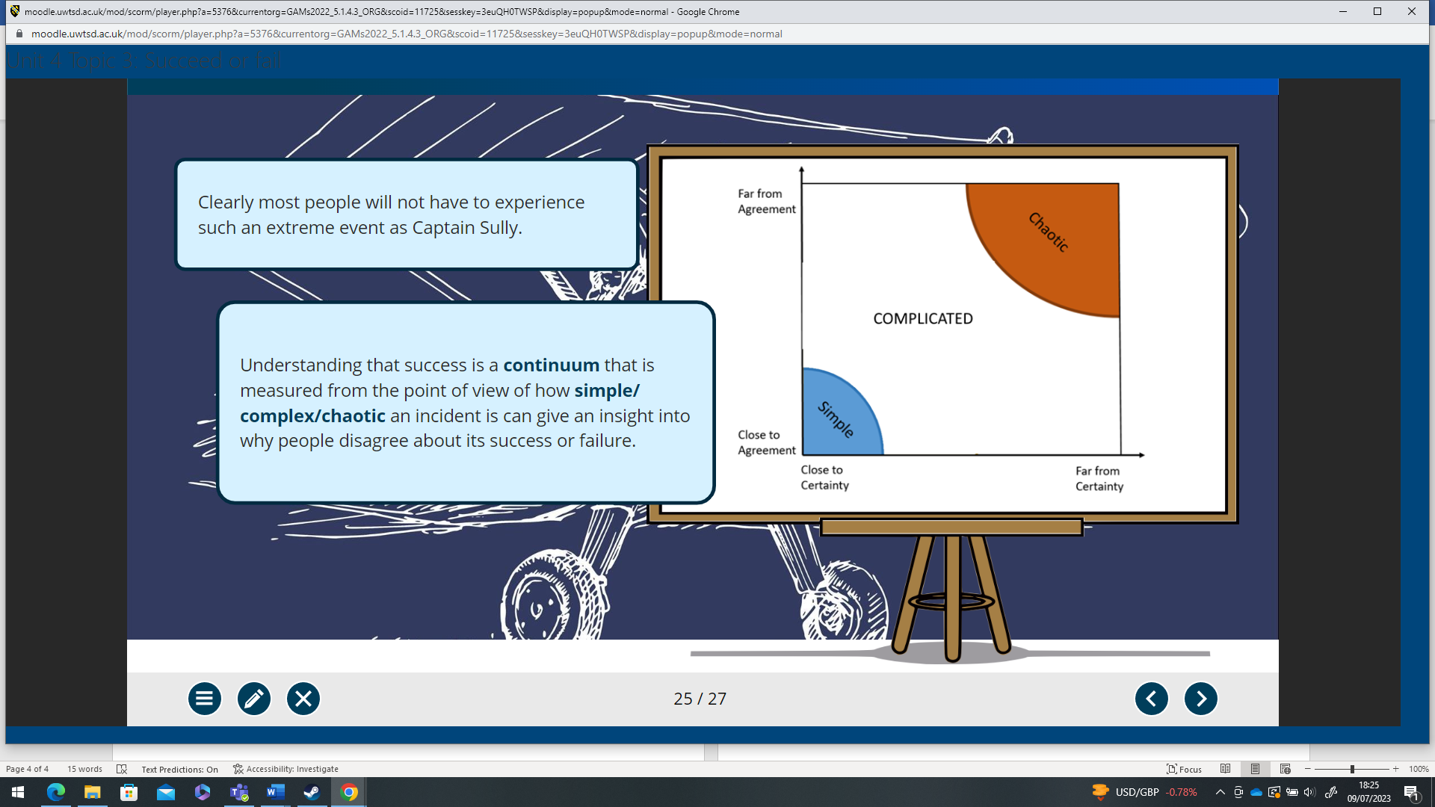

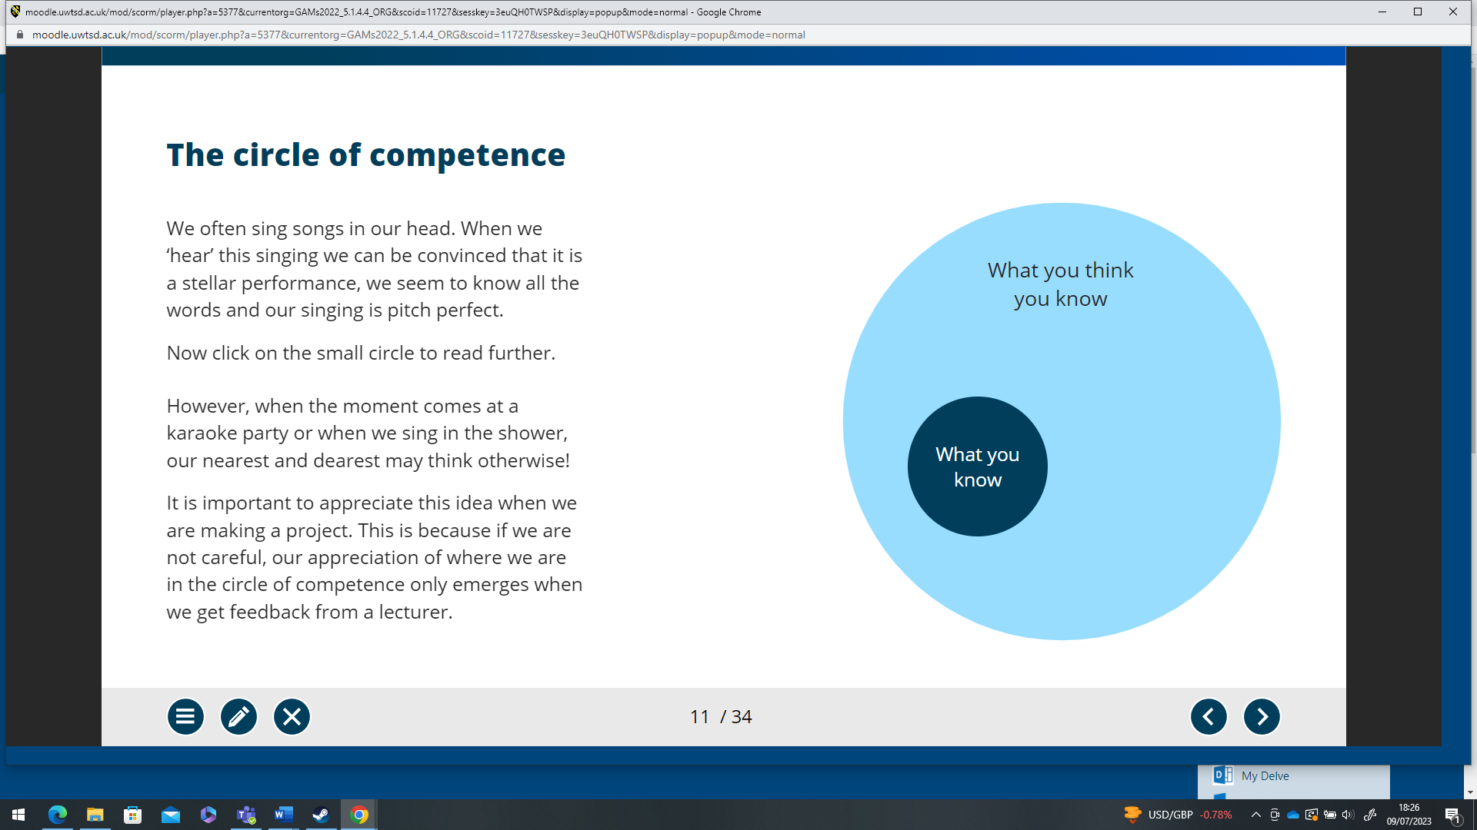

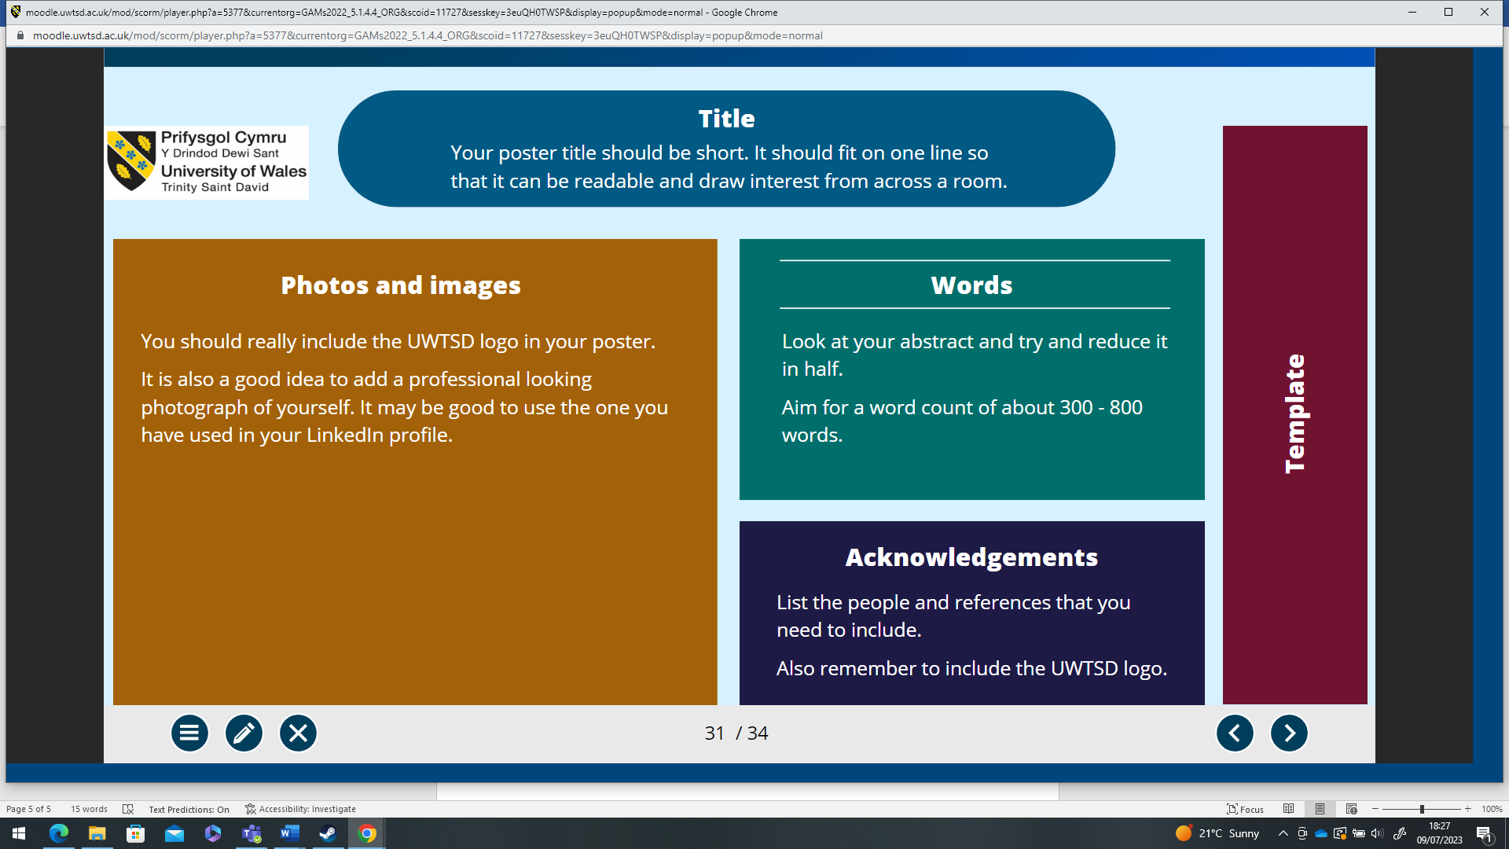

Bibliography

[1]“SolarXOne: fully electric, solar-powered autonomous drone,” DroneDJ, Aug. 30, 2021. https://dronedj.com/2021/08/30/solarxone-fully-electric-solar-powered-autonomous-drone/
[2]S. Gupta, “What Is Quantitative Data? [Overview, Examples, and Uses],” Springboard, Sep. 22, 2022. https://www.springboard.com/blog/data-analytics/quantitative-data/#:~:text=Numbers%20of%20cars%20passing%20through,to%20help%20engineers%20make%20predictions
[3]Winston-Salem State University, “Key Elements of a Research Proposal Quantitative Design,” 2022. Available: https://www.wssu.edu/about/offices-and-departments/office-of-sponsored-programs/pre-award/_Files/documents/develop-quantitative.pdf
[4]“Qualitative vs. Quantitative Data: What’s the Difference? And Why They’re So Valuable | FullStory,” www.fullstory.com. https://www.fullstory.com/blog/qualitative-vs-quantitative-data/#:~:text=Unlike%20quantitative%20data%2C%20qualitative%20data
[5]“Organising Your Data | UWTSD,” www.uwtsd.ac.uk. https://www.uwtsd.ac.uk/library/research-data-management/working-with-data/organising-your-data/ (accessed Jul. 15, 2023).
[6]“Rolls-Royce and SOWITEC cooperate on power-to-X projects,” www.rolls-royce.com. https://www.rolls-royce.com/media/press-releases/2022/04-10-2022-rr-and-sowitec-cooperate-on-power-to-x-projects.aspx (accessed Jul. 15, 2023).
[7]“Taranis,” BAE Systems | United Kingdom. https://www.baesystems.com/en-uk/product/taranis1
[8]Tesla, “Megapack | Tesla,” Tesla.com, 2020. https://www.tesla.com/en_gb/megapack
[9]K. Inagaki, “Toyota says solid-state battery breakthrough can halve cost and size,” Financial Times, Jul. 04, 2023. Available: https://www.ft.com/content/87cb8e92-8e82-4755-8fc3-2943f8f63e1d

