Digital Surveying

Assignment 2

ACBA4002

2000 words +/- 10%

Table of Contents
Introduction 3
General overview of levelling surveying 3
Equipment used in levelling 3
Level 3
Tripod 4
Measuring Staff 4
Measuring tape 4
Synthetic tape 4
Steel tape 5
Range Pole 5
Pegs 5
Plumb bob 6
Levelling procedure 6
Computation and plotting of level 7
9
Conclusion 10
Bibliography 11

Introduction

The University of Wales Trinity Saint David are planning a major road reconstruction around the city campus. In this assignment we have been consulted by the University to conduct a levelling survey. As a part of the levelling survey, we will also estimate the volume of earthwork involved assuming the slope of the road with a straight line connecting the reduced level of the Temporary Benchmark (TBM) with the reduced level of the last station.

General overview of levelling surveying

A levelling survey is the process of calculating the height of one level in relation to another. Leveling surveys are used to determine the elevation of a location in relation to a datum. The height of collimation method and the rise and fall method are the two primary methods for performing levelling surveys. There is no more accurate procedure than another. The Rise and Fall approach, on the other hand, has an extra check, which makes it the preferred choice.

Leveling may be utilised in construction and infrastructure projects, aiding in the design of roadways, sewers, trains, and other constructed types of construction. It may also be used to compute the volumes of earthworks and as a site plan for new foundations, contouring, drainage, and estimating the fall/gradient of piping.
Primarily, Levelling is used to:

- To determine the difference in height between two or more points.
- To determine the height of discrete points.
- To provide spot heights or contours on plan.
- To provide the data for road cross-sections or volume of the earthworks.
- To provide a level or inclined plane in the setting out of construction works.
(Pang, n.d.)

Equipment used in levelling

Whilst conducting levelling surveys it is very important the correct equipment is used in the correct applications to ensure accurate information is collected.
The equipment used includes the items below:

Level

During the levelling process, a level is an optical equipment used to establish or inspect points in the same horizontal plane. It is used in tandem with a levelling staff to determine the relative heights of objects or markers. In surveying and construction, it is widely used to measure height discrepancies as well as to transfer, measure, and fix the heights of known objects or markers.
Most popular levelling instrument in use currently is the Automatic or Digital Level. The level includes an eyepiece, spirit level, and three levelling adjustors. The level also includes a telescopic lens and a 360-degree compass.
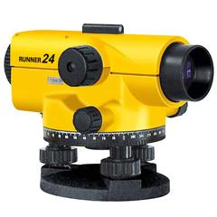 (One Point Survey , n.d.)

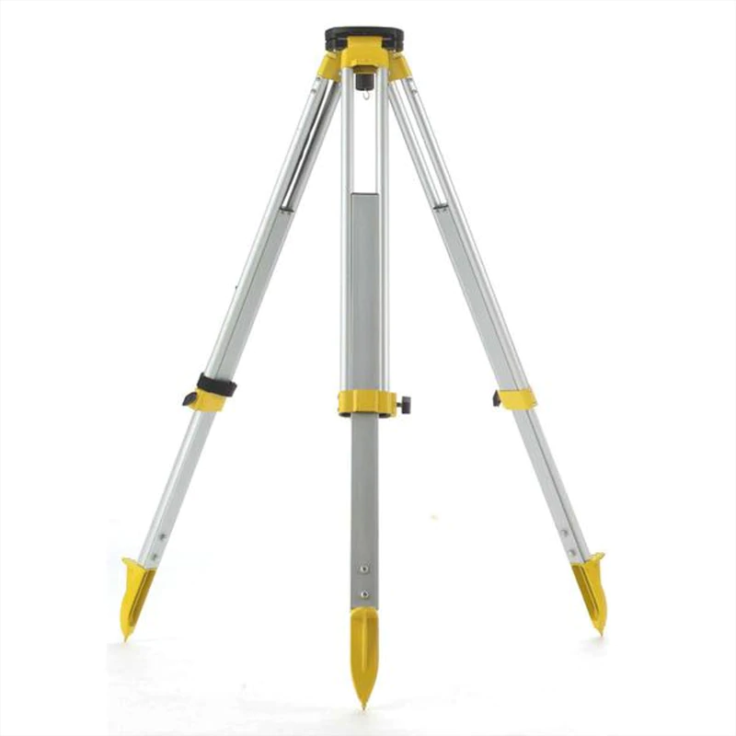
Tripod

Tripods are typically made from Aluminium and Plastic; this ensures they are robust whilst also remaining light and easy to carry or manoeuvre. The Tripod has three lockable legs adjustable to suit different heights and a base plate with an attachment to attach the Theodolite to. A carry strap and belt are also included to secure the legs in transport.

(One Point Survey, 2022)

Measuring Staff

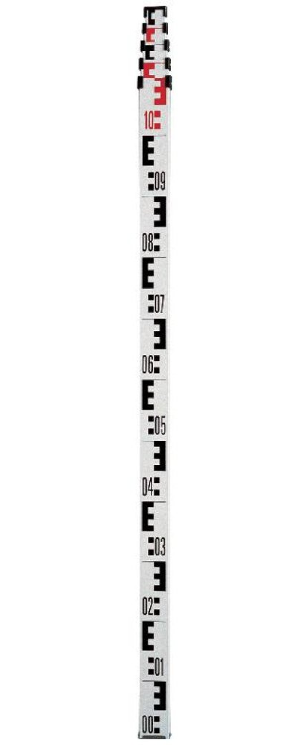
Measuring staffs are large measuring sticks that are made to be read through an electronic laser level. To eliminate error, the staff must be held as vertically as possible. Some staffs may have a spirit level attached to assist. Staffs are constructed using Aluminium to ensure they’re lightweight and easily manoeuvrable. Each block on the staff represents 1 centimetre and each E represents 5 centimetres, there will additionally be alternate sections shown in black and white, representing 10-centimeter sections. Also, there are black and red sections that state each meter.

(Smith Surveying Equipment , 2022)

Measuring tape

Synthetic tape

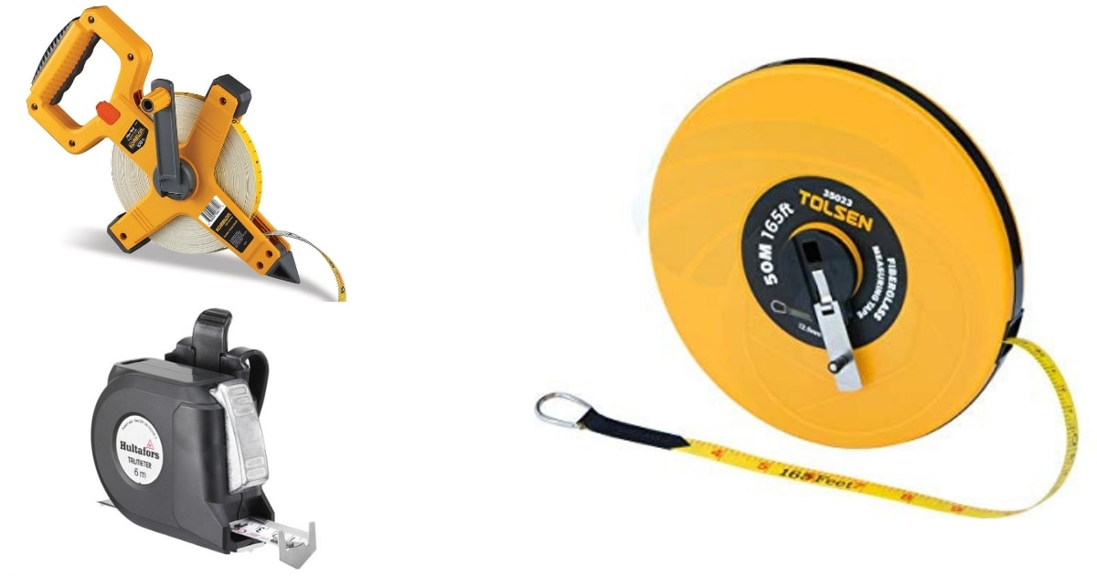
Glass fibres coated with PVC are used to make synthetic tapes. These are lightweight and adaptable. They are available in 5m, 10m, 20m, 30m, and 50m lengths. When tension is applied to synthetic tapes, they may stretch. As a result, they may be unsuitable for precise surveying operations. However, synthetic tapes are preferred over steel tapes for taking measures near electric fences and railway lines, amongst other things.
(Kathir, 2019)

Steel tape

A steel tape is primarily made of steel or stainless steel. It is made of a steel strip that ranges in width from 6mm to 16mm. It is available in lengths of 1m, 5m, 8m, 10m, 20m, 30m, and 50m. The steel strip is arranged in metres, decimeters, and millimetres. During measuring, the tape is extracted from the case by hand and rewound into the case by simply pressing a button on the case. Steel tapes are rigid and should only be used to measure flat surfaces. Unfortunately, steel tapes can corrode rapidly when exposed to moisture, steel tapes should be cleaned and oiled often to ensure the’re correctly maintained. These tapes are commonly used for standardising chains, measuring constriction works, and so forth.

Range Pole
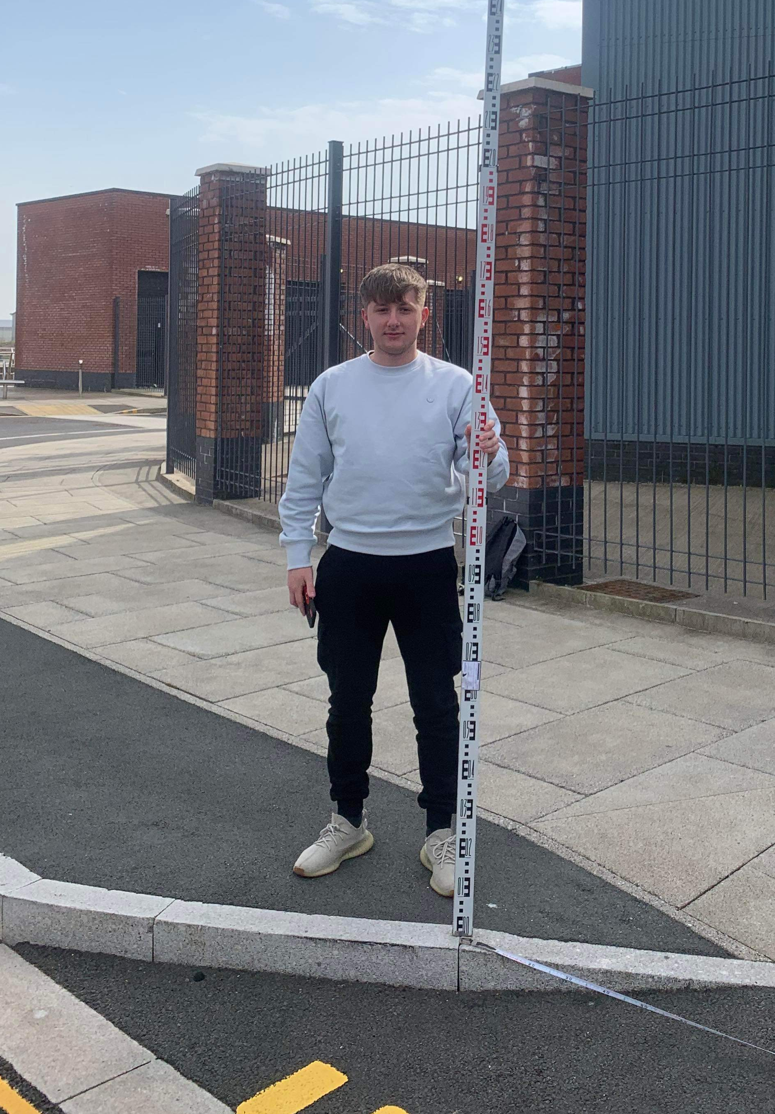
Ranging poles are used to mark regions and straight lines. They are also used to designate locations that must be seen from a distance, in which case a flag may be added to increase visibility. Ranging poles are 2m long, straight circular stalks that are 3 to 4 cm thick. They are made of either wood or metal. Homemade ranging poles can also be made from sturdy straight bamboo or tree branches.
A range pole should be held loosely between the thumb and index finger, approximately 10 cm above the ground. Ranging poles are often painted with alternating red-white or black-white bands. Metal spikes are used to reinforce the bottom end of wooden range poles wherever possible.

When the observer indicates that the range pole is in the proper position, the helper loosens it. The pointed bottom end of the range pole leaves a mark on the ground exactly where the pole must be positioned. Once in place, the range pole should be checked for verticality with a plumb bob.

Pegs

When points in the field require more permanent marking, a peg is installed. Pegs are typically constructed of wood and range in size from 40 to 60 cm, depending on the sort of survey work required and the type of soil into which they must be driven. The pegs should be hammered vertically into the dirt, with the top clearly visible.

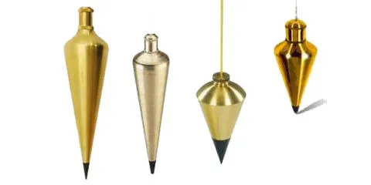
Plumb bob

A plumb bob is used to determine whether items are completely vertical. They are typically made of a piece of metal (called a bob) that points downwards and is linked to a string. The cord is vertical when the plumb bob is free and not moving.
(Popular Mechanics, 2016)

Levelling procedure

- Establish TBM
Step one of the levelling processes would be establishing a solid benchmark; this benchmark must be easily identifiable permanent feature such as a fence post or a kerb edge (pictured). A precise description and location of the TBM must be made, photographs and marked maps of the TBM’s location will assist with this.

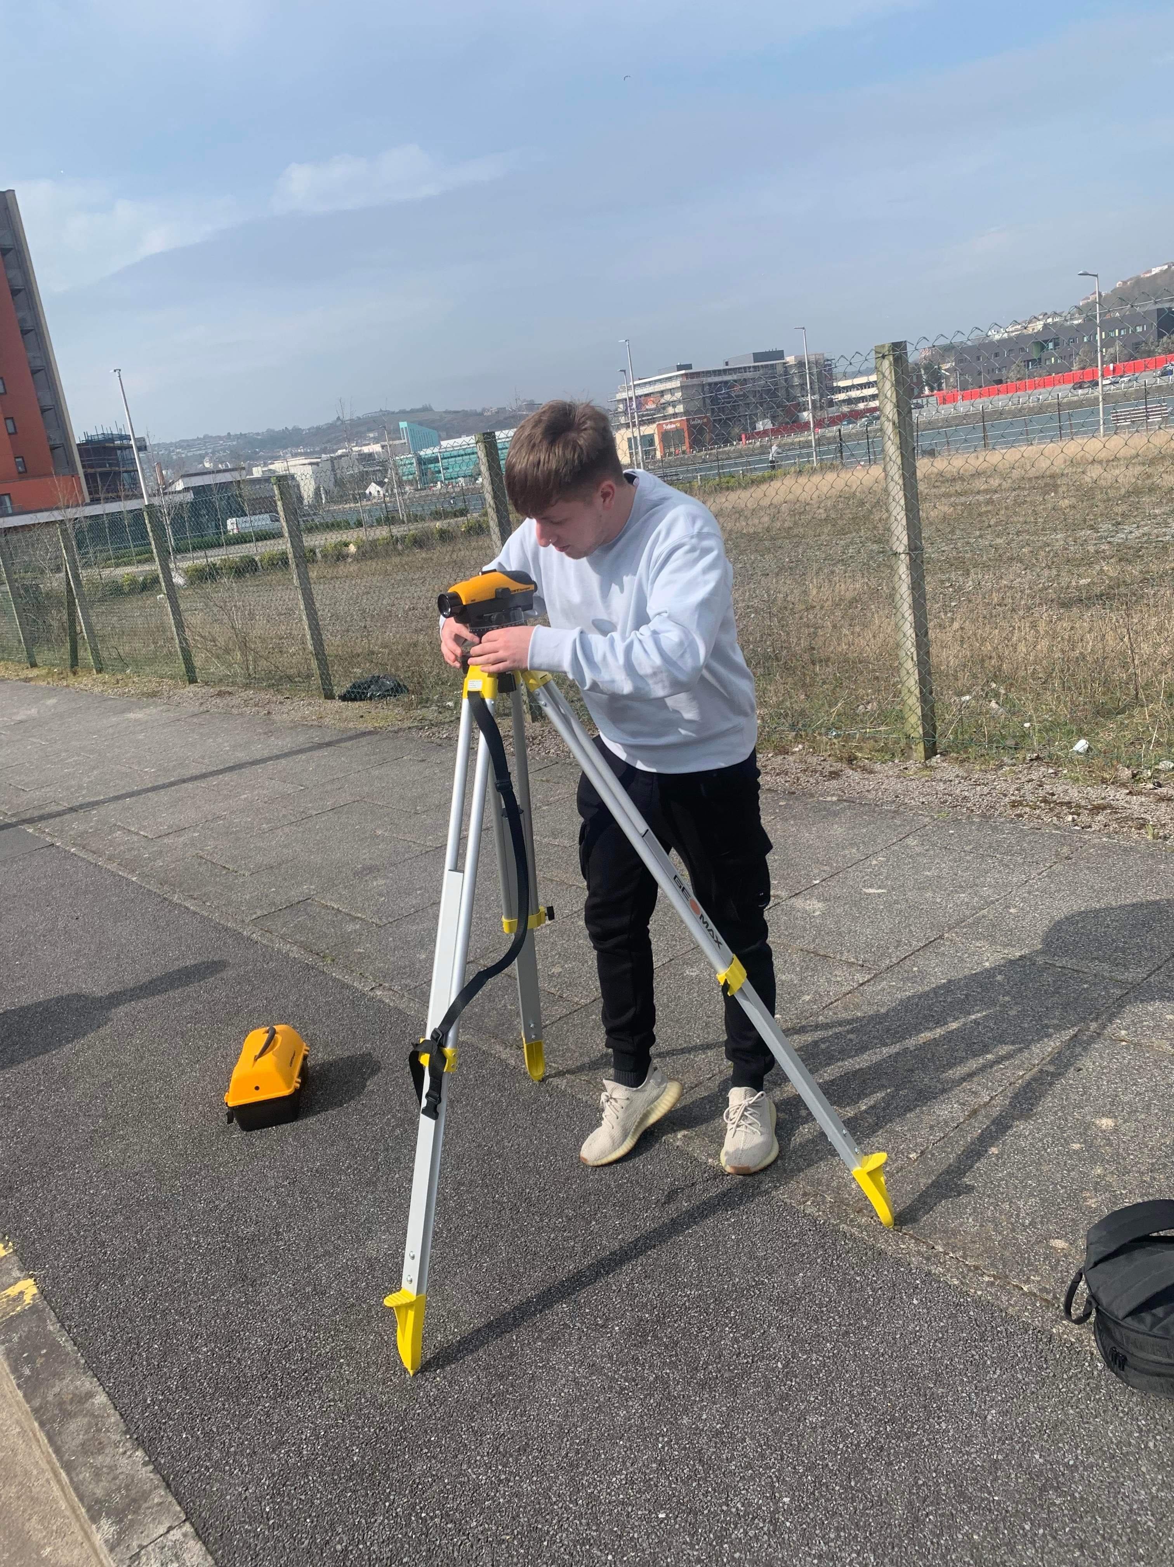
- Setting up tripod
Place the tripod in clear view of the benchmark, preferably at a little higher height. Set up the tripod in the centre of the survey area, or anywhere that displays as much of the site as possible, including the backsights/foresights. Extend the tripod legs well apart, with the level plate at a sufficient height for the workers to use, with the top plate generally level (around chest height).

- Setting up level
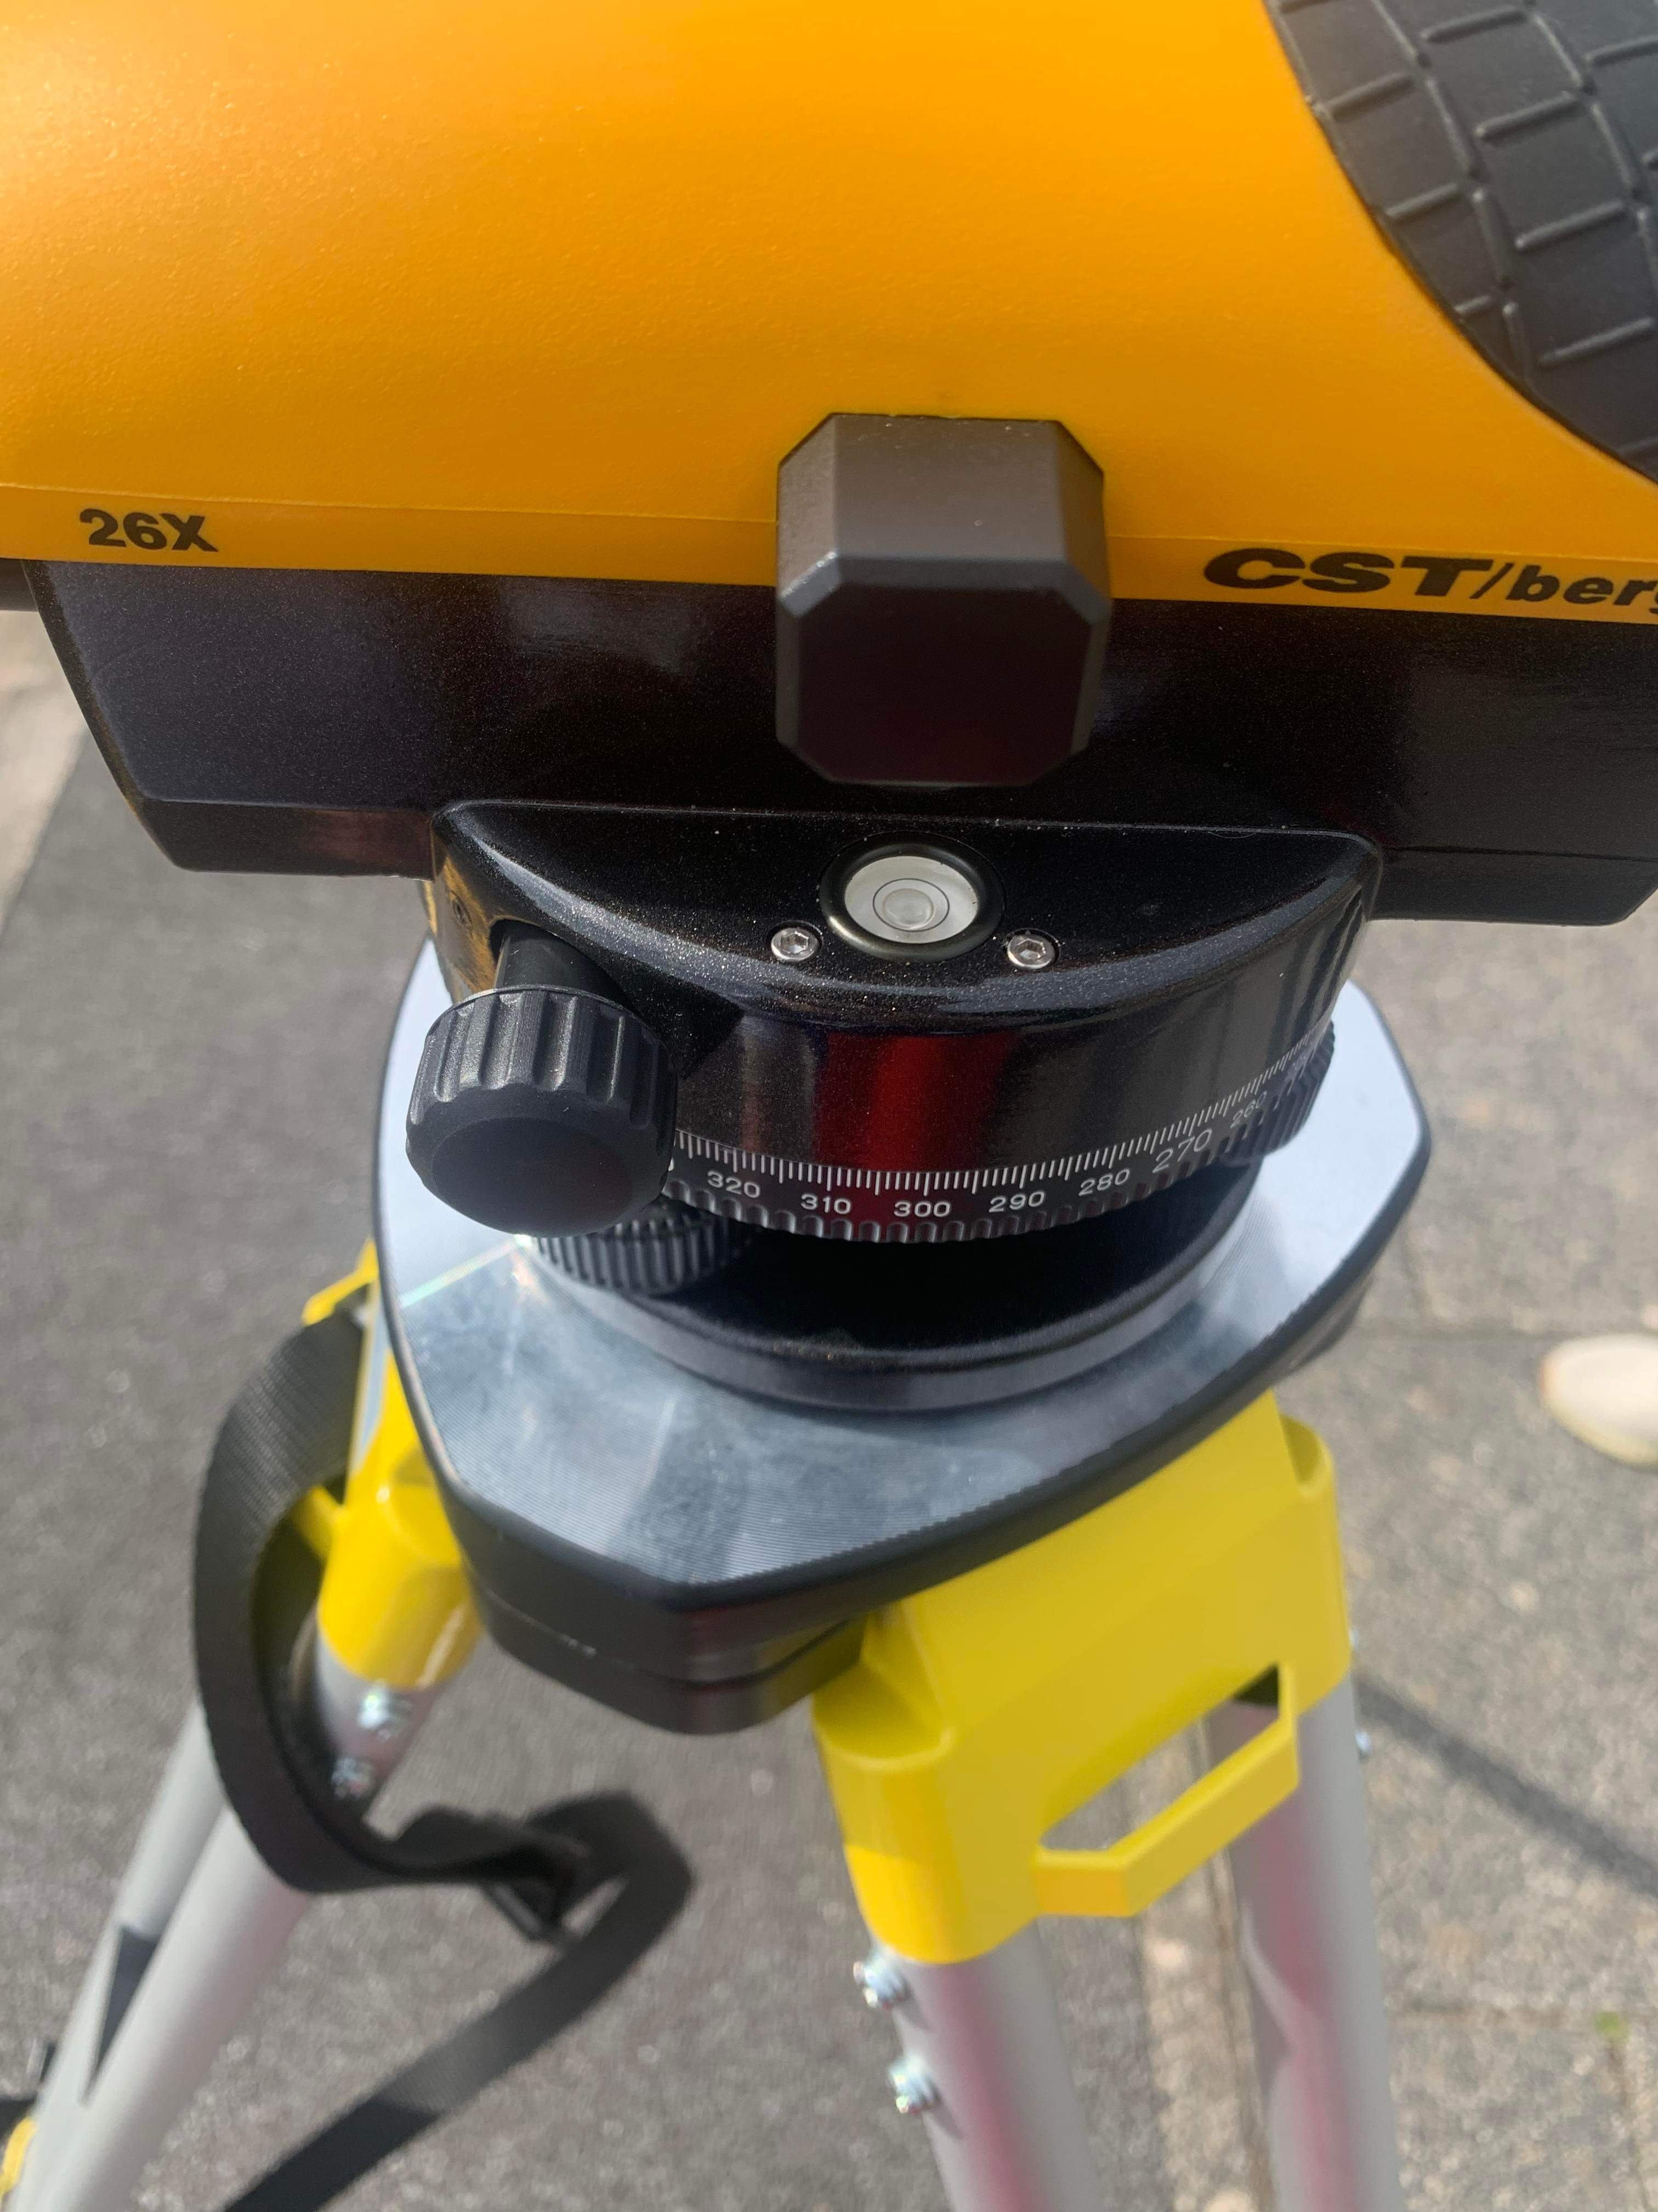
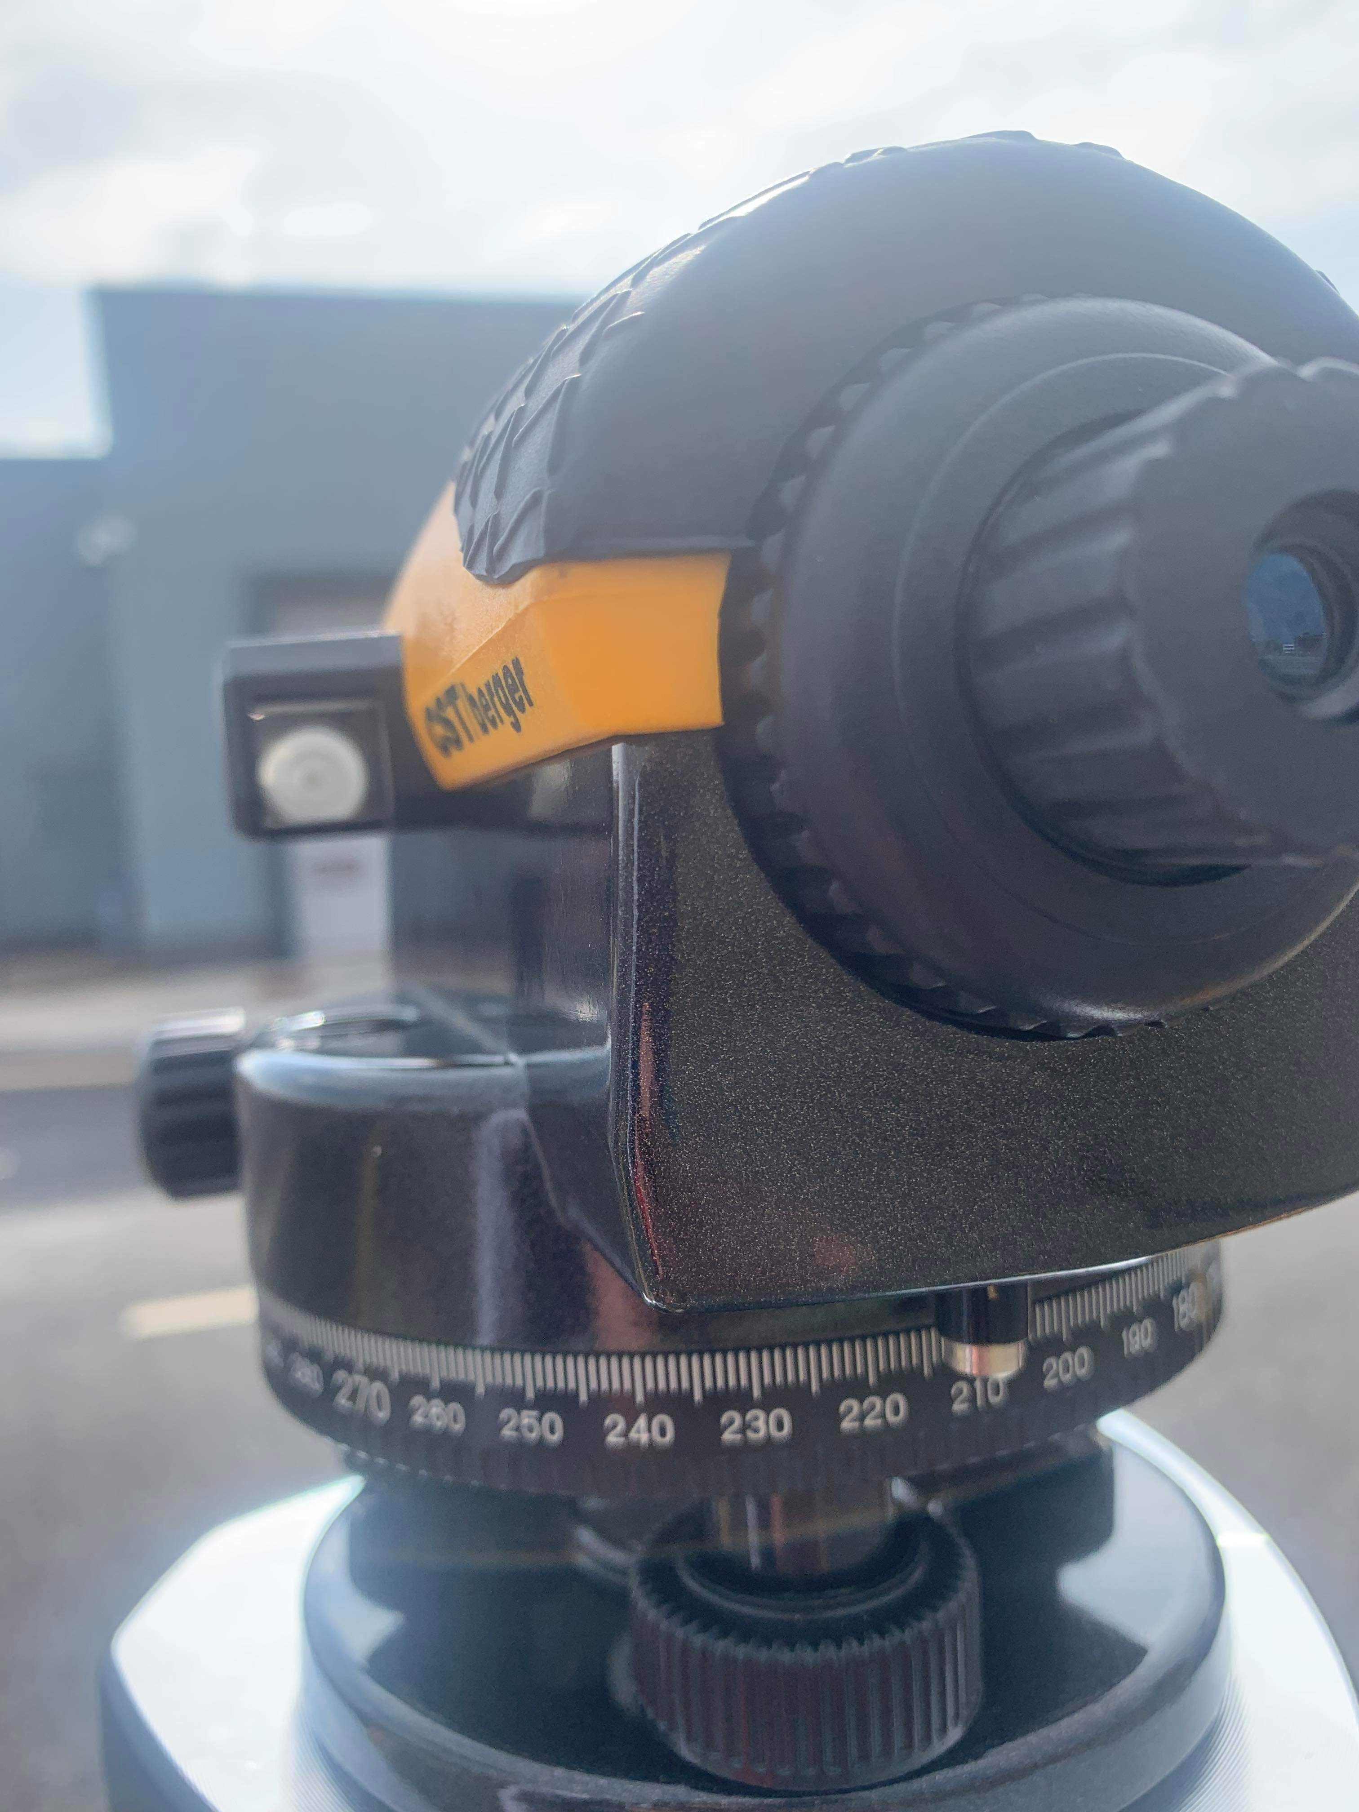
Attach the level to the base plate using the screw attachment below, with the level parallel to two of the foot screws, then level off with the adjustors until the bubble is centred on the device. Turn the level 90 degrees so that the device is facing the third foot screw, and then adjust the spirit level with the third screw until the bubble is centred along this axis..

- Taking backsight
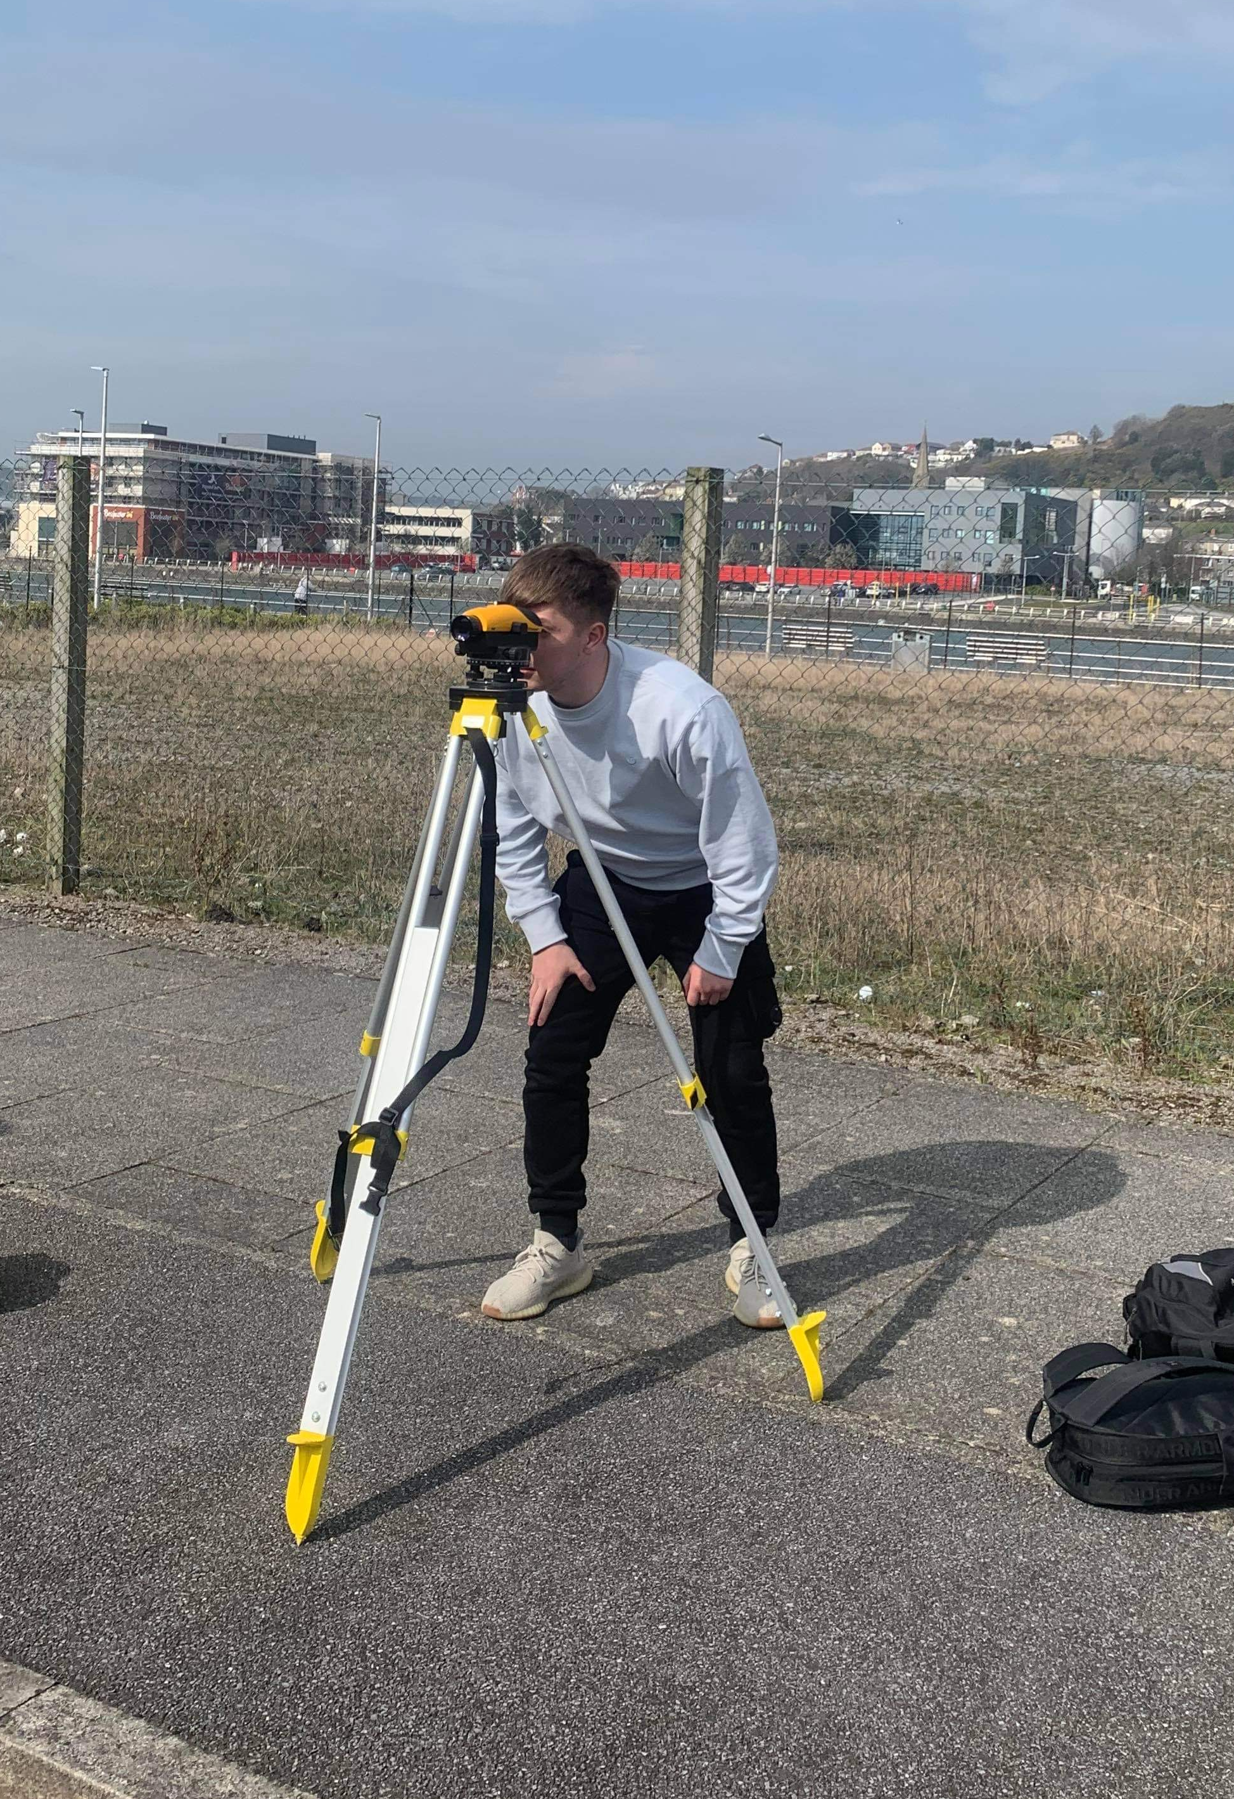
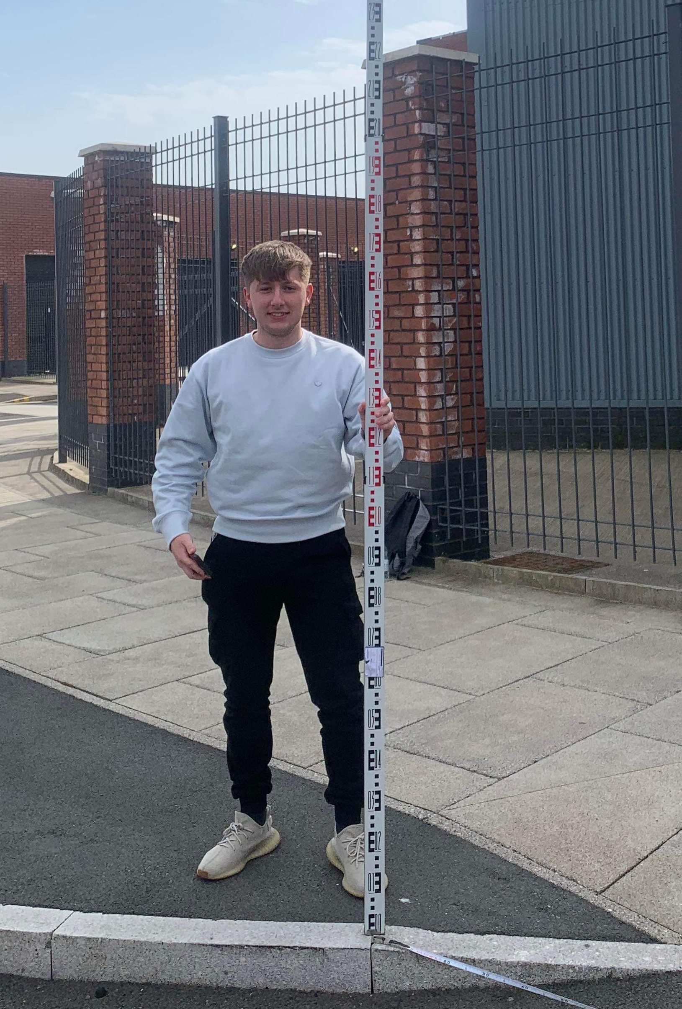
A Following the setup of the apparatus, the first measurement obtained will be backsight, allowing determination of the instrument's height from which all subsequent levels are derived. The person in charge of the personnel should set the bottom of the staff level as vertically as possible on the BM or TBM.

The Level will spin till the centre line/cross hairs line up with the staff. It is possible that you will need to focus the eyepiece first to see the cross hairs, then the telescope focus to see the numbers. When looking through the telescope, the reading is obtained at the centre cross.

- Calculate Instrument Height/Height of Level.
To calculate the instrument height (i.e. the height of the Level Head telescope), add the value of the most recent measurement to the known value of the Benchmark or TBM in use.

- Taking Foresight readings and calculating reduced levels
Begin capturing height (level) readings of whatever you wish to show on your site: top of slope, bottom of slope, break of slope — to show height variations and generate profiles. Mark the location of your levels on the plan, starting with 1 (as shown below) or the next available number if returning to a survey, and then read off each height reading and record it in a notebook. Make a thorough note of the date, location of the survey, BM or TBM, and the initials of the individuals doing the survey.

To eliminate errors caused by line of sight (or collimation) readings, all staff readings must be recorded in the field book. The distance between the backsights and the foresights should be equal, and the line of sight should not exceed 100 metres. The survey should always begin and conclude a level run on a known datum or benchmark and shut the level traverse, allowing the level run to be confirmed.

Computation and plotting of level

Levelling surveys are used to work out the elevation of a point compared to a datum. There are primarily 2 methods of conducting levelling surveys, the height of collimation method and Rise and fall method. The levelling survey will be used to determine the profile of the ground and estimate the volume of earthwork required to be excavated and/or filled.
Whilst conducting a levelling survey on behalf of the University, the Rise and Fall method was used. The points below clarify the working process of this method:
- Backsight, intermediate sight, and foresight readings are entered on separate lines in the relevant columns. However, if the level instrument is changed, backsights and foresights are positioned on the same line.
- The height of the datum, benchmark, or R.L. is the first reduced level.
- If an intermediate sight or foresight is less than the immediately previous staff reading, the difference is recorded in the rise column.
- If an intermediate sight or foresight is greater than the immediately previous staff reading, the difference is recorded in the fall column.
- A rise is added to the preceding reduced level (RL) and a fall is subtracted from the preceding RL.
Through conducting the above survey and gathering data, this enabled us to compute and plot a graph representing the data as below:
Backsight | Intermediate | Foresight | Rise/Fall | Reduced Level | Remarks | Chainage (X Axis) (Metres) | Reduced Level (Y Axis)
1.700 |  |  |  | 79.00 | 1 (Datum) | 0 | 79.000
 | 1.750 |  | -0.050 | 78.950 | 2 | 20 | 78.950
1.483 |  | 1.623 | 0.127 | 79.077 | 3 (Change Pnt) | 40 | 79.077
 | 1.412 |  | 0.071 | 79.148 | 4 | 60 | 79.148
 | 1.209 |  | 0.203 | 79.351 | 5 | 80 | 79.351
 | 1.214 |  | -0.005 | 79.346 | 6 | 100 | 79.346
 | 1.213 |  | 0.001 | 79.347 | 7 | 120 | 79.347
 | 1.222 |  | -0.009 | 79.338 | 8 | 140 | 79.338
1.529 |  | 1.232 | -0.010 | 79.328 | 9 (Change Pnt) | 160 | 79.328
 | 1.614 |  | -0.085 | 79.243 | 10 | 180 | 79.243
 | 1.573 |  | 0.041 | 79.284 | 11 | 200 | 79.284
 | 1.510 |  | 0.063 | 79.347 | 12 | 220 | 79.347
 | 1.462 |  | 0.048 | 79.395 | 13 | 240 | 79.395
 | 1.412 |  | 0.050 | 79.445 | 14 | 260 | 79.445
 | 1.498 |  | -0.086 | 79.359 | 15 | 280 | 79.359
 | 1.585 |  | -0.087 | 79.272 | 16 | 300 | 79.272
2.600 |  | 1.543 | 0.042 | 79.314 | 17 (Change Pnt) | 320 | 79.314
 | 2.437 |  | 0.163 | 79.477 | 18 | 340 | 79.477
 | 2.671 |  | -0.234 | 79.243 | 19 | 360 | 79.243
 | 2.512 |  | 0.159 | 79.402 | 20 | 380 | 79.402
 | 2.431 |  | 0.081 | 79.483 | 21 | 400 | 79.483
 | 2.371 |  | 0.060 | 79.543 | 22 | 420 | 79.543
 | 1.515 |  | 0.856 | 80.399 | 23 | 440 | 80.399
1.312 |  | 1.491 | 0.024 | 80.423 | 24 (Change Pnt) | 460 | 80.423
 |  | 1.320 | -0.008 | 80.415 | 25 | 480 | 80.415
8.624 |  | 7.209
 | 1.415 |  |  | 1.415
 | Backsight | Foresight | Diff | Rise/Fall | Reduced Level Check
Total | 17.248 | 14.418 | 2.830 | 1.415 | 1.415
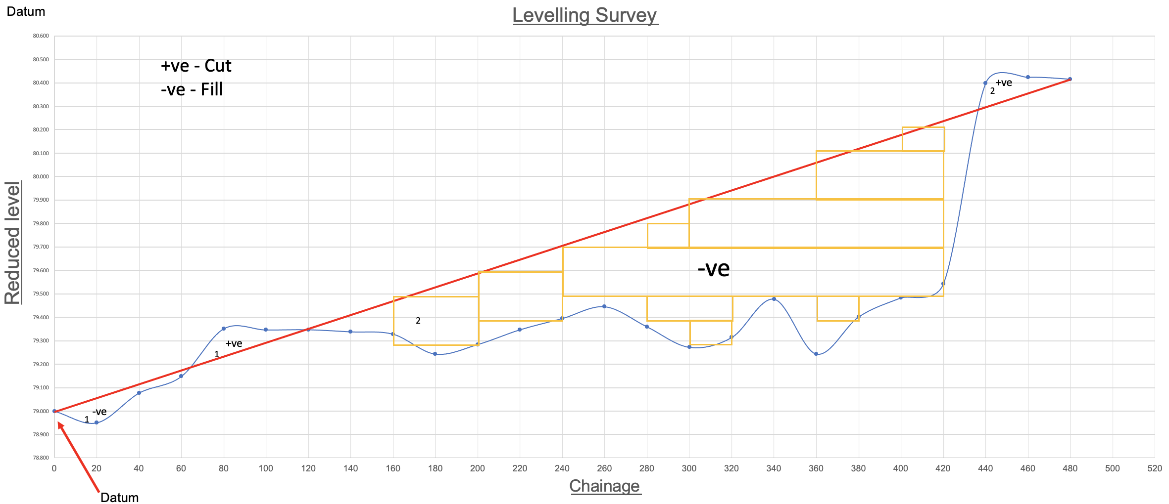

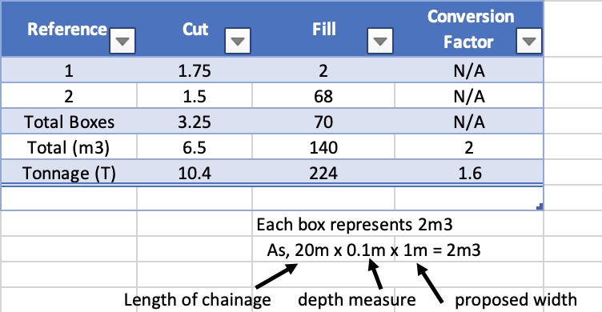

Conclusion

While all mathematical calculations can be verified, there is no guarantee that inconsistencies in the field operation will be detected. The arithmetic check simply proves that the rise and fall are recorded accurately in the relevant rise and fall columns. The level traverse must be closed to examine the field process for errors. It is important to have a partner review your reading to avoid repeating the level. If the mathematical calculation is right, the difference between the sum of the backsights and the total of the foresights will equal: the sum of the rises and the sum of the falls, and the difference between the first and final R.L., or vice versa. (On the intermediate sight computations, no arithmetic checks are performed. Make sure you read them thoroughly.

Through studying at the graphs and information provided above, there was a total of 140m3 (224 tonne) of fill required and a total of 6.5m3 (10.4 tonne) of cut required.
To minimise the earthwork taken from site, the 6.5m3 of cut can be re used in the required fill, this reducing the required fill to 133.5m3. Reducing the amount of required fill will effectively reduce costs and the carbon footprint, making the project to be more sustainable.

Bibliography

(2022, April ). Retrieved from One Point Survey: https://www.onepointsurvey.com/blogs/guides/top-five-survey-tripods
Kathir. (2019, January 26). Retrieved from Civil Snapshot: https://civilsnapshot.com/types-of-measuring-tapes-in-surveying/
One Point Survey . (n.d.). Retrieved from https://www.onepointsurvey.com/blogs/guides/a-buyers-guide-to-levels
Pang, K. Y. (n.d.). Slideshare. Retrieved from https://www.slideshare.net/KaiYun96/assignment-1-levelling
Popular Mechanics. (2016, December 24). Retrieved from https://www.popularmechanics.com/home/tools/a24335/should-i-use-brass-or-steel-plumb-bobs/
Smith Surveying Equipment . (2022, May). Retrieved from Smith Surveying Equipment : https://smithsurveyingequipment.co.uk/shop/surveying-equipment/lasers/laser-accessories/leica-btl5d-telescopic-aluminium-levelling-staff-663131/

