Performance Measurements:
IPv4 vs IPv6
MSc Research Proposal
Ross Thomas
Dr Kapilan Radhakrishnan
Table of Contents
1. Introduction 3
2. Background to the Proposed Research 4
2.1 Basics of IPv4 and IPv6 4
2.2 IP Address Transition Methods 5
2.3 DHCPv4 and DHCPv6 7
2.4 Header Comparison 8
2.5 Further Related Research on Project Implementation 9
2.6 Testing Methods 10
3. Aims & Objectives 11
3.1 Aim of the Project 11
3.2 Objectives of the Project 11
3.3 Hypothesis and Null Hypothesis 11
4. Research Methods 12
4.1 Data Collection Methods 12
4.2 Philosophy 13
4.3 Strategy 14
4.4 Approaches 14
4.4.1 Deductive 14
4.4.2 Inductive 14
4.5 Risks & Limitations 14
5. Resources & Planning 14
5.1 Resources Required 15
5.2 Planning - Gantt Chart 16
6. Conclusion 17
7. References 17

1. Introduction
The aim of this report is to achieve a successful project proposal with sections to highlight the overall project goal. The title of the project is “Performance Measurements: IPv4 vs IPv6”, with this title the aim is to create an enterprise network consisting of many routers and switches in order to recreate a real-life scenario in order to bench test performance.
It is no secret that this project has been done several times in the past, along with multitudes of research papers to back up many claims of this performance test. However, the main difference of this report, is the comparison of different versions of DHCP for instance, IPv4 and DHCPv4 compared against the many different methods of DHCPv6 such as SLAAC, Stateful and Stateless supported by IPv6.
Further measurements can also be considered for comparison, for instance throughput and latency of data being sent over the enterprise network with both IPv4 and IPv6. Along with this, this proposal looks to make apparent the beneficial factors and features of why IPv6 is needed and why IPv4 is being transitioned out.
After thorough research into the related and background topics of the underlining project. The rest of this report seeks to make clear the methodologies used in order to gather further findings throughout the main project’s timeline. Aspects of this section are the philosophy used, the strategies and approaches to further research, while also making it apparent of the risks to the project. Despite such potential risks. Discussed lastly is planning and with correct planning by using a GANTT chart, any risks to the project could be avoided.

2. Background to the Proposed Research
In this section many aspects of IPv4 and IPV6 will be covered and discussed, then moving on to covering the different methods used in the implementation of this project. Such as dual stack or NAT64, for which is a realistic example of what a business would use for whom are migrating to only IPv6 address over time. As this is a realistic test of an enterprise network, it was thought best to set one of these transition methods in the final part of the project in order to achieve a working enterprise network that does not just use IPv4 but also IPv6 in tandem.
Other research topics in this section will be aimed more towards the final goal of the project, for example DHCPv4 and DHCPv6. Both protocols will be used in on separate occasions and not together, in order to gather realistic results from the enterprise network. Comparing both by analysing the data sent from one end of the network to the other end of the network. Further research will be then discussed like IPsec, a method of securing the enterprise network that IPv6 offers as mandatory once the data analysation is finalised.

2.1 Basics of IPv4 and IPv6
Internet Protocol (IP) addresses are numbers that are uniquely assigned to every device that is to be connected to the internet. If devices did not have these addresses, data could have to be copied from device to device manually, but drastically the most important issue would be that without these addresses’ devices could not send data to one another without human intervention. [1]
With all these devices demanding addresses in order to run, IPv4 addresses are becoming limited as according to IEEE (Institute of Electrical and Electronics Engineers), the prediction was that all IPv4 address would come to exhausted in 2013. [2] The reason these addresses are becoming exhausted is due to the limitation that IPv4 processes, the main issue is that there can only ever be a maximum of 4.5 billion addresses. [3]
IPv4 addresses are widely used in modern TCP/IP, they are 32 bits long, as seen in figure 1 these 32 bits are split into four octets that consist of 8 bits each to make a total of 32 bits. [4] For example, as seen in figure 2 a basic IP address looks like 192.168.1.1, an address like this in comparison to figure 1 is split up by a dot into four octets, with each bit representing a specific number as seen in figure 3. Each bit can either be on or off represented by a 1 or 0. If it is on then that bit is added for example 128 + 64 = 192.
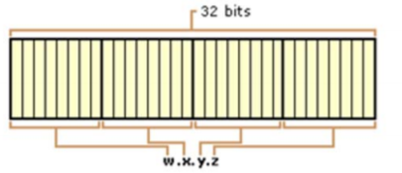
Figure 1. Shows what the 32-bit address structure looks like, with four octets and 8 bits in each octet to make a total of 32 bits. [5]

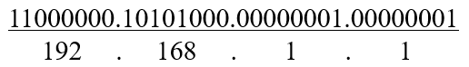
Figure 2. Showing the binary bits in each octet that make up the IPv4 address.
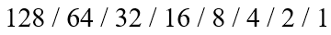
Figure 3. Each bit is represented by these numbers, these numbers are then added for example, “11” in the first part of figure 2 is 128 + 64 = 192.
Once all the IPv4 addresses are gone there is only one way to go, that is to adopt IPv6 addresses onto all devices. As IPv6 has an address space of 128 bits this provides the world with 340 undecillion address, this address space looks like 340,282,366,920,938,463,463,374,607,431,768,211,456. [6] These addresses consist of 8 sets of 16-bit hexadecimal value that are separated by colons as seen in figure 4. [7] Despite the apparent advantage that IPv6 gives the world with its very large range of available addresses, IPv6 also offers a few additional benefits over IPv4.
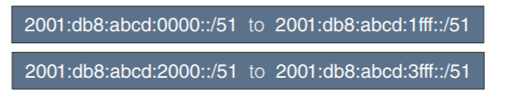
Figure 4. Four examples of an IPv6 address, from the lowest to the highest address in the ranges. [8]
The advantages of using IPv6 according to Juniper Networks are: [9]
- Routers no long need to fragment packets, meaning a more efficient routing method.
- IPv6 has methods to distinguish delay sensitive packets called QoS (Quality of Service).
- Elimination of NAT (Network Address Translation) to extend address space.
- IPv6 has its own built in security called IP Security (IPsec) which was optional in IPv4.
- IPv6 provides stateless address autoconfiguration.
- As seen later in a header comparison, IPv6 header eliminates a lot of infrequently used header fields that were present on the IPv4 header.

2.2 IP Address Transition Methods
Even though the prediction by IEEE was that all IPv4 address would be distinguished by 2013, further predictions kept getting made however it can now be possible to extend these predictions, because while businesses migrate to IPv6, IPv4 are being made available again. However, for these businesses that are not switching, there are methods to keep using both IP addresses.
There are various methods of communicating between IPv4 and IPv6. From Dual Stack to Network Address Translation and even tunnelling. Tunnelling is a method to allow IPv6 domains that are connect through IPv4 networks, then allowing them both to communicate with one another. [10]

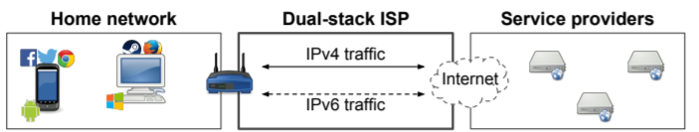
Figure 5. [11] Dual Stack is another communication method that can be used. It allows the use of IPv4 and IPV6 address side by side, however IPv4 is used on for IPv4 hosts and IPv6 for IPv6 hosts. [12] Usually Dual stack is used if an organisation is migration from IPv4 to IPv6 over time, in order to keep production rate to a max. [13]
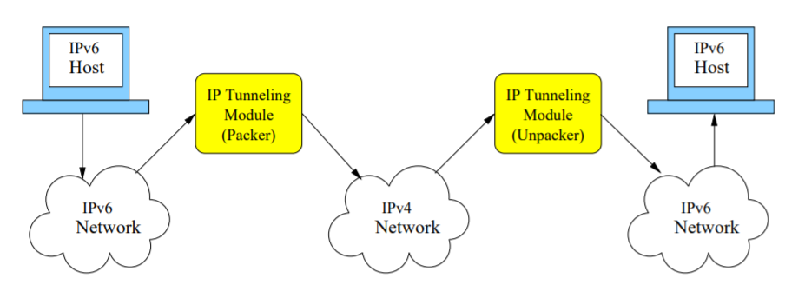
Figure 6. [14] A method called Tunnelling, which is a protocol that allows the movement of data from one network to another. The encapsulation process, in this figure the packer allows for data packets to appear as public packets, however, are in fact private data packets allowing them to pass with no issues, which is also known as port forwarding.
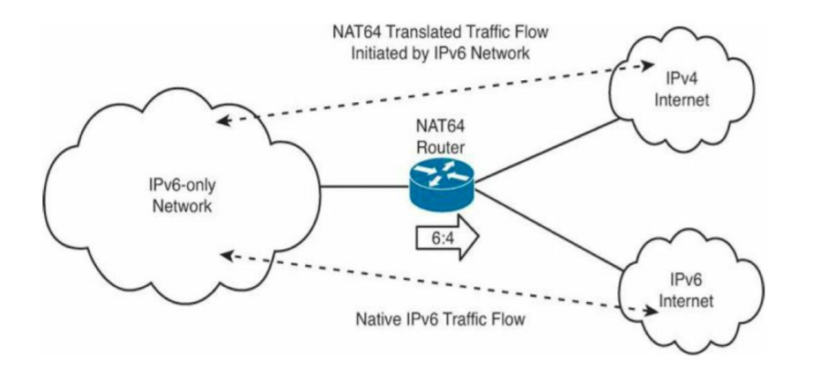
Figure 6. A diagram showing the use of both Internet Protocols over the same network using NAT64 (Network Address Translation). [15] NAT64 is a method that is used to translate network addresses on the same network using both IPv4 and IPV6 address schemes, it is a method for concealing host addresses on a private network, behind a pool of public addresses. [16]

2.3 DHCPv4 and DHCPv6
DHCP (Dynamic Host Configuration Protocol) is a protocol that was designed to dynamically allocate IP addresses onto devices through a client and server scenario, where the server sends out leased IP addresses that are then renewed in a specific lease time. Before DHCP all address was configured by a Network Administrator that could manually enter details like IP address, subnet mask and default mask for that one device to be able to connect to the internet. This took a long time, so the invention of DHCP was created bringing the advantage of configuration ease by reducing the network administrator’s workload. [17]
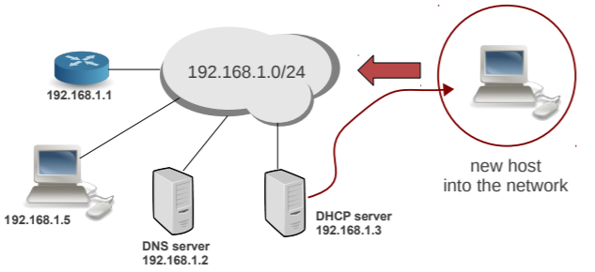
Figure 7. Showing the basic DHCP scenario where the DHCP server takes a new host onto a network, by then using the given network address it leases an address. [18]
SLAAC (Stateless Address Autoconfiguration) may be linked to the same principle as DHCPv6, however it is rather different because it does not actually use the DHCPv6 features like the other methods like Stateless and Stateful DHCPv6. SLAAC is one of the most useful and convenient methods in order to assign and IP address to devices, because this method does not require any human interaction to be configured. The only interaction is the configuration of one router on the network in order to send out router advertisements, these announcements then allow the devices to configure themselves with IPv6 addresses. [19]
Stateless DHCPv6 uses the combination of DHCP and SLAAC, once SLAAC is used DHCPv6 requests are sent throughout the network, the DHCP server then replies with all the information needed in order to obtain DNS server or domain name information. With this approach, stateless configurations do mean that the DHCPv6 server does not manage any IP address leases for the devices. [20]
Stateful DHCPv6 does not use SLAAC, in fact it uses DHCPv6 in a very similar method as IPv4 uses DHCP, with this approach the DHCPv6 server handles IP leases and any extra information. The server is the decider of the IPv6 addresses given to the devices over the network and not the client. [20]

There are two major differences with DHCPv4 and DHCPv6 according to Oracle: [21]
The administrative model
  - DHCPv4 – The administrator enables DHCP for each interface. Administration is on a per-logical interface basis.
  - DHCPv6 – Explicit configuration is not necessary. This protocol is enabled on a given physical interface.
Protocol details
  - DHCPv4 – The DHCP server supplies the subnet mask for each address. A hostname option sets the system-wide host name.
  - DHCPv6 – The subnet mask is supplied by Router Advertisements, not the DHCPv6 server. There is no DHCPv6 hostname option.

2.4 Header Comparison
In this section both IPv4 and IPv6 headers are looked at and compared as seen in the table below provided by Pediaa. In this comparison there are basic differences between the headers for example the header size is much larger for IPv6 at 128 bits rather than IPv4 32-bit header.
IPv4 Header | IPv6 Header
IPv4 is a numeric address scheme, for which the binary bits are divided by a dot.  IPv4 does not support hexadecimal. | IPv6 is an alphanumeric address, for which the binary bits are divided by colons, this method also contains hexadecimal.
Complex. | Simple.
Fields such as header length, identification, flags, etc are available. | Fields such as header length, identification and flags are NOT available.
Contains a field for options. | Contains a field called next header for extensions.
Source address is 32 bits. | Source address is 128 bits.
Destination address is 32 bits. | Destination address is 128 bits.
Has a field called TTL to indicate the number of hops. | Has a field called hop limit to indicate the number of hops.
Table 1. Showing a basic comparison of IPv4 and IPv6 headers. [22]
As seen in the comparison of the different Internet Protocol headers, not only are there many other differences IPsec is considered the main advantage to using IPv6 along with its large address pool. IPsec also known as IP security is the leading security feature of IPv6 and it secures data packets using cryptography and filtering to do the job, by using cryptography it helps to achieve user data confidentiality, authentication and integrity which are the three fundamentals of the CIA triangle. [23] [24]

2.5 Further Related Research on Project Implementation
Enterprise network are often large networks that run many applications and protocols, often operated under strict constraints like reliability and security, which usually means that it is a challenging environment for any network manager. Through much project planning any network can avoid major issues that could be a problem when setting up an Enterprise network, as with these networks one issue could lead to a drop-in business productivity. [25]
Most enterprise networks use the Hierarchical Network Design Model as a template for the basis of correct network configuration, this model is the backbone of any organisations network and it splits these networks into three layers; core, distribution and access layers. There is one major benefit to this model and that is security because this design allows for fine tunes Access Control Lists (ACL’s), traffic shaping and blocking unwanted traffic. [26]
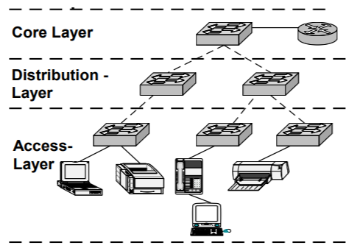
Figure 8. The basic Hierarchical Network Design Model. [27]
According to Cisco’s CCNA program, these layers are as described: [28]
- Core, also referred to as the backbone of the network is the layer that provides interconnectivity between the distribution layer devices. This layer usually consists of high-speed switches and routers with redundant links. This layer can forward large amount of traffic.
- Distribution is the communication point between both the core and access layer of the network model, the main function is to provide routing capabilities, filtering and WAN access by using policies.
- Access layer is the layer where users can connect to, or gain access to any resources already connected to the network. This layer usually only consists of layer 2 switches, which act as access points on the network to provide simple connectivity.

2.6 Testing Methods
There are two potential testing methods that can be used in order to test performance. The most basic method is by pinging and documenting the time it takes for a successful ping from one end of the network to the other. The second and more advanced method of testing performance differences, is using software. For example, TTM (Test Traffic Measurement) Service by RIPE. TTM is now shut down as of the July 1st, 2014. However, is a perfect example of how to test and monitor connectivity performances over a network. [29] Another example of a potential method of testing network performances is by using SolarWinds. SolarWinds is a “network monitoring software designs to reduce network outages and improve performance”. [30]

3. Aims & Objectives
In this section, the main aim of this project will be made clear along with the objectives that must be achieved for this project to be successful. Later discussing the hypothesis which is what is expected; however, a null hypothesis is covered which underlines the alternative and yet potential failure of the project.

3.1 Aim of the Project
The main goal of this project is to set up an enterprise network using Cisco Routers and Switches in Lab 205, in order to simulate a realistic testing environment.

3.2 Objectives of the Project
There are many aims of this project, however during the project timeline it is expected from the author that these could change slight, as well as gaining more objectives when potentially new information is researched and found.
- To research and identify the differences between IPv4 & IPv6.
- To research known issues with IPv4 networks.
- To research the advantages of uses IPv6 networks.
- To implement IPv4 & IPv6 networks using the hierarchical network model.
- Compare IPv4 & IPv6 results of the basic network.
- To setup a DHCPv4 and DHCPv6 server on the network’s distribution layer.
- To compare both DHCPv4 and DHCPv6 simulated results.

3.3 Hypothesis and Null Hypothesis
It is hypothised that there will not be much difference between both performance results in the comparison as seen as an example in figure 8, however great beneficial features. During the Data Analysis section of this project, the Null Hypothesis of this project could simply be that the data analysed would cause of the project to be unsuccessful. This is because as recently researched, it seems the results comparison section predicts that IPv4 has better performance. If this is the case the project would aim towards replicating this survey to see if this study is considered an accurate performance reading.
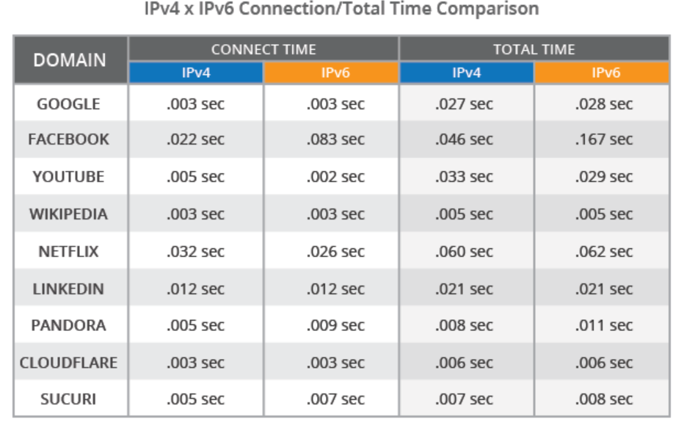
Figure 8. Sucuri’s study of performance times of IPv4 vs IPv6. [31]

4. Research Methods
In this section, methodologies that could help the success of the project are discussed, while underlining the methods that will be used throughout this project. Without these methods the project could get lost, with no sense of direction and by doing this it allows for this project to move forward at a steady pace. There are many research designs that can be followed to achieve the research needed for any project to succeed, however throughout this whole project the design used will be the Research Onion. Research methods is very important as “research is an art of scientific investigation.” [32]
The Research Onion is the model of choice for this project, with it comes an understanding of which methodologies to use. “It includes a system of believes and philosophical assumptions which shape the understanding of the research questions and underpin the choice of research methods.” [33]
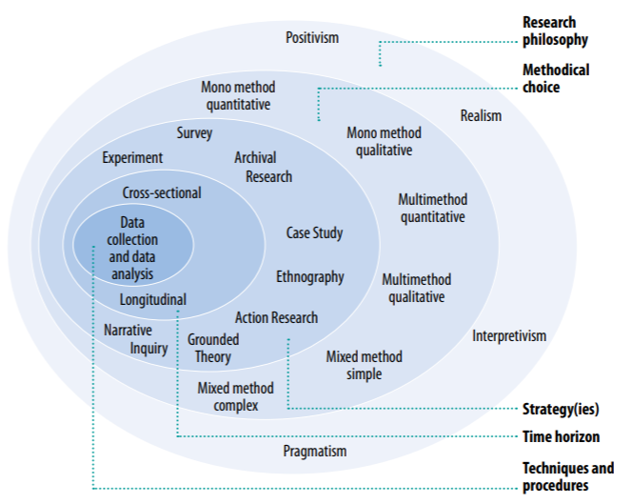
Figure 9. The Research Onion. [34]

4.1 Data Collection Methods
There are two types of data collection methods that can be used when gathering the information needed in order to complete the project. Primary data can be considered as data that can be collected all around us through sounds, sights and even tastes. However, in consideration to this project primary data would be collected from doing an experiment, by then taking the measurements of the experimental data and analysing it. [35]
There are many methods of collecting primary data, but the four main types of primary data are:
- Measurement.
- Observation.
- Interrogation.
- Participation.

Secondary data as seen in figure 10, can be collected by more traditional means of general research from personal records, research papers, government publications, white papers etc. Usually secondary data is data that has been recorded or interpreted already without the need for experiments.
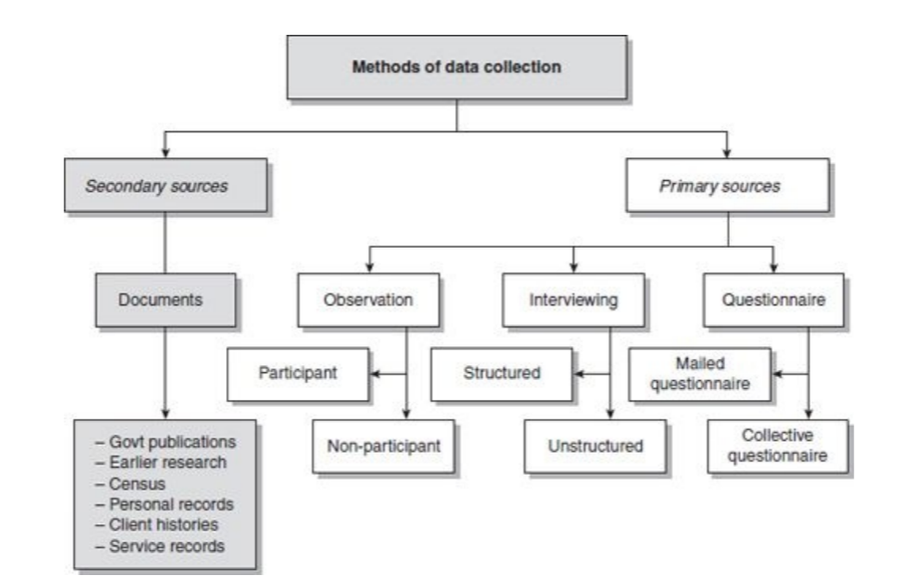
Figure 10. The two methods of Data Collection. [36]
The primary and secondary data collected through this project will be from experiments and resources:
Primary – Experiment
  - Special software and hardware will be used, Cisco routers and switches, with software tools like SolarWinds.
Secondary – Resources
  - Resources will be IEEE, Google Scholar, White Papers and Research Journals.

4.2 Philosophy
For this networking project, the best suited philosophy would be positivism, this is because positivism usually only ends in a yes or no answer, basically does it work, or does it not work. This is since the information collected by positivism is real life situation information that helps product credible data. Positivism is a methodological philosophy in quantitative research where methods of the natural sciences are used to discover the study of social science. This helps positivist researchers understand objectives through tests and other methods such as measurements, sampling and questionnaires. Which suggests any research provided by positivists, is research that is of high quality, validity and reliability. [37] Quantitative research can be defined as “the research that places emphasis on numbers and figures in the collection and analysis of data.” [38]

4.3 Strategy
Throughout this project there are going to be three main strategies of gathering data, first is through experimentation to gather data. The second method will be through existing surveys that have been done by other researchers or businesses that already have done tests like this project. The third and final method would be through action research, which refers to the practical research that brings together theory and practise, action and reflection.

4.4 Approaches
There are two approaches to data collection called inductive and deductive research. These research methods are both very relevant to this project.

4.4.1 Deductive
Deductive research is the approach of developing assumptions based off previous theories, then taking the existing theories and forming a plan to test them. [39] For example, in this project, this could be attempting to replicate Sucuri’s survey in order to see if its comparative result is as accurate as they state. In this project the plan is to find as many examples of existing theories based around this topic in order to compare the results to achieve the most out of this project.

4.4.2 Inductive
Throughout this project, inductive research will also be an approach used. The inductive approach usually starts from experiences and then it develops into a general conclusion based around those experiences and learning from them. [40] In this project, inductive research will be considered constantly due to the nature of the project where a new theory could emerge from the data presented at the end of the project timeline.

4.5 Risks & Limitations
There are many potential risks to this project that could ultimately affect the overall effectiveness of the project or effect the successfulness of the project by stunting productivity. Listed are a few potential risks that could be faced during the project.
- Equipment failure through misuse by other students.
- Lab time unavailable because of other student using the devices.
- Emotional distress from unforeseen circumstances.
- Delays due to power outages on the campus or incorrectly installed equipment.
It would be a good idea to get more involved with the project supervisor, which would help avoid any issues that could cause disruption or termination of this project, a backup plan for this project has also been thought of where if all else fails simulations can be done using software like Cisco Packet Tracer if there are issues with the equipment.

5. Resources & Planning
In this section resources and planning are two important topics to cover, because without the resources then the project will not be able to progress further than simple simulations, which could prove useless in this project however it goes against the idea of gathering more realistic results from real world routers and switches. In order to get through the potential risks and keeping the project on track, a GANTT chart will be used as later discussed which will allow for strategic progress to be made while giving enough time for other potential priorities.

5.1 Resources Required
Throughout this experimental project there will be a load of resources needed in order to complete the experiment, as well as resources to capture any data needed in order to complete the comparative section of this project. Firstly, multiple devices will be needed as listed below:
- Cisco 1941 routers for the core layer.
- Cisco 3650 layer 3 switches for the distribution layer.
- Cisco 2960 layer 2 switches for the access layer.
All these devices will need to be secured for the project to be completed, these devices will be used to make an enterprise network. Consisting of total 20 devices, two router for a multi dual homed scenario where there are two ISP’s. Three layer 3 switches as distribution, with many layer 2 switches attached to distribution so there is access for hosts to connect to the network.
In order to complete this project, the main resources needed in order to collect the data needed to compare IPv4 and IPv6 are software packages like SolarWinds and TTM (Test Time Measurement) by RIPE.
Other resources that will be needed are:
- Access to online libraries.
- Access to articles, journals and books.
- Basic Microsoft Office software.

5.2 Planning - Gantt Chart
The most important aspect before starting this project it to plan the project with the steps that are going to be taken in order to complete it successfully. As seen in figure 11 and 12 the project time spans from the start of June to the end of August when the project is to be submitted for grading. During that time several tasks are to be completed such are the background research, literature review and aims and objective on the project report. Following that is the many implementation stages of the project, just as the setup and testing stages along with the analysis of results and comparison write up. Extra time was allocated just in case there are some interruptions, either from the listed risks or possibly from unforeseen circumstances.
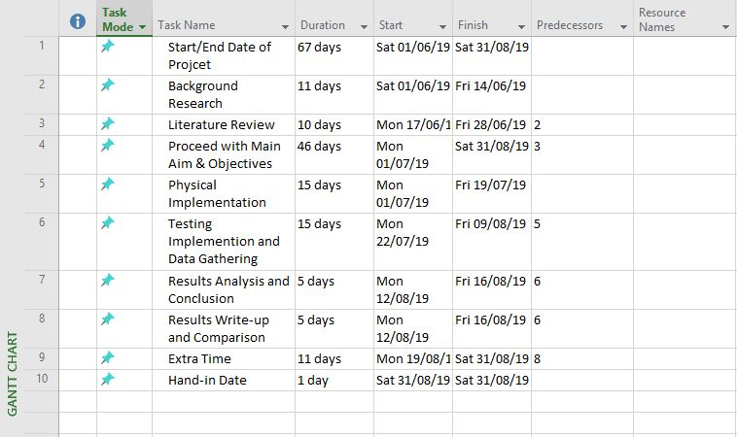
Figure 11. Showing the inputs in Microsoft Project to make the GANTT chart.
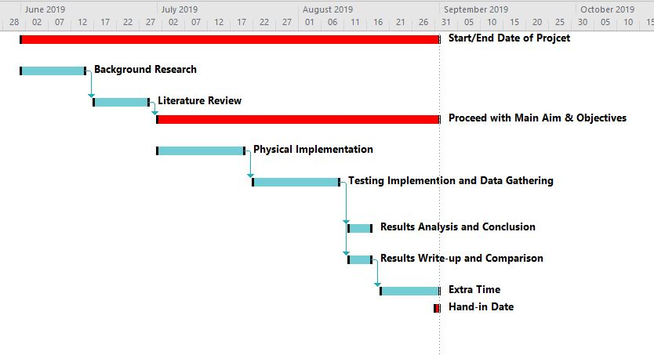
Figure 12. Showing the overall time span of the project and the tasks involved, these are represented by bars and the length dictates on how long the duration of that activity is.

6. Conclusion
To conclude, after the completion of this proposal it is now clear of what will be needed to complete the project through resources, research methodologies and careful planning. As the project is to compare both IPv4 and IPV6, while implementing DHCPv4 and DHCPv6 the methodologies are based around the research onion framework, because it helps analyse and depict issues based around data collection and research methods. Resources needed have also been listed that will be required for the project’s success and completion, without these resources the project will be forced to use other mean such as software that simulates a network like Cisco Packet Tracer. Once the practical resources such as the routers and switches have been set up using the hierarchical network model design, the task is to test both Internet Protocols with both DHCPv4 and DHCPv6 for performance differences.
This project plans to follow a positivism philosophy, with a three strategies; action research, experiment and survey and both inductive and deductive approaches will be used in order to collect data. After covering all the relevant information throughout this proposal, the next step is to start the project at the beginning of June while following a well thought out GANTT chart that will help guide the project to a smooth and successful finish at the end of August. Throughout the project duration the plan is to be engaged fully with the project supervisor in order to achieve the best from the guidance that can be given, with further strategies in place such as planned extra time if needed.

7. References
[1] “Beginner’s Guide to INTERNET PROTOCOL (IP) ADDRESSES.”
[2] IEEE, “IPv4 Address Exhaustion,” 2009.
[3] V. Van Der Eijk and E. Lamers, “A Comparative Security Evaluation for IPv4 and IPv6 Addresses.”
[4] Cisco, “IP Addressing: IPv4 Addressing Configuration Guide,” 2015.
[5] S. Isaac, “Comparative Analysis of IPV4 and IPV6.”
[6] R. Graziani, “IPv6 Fundamentals: A Straightforward Approach to Understanding IPv6 Second Edition,” 2017.
[7] Cisco, IPv6 Basics. .
[8] “IPv6 Addressing Plan Basics,” 2015.
[9] W. Goralski, “Learn About Differences in Addressing Between IPv4 and IPv6.”
[10] A. S. Narayanan, M. S. K. Mohideen, and M. C. Raja, IPV6 Tunneling over IPV4. 2012.
[11] E. Pujol, P. Richter, and A. Feldmann, “Understanding the Share of IPv6 Traffic in a Dual-stack ISP.”
[12] D. S. Punithavathani and K. Sankaranarayanan, IPv4/IPv6 Transition Mechanisms, vol. 34, no. 1. 2009.
[13] Cisco, “NAT64 Technology: Connecting IPv6 and IPv4 Networks,” 2012.
[14] J. M. Moscola, D. Lim, and A. Tetley, “IPv6 Tunneling Over an IPv4 Network,” 2001.
[15] Juniper Networks, “Network Configuration Example Configuring Stateful NAT64 for Handling IPv4 Address Depletion,” 2017.
[16] B. Chhetri, “TRANSITION FROM IPV4 TO IPV6,” 2015.
[17] N. Alcott, “DHCP for Windows 2000.”
[18] J. L. Muñoz, J. Alins, O. Esparza, and J. Mata, “Dynamic Host Configuration Protocol (DHCP).”
[19] Cisco, “DHCPv6 Based IPv6 Access Services,” 2011.
[20] A. Maggio, “DHCPv6 Configuration: SLAAC, Stateless and Stateful - ICTShore.com.” [Online]. Available: https://www.ictshore.com/free-ccna-course/dhcpv6-basics/. [Accessed: 15-May-2019].
[21] Oracle, “Differences Between DHCPv4 and DHCPv6 - Working With DHCP in Oracle® Solaris 11.2.” [Online]. Available: https://docs.oracle.com/cd/E36784_01/html/E36812/gnykf.html. [Accessed: 15-May-2019].
[22] “What is the Difference Between IPv4 and IPv6 Header - Pediaa.Com,” 2019. [Online]. Available: https://pediaa.com/what-is-the-difference-between-ipv4-and-ipv6-header/. [Accessed: 15-May-2019].
[23] A. Moravejosharieh, H. Modares, and R. Salleh, “Overview of Mobile IPv6 Security,” in 2012 Third International Conference on Intelligent Systems Modelling and Simulation, 2012, pp. 584–587.
[24] S. S. Chaeikar, M. Jafari, H. Taherdoost, N. Shojae, C. Kar, and M. Jafari, “Definitions and Criteria of CIA Security Triangle in Electronic Voting System,” 2012.
[25] M. Casado et al., “Rethinking Enterprise Network Control,” 2007.
[26] “What Are the Benefits of Hierarchical Network Design? | Techwalla.com.” [Online]. Available: https://www.techwalla.com/articles/what-are-the-benefits-of-hierarchical-network-design. [Accessed: 15-May-2019].
[27] J. Mbale, “The Switch Hierarchical Network Design Model (SHiNDiM): A Mechanism for Identifying and Determining the Correct Switch for the Appropriate Position in the Network Layer,” 2013.
[28] CCNA, “Cisco three-layer hierarchical model.” [Online]. Available: https://study-ccna.com/cisco-three-layer-hierarchical-model/. [Accessed: 15-May-2019].
[29] RIPE NCC, “Test Traffic Measurement Service (TTM) — RIPE Network Coordination Centre.” [Online]. Available: https://www.ripe.net/analyse/archived-projects/ttm. [Accessed: 15-May-2019].
[30] SolarWinds, “Network Monitoring Software | SolarWinds.”
[31] D. Cid, “IPv4 vs IPv6 Performance Comparison,” 2016. [Online]. Available: https://blog.sucuri.net/2016/08/ipv4-vs-ipv6-performance-comparison.html. [Accessed: 15-May-2019].
[32] C. Kothari, Research Methodology: Methods and Techniques. New Age International, 2004.
[33] A. Melnikovas, “Towards an Explicit Research Methodology: Adapting Research Onion Model for Futures Studies,” J. Futur. Stud., vol. 23, no. 2, pp. 29–44, 2018.
[34] M. Saunders and P. Tosey, “The Layers of Research Design,” 2013.
[35] N. Williman, Research Methods The Basics. 2011.
[36] R. Kumar, RESEARCH METHODOLOGY a step-by-step guide for beginners. Sage, 2011.
[37] L. T. M. Pham, “Qualitive Approach to Research,” Theory, Cult. Soc., vol. 10, no. 2, pp. 43–60, May 1993.
[38] D. 0 Fakeye, The Usefulness of Qualitative and Quantitative Approaches and Methods in Researching Problem-Solving Ability in Science Education Curriculum, vol. 7, no. 15. Online, 2014.
[39] H. Zalaghi and M. Khazaei, “The Role of Deductive and Inductive Reasoning in Accounting Research and Standard Setting,” Asian J. Financ. Account. ISSN, vol. 8, no. 1, 2016.
[40] J. Lucasites and I. West, “INDUCTIVE REASONING: An Overview,” 2011.

