AHHI5017 Contesting Conflict: Representations of War, 1789–Present
Week 6: The First World War
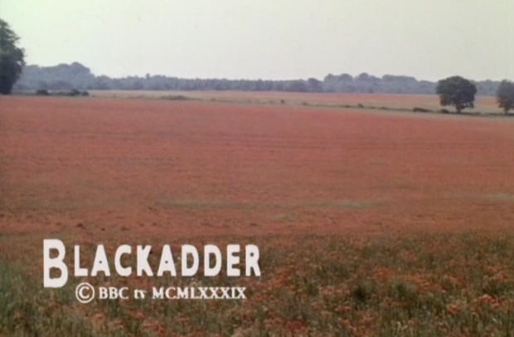
Final scene of ‘Goodbyeee,’ Blackadder Goes Forth (1989)
Lectures summary:
In this week’s sessions we will contemplate the status of World War One in British culture. After examining memorial practices which were put in place in the immediate aftermath of the war, students will give thought to how attitudes have (or have not) shifted in the hundred years since. Taking a lead from media coverage of the war’s centenary, students will scrutinise common-held myths and tropes which surround the Great War and debate whether they think popular culture is a useful vehicle for helping to understand and interpret past conflicts. An episode of Blackadder Goes Forth will act as a prompt to such discussions.
On Monday, we will begin by outlining some of the general contours of First World War memory in Britain and continental Europe, paying special attention to various forms of public commemoration that developed in response to the conflict. From there, we will hone in on a distinctive form of commemoration that emerged from the World War One years: Britain’s Imperial War Museum.
In Friday’s lecture, we will then scrutinising the status of World War One memory in contemporary Britain. The point of departure for our discussion will be articles about the war’s centenary which were penned by the UK’s then-Education Secretary Michael Gove, and his then-Shadow Minister Tristram Hunt. Because an important aspect of Gove’s argument is his distaste for popular culture representations of the war, we will watch an episode of Blackadder Goes Forth, and think about it in relation to the different issues raised by the centenary of the war. This leads into an exercise designed to aid students’ preparation for the upcoming AHHI5017 coursework essay.
Required reading and other preparation:
- Michael Gove, ‘Why does the Left insist on belittling true British heroes?’ The Daily Mail, January 2 2014 (http://www.dailymail.co.uk/debate/article-2532930/MICHAEL-GOVE-Why-does-Left-insist-belittling-true-British-heroes.html#ixzz3m69ehnXh; accessed October 21 2015)
- Tristram Hunt, ‘Michael Gove, using history for politicking is tawdry,’ The Guardian online, January 4 2015 (http://www.theguardian.com/commentisfree/2014/jan/04/first-world-war-michael-gove-left-bashing-history; accessed October 21 2015)
- Catriona Pennell, ‘Popular History and Myth-Making: The Role and Responsibility of First World War Historians in the Centenary Commemorations,’ Historically Speaking (Vol. 13, No. 5, November 2012) pp. 11–14

Background reading:
- Marita Sturken, introduction, Tangled Memories: The Vietnam War, the AIDS Epidemic, and the Politics of Remembering (University of California: Berkeley, 1997), pp. 1–17. On memory studies – referenced extensively in Monday lecture.
- Jay Winter, ‘Introduction,’ ‘War Memorials and the Mourning Process’ in Sites of Memory, Sites of Mourning: The Great War in European Cultural History, pp. 1–11, 78–116. Note: the PDF file contains another chapter (‘Homecomings,’ pp. 15–28), which – while tangentially relevant – will not be discussed in the seminar.

Preparing for the lectures:
The assigned readings (the Gove and Hunt articles, and the piece by Catriona Powell) concentrate on issues of contemporary resonance and are all short: read the Michael Gove piece, and then its riposte by Tristram Hunt. Pennell’s article picks up on similar themes, relating the WWI centenary both to ‘popular history’ and the historiography of the conflict.
Two general background readings are also available via Moodle. The one by Marita Sturken discusses the concept of cultural memory, and will be referenced extensively in the Monday lecture. The chapters by Jay Winter are of relevance to this week and next week.
A small selection of additional further reading by historians on the World War One centenary on the Imperial War Museum is also listed below.

Questions to consider:
General
- What types of World War One memorials and commemorations are you familiar with?
- What (if any) institutions and practices for commemorating the war have you been exposed to, and what are their notable characteristics?
- Have you ever visited a museum display on the war, and if so what were its notable characteristics?

- What (if any) cultural representations of the First World War are you familiar with, and what are their notable features and characteristics?
- Are there any familiar images, tropes and stereotypes associated which recur in representations of the war?
- How ‘accurate’ do you think cultural representations of the war are?
- Is ‘accuracy’ an important virtue when representing war?

- Has World War One been a feature of your education prior to attending university, and if so in what ways?
- Have you learned about the history of the war, and if so in what ways?
- Have you learned about the war in subjects besides history, and if so in what context?

Gove, Hunt
- In what ways do the two articles differ in their attitude to the First World War, and why?

- Whose point-of-view are you more sympathetic to, and why?

- What are your responses to Gove’s points about how World War One is represented a)in popular culture, and b) the UK education system?

Pennell, ‘Popular History and Myth-Making’
- What points does Pennell make about different popular culture representations of World War One, and how do you react to them?

- What points Pennell make about the role historians should play in the World War One centenary, and how do you react to them?

- Is ‘popular history,’ as termed by Pennell, simply a vehicle for ‘myth-making’ about World War One?

Winter, Sites of Memory, Sites of Mourning
- What practices arose for commemorating the Great War in Britain, France and Germany respectively?
- Do these bear relation to various commemorative practices that were put in place after the American Civil War (Week 3)?

- What comparisons and contrasts can be drawn between the war memorials created by Edwin Lutyens and Käthe Kollwitz?
- What are the main aesthetic features of their memorials and do they differ from one another?
- Were their memorials intended to commemorate the same thing or something different?
- Were their memorials directed at a similar or different audience?
- Were their memorials intended to have a similar or different effect on their audience? How does Winter differentiate ‘traditional’ from modern memorials, and how sustainable do you believe this distinction to be?

Recommended further reading:
- Teaching History (Issue 155, Jun2014); special edition on teaching World War One history – available through UWTSD online library.
- Gaynor Kavanagh, ‘Museum as Memorial: The Origins of the Imperial War Museum,’ Journal of Contemporary History, Vol. 23, No. 1, January 1988, pp. 77–97.
- Gabriel Koureas, ‘Unveiling Polished Guns/Veiling Fragile Masculinities,’ ‘Conclusion’ in Memory, Masculinity and National Identity in British Visual Culture, 1914–1930, pp. 143–186.
- Gary Sheffield, ‘A Once in a Century Opportunity? Some Personal Reflections on the Centenary of the First World War,’ British Journal for Military History (Vol. 1, No. 1, 2014), pp. 1–11.
- Pat Thane, ‘Revisiting the Great War: Historians and the Centenary Commemorations,’ Revue Française de Civilisation Britannique [French Journal of British Studies] (Vol. 20, No. 1, May 2015)

