Name: George Parker

Student Number: 1704367

Programme of Study: BA Business and Management

Module: Business Inquires and Research

Tutor: Dr Alex Bell

Date Due: 06/05/19

Introduction
This is a report that presents the study of why people choose to go out at night for nights out that involve pubs, clubbing and drinking.
The reason that I have chose to focus on this area of study is that South Wales is becoming a tourism hotspot with an estimated annual turnover of four point eight billion pounds. From this a large aspect of tourism and business in Wales focuses around leisure and relaxation such as visiting restaurants for an evening out or time out celebrating in bars and clubs. Eight percent of the countries workforce are a part of the service industry which makes up over one hundred thousand jobs ("Announcements | GOV.WALES", 2019) This is the industry that I have an interest in joining by opening my own bar or restaurant after university, so it seemed a natural progression to look into this area in some further detail to see what types of people choose to go out and why do they do so ("The regional value of tourism in the UK - Office for National Statistics", 2019).
The chosen method of data collection was done through conduction an anonymous survey eighteen individuals, originally, I chose to have a maximum of ten participants for the survey however after designing the survey I chose to increase the maximum number of surveys to eighteen. This allowed me to collect a broader range of data for analysis to have a clearer picture behind why people choose to go out for the night.
The participants were chosen at random across a bank holiday weekend from five o’clock in the evening until nine o’clock in the evening. The reason for this time was because it was late enough in the afternoon for people to be out enjoying themselves however not too late where they would be too impaired to take part.
The chosen research approach for this data is a quantitative approach and the method of analysis is to create frequency tables for the data received then use this data to create various charts to display the information. Following this there will be crosstabulation of data to compare and contrast between how different parts of the data set relate to one another for conclusions to be drawn for future use.

Procedure
This report is focused around the Positivistic paradigm which translates to the quantitative or scientific approach to data collection, quantitative data is focused around objectives, rational scientific experimentalism and traditionalism. This means that quantitative data is specialised around collection numerical data in a way that it can be compared and analysed in a highly specific way for the realisation of a goal or signalling out of integral data (Hair, Black, Babin & Anderson, n.d.), (Tabachnick & Fidell, 2013).
The data was collected anonymously over the course for a bank holiday weekend, this time was chosen as it would give me the widest range of participants possible as both individuals that go out on a regular basis would be out as well as individuals that choose to go out on an irregular bases so that it would be possible to see what they enjoy and don’t enjoy when the do choose to go out. The data collected came from a questionnaire made up of ten questions as can be seen in appendix 1, as the questionnaire was done anonymously each questionnaire was a participant number in the top right corner so that the data can be placed in a sequential order.
Following the data collection, the data was inputted into a table on statistical package for the social sciences or SPSS. The first stage in the process was to input the variables into the variable view table of the data this included the names of the data as well as the data type which in this case consists of numerical data. Following this the data was labelled so that coming back to the data at a later data it would be easier to understand with more detail, next was values where meaning was given to the data such as assigning the value of 1 to male and the value of 2 to female (Johnson & Wichern, 2003). This allowed the data to be entered much easier by only entering a single number instead of a word or in many cases multiple words, following this the next field the required accurate impute was the measure of the data so that it could be analysed accurately this could be either nominal, ordinal or scaled. This can be seen bellow.
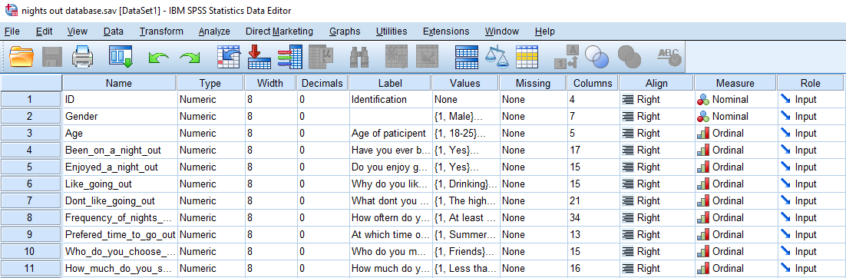
Following this the data was entered in numerical view with each optional answer from the questionnaire having a different number assigned to it so that the imputed data would be as bellow.
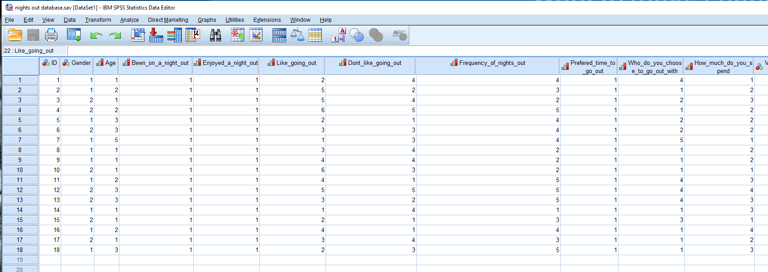
Following the completion of the imputed data the view of the data was changed using the values tab on the top control bar to make sure that is was inputted correctly as can be seen bellow.
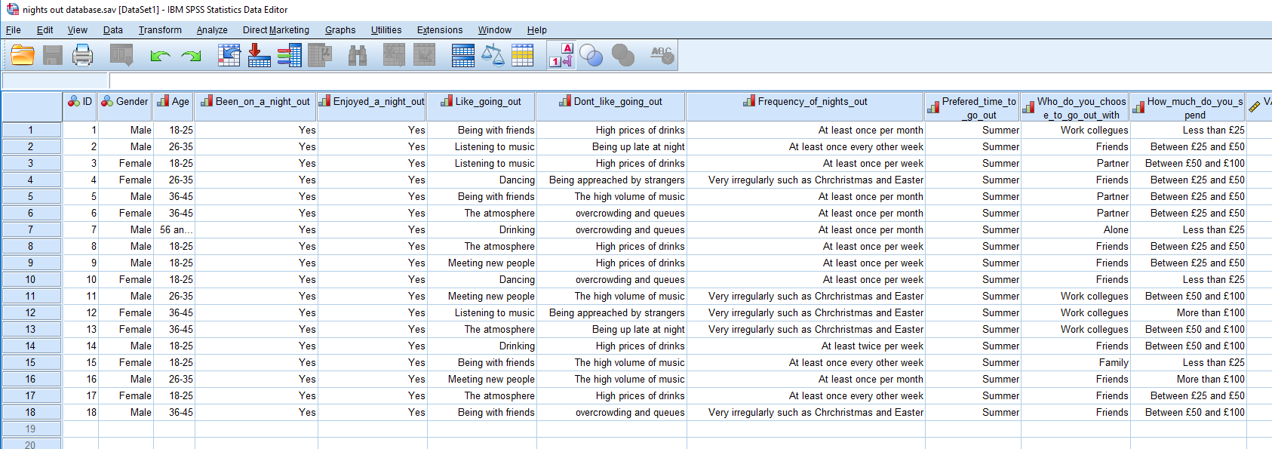
Following this I chose to look at frequencies within the data, this was done by opening the tab labelled analysis then pressing descriptive statistics and then finally pressing frequencies. Then the frequencies table opened where I chose which pieces of data, I wished to find the frequencies of as can be seen bellow.
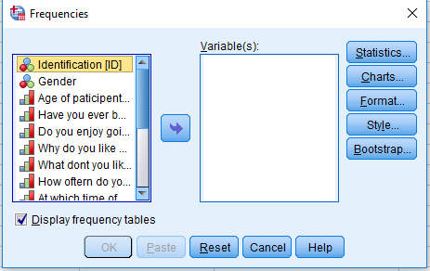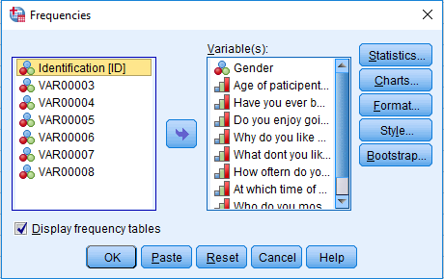
This then created frequency tables for all chosen data these tables are able to show the percentile difference between different groups with the data such as showing that 55.5%of the participants were male and 44.4% were female these tables also showed percentiles for multiple variables such as the reasons why people like going out as seen bellow.
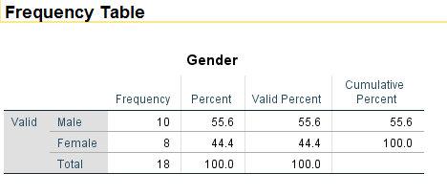
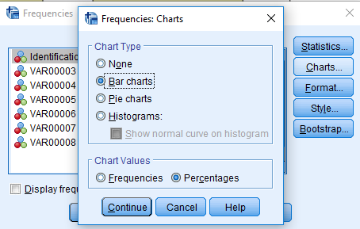
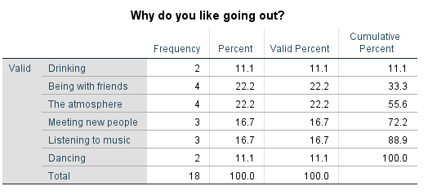
After this I then chose to create chats to display the data in a more user-friendly format so that it was simpler to understand. This was done by returning the frequency tales and choosing charts, both bar and pie charts where used.

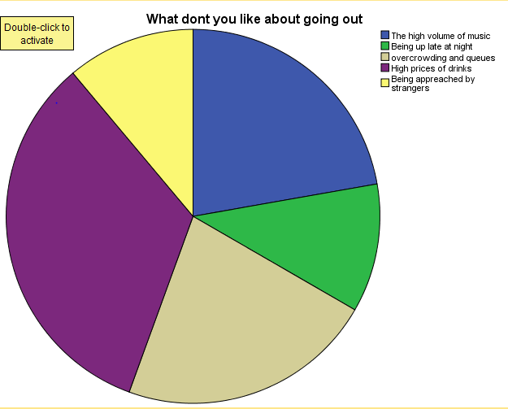
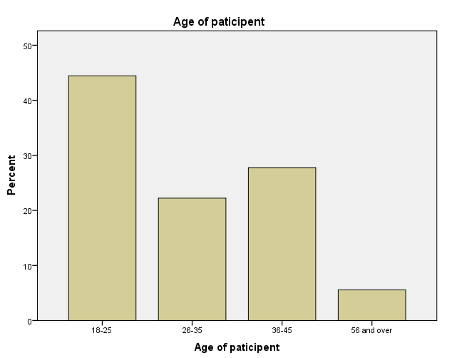
Data Presentation and Findings

For the presenting of data findings cross tabulation was used to compare different questions against age and gender. The first two categorise of data analysed was gender against what do people like about going out, as seen bellow.
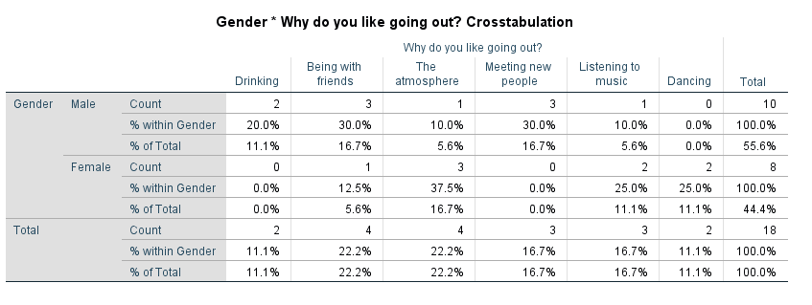

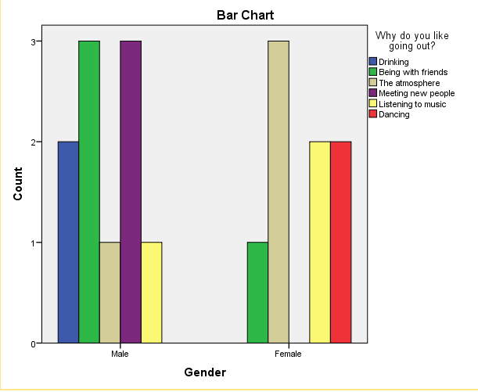

The chosen data can also be placed into a bar chart format to provide visual differences in what men and women enjoy about nights out. This graph shows that 20% of men enjoy going out to drink however no females favour this part of a night out. Next the chart shows that 30% of men favour being with friends on nights out whilst only 12% of women favour being with friends.

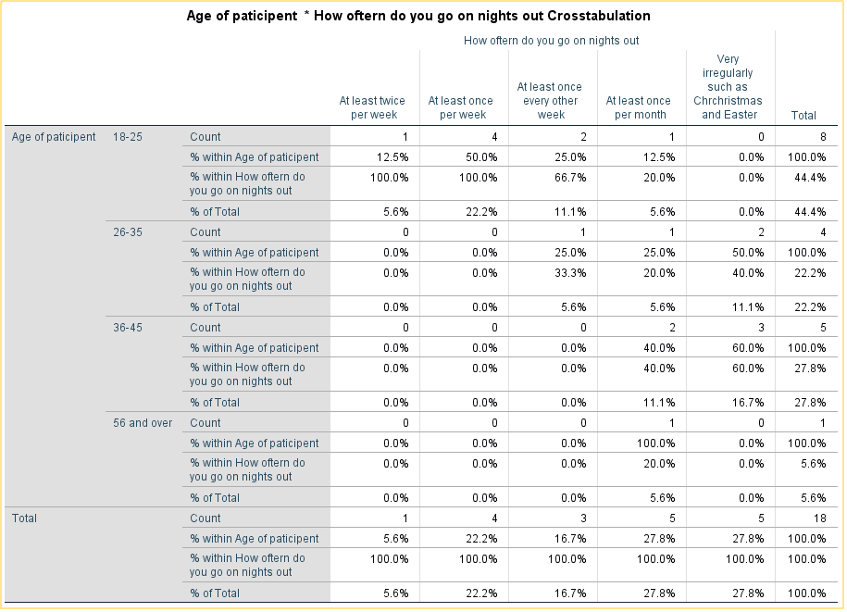

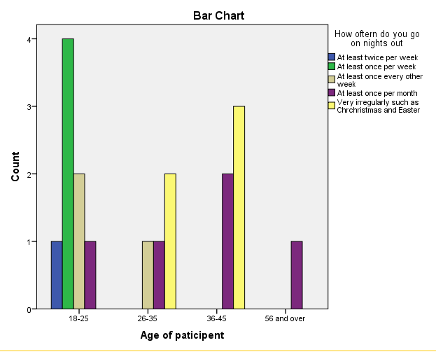

This data shows the relationship between age and how often a person goes on a night out. From the data you can see that only those between 18-25 go out at least twice per week as well as at least once per week. As the age groups increase the regularity of going out for the night decreases as these age groups may have to work more as well as have other responsibilities. In total this shows that shows that the younger you are the more likely you are to go on a night out.
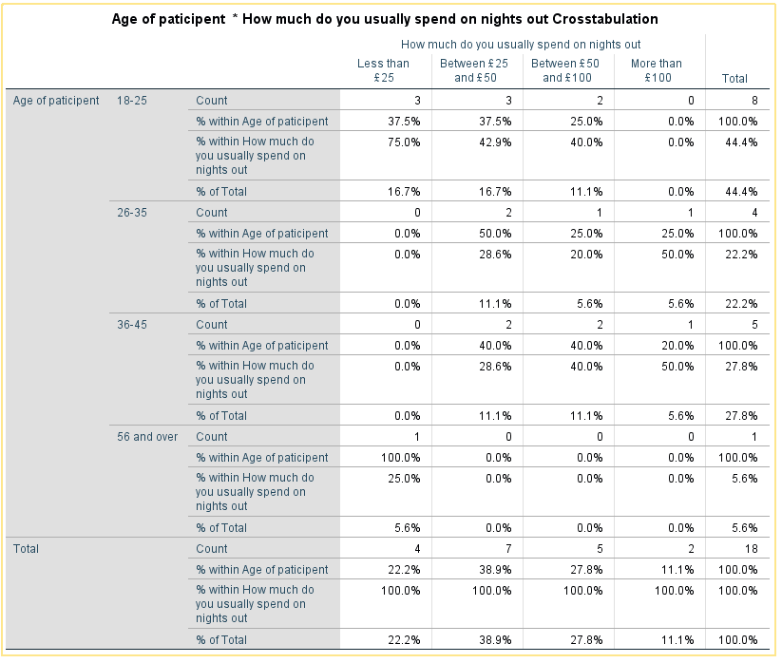
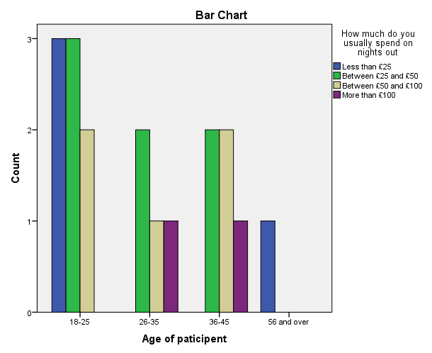
This data set shows the relationship between the age of the participants and the amount spent on a night out. This shows that the younger the participant the less they are likely to spend with almost 40%of 18-25-year olds spending less that £25 on a night out this may be because they are unable to spend more or do not want to. Whilst other age groups of 26-35 and 36-45 being much more likely to spend over £100 on a night out with the percentage being 50% of these age groups spending this amount on an average night out.
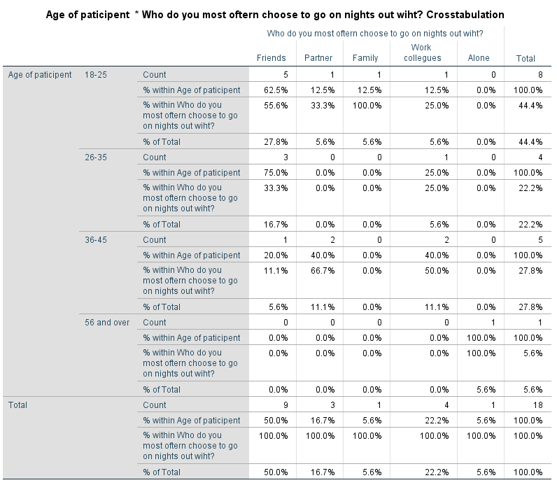
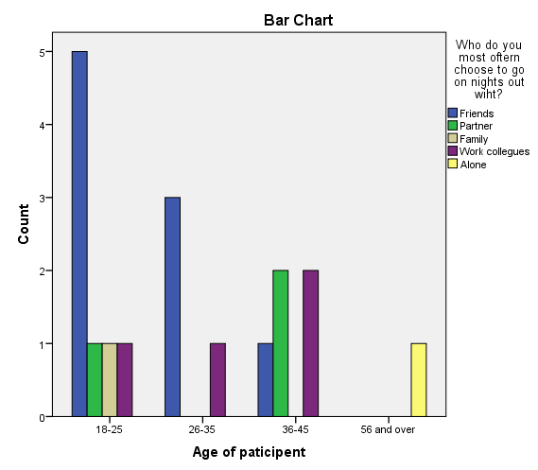
This set of data shows the relationship between the age of the participant and who does the participant choose to go on a night out with. This data set shows that between the age of 18-25 over 62% prefer to go out with their friends this trend continues between 26-35 with 75% of participants preferring to go out with friends. However, this trend is not visible between 36-45 with these participants choosing to go out with partners and work colleagues with equally chances of 40%.

Conclusion/Reflection
In conclusion the data collected shows many links visible through crosstabulation of the data sets, the links include high likelihood of going out at a younger age. Comprised with those in older age groups as well as links between age and favoured parts of going out to create conclusive information these links can be used to identify the likely target audience for a business and using what they like and dislike about nights out can model a business around their desired clientele.
In reflection of the quantitative research method or data collection and analysis there were both strengths and weaknesses to the process such as the method being very straight forward, and the surveys were easy to hand out and get results from. Although a main weakness is that the surveys were done anonyms, so it was impossible to follow up on the data or attempt to understand the reasons behind the data with any being left to think theoretically about the reasons.
If I were to conduct the study again I would choose to increase the sample size to fifty as well as doing it over different weeks in a month to see a wider range of opinions as well as making the survey no longer anonymise with names and contact details given so the information can be followed up if needed to.

Word Count: 1593

Bibliography

Announcements | GOV.WALES. (2019). Retrieved from https://gov.wales/announcements
Hair, J., Black, W., Babin, B., & Anderson, R. Multivariate data analysis.
Johnson, R., & Wichern, D. (2003). Applied multivariate statistical analysis. Upper Saddle River, N.J.: Prentice Hall.
Tabachnick, B., & Fidell, L. (2013). Using multivariate statistics. Boston: Pearson Education.
The regional value of tourism in the UK - Office for National Statistics. (2019). Retrieved from https://www.ons.gov.uk/peoplepopulationandcommunity/leisureandtourism/articles/theregionalvalueoftourismintheuk/2013

Appendices
Appendix 1
Nights Out Questionnaire participant number ( )
This questionnaire can be completed in under four minutes.

Q1. Gender:
- Male
- Female

Q2. Age:
- 18-25
- 26-35
- 36-45
- 46-55
- 56+

Q3. Have you ever been on a night out?
- Yes
- No

Q4. Do you enjoy going out for the night?
- Yes
- No

Q5. What do you like about going out?
- Drinking
- Being with friends
- The atmosphere
- Meeting new people
- Listening to music
- Dancing
- Other…………………….

Q6. What do you not like about going out?
- The high volume of music
- Being up late at night
- Overcrowding and queues
- High prices of drinks
- Being approached by strangers
- Other………………….

Q7. How often do you go on nights out?
- At least twice per week
- At least once per week
- At least once every other week
- At least once per month
- Very irregularly, such as bank holidays and Christmases

Q8. At which time of year are you most likely to go out?
- Summer
- Winter
- Spring
- Autumn

Q9. Who do you most often choose to go on nights out with?
- Friends
- Partner
- Family
- Work colleagues
- Alone
- Other…………………

Q10. How much do you spend on a night out?
- Less than £25
- Between £25 and £50
- Between £50 and £100
- More than £100

