BENEFITS OF SOCIAL MEDIA FOR MARKETING & BUSINESS



Student Horhocea Cristiana-Mara
Student no. 1604608
Module: Marketing Fundamentals
Tutor: Richard Small
University of Wales Trinity Saint David, London Campus

Table of Contents
Task A………………………………………………………………………………2
1. Introduction……………………………………………………………………...2
2. Marketing………………………………………………………………………..2
2.1 Marketing Strategy…………………………………………………………...3
2.2 Stages of Business Thought…………………………………………………..3
2.3 The Marketing Concept……………………………………………………....3
2.4 The 4 pillars…………………………………………………………………...4
2.5 Functional Marketing Strategy………………………………………………4
2.6 SWOT Analysis (Samsung)……………………………………………….….5
3. Internal & External Stakeholders……………………………………………...6
Task B……………………………………………………………………………….7
4. References………………………………………………………………………..8
5. Appendices……………………………………………………………………….9

TASK A

- INTRODUCTION
Nowadays, there are some modern platforms that businesses can use in order to socialize directly with their audiences, like Twitter, Facebook, Instagram, Pinterest, Yahoo Mail and others. According to Amy Vernon, social marketing consultant and cofounder and CMO of Predictable.ly., a big wrong supposition about the relationship between social media and marketing it that it is fast and it does not cost money either. But her opinion is that there are some things we can do to help speed up the process.
Today, every single product sold around the world is being reached to the prospective customer through marketing. It could be the world’s cheapest product or it could be the world’s most expensive product, both of them come out via marketing.

2. MARKETING

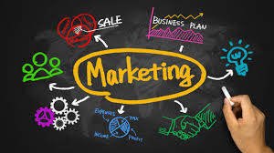

Best use – philosophy; putting customers at heart of business; producing and offering distinctive value for customers; making decisions based on the impact of customer.
A way of looking at a business and what it does from the outside whilst being inside.
Needs, wants > products > utility, satisfaction, value > Exchange, transactions, relationships > Markets.
Marketing is not selling. Selling is meeting the seller’s needs; converting product into cash; inside-out perspective. Marketing is meeting the buyers’ needs; offer product to customers; outside-in perspective; aims to make selling superfluous.

Marketing means promoting and selling products/services. It is a process used to tell the customers why they should choose a product or service over competitors. It is important to know the differences between Marketing and Advertising or Sales because it is often confused with these two different things. It is true that it involves them, but they are not the same things.

2.2 Marketing Strategy
A marketing strategy is a tool used by businesses with the design to attract people and turn them into customers of the products that the businesses provide. A business’ marketing strategy should normally have a lifespan longer than any other marketing plan, as a business consists in value offering and key outlines of a company’s brand; it outlines the overall game plan. A Marketing Strategy represents a company’s goals and objectives. It first sets its goals, but it must create a strategy to reach its objectives too. This thing is like a journey – when you start, all you have is only your wishes and aspirations; but when you get to the end, you will have your purpose accomplished.

2.3 Stages of Business Thought
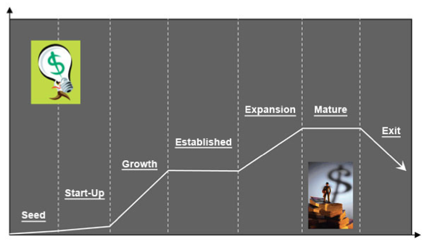
- Production Concept – reduce unit costs
- Product Concept – make the best
- Selling Concept – all the same-sell harder
- Marketing Concept – listen to the customers, target and be different or better

2.4 The Marketing Concept
Developed in 1950’s.
To achieve organisational goals, determine the needs and wants to target markets and deliver the satisfiers more effectively and efficiently than the competitors.
The outside-in perspective (see through customers’ eyes).

2.5 The Marketing Mix - 4P’s
There are different stages in marketing a product. The marketing mix refers to the way an organization uses in taking their product to the ultimate customer; that means making the customer to pay the value to the product they sell. Forwards I will explain what every single ‘P’ of the Marketing Mix means:
- Price – it is usually tested via focus groups or surveys. Level of pricing must be comparable to competitors; if the price is too higher, then the sales can drop off remarkable. In case of introducing a product that has never been sold before, producers must firstly think of how much the customers would be able to pay for it.
- Product – companies have a lot of procedures that they must carry on before selling a product in order to make sure that it is ready for it. This process starts with a stage called ‘ideation stage’ – that is when the product is devised. Afterwards, they also use focus groups (a collective on purpose) and surveys as well, to test the concepts of the new products in order to determine the level of interest among potential buyers. If the level of buyers’ interest is high, marketers start selling the products in a limited amount to observe the sales. Then, if the sales of the product are high, the product is finally released on a national level.
- Promotion – it stays in creating the business’ own website, promoting it via social media (on web sites like Facebook, Instagram, Twitter and so on), publishing in magazines, brochures, ads and other ways. Their purpose is to make their products more popular in order to increase the sales and the business’ popularity. It competition is selling internationally, people are going to promote more and more in order to compete and reach their goals.
- Place – where the products are sold. Place is an important part of the mix as our product should reach the potential buyer. For this the placement should be accurate and the way if distribution to the expected segments must on time. As we are fulfilling our target market so we must understand all our distribution channels. For example we must identify how the customer prefer to by our product according to the location as they prefer online or by visit.

2.6 Functional Marketing Strategy
- 4P’s : Price, Product, Promotion, Place
- For services : 7P’s : Price, Product, Promotion, Place, Physical Evidence, Processes, People
Plus ‘POSITIONING’; psychological; competitive; over, under and dispositioned.

2.7 SWOT Analysis (Samsung)
According to Philip Kotler the process of marketing should be done according to a plan under four main points. In any marketing process the first step is to find out the stage where the company or the brand is now being situated. Because from that point only we can start our next process. Then, the second process goes to next stage, to set the goals, which means identifying the accurate objectives to be achieved where it says about new products to be launched. The third process is to find out the ways to achieve objectives; that means using the marketing strategy. The last process is to ensure whether we are on track, achieved our goals how to move forward with the competition, its implementation and control.
For example, the Samsung Company is one of the top electronic seller in the world. They sell a variety of electronic products by competing with other big and well-known companies like Apple or Huawei. That’s the power of marketing. They use different market strategies to survive in form capturing the target groups. Samsung always do market research in order to find out the consumers views about their products and what they expect more. Also this helps Samsung in implementing fair price for their products according to the geographical locations they exist which brings them profit.

Strength  - Top brand image.  - Able to maintain large market share around the world. | Weakness  - Don’t have its own operating system, it depends on google.  - Trying to get in with many products which may result in failure in some.
- Large number of loyal customers around the world.  - Manufacturing and regional plants in many countries. | - Giant competitors.  - No particular focused product result in over production.
Opportunities  - Advancement in technology  - Day by day demand for smartphones raise  Able to get patent rights. | Threats  - Always change in technology which cause loss for old innovations.  - Increasing competition.  Innovations of advanced products by the competitors.

3. Internal & External Stakeholders
Internal Stakeholders
- Employees: Employees are the main group who run the organization by doing the process of business. They are to be considered more important in marketing decisions as they are the persons who will implement take responsibilities marketing strategies.

- Directors/Managers: They are persons who take decisions in implementing any marketing strategies. And they are the responsible able for any fault or good happens because of the implementation into the market. They always make sure whether the process of their strategies go on correct flow and they are able to take quick and change decisions and practice according to the need.
External Stakeholders
- Government: The government of a country can influence the decision made in any kind of organization that exist within their country. Because each and every organization exist in this world are to be worked under the government policies of each country those exist. So legal requirements like environment protection law, taxation like VAT, consumer law are directly affect the marketing decisions of the organizations.
- Pressure Groups: Pressure groups could be an individual or a group who can influence any government policies, organization decisions etc.…. When organization implement decisions into action sometimes it could be favourable those pressure groups but if it’s not they may protest or work against the implementation. This how this pressure group impact towards marketing strategies of organizations.
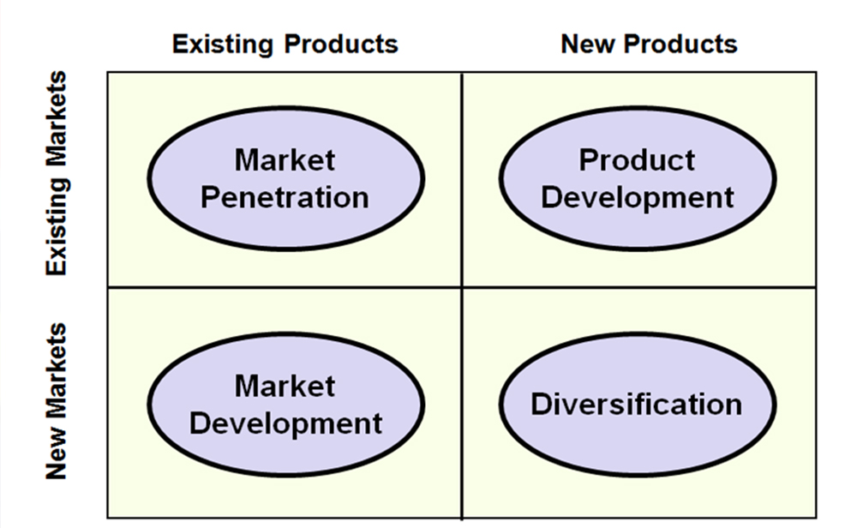

Task B

The promotion part of marketing is communication with customers. According to this report, we can see that the marketing communication tools play the leading role in the relationship between manufacturer and consumer. Without spreading the information, products would not be sold properly. More important, the communication tools are used in the advertising part of marketing. At the moment, most of the world’s organizations are commonly using their own websites, blogs, video blogs and TV channels and Social Medias like Facebook, Instagram, Twitter as well, with the purpose of promoting their products.
In the above mentioned tools I can say that social media is fastest way of communication tool. Particularly, blogs are being now most popular in implementing marketing strategies towards new launches of companies. As these blogs help the company to keep connected with customers always by getting their feedbacks time to time
Also, due to direct interaction between organization and customers, it makes an advantage to the firms in reducing the market research to find people’s expectations, as they are already up to date with on time feedbacks. At this moment, the technology is developing more and more day by day and businesses take place through internet without even knowing each other’s trade. So to go with that fast only these types of social media tools are the most appropriate communication methods in marketing strategy. And it is more effective than any other one to use around the world in one click.
For writing this report, I had to do a lot of research on marketing theories and how it works, the marketing strategy, the marketing mix and so on so now I can say that I have a vast knowledge about Marketing and its benefits through social media. Also I came to know how the brands make their pride on top than their products by competing with each other’s. It is very interesting to find out how companies use communication methods in order to make people think about their products and then buy them and becoming their customers and also to find out how companies compete with each other with the purpose of reaching the same goal and selling their products.
Now I know a lot more about this subject after working on this report and I am sure that this adding to my knowledge will help me to develop my future career in the business field.

4. References

- A Beginner's Guide to Marketing [Online]
Available on: www.thebalance.com/what-is-marketing-2296057

- Charted Institute of Marketing, 2018. CIM. [Online]
Available on: https://www.cim.co.uk/

- How To Use Social Media To Market Your Business [Online]
Available on: https://www.fastcompany.com/3047232/how-to-use-social-media-to-market-your-business

- Marketing Strategy [Online]
Available on: www.investopedia.com/terms/m/marketing-strategy.asp

- Marketing Strategy for Home Business Success [Online]
Available on: https://www.thebalance.com/marketing-strategy-for-home-business-success-1794314

- Peel, M., 1993. Introduction to Management. First ed. London: Pitman.

- Samsung, 2018. Samsung UK. [Online]
Available on: http://www.samsung.com/uk/

5. Appendices
- Figure 1 ‘Marketing’……………………………………………………………………………2
https://everydayinterviewtips.com/marketing-job-interview-questions-for-graduates-background-questions/
- Figure 3 ‘The 7 stages of business cycle’………………………………………………………3
http://www.justintimemanagement.com/en/The-7-stages-of-business-life-cycle

- Figure 2 ‘Ansoff Matrix’………………………………………………………………………..6
http://nanayawkesse.com/pursuing-strategic-growth-through-the-ansoff-matrix/

