
Applied Leadership and Management in the Workplace
Module Assignment Submission
Student Name: | Kaylea Haynes
Student Number: | 2206928
Module No: | BMSK4011
Module Title: | Continuous Professional Development

Statement of Confirmation of Authenticity
By the act of making this submission, the student declares that this is the work of the student named above. The work has not, in whole or in part, been knowingly presented elsewhere for assessment, or where assessment has been built on a previous assessment, this has been identified. Where materials have been used from other sources it has been properly acknowledged. If this statement is untrue, the student acknowledges that an assessment offence has been committed.
Attention is drawn to the plagiarism and unfair practice policies of both the University and of ILM.

Table of Contents
Introduction 2
Section 1: Know how to identify development needs 3
1.1 Identify learning styles for self and another 3
1.2 Use a simple technique for identifying development needs for self & another 4
1.3 Identify potential barriers to learning for self and another. 6
1.4 Explain how these barriers to learning can be overcome. 7
Section 2: Know how to develop self & others to achieve organisational objectives 8
2.1 Analyse learning/development options to meet needs of self & another. 8
2.2 Identify support mechanisms for the development of self & another 9
2.4 Method used to monitor the development of self & another. 12
Section 3: Reflection on the interview process 12
3.1 Review of interview technique. 12
References 13
Appendix A Curriculum Vitae 14
Appendix B Continuous Professional Development Record 14

Introduction

This assignment will demonstrate the importance in understanding and awareness to an individual's own learning styles and how internal and external barriers can impact while looking at how to overcome these. furthermore, looking at setting future goals through personal development plans for myself and a team member in the retail environment. Looking at each of our support mechanisms and how they can be best utilised to help in the process on progression. Finally putting a personal development plan in for myself and team member and look at how the interview process works, as in what makes for a good interview technique.

Section 1: Know how to identify development needs

1.1 Identify learning styles for self and another

It is vital as a manager that you can adapt to all team members individual learning style as not everyone will fit into one generic box. To show understanding I have undertaken three separate learning styles questionnaires and asked one team member to take two of them to see how we differ in learning while figuring out how I can improve on his learning journey at the company. Firstly, we both began by taking the VARK questionnaire which concludes there are 4 groups of learners visual, auditory, read/write and kinaesthetic (Fleming, 1987). The results of this for myself and my team member were very surprising as I came out as a visual learner, and he came out as a kinaesthetic meaning I would prefer to be given books or videos to watch then try whereas he would prefer to get straight into practical hands-on learning.
Secondly, we both completed the Honey & Mumford questionnaire as they also have four types of learners but categorise them as an activist, pragmatist, theorist, and reflector (1986). The results to this were along the similar lines as the first result from questionnaire one, showing that myself was a reflective learner, where I need time to process and take in what is being learnt while being quite reserved in the process. My team member showed as a pragmatist, so once again would thrive by being hands on in a practical environment where they can learn in the process. Thirdly, for myself to cover all aspects I completed the Dantec questionnaire where I also came into the reflective category, which runs in line with the previous results. Finally, by completing all these questionnaires for myself and team member it shows how important it is to be aware of how we learn as this could be a major downfall in a happy work environment and happy employees. Whereas is I just went in with one agenda that everyone was a visual learner like myself and gave a kinaesthetic learner a video or book to read the would be more inclined to lose interest and not give what is required of them and would show power management from myself. Showing a complete understanding that you can adapt to everyone's individual learning styles is key to becoming a successful manager.

1.2 Use a simple technique for identifying development needs for self & another

SWOT Person 1

STRENGTHS  - I work well in both group and solo settings  - Ability to adapt in high-pressure situations  - Time management  - Over 15 years with one company | WEAKNESSES  - I lack confidence in public speaking  - Taking on too much causes stress and anxiety  - Saying no is extremely uncomfortable  - Being able to present my ideas clearly
OPPORTUNITIES  - Taking the opportunity to learn new skills on the courses booked for development  - With competitors closing extensively use it to our advantage  - Taking personal confidence courses | THREATS  - Online retail becoming more relevant  - Only way to progress is if someone retires or leaves  - More than one member off staff aiming for promotion  - Family commitments  - Health issues

SWOT Person 2

STRENGTHS  - Strong presentation skills  - Customer relationships are superb  - Works under pressure at a high standard  - Marketing qualifications | WEAKNESSES  - Struggles to work in teams  - Taking criticism  - Being able to attend courses  - Being flexible
OPPORTUNITIES  - Working in the team projects coming up for the Christmas sale  - Take online courses available  - Competition closing due to lack of in-store sales  - Team members going on maternity so take on their role to demonstrate drive for progression | THREATS  - Online becoming the future of retail  - Family commitments  - Progression is slow in retail  - Promotion is incredibly competitive due to few jobs higher up
Albert Humphrey (1960)
Gap analysis can be used to determine what is needed to move from where you are at present to get you to where you want to be or should be, this is supported by M. J. Scott (1980). Conducting gap analysis creates a clear path of what need to be done by looking and what is needed to get you from where you are to where you want to be.
Gap Analysis person 1
- Where I am at present is in a lack of confidence with my overall learning, I struggle to be able to present in a public setting such as work presentations. Working I retail causes high stress and anxiety as I have poor public speaking in large crowds.
- Where I want to be is a well-presented confident person who can stand in public setting and speak or be able to standup and give a strong presentation, to be taken more seriously and be accretive.
- What is needed to achieve this outcome would be to attend courses that improve confidence in public speaking and presentation courses, while also reading books and watching how people do it and taking notes.
Gap Analysis person 2
- Where my team member is now would be having a lack of team working, flexibility or time management is lacking and interest in learning is not there along with refusal to accept constructive criticism.
- Where my team member wants to be is to work better as a team with great time management skills and flexibility to adapt to situations that arise, also taking onboard constructive criticism.
- What is needed to achieve this for my team member would be for him to take on the courses available to him and to ask for their opinions and suggestions, using team-building exercises to create a bond and planning to be able to manage his time in a better way.

1.3 Identify potential barriers to learning for self and another.

It is apparent that there will always be barriers to learning and these would come in two categories one being external factors meaning things that are outside of you that you can’t control but can adapt to and the other being internal factors, things that are within you that can be changed with the correct support or guidance. Firstly, looking at myself, starting with the internal barriers I have identified is to have a lack of self-belief and knowledge, skill level, confidence, and doubt that I can succeed at something new. Secondly, the external barriers that have been identified are family which can be very unpredictable, work commitments and my lifelong health condition that requires many appointments throughout the year.
Moving on to my team member and the learning barriers they face. Firstly, internal barriers that has been identified are a lack of interest in progressing as does not believe in the self, IT skills that are required for learning and a belief in themself. Secondly, the external barriers to have been identified are family and all the unpredictability with that, work patterns.
By looking at what barriers there are you can have a clearer understanding to what you need to address to help learning become a success. For example, Covey gets you to think about what is required and how important it is to manage your time (2013). This will give you the ability to prioritise your needs to get the best out of yourself.

1.4 Explain how these barriers to learning can be overcome.

After identifying the learning barriers for myself and my team member it is apparent that we have some remarkably similar that can be overcome and others that we can plan to change as best we can. Thinking about how to overcome these learning barriers has opened up a new way to manage the team and myself so looking first at confidence and the way this can be overcome is by joining classes that support confidence building while also going on courses that help with self-belief, also reading books and watching videos would be a way to improve and in turn have a positive impact. For the barriers such as doubt in your work or skill you can ask for feedback from friends, family, or colleagues so you can see how others see how you are doing. Moving on to the external barriers that has been identified, these become unintentionally harder to control due to the unpredictability of things such as family as you can have emergencies that will require you to leave or change plans at an instance, but to overcome this you can plan by using other family or friends to call upon in these times, by planning in advance it gives you some security that you have help other than yourself leaving you to carry on. Then there are the health barriers that became even more unpredictable as for myself with a lifelong illness which brings a lot of appointments and random infections brings a harder challenge but also with this barrier planning would be extremely beneficial with regular appointments and as for the times that come with surprise go online and use the online environment to be available. Being more self-aware which you can find out how self-aware you are by looking at The Johari Window (Loft & Ingham, 1955) you have a higher chance of overcoming barriers in learning as how people perceive you I.e. as extremely confident, when in reality you might not be hiding this barrier and be harder to overcome if unknown by others.

Section 2: Know how to develop self & others to achieve organisational objectives

2.1 Analyse learning/development options to meet needs of self & another.

To further look at how to develop we have internal training courses available free of charge for all needs, so I have signed myself and my team member to the self-confidence building conference where we will spend 8 hours in a group setting to create a stronger confidence in both, I have also given them links to books to purchase or borrow to help with this. I have given the option of a quarterly timetable so that we can plan for any future events coming up while also giving them the option to plan around shifts.
I have also looked at the Go M.A.D and asked for my team member to fill one in and my findings and thoughts are below.
Gilbert & Chackrovaity created the Go M.A.D to allow people to improve the probability of success in their goals personally or within the workplace (2001). Getting my team member to create one for themselves has given them the ability to see where they want to develop, they allowed me to take this on board and see where we can help in setting plans to help with this. So, looking at the team member I can clearly see they want to progress to a higher-level job within a year whether this is in the same company or a smaller one. So now we must look at this with the SMART objective (specific, measurable, achievable, realistic, and time-bound) process (Doran, 1981). So, with this in mind for them making sure they have a realistic look at the timescale as in retail the higher-level jobs are very few which become available after retirement etc, so for them one year could be a challenging thing to achieve. For myself I have created my own on completing my level 4 ALAMO at university this year. You can see below my own Go M.A.D.
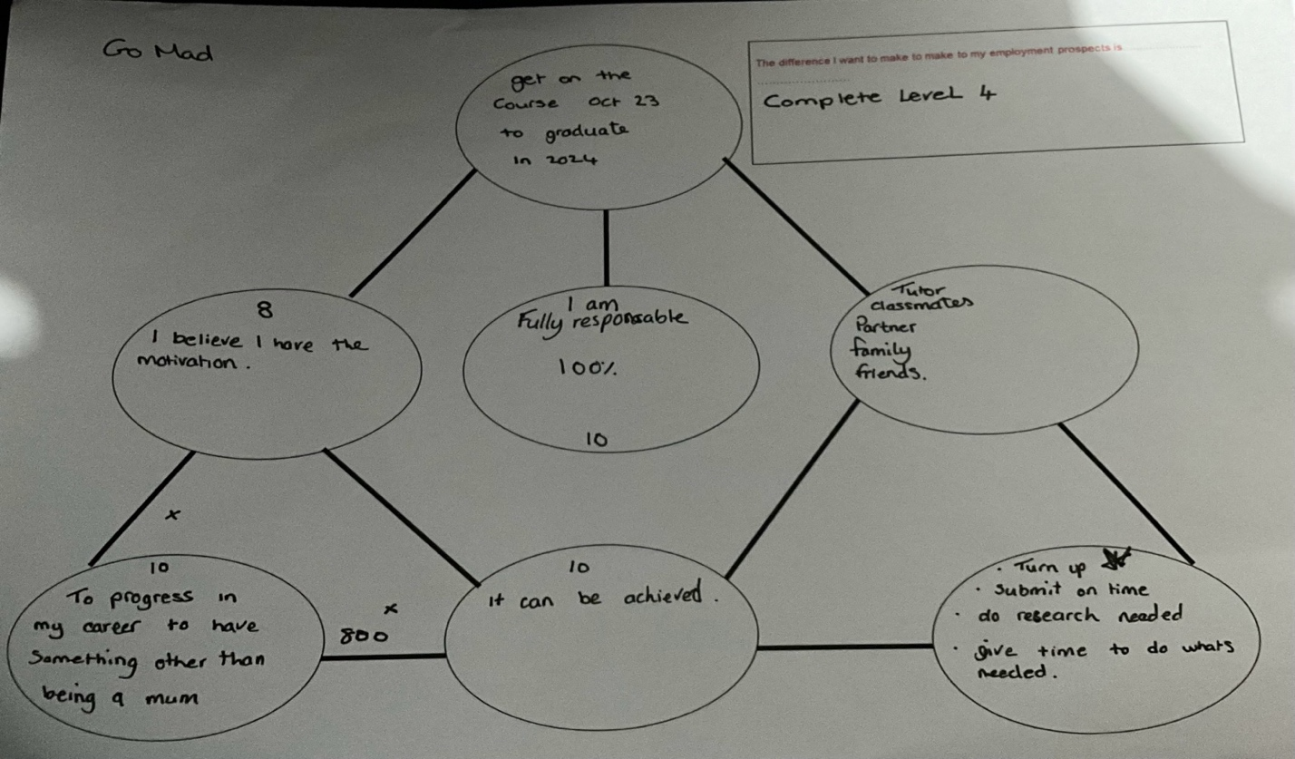

2.2 Identify support mechanisms for the development of self & another

Creating support mechanisms for an individual is imperative to succeed in this development, it takes significant effort from a variety of support avenues to come together to help. The support mechanism for myself that I have starts with my family members as having children I have their availability to help with childcare allowing me to focus on my own development. My tutor is also my support as if anything is feeling overwhelming or I hit an obstacle then I have the option to have help. I have an extraordinarily dedicated support connection with my health professional because it can control my day to day, I have the option for quick care. Having the IT equipment required for working at home in the Times I cannot make it in or to my course. Moving on to my team member who has major support of family as they do not drive so has to rely on family members to be able to transport them to the destination while also having children that would need to be cared for so childcare is heavily relied upon with family. They have support of staff and members of management in work when things become tough.

2.3 Prepare development plans for yourself and another person
Level 1 low – 5 high
Person 1
Skill/Behaviour | Action needed | Resources needed (including people) | Date(s) for action | Date for Review
Presentation skills  Current level 1 | Take courses  Get feedback  Practice  Read | Colleagues  Online courses  Books on presenting  IT equipment | Giving 2hour a week to online course  2 hours a week to reading  Practice one presentation a week | I want to be at level 5 in 1 year
Self confidence  Current level 2 | Conferences  Take on more public tasks  Read  Watch | Friends  In person courses  Books on self confidence  motivational video’s | Try things at least once a day that I would not do normally  Read a book in a month  Ask friends every day for feedback | I want to be at level 4 in 1 year
Morgan, P. (2017)

Personal Objectives

Short Term Goals (next 12 months)
To become a more confident person who can finish her level 4 ALAMO.
Medium Term Goals (2-3 years)
To have completed level 5 and 6 on my degree and graduate.

Long Term Goals (3-5 years)
To be successful in my career and to have stability.

Person 2
Skill/Behaviour | Action needed | Resources needed (including people) | Date(s) for action | Date for Review
IT Skills  Current level 2 | Take classes  Read | Computer  Books on IT  Going to collage | I will attend class once a week  I will allow two days revision | I want to be at level 5 in 6 months
Self-belief | Read  Watch  Courses | Buy books  Go online to do courses or watch video’s | Allow 30 minutes each day to learn | I want to be at level 4 in 1 year
Morgan, P. (2017)

Personal Objectives

Short Term Goals (next 12 months)
I want to become a confident person with technology.

Medium Term Goals (2-3 years)
I want to be working in a higher position within retail.

Long Term Goals (3-5 years)
I want to be comfortable and not have to worry about money, with job security.

2.4 Method used to monitor the development of self & another.

Development and learning are something that has no end, they are seen as a continuous circle with four sections comprising of experience, reflection, theorising, and planning as described by David Kolb (1984). Working through the personal development plans that have been created for myself and a team member we will both go through this cycle by firstly, having the experience in which we can then reflect on how that when and move on to whether or not it was a successful and whether it has to be altered as wasn’t going to help with what was desired or to continue with that route. As we go through the development learning It can be monitored by putting plans in place and making sure those plans have been met, if not why? And where do we need to alter to get the outcome desired.

Section 3: Reflection on the interview process

3.1 Review of interview technique.

What? | I attended an individual interview where I was greeted then taken to the lobby and given an application form to fill out while I waited to be interviewed. I was then taken into the interview room where I was seated with two people in front of me who were from HR. I was asked questions about situations I had been in and how I would handle these to gain a successful outcome, also about what animal I would be. Then I was told I would hear back within a week.
So what? | I found the individual interview to be noticeably clear and appropriate for the job role offered, which was team leader in delivery. I found the question of what animal to be very strange, but the competency questions were extremely helpful to highlight my knowledge and experience.
Now what? | If I were to think about how I would do the interview I would keep to the individual interviews but without the random questions and keep to questions that would highlight the needs required for the position.
Terry Borton (1970)

References

- Borton, T. (1970). Reach, touch, and teach: Student concerns and process education. New York,: McGraw-Hill Paperbacks.
- Covey, S. R., (1999). The seven habits of highly effective people. Simon & Schuster UK Ltd.
- Doran, G. T. (1981). There’s a S.M.A.R.T. way to write management’s goals and objectives. Management review. AMA FORUM.
- Fleming, N. D. (1995). “I’m different: not dumb” Modes of presentation (VARK) in the tertiary classroom.
- Honey, P., & Mumford, A. (1992). The manual of learning styles. Ardingly House.
- Humphrey, A. (2005). SWOT Analysis for Management Consulting. SRI Alumni Newsletter. SRI International.
- Kol, D. A., & Fry, R. (1975). Toward an applied theory of experimental learning. In theories of group process. John Wiley.
- Lift, J.; Ingham, H. (1955). “The Johari window, a graphic model of interpersonal awareness”. Proceedings of the Western Training Laboratory in Group Development.
- Morgan, P. (2017). Business Student’s Guide to Study and Employability. Sage Publications.
- Scott, M. J. (1980). GAP, Gap Analysis project. University of Idaho.

Appendix A Curriculum Vitae
CV

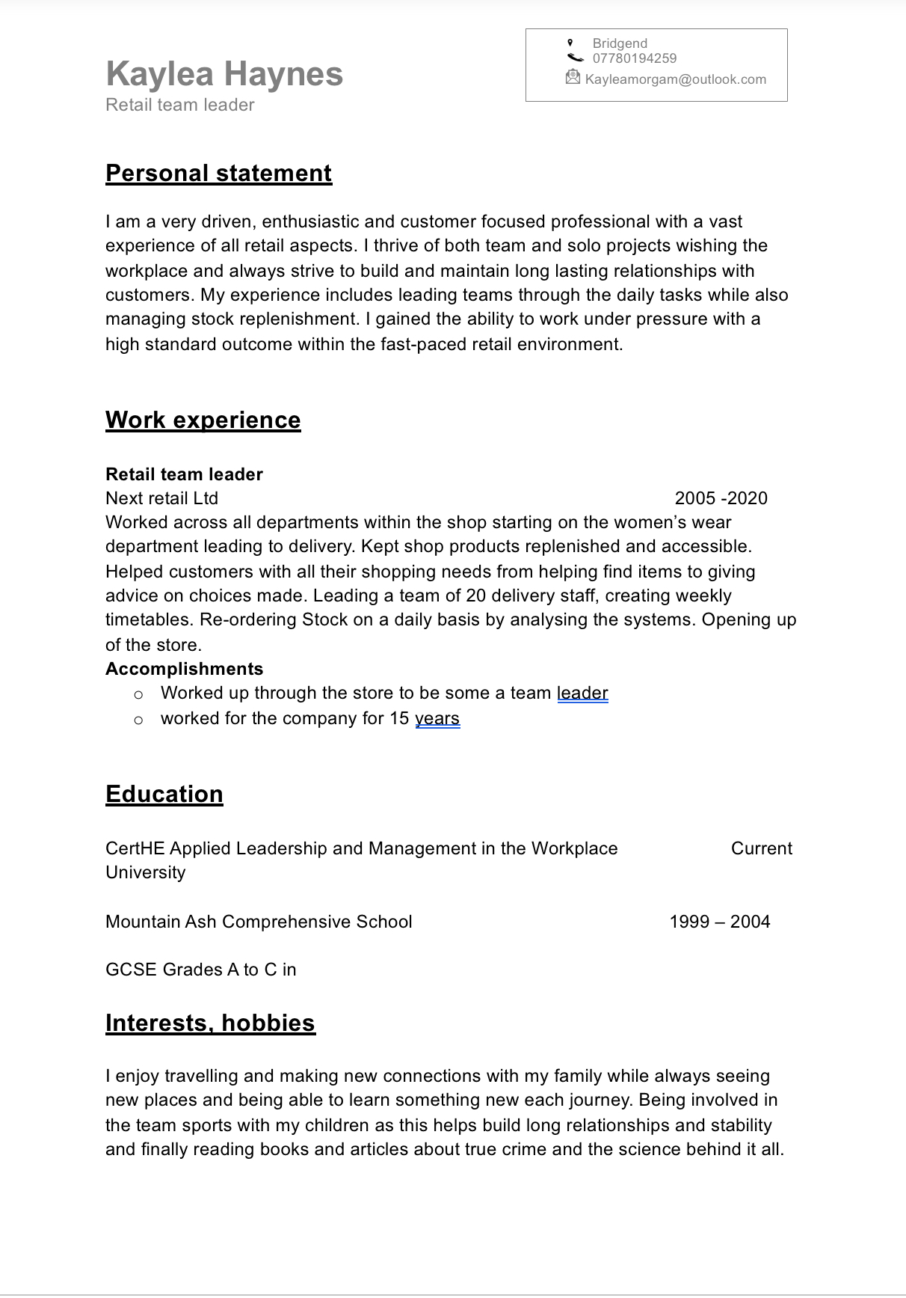

Appendix B Continuous Professional Development Record

CPD


