Geraint Jones (1908119)
1908119@student.uwtsd.ac.uk

Network Programmability

Name of the author – Geraint Jones
Course – Network Programmability
The Faculty name – School of applied computing
The date of submission – 16/12/2021

Declaration

The work of this report is completed under the supervision of Dr Tim Bashford. I declare that this report is the product of my own work and is not being submitted for any other degree etc.

Acknowledgement

I would like to thank my family for giving me the additional time to undertake a degree, my employer for sponsoring the degree and the many lecturers for giving their time and knowledge to arm me with the necessary to complete the tasks at hand.

Abstract

This report is produced as a written reflection of the academic and professional skills covered during the course. The report will cover the impact on industry with the move to cloud, specifically how that impacts the network professional, RESTful Web Services, Software Defined networking, interoperability, standards, as well as offering conclusion and evaluation of said tasks including evidencing the studies via the appendices.

Contents page
Declaration 1
Acknowledgement 1
Abstract 1
Contents page 2
Main chapters 3
Introduction 3
1. Standards 3
1.1 Interoperability 3
1.2 REST/ful 4
1.2.1 RESTful Web Services 4
2. Cloud Computing 5
2.1 Concept 5
2.2 Origin of Virtualisation 5
2.3 ARPANET/Internet 5
2.4 Cloud 6
2.4.1 XaaS 7
2.4.2 Cloud in numbers 7
3. Role of the network professional 8
3.1 Accessing the cloud 8
3.2 Networks in the cloud 8
3.3 Abstractions 9
3.4 Software-Defined Networking 9
3.4.1 North and Southbound interfaces 10
5. Conclusion and Evaluation 11
5.1 Future work 11
References 12
Supporting material 14

Main chapters

Introduction

This report contains information gathered via research on how computer networks are moving towards a greater emphasis on software. It will look at and reflect on the following key areas, cloud computing, job role of the network professional in relation to this, RESTful web services, software defined networking, standards such as Json and evaluation of said tasks along with evidencing studies via the appendices.

1. Standards

In computing standards are an agreed way of doing things, for the purpose of making it easier for people to create software. De factor standards, are those which have risen to be the accepted standard for doing things, for example HTML or MP3. De jure standards have been approved by a formal organisation such as the Institute of Electrical and Electronics Engineers (IEEE), an example being ASCII, or hardware like USB or HDMI.
They will either be open or proprietary. Open standards are usually controlled by “Creative Commons License”, or unlicensed, developed by a community. Whereas Proprietary software is controlled by a “License Agreement” and is sold by privately owned companies who develop it.
When standards are agreed and met with use, it leads to wide scale adoptions, which is good for a community or the business which created them. Take HTML as an example, which allows people to code websites. With this as a standard language, understood by all web browsers, developers of websites can code in the single language, and reach the entire market of users.[1]

1.1 Interoperability

L. Bronsword et al of the Carnegie Mellon Software Engineering Institute, define interoperability for the intention of being encompassing of many areas as
“The ability of a collection of communicating entities to (a) share specified information and (b) operate on that information according to an agreed operational semantics”[2]
As described by Bill Gates, Interoperability is
“letting different kinds of applications and systems do what they do best, while agreeing on a common ‘contract’, for how disparate systems can communicate to ex-change data with one another”[3]
If we take a real-world example of Health care, considering a patient journey between departments, we are likely to find that each department will have different software systems to capture information on the patient. For example, they would require an appointment to see a Doctor, after which they were sent for an x-ray, and a blood test. Each one of these tests use a different tool, and ultimately different software set, to the booking system. That Doctor would now need to look at both systems to see the results, however if the systems were interoperable with the booking system, that data could be viewed there for the Doctor to make use of the information.

1.2 REST/ful

Representation State Transfer (REST), is an architectural style with specific constraints, for the purpose of making it simpler for systems to communicate. REST compliant systems are often called RESTful.
Through these restraints they are performant, modifiable and scalable.
For something to be REST complaint it should follow the following rules
- A uniform interface will be agreed, along with-is characteristics, that exposer and consumer will follow without fail.
- Separation of server and client, with agree standards for communication between the two, allows code changes for one to not affect the other. Allowing them to be developed independently.
- They are stateless, server and client do not need to be aware of each other. As interaction is to agreed standards.
- Support caching for client and server, tagged appropriately, specifically improving scale and performance.
- Layered system, for example where exploded mechanisms act as one but are invisible to the client. For example, different servers for stored data, authentication and APIs yet the client performs a single action.
- Optionally, code on demand. You are free to “return executable code” to support part of an application[4].

1.2.1 RESTful Web Services

An example of a RESTful system is, RESTful Web Services which are designed to use stateless communication protocols, typically HTTP. They follow REST principles in the following way
- Resource identification: via Uniform Resource Identifiers (URIs), typically links on the web.
- Uniform interface: for resource manipulation or CRUD (create, read, update, delete) in the form of PUT, GET, POST and DELETE.
- Self-descriptive messages: decoupling resources from their representation so they can be accessed in a variety of formats, for example JSON, JPEG, HTML are accessed in the same way, but displayed appropriately.
- Stateful interactions through hyperlinks: allowing interactions to be stateless, so that the request is self-contained[5][6].

2. Cloud Computing

Cloud computing as defined by National Institute of Standards and Technology (NIST)
“is a model for enabling ubiquitous, convenient, on-demand network access to a shared pool of configurable computing resources (e.g., networks, servers, storage, applications, and services) that can be rapidly provisioned and released with minimal management effort or service provider interaction”[7]

2.1 Concept

The concept of Cloud computing can be traced back as far as 1954 where John Backus described it in a summer session at the Massachusetts Institute of Technology (MIT), it was then developed further by Bob Berner in 1957 and expressed in a scientific paper by W. F. Bauer in 1958, where he outlined the idea as
“Organizations would have input-output equipment installed on their own premises and would buy time on the computer much the same way that the average household buys power and water from utility companies”[8]
Researchers were looking to free computers from the limitation of working on single tasks, due to human interaction happening directly at the console, to working on multiple tasks using the proposed time-shared model. This would allow the very expensive computer hardware, to be shared by multiple users, giving inputs remotely, therefore making computer use more cost effective. This is not to dissimilar to today’s business drivers, which will be discussed later[9].

2.2 Origin of Virtualisation

The time-sharing model wasn’t without its issues, such as the added complexities it brought. One novel approach to the issue invented and implemented by a team at IBM which included Jim Rymarczyk, was to run multiple Virtual Machines (VM) on its CP-40 operating system, running on its System/360 mainframe hardware. As the VM was only catering for a single user, it could be a lot simpler, and therefore take up less resources allowing multiple instances to run on the single system.
The concept of the hypervisor became commercially available in 1972 on IBM’s bespoke hardware and operating system. However, Rymarczyk explains its benefits were clearly felt much sooner within IBM by enabling better test and development processes[10].

2.3 ARPANET/Internet

Some view the father of “Cloud” as Leonard Kleinrock who lead research in 1969, for the Defence Advanced Research Projects Agency (DARPA) on a new network, ARPANET, which became the basis of the internet. In that year he said
“As of now, computer networks are still in their infancy, but as they grow up and become sophisticated, we will probably see the spread of “computer utilities”[11]
A member of his team, John McCarthy, publicly proposed eight years earlier
“If computers of the kind I have advocated become the computers of the future, then computing may someday be organized as a public utility just as the telephone system is a public utility … the computer utility could become the basis of a new and important industry” [11]
ARPANET was looking to connect the users of several independent time-sharing systems of ARPA funded research contractors. The solution was the packet switching network, ARPANET, which achieved the goal over four locations in the United States.
It achieved this with early versions of packet-networking algorithms, algorithms for reliable end to end transmissions (windowing methods, time-out etc), distributed dynamic routing computation approaches, eventually maturing to the protocols Transmission Control Protocol (TCP) and Internet Protocol (IP) by the summer of 1973 via the work of Robert Kahn and Vint Cerf (TCP/IP being the main protocol, or standard rule set, of the internet connected devices of today).

2.4 Cloud

Through the passage of time Leonard Kleinrock was shown to be correct, with the wide adoption of multiple input/output devices in most homes and businesses. As predicted these components increased in sophistication for example mobile devices, network reliability and speeds creating the business need for accessing systems and data from anywhere in the globe. With user appetite and expectation, meeting technical capability it became commercially viable to provide services through a modern cloud, under pinned by advanced secure hypervisors, which virtualise compute, storage and networking.
Coined by Google CEO Eric Schmidt in 2006, the modern cloud was described as
“It starts with the premise that the data services and architecture should be on servers. We call it cloud computing – they should be in a "cloud" somewhere. And that if you have the right kind of browser or the right kind of access, it doesn't matter whether you have a PC or a Mac or a mobile phone or a BlackBerry or what have you – or new devices still to be developed – you can get access to the cloud.”[12]
The journey described above can be summarised in the timeline figure 1 below.

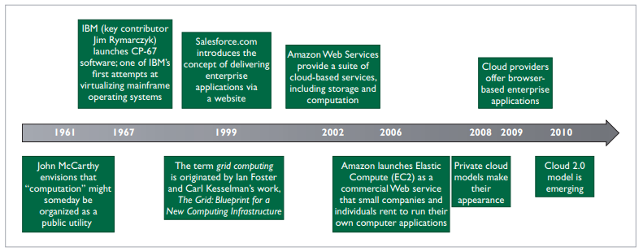
Figure 1[13]

2.4.1 XaaS

“Anything as a service”, XaaS, is a catch all phrase for the various cloud models which a customer can procure, either directly via subscription or by sale of their personal data[14]. The three main models are IaaS (Infrastructure as a Service), Paas (Platform as a Service) and Saas (Software as a Service).
The ownership of the various aspects of the service stack, are shown in Figure 2

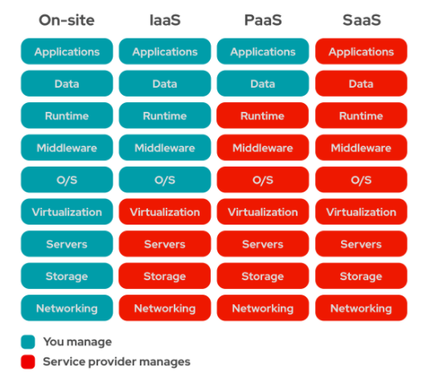
Figure 2 [15]

2.4.2 Cloud in numbers

In 2021 business spending on Public Cloud has risen to over 300 Billion USDs[16] driven by the technical benefits it brings such as quicker feature releases, higher availability, access anywhere (accelerated by COVID-19 pandemic). This makes up about 9% of total global IT budgets, projected to rise to around 14% in 2024[17].
This growth is widely projected to increase year on year for the foreseeable future, driven by emerging technologies such as Internet of Things, Artificial Intelligence and 5G. Figure 3 shows the International Data Corporations (IDC) projected total market value growth between now and 2025.
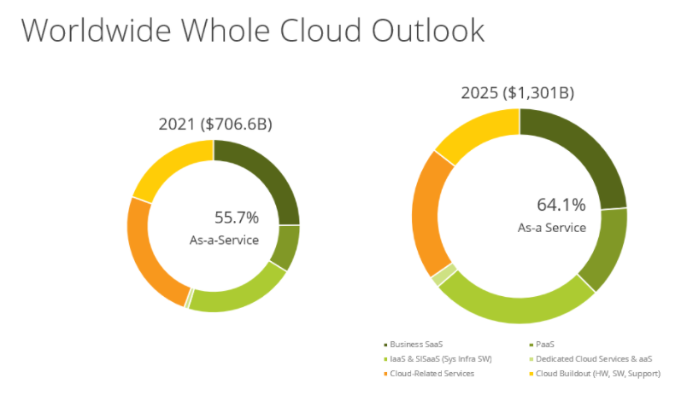
Figure 3 [18]

3. Role of the network professional

As can be understood from the previous sections, Cloud has fundamentally changed the approach of IT departments and will continue to do so in the future, and as expected this impacts the role of all IT professionals. As figure 2 expresses, moving from On-Site (traditional in house provided IT systems) to XaaS services, means the responsibility of aspects of the stack transition to the service provider. Therefore, the role of the traditional IT team changes, as whereas once upon a time they were responsible for managing all aspects of a component, they become responsible for none of it, or partially responsible in a different way.

3.1 Accessing the cloud

In most scenarios, the business will require networking support, to access the cloud. It would be sensible if this remained the role of the network professional, as they could call upon experiences in the traditional Local Area Network (LAN) / Wide Area Network (WAN) space to ensure robust, low latency, secure network links out of business premises to the Cloud, whether consumed entirely in XaaS or hybrid fashion[19].
Likewise, it would be optimal to leverage this knowledge, if a business was to elect to use WAN Edge Infrastructure[20] to connect to Cloud services. These technologies can be procured to increase availability and performance while accessing Cloud services. Either, potentially building upon existing Multi-Protocol Label Switching (MPLS)[21] connections, commissioning new ones, or introducing an emerging Software Defined Wide Area Network (SD-WAN) solution which is noted by Cisco as being born out of MPLS technologies, in the software abstraction arena[22].

3.2 Networks in the cloud

Depending on the XaaS procured, from a Cloud Service Provider (CSP), such as Amazon, Google or Microsoft, network management of a kind could be required on the platform to provide redundant, secure, performant access. Examining Microsoft literature this is described for the different models as either the realm of Microsoft, Shared or the Customer as outlined in Figure 3
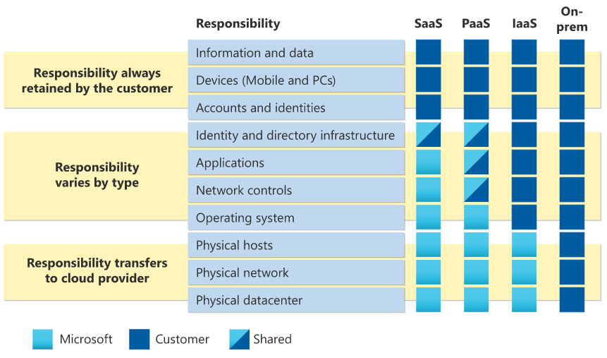
Figure 3 [23]
A network administrator would use the tools provided by the CSP, to configure the network as required, giving their business reassurance that their corporate data was secure. As these are bespoke it would differ, but below is a quick start guide from Microsoft
https://docs.microsoft.com/en-us/azure/virtual-network/quick-create-portal

3.3 Abstractions

Abstraction in mathematics and computing, is a process, of dividing a concept or system, into its simpler base components. For the purpose of disconnecting it from the dependency of the real-world object it was formed from, removing redundancy, therefore allowing generalization and wider application through for example standard algorithms and models, such as the OSI model[24].
The concept of abstraction is at the heart of many of Cloud’s building blocks, the various components which allow it to exist in its current, and future form. As introduced in section 2.1, the industry at large is evolving the various computer components shown in figure 2, to be abstracted, or software defined.

3.4 Software-Defined Networking

As noted by Nate Foster et al in “Abstractions for Software-Defined Networks” Software-Defined Network (SDN) is based on two simple ideas. Firstly, the creation of general network hardware, which has standardised packet processing abilities and secondly, decoupling the management pane so it becomes centralised. A comparison can be seen in Figure 4.
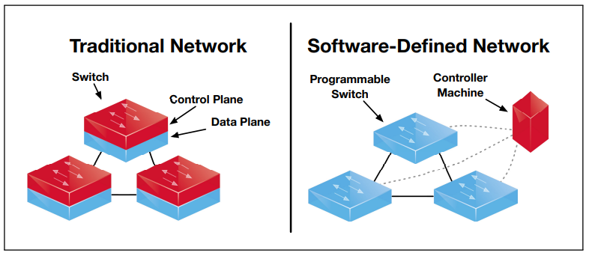
Figure 4 [25]
This abstraction of the traditional network has some of the following benefits –
- Ease of control through direct programming resulting from the separation of forwarding functions
- Flexibility to dynamically load balance traffic flow as need and usage change. Thus, reducing latency and increasing efficiency
- Improvements in security, due to centralised controller, allowing granular policies to be applied across the entire estate, as well as micro segmentation reducing complexity over any network architecture (public, private, hybrid or multi cloud)
- Automation introduced by the nature of software, to allow creation of code to configure, secure and optimize at large.
- Simplified design and operation through the use of open controllers (vs vendor specific protocols and devices)[26]
Due to these merits over traditional hardware driven networking, and the open source nature of much of the stack[27] it has become heavily adapted and adopted by the industry despite the requirement to learn new techniques and approaches for example coding, instead of Command Line Interface (CLI) on a switch.

3.4.1 North and Southbound interfaces

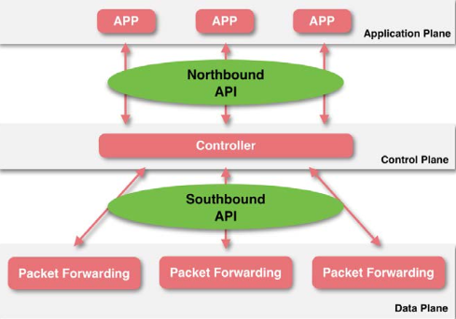
Figure 5[28]
Figure 5 shows the logical presentation of a SDN. It introduces the concept of North and Southbound interfaces/application programming interfaces (APIs), north or higher in the model than the controller, south or lower in the model than the controller. The APIs are used to communicate between the different fabrics, of the abstracted network stack, being application, control and data.
Northbound APIs are usually based on the REST architecture in the form of RESTful APIs[29]. The various types of Applications in the Application Plane, such as Firewalls, Load Balancers, or Orchestrations (OpenStack, CloudStack) /Automation (Puppet, Ansible) systems use RESTful APIs to send their requests to the Controller, in an agreed standardised format such as JSON.
The major Southbound API is OpenFlow, which defines how the SDN Controller interacts with the data plane. It is developed by the Open Networking Foundation (ONF) which is a non-profile operator-led consortium, using an open source model to promote SDN and standards[30][31].
A real-world example would be, a security system in the application pane, is alerted to an IP range as being compromised by malware. It would tell the controller, via the northbound APIs, that an action was needed to secure the network. The Controller with its understanding of the data pane, would send this request on to a device in the data plane through the southbound APIs, informing a device to drop packets to or from that IP range. Once this is actioned, the device would feedback via southbound to the controller confirming the change, with the controller then updating the application though the northbound APIs. Once the IP range is secure, the cycle would be repeated removing the rules.

5. Conclusion and Evaluation

The computing eco systems that we take for granted, did not happen by mistake. They were born out of negotiated standards, across a range of disciplines, that were then taken advantage of and improved, to reach where we are today. There may be no better example than this than the open internet, which allows information and ideas to flow freely around the earth no matter your computer manufacturer, operating system, router, or even country of birth etc.
The research here, and in class, have made me think independently at times about both the idea of singularities[32] and the proposed laws of accelerating returns[33]. It comes from considering how the various individual building blocks, such as the internet and virtualisation of storage, or compute have complimented each other to build what we now understand to be the “Cloud”. Moreover, how that will go onto compliment other advances in the future. As discussed by Mark Buchanan, for Nature Physics[33], in reference to another topic DNA sequencing in 2008, he marvelled at the idea of using ionic current’s to moved DNA strands around to allow us to scan them during this journey, allowing sequencing to happen much quicker. I wonder what he makes of AlphaFold appearing in his stated timeframe[34].
This relating back to that major component which carries information from one node to another, the network. Like everything else in the realm of IT, it cannot stay the same forever, or only linearly change, and ushered in by a disruptor[35], the Cloud, new ways of delivering networks are entering the enterprise at pace in the form of the SDN. This requires a different approach from the traditional network engineer, to introduce complimenting agility, performance and availability which has come to define “Cloud” and that will enable the next great leap in innovations.

5.1 Future work

I would like to look at the practicalities of introducing a SDN in my home setup, to introduce some better software controls around security like packet inspection, as well as QoS improvements.
Read further into OSS, NMS, EMS, YANG (schema for network device configuration), NETCONF/RESTCONF (APIs).

References

[1] “Standards - Standards - GCSE Computer Science Revision - BBC Bitesize.” https://www.bbc.co.uk/bitesize/guides/zdn3d2p/revision/1 (accessed Nov. 05, 2021).
[2] L. L. Brownsword et al., “Carnegie Mellon Current Perspectives on Interoperability,” 2004, Accessed: Nov. 06, 2021. [Online]. Available: http://www.sei.cmu.edu/publications/pubweb.html.
[3] G. A. Lewis, E. Morris, S. Simanta, and L. Wrage, “Why standards are not enough to guarantee end-to-end interoperability,” Proc. - 7th Int. Conf. Compos. Softw. Syst. ICCBSS 2008, pp. 164–173, 2008, doi: 10.1109/ICCBSS.2008.25.
[4] “REST Architectural Constraints.” https://restfulapi.net/rest-architectural-constraints/ (accessed Nov. 08, 2021).
[5] “Stateful vs stateless.” https://www.redhat.com/en/topics/cloud-native-apps/stateful-vs-stateless (accessed Nov. 09, 2021).
[6] “What Are RESTful Web Services? - The Java EE 6 Tutorial.” https://docs.oracle.com/javaee/6/tutorial/doc/gijqy.html (accessed Nov. 08, 2021).
[7] P. Mell and T. Grance, “The NIST Definition of Cloud Computing Recommendations of the National Institute of Standards and Technology,” doi: 10.6028/NIST.SP.800-145.
[8] W. F. Bauer, “A REVOLUTIONARY TECHNOLOGY Computer Design from the Programmer· s Viewpoint,” Accessed: Nov. 01, 2021. [Online]. Available: www.computerhistory.org.
[9] S. Marston, Z. Li, S. Bandyopadhyay, J. Zhang, and A. Ghalsasi, “Cloud computing - The business perspective,” Decis. Support Syst., vol. 51, no. 1, pp. 176–189, Apr. 2011, doi: 10.1016/J.DSS.2010.12.006.
[10] “Today’s VMs learn from mainframes - ProQuest.” https://www.proquest.com/docview/215992577/fulltextPDF/FDB082234A674E28PQ/1?accountid=130472 (accessed Nov. 01, 2021).
[11] T. Erl, R. Puttini, and Z. Mahmood, “Cloud computing : concepts, technology, & architecture.”
[12] “Search Engine Strategies Conference.” https://www.google.com/press/podium/ses2006.html (accessed Nov. 01, 2021).
[13] G. Pallis, “View from the Cloud Cloud Computing The New Frontier of Internet Computing,” 2010, Accessed: Nov. 01, 2021. [Online]. Available: http://csrc.nist.gov/groups/.
[14] M. Szczepański, “BRIEFING EPRS | European Parliamentary Research Service.”
[15] “IaaS vs PaaS vs SaaS.” https://www.redhat.com/en/topics/cloud-computing/iaas-vs-paas-vs-saas?sc_cid=7013a000002pgRZAAY&gclid=Cj0KCQjww4OMBhCUARIsAILndv71Qoc-QdPsrjwmbUfVGM_nFWymqbuN5rfckFB5zr-w0QN7l8WO9X8aAtzCEALw_wcB&gclsrc=aw.ds (accessed Nov. 02, 2021).
[16] “Gartner Forecasts Worldwide Public Cloud End-User Spending to Grow 23% in 2021.” https://www.gartner.com/en/newsroom/press-releases/2021-04-21-gartner-forecasts-worldwide-public-cloud-end-user-spending-to-grow-23-percent-in-2021 (accessed Nov. 04, 2021).
[17] “Cloud computing is grabbing even more of your IT spending | ZDNet.” https://www.zdnet.com/article/cloud-computing-now-even-more-of-your-apps-are-about-to-make-the-jump/ (accessed Nov. 04, 2021).
[18] “IDC Forecasts Worldwide ‘Whole Cloud’ Spending to Reach $1.3 Trillion by 2025.” https://www.idc.com/getdoc.jsp?containerId=prUS48208321 (accessed Nov. 04, 2021).
[19] “Types of cloud computing.” https://aws.amazon.com/types-of-cloud-computing/ (accessed Nov. 01, 2021).
[20] “WAN Edge Computing Infrastructure Reviews 2021 | Gartner Peer Insights.” https://www.gartner.com/reviews/market/wan-edge-infrastructure (accessed Nov. 02, 2021).
[21] “What is MPLS: What you need to know about multi-protocol label switching | Network World.” https://www.networkworld.com/article/2297171/network-security-mpls-explained.html (accessed Nov. 02, 2021).
[22] “What is SD-WAN? | Software-defined WAN (SD-WAN) | IBM.” https://www.ibm.com/services/network/sd-wan (accessed Nov. 02, 2021).
[23] “Shared responsibility in the cloud - Microsoft Azure | Microsoft Docs.” https://docs.microsoft.com/en-us/azure/security/fundamentals/shared-responsibility (accessed Nov. 04, 2021).
[24] “Abstraction.” http://www.cs.cornell.edu/courses/cs211/2006sp/Lectures/L08-Abstraction/08_abstraction.html (accessed Nov. 09, 2021).
[25] M. Casado, V. N. Foster, and A. Guha, “Abstractions for Software-Defined Networks.”
[26] “What is Software-Defined Networking (SDN)? | IBM.” https://www.ibm.com/cloud/blog/software-defined-networking (accessed Nov. 03, 2021).
[27] “Open Networking Foundation Software Defined Standards.” https://opennetworking.org/software-defined-standards/overview/ (accessed Nov. 04, 2021).
[28] J. Wu, Y. Huang, J. Kong, Q. Tang, and X. Huang, “A Study on the Dependability of Software Defined Networks,” 2015, doi: 10.2991/MEITA-15.2015.58.
[29] “What is a REST API?” https://www.redhat.com/en/topics/api/what-is-a-rest-api (accessed Nov. 06, 2021).
[30] “What are SDN Southbound APIs? - Where they are used.” https://www.sdxcentral.com/networking/sdn/definitions/southbound-interface-api/ (accessed Nov. 06, 2021).
[31] “Open Networking Foundation.” https://opennetworking.org/ (accessed Nov. 06, 2021).
[32] “Singularity: Explain It to Me Like I’m 5-Years-Old.” https://futurism.com/singularity-explain-it-to-me-like-im-5-years-old (accessed Nov. 08, 2021).
[33] M. Buchanan, “The law of accelerating returns,” Nat. Phys., vol. 4, no. 7, p. 507, 2008, doi: 10.1038/NPHYS1010.
[34] E. Callaway, “DeepMind’s AI predicts structures for a vast trove of proteins,” Nature, vol. 595, no. 7869, p. 635, Jul. 2021, doi: 10.1038/D41586-021-02025-4.
[35] Z. Yang, “Disrupt the disruptor - A theoretical approach of cloud computing on IT outsourcing industry disruption,” Proc. - IEEE 9th Int. Conf. Dependable, Auton. Secur. Comput. DASC 2011, pp. 526–531, 2011, doi: 10.1109/DASC.2011.99.

Supporting material

