DATA aNALYSIS AND vISUALIZATION
ACCB4002_LON
Lecturer: Dr Anupam Mazumdar
Assessment 2
Arpad Antal - 2010909

Table of Contents
Introduction: 2
What is Covid-19? 2
Methodology: 3
What Is T -Test? 3
Types of T-test? 3
What is Hypothesis? 4
Type 1 and Type 2 Errors: 5
What is P-value? (Significance level) 5
Findings/Results: 6
a T-Test: 8
Discussion: 9
Conclusion: 10
Table of Figures: 11
References: 11

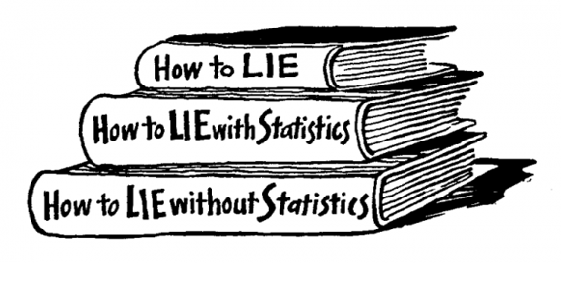

Introduction:

In this report I will analyse and investigate the truthfulness of the Covid-19 infection ratio between White and Bame (Black, Asian and Minority) people in the United Kingdom from the given data. I will also be searching after valuable information and news to support my theory, my main source for this is the internet. My Research will include numbers of charts, links, references for more information about this report, which can show a clear picture of my findings.

What is Covid-19?

“Coronaviruses are a group of viruses that cause illnesses such as the common cold, to more severe conditions such as pneumonia, Middle East Respiratory Syndrome (MERS) and Severe Acute Respiratory syndrome (SARS). The COVID-19 strain of coronavirus is new and not previously known [1].”
This research is based on the given data of total 100 patient, which is 2 group of 50, 50 white and 50 Bame people age is between 20 and 50 years. To understand the given data, I will use a called: t-test, which is a commonly used test in statistics, more about the t-test a bit later, also I will state an appropriate hypothesis and perform a two tailed unpaired t-test too from the given facts to understand better its content. Finally, I will state my research results and findings below with the correct references.

Methodology:

To start this research, I will go through some recent news about Covid-19 infections rates in the United Kingdom, this help me to build a correct hypothesis about this matter. To decide the truthfulness of the infection rate of coronavirus I will perform a t-test with a hypothesis also I will look out for evidence online and I will state the results.

What Is T -Test?

“The T Test is one of the most commonly used statistical tests. Its primary purpose is to determine whether the means of two groups of scores differ to a statistically significant degree. [1]” I used Microsoft Excel to do a T-Test in this link you can follow the steps how to perform one: Two-Sample T-test Excel [TUTORIAL] - YouTube

Types of T-test?

- There are different types of t-tests
- One Sample Paired t-test: compares the same sample twice (i.e., before and after the treatment in an experiment
- Two Sample Student t-test: this test can be equal variance or unequal usually for the longer dataset’s unequal is the better choice, what two sample does is compares two different samples (i.e., female and male as separate group in an experiment who is taller?)
I will use two sample t-test with unequal variance is this because I will checking two different groups of people and those people do not have relation each other 50 white people and 50 Bame, also the given dataset is not relatively small to identify means. Let me state below my hypothesizes:

- (Null Hypothesis) H₀ ₌ There are no significant differences of infection ratio between White and Bame people in the United Kingdom. – Note my goal here is too able to reject this hypothesis and accept the alternative
- (Alternative Hypothesis) H₁₌ There are significant differences of infection ratio between White and Bame people in the United Kingdom. – Note this is what I would like to prove
- Testing of these hypotheses of significance level 90% and 98% also 99%

What is Hypothesis?

A hypothesis is a statement that the researcher predicts and believe that it will be the outcome of the study. “The problem is that its very hard to demonstrate that something is true, with statistical methods much better to demonstrate that something is false. So, the best way is to make as a null hypothesis which is the exact opposite of what we want to demonstrate to be true, so if we can disprove null hypothesis means what is left it must be true, known as alternative hypothesis. [1]” In my own words null hypothesis is everything that I want to disprove I want to reject this I wanted null hypothesis failed so I can accept the alternative which I think the truth.

Type 1 and Type 2 Errors:

“You can never be completely sure if Null Hypothesis true or not therefore you can make 2 types of errors, as you can see on the figure below there is no option to reject null hypothesis is either you reject and believe that there are important differences between the two groups, or you cannot reject it, but you still do not know if there is are important differences or not [1].”
The Real Situation (Unknown to the investigator)
Investigator’s Decision | H₀ True | H₀ False
Reject H₀ | Investigator makes a type 1 error | Investigator makes a correct decision
Do not reject H₀ | Investigator makes a correct decision | Investigator makes a type 2 error
1. Figure

What is P-value? (Significance level)

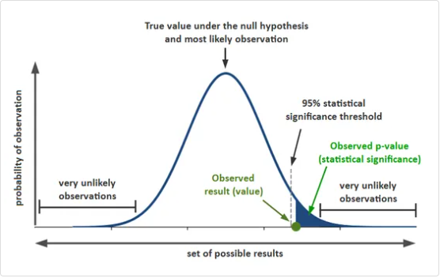
“When you perform a statistical test a p-value helps you determine the significance of your results in relation to the null hypothesis. A p-value is a measure of the probability that an observed difference could have occurred just by random chance. [2]”
2. Figure

Findings/Results:
3. Figure

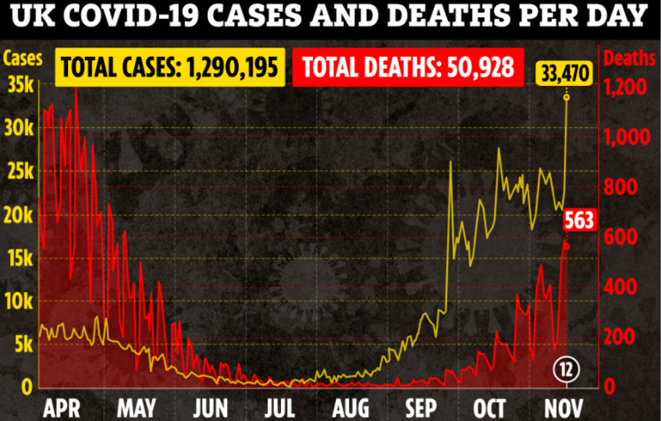
I did my research, and I found some interesting facts that, according to “Bame population chances double to get coronavirus than white people also minorities more often needs intensive care and to die from the bug if they catch it. Researchers believe that is nothing to do with race or even genetics its most likely the lifestyles, the type of job and the financial position .” [3]
3. Figure

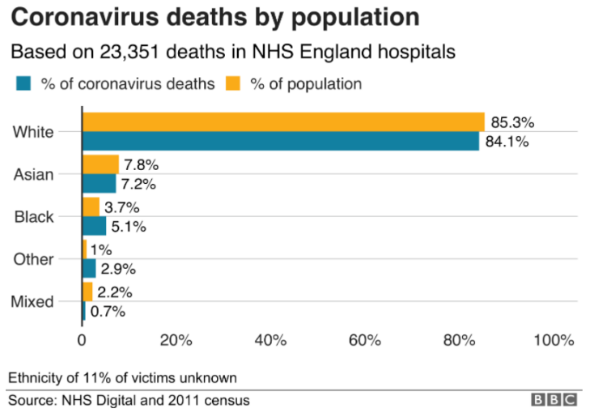
Analysis of the NHS data revealed that Bame not only have higher risk to caught coronavirus, but the chances can be double or even triple times more occur to die from Covid-19 than others from the population according to Metro.
4. Figure

„Japanese and American scientists found no differences in associated genes in seven genes associated with viral entry of SARS-CoV-2 – the virus that causes Covid-19 – across ethnic groups, suggesting genetics are not the reason for the disparity. Experts say that medical conditions, environmental and social-economic factors are more likely to blame for people of ethnic minorities being disproportionately impacted by the virus. [4]„

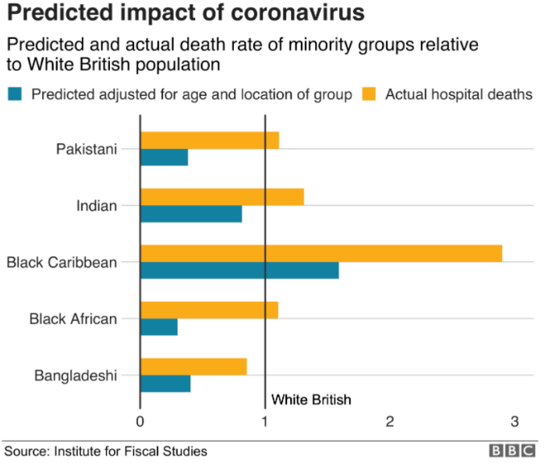
Research shown that the reason behind this higher risk of infection and increased rate of dying from coronavirus is related with the location as those people who live in a denser population are more likely to fall in this numbers.
“Black People are 1.9 times as likely to die as white people. Bangladeshis and Pakistanis are 1.8 times as likely to die and Indians are 1.5 times as likely [5]”
5. Figure

Altogether I can say that there is a difference between Bame, and White people ratio of infection, studies and reports are clearly show that Bame people high likely to caught coronavirus and develop serious complications than White people, however this ratio is not genetic related is more likely the way where and how these people live, work, and how dense is the particular living space.

a T-Test:

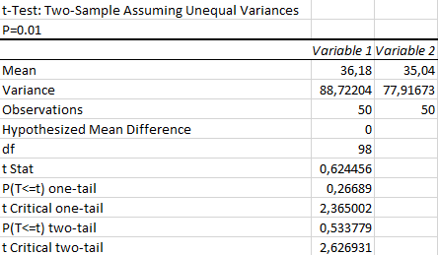
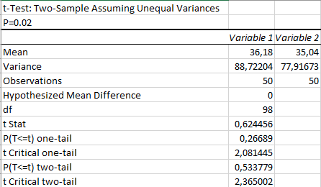
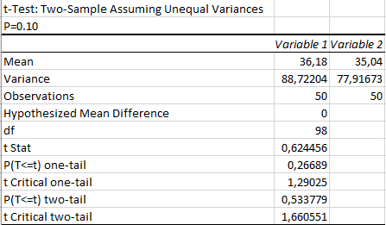
Now let see the results of the t-test with different significance levels (P=0.10 or 0.01 or 0.02). To understand these numbers, we need to check if the t stat value is greater than t critical two tail value if so than I can reject the null hypothesis, as you can see in all three figures the t stat is not greater than t critical value therefore, I fail to reject the null hypothesis. If you remember my null hypothesis was that H₀ ₌ There are no significant differences of infection ratio between White and Bame people in the United Kingdom.

Basically, fail to reject the null indicates that our sample did not provide sufficient evidence to conclude that the effect exists. However, at the same time that lack of evidence does not prove that the effect does not exist.
6. Figure

Discussion:

First of all, I collected many sources to give you an overall report from the matter. I analysed the given dataset to see if any truthfulness of infection ratio of between White is and Bame people in the United Kingdom. The result was failed to reject the null hypothesis which means I do not have enough evidence based on the data to prove it either, but that does not mean that it false. However, my other sources clearly indicate that there is something not quiet right with the ratio of infections, in other words Bame people are more likely to get ill, and die from coronavirus than white peoples, moreover that is not due a special gene, a difference and nothing to do with the race. Whatever is affect negatively Bame peoples in the United Kingdom is a worldwide issue too. Sadly, studies show that dense populations, poor health, poverty and even the job role could result in a weakened immune system and that is why the ratio is higher in the minorities. These factors make them suffer more likely from coronavirus and unfortunately the mortality ratio is higher too. These facts are true and not just in coronavirus cases but other illnesses too, people who live in poverty or in a dense population more likely to have health issues or other sickness, money is not everything but, in this case, could lead to increased stress level which is known to a factor which could lead to other health problems. “This research, led by Sarah Salway at Sheffield Hallam University, studied Pakistani, Bangladeshi, Ghanaian and white English working-age people living with long-term ill health. The study used quantitative and qualitative methods to examine why there are links between ill health and poverty, and why the consequences appear to be worse among minority ethnic groups. [6]. Black, Asian and Minorities twice as likely to live in poverty in the United Kingdom according to a guardian article, which means that the source of the infection ratio is coming from poverty and underpaid jobs which lead to all sort of health risks [7].

Conclusion:

Finally, in order to decide the ratio of infection between two group we need a much wider dataset. Currently I do not have enough evidence to reject H₀ from the given sample. My thoughts are there is a truth about the ratio of infection as my research shows it, but I cannot prove it from the given data, because I need more evidence to prove it and therefore, I start to gather information from the internet, and I stated here. Peoples are more complex and to analyse we need denser data set from the patient lifestyle such as job, health condition, location. Unfortunately, majority of the population is live in poverty which will lead variety of problems specially now in this pandemic and the virus can spread more faster and yet unstoppable.

Table of Figures:
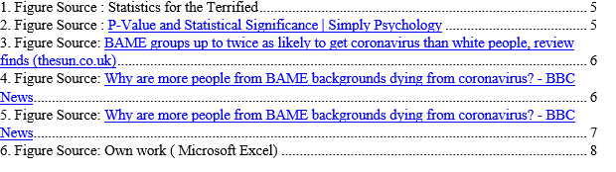

References:

[1] | Gerald Kranzler, Janet Moursund, Statistics for the terrified - second edition, New Jersey: Prentice Hall, 1999.
[2] | S. Mcleod, “Simply Psychology,” 2019. [Online]. Available: https://www.simplypsychology.org/p-value.html. [Accessed 31 12 2020].
[3] | S. Woller, “The Sun,” 13 11 2020. [Online]. Available: https://www.thesun.co.uk/news/13184785/bame-covid-risk-twice-white-people/. [Accessed 31 12 2020].
[4] | D. Jimenez, “Metro,” 24 9 2020. [Online]. Available: https://metro.co.uk/2020/09/24/bame-people-not-genetically-more-at-risk-of-dying-from-coronavirus-study-says-13323240/. [Accessed 31 12 2020].
[5] | Benjamin Butcher & Joel Massey, “BBC,” 19 june 2020. [Online]. Available: https://www.bbc.co.uk/news/uk-52219070. [Accessed 31 12 2020].
[6] | Sarah Salway, Lucinda Platt, Punita Chowbey, Kaveri Harriss and Elizabeth Bayliss, “JRF,” April, 2007. [Online]. Available: https://www.jrf.org.uk/report/long-term-ill-health-poverty-and-ethnicity. [Accessed 1 1 2021].
[7] | P. Butler, “The Guardian,” 1 jul 2020. [Online]. Available: https://www.theguardian.com/society/2020/jul/01/nearly-half-of-bame-uk-households-are-living-in-poverty. [Accessed 1 1 2021].
[8] | D. J. Luke, “Bupa,” 17 March 2020. [Online]. Available: https://www.bupa.co.uk/newsroom/ourviews/coronavirus. [Accessed 31 12 2020].

