TITLE PAGE

NAME: ZAINEB RAJPAR
STUDENT NUMBER: 2421792
PROGRAMME: Certificate of Higher Education in Health and Social Care
MODULE: Psychology in Health and Social Care
MODULE CODE: LCHS4010
MODULE LEAD: NEALE HADDON /LECTURER: ALICE CLAYTON
ASSIGNMENT TITLE: Assignment 2: Written Task (1500) (To be submitted in a Word Document)

CONTENTS PAGE

Title page 1

Contents page 2

Introduction 3

THEORY 1: ERICKSON’S STAGE 8
EGO-INTEGRITY VERSUS DESPAIR 3

KEY CONCEPTS 4
APPLICATION OF ERIKSON’S THEORY 5
PSYCHOLOGICAL CHALLENGES: 5
BEHAVIOURAL CHALLENGES 6
CRITICAL EVALUATION OF ERIKSON’S THEORY 6
Theory 2: THE HIERARCHY OF NEEDS BY MASLOW
IN GERONTOLOGY AND 7
KEY CONCEPTS DEFINED 8
APPLICATION OF THE THEORY: DEMENTIA CARE HOME 8
PSYCHOLOGICAL CHALLENGES
(LOVE AND BELONGING /ESTEEM): 9
CRITICAL EVALUATION OF THE THEORY: 10
CONCLUSION 10
REFERENCES 11

INTRODUCTION

This report introduces and applies two seminal psychological frameworks – Erik Erikson’s final stage of ego integrity versus despair and Abraham Maslow’s hierarchy of needs – to enhance understanding and support for adults aged 65 and over in residential care living with dementia. The scenario of older residents living in a dementia care home shows significant psychosocial needs that necessitate person-centred, coordinated support from health and social care providers (AGE UK, 2025). Dementia is a condition characterised by cognitive decline that directly impacts an elderly person sense of self and ability to meet fundamental needs; this amplifies the developmental conflict of late adulthood. These theories are crucial for professionals to understand so they can move beyond the basic physical care and address the deep psychological and emotional needs of the individual.
This report will first detail the theory of Erik Erikson, then explain its practical application in a care home environment and finally offer a critical evaluation of its benefits and limitations.

THEORY 1: ERIKSON’S STAGE 8 – EGO INTEGRITY VERSUS DESPAIR
Erikson’s theory states eight stages of psychological development, each presenting a fundamental conflict (Cherry, 2025).
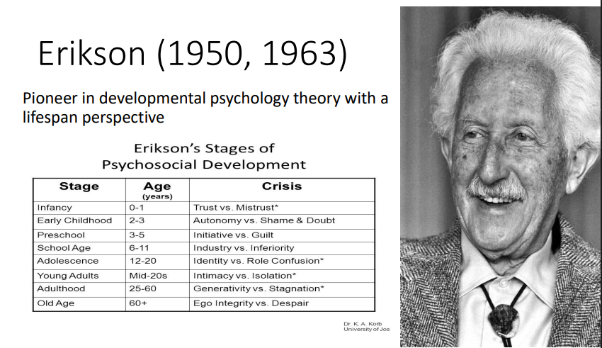
Ego integrity versus despair begins around age 65 until death, focusing on an individual reflection on their life (McLeod and Guy-Evans, 2025).
The core crisis revolves around the existential question: “Did I live a meaningful and satisfying life?” Successful resolution leads to ego integrity, where the individual achieves a sense of wholeness, contentment, and acceptance, looking at their life as a worthwhile journey despite imperfections, which culminates in the psychosocial virtue of wisdom (Cherry, 2025). On the other hand, failure to resolve this crisis results in despair characterised by regret, bitterness, and a feeling that life has been wasted. And a fear of death. (Gilleard, 2020).
This conflict is particularly relevant to vulnerable older adults with dementia, as the cognitive decline introduces new challenges that force a re-evaluation of past achievements and current capabilities (Dezutter et al., 2020).

Below are some of the key concepts, which include.
- EGO INTEGRITY: A state of satisfaction with one’s life choices and acceptance of mortality.

- DESPAIR: Feelings of regret, bitterness, and hopelessness over the life perceived as incomplete or misspent.

- WISDOM: The virtue gained from resolving the crisis: a detached yet active concern with life itself in the face of death.

- LIFE REVIEW: The cognitive process of intense reflection used to achieve acceptance or resolve past conflicts.

APPLICATION OF ERIKSON’S THEORY
Erikson’s theory offers a powerful framework for health and social care professionals working in a dementia care home to address the residents psychological and behavioural challenges by focusing on the preservation of identity and meaning.

PSYCHOLOGICAL CHALLENGES:
Dementia often fragments a person’s identity, leading to despair, shame, and a profound sense of loss (AGE UK, 2025). The theory suggests that staff should actively facilitate the life review process, helping residents focus on past achievements rather than current deficits. A practical example is implementing reminiscence therapy sessions where staff use sensory cues, such as familiar objects, old music, and photographs, to prompt positive memories (Jongsma et al., 2025). This technique reinforces a sense of ego integrity by confirming the residents’ values and unique history. For instance, a former engineer may be encouraged to look at his old tools and discuss his career; at this point, it's so important to get family or a key worker to support him in validating his life’s work, even though he may not be able to recall all the entire events. This aligns with evidence suggesting that positive self-reflection leads to better psychological well-being (Dezutter et al., 2020).

BEHAVIOURAL CHALLENGES
Behaviours such as agitation, resistance to care, or withdrawal often stem from unmet needs or feelings of distress linked to despair and a loss of autonomy (Kitwood, 2025). Applying Erikson’s principles means recognising that these behaviours may be a protest of loss of control and dignity inherent in the late-life stage.
Professionals can mitigate these behaviours by

- VALIDATING EMOTIONS:

Instead of dismissing anger or sadness (despair), staff can acknowledge the feeling “I understand this is frustrating,” which respects the person’s emotional reality
(Age UK, 2025)

- MAINTAINING IDENTITY:

By incorporating residents’ lifelong roles into daily care – e.g., asking a former teacher to help"organise” the books or allowing a past homemaker to fold laundry-staff reinforces the resident’s positive identity and purpose, battling feelings of being unproductive (stagnation) (Lidsen, 2025).

- ENCOURAGING STORYTELLING:
Using the resident’s life stories in their person-centred care ensures that all staff understand their narrative, fostering the development of wisdom (Jongsma et al., 2025).

CRITICAL EVALUATION OF ERIKSON’S THEORY
While insightful, applying Erikson's Stage 8 in dementia care presents challenges. Professionals may struggle with residents who cannot verbally communicate and participate in life review due solely to severe cognitive impairment. Applying strategies to reduce this challenge include relying on non-verbal communication, sensory stimulation, and passive reminiscing, for example, environmental cues (Gilleard, 2020). A significant limitation is that Erikson’s theory linear model does not account for the non-linear, unpredictable progression of dementia, which can swing an individual to constantly swing from integrity and despair (PMC) Maslow’s Hierarchy of Needs could be an alternative that can help provide a more immediate, foundational focus: as it addresses the basic needs (physiological, safety) prerequisites for the high-level of psychological work of integrity versus despair, which Erikson’s theory does not explicitly address or help with in its primary focus and application. This will be the focus of the second section of this report.

Theory 2: THE HIERARCHY OF NEEDS BY MASLOW IN GERONTOLOGY AND DEMENTIA CARE
A detailed overview of Maslow Hierarchy of Needs psychological model that suggests five levels of fundamental human motivation.
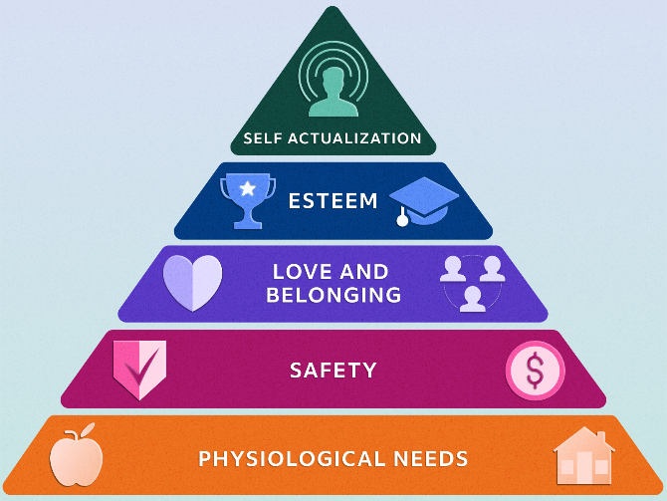

It suggests that before people may seek demands at the next, higher level, their lower, basic needs must be substantially met (Tay & Diener, 2025). To conceptualise holistic human wellbeing, this framework has proven helpful in the fields of health and social care (Scholzel-Dorenbos et al., 2025).

KEY CONCEPTS DEFINED
- PHYSIOLOGICAL NEEDS
The foundational requirements for survival, including food, water, warmth,
and sleep.
- SAFETY NEEDS:
The need for security, stability, predictability, and freedom from fear or injury is crucial for feeling protected in one’s environment (Fa et al., 2025)

- LOVE AND BELONGING NEEDS:
The emotional need for interpersonal relationships, affection, intimacy, and feeling
connected to a group, such as family or community (Ayalon, 2022)
- ESTEEM NEEDS
The desire for self-worth, achievement, independence, and respect from others,
essential for maintaining dignity.
- SELF-ACTUALISATION
The highest level, representing the drive to realise one's full potential, pursue personal growth, and find meaning in life (PMC, 2025).

The higher- order Demands of esteem and self-actualisation are especially pertinent to persons 65 and older. A person's quality of life in later years depends on their ability to maintain their feelings of competence, independence, and purpose (NIH, 2025). For example, older adults’ technologies work best when they address these psychological needs in addition to fundamental safety.

APPLICATION OF THE THEORY: DEMENTIA CARE HOME
The Maslow Hierarchy theory provides a person-centred framework for care staff to systematically assess and address the evolving needs of older adults with dementia (Scholzel-Dorenbos). When cognitive decline compromises the ability to express needs, unmet needs often manifest as challenging behaviours. By applying Maslow’s model, professionals can identify which specific need is lacking and intervene appropriately, reducing distress for the individual.

PSYCHOLOGICAL CHALLENGES (LOVE AND BELONGING ESTEEM):
- CHALLENGE: Loneliness, agitation, or repeated requests to “go home reflecting unmet Love and Belonging Needs.
- APPLICATION & EXAMPLE:
- Professionals can meet this by reinforcing social connections and identity. For example, using 360-degree videos or virtual reality (VR) of familiar places encourages spontaneous verbal interaction and nostalgic memory recall, fostering emotional comfort and belonging (Coelho et al., 2020; Flynn et al., 2020). Staff can facilitate structured social activities like a “Reminiscence Cafe” to promote connection and shared identity, addressing (Ayalon, 2022).

BEHAVIOUR CHALLENGES (SAFETY/ESTEEM);
- CHALLENGE: Pacing, attempting to leave the unit (elopement), or resisting care, often signalling unmet safety or esteem needs.
- APPLICATION & EXAMPLE
- Resistance to care (e.g., bathing) can stem from a loss of control, impacting esteem. Professionals can address this by offering choices (“Do you want to wash your hair first or last?”) and maintaining dignity by ensuring privacy and independence where possible (NIH, 2025). For pacing, which may reflect a search for safety or a desire for meaningful activity, staff can provide a “Purposeful Pacing Path” with visual cues or small, safe tasks (e.g. folding clothes) that restore a sense of purpose and control, supporting Esteem and reducing anxiety (Scholzel-Dorenbos et al., 2025)
Interventions that promote engagement have been shown to improve mood and reduce apathy (Kim et al., 2021).

CRITICAL EVALUATION OF THE THEORY:
A potential challenge in applying Maslow’s theory to dementia is that cognitive decline can cause the hierarchy to become non-linear; higher and lower needs often coexist (PMC, 2025). Staff may find it hard to prioritise needs when an elderly person is both safe (safety needs met) but deeply distressed (love and belonging need unmet). Personalisation strategy can reduce this, focusing on the individuals and current emotional state rather than strictly following a pyramid's structure. The limitation in this theory is that Maslow Hierarchy does not fully explain behaviours stemming from neurological changes of dementia. Activity theory can help fill the gap by emphasising successful ageing (Moyle et al.,2024).

CONCLUSION
This report has provided an overall judgement: both Erikson’s and Maslow’s theories are highly useful for health and social care professionals in dementia care homes; the value of using both theories are profound. Erikson’s theory provides long-term life course context, and Maslow's provide provides immediate operational guidelines for physiological, safety and belonging needs are being met every day.

Reference List
Age UK (2025). How to support older people in 2025. Age UK
https://www.ageuk.org.uk/discover/2025/january/how-to-support-older-people-in-2025/ Available at:
relationships: Maslow’s hierarchy of human needs and the adoption of health-related technologies for older adults’, ResearchGate. Available at: https://www.researchgate.net/publication/225800077_Maslow%27s_Hierarchy_of_Human_Needs Ayalon, L. (2022) ‘Elderly individuals benefit greatly from community involvement and close _and_the_Adoption_of_Health-Related_Technologies_for_Older_Adults
on Maslow’s hierarchy of needs theory and A-Kano model analysis’, International Journal of Academic Research in Business and Social Sciences, 15(10), pp. 1613–1633. Available at: https://hrmars.com/ijarbss/article/view/26763/Construct-a-Service-Functional-Needs-Model-for-Elder-Care-App-B
Fa, W., Wu, M. & Li, J. (2025) ‘Construct a service functional needs model for elder care app based ased-on-Maslows-Hierarchy-of-Needs-Theory-and-A-Kano-Model-Analysis
. Reviewed by Olivia Guy-Evans, MSc. Available at: https://www.simplypsychology.org/thinking-about-thinking-the-key-to-wise-choices.html
NIH (2025) ‘Applying Reed’s self-transcendence theory to support family members of nursing home residents living with dementia’, Scandinavian Journal of Caring Sciences. Available at: https://pubmed.ncbi.nlm.nih.gov/40622094/

PMC (2025) ‘Study on the needs of older adults with dementia care institutions based on a hierarchical interaction model’, PubMed Central. Available at: https://www.frontiersin.org/journals/public-health/articles/10.3389/fpubh.2025.1633806/pdf
Tay, L. & Diener, E. (2025) ‘Human needs are universal and exist regardless of cultural differences: Beyond Maslow’s pyramid — introducing a typology of thirteen fundamental needs for hum
McLeod, S. (2025) ‘Thinking About Thinking: The Key to Wise Choices’, Simply Psychology
an-centred design’, MDPI. Available at: https://www.mdpi.com/2414-4088/4/3/38
Van der Kaap-Deeder, J., Van Hiel, A., De Clercq, B. & Dezutter, J. (2021) ‘The role of ego integrity and despair in older adults’ well-being during the Covid-19 crisis: The mediating role of need-based experiences’, The Journals of Gerontology: Series B, Psychological Sciences and Social Sciences, 76(7), pp. e116–e125
Scholzel-Dorenbos, C., Koopmans, R. & Vernooij-Dassen, M. (2025) ‘Theoretical framework: Maslow’s hierarchy of needs and dementia care’, British Journal of Healthcare Management, 31(2), pp. 30–36.
Grabowski, D. (Moderator), Antos, J., Mathur, A. & Geber, S. Z. (2025) Autonomy and ageing policy: Leveraging behavioural economics to empower early decisions [Video]. YouTube. Available at: https://www.youtube.com/watch?v=UCNp4pPWZvo

