Name: Valentin Scriosteanu

Student Id: 2122219

Module code: BMSW4004

Module title: Problem Solving and Decision Making

Module Leader: Balendran Kandasamy

Assignment title: Problem Solving and Decision Making Report
Word Count: 1865

Table of Contents
1.0 Introduction............................................................................................................ 3
2.0 Define a complex problem from the workplace......................................................3
3.0 Analyse the problem...............................................................................................3
4.0 Alternative solutions to theproblem.........................................................................5
5.0 Decision-making – Fishbone diagram ……………………………..………….……..5
6.0 Develop a plan for implementing the solution..........................................................7
7.0 Communicate the plan to stakeholders...................................................................7
8.0 Monitoring and evaluation methods to guarantee solution implementation……………………………........................................................................8
9.0 Conclusion ................................................................................................................9
10.0 Appendix Class presentation.................................................................................10
11.0 References.............................................................................................................13

Introduction
Problem definition is the initial stage in the heuristic for solving problems. This stage can occur at any point during the problem-solving process since the situation is always evolving. I must collect data and analyse the problem, and then employ certain strategies to assist me characterise the problem. After identifying the real nature of the issue, the following phase is to generate potential solutions. One popular strategy for producing answers is implementing the fishbone diagram since it is beneficial for exploring all feasible and even impossible pathways. This report will define and analyse my current work related problem, apply fishbone diagram strategy in order to come up with solutions and make decisions. Finally, this report will implement solutions and communicate with stakeholders.

2.0 Define a complex problem from the workplace
Einstein asserted that if he had one hour to address the world's problems, he might devote 55 minutes defining the issue and the final 5 minutes developing a solution (Debevoise, 2021). My current work-related problem is the following. I have been employed by my present firm for four years, and I would want to receive a promotion and enhance my salary. At a different organisation, a fresh career opportunity has been provided with a promotion, greater salary, and expanded benefits. The organisation I am presently worked with provides me with a lower annual salary, but they support my education and cover my tuition. Therefore, I need to analyse whether the new job prescription outweighs the current job benefits.

3.0 Analyse the problem
Problematically, I must pick between accepting a new offer and continuing to work for my existing job. A superior offer is one that will assist me in achieving the following:
- Enhance my earnings
- Continue my education
- Develop my career

The predicament scenario is predicated on the following assumptions:
- My present job will neither equal nor exceed the competitive offer.
- The new position is open, and my old boss has exclusive hiring authority.
- The commencement date is set
- I am qualified for the position despite having less certifications
- Completing my education boosts my likelihood of advancement.
- As continue in my new position, I must possess comparable credentials to my colleagues, such as a master's degree.
Evaluations of these hypotheses via a critical lens indicate various flaws in the hypotheses:
- If my company were to equal or exceed the competitive offer, I might be more privileged if remaining, since my issues would be resolved. I will need to address this idea with my supervisor.
- My previous manager may not have exclusive authority over selection and hiring. While my previous manager has a strong preference for me, other individuals participating in the screening and hiring process may disagree. The fact that I have less qualifications compared to the other managers in that role, all of whom possess a Master's degree, may make it difficult for me to get the post.
- The start date for the new employment is set for two weeks from now. If I could secure a subsequent commencement date, I would not have to pick between taking my examinations and going to work.
- Even though I have had exceptional work performance during the past four years, I believe that my lack of college qualification is the primary hurdle to my promotion. However, the reason I have not been promoted may be because my employer's modest development has limited prospects for advancement. If this is the case, I should consider moving businesses.
- To continue in the new role, I must possess the same qualifications as other managers in comparable positions. My new employer and I will need to negotiate a timeframe for the completion of my master's degree.

4.0 Alternative solutions to the problem
- Consider taking online classes or completing my degree part-time while working.
- Look into financial aid options that could help offset the cost of tuition.

5.0 Decision-making technique: Fishbone diagram

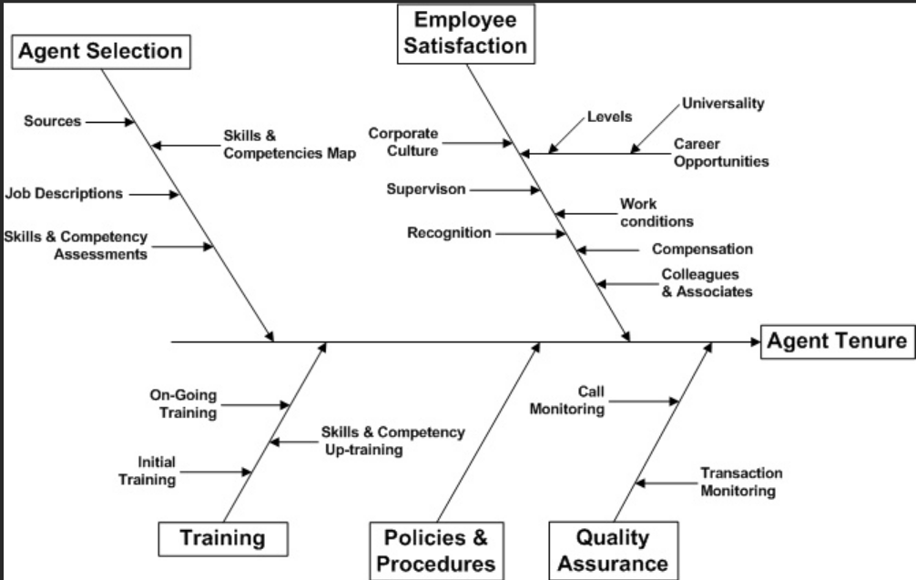

A fishbone diagram is a useful tool for evaluating the problem and making a decision. The fishbone diagram strategy is used to determine which path to take in order to reach a goal. The fishbone diagram consists of three parts: the starting point, the middle point, and the final point (Kaoru Ishikawa, 1997). This strategy can be used when there are multiple paths that lead to a desired result. On the one hand, the new company is offering me a promotion, a raise, and increased benefits, which are all very attractive. On the other hand, my current company is supporting my studies and paying my tuition fees, which is also a significant benefit.
There are a few things I could consider when trying to make this decision. Here are some potential factors that my fishbone diagram includes:

Starting point
- Consider how much of a raise and how many additional benefits are being offered by the new company. Think whether it is a significant enough increase to justify leaving your current job and starting a new one.
- Consider how important are the tuition fees and study support for me. Should I plan on continuing my studies for the foreseeable future, or do I see this support as a temporary benefit.
- Take into account the security of my current job. Consider if am to remain working for my company in the foreseeable future, what are the chances of being promoted or receiving a raise in pay.
- Loyalty is important to me. My four-year career has been founded on loyalty and commitment to my employer. My employer has been exceptional in providing different degrees of help, such as tuition reimbursements.
- Lastly, interpersonal interactions. I have had pleasant relationships with my co-workers for the last four years, which explains my extended stay with the organisation.

Middle point
- Pros of taking the new job: Promotion, increased income, increased benefits
- Cons of taking the new job: Interference with completion of my degree, no tuition reimbursement, relocation to a new state.
- Pros of continuing with my degree: Ability to complete my degree, potential for future career advancement.
- Cons of continuing with my degree: No immediate increase in income or benefits.
- Consider the long-term benefits of completing my degree versus the short-term benefits of taking the new job.
- Asses how I feel about the culture and overall work environment at the new company, would I be happier there.

Final point
- Completing my degree it is important to me because it will offer me more career opportunities in the future.
- I must discuss with my present employer if there is an opportunity for me to develop in my career and obtain a better yearly salary after I have completed my Bachelor's degree.
- If there is no opportunity for development or a raise with my present company, I must have a clear conversation with my prospective employer. To determine if they are willing to assist with tuition and education costs.

6.0 Develop a plan for implementing the solution
I have framed my predicament as a choice between continuing with my present employment, finishing my Bachelor's degree, and hoping for a promotion, or going to the new firm in order to earn a better pay, greater benefits, and change city. I have been able to examine the problem's assumptions, question those assumptions, and come up with a variety of solutions to the seeming predicament. Additionally, the fishbone diagram, decision making strategy has informed me of areas in which I need further information before making a final choice.
Specifically, I will inquire with my present company about the possibility of my promotion after I have completed my studies. As a result, if there is no comparable employment would I examine the new offer, and I will inquire about the new employer's support for my further education. Armed with all available information, I will make an informed decision that will help me reach my goals of more income, additional education, and professional advancement.

7.0 Communicate the plan to stakeholders
Communication is essential for the successful acceptance and implementation of a change process inside an organisation. An effective communication allows stakeholders to grasp the firm's and its employees' requirements (Gallivan, 2001).
Moreover, the leader as coach should facilitate a communicative approach and encourages collaborative relationship, open communication, and constructive conflict resolution, as well as ensuring that the interactive processes are inclusive and fair, so that individuals from diverse backgrounds feel recognised and respected and are encouraged to contribute to their fullest potential (Kets de Vries and Florent-Treacy, 1999, cited in Maak and Pless, 2006). That is why in order to come up with the best solution for my current company needs and my needs as an individual I will discuss future career growth possibilities. This way, I will give a chance to my employer to capitalise on their investment, because they paid my tuition expenses for my Bachelors degree.
Conversely, leaving current company for the new job without communicating effectively might have serious repercussions for the stakeholders, my current company, my future employer, and myself. Thus, communicating clearly with involved stakeholders is vital.

8.0 Monitoring and evaluation methods to guarantee solution implementation
There are several methods I can use to monitor and evaluate my progress towards completing my degree and achieving my career goals:

- Set clear and specific goals: I need to complete education in order to advance in my profession, get the position of manager, and better pay. I will eventually ascend to the desired position of branch manager. This aspiration will keep me focused and motivated in my quest of the completion of my degree.
- Track my progress: Keep track of my progress towards completing my degree and achieving my career goals. This will include tracking the classes I have taken, the grades I have received, and any relevant work experience.
- Seek feedback: I will ask for feedback from my professors, mentors, and colleagues to help me identify areas for improvement and stay on track.
- Utilize resources: I will take advantage of resources such as tutoring centres, study groups, and career services to help me succeed.
- Stay organized: Keep all of my course materials and assignments organized to help me stay on top of my workload and meet deadlines.
- Communicate with my employer: Because I am working while pursuing my degree, it is important to communicate with my employer about my goals and how they can support me. This can help ensure that I am able to balance my work and study commitments and achieve my goals.

9.0 Conclusion
This report has defined and analysed my current work related problem. With the help of the fishbone diagram, this report has concluded that completing my degree is a priority for me and I should consider it gravely when making this decision. Reaching long-term objectives is important, therefore I will discuss my professional aspirations with my present employer to determine whether there is room for progression since they offer education and tuition support. However, if there is no possibility of advancement or higher pay it is worth to switch with new firm if they offer a larger wage, tuition and education support or a feasible alternative solution.

10.0 Appendix - Class presentation
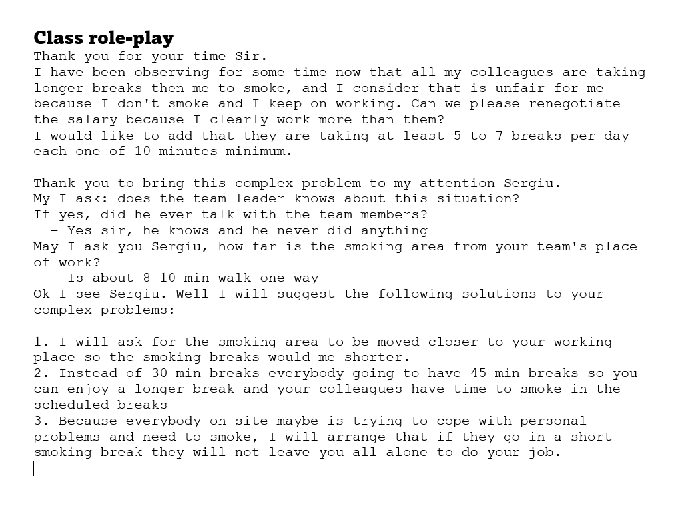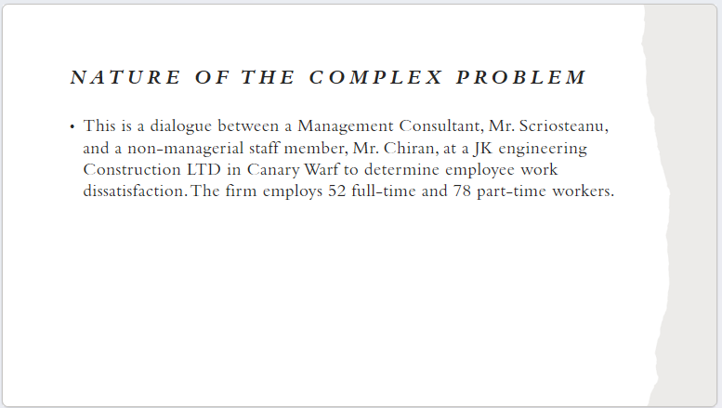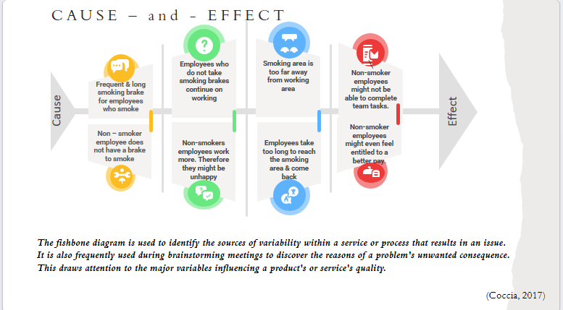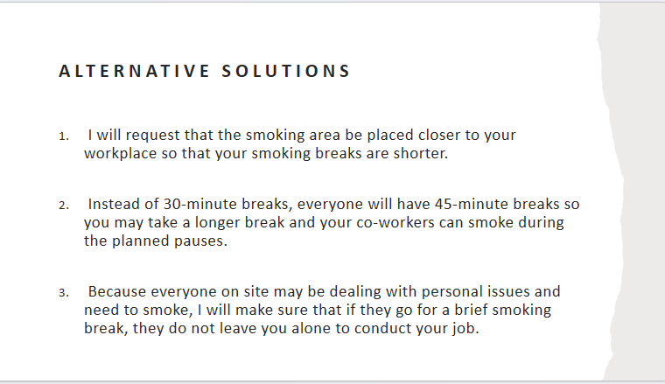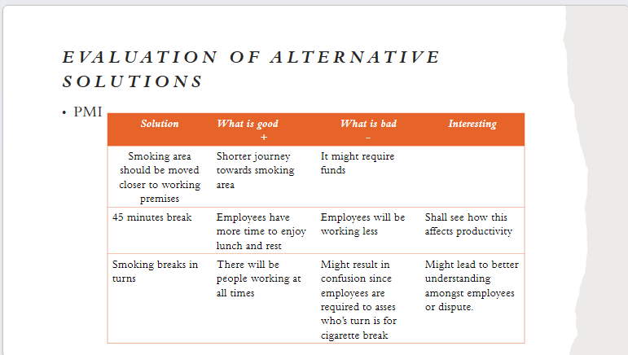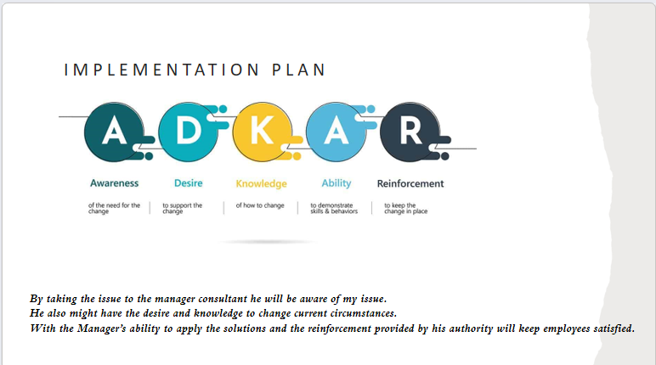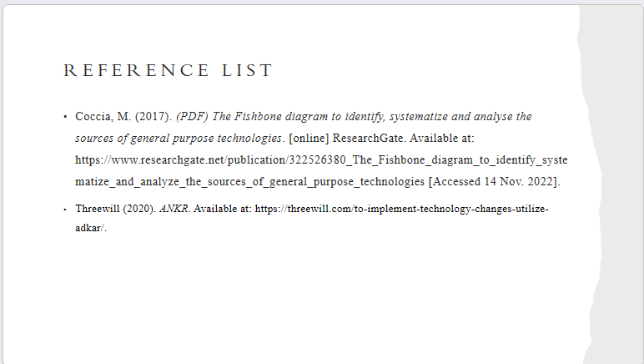

11.0 Reference List

