Reflection

The Historical Fiction
“Emmy” was developed from a class exercise. The study of “The Wonder” E. Donaghue led me to think of Victorian Britain and its many social and societal anomalies. I had an interest in the women’s suffragette movement influenced by my own mother who repeatedly said at election time “always vote even if you don’t believe in what your voting for – women died for you to vote and if you don’t use it you will lose it”
The story, first and second draft is told through the eyes and voice of Emmy a ten year old girl from a middle class Victorian Manchester family in third person narration. The Informed/Intended/imagined reader (IR) is female but not exclusively, is introduced to Emmeline Pankhurst. The iconic suffragette leader is the ten year old Emmy Goulden . Exploring her journey of girlhood to adolescence, her influences and relationships, that guide her and inspire her. The story arc has a plethora of “spin offs” that provide a wealth of story plot given the genre and trope.
The setting for the story is taken from as much research as possible within the timescale allotted. There is some available information on Emeline’s early life and family.
In the re write following workshop discussion. I have left out Emmy’s relationship with Walter, preferring to experiment with distancing him until later in the story. Embracing Emmy as a child allows me to manipulate the plot and characters. Through the naivety of a young girl, her enlightenment towards truth is drip fed through the story arc until she comes to a decision to become a suffragette. The plot and theme are reliant on each other. The IR will experience a journey the inequalities of the political and social systems for women in the late 19th C. This will create light and shade within the theme of the novel providing a backstory of changing vistas. In the background the constancy of wonderland brings satire and nonsense to a dark and often dangerous society which Emmy has to navigate.

Use of Metaphor
The first sentence of the novel is a tribute to Emmeline’s mother who it is understood to be a powerful activist in her own right Bartley (2002) deserving of the recognition I have attempted to align her character in keeping with her pivotal role in Emmeline activist career. Using the repeat adjective “Sharp” as the implied metaphor instantly informs the reader of Sophia’s contribution to the feminist cause.
There is a strong sense of the IR and the author already knowing what Emmy’s life will be as an adult therefor the story arc and its style are contingent on telling a story that the reader may not expect otherwise why read it? I have used creative discourse to introduce feminist issues whilst not specifically naming them for example introducing the mirror to Emmy and what she attempts to see.
The use of the water closet as Emmy’s private space is not only a setting for building characterisation with the mirror and deeper feminist values, but also defines a space to explore Emmy’s transition from child to adolescent to adulthood. This sets a repeated scene as the story will unfold through Emmy’s monologue thoughts and most private hopes, despairs and adventures. The plot will continue using the mirror; consistently provide metaphor to expand the feminist journey,
The use of Alice’s Adventures in Wonderland, as the novel Emmy refers to is a hidden metaphor for the repeated reflection of the transition from childhood to adulthood. Used to sight metaphor, help characterisation, its rich prose can be used with subtle undertones to depict Victorian society. Experimenting with this style has brought a depth to the piece so far as building Emmy’s world.
Further to this literary standpoint which is fictitious it is known that Sophia Goulden was a renowned abolitionist and brought up her ten children in a predominantly political household.
Research
I have made extensive research into the historical availability of Emmeline Pankhurst which is rich and plentiful. However information of her early life is scant. The Historical facts themselves can be quite ordinary and dry, yet are vital to the story of Emmy growing up. It is this history that is required to be carefully and effectively suggested. Through Emmy so that the IR believes it is a natural part of the setting, not contrived to present a list of dates and facts.
Use of dialogue, Show and Tell
In order to create a balance of character and story I have used show and tell as well as dialogue. Feedback from workshops has suggested that the dialogue between Emmy and Mary is effective and I have therefore extended this in the re write. I am pleased that this further expands Marys character and her very strong presence throughout Emmy’s life. The interaction through the water closet door is foreshadowing Emmy’s obedience to Marys request and her quiet ability to keep Emmy in line when she rebels which is a fundamental character trait that her character requires.
I decided to use thought monologue to explore Emmy’s character it is intrinsic to the story arc. Her internal battles and questions become increasingly difficult and how she manages these as the story progresses..
I am able to choose from a variety of literary works reportedly favoured by a figure who is known to “devour books” (Bartley 2002) which can be so useful to characterise Emmy and explore her growing moral convictions.
The use of letters and essays to show and tell has been extended in the re write. A class workshop feedback indicated that the dialogue had a richer ability to build character over show and tell writing strategies. The experiment to try this I believe has improved the characterisation of Emmy explaining backstory setting and introducing Sophia Goulding through her daughters eyes. I particularly like the reflection of the Snark being like her mother in a temper. further development of the story arc especially with the wider characters of Father and Mother which the dialogue has pulled in.
Writing dialogue that sounds believable
The use of dialogue language that was used at the time, I have referred to E Nesbitt, The Railway Children, Louisa May Allcott. Little Women to study children/young women use of linguistics. There is a use of local dialogue from adults in these novels often related to lower class which I will explore further with Emmy - see the Nanny explanation of Walter page 4

This rich text I intend to use to define moments of nonsense within Victorian society using similes for characters Emmy meets. For example her Godfather being a representation of the white rabbit The Queen of Hearts – her mother.
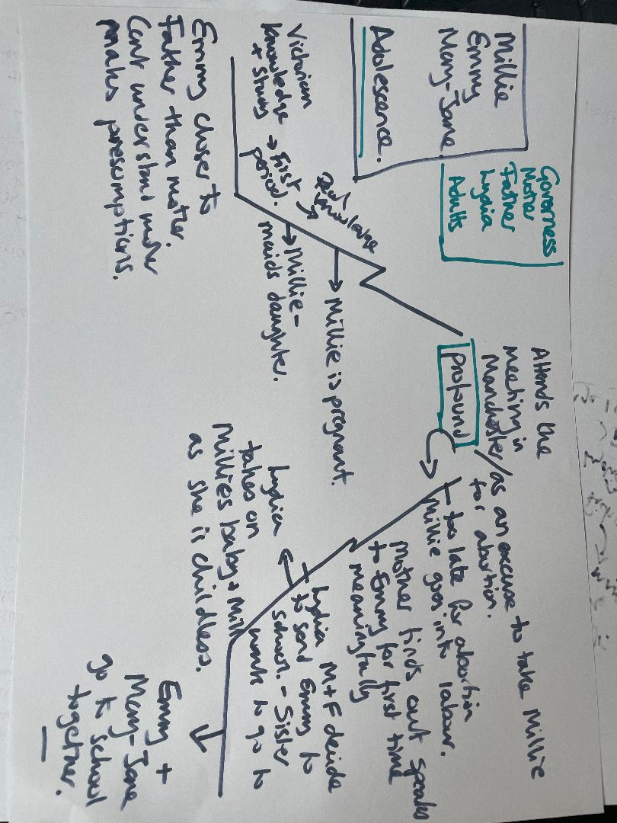
Three Act story arc

More research could be gleaned from visiting the Emmeline Pankhurst museum in Manchester which was her former home as an adult. The lack of early life literature has therefore required a fictitious/imagined early Victorian home setting which now no longer exists. The benefit is to world build around Emmeline which can help develop and refine her and others character. This can reflect both history fact and add believable context as in the water closet scene page 3
Re write as per Janet Burroway 2007 P17 – Writing Fiction A Guide to Narrative craft- seventh ed Pearson Longman “Almost all good writing starts with terrible first efforts…the first draft is the down draft – you get it down - the second - the up draft- you fix up – the third draft….” Well that’s what I need to work on.
Society rules and expectations many of which are nonsense (Alice’s adventures) in a child eyes but hold resonance for adults who are capitalist industrialist men that Emmy will learn to oppose as an adult.
Further metaphor is woven into the text, the repeat “ink” references suggesting her future writing and its importance as well as oratory skills that Emmy will use with such skill in her adult life. Discussed in workshop as a repeat – not necessary – I decided to leave this in and experiment to how it works as a repeat metaphor – it may become too cliché and be revised out in the future.
Feminism uses mirrors as a complex metaphor for self-reflection, objectification, and surveillance, challenging the societal pressure on women to define themselves through a male gaze. Mirrors symbolize both the internalization of beauty standards and, conversely, tools for reclaiming self-identity.
Sophia Goulden would read “Uncle Toms Cabin” to the children at bedtime and therefore cement a value based belief from an early age regarding equality. Emmy finds this disturbing but is constantly reminded by her mother of Victorian expectations. Sophia is a stalwart Victorian lady of society abiding by social rules and etiquette she sometimes finds it difficult to balance this with her feminist politics and is often wrong footed by her adoring husband who enjoys the fun of his wife’s discomfort.
The information I have found outlines history. It has the promise of a rich story for historical fiction, Emmeline, her development and influence. What made her the guiding forceful leader that is remembered? The research extended to a time line. I needed to develop this to ensure certain facts are actually chronological. Filling the gaps with a sense of everyday life whilst using these events to create pace and theme and setting
Mary despite being younger continues to be Emmy’s guardian and supporter throughout her life and is thought to be undervalued as to her role within the suffragette movement. She is claimed as the first Suffragette Martyr following her death on Christmas day after her release from prison where she was on hunger strike. Her importance in the story is therefore intrinsic to the integrity of the history of the feminist movement.
These books were first published at the turn of the century slightly after Emmeline Pankhurst was a child however they hold a wealth of children’s dialogue that was acceptable at the time and provide a good refrence for language choice and style. Francess Hodgeson Burnett. The Secret Garden, L.M.Montgomery. Anne of Green Gables.
“fair eat the bli-ters and it ud tek an ole wik of castor oil to get em back!” a question of class society and expectation of the IR regarding authenticity/believability and local dialect. Bibliography Bartley P. Family Background Emmeline Pankhurst (2002) London Routledge pp 15-21 Nesbit. E The Railway Children (1911) re published 1994 Wordsworth Edition Ltd Momntgomery L.M. Anne of Green Gables (1908) re published 1994 Wordsworth Edition Ltd Carroll L. Alice in Wonderland (1869) re published 1994 Wordsworth Edition Ltd Hodgeson Burnett F. The Secret Garden (1911) re published 1994 Wordsworth Editions Ltd Ursula K. Le Guin Steering the Craft (2024) Silver Press Steven Earnshaw The Handbook of Creative writing 2nd ed2007 Edinburgh Press Burroway.J. & Stuckey-French. E. Writing Fiction, A guide to narrative craft 7th ed (2027) Cecily (class handout) February 2026 Donaghue. E. The Wonder (class handout) February 2026
The Historical Fiction Novel – Age cannot wither her (Emmy) FIRST DRAFT Sharp – sharp is the word thought Emmy thought but what more, she chewed the end of her pen and dark splats of ink fell onto the page in front of her, Ugh now I will be in for it. Wasting paper again. She felt the judging eyes of her mother again before she had even written a word. Nothing got past mother not that she was horrid, quite the opposite she spent as much time as she could with Emmy and her siblings. Mother was best in the evening when she would come to the nursery to read to the children. with her busy life doing important thinks that Emmy did not understand really Write an essay about mother had been the instruction from her equally austere tutor, she stopped her chewing and sank into her chair in an act of rebellion. Emmy wanted to write about Lancelot and Merlin or Robin hood or the Mad Hatter. not the somewhat boring distant woman who occasionally entered her life momentarily uttering some unfathomable confusion of dates meetings and names which Emmy disregarded as adult world, not for her, a sacred threshold not to be trifled with. Life in the nursery was mundane with rules and Besides Emmy’s world was far more interesting, well most of the time apart from Governess Grump, that’s what Walter called her. Emmy adored Walter and was heartbroken when he left for school she so wanted to go with him rather than stay home with Gover Grump and her older sisters who had no time for her. Her world started and ended, up in the nursery with the tiny pinched windows that looked towards the industrial smoking chimneys, the roofs of the Manchester cotton mills and little else the sun trying hard to bleach through the smog which swirled in the September breeze promising occasional cracks of gold across the blackened chimney stacks. Emmy enjoyed writing to Walter as best she could at least it was not taxing and she didn’t need to worry about spilt ink. Walter would play war with her and they would pretend to march on the enemy and catch them for information, in the summer they would pretend to be spies and collect information, secrets this was usually gossip from cook or Sarah the maid who were always “wagging tongues” as Gover Grump would say. Walter would let Emmy read his boys magazines and play with his precious lead soldiers. Emmy never thought why but years later she realised that she had been the substitute brother for Walter as her other sisters were far too prissy for such games. Walter was a few years older than Emmy and school for him was an expectation that Emmy knew she would not have as only the boys went to school, they had to learn to do important jobs like bank managers and judges and business owners like father, she supposed that Walter’s dreams of leading a battle would be replaced by following father into his business because he was the only son. The best thing about Walter was that he always came home with a book for her. That was how she managed to be in possession of Alice in Wonderland the whole bound novel not a magazine run, no a whole bound novel. The pages were now so well-thumbed and she had carefully marked the best bits with some of fathers leaflets she had found on the hall table. What Emmy knew was that she was destined to be a wife. Not that she minded much or questioned it. In the long days Walter was away and her sisters practised piano and painting Emmy found solace in books she read anything but most of all she loved adventures and daydreamed when she was not reading about travelling through the amazon jungles or riding Pegasus to save some hero from certain death and of course now she could dream about falling down a rabbit hole and growing into a giant….. “flibbertigibbet” Gover Grump called her “never a consecutive thought in your head young lady” Emmy mostly ignored Gover Grumps rumblings she knew at heart she was a softy and loved her roly poly face which had any number of expressions for any number of occasions. Right now it was that of defeat. Emmy didn’t want to work today she was always clumsy with her pen and ink and dreaded the blotched document that would be received with tuts and pursed lips “still not neat enough to show mother Emmy” Gover Grump would sigh, let’s try again. It was mostly the subject matter thought Emmy it’s so dull, “why do I have to write about mother?” She asked her very patient mentor “well you see Emmy your always dreaming and thinking of this and that and you miss what’s right in front of you every day, to be educated is a privilege but to be educated and aware is learned, knowing your sums is one thing and writing a nice letter is another but to know your world, the people, God, the planets, not just the sun comes up and goes down but how everything works why we are here at all and why we have laws and right and wrong . What does the universe tell us, how do plants grow….” The words trailed off and Emmy was feeling her eyes droop and she tried to stifle a yawn, “anyway let’s just write about your mother, think about her, what do you know about her?” I am going to see Cook about dinner tonight please try and get some sentences down before I return” the defeated Gover Grump left with a sigh and Emmy went back to chewing her pen. The year is 1871 and my name is Emmeline Goulden she wrote My mother attends lunches, meetings sometimes with father. Mother always looks so beautiful as long as she does not speak to me because then she turns into a snark with a flicking tongue and claws that catch Emmy stopped again to chew the pen she was pleased with this it would rile Gover Gump and she had had enough. She absently placed her nib back into her ink and left it teetering pushing her chair back and simultaneously wiping her ink stained hand on her piny. Now she had made the decision it was easy to root out her latest book and go. Passing Sarah on the stairs she put her ink stained finger to her lips and smiled knowing only too well Sarah would most likely snitch anyway and as quietly as she could ran down the stairs tip toeing past fathers study so as not to alert anyone to her destination the downstairs water closet. The downstairs water closet was her favourite room unlike the upstairs bathroom which was white and always cold and uncomfortable the downstairs was cosy and roomy, as well as the actual WC it was so big mother had put a comfy chair and dressing table displaying perfume and scented soap there was always fresh flowers, it was a place to linger and admire the magazine prints framed and hung across the wall directly opposite the WC. Emmy knew these were the adverts for fathers theatre. She had been there often and adored the plays probably more than the musicals. Father loved Shakespeare and he took her to every production that came along no matter which play it was, carefully explaining the characters and the story until Emmy was able to recite her favourites word for word. Father was excellent, and funny, and charming he loved entertaining and would put on a theatre extravaganza at home every Christmas, Easter and summer, the next one he had already planned would be Anthony and Cleopatra and Emmy could play Cleopatra if she could learn the part. Emmy knew this would not be a problem she devoured books like cake and her ability to remember lines was excellent. It was her clumsy writing and lack of tidiness that drove Mother and Gover Grump to distraction. Emmy locked the door, What a marvellous feeling to shut out the hum drum house and settle back to read, first though she tried some of mothers perfume, it smelt of lily of the valley she dabbed some behind her ears and stared into the mirror as she did so. Brown almond eyes, nothing special there she thought, slightly fat cheeks – quite rosy and a wide mouth unlike mothers though hers was rounder and curved slightly up at the corners which made it difficult to look stern like mother always did. She practised her stern face for a while and then a tragic heroine face trying to get her eyes to stop smiling. form small slits that she had seen the actors on stage master. Father said “you could practice to be a great actress its not just learning the lines but to live who you are, feel their pain their love their sorrow.” How Cleopatra loved Anthony she knew but considering she had never been in love it was difficult to imagine only with the words to guide you imagine. If you were to be a great actress surely you must have to experience emotions to truly learn how to act them she thought. She tried her lines again – “Let Rome in Tiber melt and the wide arch of the Empire Fall – Here is my space” sweeping her arm around the room to exemplify the here is my space line. Then with a shrug she settled down on the comfort chair and opened Alice up. Her current heroine had just drunk the bottle of potion that grew her into a giant, for once Emmy felt distracted. Lost in the adventures of Alice, the late morning soon drew in to luncheon and the promise of food soon became difficult to ignore, “just one more page she said to herself or best finish the chapter then go to luncheon”. There was a faint knock on the door “Emmy are you there?” the loud whisper of her younger sister “Emmy your in trouble Gover Grump is after you and mother you spilt ink all down the carpet they are ever so cross” “Sshuuush Mary I’m not here” whispered Emmy loudly “yes you are” replied Mary triumphantly “your hiding and reading again- what are you reading will you read it to me please Emmy? “ “no go away Mary not now” Emmy was only slightly irritated at being caught usually she was left alone mother always said “well if she is reading she is learning and she wants to learn so we have already achieved what we dreamed” she would then quiz Emmy on what she was reading and what she thought of it and who was the best character mother was always so interested in Emmy’s books and said it was because she didn’t have time to read them herself she relied on Emmy to tell her about them. To keep the peace Emmy opened the door quietly and followed Mary back upstairs her book tucked under her piny “ I’ll read you some tonight after supper” she whispered to Mary “and I will practice in my best Cleopatra voice.” The house was quiet that evening after supper, Mother and Father had gone out to a meeting Gover Grump was mending some shirts of Walters and the younger brothers and sisters were in bed. Emmy decided to ask Gover Grump about her essay on mother and to apologize for the spilt ink and also calling mother a Snark. “I really do want to write better Gover she said it’s just it doesn’t come like it should so it’s easier to read or act than it is to write.” Gover Grump looked up her eyes were now soft after the anger of earlier in the day and the retribution of no luncheon and no afternoon walk, whilst her brothers and sisters played in the fields Emmy was sat at the table in the nursery carefully writing out lines “ I must not be impudent and purport to be a potential pertinent young lady who is proportionately perfect in every way” “ I think you’re a very luck young lady Emmy” said Gover Grump “ Your mother wants you to have such a life, an educated life, she has so many hopes for you and your so clever. Your mother is a wonderful lady and wishes she could do so much more but she has nine children and another on the way, she wants to help other women to live in a fairer world where women can have more choices…… not just how many children they have but equal rights to men, jobs, pay, votes for women. How can she help you to be the best you can be when she has so much to do, therefore you and I must come to an agreement” Emmy stared at Gover Grump, she had never thought of her

