

Assessment 2
(Written document)

Student name: Kary Montano
Student ID: 2121660

Module name: Changemakers: Building your Personal Brand for Sustainable Employment
Module code: BMHP5015

Part 1
I am reflecting on the key learning points I gained from completing the "Changemakers: Building a Personal Brand for Sustainable Employment" module. This module required me to complete online activities on Moodle, which were divided into four units. In this task I focus in one specific topic learning, the learning point in task are: Ambition, Making Connection and Networking, Creating your own luck and Passion and Perseverance.
Ambition
In unit 1 concept of ambitious was desiring to achieve something is just like any other form of desire. According to (Cambridge Dictionary, 2023)
“Having a strong wish to be successful, powerful, or rich”
Having ambition is crucial when it comes to career development. Without a clear goal and a desire to achieve it, it's easy to get stuck in the same position for years. Those who are ambitious and willing to take risks are often the ones who get ahead in their careers. It's important to have a plan and work towards it, but also be adaptable and open to new opportunities that may arise along the way. With determination and a strong work ethic, anyone can achieve their career ambitions. (Indeed Editorial Team, 2023)
Ambition is essential for me because it provides direction and motivation towards achieving my goals. By discussing ambition, I learned that it could drive individuals to pursue their dreams and reach their full potential. It also encourages personal growth and development, as individuals strive to improve themselves and their circumstances. Overall, ambition can lead to greater success and fulfilment in life. Furthermore, Health and Social Care professionals strive to provide the best possible care to their patients and clients. They are driven by the ambition to continuously seek new knowledge, learn new skills, and stay up to date in their field.
Reflecting on my ambitions, I can say that I started my project to achieve my desire to become an excellent health and social service professional. I started university with this objective. I am in the middle of a path that I undertook to improve my life, have a job that I am passionate about, and feel developed. I have a year left to get my degree, and I created a professional profile on different platforms to find a job in my field.

Making connections and networking

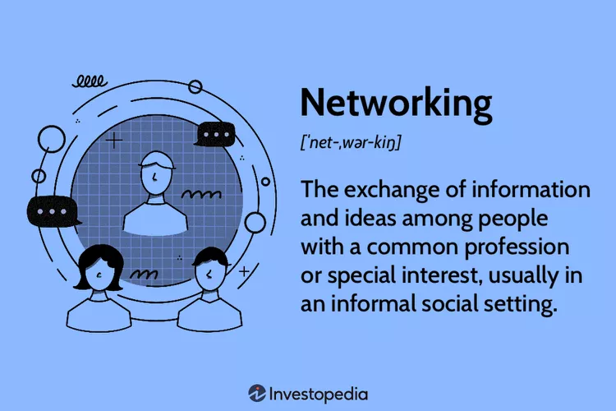

Making connections and networking involves building relationships with other professionals and individuals in your industry. (Kagan, 2022) It can include attending events, joining professional organizations, and utilizing social media platforms to connect with others. By networking, you can expand your knowledge and opportunities, gain new perspectives, and potentially find new job or business opportunities. It is essential to career development and can lead to long-lasting and valuable relationships. (Monster Contributor, n.d.)
Establishing connections and engaging in networking activities are of paramount importance for the advancement of one's career, as they facilitate the establishment of meaningful relationships with industry professionals and subject matter experts. Through the establishment of these connections, individuals can acquire knowledge, insights, and opportunities that would otherwise be inaccessible to them. Networking is also beneficial for individuals to remain informed about the most recent trends and advancements in their respective industries, thereby playing a crucial role in enhancing their professional growth. Moreover, the act of networking has the potential to facilitate employment prospects, career advancements, and even collaborative ventures within the realm of business. (Cole, 2019) In the realm of professional development, establishing connections and engaging in networking activities are fundamentally imperative for fostering career advancement and achieving desired outcomes.
In this module, I have learned different tools to establish connections, including LinkedIn, which helped me get in touch with other people with the same interests and areas. I also know that it is not easy to leave the comfort zone to create new connections, but we have to do our part and feel uncomfortable. That is a sign that we are moving forward to achieve a variety of relationships. It also helped me to prepare my cv focused on my professional area, how to highlight my knowledge, my skills and my qualities that are beneficial as a professional.
Creating Your Own Luck
Blind luck is when someone experiences unexpected success or good fortune without intention or planning. On the other hand, active luck is the type of luck that comes from taking an active role in creating opportunities for oneself. Involved luck often results from hard work, perseverance, and strategic decision-making. It can be fostered and developed over time rather than relying on chance. (Yang, 2021)
Active luck is a crucial factor in the development of one's career. It is the ability to create opportunities for oneself by taking actions that increase the likelihood of success. Being proactive and taking steps to increase one's chances of success can lead to more opportunities and help individuals achieve their goals. When one is actively seeking out opportunities and taking advantage of them, they are more likely to be successful in their career. (Bonaguro, 2018) I learned that Creating your own luck is all about taking control of your own life and making the most out of every opportunity that comes your way. It is about having a positive attitude and being open to new experiences. When you are proactive and act towards your goals, you increase the likelihood of success. Luck may seem like it's something that happens by chance, but it is often the result of hard work, determination, and a willingness to take risks. So, if you want to create your own luck, start by setting clear goals, staying focused and positive, and taking action towards achieving your dreams. Remember, you have the power to shape your own future and create the life you want.
Active luck is essential because it helps me to create opportunities and take advantage of those who come my way. For instance, I remember one time I was walking down the street, and I noticed a job fair happening nearby. Although I wasn't actively searching for a job then, I decided to take a chance and attend the fair. I landed a new job that I love, and I wouldn't have had that opportunity if I hadn't been open to the idea and willing to take action. Being actively lucky can lead to great things in life, and it's essential to stay open to opportunities that come your way.

Passion & Perseverance
Resilience
Resilience is the ability to bounce back from adversity, challenges, and setbacks. It is the quality that helps people to keep going despite difficult circumstances and to recover from hardship. Resilient individuals can adapt to changing situations and find ways to cope with stress and adversity. (BBC, 2023) Resilience is not a fixed trait but a skill that can be developed and strengthened with practice and effort. It involves cultivating a sense of inner strength, flexibility, and optimism and learning to cope with stress and adversity in healthy and productive ways. Resilience is crucial in leading productive, fulfilling, and meaningful lives, even under challenging circumstances.
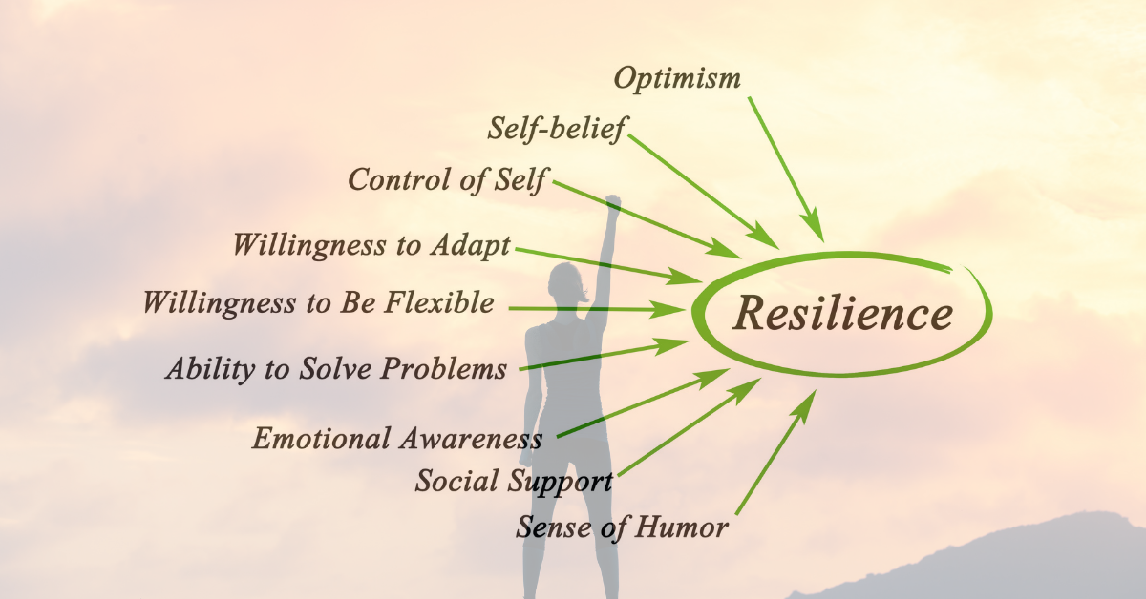 (Rawat, 2023)
Resilience is crucial for career development because it allows individuals to bounce back from setbacks and challenges. The ability to persevere through difficult times and maintain a positive attitude is highly valued in the workplace. Resilient individuals are also more willing to take risks and try new things, which can lead to new opportunities and growth. Furthermore, resilience can improve overall mental health and well-being, positively impacting job performance and satisfaction. Ultimately, resilience is crucial in achieving long-term success and fulfilment in one's career. (Mian, 2022)
Resilience is crucial because it helps me navigate difficult times and bounce back from adversity. It is adapting to changes and challenges and progressing despite setbacks. A person who has resilience can maintain a positive outlook and stay motivated even when faced with obstacles. One example of resilience is in my first year of University, I failed an Assessment but used the experience as motivation to study harder and improve my grades.

Part 2. Personal Development Plan (PDP) Example
 | SKILLS | CURRENT ABILITY | TARGET ABILITY | DEVELOPMENT OPPORTUNITY | CRITERIA TO ASSESS SUCCESS | TIME-FRAME | EVIDENCE
1st  PRIORITY | Improve my time Management skills | Improvement | bad | to complete tasks efficiently and effectively | I have been able to achieve my career goals and continue to grow professionally. | 1/01/2024 | Assignment on time  Productivity
2nd  PRIORITY | Digital Skills | good | Good | access a plethora of information, learn new skills, and even work from home. It also helps us to stay safe online by recognizing potential threats and avoiding scams.  Create profile in job tools  Create CV | Make connection.  Apply job.  Update professional data in your professional profile | 1/09/2023 | Certificate /  Online short course
3rd  PRIORITY | Communication skills | Need improvement | good | More confident in interview.  Build better relationships with your coworkers. | advance in my career and avoid conflicts and misunderstandings with other. Give me confidence in myself | 30/12/2023 | Better job interview.  my ability to articulate my thoughts clearly and concisely

In my personal development plan, I have outlined the skills that I need to cultivate. Time management is one of these crucial skills. Enhancing time management skills is a commendable objective, particularly for me aspiring to excel in my professional endeavours. Let us begin by delineating the domains in which you might be allocating excessive time or failing to utilise your time optimally. Are there any tasks or activities that individuals often experience distractions with or that consume an excessive amount of time? After identifying these areas, collaborative efforts can be made to develop a plan that facilitates task prioritisation and maximises time utilisation. This may entail establishing precise timeframes, assigning responsibilities to individuals, or employing various tools and technologies to optimise the efficiency of your work processes. By exerting a moderate amount of effort and concentration, I am optimistic that we can assist you in enhancing your time management abilities and attaining your professional objectives. My strength skills I think is digital skills, I’ve been working hard to improve my digital skills lately. As technology continues to advance, it's become more important than ever to have a strong understanding of digital tools and platforms. From social media to coding languages, there are so many different areas to focus on. But with practice and dedication, I know I can become a true digital expert. It's exciting to think about all the possibilities that come with having these skills, both personally and professionally. Whether I'm starting my own business or simply staying connected with friends and family, digital skills are a vital part of modern life, I strong believe Digital skills are becoming increasingly important in today's job market. With the world becoming more and more connected, it's essential to have a strong understanding of digital tools and technologies. In my PDP also I included Communication skill because it is a crucial aspect of any successful individual. The ability to effectively convey thoughts, ideas, and emotions is essential in both personal and professional settings. Good communication skills involve not only speaking clearly and concisely but also listening attentively and responding appropriately. It helps in building strong relationships, resolving conflicts, and avoiding misunderstandings. With good communication skills, you can articulate your thoughts clearly, understand others' perspectives, and convey your message effectively. It is a skill that can be developed and improved with practice, and it's worth investing time and effort into it as it can have a significant impact on your life and career.

References
BBC, 2023. Help me out - resilience. [Online]
Available at: https://www.bbc.co.uk/cbbc/findoutmore/help-me-out-resilience
[Accessed 22 August 2023].
Bonaguro, J., 2018. The Importance of Luck in Your Career and How to “Manage” It. [Online]
Available at: https://www.govloop.com/community/blog/importance-luck-career-manage/
[Accessed 21 August 2023].
Cambridge Dictionary, 2023. Cambridge Dictionary. [Online]
Available at: https://dictionary.cambridge.org/dictionary/english/ambitious
[Accessed 20 August 2023].
Cole, B. M., 2019. 10 Reasons Why Networking Is Essential For Your Career. [Online]
Available at: https://www.forbes.com/sites/biancamillercole/2019/03/20/why-networking-should-be-at-the-core-of-your-career/
[Accessed 22 August 2023].
Indeed Editorial Team, 2023. 10 Career Goals Examples and Why They're Important. [Online]
Available at: https://uk.indeed.com/career-advice/career-development/career-goals-examples
[Accessed 20 August 2023].
Jung, H. S. & Yoon, H. H., 2016. Why is employees’ emotional intelligence important?. International Journal of Contemporary Hospitality Management, Vol. 28, Iss. 8(DOI:10.1108/IJCHM-10-2014-0509), pp. 1649-1675.
Kagan, J., 2022. Networking: What It Is and How to Do It Successfully. [Online]
Available at: https://www.investopedia.com/terms/n/networking.asp
[Accessed 22 August 2023].
Mian, D., 2022. Why resilience is the key to career success. [Online]
Available at: https://www.linkedin.com/pulse/why-resilience-key-career-success-dan-mian#:~:text=Why%20resilience%20is%20important%201%20It%20allows%20you,you%20to%20take%20risks%20and%20deal%20with%20adversity
[Accessed 21 August 2023].
Monster Contributor, n.d. Your professional networking questions - answered. [Online]
Available at: https://www.monster.co.uk/career-advice/article/what-is-networking-and-how-do-i-do-it
[Accessed 22 August 2023].
Rawat, A., 2023. TWELVE RESILIENCE SKILLS TO BOUNCE BACK. [Online]
Available at: https://www.cushyvalues.com/twelve-resilience-skills-you-want-to-learn-to-bounce-back/
[Accessed 22 August 22].
Santilli, M., 2022. What Is Emotional Intelligence?. [Online]
Available at: https://www.forbes.com/health/mind/what-is-emotional-intelligence/
[Accessed 21 August 2023].
Yang, R., 2021. How to Create the Luck Required for a Successful Career. [Online]
Available at: https://medium.com/curious/how-to-create-the-luck-required-for-a-successful-career-b1b15486ed7
[Accessed 21 August 2023].

