

Assignment Title: Evidence of Learning (E-Portfolio)
Module Name: Learning in the Digital Era
Module Code: BMPS4009 & BMPL4007
Program of Study: Public Service Portfolio
Student Name: Mohammed Zahoor
Student ID #: 2243574
Lecturer Name: Ms. Zita Draper

Preparing for the Higher Education

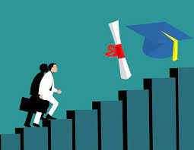

Summary
One of the early challenges (which not mostly seems like a challenge) faced by the students is the transition from college to university. From the controlled environment of the school, college to the independent environment of the university, where they are expected to take personal responsibility of growing and learning efficiently to ensure a promising future (Wollscheid et al., 2020). When they are fail to compete with this academic transition, drop out happens. Students should be aware of how they need to prepare themselves for the higher education (Lowe and Cook, 2003).
Below are the tips or the guidelines students need to consider while preparing themselves for the higher education:

- Know this transition is Difficult:
Higher education is completely the whole new world and entering the higher education means that a student is entering into the completely new learning environment, re- evaluate their learning skills and try to learn and enhance new skills based on their field. This transition will be a difficult process. Student may encounter depression, anxiety during this transition, but they need to have a clear vision of where they want to stand after their degree, and they can easily get through this phase (Wollscheid et al., 2020).

- Career Prospects:
Career prospect is the most important step in which you student have an idea of what they can do with the degree. They need to consider all the positives and the negative aspects of the field, job opportunities, growth opportunities, pay layouts and career enhancements. Career prospects, give them the opportunity to think directly what they want to achieve in their career (Prospects.ac.uk, 2018).

- On Field Experience:
Remember, students can always be successful if they have both, the academic knowledge and the on-field experience. For example, if their chosen field is the Law and they want to be a lawyer, they will need to visit courts to look the hearing, observe the communication and argumentative skills. Furthermore, sharp mind, attention to details skills of the lawyers and how they must sharp their skills to become a successful lawyer (LawCPD, 2020).

Mind map of “Becoming a Digital Learner”

Digital Skills and Digital Navigation Skills:
Digital skills are the skill set which allows to your digital technologies. It is basically technical skills, whereas Digital Navigation Skills are much broader skills which are very necessary in the digital world. It includes finding information, assessing which information is important and knowing which reliability of the information as not all information is correct (Grand-Clement, 2017).

‌
Be Safe and Secure:
While using digital learning, you need to access those tools or websites or platforms which are safe and legal. You need to understand which viruses can harm your computer, or at which website your information will be safe or any suspicious activity in your email. You must be aware of all of these to become a successful digital learner.

‌
Set Your Goals:
You need to have the clear educational goal as to what you want to learn and in which time frame. Setting the goals and their achieving time frame is important as it allows you to learn different educational skills in a proper time frame.

Combine both Academic learning and Digital learning:
To achieve your educational goals, you cannot fully depend on digital learning. On hand experiences, academic books, classroom experience is must to fully grasp the knowledge. Combining all these methods will result in a knowledge deepening.

Be Creative:
Just because of its technology, doesn’t mean that it can only be used in one way. You must be creative enough to use digital learning more effectively. This will also keep you focused in achieving your target.

Self-Motivation:
To be a successful digital learner, one must have the motivation to learn. Usually when you are trying to learn on a digital platform, you usually become bored, or distracted, or find the subject not appealing and then you stop learning. Self-motivation is the key. Try to keep yourself motivated to achieve your learning goal.

How to
Become Digital Learner

A TWO MINUTE VIDEO PRESENTATION SCREENSHOTS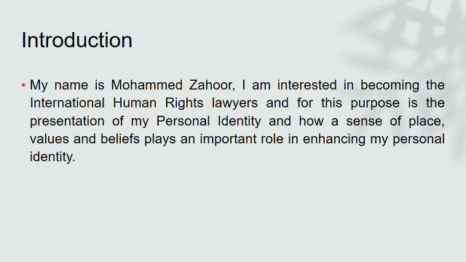
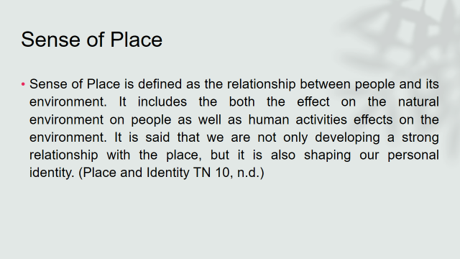

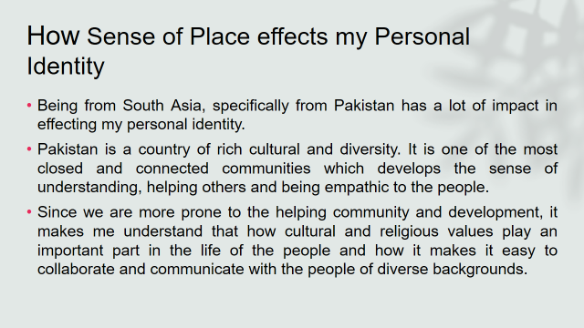
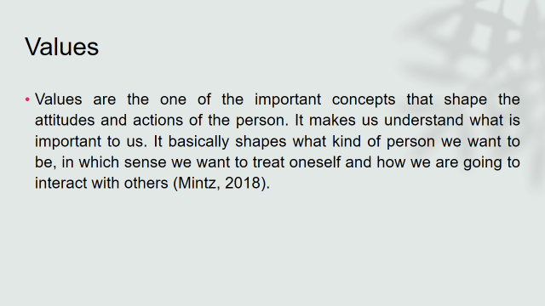
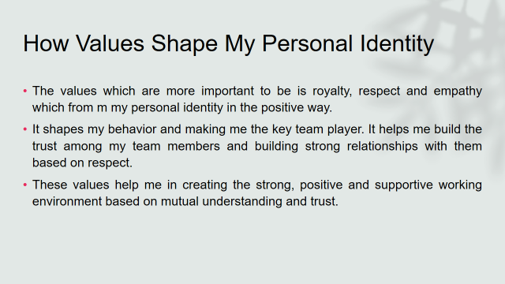
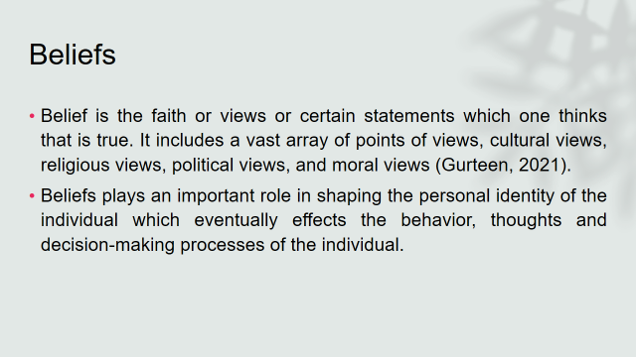
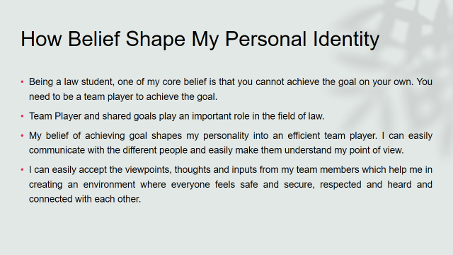
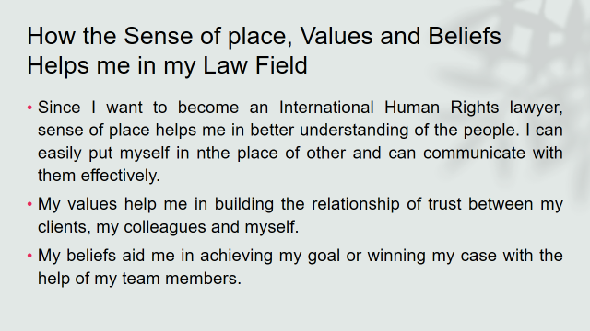
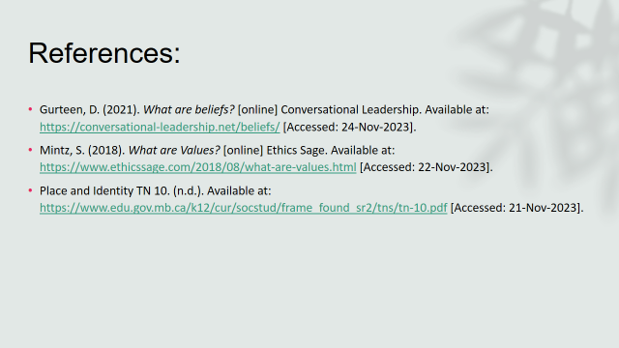

GIBBS Reflective Model

The Gibbs reflective model is one of the widely used reflection models which allows individuals to think systematically and thoroughly about the experiences they have during the specific events. (Main, 2023). It includes the following:
- Description of the situation.
- Feelings: what you felt during the situation.
- Evaluation of the situation.
- Analysis of the situation.
- Conclusion
- Action plan
Below is my reflective analysis of the starting of the university, getting grips with online learning and resources and process of writing my first assignment.

- Starting of the university:

- Description
After finishing my further studies, I was looking for the law school to get enrolled in. I was discussing with my father about which law school provides the best education and which will be best for the theme.

- Feelings
I was feeling a bit anxious as I was gathering information about the law school and later, I was satisfied when I choose the law school.

- Evaluation
The good part of the situation is that I was able to get all the information regarding the law school. The negative part was that it was a long and tiring process. Almost all the law schools were saying the same thing, so choosing a distinctive law school was a problem.
- Analysis
The things did go well as my father has great experience in collecting and analysing the information. Also, reading articles regarding choosing the best law school helps in a lot. What didn’t go well is that I want to take admission within 3 months after I completed my further studies, but it took me 6 months to take admission in law school.

- Conclusion
Information gathering and analysing is the key skill which you need to learn in order to make the perfect decision of your life. It would have been more convenient if I would have talked to the different law professionals and ask them what they would consider while choosing a law school.

- Action plan
If I had to do the same thing again, I would consider more factors in choosing the law school. I would take the insight from the graduates of different law schools which will help me in making the decision.

- Getting grips with online learning and resources

  - Description
After taking admission in a law school, I realized that only academic knowledge is not enough. To excel in law school, I also need online learning with academic knowledge. I discuss this approach with my fellow students, and they all agree.

  - Feelings
I was overwhelmed by the fact that now we will have the access of the information over the internet. We can now understand the same topics with the different point of view. Other students were a bit sceptical at the beginning, but they find it easy to learn through online books, videos, and portals.

  - Evaluations
The good part of using an online learning is that we were able to easily understand the topic which we will be unable to understand in the law school. What didn’t go well is that we find its hand in the reliability of the information available online. Much of the information is without any reference.

  - Analysis
The things go well as we are using law school internet which has access to the different digital libraries. What didn’t go well is that organizing, arranging, and storing of the information is very difficult and time consuming.

  - Conclusion
What I have learned from this situation is not everything seems easy. Getting a grasp of the online learning and resources is difficult and tiring process. You become tired simply by organizing and arranging all the information you extracted online. To excel in online learning, I must learn different online tools and software which can organize and arrange all the information for me.

  - Action plan
I had to do the same thing again, I would learn different digital tools and software prior extracting the information from online sources. I would have developed the skill of evaluating the information whether it is correct or not. I will only be considered that information from the online sources which have proper citation and references.

- The Process of writing my first assignment

  - Description
When we were assigned with our first assignment, I started collecting the information about the assignment from academic books. But the assignment is not as simple as it looks. You will have to think thoroughly and write the assignment with your own point of view. So, I interpreted the concepts of academic books and try to write them with my own thoughts. My assignment, should represent me.
  - Feelings
In the beginning, I have the mixed feelings regarding the assignment. I was not sure that how I am going to apply academic theories in my own thoughts, but after continuous understanding and watching Informational videos from online learning platforms, I was able to write down my point of view reflecting the theory. As I was doing this, I became calmer and more collected and explore that part of myself which I never thought would exist.

  - Evaluations
The best part of writing my first assignment was that I was able to explore the hidden parts of myself. The part which didn’t go well is that applying those theories into your personal life is challenging. Sometimes it fits perfectly and sometimes it requires loads of attention to details in applying those theories to your personal life.

  - Analysis
Things go well because I was amazed to explore a completely different side of me which I never knew. I looked for the theories like Personal Development Plan, Smart Goals and applied those theories in my personal life to have a greater understanding of myself.

  - Conclusion
This applying theories to your practical life can be more positive if there will be group discussion and students will tell each other so that the other students will have the clearest understanding of the theories and we will be able to do our assignments more efficiently.

  - Action plan
Co-ordinating and creating a healthy discussion with the students is important. I will try to enhance my communication skills by engaging myself in a healthy discussion with other students and try to involve them to get their point of view regarding the assignment and how the assignment needs to be done.

Personal Development Plan
To excel in the field of law, one must become competitive, which means one must excel in not only personal growth but also professional growth. Personal Development Plan is merely a very effective tool which allows you to enhance your personal development. It includes setting goals, learning new skills to achieve those goals, tracking the progress, motivating yourself in achieving your goals (Iauraduckett, 2020).
As law student, my personal development plan are as follows:
Self-evaluation | Personal Development Plan | SMART Goals | Time Duration needed
International human rights lawyers are the professionals whose job is to provide counsel to the people who faced violations of the human rights. Human rights lawyers undertake various tasks which include drafting legal documents, doing case researches, negotiating settlements and defending human right cases in the courts (Human Rights careers, 2018). Since I am planning to be a successful international human rights lawyer, I realize that I need to have good an extensive knowledge of the legal education, good communication skills, also cultural and religious knowledge and information and analyzing knowledge. | - Learning broader legal education:  I want to learn in-depth knowledge about legal education. I will be reading books, case studies, looking for the information available online to increase my understanding of legal education.  - Exceling in different skills:  Writing and communication skills are the most essential skills in the field of law. I will learn leadership language to better communicate with others. I will also practice my active listening skills so that I can clearly understand the other’s point of view. I will also try to understand the different cultures and the religious backgrounds of the people so that I can communicate with them without hurting their cultural or religious sentiments. I will try to be empathic so that I can better understand their situation.  Most of the positions in the law field include strong writing skills so that they can effectively communicate their opinions and write their legal arguments in legal memoranda and briefs. (Indeed Career Guide, 2023). I will practice how to write in an active voice, be brief and concise, use a formal tone of writing and write in a tone which is understandable by everyone.  I will also be practicing with my law teachers and law students so that they give me feedback and I will try to correct any weak points.  - Set Goals:  Goal setting is an important component in personal development plans. Law is a demanding field which requires dedication and commitment. (www.rnbglobal.edu.in, 2022). I need to develop realistic and reachable goals which will not only help me academically but also professionally by maintaining these goals for the rest of my life. | - Communication skills:  I will try to enhance my communication skills which include both verbal and non-verbal communication. I will be doing practice daily and try to write legal documents to enhance my skills. Also, I will be attending different seminars and workshops on communication skills so that I will be learning from the best professionals. | I will try to excel my communication skills within 3 months’ time
 |  | 2. In depth Legal Knowledge:  The world is continuously changing and developing and so is the field of law. I will try to learn new theories, academic and professional developments, new practices daily so that I will stay up to date with the development in the field of law. | I will try to learn about new theories and practices on the weekly basis and try to summarize them by the end of the week.
 |  | 3. Learning about International Human Rights:  Since I am more towards helping others, I will be specializing in International Human Rights. I will be reading more materials on international human rights, also attending the seminars and watching videos regarding the human rights so that before I enter in the specializing year, I will already have firsthand knowledge. | I will be learning about international human rights within 1 year prior to my specialization within 6 months’ time.
 |  | 4.Analyzing and Organizing Information Skills:  One of the relevant goal is to analyze and organize the information. As a law student, I am aware of the fact that we will be bombarded with the loads of information and we will have to organize and analyze that information by understanding which information is relevant, which need to come first, and which is of no use. I will be excelling this skill by asking my teachers for large law documents and then try to summarize it as brief and concise as possible. | I will be doing this throughout my course so that I can become best in it.
 |  | 5. Assignments:  For achieving all the goals mentioned above, I will also need to excel in my academic year. I will be doing all of my assignments timely, attending all the seminars related to law, and will be doing internships in law firms. | Will be done by the deadline provided by the teacher.

References
Lowe, H., and Cook, A. (2003). Mind the Gap: Are students prepared for higher education? Journal of Further and Higher Education. 27. 53-76.

Grand-Clement, S. (2017). Digital Learning. Education and Skills in the Digital Age. Cambridge: RAND Corporation.

Human Rights Careers. (2018). How to Become a Human Rights Lawyer. [online] Available at: https://www.humanrightscareers.com/magazine/how-to-become-a-human-rights-lawyer/ [Accessed 27 Nov. 2023].

‌Image from: Kumar, H. (2023). Tips to Prepare for Higher Education - Course Joiner. [online] Available at: https://www.coursejoiner.com/educational/tips-to-prepare-for-higher-education/ [Accessed 27 Nov 2023].

Indeed Career Guide. (2023). How To Improve Your Legal Writing Skills in 10 Ways. [Online] Available at: https://www.indeed.com/career-advice/career-development/how-to-improve-legal-writing-skills [Accessed 26 Nov 2023].

‌Iauraduckett, (2020). How to Create a Personal Development Plan. [Online] The Lawyer Portal. Available at: https://www.thelawyerportal.com/blog/how-to-create-a-personal-development-plan/ [Accessed 28 Nov 2023].
LawCPD.com.au. (2020). Are You a Good Communicator? 10 Tips to Build Your Communication Skills. [Online] Available at: https://lawcpd.com.au/blog/10-tips-build-communication-skills/ [Accessed 28 Nov 2023].

Main, P. (2023). Gibbs’ Reflective Cycle. [Online] www.structural-learning.com. Available at: https://www.structural-learning.com/post/gibbs-reflective-cycle [Accessed 28 Nov 2023].

Prospects.ac.uk. (2018). Law careers | Prospects.ac.uk. [Online] Available at: https://www.prospects.ac.uk/jobs-and-work-experience/job-sectors/law-sector/law-careers [Accessed 23 Nov 2023].

StudyMoose. (2016). Reflect on my roles as student in the university based on Gibbs theory Free Essay Example. [Online] Available at: https://studymoose.com/reflect-on-my-roles-as-student-in-the-university-based-on-gibbs-theory-essay [Accessed 23 Nov 2023].

targetjobs. (2023). What else can I do with a law degree? [Online] Available at: https://targetjobs.co.uk/careers-advice/career-ideas/what-else-can-i-do-law-degree [Accessed 27 Nov 2023].

Teague, L. (2022). Be S.M.A.R.T. With Goal Setting. [Online] Training Lawyers as Leaders. Available at: https://traininglawyersasleaders.org/2022/01/20/be-s-m-a-r-t-with-goal-setting/ [Accessed 28 Nov. 2023].

The University of Edinburgh (2020). Gibbs’ Reflective Cycle. [Online] The University of Edinburgh. Available at: https://www.ed.ac.uk/reflection/reflectors-toolkit/reflecting-on-experience/gibbs-reflective-cycle [Accessed 27 Nov 2023].

University of Cumbria (2020). Gibbs’ reflective cycle. [online] University of Cumbria, University of Cumbria, pp.1–4. Available at: https://my.cumbria.ac.uk/media/mycumbria/documents/ReflectiveCycleGibbs.pdf [Accessed 24 Nov 2023].

www.chapman.edu. (n.d.). 20 Tips for Success in Law School. [Online] Available at: https://www.chapman.edu/law/student-resources/achievement-program/20-tips-success.aspx [Accessed 25 Nov 2023].

www.rnbglobal.edu.in. (2022). Personal Skills That Can Be Developed During a Law Degree At RNB Global University. [Online] Available at: https://www.rnbglobal.edu.in/blog/personal-skills-development-at-rnb-global-university/13052022 [Accessed 28 Nov. 2023].

Wollscheid, S., Lødding, B., and Aamodt, P.O. (2020). Prepared for higher education? Staff and student perceptions of academic literacy dimensions across disciplines. Quality in Higher Education, pp.1–20.

‌

