Student name:
Fruzsina Valoczki
Student number:
2223630
Your lecturer’s name:
Kathryn Flynn
Submission Date
February 2, 2024

The module title:
International Meetings Management
The module code:
BMIH6007
Submission date:
28/02/2025
Planning and Delivering
an International Meeting/Event
I confirm that I have not used any AI tools in the research and creation of this assignment. I confirm that I have not presented any AI generated materials as my own work. I confirm I have copies of my drafts, notes, and other resources I used, which I may be asked to provide in evidence.

Table of Contents
Introduction 3
2. Strategic Planning and Delivery Considerations 3
2.1EMBOK Framework Integration 3
Design Domain 3
Administration Domain 6
Marketing DOMAIN 8
Operations Domain 9
Risk Domain 11
3. Industry Trends and Impacts 13
4. Situational and Cultural Considerations 13
5. Conclusion 14
Reference list 15

Introduction
Unison Horizon – Bridging Equality, Diversity & Inclusion is a special MICE event that will be held in Amsterdam on 9th of May 2025, at the elegant Hotel Okura. This event focuses to highlight the important of equality, diversity, and inclusion (EDI) in the hospitality industry. Amsterdam multicultural nature provides the perfect backdrop for EDI initiatives. The event will offer innovative elements, such as an interactive VR experience that simulates various forms of discrimination, cultural gastronomic programmes, enriching the experience.
EDI has become a strategic priority within the hospitality industry for achieving long-term business success. A diverse workforce boosts innovation, improves employee satisfaction, and strengthens company brands (Gomez and Bernet, 2019). Given the industry’s ongoing discussions, it’s crucial that EDI initiatives are implemented authentically, bringing about real change (Fletcher, 2023). When planning the event, changes in the labour market and sustainability requirements should be considered, as they are increasing the demand for ethically sustainable events (Allen, Harris and Jago, 2021).
The goal of the event is to provide a credible platform that drives real change in the sector. This report analyses the creation of the Unison Horizon event using the EMBOK framework and offers guidance on successfully implementing EDI-focused events.

2. Strategic Planning and Delivery Considerations

2.1EMBOK Framework Integration
The organisation and implementation of the Unison Horizon event is examined through the lens of the Event Management Body of Knowledge (EMBOK) framework. EMBOK includes the fundamental aspects of event management divided into five categories: Design, Administration, Marketing, Operations, and Risk Management (Smith & Lester, 2024). This framework promotes comprehensive planning, making sure all pertinent elements are considered at each phase of the event.
The subsequent EMBOK domains will be utilised in the event planning procedure:

Design Domain
The Design Domain lays the foundation for the creative concept of the event and the participant experience (Bowdin et al., 2023).
Content
The event will include keynote addresses and panel discussions examining how EDI fosters innovation and establishes a competitive edge. Subjects encompass intersectionality within hospitality, strategies for inclusive leadership, and actionable methods to promote inclusion. These sessions aim to offer participants both theoretical knowledge and practical lessons.
Theme
The central theme of the event is the role of EDI in driving innovation, emphasising the need to move beyond superficial actions and implement meaningful, impactful change in the hospitality industry. According to a 2023 Deloitte survey, diverse teams are 19% more likely to increase revenue, underscoring the strategic importance of EDI (Adamu, 2024).
Programme
The programme is carefully structured to balance theory and practice:
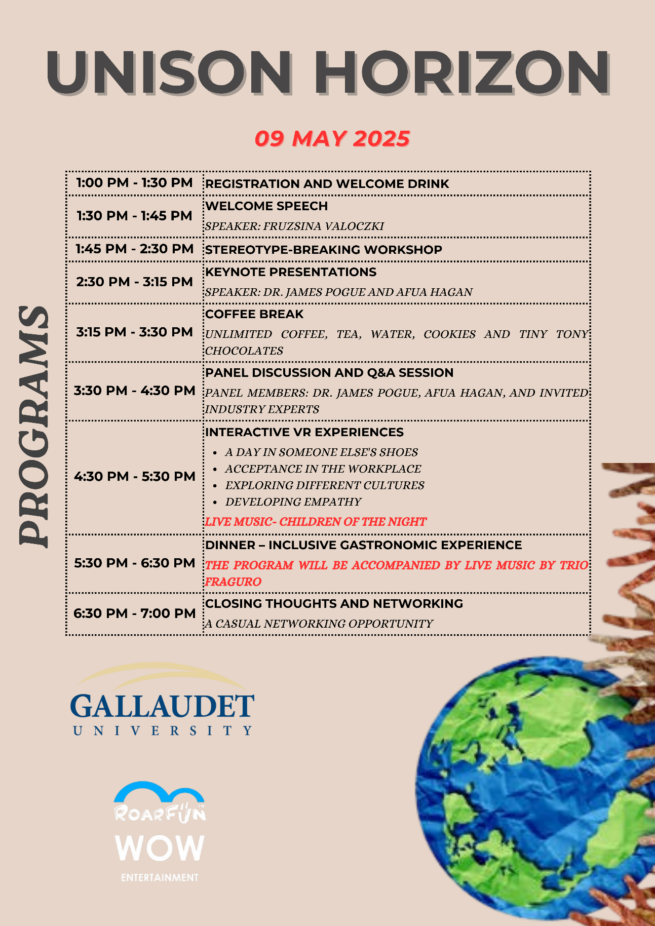
Culinary Experience
The event provides a culturally rich culinary experience, featuring an assortment of international menus. Every dish is made with allergy-friendly options, guaranteeing that all dietary requirements are fulfilled.
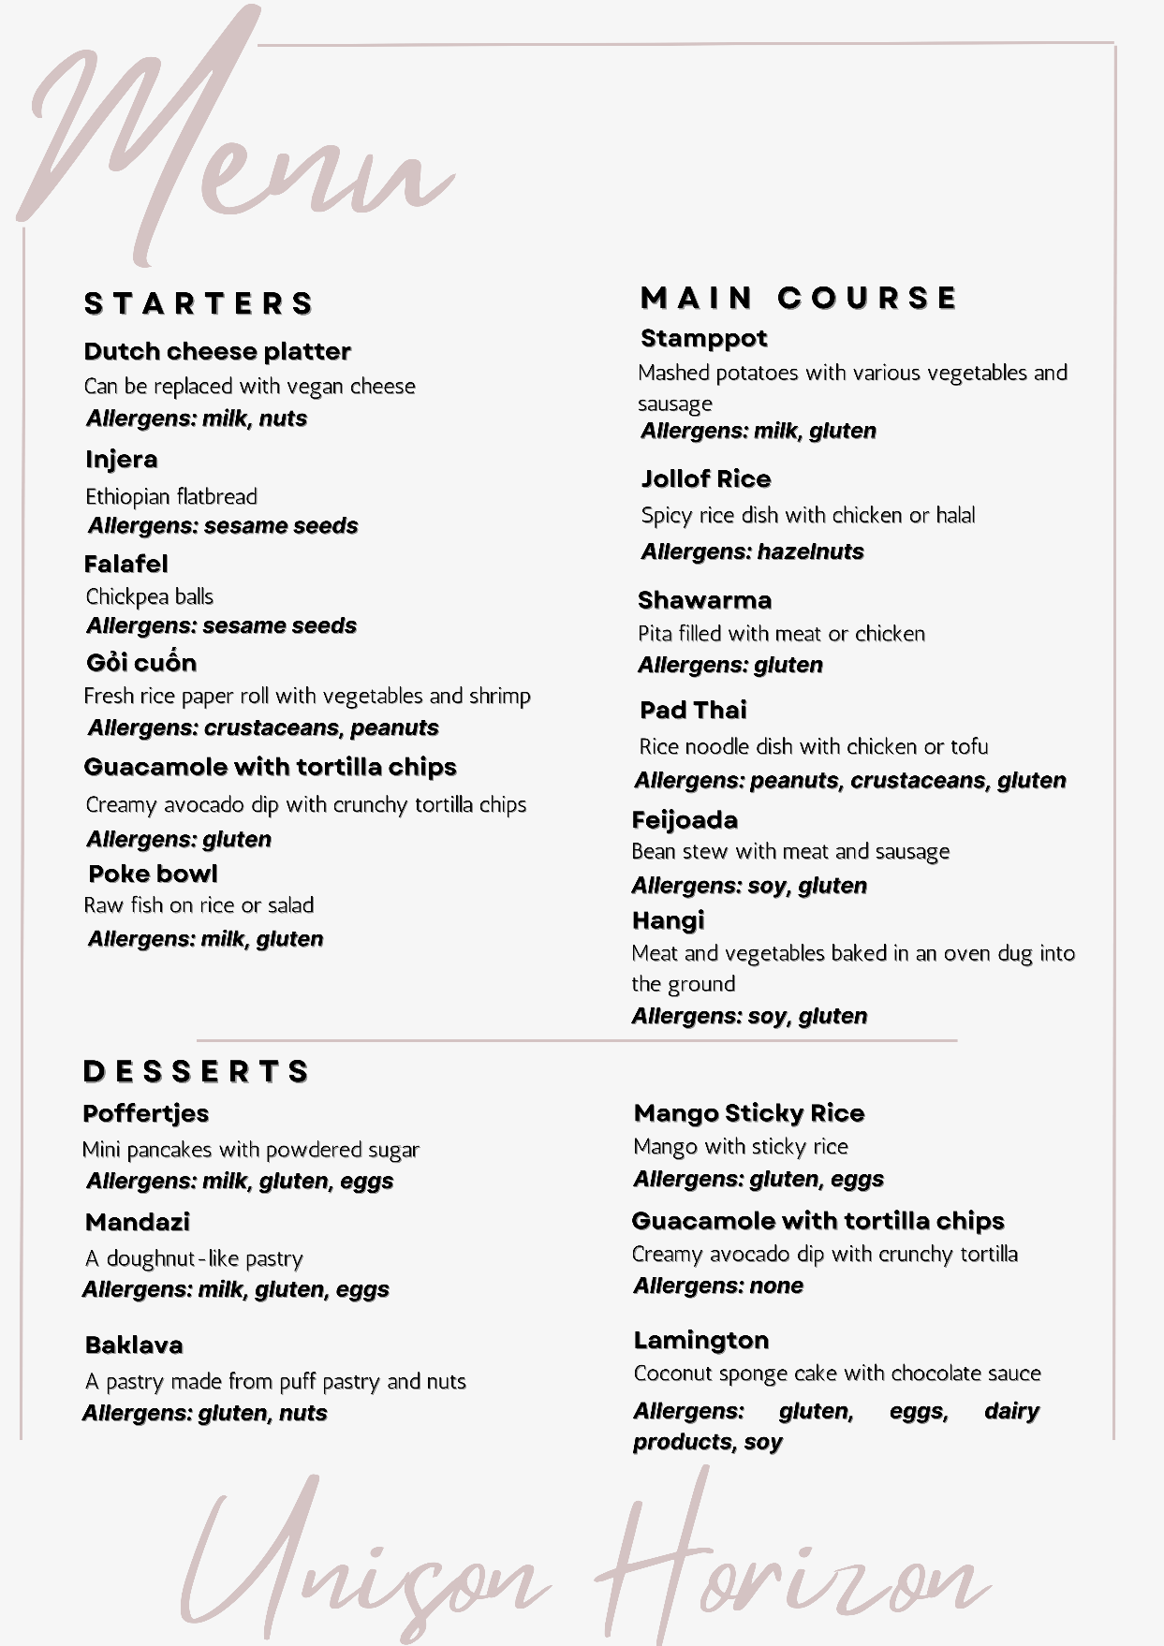
Environment
The gathering will be held at Hotel Okura, boasting more than 20 event venues and cutting-edge audiovisual technology, such as 4K projectors and wireless microphones, guaranteeing a smooth experience for every participant (Hotel Okura, 2022). Attributes like soundproof rooms and adjustable lighting accommodate wheelchair users and those with diverse neurological conditions, promoting a friendly and inclusive atmosphere. The location is also accessible.

Administration Domain
The Administration Domain presents the organisational and management background of the event (Bowdin et al., 2023).
Finance
The financial strategy for the Unison Horizon event relies on a comprehensive budget, guaranteeing sustainability and adaptability. The event is expected to raise £303,950 from ticket sales and the Kickstarter campaign. In terms of expenses, the total budget is around £105,571, split between areas such as catering (£20,000), marketing (£25,000) and contingency fund (£30,000).The contingency fund, making up nearly 30% of the total budget, is designed to cover unexpected costs, in line with industry norms (Tirona, 2025).
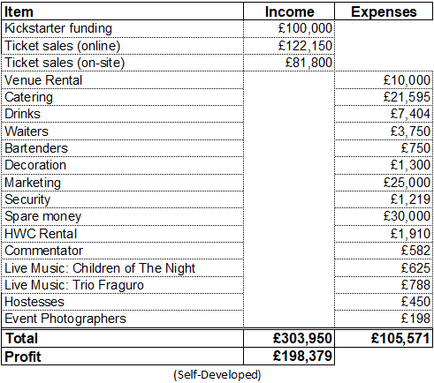
A significant cost-saving measure is the cross-promotional partnership with RoarFun, which provides the VR equipment free of charge in exchange for brand visibility. A small deposit is required to secure the equipment, but this is minimal compared to the potential expense of renting the technology independently. The projected profit is £198,379, ensuring the event’s financial sustainability and enabling high-quality execution.
Human Resources
The success of Unison Horizon relies on a highly skilled and diverse team of 50 people, all of whom are trained to adhere to the EDI principles of the event. Key roles include staff, sign language interpreters and first responders. A partnership was established with Gallaudet University interpreters to assist hearing impaired attendees. In addition, Upevents is responsible for security and Splento is responsible for photography.
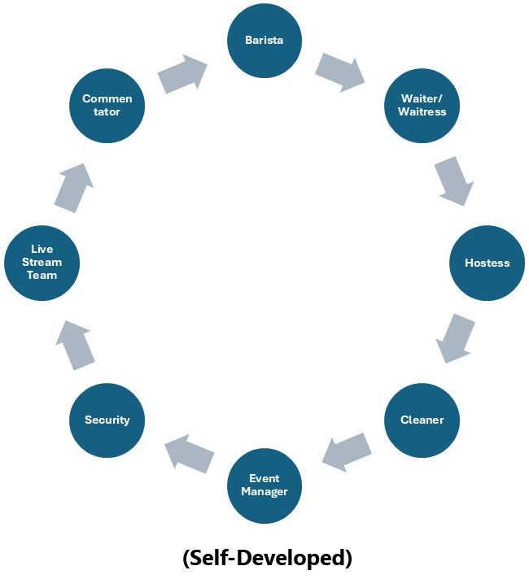
Procurement
The purchasing strategy highlights sustainability and ethical sourcing, reinforcing the dedication to EDI and environmental protection. Efforts involve obtaining food from local organic vendors, choosing sustainable resources, and collaborating with suppliers that comply with fair labor practices and environmental laws. The catering company Amerpodia will create meals with fresh ingredients, minimising the event's carbon footprint and supporting the local economy. Participants will be given sustainable branded items such as recycled tote bags and bamboo USB drives that combine functionality with eco-consciousness.

Marketing DOMAIN
The Marketing domain ensures the event's message reaches the right audience by understanding participant needs and using targeted strategies (Bowdin et al., 2023).
SMART Objectives
A SMART objective is an objective that is specific, measurable, achievable, relevant, and time-bound (Aldridge and Colvin, 2024). The SMART objectives for this event are as follows:
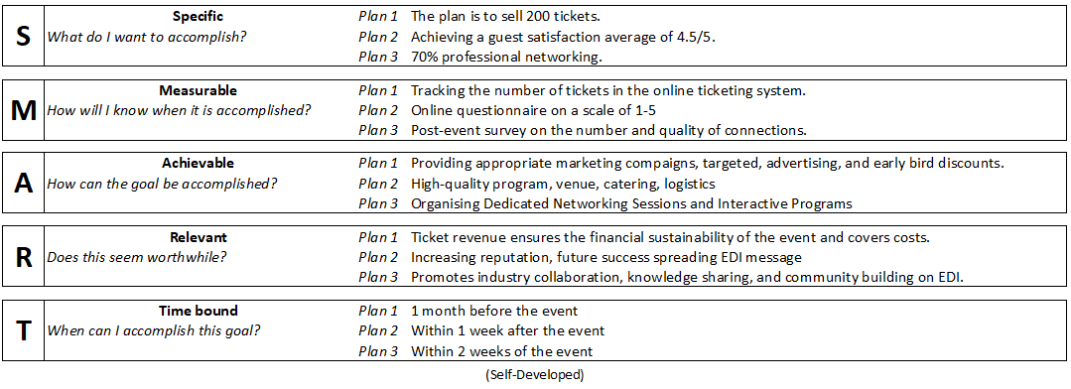
Marketing Materials
Extensive marketing resources have been created to aid the promotional campaign. Digital resources consist of the event website, social media updates, email marketing templates, and digital banners. Offline materials like brochures and presentation kits have been created to maintain a consistent brand identity. All materials underscore key themes related to the event's focus on EDI, as well as its distinctive features like the VR experiences and global presenters. The purpose of these materials is to spark engagement, provide essential information, and encourage registrations.
Merchandise
To enhance the experience for participants and foster lasting memories, the event will offer branded products. Attendees will receive beneficial EDI-related items such as USB drives featuring logos, notebooks, and writing instruments. These products act as keepsakes while also strengthening the event's message and enhancing brand recognition. Alternatively, high-end gifts such as unique canvas bags will be offered, enhancing their appeal and distinctiveness
Promotion
The promotional strategy is integrated and digitally focused, targeting key audiences through multiple channels. LinkedIn campaigns will reach HR managers and diversity officers in the hospitality industry, highlighting the event’s professional relevance. Instagram reels will showcase engaging previews of the VR experiences and keynote speakers, appealing to a younger, tech-savvy audience. Email marketing will ensure that registered participants and industry experts receive regular updates and exclusive information. Collaborations with EDI influencers will enhance the event's visibility, utilising their knowledge and audience to market Unison Horizon as an essential event to attend.
PR
Public relations activities seek to boost the event's credibility and presence in the media. A press release will be issued to showcase significant accomplishments, and a press conference will be organised to provide journalists with thorough information. Media organisations will gain access to interview chances, and links will be formed with experienced journalists and bloggers. The digital PR campaign will focus on social media channels and industry discussions, encouraging positive reactions and conversations to boost the event's image and draw a bigger crowd.
Sales
The main sales channel is the event website, which is linked to an online ticketing system. To promote early sign-ups, discounts will be available for advance purchases and group reservations. Promotional codes and targeted coupons will also be introduced to drive ticket sales. The sales strategy is designed to maximise revenue while ensuring accessibility for a diverse range of participants.
Sponsorship
The sponsorship approach emphasises involving key industry participants. Different sponsorship packages will be available, offering chances for monetary and non-monetary donations. Sponsors will gain prominent exposure, networking chances, and connection with the target audience, guaranteeing reciprocal advantages.

Operations Domain
The Operations Domain summarises the practical steps needed to run an event smoothly (Bowdin et al., 2023).
Attendees
The event expects approximately 550 attendees, including:
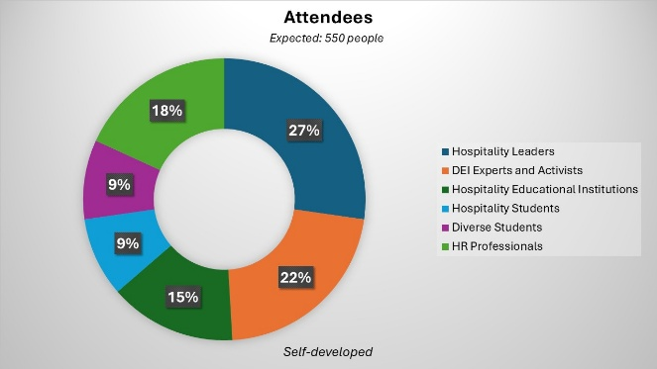
Communications
Successful communication is guaranteed via digital registration (through Eventbrite), QR code check-in, and live streaming for those attending remotely. Multilingual communication (English/Dutch) is prioritised, with pre-event emails providing detailed schedules and venue maps. Real-time updates via a mobile app and on-site information kiosks keep attendees informed. Post-event feedback will be collected through online surveys and social media monitoring.
Infrastructure
The event will take advantage of the state-of-the-art infrastructure of Hotel Okura, including a multifunctional event space equipped with modern audiovisual technology. Key features include VR equipment (provided by RoarFun), three-camera live streaming, and accessible facilities (ramps, elevators, sensory rooms). Sustainable solutions such as zero-waste catering and digital event programs are in line with the event’s environmental goals.
Logistics
Logistical planning focuses on efficiency and accessibility. Dynamic ticket sales include early bird discounts and group pricing, while on-site registration counters ensure smooth entry. Catering by Amerpodia offers allergy-friendly menus inspired by six global cuisines. Staff logistics involve 25 waiters, 8 security personnel, and a technical team. Transportation partnerships with nearby hotels and public transit providers simplify travel for attendees. Hybrid event requirements double logistical efforts, ensuring seamless coordination for both in-person and virtual participants.

Active Participants
The heart of the Unison Horizon event lies in its active contributors. Renowned speakers such as Dr James Pogue and Afua Hagan elevate the event with their insightful talks and expertise. Workshop leaders challenge stereotypes through hands-on exercises and interactive sessions. Musicians like Children of the Night and Trio Fraguro create an uplifting cultural experience. Partner organisations, including Gallaudet University and RoarFun, provide essential expertise and cutting-edge technology, from sign language interpretation to VR experiences (Gallaudet University, 2025; RoarFun, 2024).
Venue
The Hotel Okura Amsterdam, situated in the cultural center of the city, offers a high-quality, inclusive, and diverse setting. Its facilities are fully equipped to accommodate wheelchair users and diverseness guests, featuring quiet spaces and adjustable lighting. The venue’s elegant and welcoming ambiance aligns seamlessly with the event’s focus on EDI.
Technical
Cutting-edge technology ensures a seamless experience at Unison Horizon. RoarFun’s VR equipment offers immersive workplace discrimination simulations, while live streaming via OBS Studio, Zoom, and Microsoft Teams connects hybrid audiences in real time. The role of event technology is continuously growing in importance, as evidenced by the fact that 65% of organisers plan to implement VR or AI solutions to enhance the participant experience (Kazim, 2024). Unison Horizon leverages innovative technologies, such as VR simulations, to create immersive experiences that highlight the impact of discrimination and promote inclusivity.

Risk Domain
The Risk Management Domain will identify and manage potential risks to the event (Bowdin et al., 2023).
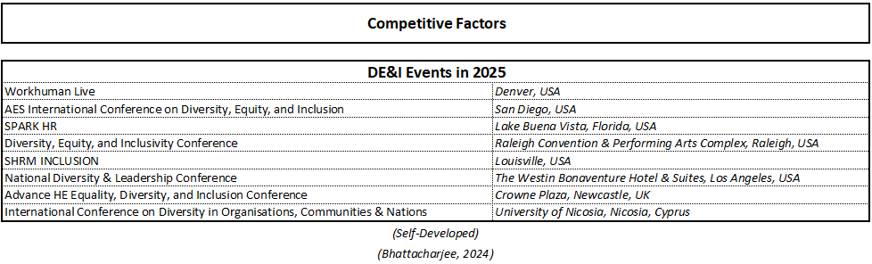
Compliance
The event adheres to legal and ethical standards, guaranteeing GDPR compliance for the safety of attendee data, following copyright laws, and honoring consumer rights. Every vendor agreement contains anti-discrimination provisions, and cybersecurity assessments are conducted to safeguard confidential information. All required permits and approvals are obtained beforehand to guarantee a legal and ethical event. To guarantee legal compliance, we consider European data protection laws (GDPR 2018), international workplace health and safety guidelines (ISO, 2018), and agreements with suppliers and service providers that reduce risks. These actions guarantee that the event functions within legal boundaries and complies with the utmost ethical principles.
Decisions
Clear decision-making protocols are established, with designated responsibilities for the event leadership team. Critical decisions are made by senior management in consultation with relevant experts. In urgent situations, a rapid decision-making procedure guarantees prompt and efficient reactions. Every decision is recorded and shared with the team to ensure transparency.
Emergency
A thorough emergency plan has been created, featuring evacuation paths, first aid centers, and available medical personnel. Emergency communication procedures are put in place to guarantee quick reaction and collaboration with local agencies. Backup generators and refund policies are also prepared to address unforeseen circumstances.
Health & Safety
Attendee health and safety are top priorities. Rigorous health and safety protocols are implemented, including hygiene measures, first aid stations, and trained medical personnel. Food safety and allergy management are carefully addressed. The goal is to create a safe and healthy environment for all participants.
Insurance
Liability insurance is taken out against third-party damage and personal injury. The insurance provides sufficient financial security against potential threats, reducing the financial impact in the event of unforeseen events.
Legal
Legal compliance is achieved by expert examination of all agreements and following applicable regulations, especially regarding data protection and copyright legislation. Legal advice is sought to minimise risks and ensure robust legal protection for the event.
Security
Qualified security staff are assigned to guarantee the safety of every attendee. Access control procedures, such as identity verifications and security stations, are enforced. A CCTV system enhances asset protection, and close coordination with local police ensures rapid response to any security incidents.

3. Industry Trends and Impacts
With 26 million jobs worldwide and $1.7 trillion in direct spending (Salvatori, 2022), the events industry plays a crucial economic role, making EDI initiatives essential for sustainable growth. Unison Horizon embraces this shift, combining in-person and live-streamed formats—aligned with industry trends, where 81% of meetings in 2024 included in-person participation (Shah, 2024).
In the hospitality industry, EDI is not only an ethical issue but also an increasing business imperative. Industry trends show that consumers are more aware of EDI matters and expect companies to commit to equality, diversity, and inclusion (Dixon-Fyle et al., 2020). This has become both an ethical and business expectation. In the job market, diversity provides a competitive advantage in hospitality, with diverse teams being more innovative and responsive to changing customer needs (Yang, Luu and Qian, 2021).
However, the COVID-19 pandemic has exacerbated social inequalities, reinforcing the need for more inclusive strategies in hospitality (Baum et al., 2020). In addition, barriers remain, including the lack of representation of women and minorities in leadership positions, and the persistent gender pay gap (Russen, Dawson, & Madera, 2021). These industry trends, obstacles, and effects highlight the significance and necessity of the Unison Horizon event, designed to act as a trustworthy platform for advocating EDI in the hospitality sector.

4. Situational and Cultural Considerations
The PESTEL analysis is a strategic tool that examines the political, economic, social, technological, environmental, and legal factors affecting a company or industry (Two Teachers, 2020). When applied to the event, it helps to understand how these factors may influence the success of the 'Unison Horizon' event.
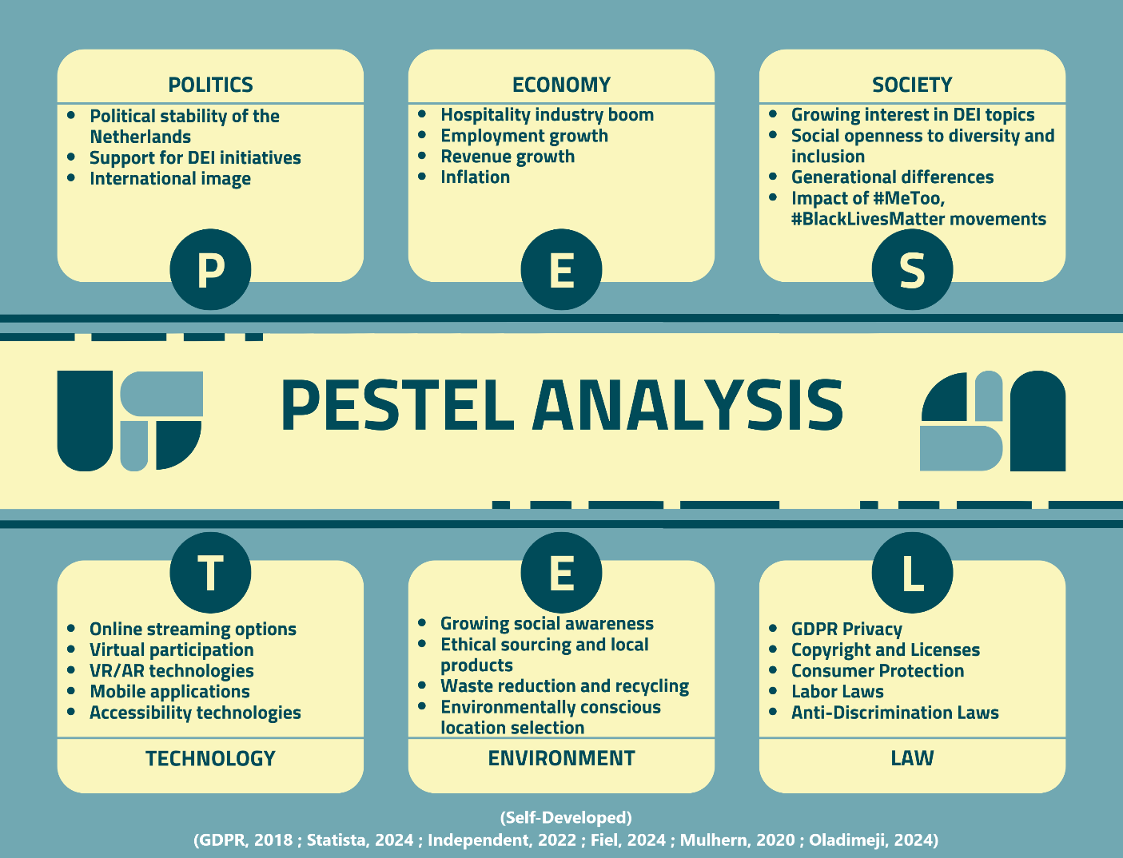

5. Conclusion
Unison Horizon illustrates how strategic planning, rooted in EMBOK and adaptable to industry trends, can convert EDI from theoretical concepts into practical results. By combining education with hands-on experiences, the event enables hospitality leaders to break down systemic barriers and promote inclusive cultures. Its achievement depends on careful risk management, collaboration across sectors, and utilising Amsterdam’s forward-thinking ecosystem. Unison Horizon provides a reproducible model for integrating EDI into organisational DNA as the hospitality sector develops, guaranteeing long-term resilience and moral expansion.

Reference list
- Adamu, K. (2024). Intersectionality in an Inclusive Workplace Culture. [online] Kin&Co. Available at: https://kinandco.com/intersectionality-in-an-inclusive-workplace-culture/ [Accessed 21 February. 2025].
- Aldridge, C.A. and Colvin, M.E. (2024). Writing SMART objectives for natural resource and environmental management. Ecological solutions and evidence, 5(1). DOI: https://doi.org/10.1002/2688-8319.12313
- Allen, J., Harris, R. and Jago, L. (2021). Festival & Special Event Management Interactive Wiley E-Text. S.L.: John Wiley.
- Baum, T. et al. (2020) ‘COVID-19’s impact on the hospitality workforce – new crisis or amplification of the norm?’, International journal of contemporary hospitality management, 32(9), pp. 2813–2829. Available at: https://doi.org/10.1108/IJCHM-04-2020-0314
- Bhattacharjee, M. (2024). Top DE&I Events to Attend in 2025. [online] Airmeet. Available at: https://www.airmeet.com/hub/blog/top-dei-events-to-attend-in-2025/ [Accessed 3 Feb. 2025].
- Bowdin, G., McDonnell, I., Harris, R., O’Toole, W., Allen, J. and Leo Kenneth Jago (2023). Events Management. Routledge. DOI: https://doi.org/10.4324/9781003044963
- Dixon-Fyle, S., Dolan, K., Hunt, V. and Prince, S. (2020). Diversity wins: How inclusion matters. [online] McKinsey & Company. Available at: https://www.mckinsey.com/featured-insights/diversity-and-inclusion/diversity-wins-how-inclusion-matters [Accessed 19 February. 2025].
- Fiel, S. (2024). Augmented Reality in Entertainment & Media. [online] Rock Paper Reality. Available at: https://rockpaperreality.com/insights/ar-use-cases/augmented-reality-in-entertainment-media/ [Accessed 21 February. 2025].
- Fletcher, A. (2023). Employer’s Guide to EDI in the Workplace | HR Consultancy. [online] Fitzgerald Human Resources. Available at: https://www.fitzgeraldhr.co.uk/equity-diversity-inclusion-work/ [Accessed 18 February. 2025].
- Gallaudet University (2024). Learn ASL at Gallaudet | Gallaudet University. [online] Gallaudet University. Available at: https://gallaudet.edu/asl/ [Accessed 19 January. 2025].
- GDPR (2018). General Data Protection Regulation (GDPR). [online] General Data Protection Regulation (GDPR). Available at: https://gdpr-info.eu/ [Accessed 16 February. 2025].
- Gomez, L.E. and Bernet, P. (2019) ‘Diversity improves performance and outcomes’, Journal of the National Medical Association, 111(4), pp. 383–392. Available at: https://doi.org/10.1016/j.jnma.2019.01.006
- Hotel Okura (2022). A pencil is writing on a piece of paper. [online] Okura. Available at: https://www.okura.nl/events [Accessed 13 January. 2025].
- Independent (2022). Dutch government names commissioner to tackle #MeToo issues. [online] The Independent. Available at: https://www.independent.co.uk/news/dutch-european-union-marc-overmars-police-parliament-b2010382.html [Accessed 28 February. 2025].
- ISO (2018). ISO 45001:2018. [online] ISO. Available at: https://www.iso.org/standard/63787.html [Accessed 16 February. 2025]
- Kazim, W. (2024). 70 Event Planning Industry Statistics for 2025. [online] G2. Available at: https://www.g2.com/articles/event-industry-statistics [Accessed 15 February. 2025]
- Mulhern, O. (2020). Netherlands - Ranked 13th in the Global Sustainability Index. [online] Earth. Available at: https://earth.org/global_sustain/netherlands-ranked-13th-in-the-global-sustainability-index/ [Accessed 19 February. 2025].
- Oladimeji, P. (2024). What Is the Privacy Law in the Netherlands. [online] Didomi. Available at: https://www.didomi.io/blog/privacy-law-netherlands [Accessed 25 February. 2025].
- RoarFun (2024). #1 service to rent VR for your event. Best Virtual Reality. [online] RoarFun.com - New-Gen entertainment with LOVE for children, youth and adults anywhere. Available at: https://roarfun.com/virtual-reality-rental/ [Accessed 3 February. 2025].
- Gomez, L.E. and Bernet, P. (2019) ‘Diversity improves performance and outcomes’, Journal of the National Medical Association, 111(4), pp. 383–392. Available at: https://doi.org/10.1016/j.jnma.2019.01.006
- Salvatori, H. (2022). Bringing Diversity, Equality, and Inclusion to Life in Your Events | Cvent Blog. [online] www.cvent.com. Available at: https://www.cvent.com/en/blog/events/diversity-equality-inclusion-your-events [Accessed 23 February. 2025].
- Shah, K. (2024). 60+ Must Know Event Industry Statistics in 2025. [online] Upmetrics. Available at: https://upmetrics.co/blog/event-planning-industry-statistics? [Accessed 23 February. 2025].
- Smith, R.L. and Lester, H.D. (2024). Driving Innovation through Agile methods: Comparative Insights from the EMBOK and PMBOK. [online] Proquest.com. Available at: https://www.proquest.com/conference-papers-proceedings/driving-innovation-through-agile-methods/docview/3166810142/ [Accessed 27 February. 2025].
- Statista (2024). Hotels - Netherlands | Statista Market Forecast. [online] Statista. Available at: https://www.statista.com/outlook/mmo/travel-tourism/hotels/netherlands [Accessed 16 February. 2025].
- Tirona, C. (2025). Best Practices for Managing Large-Scale Events. [online] VenueNow. Available at: https://venuenow.com/blog/managing-large-scale-events-best-practices-for-event-planners/? [Accessed 28 February. 2025].
- Two Teachers (2020). PESTLE Analysis | What Is PESTLE analysis? YouTube. Available at: https://www.youtube.com/watch?v=F0KQ-h6v3-s [Accessed 2 February. 2025].
- Yang, M., Luu, T.T. and Qian, D. (2022) ‘Group diversity and employee service innovative behavior in the hospitality industry: a multilevel model’, International journal of contemporary hospitality management, 34(2), pp. 808–835. Available at: https://doi.org/10.1108/IJCHM-06-2021-0822

