

Student name: Roqia haji haidar
Programme: BA (Hons) Leadership and Management Skills in the Workplace
Module: Developing the Learning Organisation
Module code: BMSK5010
Lecturer: Paul Tinkler
Assignment Title: Developing Relationships and Workplace Achievement
Submission deadline: 11th October 2026
Wordcount: 4215
AI Acknowledgement
I confirm that I have not presented any AI generated materials as my own work.
I confirm that I have copies of my drafts, notes, and other resources I used, which I may be asked to provide in evidence.

Table of Contents
1. Introduction 4
2. Employee Development and Its Importance 4
2.1 Benefits for Vision Express 5
2.2 Benefits for the Employee 5
3. Career Development Models 6
3.1 Holland's Model of Vocational Choice 6
3.2 Schein's Career Anchors 7
4. Michigan Model and Employee Development 8
5. Senge's Fifth Discipline and the Learning Organisation 9
5.1 Systems Thinking 9
5.2 Personal Mastery 10
5.3 Mental Models 10
5.4 Shared Vision 10
5.5 Team Learning 11
6. Greiner's Six Phases Growth Model 11
7. Appraisals and Continuous Professional Development 13
7.1 Appraisals 13
7.2 Continuous Professional Development 14
8. Development Methods and Twelve Month Plan 14
8.1 Training 15
8.2 Coaching 15
8.3 Mentoring 15
8.4 Job Shadowing 15
8.5 Practical Experience 15
8.6 Twelve Month Development Plan 16
9. Reflection, Workplace Relationships and Teamwork 16
9.1 Reflection 16
9.2 Building Better Workplace Relationships 17
10. Sustainability and Future Development 17
11. Critical Application of the Models 18
11.1 Michigan Model 18
11.2 Holland's Model 19
11.3 Schein's Career Anchors 19
11.4 Senge's Fifth Discipline 19
11.5 Greiner's Growth Model 20
11.6 Appraisals and CPD 20
12. Recommendations 20
13. Conclusion 21
References 22

Developing Workplace Relationships and Employee Performance at Vision Express

1. Introduction
Employees are an important part of every organisation because their knowledge, skills and behaviour can affect business performance. Employee development can improve individual performance and support teamwork, communication and customer service (KAREEM & HUSSEIN, 2019).
This report examines employee development and workplace relationships at Vision Express. The employee discussed works as a Retail Optical Assistant and wants to progress towards a Store Manager position. To prepare for a Store Manager position, the employee should strengthen their ability to guide colleagues, communicate effectively, organise tasks, make informed choices, resolve workplace disagreements and monitor team performance.
The report uses several theories and models to understand the employee's development. These include the Michigan Model, Holland's Model of Vocational Choice, Schein's Career Anchors, Senge's Fifth Discipline and Greiner's Six Phases Growth Model. The report also considers appraisals and Continuous Professional Development (CPD).
A twelve month development plan is included to show how the employee can improve through training, coaching, mentoring, job shadowing, practical experience, feedback and reflection. The report also explains how employee development can improve workplace relationships and create a more positive working environment.

2. Employee Development and Its Importance
Employee development is important because it can benefit both the employee and the organisation. For Vision Express, developing employees can improve skills, confidence, teamwork and customer service. It can also help the organisation prepare employees for future positions.
Research suggests that human resource development can contribute to employee performance and organisational effectiveness (KAREEM & HUSSEIN, 2019). Research into learning organisations also shows links between learning practices, organisational performance and employee attitudes (Ju et al., 2021).

2.1 Benefits for Vision Express
One benefit of employee development is improved performance. Developing communication and customer service skills can improve customer experiences, while leadership training can prepare the employee for greater responsibility. However, training alone may not improve performance without coaching, feedback and practical experience (Adamu Mohammed et al., 2022).
Employee development can also strengthen teamwork by improving communication, listening and problem solving skills (Buła et al., 2024). However, effective teamwork also requires trust, clear communication and management support, meaning training cannot solve every workplace problem.
Another benefit is succession planning, as leadership development may prepare the employee for a future Store Manager role. However, promotion depends on demonstrated ability and available vacancies. Development may also improve retention, but employees need meaningful career opportunities. Systems thinking highlights the connections between employee skills, teamwork, customer service and organisational performance (Reynolds & Holwell (Retired), 2020). Nevertheless, staffing levels, workload and management support also influence these outcomes. Therefore, Vision Express should combine training with regular feedback and practical experience to benefit both the employee and the organisation (Kareem & Hussein, 2019).

2.2 Benefits for the Employee
Development can also benefit the employee. The employee can improve leadership, communication, delegation, decision making, conflict management, coaching, feedback and performance management skills.
Developing personal strengths can support personal growth (Woerkom & Meyers, 2018). Development can also improve motivation because the employee can see a possible career path.
The employee wants to become a Store Manager, so opportunities to practise management skills may help them feel that their career goals are being taken seriously. A clear connection between employee goals and organisational objectives can support motivation and organisational performance (Nowak, 2020).
Shared visions can also help employees understand how their personal goals connect with wider organisational goals (Kaiser et al., 2021).
Confidence can be developed gradually. The employee could first observe management activities, then assist with tasks, lead small activities and eventually take on more responsibility.
The process can be:
Learning, Practice, Feedback, Improvement, Confidence, Greater responsibility
Coaching and performance feedback can support employee development and engagement (Lee et al., 2019).

3. Career Development Models

3.1 Holland's Model of Vocational Choice
Holland's Model can help understand whether the employee's interests fit their intended career direction. Holland identifies six areas: Realistic, Investigative, Social, Conventional, Enterprising and Artistic.
The Realistic area involves practical activities and working with tools or equipment. This may be less strongly related to the employee's management ambition, although practical knowledge can still be useful in an optical retail environment.
The Investigative area involves understanding information and data. This can be useful for a Store Manager because managers need to understand performance information and make decisions.
The Social area is particularly relevant. Social interests involve working with people, helping others and communicating. The employee already works with customers and colleagues, so these skills can support future management.
The Conventional area involves structure and organisation. Optical retail involves procedures, records and organised work. These skills can also be useful to a Store Manager.
The Enterprising area is highly relevant to management because it involves communication, influence and leadership. The employee can develop these skills through team briefings, delegation, coaching and leading small activities.
The Artistic area involves creativity and self-expression. It may be less directly related to the employee's career goal, although creativity can still help with problem-solving.
Overall, the employee's Social, Conventional and Enterprising interests appear particularly relevant to a future Store Manager role. However, Holland's model should be used as a guide rather than a prediction. Career success also depends on experience, performance and opportunities. 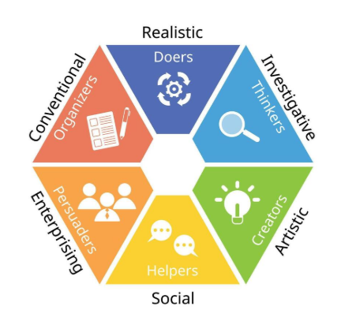

3.2 Schein's Career Anchors
Schein's Career Anchors help explain what motivates an employee's career choices. The eight anchors are:
- Technical/Functional
- General Managerial
- Security and Stability
- Autonomy/Independence
- Entrepreneurial Creativity
- Service/Dedication to a Cause
- Pure Challenge
- Lifestyle
For this employee, General Managerial is the most relevant because they want to become a Store Manager and take responsibility for employees and resources.
Service/Dedication to a Cause is also relevant because the employee's current role involves helping customers.
Schein's model can help the Store Manager understand the employee's career motivation and identify suitable development activities. These could include leadership training, coaching, mentoring and job shadowing.
However, the employee may have more than one career motivation, and these motivations may change over time. The model should therefore be used as part of a wider career discussion.

4. Michigan Model and Employee Development
The Michigan Model examines the relationship between business strategy, organisational structure and HRM activities, including selection, appraisal, rewards and employee development.
This model is relevant to Vision Express because employee development should support both business needs and personal career goals. For example, if customer service is a priority, employees need strong communication skills. If the organisation requires future managers, employees should develop leadership and management skills.
The relationship can be viewed as: Business strategy, HR approach, Employee development, Performance, Organisational outcomes.
The model also highlights the importance of appraisal. The Store Manager can identify strengths and weaknesses and agree on development priorities. For example, if the employee lacks confidence in delegating tasks, coaching and practical experience can help develop this skill.
The Michigan Model is useful because it links employee development to organisational performance. However, its focus on business needs may overlook individual interests and motivation. Therefore, combining it with Holland's and Schein's models can provide a more balanced approach to career development.
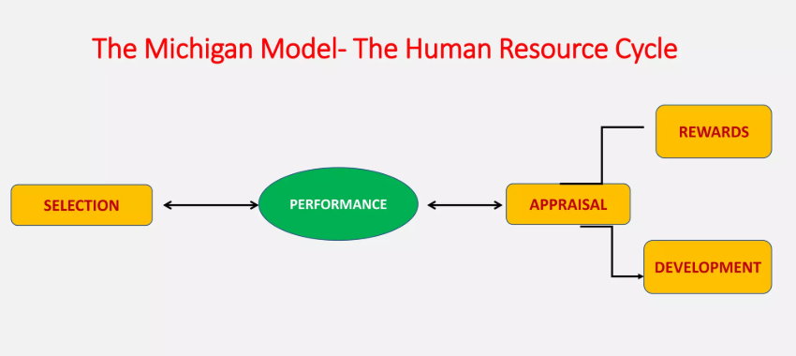

5. Senge's Fifth Discipline and the Learning Organisation
Peter Senge's Fifth Discipline identifies five disciplines that support learning organisations. Senge (1990) explains the importance of organisations learning and adapting. Later research has also considered the impact of the Fifth Discipline on learning organisations (Reese, 2020).
The five disciplines are:
- Systems thinking
- Personal mastery
- Mental models
- Shared vision
- Team learning

5.1 Systems Thinking
Systems thinking means understanding that different parts of an organisation are connected.
At Vision Express, employee development can affect teamwork, customer service and store performance. For example, if the employee improves communication, this may improve communication with colleagues. Better communication may improve teamwork, which can then support customer service.
A systems approach encourages managers to consider how different parts of an organisation work together rather than looking at problems separately (Reynolds & Holwell (Retired), 2020).
Systems thinking can also help organisations understand how employee motivation and development may influence wider organisational outcomes (DSpace, 2026). Research has also considered systems thinking in relation to competitive capabilities and firm performance (R. Siriram & C. Du Plessis, 2024).

5.2 Personal Mastery
Personal mastery involves continuously developing knowledge, skills and abilities.
For this employee, personal mastery could involve leadership training, CPD, reflection and gaining practical management experience.
Personal mastery encourages employees to take responsibility for their own development (Koehle et al., 2008). Personal growth activities can also support employees in developing their strengths (Woerkom & Meyers, 2018).
The employee should therefore not depend completely on the Store Manager. They should identify their own weaknesses, ask for feedback and use learning to improve their performance.

5.3 Mental Models
Mental models are the beliefs and assumptions that influence how people understand situations.
For example, the employee may believe that a manager's main job is to give instructions. Development can challenge this idea by showing that effective managers also need to listen, coach and support employees.
Mental models can influence how leaders and teams understand situations and make decisions (Paoletti et al., 2019).
Management assumptions can also influence talent management and how employees are viewed in organisations (Meyers et al., 2020).
The employee should therefore develop an open attitude and be willing to consider different management styles.
Challenging traditional ideas about leadership can encourage more critical thinking and support leadership development (Dugan, 2024).

5.4 Shared Vision
Shared vision means employees understand and work towards a common direction.
The employee's goal of becoming a Store Manager can relate to the wider objectives of Vision Express, including good customer service and effective teamwork.
A shared vision can help teams work towards common goals (Zasa & Buganza, 2022).
Creating shared visions can also connect organisational learning and knowledge management with employees' understanding of organisational direction (Kaiser et al., 2021).
The employee should understand that their career goal should support the organisation rather than conflict with its needs.
Employees' understanding of organisational objectives can influence culture and performance (Nowak, 2020). Organisational and employee goals should therefore be connected where possible (Buchanan & Huczynski, 2019).

5.5 Team Learning
Team learning involves employees learning together by sharing knowledge, discussing experiences and supporting one another.
At Vision Express, the employee could help new employees, share knowledge and contribute to team discussions.
Team learning develops as employees interact, learn from experience and share information (Wiese & Burke, 2019).
Knowledge sharing can support team effectiveness and individual learning (Lin & Huang, 2019). It can also contribute to organisational learning (Mohajan, 2019).
This is important for a future Store Manager because employees should feel comfortable asking questions, sharing ideas and learning from mistakes.

6. Greiner's Six Phases Growth Model
Greiner's Six Phases Growth Model explains how organisations can move through different stages of development and experience different management challenges.
The six phases are:
- Creativity
- Direction
- Delegation
- Coordination
- Collaboration
- Alliances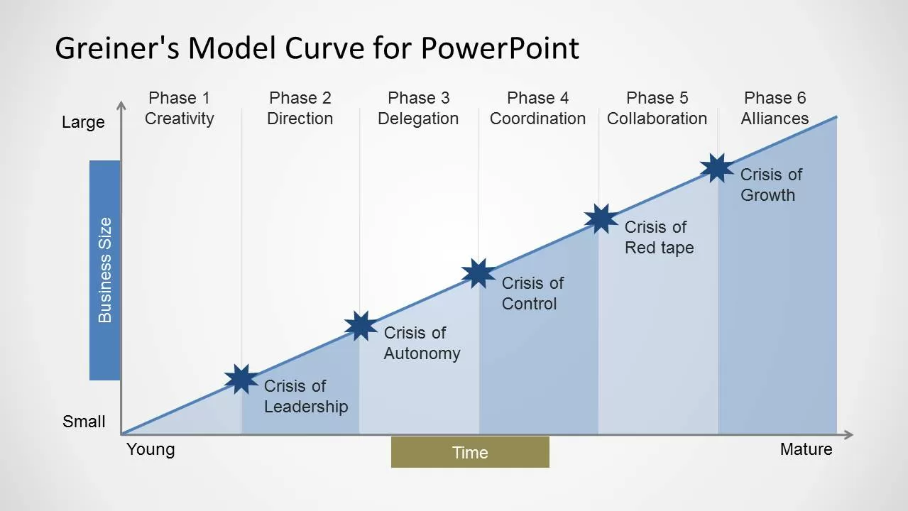

The model is relevant because management requirements can change as organisations develop.
For the employee, becoming a Store Manager would mean moving from mainly completing individual tasks to coordinating the work of other employees.
Delegation is particularly important. A manager cannot complete every task themselves. They need to decide which tasks can be given to other employees and provide support when needed.
Coordination is also important because managers need to organise people and activities effectively.
Collaboration is important because managers need to work with different employees to achieve common goals.
The employee can develop these skills gradually:
Current responsibilities, supporting colleagues, Coordinating tasks, Delegating, Leading, Managing
Greiner's model also shows why development should begin before promotion. If the employee only starts developing management skills after becoming a manager, the transition may be more difficult.
The model therefore supports the use of practical experience, coaching and job shadowing before the employee moves into a management position.

7. Appraisals and Continuous Professional Development

7.1 Appraisals
Appraisals are an important part of employee development. An appraisal gives the employee and Store Manager an opportunity to discuss performance, strengths, weaknesses and future development.
The discussion should consider:
- What the employee is doing well
- Areas that need improvement
- Training completed
- Skills developed
- Career ambitions
- Future responsibilities
- Support required
- Further development
The appraisal should be a two-way discussion. The employee should have the opportunity to explain their experiences and identify areas where they need support.
For example, the employee may feel confident when dealing with customers but less confident when dealing with disagreements between colleagues. The Store Manager could then identify conflict management as a development need.
Appraisals should not only happen once a year. Regular discussions can help the employee receive feedback and make changes during the year.
Supervisory coaching and performance feedback can support employee development, engagement and performance (Lee et al., 2019).
The process can be:
Performance discussion, Development needs, Development activity, Workplace application, Feedback, Appraisal, Further development
This also links with the Michigan Model because appraisal and development are important HR activities.

7.2 Continuous Professional Development
Continuous Professional Development is important because employee learning should continue throughout a career.
Training and continuous development can contribute to employee productivity and organisational performance (Yertas, 2024).
The CPD process for this employee is:
Identify, Plan, Act, Reflect, Apply, Share, Impact
Identify: The employee identifies development needs such as leadership, communication, delegation, conflict management and decision-making.
Plan: The employee decides how these areas will be developed through training, coaching, mentoring or job shadowing.
Act: The employee completes the planned development activities.
Reflect: The employee considers what went well, what was difficult and what could be improved. Reflection helps employees learn from workplace experiences (Faller et al., 2020).
Apply: The employee uses learning in the workplace, such as using improved communication during team meetings.
Share: The employee shares learning with colleagues or supports new employees.
Impact: The employee considers whether the development has improved confidence, communication, teamwork, customer service or leadership.
The employee should keep a CPD record to show progress. CPD also connects with Senge's Personal Mastery because both encourage continuous learning and improvement.

8. Development Methods and Twelve Month Plan
Different development methods should be used because employees learn in different ways.

8.1 Training
Formal training can provide structured knowledge. Training could cover leadership, communication, conflict management, customer complaints, performance management and coaching.
Training can support productivity when employees are able to use what they have learned (Adamu Mohammed et al., 2022).

8.2 Coaching
Coaching allows the Store Manager to support the employee during real workplace situations.
For example, the manager could observe the employee dealing with a difficult customer and discuss the situation afterwards.
Managerial coaching can support employee commitment and individual performance (Ribeiro et al., 2021).

8.3 Mentoring
A mentor can provide career guidance and explain the responsibilities and challenges of management. This can help the employee understand what is expected from a Store Manager.

8.4 Job Shadowing
Job shadowing allows the employee to observe the Store Manager. They could observe team meetings, delegation, planning, decision-making, customer complaints and performance discussions.

8.5 Practical Experience
The employee should gradually take on additional responsibilities, such as leading team briefings, supporting new employees, organising selected tasks and helping with customer problems.
Practical experience is important because it shows whether the employee can apply learning in real situations.

8.6 Twelve Month Development Plan
Development area | Development activities | Timescale | How progress will be checked
Leadership | Coaching, job shadowing and supervised leadership | Months 1–6 | Manager observation and appraisal
Communication | Coaching and feedback | Months 1–4 | Manager and colleague feedback
Delegation | Practising delegation through suitable tasks | Months 3–6 | Observation and task completion
Conflict Management | Coaching and workplace practice | Months 2–5 | Store Manager feedback
Decision-Making | Job shadowing and supervised activities | Months 4–8 | Manager feedback and review of decisions
Performance Management | Mentoring and observing performance discussions | Months 5–9 | Discussion with the Store Manager
Commercial Awareness | Discussions and shadowing to understand store performance | Months 6–9 | Review of understanding of store performance
CPD | Maintain a record of learning and development | Months 1–12 | Regular review of CPD records
Career Readiness | Mentoring, practical experience and appraisal | Throughout the year | Review of skills and readiness for greater responsibility

9. Reflection, Workplace Relationships and Teamwork

9.1 Reflection
Reflection should be an important part of the employee's development.
For example, if the employee leads a team briefing and some colleagues do not understand the instructions, they can reflect on what happened. They may realise that they gave too much information at once. In the next briefing, they could communicate more clearly and check whether colleagues understand.
Reflection allows employees to learn from experiences and improve future performance (Faller et al., 2020).
The process can be:
Experience, Reflection, Learning, Application, Impact
Reflection also supports Senge's Personal Mastery, because the employee takes responsibility for improving their own performance. Learning organisations can encourage self-directed learning and employee responsibility for development (Hutasuhut et al., 2021).

9.2 Building Better Workplace Relationships
Employee development can also improve workplace relationships. A future Store Manager needs to communicate clearly, listen to colleagues, give and accept feedback, support employees and manage disagreements professionally. These behaviours can build trust and encourage teamwork.
For example, when a colleague makes a mistake, the employee should discuss the problem constructively rather than criticise them. This can help the colleague learn and create a supportive workplace.
Coaching and feedback can improve employee engagement and performance (Lee et al., 2019; Ribeiro et al., 2021). Senge's Team Learning also encourages employees to learn from mistakes rather than blame others (Wiese & Burke, 2019). Sharing knowledge with colleagues can further support learning and team effectiveness (Lin & Huang, 2019; Mohajan, 2019).
Therefore, individual development can lead to better communication, stronger workplace relationships and improved teamwork. However, these benefits also depend on trust, management support and employees' willingness to learn from one another.

10. Sustainability and Future Development
Employee development can support the long-term sustainability of an organisation by developing future leaders and maintaining organisational knowledge.
For Vision Express, developing this employee could create an internal candidate for a future management position. This could reduce the organisation's dependence on external recruitment.
Senge's learning organisation approach is relevant because employees who continuously learn can help organisations adapt. Learning cultures can encourage continuous learning and support learning organisations (Chanani & Wibowo, 2019).
Research also suggests that learning organisations can be associated with organisational performance and positive employee attitudes (Ju et al., 2021).
Greiner's model is also relevant because organisations may require different management skills as they develop.
A sustainable approach to employee development should support:
- Learning
- Career development
- Fair opportunities
- Employee wellbeing
- Teamwork
- Good leadership
- Knowledge sharing
Knowledge sharing is particularly important because organisational knowledge can develop when employees share information and experiences (Mohajan, 2019).
Employee development should therefore continue after the employee reaches a higher level of responsibility. Management requirements can change, so employees need to continue learning.

11. Critical Application of the Models

11.1 Michigan Model
The Michigan Model focuses on the relationship between organisational strategy, HR practices and employee development. It is useful because it ensures development supports organisational needs. However, it may focus more on the organisation than the individual.
The Michigan Model may not fully consider the employee's personal interests and career ambitions if organisational performance is the main priority. For example, Vision Express may need employees to meet store targets, but the employee may also need time to develop leadership and management skills. If development focuses only on immediate business needs, long-term career growth could be overlooked. Therefore, the model should be combined with individual development discussions to balance organisational objectives with the employee's ambitions.

11.2 Holland's Model
Holland's Model focuses on career interests. It can help identify whether the employee's interests fit their intended career. However, career interests alone do not determine management success.
A limitation of Holland's Model is that career interests alone cannot show whether someone has the skills and experience needed for a management role. The employee may be interested in becoming a Store Manager but still need to improve delegation, decision making and conflict management. Therefore, career interests should be considered alongside feedback, practical experience and an assessment of current skills.

11.3 Schein's Career Anchors
Schein's Career Anchors focus on career motivation. They can help explain why the employee wants to become a manager. However, employees may have several motivations, and these may change.
An employee's career motivation may change over time because of personal circumstances, work experience and new responsibilities. For example, the employee may currently value promotion but later place greater importance on work-life balance. The Store Manager should therefore review career goals regularly rather than assuming that the employee's motivations will remain the same.

11.4 Senge's Fifth Discipline
Senge's Fifth Discipline focuses on organisational learning, teamwork and continuous improvement. It is useful because development should benefit both the individual and the wider team.
Research into learning organisations suggests that learning practices can have positive relationships with organisational performance and employee attitudes (Ju et al., 2021). Learning organisations can also encourage self-directed learning and employee involvement in continuous development (Hutasuhut et al., 2021).
Although Senge's model encourages teamwork and continuous learning, these activities may be difficult to maintain when the store is busy, or employees have limited time for training. Team learning also depends on employees feeling comfortable sharing ideas and discussing mistakes. Vision Express should therefore encourage open communication, provide opportunities for feedback and allow time for learning. This would help turn the model's principles into practical workplace improvements.

11.5 Greiner's Growth Model
Greiner's Growth Model considers organisational development and changing management requirements. It can help explain why employees need to develop as responsibilities change.
However, Greiner's model focuses mainly on organisational growth and the management challenges that can develop as an organisation expands. It does not provide a complete explanation of an individual employee's career development. Therefore, it is more useful for understanding changing organisational needs than for identifying the employee's specific training requirements. It should be used alongside career development models and regular performance reviews.

11.6 Appraisals and CPD
Appraisals provide a practical way of reviewing performance and development, while CPD provides an ongoing process for learning and improvement.
Appraisals can help identify development needs, but their effectiveness depends on the quality of the discussion and the actions taken afterwards. If feedback is too general or no development activities follow, the appraisal may have little impact. For this employee, the Store Manager should agree specific targets, review progress regularly and provide constructive feedback. CPD records can then be used to monitor learning and identify areas that still need improvement.
Using these approaches together provides a broader understanding of the employee's development than using one model alone.

12. Recommendations
Vision Express should use a mixture of development activities, including training, coaching, mentoring, job shadowing and practical experience. Training provides knowledge, while coaching and practical experience help employees apply learning (Adamu Mohammed et al., 2022).
Development should be connected to organisational requirements as well as the employee's career goals. The Michigan Model can help ensure that development supports business and HR needs.
The Store Manager should use regular appraisal discussions to review performance and identify development needs. Regular discussions can help problems be identified early.
The employee should maintain a CPD record using Identify, Plan, Act, Reflect, Apply, Share and Impact. Continuous development can contribute to productivity and performance when learning is applied effectively (Yertas, 2024).
Management responsibilities should increase gradually. The employee could begin with team briefings and then develop towards delegation, coordination and leadership.
Holland's Model and Schein's Career Anchors should be used during career discussions so that development is connected to the employee's interests and motivation.
The employee should also be encouraged to share knowledge and support colleagues. This supports Senge's Team Learning discipline and can improve team effectiveness (Lin & Huang, 2019).
Finally, the Store Manager should manage promotion expectations. The employee should understand that development improves preparation for future opportunities but does not guarantee promotion. This can help maintain a realistic and trusting relationship.

13. Conclusion
Employee development is important for both employees and organisations. At Vision Express, communication, customer service, teamwork and leadership skills are important for providing good customer support and maintaining effective workplace relationships.
The employee discussed in this report works as a Retail Optical Assistant and wants to become a Store Manager. To work towards this goal, they need to develop leadership, communication, delegation, decision-making, conflict management and performance management skills.
The Michigan Model, Holland's Model, Schein's Career Anchors, Senge's Fifth Discipline and Greiner's Six Phases Growth Model provide different ways of understanding the employee's career goals and development needs.
Senge's learning organisation approach is particularly useful because it highlights systems thinking, personal mastery, mental models, shared vision and team learning (Senge, 1990; Senge, 1994). These ideas can support a workplace where employees continue learning and share knowledge.
Appraisals and CPD can help the employee identify development needs, improve skills and plan future career development. The twelve-month plan combines training, coaching, mentoring, job shadowing, practical experience, feedback and reflection.
Overall, employee development can improve skills, performance, teamwork, customer service and workplace relationships. Research on employee development and organisational effectiveness supports the importance of developing employees as part of wider organisational performance (KAREEM & HUSSEIN, 2019).
Employee development should therefore be treated as an ongoing process rather than simply completing training. By providing regular appraisal, practical opportunities, feedback and CPD, Vision Express can support the employee's career ambitions while also developing stronger workplace relationships and preparing for future management needs.

References
- Reese, S. (2020). Reflecting on impacts of Peter Senge’s Fifth Discipline on learning organizations. The Learning Organization, 27(1), 75–80. https://doi.org/10.1108/tlo-01-2020-244
- Senge, P. M. (1990). The Fifth Discipline. Broadway Business.

- Senge, P. M. (1994). The Fifth Discipline Fieldbook: Strategies and Tools for Building a Learning Organization. Crown. https://books.google.com/books?id=thTtrQVR8EIC
- Reynolds, M., & Holwell (Retired), S. (Eds.). (2020). Systems Approaches to Making Change: A Practical Guide. Springer London. https://doi.org/10.1007/978-1-4471-7472-1
- DSpace. (2026). Brad.Ac.Uk. https://bradscholars.brad.ac.uk/entities/publication/75a16f0d-19d8-42b0-89b9-8e77b241b1b9
- R. Siriram, & C. Du Plessis. (2024). A Systems Thinking Approach to Improving Firms’ Competitive Capabilities and Firm Performance. Systemic Practice and Action Research, 37. https://doi.org/10.1007/s11213-024-09704-z
- Ferreira, S., Greilich, P., Componation, P., Sadighi, M., Phelps, E., & Reed, G. (2024). A Systems Thinking Understanding of Teamwork Competencies and Their Relationship to Health System Outcomes. Conference on Systems Engineering Research Series, 559–568. https://doi.org/10.1007/978-3-031-49179-5_38
- Breckenridge, D. (2016, June 22). Customer Experience Can Improve with a Systems Thinking Approach. BenchmarkONE. https://www.benchmarkone.com/blog/customer-experience-systems-thinking/
- Koehle, M., Bird, D., & Bonney, C. (2008). The Role of Personal Mastery in Clinical Practice: How Personal Leadership Can Transform the Workplace. Journal of PeriAnesthesia Nursing, 23(3), 172–182. https://doi.org/10.1016/j.jopan.2008.03.006
- Woerkom, M. van, & Meyers, M. C. (2018). Strengthening personal growth: The effects of a strengths intervention on personal growth initiative. Journal of Occupational and Organizational Psychology, 92(1), 98–121. https://doi.org/10.1111/joop.12240
- Yertas, M. (2024). The Role of Training and Continuous Development in Improving Employee Productivity and its Impact on Company Financial Performance. Atestasi : Jurnal Ilmiah Akuntansi, 7(2), 1362–1379. https://doi.org/10.57178/atestasi.v7i2.1047
- Adamu Mohammed, N., Mohammed, D., & Gana, J. (2022). THE IMPACT OF TRAINING AND DEVELOPMENT ON EMPLOYEE PRODUCTIVITY IN THE 21ST CENTURY. African Journal of Management and Business Research, 3(1), 41–58. https://publications.afropolitanjournals.com/index.php/ajmbr/article/view/104
- Faller, P., Lundgren, H., & Marsick, V. (2020). Overview: Why and How Does Reflection Matter in Workplace Learning? Advances in Developing Human Resources, 22(3), 248–263. https://doi.org/10.1177/1523422320927295
- Paoletti, J., Reyes, D. L., & Salas, E. (2019). Leaders, Teams, and Their Mental Models. Leader Thinking Skills, 277–306. https://doi.org/10.4324/9781315269573-12
- Meyers, M. C., van Woerkom, M., Paauwe, J., & Dries, N. (2020). HR managers’ talent philosophies: prevalence and relationships with perceived talent management practices. The International Journal of Human Resource Management, 31(4), 1–27. https://doi.org/10.1080/09585192.2019.1579747
- Dugan, J. P. (2024). Leadership Theory: Cultivating Critical Perspectiv Es 2nd Edition. Jossey-Bass.
- Lee, M. C. C., Idris, Mohd. A., & Tuckey, M. (2019). Supervisory coaching and performance feedback as mediators of the relationships between leadership styles, work engagement, and turnover intention. Human Resource Development International, 22(3), 257–282. https://doi.org/10.1080/13678868.2018.1530170
- Ribeiro, N., Nguyen, T., Duarte, A. P., Torres de Oliveira, R., & Faustino, C. (2021). How managerial coaching promotes employees” affective commitment and individual performance. International Journal of Productivity and Performance Management, 70(8), 2163–2181. https://doi.org/10.1108/ijppm-10-2018-0373
- Zasa, F. P., & Buganza, T. (2022). Developing a shared vision: strong teams have the power. Journal of Business Strategy, 44(6), 415–425. https://doi.org/10.1108/jbs-04-2022-0065
- Kaiser, A., Fahrenbach, F., & Martinez, H. (2021). Creating Shared Visions in Organizations – Taking an Organizational Learning and Knowledge Management Perspective. Proceedings of the Annual Hawaii International Conference on System Sciences. https://doi.org/10.24251/hicss.2021.632
- Buchanan, D. A., & Huczynski, A. A. (2019). Organizational Behaviour (11th ed.). Pearson Education Limited.
- Nowak, R. (2020). Does employee understanding of strategic objectives matter? Effects on culture and performance. Journal of Strategy and Management, 13(4), 477–493. https://doi.org/10.1108/jsma-02-2020-0027
- iese, C. W., & Burke, C. S. (2019). Understanding Team Learning Dynamics Over Time. Frontiers in Psychology, 10(1417). https://doi.org/10.3389/fpsyg.2019.01417
- Lin, C.-Y., & Huang, C.-K. (2019). Understanding the antecedents of knowledge sharing behaviour and its relationship to team effectiveness and individual learning. Australasian Journal of Educational Technology, 36(2), 89–104. https://doi.org/10.14742/ajet.4549
- Mohajan, H. K. (2019). Knowledge Sharing among Employees in Organizations. Journal of Economic Development, Environment and People, 8(1), 52–61. https://www.ceeol.com/search/article-detail?id=757503
- Buła, P., Thompson, A., & Żak, A. A. (2024). Nurturing Teamwork and Team Dynamics in a Hybrid Work Model. Central European Management Journal, 32(3), 475–489. Emerald. https://doi.org/10.1108/cemj-12-2022-0277
- Chanani, U. L., & Wibowo, U. B. (2019). A Learning Culture and Continuous Learning for a Learning Organization. KnE Social Sciences, 2019. https://doi.org/10.18502/kss.v3i17.4686
- Ju, B., Lee, Y., Park, S., & Yoon, S. W. (2021). A Meta-Analytic Review of the Relationship Between Learning Organization and Organizational Performance and Employee Attitudes: Using the Dimensions of Learning Organization Questionnaire. Human Resource Development Review, 20(2), 153448432098736. https://doi.org/10.1177/1534484320987363
- KAREEM, M. A., & HUSSEIN, I. J. (2019). The Impact of Human Resource Development on Employee Performance and Organizational Effectiveness. Management Dynamics in the Knowledge Economy, 7(3), 307–322. https://doi.org/10.25019/mdke/7.3.02
- Hutasuhut, I., Ahmad Zaidi Adruce, S., & Jonathan, V. (2021). How a learning organization cultivates self-directed learning. Journal of Workplace Learning, 33(5), 334–347. https://doi.org/10.1108/jwl-05-2020-0074

