Name: Aasma Amjid
Student ID: 2322971
Module: Change Makers: Building your Own Personal Brand For Sustainable Employability
Module Code: BMHP5015-BIRM
Assignment: Written Report (Comp-2)
Lecturer: Raheela Shaikh

Contents
Cover Page ………………………………………………………………... 01
Contents Page …………………………………………………………… 02
Introduction …………………………………………………………....... 03
Screen shots of the advertisement …………………………………... 03-04
Analysis of employability skills ……………………………………… 05
Evaluation of personal skills …………………………………………. 06
Timeline and Action plan ………………………………………………… 07
Building personal brand …………………………………………………… 08
Promoting professional identity ……………………………………………... 08-09
Building network for future employment ……………………………………. 09
Conclusion …………………………………………………………………………. 10
Reference list ………………………………………………………………………. 11-12

Written Report
Introduction
Speech and Language Therapy (SLT) represent a specialised clinical profession within the health and social care sector of the UK. SLTs assist both children and adults facing challenges related to communication, speech, language, voice, and swallowing, facilitating enhancements in their independence, participation, and overall quality of life (RCSLT, 2023).In the UK, SLTs operate in various settings including hospitals, schools, community clinics, care homes, and social care organisations, working in collaboration with clients, families, caregivers, and other professionals (NHS England, 2024).
As a level 5 Health and Social Care student I am interested in progressing into Speech and Language therapy after completing my current qualification. This report examines the essential employability skills required for the position of SLT, assesses my personal skills and areas for development, and formulates a five-year action plan to facilitate my entry into the profession. Additionally, the report discusses the ways in which personal branding, professional identity, and networking can enhance future employability.
Screenshots of the job advertisement, job description and person specification.
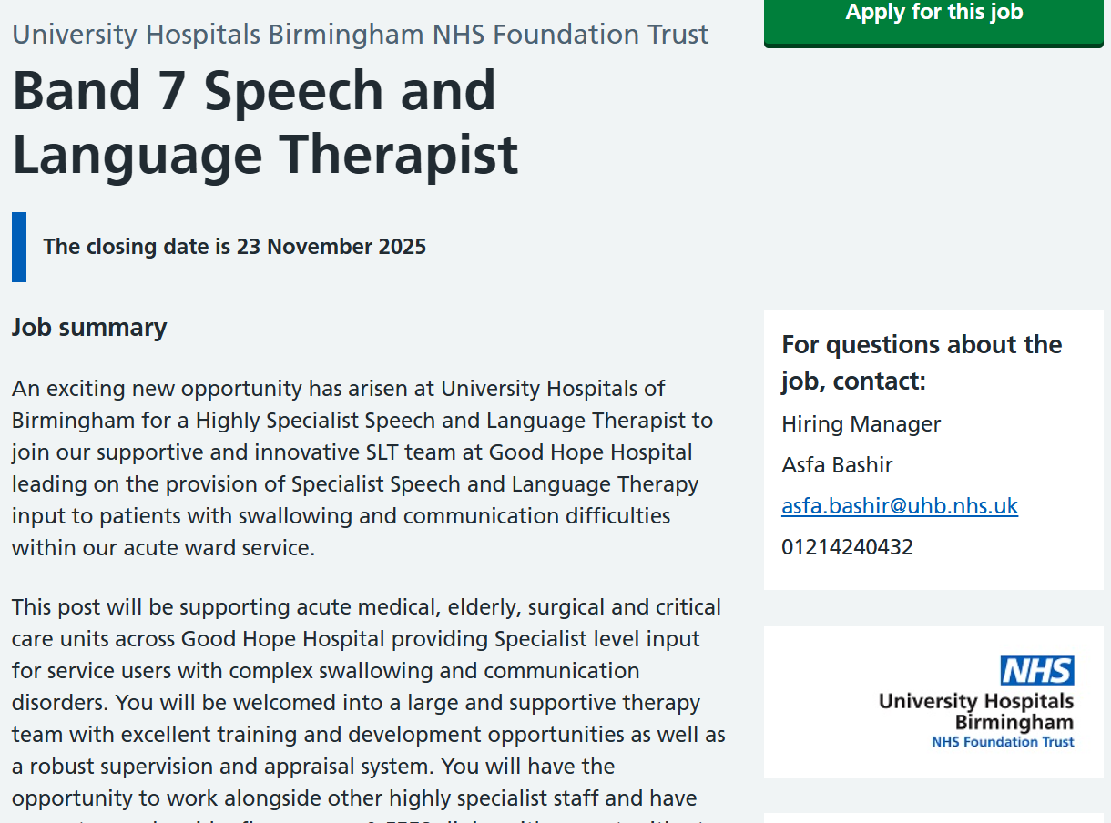
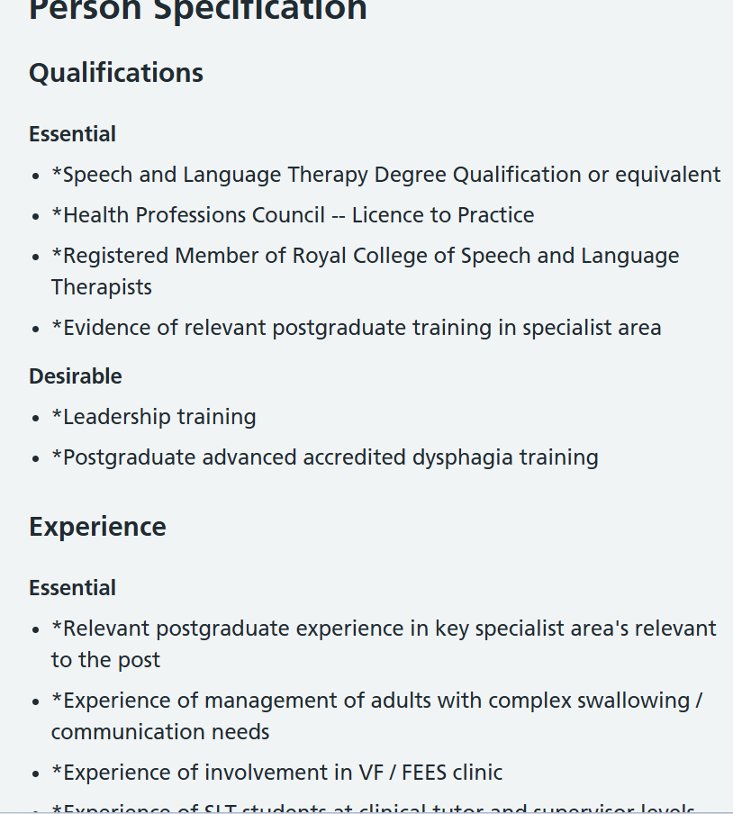
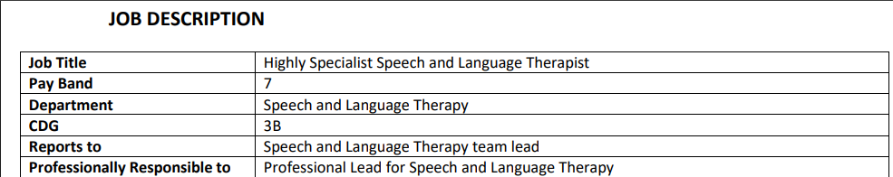
(Jobs.nhs.uk,2025).

Analysis of Speech and Language therapist Employability skills
The job listed above SLTs are responsible for independent caseload management, carrying out clinical assessments, delivering therapy, evaluating progress and writing professional reports (NHS Jobs, 2025). The role also includes partnership working with clients, families and multidisciplinary teams to ensure high-quality, person-centred care (DoHSC, 2023).
The role of a Highly Specialist Speech and Language Therapist entails a comprehensive set of employability skills that align with both professional and personal competencies. Key to this position are advanced clinical skills, which involve the ability to implement evidence-based assessments and interventions for complex communication and swallowing challenges (Royal College of Speech and Language Therapists, 2021). Such technical expertise highlights the necessity of specialised knowledge and ongoing professional development, as emphasised by the requirement for postgraduate training and experience in applicable clinical areas.
The importance of communication and communication skills cannot be overstated (Saavedra, 2023), as they are vital for successful collaboration in multidisciplinary teams, leading audits, mentoring students, and training staff at every level (Health Education England, 2020). The person specification stresses the ability to negotiate, influence, and serve as both a team member and a leader, which reflects the critical role of emotional intelligence and leadership in healthcare contexts (Hargreaves et al, 2019).
Organisational and analytical competencies are essential attributes for employability (Tushar and Sooraksa, 2023) , as the role necessitates the planning and prioritisation of interventions, overseeing caseloads, and evaluating evidence-based practices via audits and research. The specification distinctly outlines the need for problem-solving, reflection, and decision-making abilities, particularly in the context of mental capacity assessments and professional boundaries (NHS Employers, 2021).
According to Middleton et al. (2022) adaptability and resilience are fundamental to requirements like flexible work arrangements across different sites, involvement in seven-day services, and the use of interpreters for information gathering (Jennifer Herrity, 2024). Overall , digital literacy, an understanding of clinical governance, and familiarity with national policies reflect the synthesis of technical, administrative, and regulatory skills vital for effective practice. Collectively, these employability skills encompass clinical expertise, interpersonal skills, leadership, and organisational proficiency, ensuring the delivery of safe, effective, and patient-centred care (Ferreira et al, 2025) .

Evaluation of my skills against the profession
As a student who is in the process of completing the final term of a Level 5 Health and Social Care qualification, my skills have been shaped through systematic academic study rather than through direct employment experience. While I currently lack formal workplace experience, I have achieved a Level 4 Health and Social Care certificate and have progressed to Level 5, which has laid a foundation in essential areas such as legislation, safeguarding, equality, person-centred care, and interprofessional collaboration. These aspects are core expectations for professional healthcare practice in the UK (Skills for Care, 2023). Theoretical learning has also allowed for the development of critical reflection, a skill that is necessary in regulated health professions to support professional advancement and improve the quality of care (HCPC, 2023).
An essential strength that has emerged from my educational experiences is my proficiency in academic and professional communication. Through the completion of written assignments, participation in presentations, and contributions to discussions, I have developed the ability to convey complex topics in a clear manner, adjusting my structure and language to meet the needs of diverse audiences. This skill aligns with the professional expectations of SLT, where advanced communication abilities are vital for aiding individuals with communication challenges and for educating families, caregivers, and colleagues (RCSLT, 2024). For example, while presenting on developmental theories in Psychology, I utilised visual diagrams and simplified terminology to ensure that the content was easily understood by my peers, reflecting the communication techniques employed in professional practice (NHS England, 2023).
I acknowledge the areas that require improvement. The most significant deficiency is the lack of direct experience in health or social care environments, which is vital for advancing into Speech and Language Therapy (SLT) training and subsequent practice. Additionally, I require further exposure to advanced interpersonal skills, including negotiating treatment decisions, managing sensitive discussions, and encouraging clients facing communication difficulties skills essential in SLT positions (NHS England, 2023).
To tackle these gaps, the importance of professional guidance cannot be overstated. University tutors can contribute to the enhancement of academic, reflective, and theoretical skills, while career advisers can facilitate professional branding and job preparation. Volunteering opportunities, shadowing experiences, or assistant roles would grant supervised experience allowing for the practical application of theoretical knowledge and aiding in the development of the confidence and competence required for future SLT training (NHS, 2019).

Timeline and Action plan
Timeframe | Goal | Action Plan
Year 1 | Gain foundation exposure | - Complete level 6 H&SC qualification  - seek voluntary role in SEN schools, NHS departments, children’s centres or Speech therapy charities.  - Build LinkedIn and portfolio showcasing learning.  - Attend SLT open days and webinars
Year 2-3 | Professional SLT education | - Apply for an HCPC approved SLT degree(MSc).  - Undertake clinical placements in paediatrics, adult neuro, dysphagia etc.  - Maintain CPD log with reflections.  - Join RCSLT as student member.  - Seek mentorship from qualified SLTs.
Year 4 | Transition to qualified practice | - Graduate and register with HCPC.  - Apply for Band 5 NHS SLT role.  - Begin Structured professional development.
Year 5 | Progress towards senior competence | - Work toward Band 6 SLT role.  - Complete leadership training.  - Contribute to clinical audit or service improvement.  - Supervise students or new staff.  - Strengthen specialist expertise toward Band 7 level role.

Building My Personal Brand
Building a strong personal brand is vital for enhancing future employability in the field of speech and language therapy, as it enables potential employers to recognise my professional identity, skills, and career objectives (NHS Careers, 2024).A key strategy involves establishing a professional presence on LinkedIn, which is widely viewed as an effective platform for presenting qualifications, achievements, and career development within the healthcare sector (LinkedIn, 2024).On this platform, I can highlight my academic progress, volunteer experiences, and reflections from my learning journey, demonstrating my commitment to entering the profession. Regular updates, including short reflections, learning summaries, or insights from relevant modules, can effectively convey my values and interest in evidence-based practice (HCPC, 2023).
Participating in professional networking events, such as NHS webinars, university employability gatherings, and sessions organised by the Royal College of Speech and Language Therapists (RCSLT), will facilitate the establishment of professional relationships and enhance understanding of employer expectations (RCSLT, 2024). Over time, the act of sharing professional content such as blog posts, concise articles, reflections on communication theories, or summaries of research and case studies can serve to showcase the evolution of expertise and active participation in the field. The creation and sharing of relevant content signal a commitment to professional learning, which is a critical expectation in health professions where ongoing professional development is imperative (HCPC, 2023).
By consistently demonstrating professionalism, motivation, and a commitment to growth, my personal brand can foster confidence, enhance credibility, and create future employment opportunities in the field of speech and language therapy.
Promoting My Professional Identity
Effectively showcasing my professional identity is essential for proving my capability for future jobs in speech and language therapy. A key approach is to create a well-organised CV and Cover letter that are customised to the specific requirements of the job. Employers want candidates to clearly present relevant skills, qualifications, and achievements, illustrating how they meet the job criteria (NHS Careers, 2024). Tailoring applications also helps me highlight my academic successes, transferable skills, and dedication to patient-centred care acquired through my Health and Social Care studies. A focused cover letter can further show my motivation, understanding of professional values, and awareness of the needs of service users (RCSLT, 2024).
Maintaining a professional online presence significantly enhances employability. An updated LinkedIn profile can effectively highlight my educational advancements, certifications, volunteer experiences, and insights on learning, thereby assisting employers in recognising my professional development (LinkedIn, 2024). Furthermore, LinkedIn facilitates networking with industry professionals, participation in professional discussion groups, and access to sector-specific insights. As my experience grows, establishing a personal website or digital portfolio may offer a platform to showcase written reflections, case study evaluations, academic projects, and instances of ongoing professional development. A well-curated online presence can enhance visibility, credibility, and aid in presenting a coherent professional identity that aligns with HCPC standards for communication, professionalism, and lifelong learning (HCPC, 2023).
Building a Network for Successful Employment
Networking plays a crucial role in the advancement of careers within health and social care, facilitating the exchange of knowledge, exposure to job opportunities, and access to mentorship (Jackson, 2024). In the field of speech and language therapy (SLT), networking aids students in grasping workplace expectations, understanding service-user needs, and staying informed about current evidence-based practices, thereby fostering the development of professional identity and enhancing employability (Karadzhov, 2024). Furthermore, professional relationships offer informal learning experiences and career advice, which are vital for cultivating clinical competence and self-assurance (HCPC, 2023).
Essential networking opportunities encompass professional organisations like the Royal College of Speech and Language Therapists (RCSLT), which provides student memberships, webinars, conferences, and online forums for interaction with seasoned practitioners (RCSLT, 2024).Academic institutions host career events, employer presentations, and workshops to establish connections with Speech and Language Therapists (SLTs) from various clinical environments (NHS Careers, 2024).Digital professional networks, especially LinkedIn, enable virtual networking by allowing users to follow organizations, participate in discussion groups, and seek mentorship (LinkedIn, 2024).
Possible mentors consist of placement supervisors, academic tutors, and practicing SLTs met at professional events. Mentors can provide support on career advancement, feedback on skill enhancement, and tips for managing challenging clinical and organisational settings (Jackson, 2024). By engaging actively in professional networks, I can enhance my employability, broaden my knowledge base, and forge connections that will facilitate entry and advancement within SLT.
Conclusion
In conclusion, embarking on a career as a Speech and Language Therapist (SLT) necessitates a blend of theoretical understanding, hands-on experience, and the cultivation of sophisticated interpersonal and professional competencies. This report has allowed me to contemplate my present status as a student pursuing a Level 5 Health and Social Care qualification, acknowledging both my strengths and areas that require improvement. My academic accomplishments, communication skills, organisational capabilities, and dedication to reflective practice establish a robust basis for advancing into SLT training and future professional profession.
The proposed action plan illustrates a well-organised approach for the upcoming five years, incorporating short-term volunteer work and educational experiences, medium-term accredited Speech and Language Therapy (SLT) studies and placements, as well as long-term professional development following qualification, all aimed at fostering competence and preparedness for senior positions.
Establishing a personal brand, sustaining a professional online presence, and proactively participating in networking and mentorship opportunities will improve visibility, credibility, and employability within a competitive field.
By systematically identifying deficiencies in experience and skills, obtaining advice from mentors, and dedicating myself to ongoing professional growth, I am well-equipped to fulfil the demands of the SLT profession and make a meaningful contribution to person-centred care.
Overall, the integration of reflection, strategic planning, and active participation creates a definitive route toward realising a successful and rewarding career in speech and language therapy.

Reference list
Ferreira, J.C., Elvas, L.B., Correia, R. and Mascarenhas, M. (2025). Empowering Health Professionals with Digital Skills to Improve Patient Care and Daily Workflows. Healthcare, 13(3), p.329. doi:https://doi.org/10.3390/healthcare13030329.
Gibbs, G. (1988) Learning by doing: A guide to teaching and learning methods. Oxford: Oxford Further Education Unit.
Hargreaves, J., Walker, P. and Martin, C, (2019). Leadership and interpersonal skills in healthcare practice. London: Routledge.
Health and Care Professions Council (HCPC) (2023) Standards of proficiency: Speech and Language Therapists. Available at: https://www.hcpc-uk.org (Accessed: 20th October 2025).
Health Education England, 2020. Competencies for specialist speech and language therapists. London: HEE.
Health and Care Professions Council (HCPC) (2023) Standards of proficiency: Speech and language therapists. Available at: https://www.hcpc-uk.org/standards/standards-of-proficiency (Accessed: 10th October 2025).
Health and Care Professions Council (HCPC) (2023) Standards of proficiency: Speech and language therapists. Available at: https://www.hcpc-uk.org (Accessed: 10th October 2025).
Jackson, D. (2024) ‘Student employability-building activities: participation and perspectives’, Higher Education Research & Development, 43(4), pp. 582–598. doi:10.1080/07294360.2024.2325154 (Accessed: 15th October 2025).
Jennifer Herrity (2024). Adaptability Skills: Definition and Examples | Indeed.com. (online) www.indeed.com. Available at: https://www.indeed.com/career-advice/career-development/adaptability-skills.
Jobs.nhs.uk. (2025). Job Advert. (online) Available at: https://www.jobs.nhs.uk/candidate/jobadvert/C0020-25-1877?keyword=speech%20and%20language&location=b8%203DA&distance=10&language=en (Accessed: 20th September 2025).
Karadzhov, D. (2024) ‘Enhancing discipline-specific employability skills in online learning’, Journal of Practice and Application in Professional Studies, 4(2), pp. 15–28. Available at: https://jpaap.ac.uk/ (Accessed: 18th October 2025).
LinkedIn (2024) Building a professional online presence. Available at: https://www.linkedin.com (Accessed: 21st October 2025).
LinkedIn (2024) Professional networking for healthcare. Available at: https://www.linkedin.com (Accessed: 22nd October 2025).
LinkedIn (2024) Using LinkedIn to build a professional profile. Available at: https://www.linkedin.com (Accessed: 25th October 2025).
Middleton, R., Kinghorn, G., Patulny, R., Sheridan, L., Andersen, P. and McKenzie, J. (2022). Qualitatively exploring the attributes of adaptability and resilience amongst recently graduated nurses. Nurse Education in Practice, (online) 63, p.103406. doi:https://doi.org/10.1016/j.nepr.2022.103406.
NHS (2019). Speech and language therapist. [online] NHS Health Careers. Available at: https://www.healthcareers.nhs.uk/explore-roles/allied-health-professionals/roles-allied-health-professions/speech-and-language-therapist.
NHS Employers, 2021. Developing skills and capabilities for advanced practice. London: NHS Employers.
NHS England (2023) Good communication with patients waiting for care. Available at: https://www.england.nhs.uk (Accessed: 5th November 2025).
NHS Careers (2024) Improving employability in healthcare. Available at: https://www.healthcareers.nhs.uk (Accessed: 7th November 2025).
NHS Careers (2024) How to write a healthcare CV. Available at: https://www.healthcareers.nhs.uk (Accessed: 9th November 2025).
NHS Careers (2024) Career development in healthcare. Available at: https://www.healthcareers.nhs.uk (Accessed: 10th November 2025).
Royal College of Speech and Language Therapists, 2021. Standards for clinical practice and professional development. London: RCSLT.
Royal College of Speech and Language Therapists (RCSLT) (2024) Professional standards and workforce guidance. Available at: https://www.rcslt.org (Accessed: 10th November 2025).
Royal College of Speech and Language Therapists (RCSLT) (2024) Professional development and employability guidance. Available at: https://www.rcslt.org (Accessed: 12th November 2025).
Royal College of Speech and Language Therapists (RCSLT) (2024) Networking and professional development. Available at: https://www.rcslt.org (Accessed: 5th November 2025).
Royal College of Speech and Language Therapists (RCSLT) (2024) Professional development and networking. Available at: https://www.rcslt.org (Accessed: 14th November 2025).
Saavedra, J. (2023). Communication Skills: Definition, Examples, & Activities. [online] The Berkeley Well-Being Institute. Available at: https://www.berkeleywellbeing.com/communication-skills.html.
Skills for Care (2023) Core skills, values and behaviours for the care workforce. Available at: https://www.skillsforcare.org.uk (Accessed: 15th November 2025)
Tushar, H. and Sooraksa, N. (2023). Global employability skills in the 21st century workplace: A semi-systematic literature review. Heliyon, (online) 9(11), p.e21023. doi:https://doi.org/10.1016/j.heliyon.2023.e21023.

