Research, build, and deploy a Virtualised Enterprise network

Task 1

Research on Hypervisor
The design of virtualisation has a direct effect on security, scalability, performance, and administrative control in a networked domain environment. There are two main types of hypervisors: Type 1 bare metal and Type 2 hosted. Type 1 hypervisors run directly on physical hardware. They are usually used in enterprise data centres because they provide better privacy, also a smaller attack surface, and better resource governance. Their design makes them less dependent on a host operating system, which improves performance and limits security risks.
Type 2 hypervisors, on the other hand, run on top of an already installed host operating system. This adds another layer of software, but it makes tasks more flexible and accessible when dedicated server hardware isn't available. This compromise becomes important in schools or on computers with limited resources.
For the SWANSEA.ACCA domain topology, which includes Windows Server 2022 (AD DS), a Debian server that does routing and DHCP relay, and a mix of Windows and Debian clients on two subnets, Oracle VirtualBox (Type 2) is a practical and appropriate choice. The environment must be able to handle different types of operating systems, internal virtual networking, and domain services without needing high-level infrastructure.
A Type 1 hypervisor would allow for more scalability and production-level isolation especially when you think about the Enhanced Topology for Coursework 2, but because of hardware limitations and the academic simulation setting, a Type 2 platform is better. VirtualBox allows for enough network segmentation, works with Windows and Debian guests, and lets you manage resource allocation while keeping the domain working. So, the chosen system meets both technical requirements and limitations of the environment.
Research on IP Addressing
IP addressing is the basis for all communication between networks. It lets devices be logically identified and figures out how packets move between networks. An IP address is not just a number it is part of a structured addressing scheme that decides routing boundaries, broadcast domains, and network separation.
In a multi-subnet topology like the SWANSEA.ACCA environment, IP addressing needs to keep infrastructure services like the domain controller and relay server and client devices apart. Subnetting makes this possible by breaking up a larger address space into smaller logical networks. This cuts down on broadcast traffic, makes security control better, and makes it easier to figure out what's wrong.
IPv4 employs 32-bit addressing in dotted decimal notation, limiting available address space and necessitating effective allocation algorithms. IPv6 increases addressing to 128 bits, reducing limitation concerns and allowing layered aggregation for scalability. While IPv4 is still widely used in enterprise labs, understanding IPv6 architecture is essential for future-proofing network design.
Efficient IP utilisation is especially important when constructing subnet architectures for server and client networks separately. Static addressing is often required for infrastructure nodes to ensure reliable services resolution, whereas DHCP provides dynamic allocation for clients. This balance promotes stability while preserving scalability.
Routers use IP addresses to transport packets between subnets, whereas switches generally function at Layer 2 within broadcast domains. As a result, addressing design has a direct impact on routing behaviour, performance efficiency, and policy enforcement throughout the network.

Research on Routing

Routing allows communication across different IP networks by defining how packets travel from source to destination across subnet boundaries. The main distinction in route design is between static and dynamic techniques.
Static routing is based on manually established routes defined by administrators. It provides predictability, decreased overhead, and low protocol complexity. However, it lacks adaptability and requires human intervention when the network architecture changes. Dynamic routing systems, like OSPF or RIP, communicate routing information between routers and automatically generate the best solutions based on network status. This improves scalability and resilience, but also adds configuration complexity and potential security concerns.
Routing in the SWANSEA.ACCA topology must allow for communication between two subnets while also supporting the Debian server's DHCP relay function. Because DHCP uses broadcast methods that do not traverse subnet borders, the relay must reliably route requests to the domain's DHCP service. This requires reliable inter-subnet routing and precise gateway roles.
Given the modest scope of the topology in Coursework 1, static routing is adequate and operationally efficient. It allows controlled connectivity while avoiding excessive protocol complexity. However, when contemplating further development of the Enhanced Topology for example, the extra subnets or inter-site simulation between Swansea and London), dynamic routing becomes more appropriate as it ensures automated route management.

Research on Network Services

Enterprise networks rely on integrated services that go past connectivity and include identity management, automated configuration, secure communication, and trust validation.
Active Directory Domain Services (AD DS) is the primary identity framework in the SWANSEA.ACCA environment. It allows for centralised authentication, policy enforcement, and resource access control. Its dependability is based on reliable DNS resolution and secure time synchronisation. Poor setup could harm domain integrity, emphasising the importance of structured installation and least-privilege policies.
DHCP simplifies network administration by dynamically assigning IP addresses to client systems. In multi-subnet setups, the usage of a DHCP relay enables centralised IP administration without the need for separate DHCP servers per subnet. While this enhances efficiency, it increases reliance on routing stability.
Virtual Private Networks (VPNs) provide safe connectivity across separated networks, which is relevant in the Swansea and London operational scenarios. VPN systems provide encrypted tunnelling across public infrastructure, facilitating secure inter-site communication.
Certificate Authorities (CAs) provide secure authentication and encrypted services by issuing digital certificates. CAs are used in domain contexts to facilitate secure communication protocols and identity validation. Maintaining trust requires proper lifecycle management and the safeguarding of private keys.

Task 2
2.1 Hypervisor Choice

I chose VirtualBox as the hypervisor for this network deployment. It works with more than one operating system, such as Debian and Windows Server, which were needed for this topology. VirtualBox lets you set up multiple network adapters, like NAT and Internal Network, which made it a good choice for making separate subnets. It is free to use, widely used in schools, and gives you a lot of options for managing network services in future classes. VirtualBox was a good and useful choice for this project because of these features and the need for compatibility.

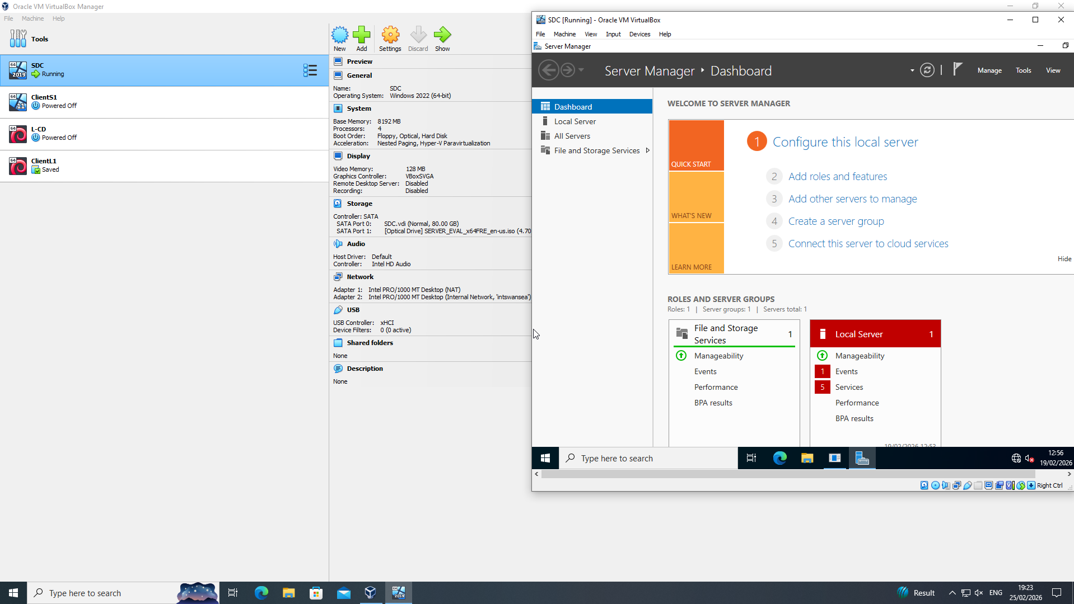

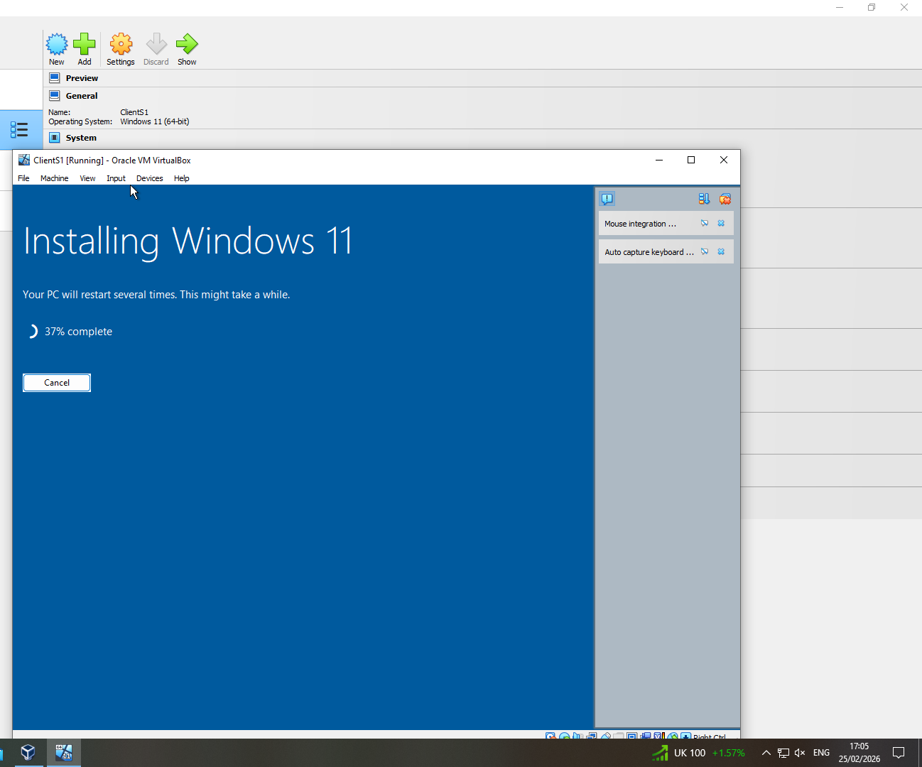
Windows ISO download and windows 11 download
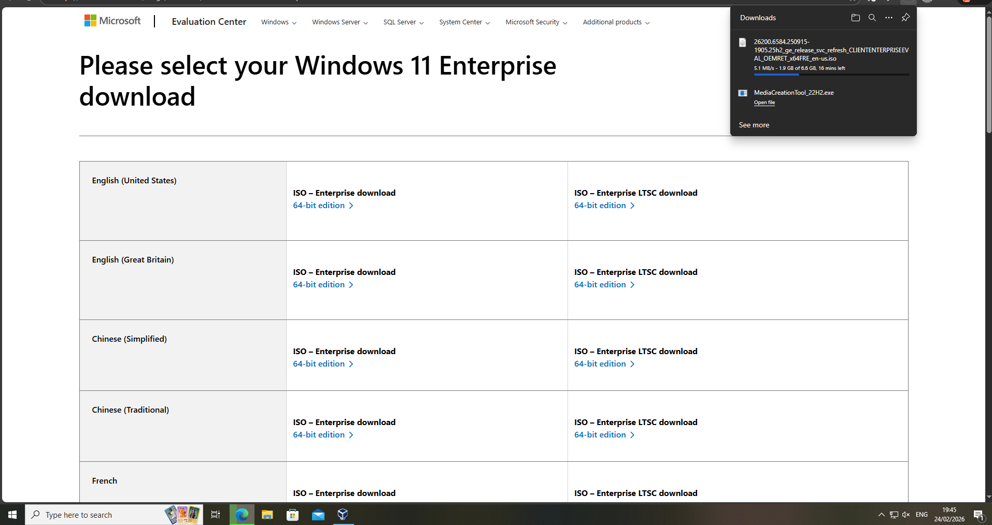

Download and Deployment

Virtual machine creation
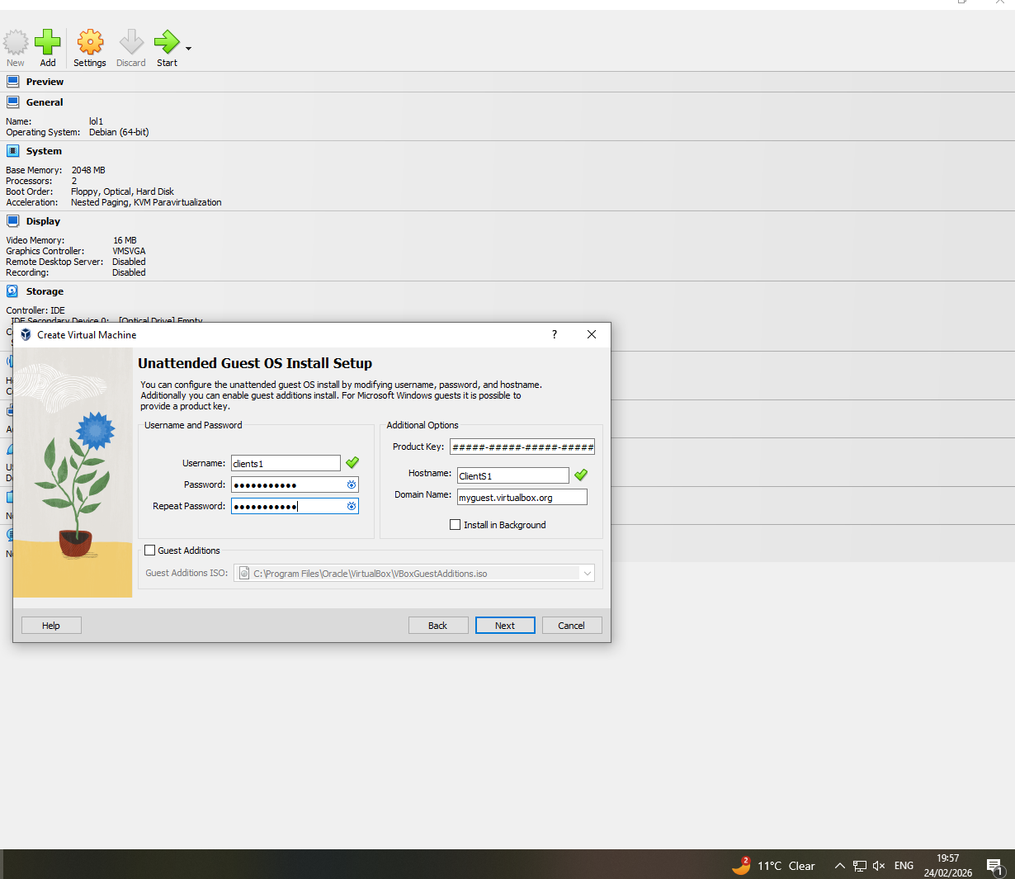

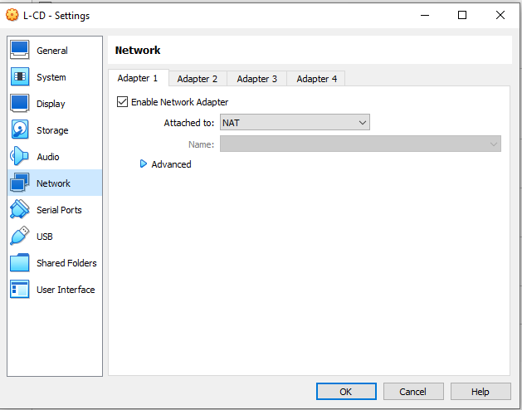
LCD – Adapter 1 (NAT) and LCD – Adapter 2 (internal network – INTLondon)
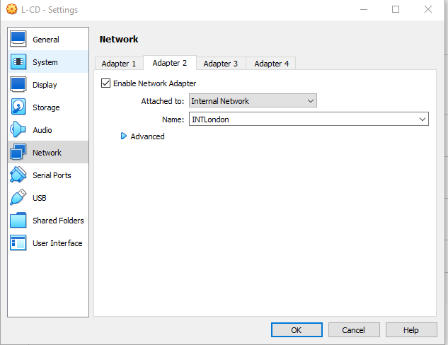

i

S-DC – Adapter 1 (Internal Network for 192.168.1.0 network) & S-DC – Adapter 2

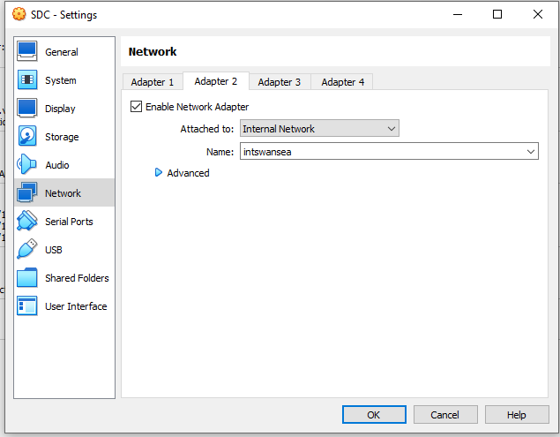
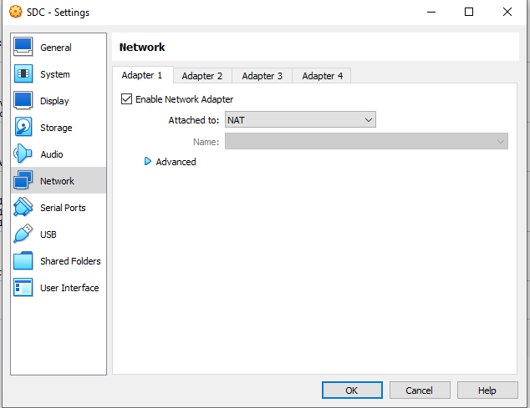

ClientL1 – Internal Adapter
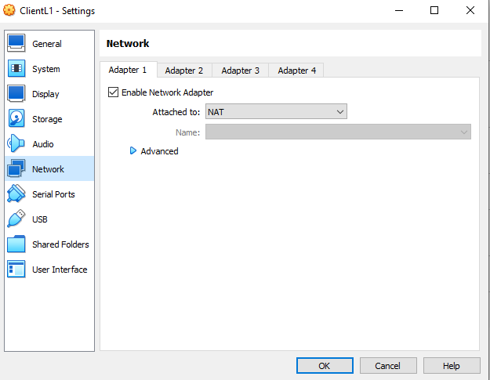

ClientS1 – Internal Adapter
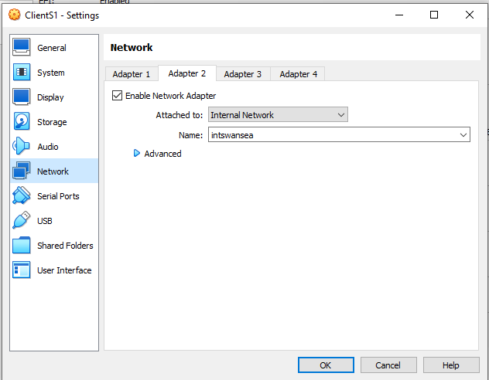

2.3 Configure IP Addressing

LCD – ipconfig showing 192.168.2.1
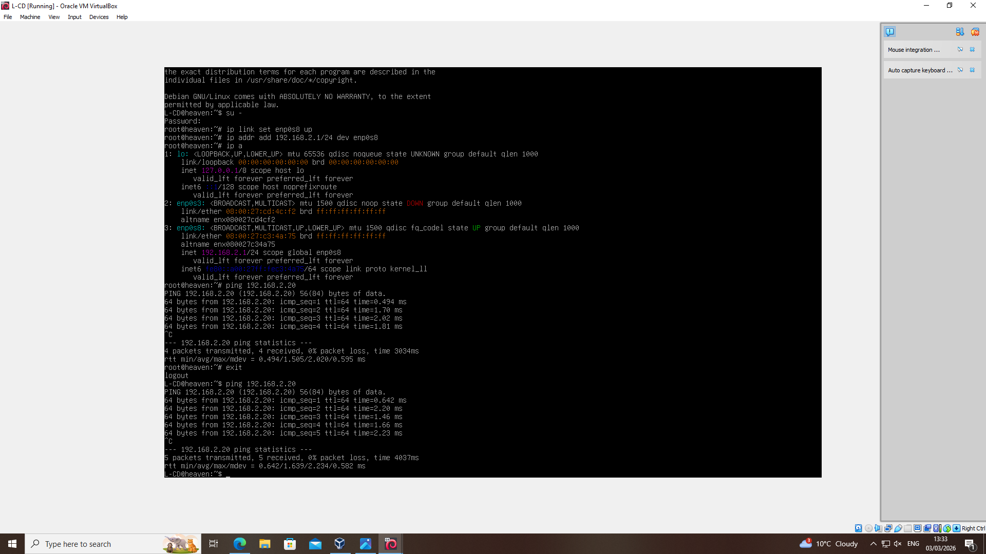

ClientL1 - ipconfig
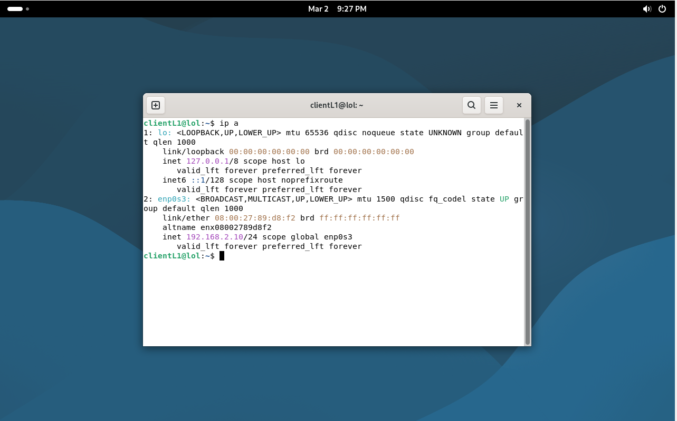
S-DC – IPCONFIG
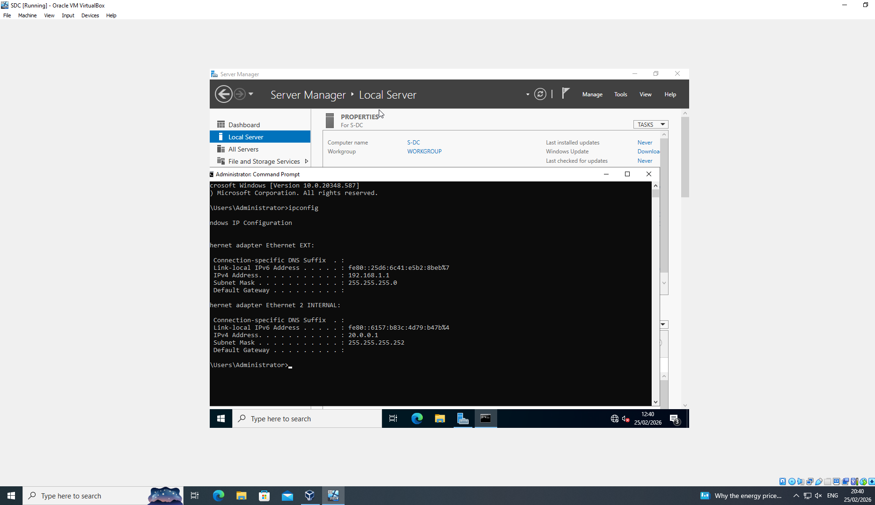
ClientS1 – IPCONFIG showing 192.168.1.10
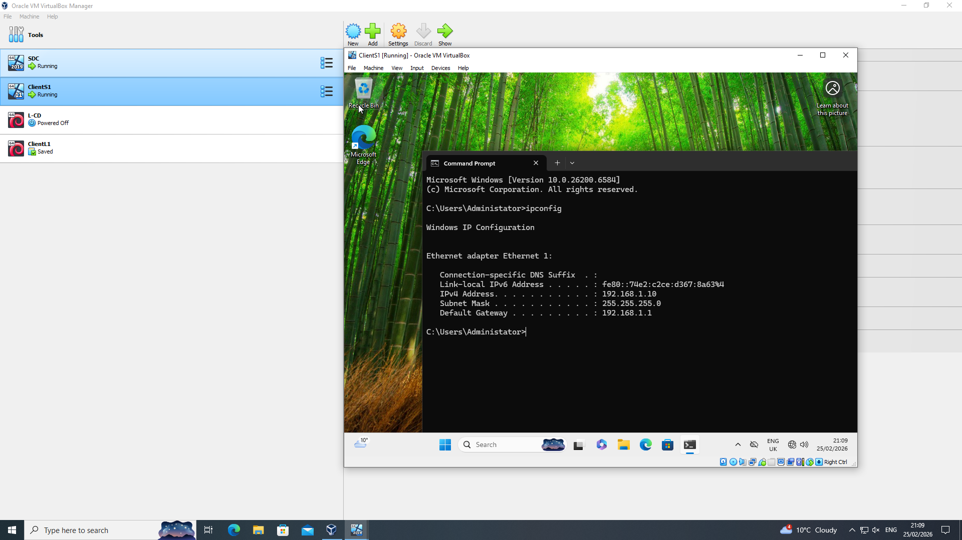

2.4 Connectivity Testing

LCD ping ClientL1 (SUCCESS)

ClientL1 ping LCD (SUCCESS)
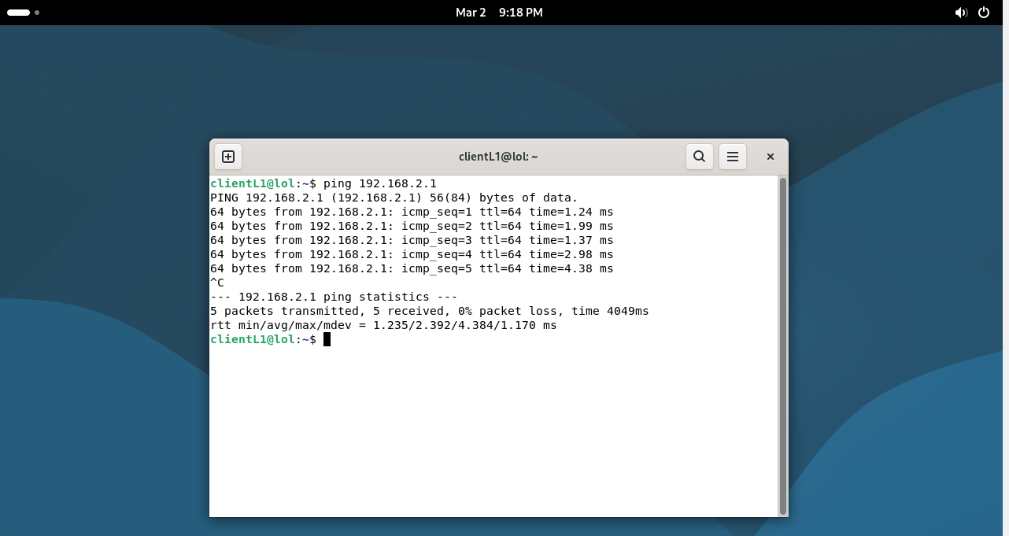
LCD ping 192.168.1.10 (FAIL – Network unreachable)
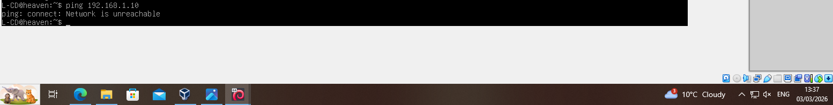
SDC ping to clientS1
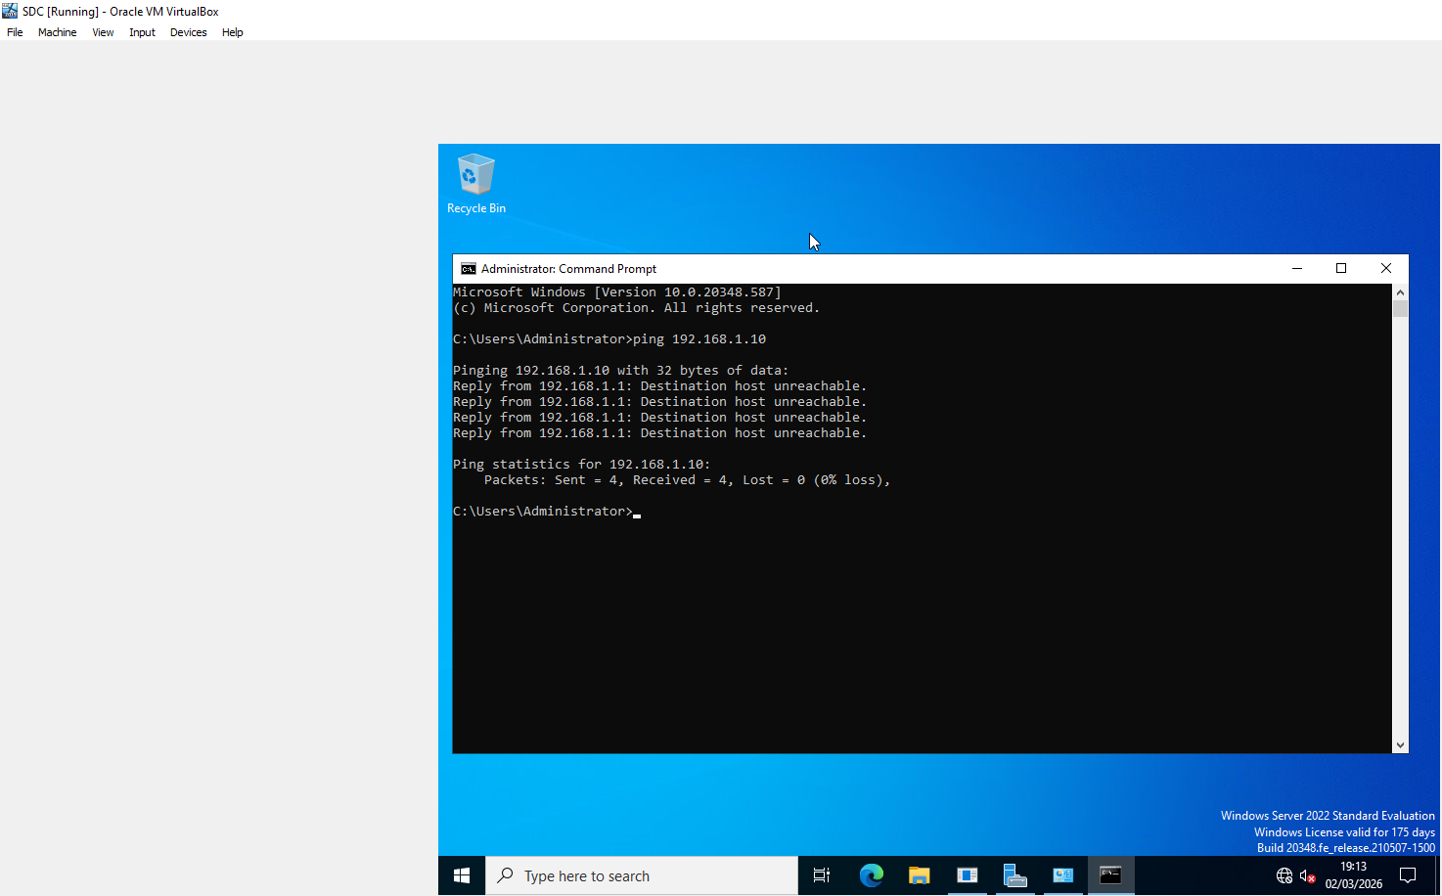

Clients1 ping to SDC
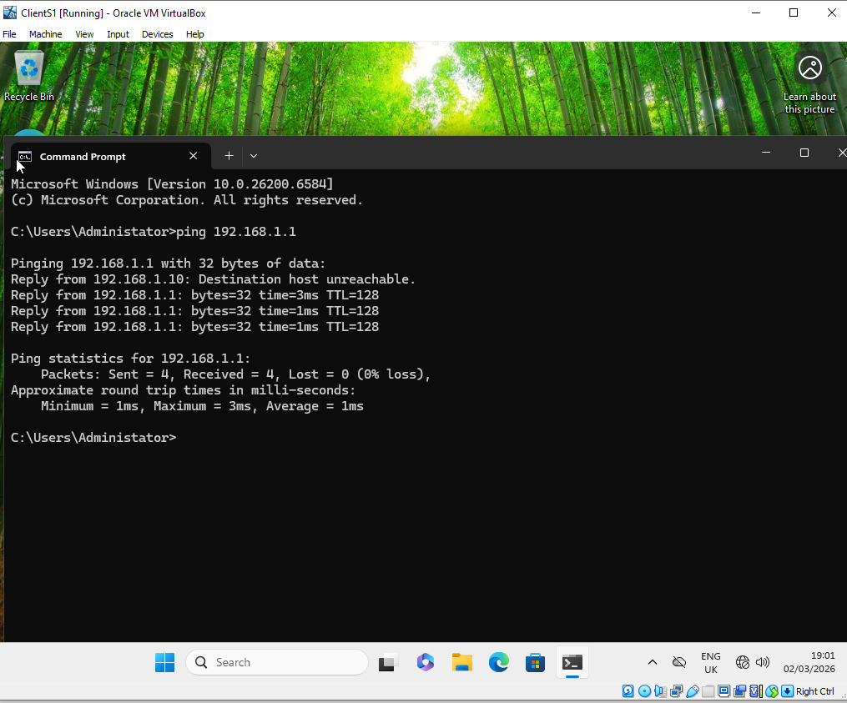

Task 3 – Reflection

In Task 2, I set up a virtualised network with VirtualBox, with several virtual machines (VMs) set up on two different subnets. One of the biggest problems was making sure that the dual network adapters (NAT and Internal Network – INTLondon) were set up correctly. Even though the adapters were set up correctly in VirtualBox, the connection didn't work at first because the internal interface was down.
While setting up static IP addresses on the Debian server (L-CD), I ran into problems where the interface didn't keep settings and ping tests said Network is unreachable. I figured out that the interface wasn't working right by using commands like ip a, ip route, and ip neigh. I used ip link set to manually bring up the interface and ip addr add to give it an IP address.
Ping was used to test both successful connectivity within the same subnet (192.168.2.0/24) and failed connectivity across different subnets (192.168.1.0/24), as needed. This proved that the network was divided up correctly.
Instead of changing a lot of things at once, problems were fixed one step at a time by checking adapter settings, IP configuration, and routing tables.
This task made me feel more sure of my ability to fix network problems. I learned that it's important to check the states of both physical and virtual adapters before assuming that there are problems with the configuration. The experience showed me again how important it is to use structured testing and command-line diagnostics to fix connectivity problems.

