

University of Wales Trinity Saint David’s
School of Engineering
Contemporary Logistics Challenges
Social Trends and Consumerism
M5X01285
Bence Tary
1902733
BSc Logistics and Transportation

Abstract

This paper considers the use of SM in contexts of marketing concepts relating to the broader concept of logistics, focusing on transportation management applications. The primary consideration is the use of SM to gather Big Data to do perspective and predictive analysis, ideas from marketing that help to reach an audience. Conclusion after the literature review is that there seems to be a lack of active use of social media within the logistics sector.

Table of Content
1. Introduction 2
2. Big Data 3
2.1. Logistics Application 3
2.1.1. Predictive Methods 4
2.1.2. Perspective Analysis 5
2.2. Theoretical Applications – Transport Planning 5
3. Social Media Marketing 6
3.1. SMM concept 6
3.2. Threats - #Aurora 8
4. Conclusions 8
5. References 8

- Introduction

Social media is a growing phenomenon, enabled by the Web 2.0 (Baines and Fill, 2014; Ismail, 2017), is a two-way conversation platform that can be used by marketers and academics to collect Big Data (Bruns, 2013). Sites like Twitter and Facebook have thousands of daily users, 3.2 billion for Facebook according to Zephoria Digital Marketing (2020), and 340 million for Twitter, generating around 500 million tweets a day (Omnicore, 2020).
Having such an active base, it is no surprise that there has been a drastic increase in Social Media Marketing (SMM). While the term SMM covers a range of digital marketing actions and is a loose umbrella term, this paper will use the definition given by Baines and Fill (2014), which is:

Social Media Marketing: “…is a form of internet marketing that utilises social networking websites as a marketing tool.” (Baines and Fill, 2014)

Social Media: Social media is a site enabled by Web 2.0 and allowing for user-generated content to be shared, created and exchanged (Ismail, 2017).

With this definition in mind, we will consider if SMM is positively affecting logistics firms and companies, and what risks it has.
Furthermore, this paper looks into further use of Social Media (SM) for purposes other than direct targeting. SM has been hailed as a method of investigating personal patterns of people, something that has been proposed to be put into use in transportation planning (Herrera-Quintero et al., 2018; Suma et al., 2017; Xu et al., 2020), and as a source of Big Data, especially Twitter which provides all the 3Vs that Big Data depends on Velocity; Volume; and Variety (Suma et al., 2017)
For this paper, Big Data will be defined as:

Big Data: Large amounts of data collected that are being stored and analysed by technology-enabled techniques (Ward and Barker, 2013), dependent of the 3 Vs (Suma et al., 2017; Wang et al., 2016).

- Big Data

Big Data has been challenging to define as many companies, including hardware giant Intel and software giant Microsoft, have different definitions, and in academic terms, which is the one used by this paper, is also different (Ward and Barker, 2013).
Ward and Barker (2013) highlight that Intel defines Big Data in terms of numerical quantity, placing the limit of Big Data above 300TB (terabytes) a day. This definition seems to be the outlier, as all others vaguely define Big Data in terms of data analysis.

  - Logistics Application

Mangan et al. (2008) highlight the need for high visibility and transparency in supply chains and logistics operations. They propose that the companies should communicate with each other and have easy access to each other’s information to ease the friction between companies working on the same operations.
Though they do not mention SM for this purpose, as a platform that allows interaction, it can be looked into that, though Jussila et al. (2014) found that companies do use SM internally, and even in Business to Business communication, though not regularly and not actively.
Other methods that SM can be used in has been explored by Ghani et al. (2019), and of the applications, they found this paper further wishes to explore two: Predictive Methods, mostly concerning demand; and Perspective Analysis, in the perspective of how companies get perceived on SM.
    - Predictive Methods

Ghani et al. (2019) argue in their paper that Big Data collected through SM can be used in many ways, and one of those is predicting trends. They called that trend discovery, a method whereby going through SM trending posts and sees what is seen as “cool” and “trendy”. Many SM sites, like Reddit, an SM site, have dedicated sections for trending topics and posts, which, in case of Reddit, is sorting post by “Popular”. One of these posts was a shared news article by a “Redditor” about climate change and the G20 meeting (Pessimist2020, 2020).
With visitor numbers similar to Twitter, Reddit is quite a popular site and is an excellent site to advertise on, and due to the simple up/down vote system it uses instead of likes/dislikes, it is easy to see if something is trending or not (Fundation, 2019). In the example above, it can be deduced that people are interested in climate change, which seems to be a trend in many sectors, especially in logistics (Mangan et al., 2008; Manners-Bell, 2017; McKinnon et al., 2015).
Another example studied by Chen et al. (2018) is the China Southern Airlines (CHA) and its mentions on Chinese SM site Weibo. While their research focuses on how Weibo users perceived CHA, they touch on the subject of prediction. They argue that using user post location data, and time, one can predict a possible spike in ridership, and destination/origin locations. On Figure 1.1 we can see how many #s were left on posts related to CHA, which shows clearly that New Year’s Vacation was often mentioned, while Figure 1.2 shows locations from where posts originated from, which shows that there is a large likelihood that there be a spike in departures from Beijing.
Suma et al. (2017) further highlight the use of SM to gather location information through SM. In their paper, they bring this up to monitor transportation, which they find can be predicted, as there was a spike in transportation-related tweets when events affecting people’s movements happen. They highlight this when the “Premier League” happened, a spike in transport-related posts increased in London.

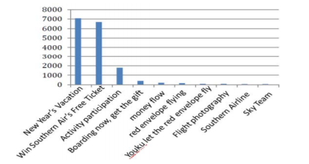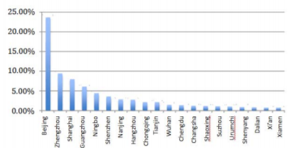
Figure 1.1 Associated terms mentioned by number and Figure 1.2 Percentage of post origins (Chen et al., 2018)

    - Perspective Analysis

In their paper, Felix et al. (2017) argue that social media can be used to gauge the perception of the public towards the frim, which is reinforced in other research that shows that opinion mining is an excellent method to gauge the public perception of a company (Ghani et al., 2019). This seems to be reflected in the British train industry, as Parkinson (2015) reports in the BBC news about angry tweets regarding British train industry. Many people have written complaints to train companies about late trains and crowds over social media, which has become such an issue that companies are now answering to these posts.
Although this seems to have its limitation as highlighted by Tufekci (2014), it must be mentioned, the limitations listed by them is concerning algorithmic research done through data mining, many of the points they make can be applied to the example above.
Tufekci (2014) highlights that quantifiable information on SM is usually the number of “likes” and “re-tweets”, which are not reliable. Clicks on a post can be numbered, but that does not include people who saw the post, agreed with it, but scrolled past without commenting, liking or re-tweeting the post, and does include those only clicked on it on accident. This means that gatherable data is not reliable.
There is also the issue of “screen capturing” and “hate-linking”, which are undetectable undertones. “Screen capturing” is the act of writing long texts, and posting it as a picture, popular of Twitter, where the number of characters is limited. As such, hashtags on the picture might not be picked up by the algorithm, and people might also miss them.
“Hate-linking”, as referred to by Tufekci (2014), as the act of sharing and linking ones original post on social media to hate on it. He brings up the example of #Aurora and Celeb Boutique, where a company wrongly posted something they should not have (see Figure 1.6) for which most re-tweets were made to mock the company.
Overall, however, this paper agrees with Felix et al. (2017) assessment that with an excellent SM department, perceiving the popularity of the firm through SM is possible. It takes proper management and control, but the company can gauge its audience’s emotions through SM.

  - Theoretical Applications – Transport Planning

Transit Signal Priority (TSP) systems already exist, which are systems where buses communicate with signal lights to ask for priority (Altun and Furth, 2009). In systems like these, employed successfully in Portland, Oregon, lights give buses extra green light if they are running late, and shorten red lights.
A similar system is proposed by Herrera-Quintero et al. (2018) in their research paper about Bluetooth gathering information from passengers and gathering it for storage. Their idea is shown in Figure 1.3, and though their paper does not link it back to transport planning, data collected through this method can be used in transport planning. Possible uses include counting the number of captured data at each junction and road, which can give a good indication as to the number of users.
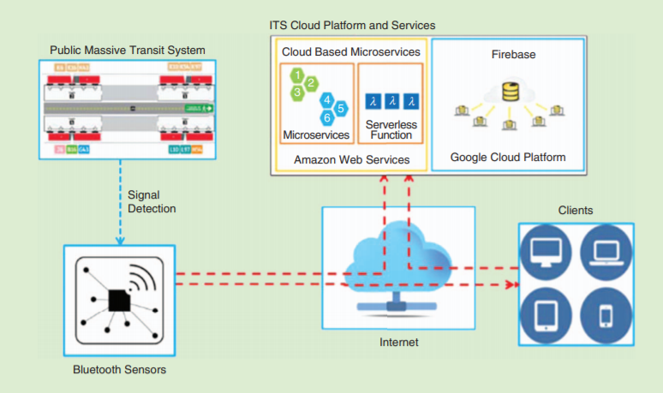
Figure 1.3 Idea of the Bluetooth collecting data (Herrera-Quintero et al., 2018)

Further uses might include utilizing the data collected to filter through topics, and to see what the most common origins/destination locations are. Though, these methods are contentious, as not everyone likes sharing their destination on social media.

- Social Media Marketing
  - SMM concept

SMM marketing evolved from a social shift towards the internet, which was driven by increased use of the internet (Baines and Fill, 2014). By 2012, a study by INSTEAD found that Europe had an internet penetration of 63.2% while North Amerika had around 78.6%. This is taken advantage of by logistics companies like Amazon, who regularly advertise online (Amazon, 2020).
This led to research into the forms of SMM and how companies interact through the internet. Companies seem to be divided as to how SMM should be managed, how active one should be on SM, and if one should allow employees to post, or should it all be regulated through a company department (Felix et al., 2017), presented on Figure 1.4, which shows the extremes discussed by Felix et al. (2017).
In their paper, Felix et al. (2017) argue that the extremes of SMM are modernist’s thinkers against conservative thinkers; exploders against defenders, hierarchies against networks; and anarchies against autocracies, all of which are sliding scales as to how much power stakeholders have in SMM effort of the company.
Modernists like to leave stakeholders to make most of the content, utilizing user-generated media, while conservatives like to control what is made. Same way, explorers refer to those who want to interact more with their stakeholders, against those who prefer statements rather than two-way communication.
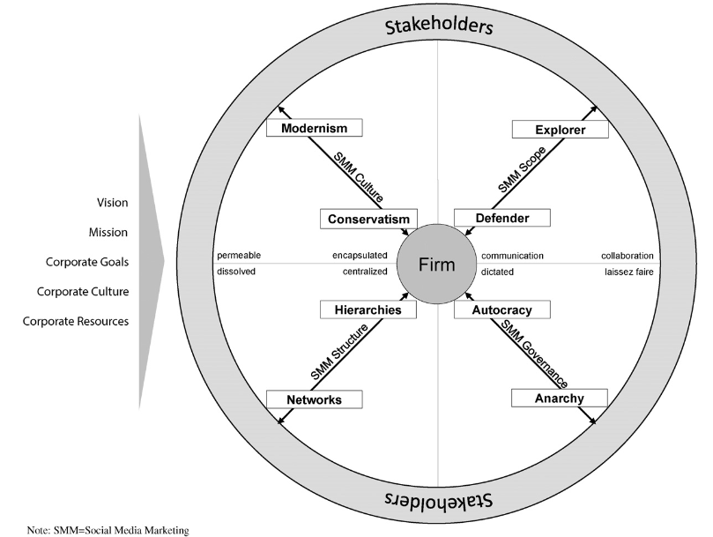
Figure 1.4 How Firms and Stakeholders interact (Felix et al., 2017)

Further, there is a debate as to all departments should be able to post, or should that task fall solely on a dedicated SMM department, which is the Hierarchy v Network debate. In all the above cases, there seem to be strong proponents to each method, and those who strongly value one over the other extreme.
Autocracy v Anarchy differs in that sense, as most people agree that complete anarchy is a bad idea, and cannot be worked. Because of that, most people preferring anarchies accept that some degree of control over what can be posted is needed, realising the risks of careless posting.
Overall, however, Ismail (2017) shows that while SMM has its limitations, most companies perceive the value of SMM as positive, and support expansion into SMM.

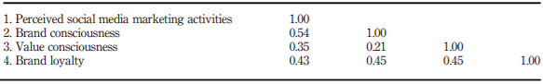
Figure 1.5 Perceived value of SMM (Ismail, 2017)

  - Threats - #Aurora

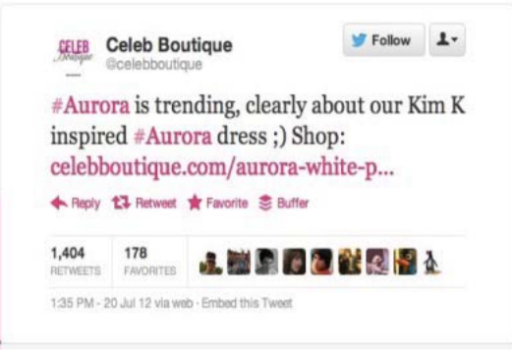
One of the threats is “mistweets”, tweets that anger population or create tension between target groups. An example is a tweet made by Celeb Boutique in the wake of the Aurora massacre when people supporting the victims and families started tweeting with the #Aurora to identify markers (Tufekci, 2014). This event caused an outrage on Twitter that negatively affected the company as people believed that they are negligent in their marketing (Golijan, 2012).
This is a significant example of threats that need to be avoided, and those who prefer to centralise SMM want to avoid these kinds of mistakes.
Figure 1.6 #Aurora mis-tweet (Tufekci, 2014)

- Conclusions

In conclusion, SM and its uses for logistics, when examined in SMM contexts, reveals that while there is use for SM in Logistics, Transportation is still figuring out how to use and take advantage of SM. There seems to be a leaning towards using SM for the gathering of Big Data, which can be used for a multitude of purposes, forecasting one of them, though that idea is mostly explored outside the industry contexts.
SMM is also considered by many companies, though only those who do more interaction with final customers, such as Amazon, while business to business marketing seems to lean strongly against SMM (Ismail, 2017), as there seems to be no benefit to talking to other companies through such methods.
Overall, there seems to be a lack of use of SMM and SM in the logistics sector outside of Big Data, and theoretical uses, a trend only broken by companies like Amazon, which deal directly with customers in the last leg of logistics chains.

- References

Altun, S.Z., Furth, P.G., 2009. Scheduling Buses to Take Advantage of Transit Signal Priority. Transportation Research Record 2111, 50–59. https://doi.org/10.3141/2111-07
Amazon, 2020. The show must go on.
Baines, P., Fill, C., 2014. Marketing, 3rd ed. Oxford, New York.
Bruns, A., 2013. Faster than the speed of print: Reconciling “big data” social media analysis and academic scholarship. First Monday 18, 1–5.
Chen, M., Liu, H., Wei, S., Gu, J., 2018. Top managers’ managerial ties, supply chain integration, and firm performance in China: A social capital perspective. Industrial Marketing Management 74, 205–214. https://doi.org/10.1016/j.indmarman.2018.04.013
Felix, R., Rauschnabel, P.A., Hinsch, C., 2017. Elements of strategic social media marketing: A holistic framework. Journal of Business Research 70, 118–126. https://doi.org/10.1016/j.jbusres.2016.05.001
Fundation, 2019. Reddit Statistics For 2020: Eye-Opening Usage & Traffic Data [WWW Document]. URL https://foundationinc.co/lab/reddit-statistics/ (accessed 11.21.20).
Ghani, N.A., Hamid, S., Targio Hashem, I.A., Ahmed, E., 2019. Social media big data analytics: A survey. Computers in Human Behavior 101, 417–428. https://doi.org/10.1016/j.chb.2018.08.039
Golijan, R., 2012. Clothing retailer’s insensitive #Aurora tweet enrages Internet. NBC News.
Herrera-Quintero, L.F., Vega-Alfonso, J.C., Banse, K.B.A., Zambrano, E.C., 2018. Smart ITS Sensor for the Transportation Planning Based on IoT Approaches Using Serverless and Microservices Architecture. IEEE Intelligent Transportation Systems Magazine 10, 17–27. https://doi.org/10.1109/MITS.2018.2806620
Ismail, A., 2017. The influence of perceived social media marketing activities on brand loyalty: The mediation effect of brand and value consciousness. Asia Pacific Journal of Marketing and Logistics 29, 1–17. https://doi.org/10.1108/APJML-10-2015-0154
Jussila, J.J., Kärkkäinen, H., Aramo-Immonen, H., 2014. Social media utilization in business-to-business relationships of technology industry firms. Computers in Human Behavior 30, 606–613. https://doi.org/10.1016/j.chb.2013.07.047
Mangan, J., Lalwani, C., Butcher, T., 2008. Global Logistics and Supply Chain Management, 2nd ed. Wiley, Great Britian.
Manners-Bell, J., 2017. Introduction to global logistics: delivering the goods, Second edition. ed. Kogan Page, New York.
McKinnon, A., Browne, M., Piecyk, M., Whiteing, A. (Eds.), 2015. Green Logistics; Improving the environmental sustainability of logistics, 3rd edition. ed. KoganPage, London.
Omnicore, 2020. • Twitter by the Numbers (2020): Stats, Demographics & Fun Facts. URL http://www.omnicoreagency.com/twitter-statistics/ (accessed 11.19.20).
Parkinson, J., 2015. What’s it like to answer angry tweets about trains? BBC News.
Pessimist2020, 2020. Boris Johnson to urge Trump and other G20 leaders to do more to fight coronavirus and climate change. r/worldnews.
Suma, S., Mehmood, R., Albugami, N., Katib, I., Albeshri, A., 2017. Enabling Next Generation Logistics and Planning for Smarter Societies. Procedia Computer Science, 8th International Conference on Ambient Systems, Networks and Technologies, ANT-2017 and the 7th International Conference on Sustainable Energy Information Technology, SEIT 2017, 16-19 May 2017, Madeira, Portugal 109, 1122–1127. https://doi.org/10.1016/j.procs.2017.05.440
Tufekci, Z., 2014. Big Questions for Social Media Big Data: Representativeness, Validity and Other Methodological Pitfalls. arXiv:1403.7400 [physics].
Wang, G., Gunasekaran, A., Ngai, E.W.T., Papadopoulos, T., 2016. Big data analytics in logistics and supply chain management: Certain investigations for research and applications. International Journal of Production Economics 176, 98–110. https://doi.org/10.1016/j.ijpe.2016.03.014
Ward, J.S., Barker, A., 2013. Undefined By Data: A Survey of Big Data Definitions.
Xu, Z., Liu, Y., Yen, N.Y., Mei, L., Luo, X., Wei, X., Hu, C., 2020. Crowdsourcing Based Description of Urban Emergency Events Using Social Media Big Data. IEEE Transactions on Cloud Computing 8, 387–397. https://doi.org/10.1109/TCC.2016.2517638
Zephoria Digital Marketing, 2020. Top 20 Facebook Statistics - Updated October 2020. Zephoria Inc. URL https://zephoria.com/top-15-valuable-facebook-statistics/ (accessed 11.19.20).

