
‘Configuring and Managing a Virtualised Network’
Network Operating Systems and Services (ACCA5023)

Jonathan Lesmond (2300728)
BSc Applied Computing

Table of Contents
1. Swansea Network 4
1.1 Routing and Remote Access Services and Modifying Firewall 4
1.2 Configuring VPN Between Debian and Windows Server 4
1.3 Creating a Forest 5
1.4 Creating Appropriate A Records on Both Servers 5
1.5 Creating Reverse Lookup Zones and PTR Records on Both Servers 6
1.6 Creating Users in the Domain 6
1.7 Mounting a Second Disk Drive 7
1.8 Configuring DHCP Services 8
1.9 Joining Swansea Client to the Domain 8
1.10 Assigning DHCP IP Address to Swansea Client 9
2. Cardiff Network 10
2.1 Install RRAS and Allow ICMP Traffic Through the Firewall 10
2.2 Configure Site-To-Site Persistent VPN Connection to Swansea Network 10
2.3 Joining Cardiff Network Devices to the Domain 10
2.4 Configure DHCP Services 10
2.5 Joining Cardiff Client to Child Domain and Assign DHCP IP Address 11
3. Testing Connectivity Across the Network 11
4. Sharing the Swansea Disk Drive 11
5. Configuring the IIS Server 12
5.1 Creating a Webpage and Enabling Windows Authentication 12

Table of Figures
Figure 1 – Creating a New Inbound Rule to Allow ICMP Traffic Through the Firewall. 4
Figure 2 -Enabled and Successfully Connected Persistent VPN. 4
Figure 3 - Creating Domain/Forest. 5
Figure 4 - PowerShell Commands Used to Create Resource Records. 5
Figure 5 - Displaying A Records. 5
Figure 6 - PowerShell Commands Used to Create PTR Records. 6
Figure 7 - PowerShell Script to Create Users. 6
Figure 8 - Users in Active Directory. 7
Figure 9 - Creating Swansea Files Disk Drive. 7
Figure 10 - Creating DHCP Server. 8
Figure 11 - Swansea Client in Active Directory. 8
Figure 12 – Swansea Client in DHCP IP Address Leases. 9
Figure 13 - VPN Connection from Debian Server's Perspective. 10
Figure 14 - Debian Server in Active Directory Along with Swansea Client. 10
Figure 15 - DHCP Relay Configuration. 10
Figure 16 - Cardiff Client Joined to the Domain. 11
Figure 17 - Giving Users in the Domain Full Control Permissions on Swansea Files Drive. 11
Figure 18 - Webpage for IIS Server. 12
Figure 19 - Adding the Webpage to the IIS Manager. 12
Figure 20 - Enabling Windows Authentication. 12

1. Swansea Network

1.1 Routing and Remote Access Services and Modifying Firewall
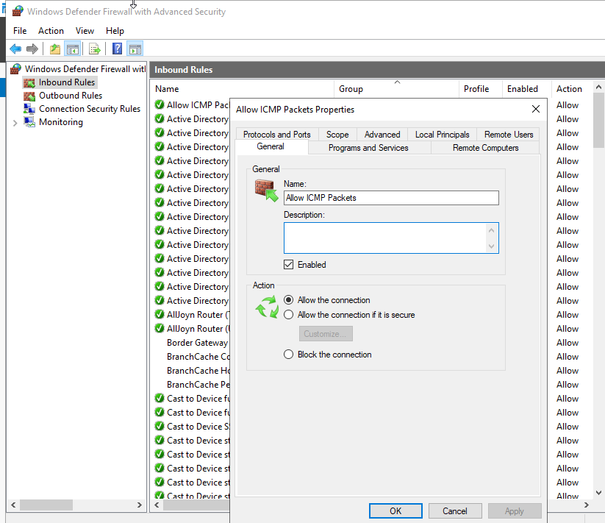
Figure 1 – Creating a New Inbound Rule to Allow ICMP Traffic Through the Firewall.

1.2 Configuring VPN Between Debian and Windows Server
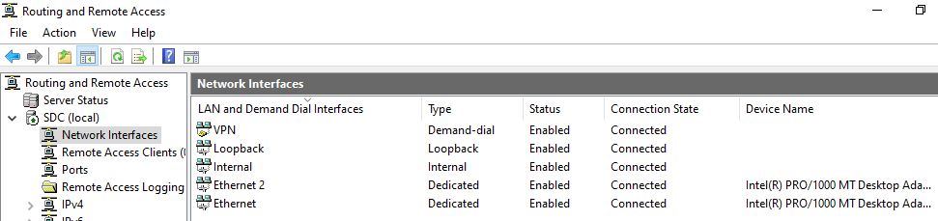
Figure 2 -Enabled and Successfully Connected Persistent VPN.

1.3 Creating a Forest
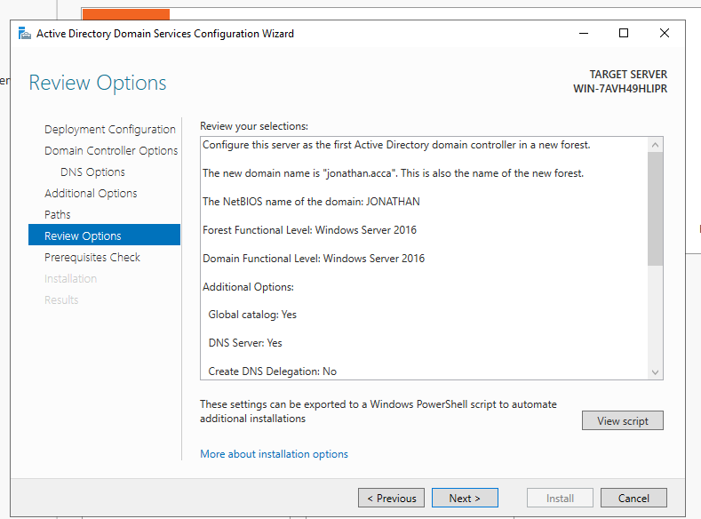
Figure 3 - Creating Domain/Forest.

1.4 Creating Appropriate A Records on Both Servers
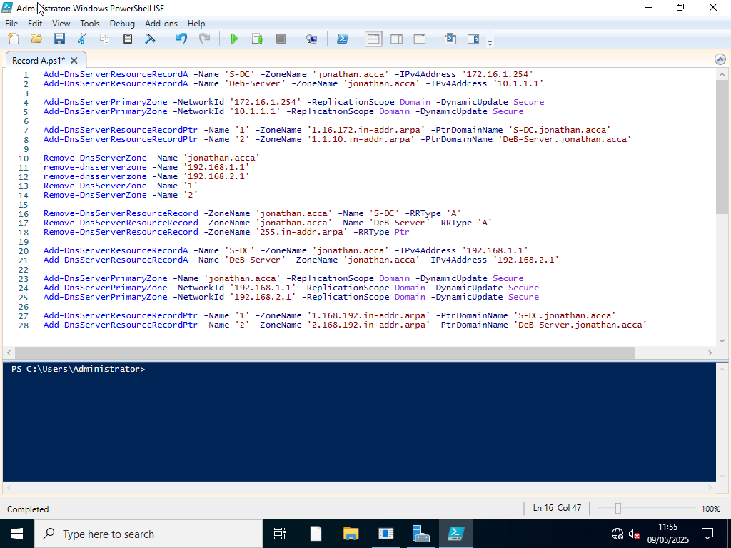
Figure 4 - PowerShell Commands Used to Create Resource Records.
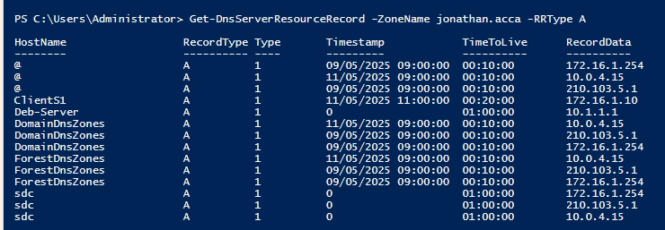
Figure 5 - Displaying A Records.

1.5 Creating Reverse Lookup Zones and PTR Records on Both Servers
Figure 6 - PowerShell Commands Used to Create PTR Records.

1.6 Creating Users in the Domain
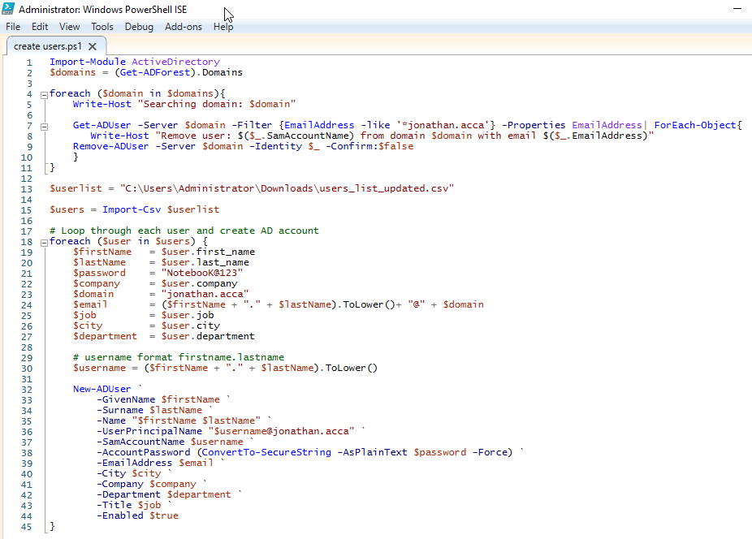
Figure 7 - PowerShell Script to Create Users.
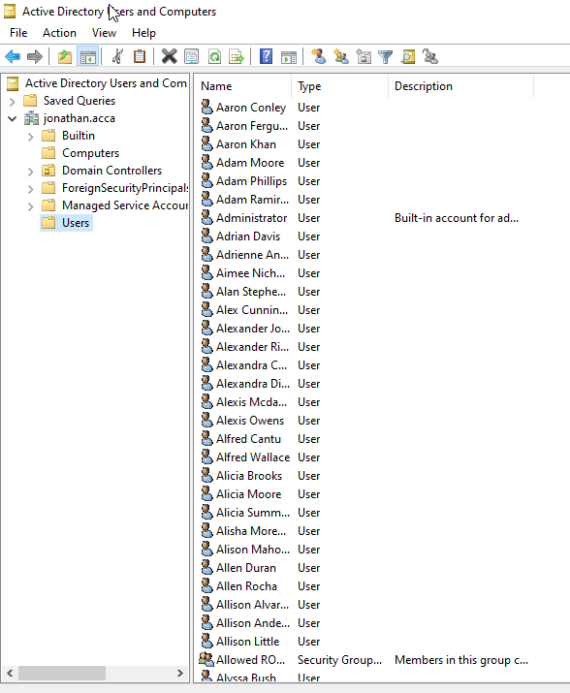
Figure 8 - Users in Active Directory.

1.7 Mounting a Second Disk Drive
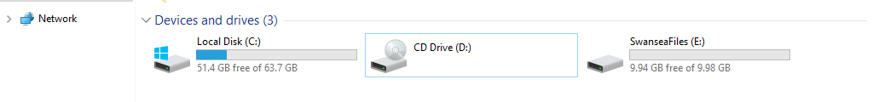
Figure 9 - Creating Swansea Files Disk Drive.

1.8 Configuring DHCP Services
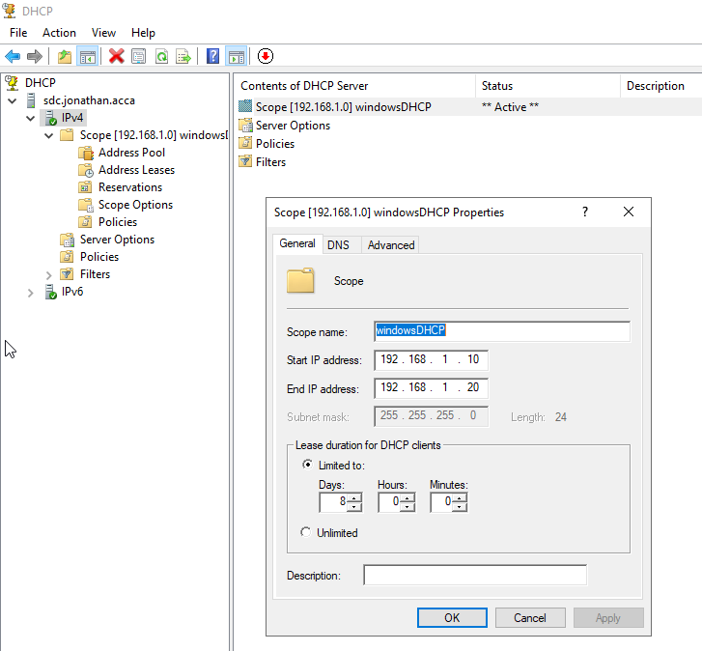
Figure 10 - Creating DHCP Server.

1.9 Joining Swansea Client to the Domain
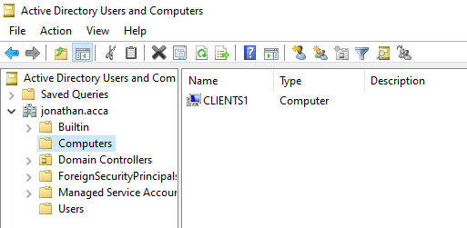
Figure 11 - Swansea Client in Active Directory.

1.10 Assigning DHCP IP Address to Swansea Client
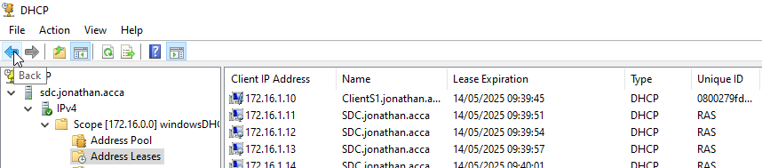
Figure 12 – Swansea Client in DHCP IP Address Leases.

2. Cardiff Network

2.1 Install RRAS and Allow ICMP Traffic Through the Firewall

2.2 Configure Site-To-Site Persistent VPN Connection to Swansea Network
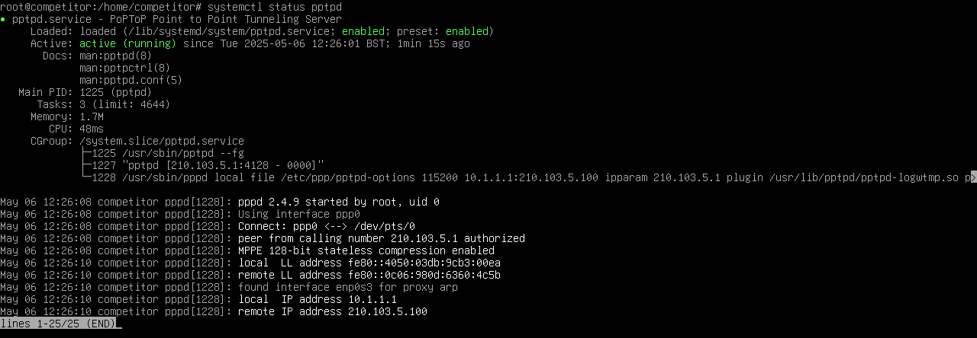
Figure 13 - VPN Connection from Debian Server's Perspective.

2.3 Joining Cardiff Network Devices to the Domain
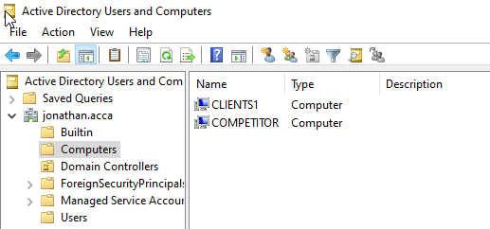
Figure 14 - Debian Server in Active Directory Along with Swansea Client.

2.4 Configure DHCP Services
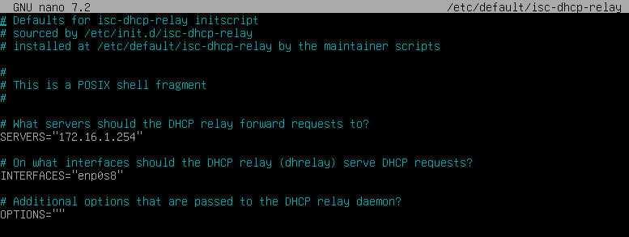
Figure 15 - DHCP Relay Configuration.

2.5 Joining Cardiff Client to Child Domain and Assign DHCP IP Address
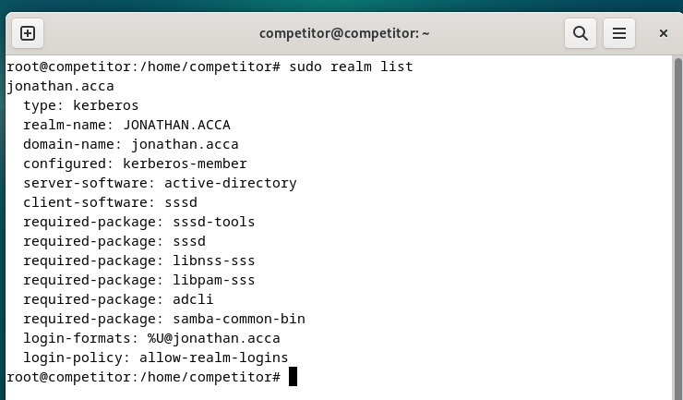
Figure 16 - Cardiff Client Joined to the Domain.

3. Testing Connectivity Across the Network

4. Sharing the Swansea Disk Drive
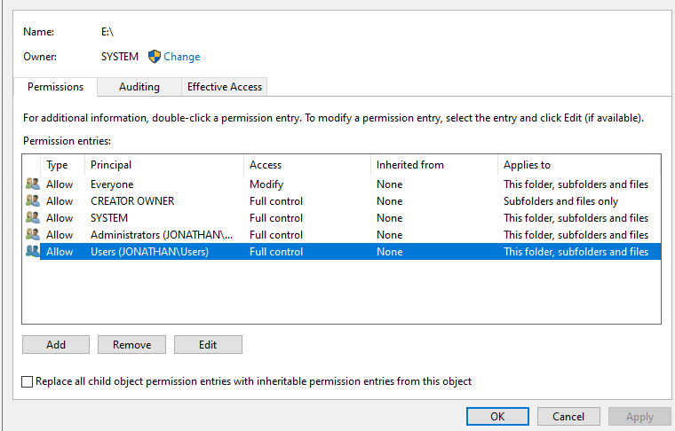
Figure 17 - Giving Users in the Domain Full Control Permissions on Swansea Files Drive.

5. Configuring the IIS Server

5.1 Creating a Webpage and Enabling Windows Authentication
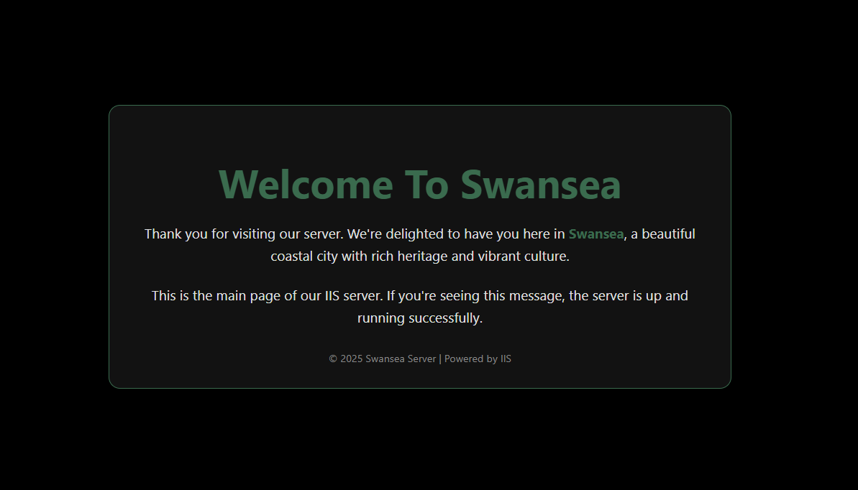
Figure 18 - Webpage for IIS Server.
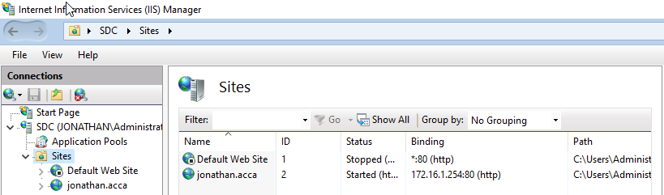
Figure 19 - Adding the Webpage to the IIS Manager.
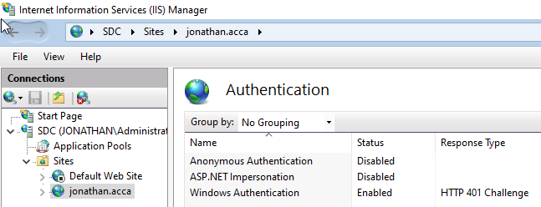
Figure 20 - Enabling Windows Authentication.

