

Hotel Placement – Managing Hotel Administration

Student Name: Raducu – Viorel Ciolpan
Lecturer`s Name: Jessica Newport
Word Count: 1251
Student ID: 2221478
Date of Submission: 17/06/2025

Table of Contents
Introduction 3
Section 1: Role Reflection 4
Section 2: Management Performance & Guest Service Analysis 6
Section 3: Guest Service Improvement Plan 8
Conclusion 9
References 10
Table of figures
Figure 1:Ashford International Hotel 3

I acknowledge the use of Grammarly (https://www.grammarly.com/) on 17 June 2025 to check my work using the prompt(s):
- Please check the following text for readability, grammar and syntax.

I confirm that I have not presented any AI generated text as my own work. I confirm I have copies of my drafts, notes, and other resources I used before, and after the use of AI tools which I may be asked to provide in evidence.

I acknowledge the use of Google Scholar on 17 June 2025 to check my work using the prompt(s):
- Please check the following text for readability, grammar and syntax.

I confirm that I have not presented any AI generated text as my own work. I confirm I have copies of my drafts, notes, and other resources I used before, and after the use of AI tools which I may be asked to provide in evidence.

Introduction
In my time at Ashford International Hotel & Spa, I gained experience of a multitude of departments. This reflective learning log will regard the housekeeping department, which is a critical place that must ensure the guest rooms, public areas, and service areas are appropriately clean, comfy, and appealing according to the hotel’s high standards of cleanliness (Bhatnagar, and Nim, 2019). Cleanliness is considered one of the most important contributors to guest satisfaction in the hospitality industry, and housekeeping is a major contributor to a positive experience and one of the constituent parts of a positive guest experience. Services include daily room service, deep cleaning, laundry management, and responding to special guest requests offered by the department at Ashford. In my assignment I wanted to complete three major learning objectives: firstly, to be able to develop a sturdy understanding of the administrative home cleanliness norms; secondly, to enhance my show and teamwork skills inside an exceedingly fast-paced condition; and thirdly, to nurture my capacity to solve conflicts and make choices properly during real guest service conditions.
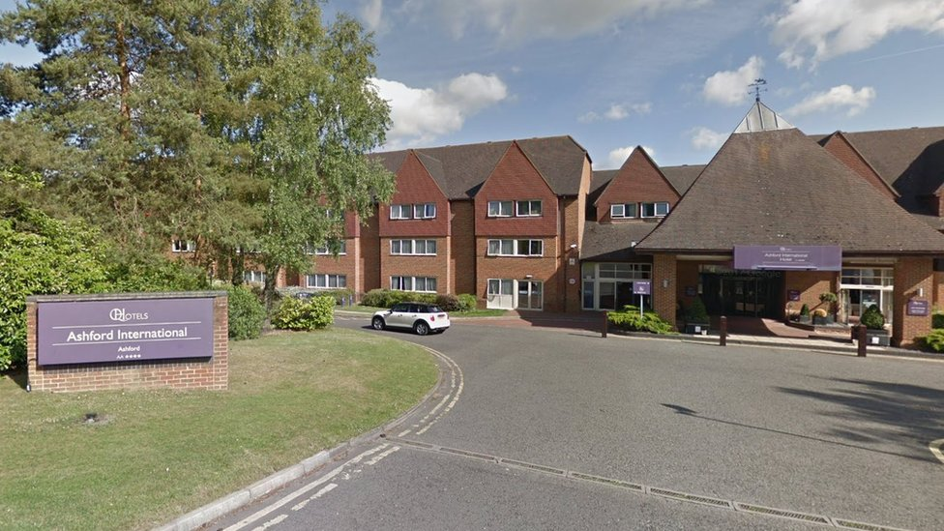
Figure 1:Ashford International Hotel
(Source: 2018, https://www.bbc.com/)

Section 1: Role Reflection
There is a widely accepted model of structured thinking through six stages: Description, Feeling, Evaluation, Analysis, Conclusion, and Action Plan (Baron, 2023).
Role Overview:
While I was at my placement, I was a housekeeping assistant. Preparing guest rooms, maintaining public areas, operating laundry, reporting maintenance issues, and responding to guest requests are my tasks.
Key Skills for Supervisors/Managers in Housekeeping:
- A housekeeping manager should be able to effectively delegate duties for their staff to see that all of the rooms
- The main point of coordination involves supervisors, attendants, and maintenance staff.
- Managers are faced with unexpected guest complaints or necessary maintenance issues that must be dealt with immediately.
Real Examples from Placement:
Example 1- Effective Leadership:
There was one morning where early check-ins came in with a sudden influx. The staff were quickly reassigned by the Housekeeping Manager to rooms that were prioritized without blowing one factor out of proportion. This clear delegation made the team calm and guests satisfied.
Reflection:
Seeing it takes calm leadership and effective delegation under pressure. It showed us how essential it is to get sharp on the disruption without throwing the team into a tailspin.
My Strengths and Weaknesses:
Lack of flexibility for creativity, unwillingness to compromise when it comes to their ways, can’t follow instructions unless they have already been written by someone else (Adams, 2019).
Hesitation(s) in making quick decisions under pressure and of which one is a lack of confidence when deciding to pass on escalation of issues to supervisors.

Section 2: Management Performance & Guest Service Analysis
Management Styles:
It was mostly transformational in the leadership style used in the housekeeping department, i.e., motivation of the staff and encouragement towards a more professional approach. According to theories of my Management & Organizational Behavior (Level 5) module, transformational leadership enhances staff motivation, improves service quality, and enhances organizational productivity (Hawkins, 2021).
At Ashford I found that the level of team motivation was greater when the manager was fresh and participative with staff and praised good performance. However, times when staff morale was dipped by the rigid, transactional supervision where all staff were focused on task completion (to the exclusion of anything else) stemmed from the same direction.
Health & Safety Compliance:
Health and safety were very important to Ashford International Hotel & Spa (Hudson, 2025). Equipment (e.g., vacuum cleaners, usage of chemicals) was regularly checked, and manual handling procedures were carried out. This also fits within industry best practice, such as COSHH regulations and the Health and Safety at Work Act 1974 (UK legislation).
Another compliance exercise that I undertook at my placement was the mandatory health and safety briefing, which reiterated the importance in the prevention of injury by ensuring correct handling techniques.
Culture & Teamwork:
Daily work was highly dependent on organizational culture (Davis, 2023). In respect to Personnel Resourcing & Development (Level 5), the Housekeeping promoted a culture of teamwork and respect, which is supported by theories.
An open climate, an open sky, and a supportive culture that created a positive atmosphere: one of feeling valued. Clean, welcoming, or something you hear over and over again: how internal teamwork directly impacts external service delivery. That was the theme.

Marketing & Guest Experience:
The work of the housekeeping team to manage guest expectations amounted to work that often was behind the scenes but was very important to managing guest expectations. Being a 4-star hotel, cleanliness is a given.
I know that in order to maintain a strong brand reputation, operational excellence is its own form of marketing from the Marketing Essentials (Level 4) module. High housekeeping standards never (or rarely) resulted in guest reviews or loyalty blemishes (GUPTA, 2024).

Section 3: Guest Service Improvement Plan
Why is this significant?
First impressions matter most when determining how guests will find overall satisfaction. Negativity from waiting for a room will negatively impact the entire stay.
Additionally, delayed room preparation can also bottleneck reception operations and negatively impact both guest service scores and operation flow.
Three-Step Improvement Plan:
Implement Real-Time Communication Tools:
Create a live room-status update app that is accessible to Reception, Housekeeping, Maintenance, etc. (Mourmoura, 2020).
Operational efficiency technology adoption is imperative in modern hotels.
Introducing a Flexible Staffing Model:
During the busy times, schedule a few ‘floating’ housekeeping team members who will be on standby to assist with the priority room cleanings.
Loosely, impact includes reducing bottlenecks and having rush rooms ready sooner.
Pre-Arrival Room Assignment:
In case there are early arrival guests flagged by Reception in advance, assign rooms to housekeeping teams.
Strategic prioritization enables the guest to receive an improved service and decrease the number of complaints (Goodman, 2019).
The main problem observed for which a solution was sought in the housekeeping department of Ashford International Hotel & Spa was room readiness delays which occurred sporadically during peak occupancy. As it is no secret to you, you only have one chance to prepare a room for your guest, and it must be done on time. The research concludes that there is no better way to perform housekeeping management than by making use of proper scheduling and workload balancing. For this, a three-step improvement plan is initiated.

Conclusion
Ashford International Hotel & Spa gave me insight as to how guest service operations operate, and being in the housekeeping department gave a better grasp of how important cleanliness is in helping guests to be satisfied. I had hands-on experience that allowed me to see how direct impact on operational success and guest experience is made by strong leadership, good communication, and teamwork.
This placement gave me the majority of what I aimed to achieve in my first learning objectives. I learnt the different housekeeping standards and was able to work at a high pace within a busy team. Despite the fact that I knew there were still some things that my confidence in high-pressure decision-making situations required work on, I wrote up an action plan to help me with my future professional growth.
Management style, organizational culture, health and safety practices, and marketing components were analyzed, and it was found that all the elements of the work are coupled with each other to attain high levels of guest satisfaction. All in all, I believe the placement helped me firm up my ambition to work in the field of hospitality management and set up a perfect course for my continuous improvement.

References
Adams, J.L., (2019). Conceptual blockbusting: A guide to better ideas. Hachette UK.
Baron, J., (2023). Thinking and deciding. Cambridge University Press.
Bhatnagar, E. and Nim, D., (2019). Impact of housekeeping services and practices on customer satisfaction and repeat business. Prabandhan: Indian Journal of Management, 12(8), pp.46-57.
Davis, S.G., (2023). Spectacular nature: Corporate culture and the Sea World experience. Univ of California Press.
Goodman, J., (2019). Strategic customer service: Managing the customer experience to increase positive word of mouth, build loyalty, and maximize profits. Amacom.
GUPTA, R., (2024). Managing hotels: nuts & bolts of hotel management. Notion Press.
Hawkins, P., (2021). Leadership team coaching: Developing collective transformational leadership. Kogan page publishers.
Hudson, S., (2025). Hospitality Management: International Introduction. Taylor & Francis.
Mourmoura, M., (2020). The use of smartphones applications for customer service purposes.

