

The Application of an Engineering Design Methodology – Dry Sump Design

Engineering Design & Materials

Reuben Shepherdson
1702446

08/03/2018

A Dry Sump is required for a 1.6 Ford Zetec engine as it is going to be used for a motorsport application, for this particular application it will be used on a race track. As the engine will be used on track it will be put under forces that it would not usually be put under in its usual application (a road car) this means that the oil inside the engine, primarily the sump will be put under greater g forces than usual this means that the engine could be starved of oil due to there not being enough oil delivered to the standard oil pick up. This could result in engine failure which could in turn result in the engine having to be rebuilt.
By having a Dry Sump system in place, the issues stated above can be prevented as any oil that is in the sump can be pumped out into an oil reservoir and the fed straight back into the engine. The benefit of a Dry Sump is that the standard oil pick up is not required as the engine always has an oil supply from the reservoir meaning there is very little chance of the engine being starved of oil.
As this sump is going to be used for a motorsport application (track) there are several requirements that it should meet. The product should be light weigh, the product should be easy to install, In the event of a roll-over, the engine should not be flooded with lubricant, The product should be low cost, The product should allow easy/fast access for servicing/maintenance. These requirements will be elaborated on further on in the report.

During the development of the product is was decided that as the sump no longer needed to store the oil required for the engine and the Crankshaft goes no lower than the bottom of the engine block it would be possible that the depth of the sump could be reduced meaning it would be shallower. This would benefit the car and its application as the engine could possibly be mounted lower in the engine bay meaning the cars centre of gravity in a Z axis is lower, this can help with handling. This could also mean that the sump is less likely to bottom out on the floor or catch a curb which could result in potential damage the rest of the engine. As the sump is shallower there would be less material required, therefore the sump is lighter, which means that the cars overall weight is less.

A number of factors had to be taken into account while designing the sump to fit the specified customer requirements. As it was important that the product was light weight, the material that the sump would have been made of should have been thought about carefully. The materials that were considered where Aluminium, Steel, and Titanium. While considering Titanium it was important to think abut the other customer requirements. As one of the requirements was for the sump to be low cost it didn’t make it feasible to use Titanium to be as the material that the sump would be manufactured from as it is expensive. Steel could have been a good option as it is strong and less prone to cracking compared to Aluminium and Titanium it was more likely that Steel would bend if it had to take an impact, this would mean that if a steel sump were to bottom out while on track it was more likely to bend than crack which would mean that there would be less of a likelihood of having to retire from an event as there isn’t as high of a possibility of engine failure as the engine wouldn’t lose any oil. But as steel is rather heavy in comparison to Aluminium and Titanium it was less likely that it would have been used, the material thickness could be less if steel was used but considering as the sump had to help mount the Gearbox, it would have to be strong so the material would have to be thick, so if steel was used it the sump would become heavy. While considering Aluminium for the material that the sump would have been made from it was seen that it met both of the customer requirements that were specified. Aluminium is light weight and is low in cost, so it was decided that the sump would be manufactured out of aluminium.
Another factor that was considered in the design process was the manufacturing proses that the sump would undergo while in production. The sump could have been CNC machined out of a solid billet which would have been an expensive option as CNC machines are expensive to run and the would be a lot of wasted material from the original Aluminium billet from which the sump would have been machined from. So due to cost the process of CNC machining the sump was ruled out as it would have been too expensive. Another option for the manufacturing process of the sump was injection. This is a good option if high production numbers are necessary, but this is an expensive process to go through if only a small batch of sumps need to be made and it was not specified to the exact number of sumps that would need to be made. This process was also ruled out due to cost factors. The last option that was considered for the manufacturing proses was for the sump to be made out of sheet/ plate. This option was considered as it seemed the production numbers of the sump would have been low meaning that by making the sump out of Aluminium plate and welding the individual pieces together was a viable option, it would just need to be decided on the material thickness that would need to be used. As 6mm is a common thickness that aluminium plate is usually made in and as this thickness would have been strong enough to support the gearbox yet light enough to make it worth wile it was decided that the manufacturing process that the sump would undergo was this.
One of the customer requirements was that in the event of a roll-over, the engine should not be flooded with lubricant. This is a rather easy problem to overcome by inserting a non-return valve somewhere outboard off the engines internals such as an oil line so it was decided that the valve would be located in the line going from the sump to the oil reservoir as this would prevent oil from going back into the engine.
Installation of the sump would also need to be considered as it was a customer requirement. As the Dry Sump is now shallower than the original Wet Sump it takes up less space meaning that access the Sumps mounting locating holes is now far easier than original. This also means that it is easier to access for servicing and maintenance which fits another customer requirement.


Figure 1FMEA Table
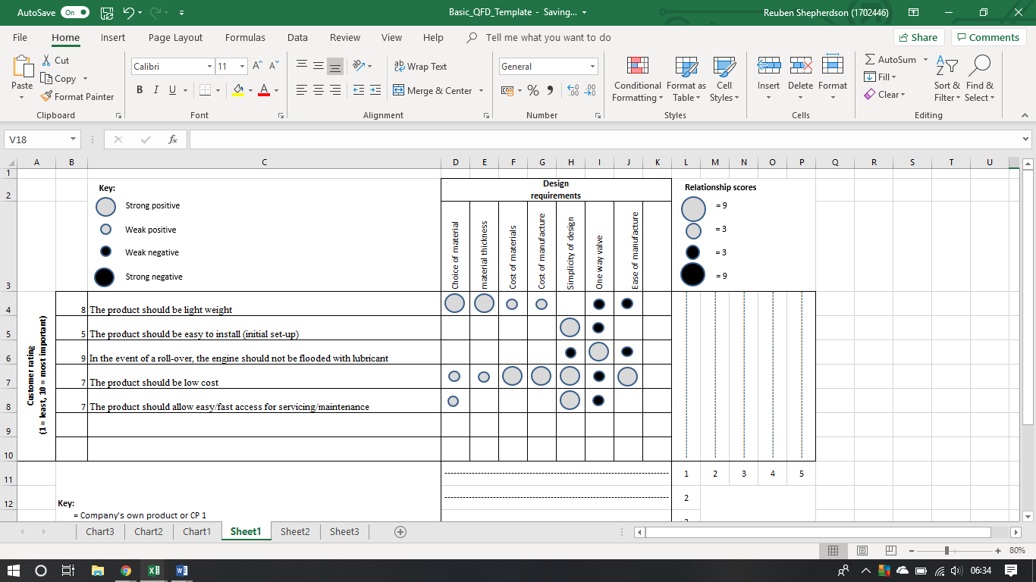
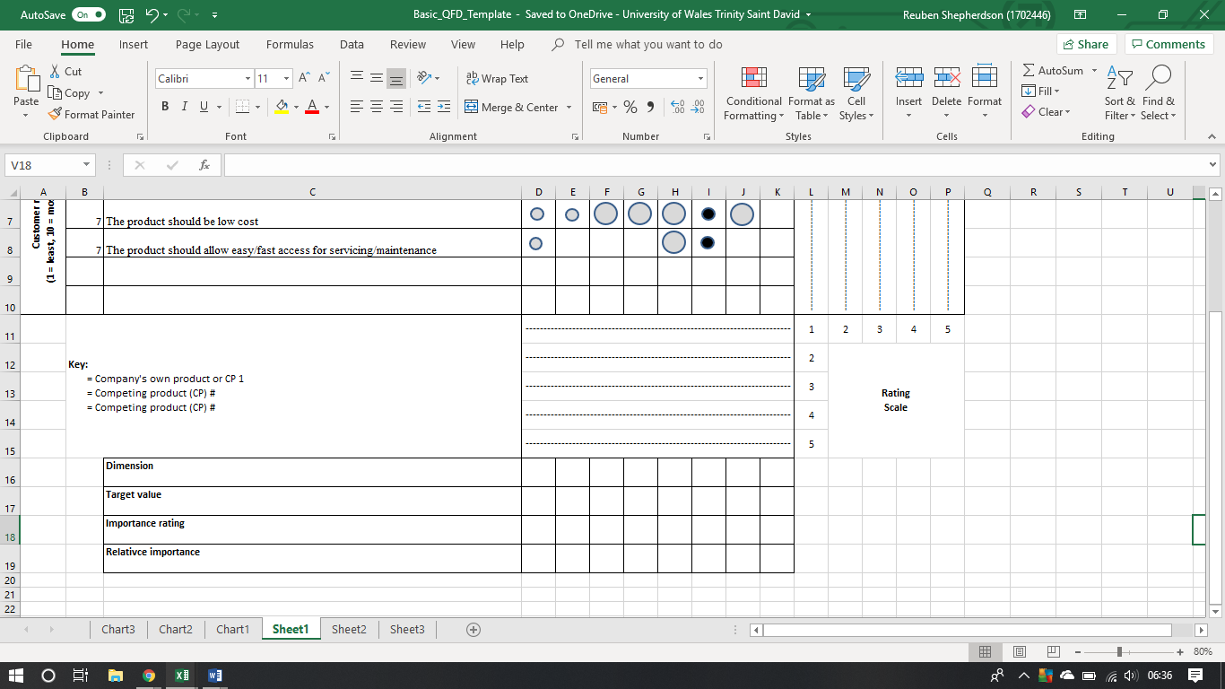
Figure 2QFD Table

