Data Analysis & Visualisation
Assessment 2

Student ID: 2023296
Student: Larisa Tamas
Module Code: LCBB5000
Lecturer: Gasso Wilson Mwaluseke
BA Business Management
6 January 2023

Table of Contents

PART ONE: SUPERSTORE DATA ANALYSIS 3
1.1 Application of Excel 3
1.2. The IF function in Excel 5
1.3. Use of pivot tables 6
1.4. Using Charts and graphs to visualise profit trends 8
1.5. Reflection on Excel experience 9
PART TWO: SPSS VS EXCEL 10
2.1. Students that like the vanilla flavour of ice-cream 10
2.2. Gender 11
2.3. Mean and Median of participants who like chocolate and strawberry flavour ice-cream. 12
2.4. K-means clustering 12
2.5. Data mining techniques 14
2.6. Advantages and disadvantages of SPSS and Excel 17
References 20

PART ONE: SUPERSTORE DATA ANALYSIS

1.1 Application of Excel
Excel is well recognised as a powerful and versatile application in the realms of data preparation, analysis, and visualisation. The software is part of the core package offered by software giants Microsoft Inc. Excel has stood out among the most popular application because of its data analytic utility, along with basic arithmetic and statistical analysis, which is augmented by the ability to import and export data (Science.gov, n.d.). In addition, Excel's many chart and graph choices make it simple to convey results and ideas. Excel's efficient handling of vast volumes of data is a major advantage when using it for pre-processing, a virtue that makes it versatile and effective. It supports importing information from various sources, including databases and text files. It offers several tools for cleaning and formatting that information, such as features for eliminating duplicates, merging, and dividing cells, and standardising data formats.
Excel also has several analytical capabilities, such as functions for computing statistics, doing regression analysis, and making pivot tables. Users may benefit from these tools as they assist them in seeing and understanding patterns and correlations in their data. The advanced package can be accessed by installing adds-on such as the data analysis package. Excel's data visualisation choices include bar charts, line graphs, scatter plots and pie charts. Users can better express their discoveries and insights and spot patterns in their data using these charts and graphs (Blann, 2018). Therefore, Excel is extensively utilised in many disciplines since it is a helpful tool for pre-processing, analysing, and displaying data.
Excel's efficient data management of massive datasets is an advantage for the application as a preferable data analysis tool. However, for big data, it is recommended that one install excel solver, an add-on that is offered without an additional cost. The software has several options for calculating and analysing data and sorting and filtering it in a way that is easier to learn and master, even for beginners. This allows for the efficient and accurate analysis of massive datasets, allowing for the gleaning of useful insights from such analyses. Excel's flexibility extends to its extensive design and formatting choices for tables and graphs. To successfully convey facts and thoughts, reports and presentations should be designed to seem professional, which excel accomplishes through its basic applications. Excel has been very useful in the research community, where it has been used to great effect in creating summaries, reports, models, and illustrations (Neyeloff, Fuchs, & Moreira, 2012). Thus, the app may be used for a wide variety of data-related tasks, the most important of which are meaning creation, connection testing, mistake checking, and model forecasting. Excel is a popular and effective program for many types of data preparation, analysis, and visualisation tasks. Particularly helpful for calculating and analysing data, as well as organising and altering data. Data analysis is a common task in many industries. This tool is well-suited for the task because of its extensive feature set, powerful analysis and visualisation capabilities, and ability to effectively manage massive volumes of data.

1.2. The IF function in Excel
The IF function is one of the most interesting logical functions in excel. It makes it possible to perform three functions or calculations based on three conditions: condition, when to show when the condition is met, and when it is not met.
It has the following syntax:
=IF (condition, value if true, value if false)
In the superstore data set, we have the sales data, the unit price of each sale, and the variables of profit. It is possible to determine whether there was a decline in profit or not using the IF function.
For example, in the data set, I was interested in knowing whether the store is experiencing a decline in profit or a rise between one specific sale and another. Thus, to use the IF function, I will need the combination of ">" and "<" operators to compare the profit for the two periods. If the profit is greater in the first period, the function will indicate a rise in profit, and if it is a decline, it will indicate a decline in profit.
The IF function to determine whether there was a decline or rise in profit in the data set can be deduced through the following function:
=IF (profit_this_period > profit_previous_period, "Rise in Profit", "Decline in Profit")
In this case, I began by reordering the dates from newest to oldest, matching them with the specific profit entry. Then I utilized this formula, =IF(B2>B3,"Rise in Profit”, “Decline in Profit")
The verdict included several categories with rise and decline in profit. Also, I can use the same steps to determine trends in sales across the time. However, I noted that this function is limited because it can only provide specific data comparisons. A better function is to group the data in a more meaningful and predictive manner based on a quarter or a year or business location, which can be done using the pivot function.

1.3. Use of pivot tables
The entries from the IF function produced several different verdicts, which would be difficult to interpret If I wanted an overall impression of the trends in the data set. As noted, the IF function is more useful when comparing specific data points. Now, with the pivot tables, I could group the data into specific categories and determine whether the store experienced a decline or rise in profit in most transactions. Also, I could group profit by region.
Excel's pivot tables are an extremely useful feature, which can assist in quick summaries and statistical analyses (Torres-Reyna, 2011). One may use them to organise and categorise information in several diverse ways, as well as to compute and show summary statistics like totals, averages, and counts. I will have to arrange the data in tables or columns in this case. Nevertheless, since I am interested in the profit category by region, I will only need the two columns when making the pivot tables. The specific steps followed are:
- Choose the data set to wish to include in the pivot table.
- Select the Pivot Table button located under the Insert menu.
- Select the desired location for the pivot table in the Create PivotTable dialogue box, then click OK.
- Drag the Date field to the Rows area, the Profit field to the Columns area, and the Decline/Rise field to the Values area of the PivotTable Fields window.
- Select Value Field Settings from the context menu that appears
- One may choose SUM in the Value Field Settings dialogue box and then click OK.
Following these steps yielded the following pivot table:

Row Labels | Sum of Profit
Atlantic | 238960.66
North Carolina | 2841.11
Northwest Territories | 8307.05
Ontario | 439214.57
Prarie | 321160.12
Quebec | 140426.65
West | 297008.61
Yukon | 73849.21
Grand Total | 1521767.98

1.4. Using Charts and graphs to visualise profit trends
I began by grouping the data into a few categories in a year, then extrapolating the data into a new worksheet. Then, using the chart function, I made a line graph of profit vs time through the insert option. The graph is as follows:
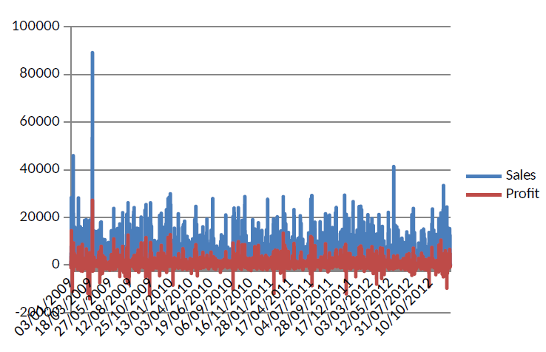
Fig 1. Analysis of the above chart reveals that January 2009 was the firm's most profitable and successful month. Conversely, 2012 shows the second-highest sales. Both sales and income exhibit extreme swings in the graph, with the firm suffering heavy losses in 2009, 2010, and 2012. While sales have fallen yearly since 2009, they dropped by their greatest percentage in late 2009.
Similarly, I could compare the value of sales alone across time. This would require me to repeat the steps above, order the dates from newest to oldest, and then highlight the two columns. Then, I will use the insert column to compare the values. The subsequent line chart would look as follows.
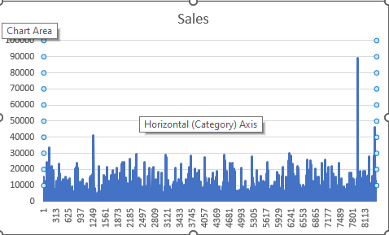
Figure 2. Figure two shows trends in sales over time. The store has been experiencing a decline in sales between 2009 and 2012, though sales peaked in January and have averaged 20,000.

1.5. Reflection on Excel experience
In conclusion, the experience I have had using Excel to create charts and graphs, use of t the IF function, and design pivot tables have proven beneficial. Pivot tables have been a particularly useful tool for data organising, summary, and analysis, which helped me make several interpretations from the data set regarding sales and profit trends. The tables made it possible to reorganise and categorise the data in several ways and produce and display summary statistics such as totals, averages, and counts. In addition, I can organise and categorise the data in several ways, thus enabling me to perceive the data and its meaning. The IF function is an incredibly useful tool for data modification and analysis. Through this function, I conducted certain operations and calculations based on criteria, which helped me automate and streamline the procedures related to my data analysis. Through the IF functions, I could extrapolate profit trend changes across various data points. Lastly, the vast range of chart and graph options that Excel gives has made it easier for me to visualise the data set and its trends regarding the two crucial variables of sales vs profit. Because of my skill in personalising and formatting charts and graphs, I can develop reports and presentations that give the impression of having been professionally prepared and that effectively convey my findings and conclusions. Excel is a useful instrument for studying and presenting data, and it is an essential resource for my work. I also enjoyed that it was easy to use and learn how to execute distinct functions in the excel application. The interface was also friendly and applicable for business-level practice.

PART TWO: SPSS VS EXCEL

2.1. Students that like the vanilla flavour of ice-cream
Using the count IF function in excel will help know the number of students who like Vanilla flavour. The results showed that 95 students liked the flavour, over 47 liked chocolate, and 58 liked strawberries. The results can also be visually presented as follows in a bar chart. In SPSS this was accomplished through the frequency function. One may determine how many observations in a data set fit a certain condition by using the FREQUENCIES method in SPSS. One chooses the variables to use in the analysis and add filters and other selection criteria by using the FREQUENCIES process. SPSS will then prepare a report containing the FREQUENCIES process findings, including summary statistics and graphics, after the analysis is complete (Tanner‐Smith, & Tipton, 2014). This report may then be used to analyse the data and develop conclusions.
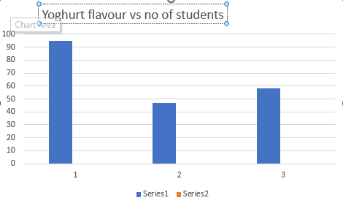

2.2. Gender
Using the count IF function in excel will help know the number of students for each gender. The results showed that 91 students are male over 109 are female. To get the values in SPSS, I used the frequency function, The results can also be visually presented in a clustered bar chart.
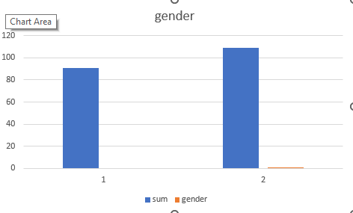

2.3. Mean and Median of participants who like chocolate and strawberry flavour ice-cream.
Mean for chocolate flavour = (2 * 47) / 47 = 2
The mean for strawberry flavour ice cream would be calculated as follows:
Mean for strawberry flavour = (3 * 58) / 58 = 3
I arranged the ratings in numerical order to calculate the median and found the median value using SPSS as well as Excel. The median for chocolate flavour ice cream would be 2 since it is the only rating. The median for strawberry flavour ice cream would be three since it is the middle value in the rating list (2, 3).

2.4. K-means clustering
In this data set, I will conduct a two-step clustering using gender as the reference variable. Two-step cluster analysis is often used in business to identify patterns and trends in data and to group customers or other data points into distinct segments based on their characteristics and behaviour. It can be useful for customer segmentation, market research, and target marketing tasks.
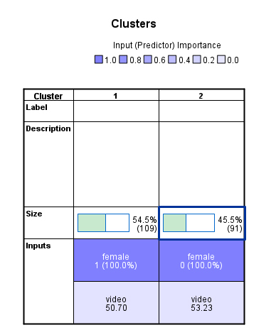

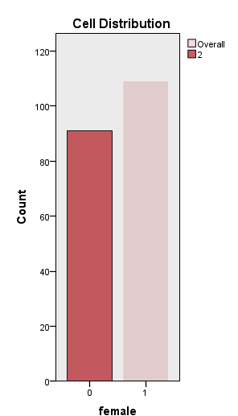
The results demonstrate the results of the relationship between gender and video category. Overall, males are more likely to be influenced by video games in selecting their favourite yoghurt flavour than females.

2.5. Data mining techniques
The terms "data mining" and "text mining" refer to similar processes used to glean insights and information from massive data sets (Tao, Yang, & Feng, 2020). These techniques are widely used in corporate settings, where they are used to detect trends, make forecasts and choices, and boost productivity.
Common data mining techniques used in the corporate world include:
Classification: The classification process includes making predictions about a category result (such as whether a client would churn) using one or more predictor factors. If a business collects client data such as age, gender, and spending habits, it may use categorisation to determine which customers are most likely to leave. Classification uses a collection of predictor factors to predict a category result (such as whether a customer would churn) using a tool like a neural network or a decision tree. Because of their ability to learn and change over time in response to new data, their scalability, and their ability to deal with vast volumes of data and complicated interactions between variables, neural networks are often employed for classification tasks (Knocklein, 2019). Decision trees, which entail building a tree-like structure to make choices based on rules, are also often used for categorisation jobs. They shine when applied to problems that need a yes/no, churn/no churn, or similar binary choice based on a collection of input variables.
Cluster analysis: Data points are clustered according to their similarities in a process known as cluster analysis. Businesses may use clustering to divide their clientele into distinct subsets according to factors like their spending patterns and product preferences. Cluster analysis is a method for grouping records that have commonalities. The contrasts and correlations between the data will become clearer as a result. This practice, also known as segmentation, aids users in making sense of database activity. Grouping customers by income, age, policy details, and claims history is frequent practice for insurance providers.
Association rule mining: Mining for associations between dataset variables is called "association rule mining." Association rule mining might be used by a corporation, for instance, to learn which goods are commonly bought together by consumers.
Regression analysis: Predicting a continuous result (like revenue or profit) from a collection of predictor variables is the goal of regression analysis. A business might use regression analysis to forecast earnings in light of factors such as marketing budget, client count, and product pricing.
Methods for text mining that are often used in business include:
Sentimental analysis: Analysing textual information (such as online reviews or social media postings) to ascertain the underlying emotional tone (positive, negative, or neutral) is what sentiment analysis is all about. A business may understand how the public receives its goods and services by analysing client feedback.
Topic modelling: Finding the overarching ideas in a corpus of text is the goal of topic modelling. Topic modelling may be used by businesses, for instance, to distil the most important themes from feedback sources like online reviews and social media postings.
Named entity recognition: Extracting named entities (such as persons, organisations, and places) from text data is the goal of named entity recognition. Named entity recognition might be used by a business, for instance, to pull the names of customers and rivals out of online feedback and social media postings.

2.6. Advantages and disadvantages of SPSS and Excel
SPSS and excel are two popular tools commonly used for data analysis in the business world. Although they are easier to use and learn and have versatile applications, both have advantages and disadvantages. The following table addresses the differences between the two by comparing the major or vital points based on the present experience and scholarly insights.

 | SPSS | Excel
Advantages | - Comprehensive statistical analysis capabilities | - Widely used and familiar to many users
 | - Provides a range of chart and graph options | - Easy to use and learn
 | - Can manage enormous amounts of data | - Provides a range of formatting and visual customisation options
 | - Offers a range of data manipulation and cleaning functions | - Allows for easy collaboration and sharing with others
Disadvantages | - More expensive than Excel | - Limited statistical analysis capabilities
 | - Requires a learning curve to use it effectively | - Limited data manipulation and cleaning functions
 | - Less familiar to some users | - Can struggle with enormous amounts of data
Practical examples | - A market research company uses SPSS to analyse survey data | - A small business uses Excel to track sales and expenses
 | - A healthcare organisation uses SPSS to analyse patient data | - A marketing team uses Excel to track and analyse campaign performance

Table 1: Summary of benefits and drawbacks of SPSS and other common data analysis tools is provided in Table 1. SPSS provides several benefits, such as the capacity to manage enormous volumes of data, a wide variety of chart and graph choices, and sophisticated statistical analysis capabilities. It also provides tools for cleaning and manipulating data. SPSS is more costly than Excel and may have a steeper learning curve. Some users may also find it unfamiliar. Excel's many benefits include its widespread adoption and familiarity, its user-friendliness, and the flexibility it affords in terms of both content structure and presentation. In addition, it facilitates communication and cooperation among team members. However, Excel lacks robust tools for statistical analysis, data manipulation, and data cleansing. To process massive volumes of information, it may need assistance from add-ons such as excel solver. Both SPSS and Excel have both merits and demerits, and that the choice between the two should be decided depending on the goal of research or business needs. SPSS demands more learning focus and is slightly hard to learn, but it is still a powerful tool that can perform a broad range of statistical analysis. Excel's accessibility and simplicity have made it a favorite among statisticians.

References
Blann, A., 2018. Data handling and analysis. Oxford University Press.
Knocklein, O. 2019. Classification using neural networks. Medium: Toward Data Science.
Neyeloff, J. L., Fuchs, S. C., & Moreira, L. B. 2012. Meta-analyses and Forest plots using a Microsoft excel spreadsheet: step-by-step guide focusing on descriptive data analysis. BMC research notes, 5(1), 1-6.
Patan, R. and Babu, M.R., 2018. A novel performance aware real-time data handling for big data platforms on Lambda architecture. International Journal of Computer Aided Engineering and Technology, 10(4), pp.418-430.
Science.gov. (n.d.). Microsoft Excel software: Topics by Science.gov. Microsoft Excel Software: Topics by Science.gov. Retrieved January 2, 2023, from https://www.science.gov/topicpages/m/microsoft+excel+software.html
Tanner‐Smith, E. E., & Tipton, E. 2014. Robust variance estimation with dependent effect sizes: Practical considerations including a software tutorial in Stata and SPSS. Research synthesis methods, 5(1), 13-30.
Tao, D., Yang, P., & Feng, H. 2020. Utilization of text mining as a big data analysis tool for food science and nutrition. Comprehensive reviews in food science and food safety, 19(2), 875-894.
Torres-Reyna, O. 2011. Princeton LibGuides. Getting Started in Data Analysis. Stata.

