UNIVERSITY OF WALES TRINITY SAINT DAVID
LEARNING IN THE DIGITAL ERA
ACCA4025 – Assignment 1: E-Portfolio
Secure Futures: Developing Academic, Professional and Virtual Collaboration Skills for a Career in Cybersecurity
Student name | EUGEN IORGU
Student ID | 2539957
Programme | CertHE Computing Skills for Workplace
Assessment | Assignment 1: E-Portfolio
Submission deadline | 24 July 2026, 2:00 p.m.

Table of Contents
E-Portfolio 3
Task 1 – IEEE Referencing and Essential Academic and Employment Skills 4
1a. Essential Skills for a Cybersecurity Career 4
1b. Turnitin Similarity and Self-Assessment Reflection 5
References for Task 1 5
Task 2 – Collaborative Teamwork and Professional Academic Poster 7
2a. Collaborative Mind Map 7
2b. Professional A3 Academic Poster 8
References for Task 2 9
Task 3 – Automatic Referencing Tool 10
3a. Unit 3 Topic Summary: Security and Privacy in Virtual Collaboration 10
3b. Practical Evidence of Microsoft Word References 11
References for Task 3 12
Task 4 – E-Portfolio Creation and Illustrative Review 13
4a. E-Portfolio Structure 13
4b. Illustrative Review of Google Sites 13
References for Task 4 15
Appendices – Generative AI Evidence 16
Appendix 1 – Task 1 research and proofreading support 16
Appendix 2 – Task 2 teamwork research support 16
Appendix 3 – Task 3 virtual-collaboration research and proofreading support 17
Appendix 4 – Task 4 platform-review research and proofreading support 17
Pre-Submission Evidence Checklist 18

E-Portfolio
Published e-portfolio homepage: https://sites.google.com/view/eugen-iorgu-2539957-acca4025/home
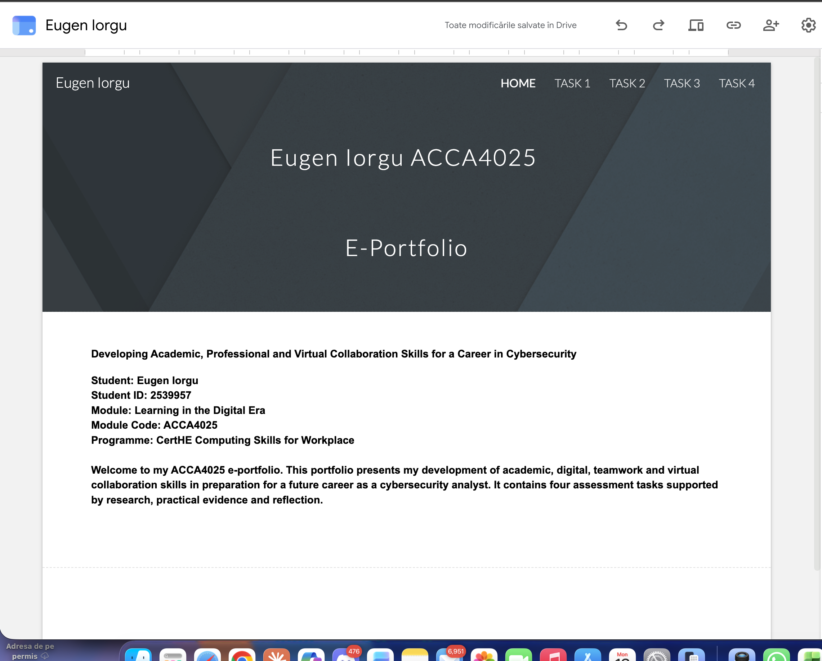

Task 1 – IEEE Referencing and Essential Academic and Employment Skills

1a. Essential Skills for a Cybersecurity Career
Cybersecurity analysts they defend the information, systems and users but more technical knowledge is not the magic bullet. According to World Economic Forum, networks and cybersecurity are the top 3 most emerging skillsets alongside analytical thinking, resilience and collaboration [1]. It matters because analysts analyze evidence that is partial in nature with limited time due to pressure to communicate risk to those without the relevant background while coordinating a response.
The case for lifelong learning, as presented by UK labour-market evidence. Other results: about half of UK businesses identified basic technical cyber-skills gaps, and employers predicted increased demand for artificial-intelligence skills [2]. An individual needs a well behaved and consistent learning routine as compared to only over the current software knowledge. Maps to specific professional roles: The NICE Framework supports this with descriptions of cybersecurity work in terms of task, knowledge and skills [3].
The academic rigour of proper IEEE referencing and source evaluation reinforces the accuracy expected in our cyber work. They prepare students to separate evidence from assertion, document the provenance of information, and report findings plainly. It has also been emphasized in Career guidance that entering a cybersecurity career revolves around adapting both technical and non-technical skills further to employer-based needs [4]. More specifically, communication and collaborative skills provided in digital content production and safety are found to produce better employability results [5].
This is why I focus on five interrelated capabilities: analytical problem-solving, digital capability including personal security in the pattern of use of digital tools, professional communication concise presentation of ideas (written and oral), responsible collaborative learning, and lifelong self-directed learning. Combined, these will enable me to go from finishing university assignments with prescribed attributes, to making defensible decisions as a cybersecurity analyst.

Figure 1. Five connected academic and employment skills for a cybersecurity analyst. Source: student-created SmartArt based on [2]–[6].

AI use acknowledgement for Task 1. ChatGPT was used to identify research keywords and provide proofreading suggestions [6]. The resulting ideas were checked against the World Economic Forum report [1], and no AI output should be submitted verbatim.

1b. Turnitin Similarity and Self-Assessment Reflection
My Turnitin similarity score was [INSERT ACTUAL SCORE]%. The main matched areas were [STATE WHAT TURNITIN HIGHLIGHTED, FOR EXAMPLE THE TITLE, COMMON TECHNICAL TERMS OR A REFERENCE ENTRY]. I consider this result [LOW / ACCEPTABLE / TOO HIGH] because [GIVE A BRIEF REASON]. Next time, I would improve the work by taking notes before writing, comparing several sources, paraphrasing ideas from understanding rather than replacing individual words, and checking that every borrowed claim is cited. Using the Generic Assessment Criteria, I would award the work [INSERT MARK]/100. This mark reflects the relevance of the sources, accurate IEEE referencing, clear application to a cybersecurity career and the quality of the visual. The mark would be reduced if any citation, reflection or evidence remained incomplete.
ACTION REQUIRED: Upload Task 1 to the Moodle practice Turnitin link, record the real score, inspect the coloured matches, replace every bracketed field above and insert a screenshot of the similarity report below.

INSERT SCREENSHOT OF THE TURNITIN SIMILARITY SCORE AND MATCH OVERVIEW HERE

Task 2 – Collaborative Teamwork and Professional Academic Poster

2a. Collaborative Mind Map
Student contributor | Eugen Iorgu
Team member 1 | Cornel Rusalim
Collaboration and mapping tools | Zoom, classroom and Coggle

Online mind-map link: https://coggle.it/diagram/aj_efYVaifWNtPIo/t/-/AlTdfPfRiBsUGh--47jqaod-KASxdlPsAbvBMcAvOR0

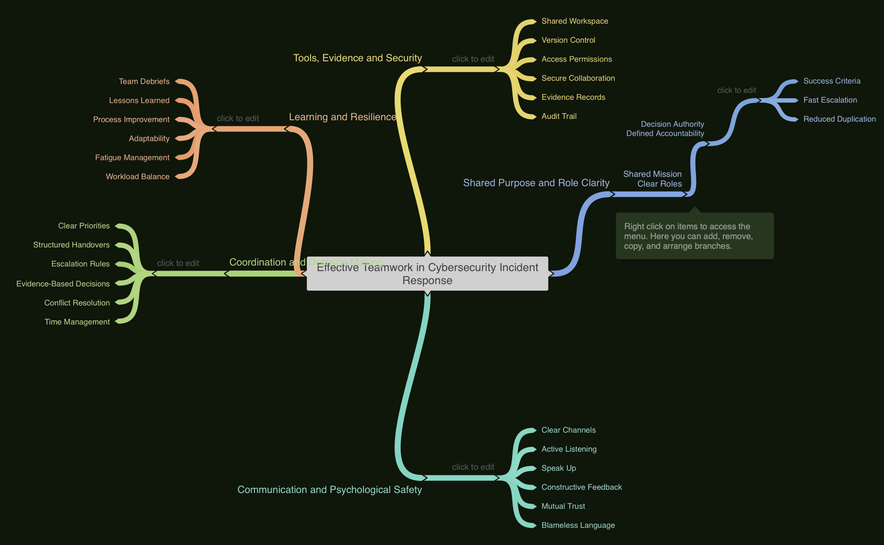

2b. Professional A3 Academic Poster
Poster title: Secure Collaboration: Teamwork Without Compromising Data
Poster file link: POSTER.png

Evidence base for the poster. The poster should connect psychological safety [7], virtual-team performance [8], trust and knowledge sharing [9], broader knowledge-sharing conditions [10], proportionate zero-trust controls [11] and supportive security culture [12]. Keep these citations visible in the completed poster.

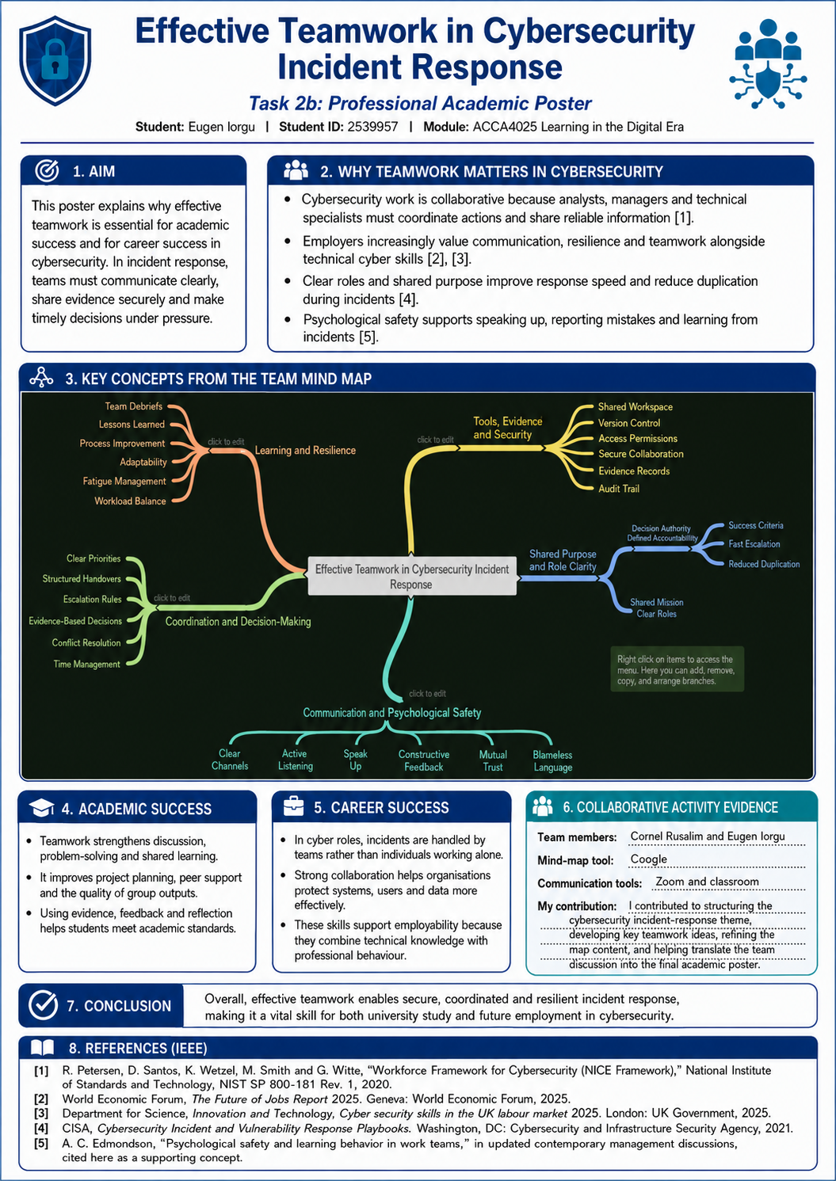

Task 3 – Automatic Referencing Tool

3a. Unit 3 Topic Summary: Security and Privacy in Virtual Collaboration
Virtual collaboration allows people to work across locations, but it also transfers communication, files and access decision to the digital spaces. An approach that assumes a user, device or network can be trusted because they are already connected is an insecure approach. With zero trust, on the other hand, each request must be evaluated against identity, device condition, context and least-privilege access required[1]. This approach is especially applicable to shared documents, cloud storage and online meetings, where one compromised account can leak multiple resources [1].
Controls should therefore be layered. The four areas of multifactor authentication (which minimize the role passwords play), role-based permissions (featuring controls over who can view or edit what information), encrypted data in transit and storage, and an extensive version history that promotes accountability [2]. CISA’s maturity model also indicates that zero trust is not a one-off product but rather an incremental improvement over identity, devices, networks, applications and data [2]. For a student team the practical equivalent is to share files only with named members, revoke access when it is no longer needed and avoid publishing confidential material via unrestricted links.
The behaviour determines the secure collaboration technology alone is not enough. Users simply need enough psychological safety to report a mistaken click, suspicious message or unintentional disclosure immediately. The NCSC therefore advocates cultural conditions which promote openness not blame [3]. As consistent with the research on virtual-team trust and communication influence knowledge sharing and performance. An ostensibly disciplined team might be hiding a risk in disguise in another mode, silenced [4].
It is also a trade-off between protection and usability. While weak controls lead to increased exposure to phishing, credential theft and data leakage; too many restrictions can push users make their own unsafe workarounds. Current threat reporting indicates that organisations have multiple, persistent attack types, as opposed to only one predictable avenue of attack. The golden mean is commensurate with the data you hold determine its classification class, apply controls matching its sensitivity, establish a reporting chain and audit access rights end-to-end [5].
This work is reinforced by establishing an automatic reference-management process, keeping information about sources and writing citation approximations consistently in different formats. But software believes neither: it does not care whether something is credible or whether a claim has been represented fairly. Study of reference-management practices reveals that tools are only one aspect of a broader academic workflow. It is still the responsibility of the student to assess, read and synthesise each source [6].

3b. Practical Evidence of Microsoft Word References
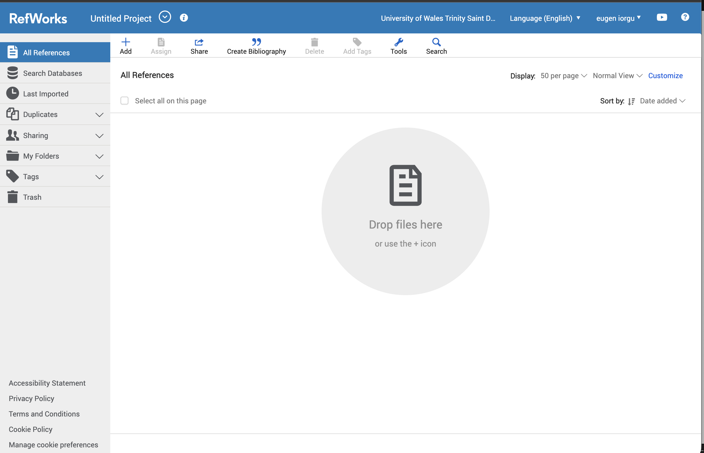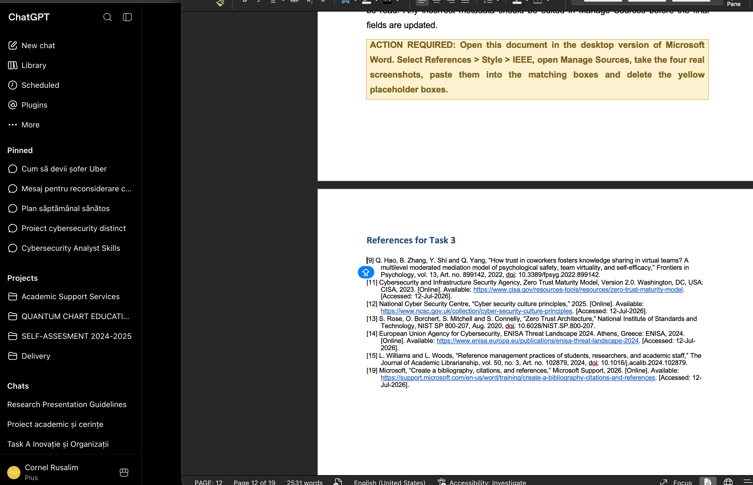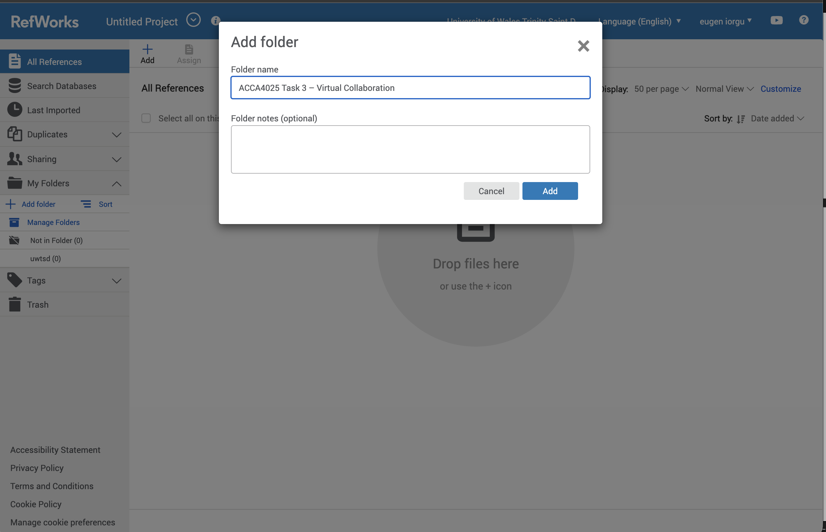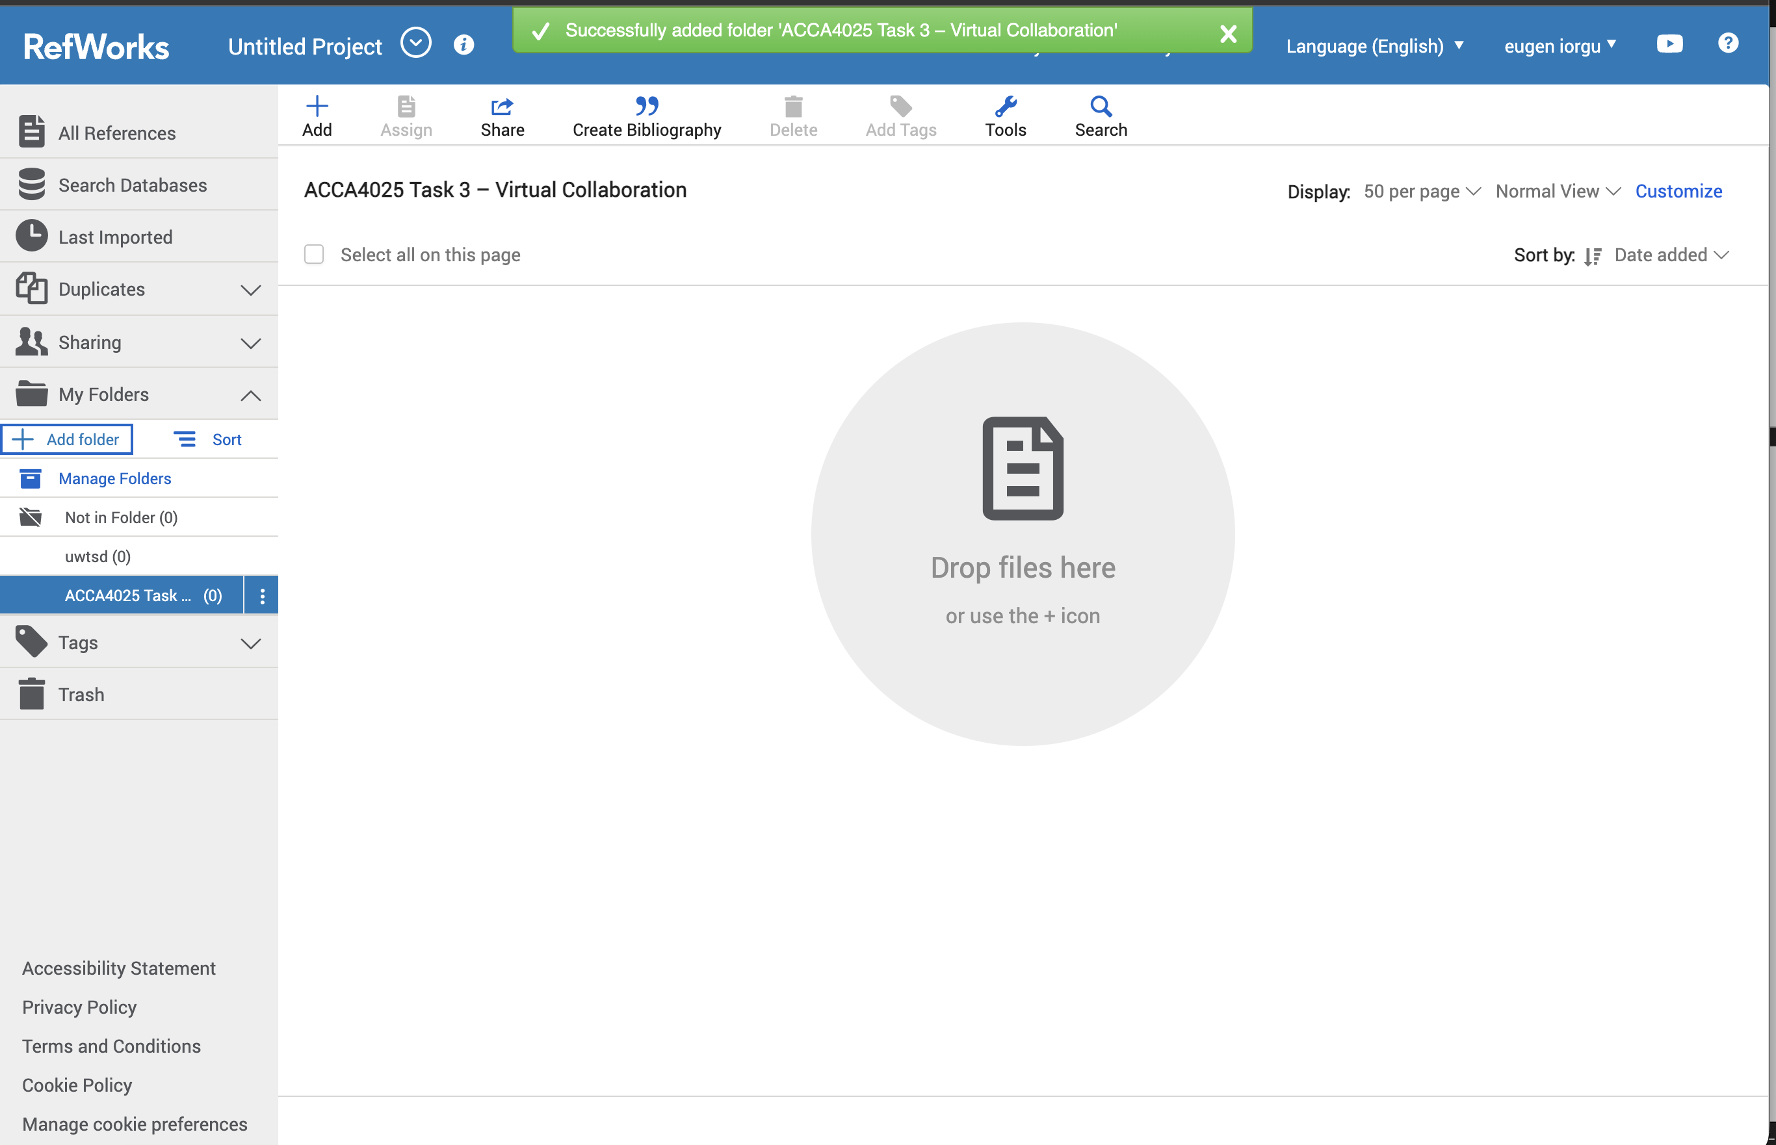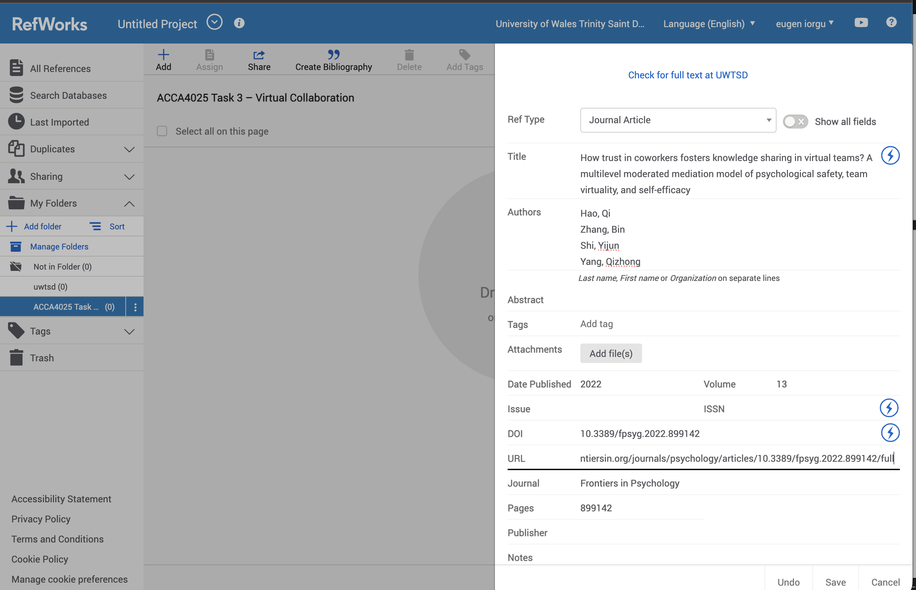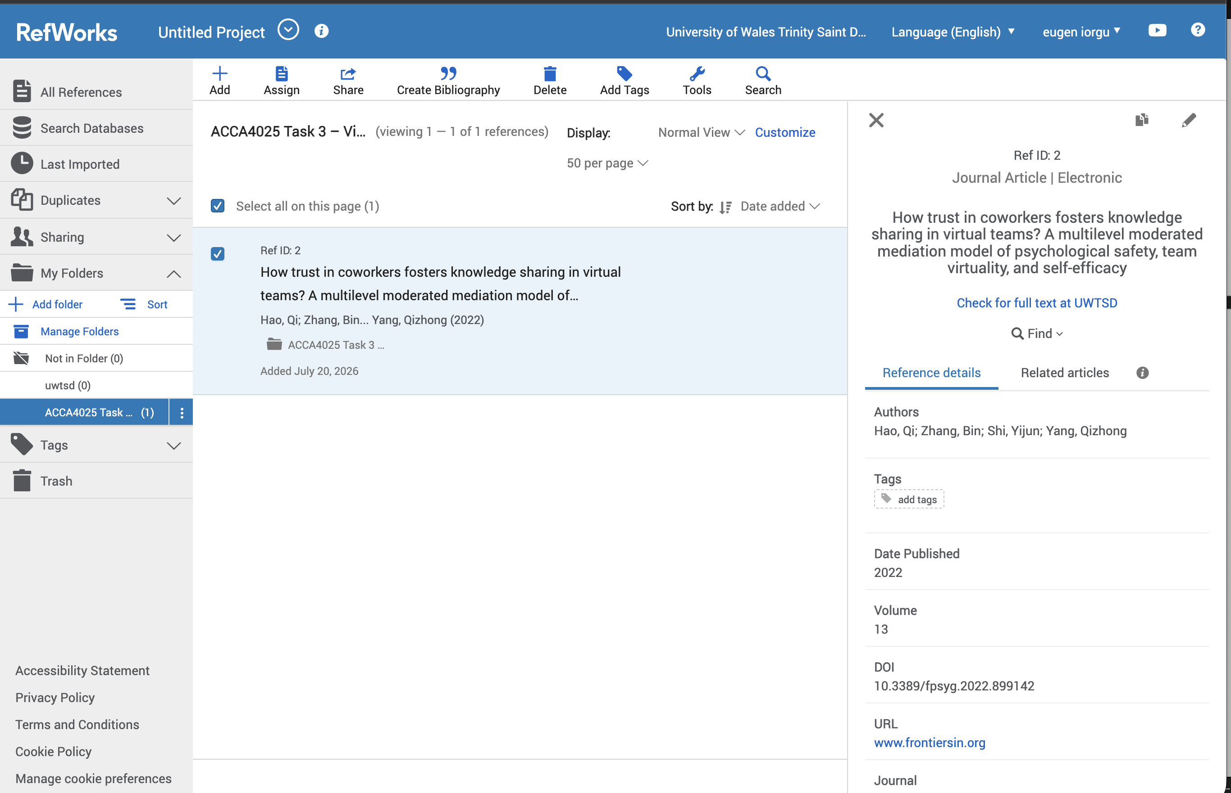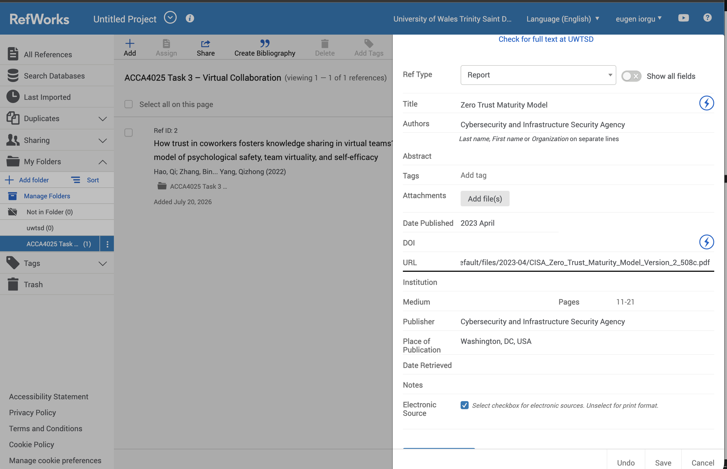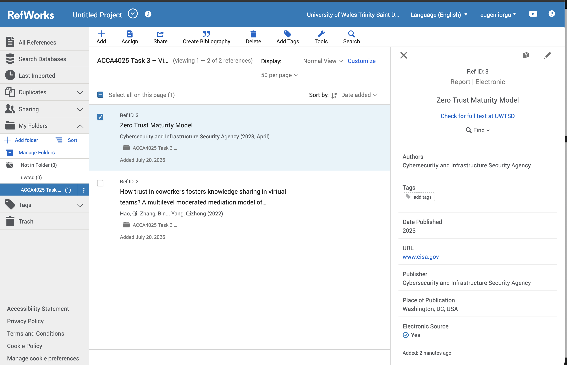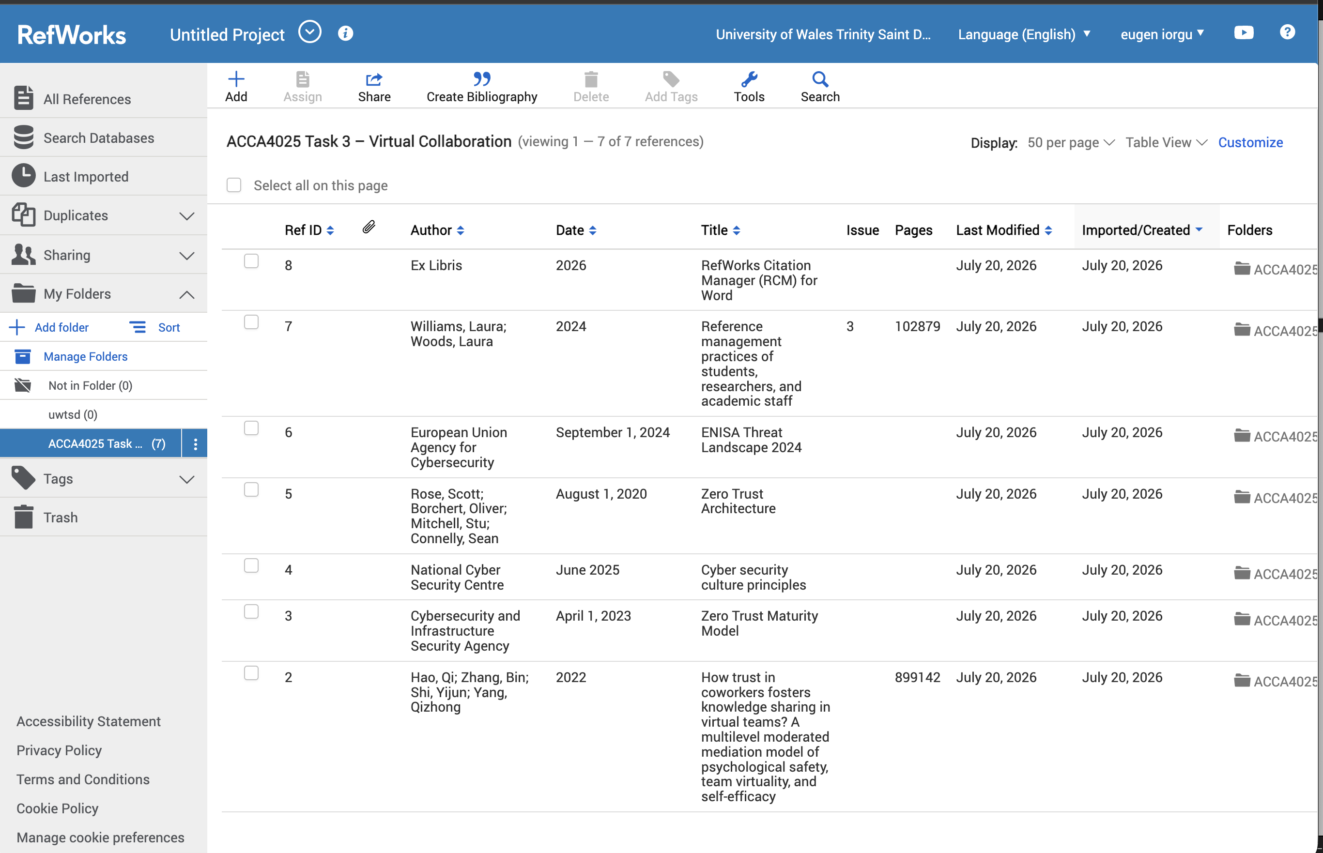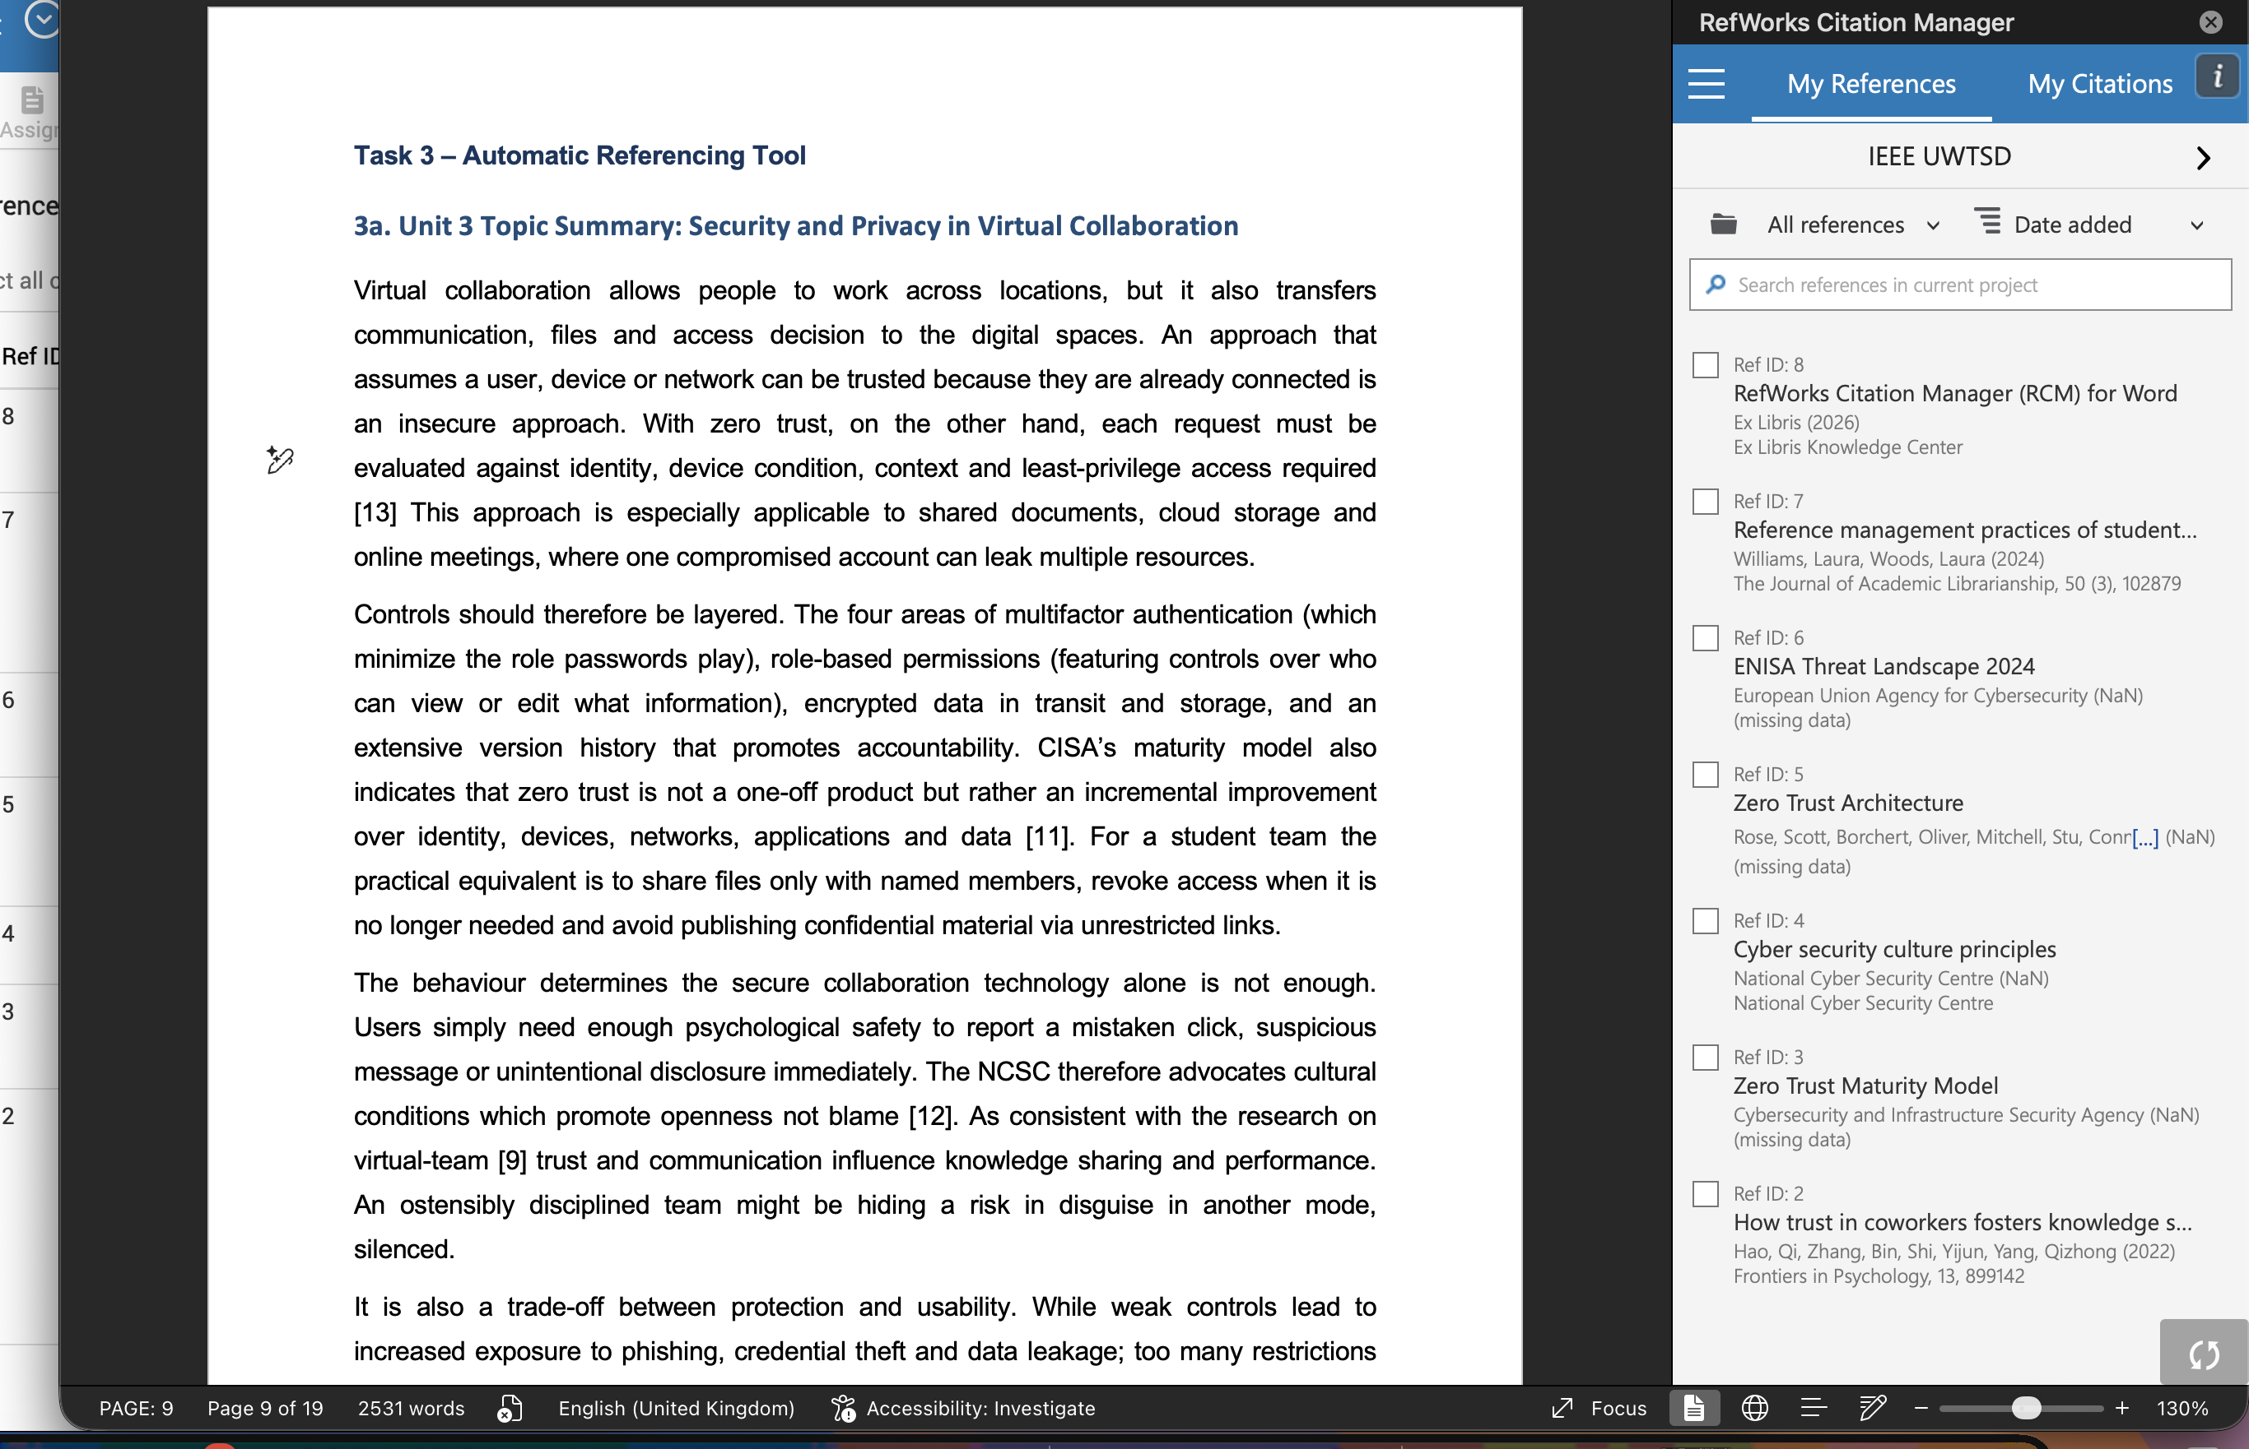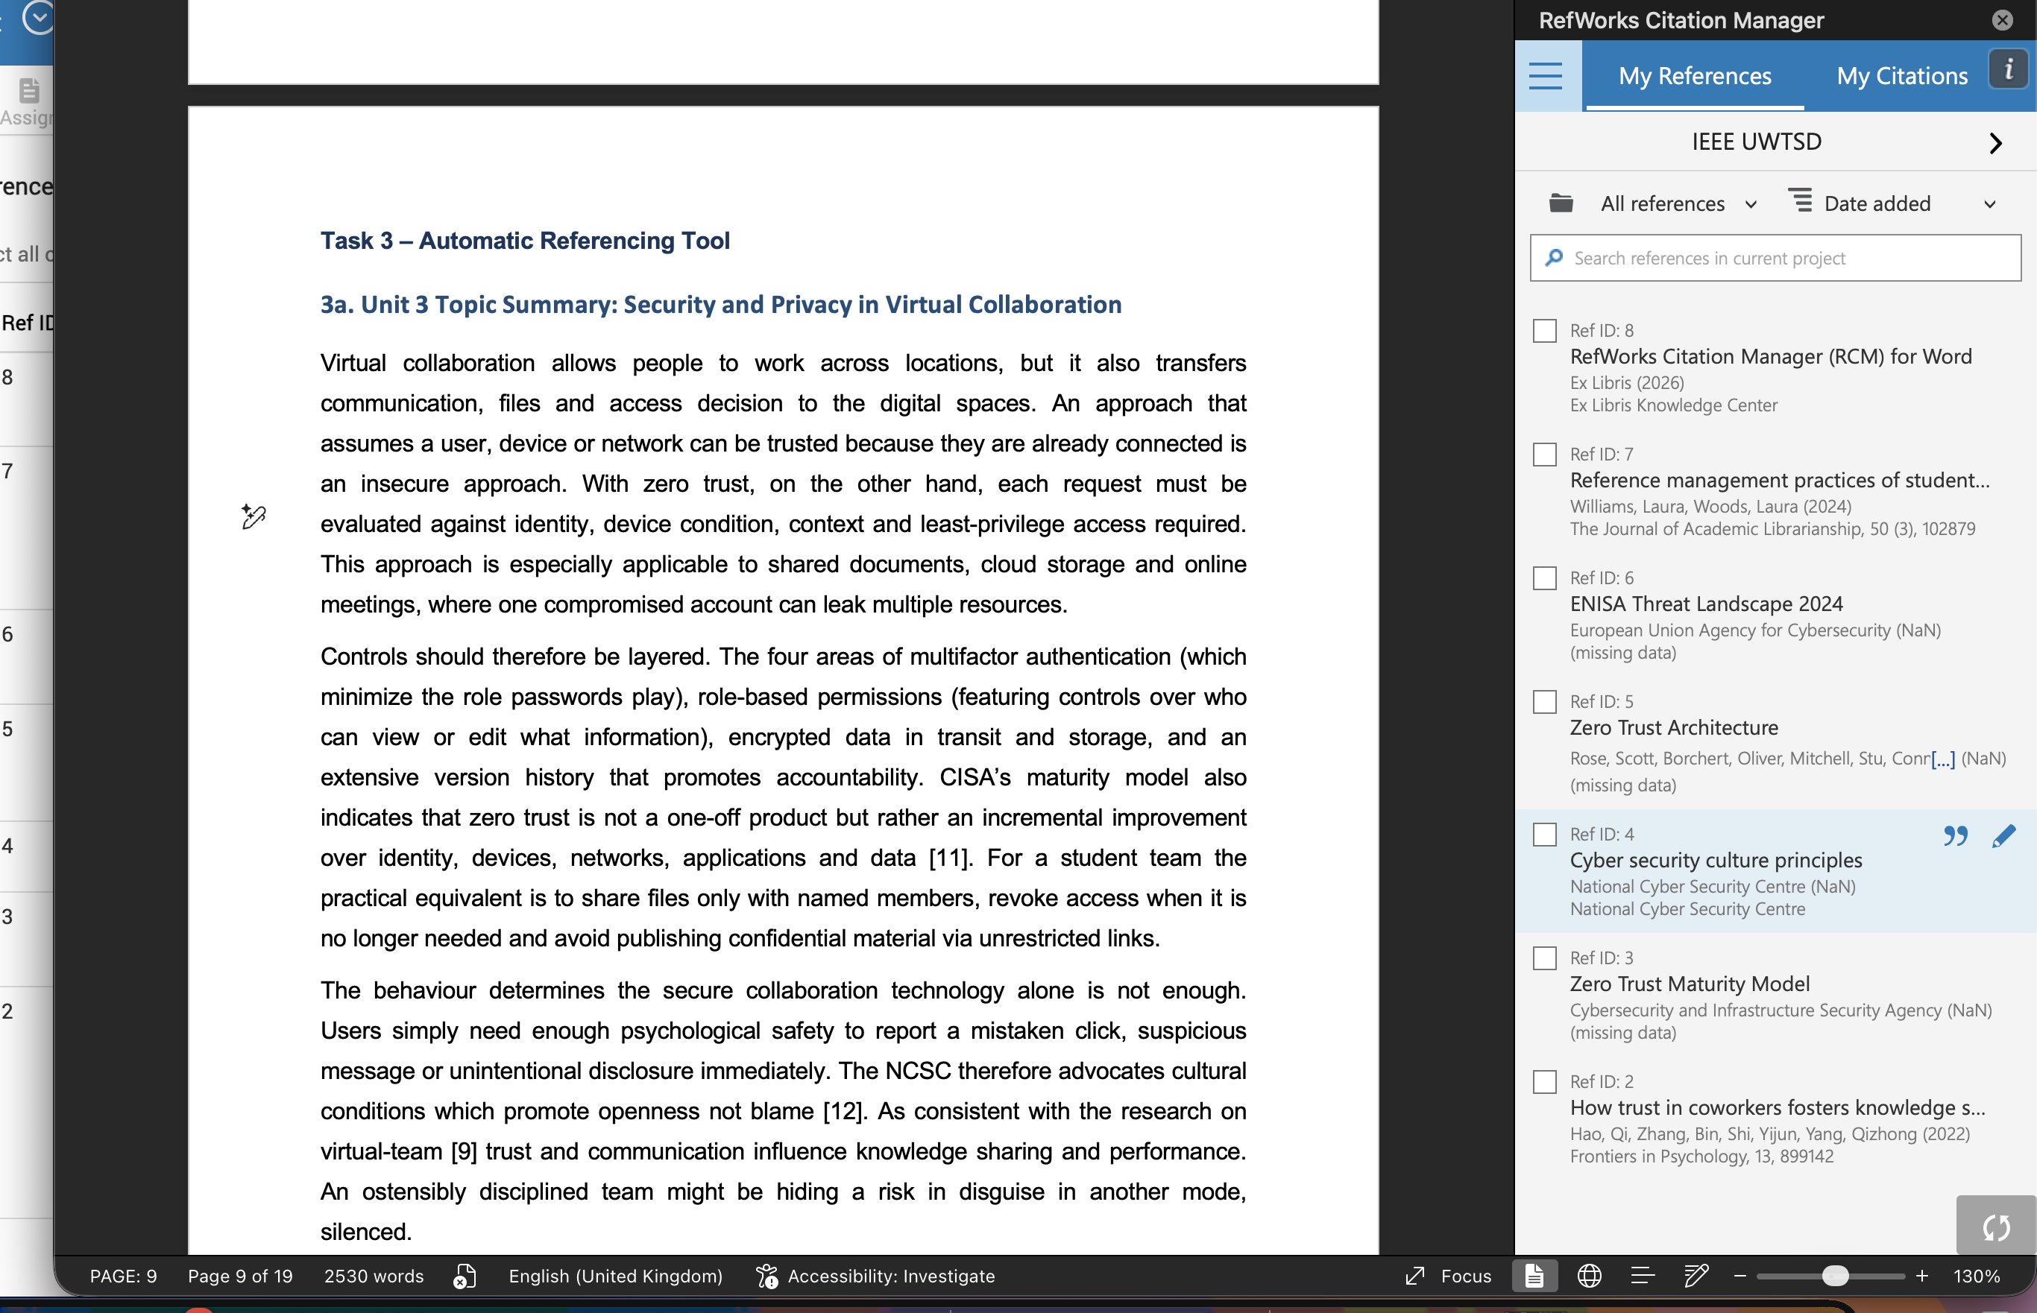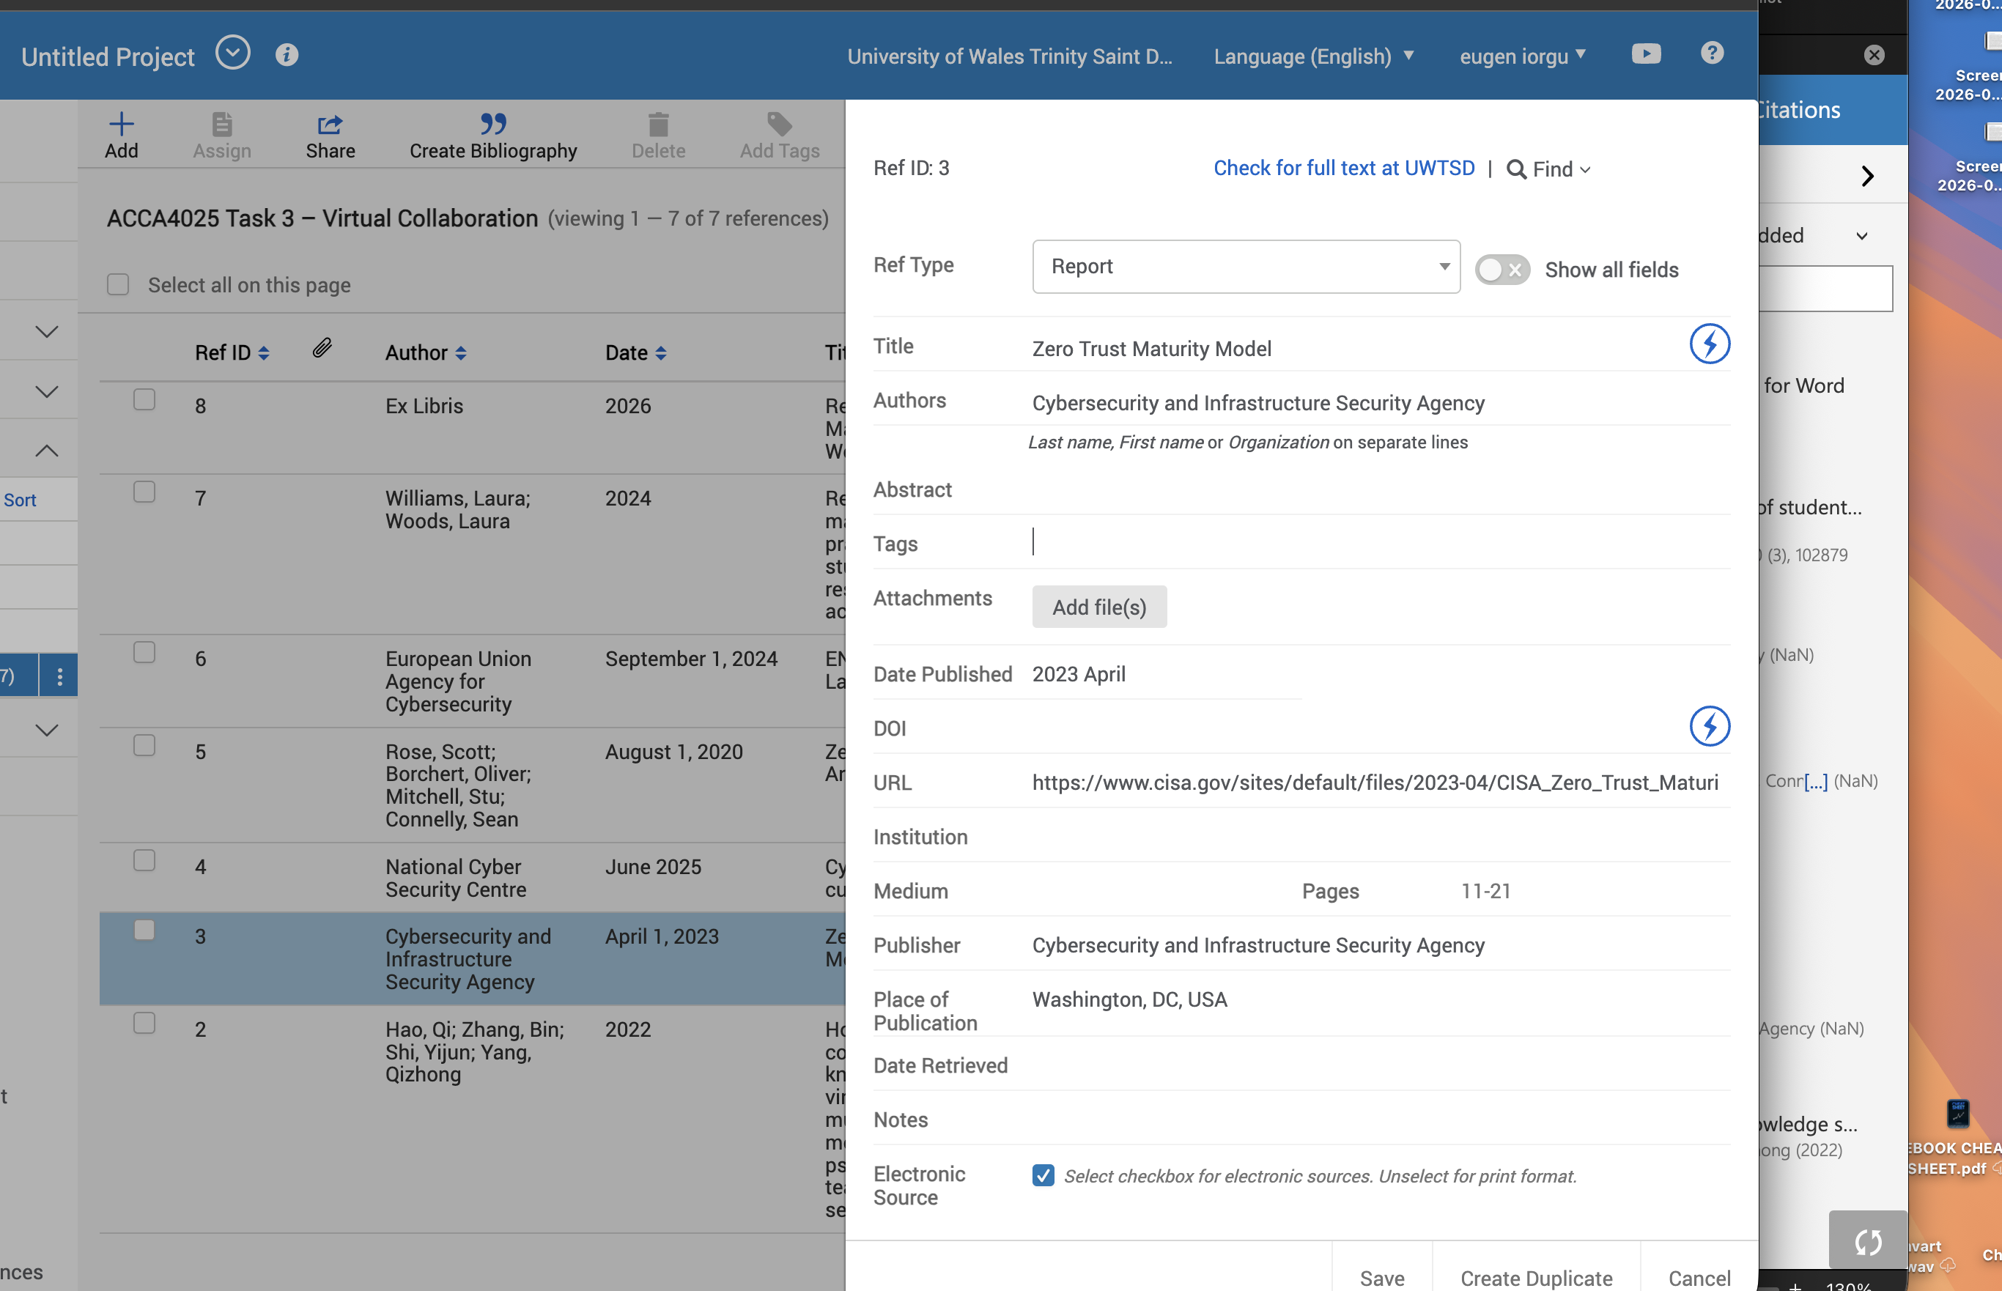

These screenshots illustrate the practical aspect of how I completed the referencing process using RefWorks Citation Manager within Microsoft Word. The paper demonstrates the selection of the IEEE referencing style, how relevant academic sources were stored and verified, and cites them directly into the summary of the paper. Additionally, the screenshots show how the reference list was automatically created from sources cited in the document. Combined, this evidence demonstrates the entire process by which references were organized, source information reviewed for accuracy and consistent IEEE formatting configured across Task 3.

References for Task 3
[1] S. Rose, O. Borchert, S. Mitchell and S. Connelly, “Zero Trust Architecture,” National Institute of Standards and Technology, NIST SP 800-207, Aug. 2020, doi: 10.6028/NIST.SP.800-207.
[2] Cybersecurity and Infrastructure Security Agency, Zero Trust Maturity Model, Version 2.0. Washington, DC, USA: CISA, 2023. [Online]. Available: https://www.cisa.gov/resources-tools/resources/zero-trust-maturity-model. [Accessed: 12-Jul-2026].
[3] National Cyber Security Centre, “Cyber security culture principles,” 2025. [Online]. Available: https://www.ncsc.gov.uk/collection/cyber-security-culture-principles. [Accessed: 12-Jul-2026].
[4] Q. Hao, B. Zhang, Y. Shi and Q. Yang, “How trust in coworkers fosters knowledge sharing in virtual teams? A multilevel moderated mediation model of psychological safety, team virtuality, and self-efficacy,” Frontiers in Psychology, vol. 13, Art. no. 899142, 2022, doi: 10.3389/fpsyg.2022.899142.
[5] European Union Agency for Cybersecurity, ENISA Threat Landscape 2024. Athens, Greece: ENISA, 2024. [Online]. Available: https://www.enisa.europa.eu/publications/enisa-threat-landscape-2024. [Accessed: 12-Jul-2026].
[6] L. Williams and L. Woods, “Reference management practices of students, researchers, and academic staff,” The Journal of Academic Librarianship, vol. 50, no. 3, Art. no. 102879, 2024, doi: 10.1016/j.acalib.2024.102879.

Task 4 – E-Portfolio Creation and Illustrative Review

4a. E-Portfolio Structure
My e-portfolio is made from Google Sites and I divided it into 5 organised pages: home, task 1, task 2, task 3 and task 4. The Home page provides a brief overview of the portfolio, module and my selected career focus into cybersecurity. In each task page, Written work delivers the chosen written pieces and supporting materials in a well-organised format that is very much readable. Task 1: Essential Skills Summary and Reflection Task 2 is split into the collaborative mind map and professional A3 poster. Task 3 is the summary of your virtual collaboration and screenshots of RefWorks Citation Manager The platform used and completed e-portfolio is reviewed in Task 4.

4b. Illustrative Review of Google Sites
Google Sites was chosen because it offers an easy, browser-based way to structure content into multiple pages whilst allowing the addition of text and images, embedding of files and publishing a sharable website [13]. This is suitable for a Level 4 e-portfolio as the platform shows the evidence of each task using a consistent navigation structure without any programming knowledge required.
The most powerful area is accessibility; the tutor can switch directly from the homepage to written summaries to mind maps to the poster and referencing evidence. Another argument for a formal, professional e-portfolio is its ability to provide employability by requiring students to articulate and portray their achievements, but research has also identified time, technical confidence and the need for support as possible limitations [14]. Benefits and barriers for reflection, continuous evidence and collaboration were likewise observed in a systematic review while worries regarding privacy, support and plagiarism were reported [14].
Only publish features relevant to assessment, not including any personal contact details, create descriptive page titles, have alternative text for images and run every actual public link on a private browser window. The site can serve as evidence for assessment but also as a controlled form of digital skills communication.

Published site link:
INSERT SCREENSHOT OF THE PUBLISHED HOME PAGE HERE
Capture the entire visible page section and ensure the navigation menu is visible.

INSERT SCREENSHOT OF THE PUBLISHED TASK 1 PAGE HERE
Capture the entire visible page section and ensure the navigation menu is visible.

INSERT SCREENSHOT OF THE PUBLISHED TASK 2 PAGE HERE
Capture the entire visible page section and ensure the navigation menu is visible.

INSERT SCREENSHOT OF THE PUBLISHED TASK 3 PAGE HERE
Capture the entire visible page section and ensure the navigation menu is visible.

INSERT SCREENSHOT OF THE PUBLISHED TASK 4 PAGE HERE
Capture the entire visible page section and ensure the navigation menu is visible.

.

References for Task 4

[14] Google, “How to use Google Sites,” Google Sites Help, 2026. [Online]. Available: https://support.google.com/sites/answer/6372878. [Accessed: 12-Jul-2026].
[17] E. Gutiérrez-Santiuste, S. García-Segura, M. Á. Olivares-García and E. González-Alfaya, “Higher Education Students’ Perception of the E-Portfolio as a Tool for Improving Their Employability: Weaknesses and Strengths,” Education Sciences, vol. 12, no. 5, Art. no. 321, 2022, doi: 10.3390/educsci12050321.
[18] P. Zhang and G. Tur, “A Systematic Review of e-Portfolio Use During the Pandemic: Inspiration for Post-COVID-19 Practices,” Open Praxis, vol. 16, no. 3, pp. 429–444, 2024, doi: 10.55982/openpraxis.16.3.656.

Appendices – Generative AI Evidence
The brief requires each use of generative AI to be acknowledged and the relevant output to be included as a separate appendix item. Insert screenshots or exported text of the exact AI interaction used for each task. The final submitted task wording must not reproduce AI output verbatim.

Appendix 1 – Task 1 research and proofreading support
INSERT THE RELEVANT CHATGPT PROMPT AND OUTPUT EVIDENCE FOR APPENDIX 1
Include only the interaction relevant to this task and ensure no private information is visible.

Appendix 2 – Task 2 teamwork research support
INSERT THE RELEVANT CHATGPT PROMPT AND OUTPUT EVIDENCE FOR APPENDIX 2
Include only the interaction relevant to this task and ensure no private information is visible.

Appendix 3 – Task 3 virtual-collaboration research and proofreading support
INSERT THE RELEVANT CHATGPT PROMPT AND OUTPUT EVIDENCE FOR APPENDIX 3
Include only the interaction relevant to this task and ensure no private information is visible.

Appendix 4 – Task 4 platform-review research and proofreading support
INSERT THE RELEVANT CHATGPT PROMPT AND OUTPUT EVIDENCE FOR APPENDIX 4
Include only the interaction relevant to this task and ensure no private information is visible.

Bibliography

[1] | World Economic Forum, “Future of Jobs Report 2025,” World Economic Forum, Geneva, 2025.
[2] | Department for Science, Innovation and Technology, “Cyber security skills in the UK labour market 2025,” UK Government, London, 2025.
[3] | R. Petersen, D. Santos, K. Wetzel, M. Smith and G. Witte, “Workforce Framework for Cybersecurity (NICE Framework),” 2020.
[4] | A. Miller, Cybersecurity Career Guide, 1 ed., Shelter Island, NY: Manning Publications, 2022.
[5] | B. Đorđević, S. Milanović Zbiljić and M. Radosavljević, “Impact of the Digital Skills on Employability: Cross-Sectional Analysis,” Economies, vol. 13, no. 7, p. 196, 2025.
[6] | OpenAI’s ChatGPT, Private communication used for research keywords and proofreading suggestions, 2026.
[7] | A. Lechner and J. M. Tobias Mortlock, “How to create psychological safety in virtual teams,” Organizational Dynamics, vol. 51, no. 2, p. 100849, 2022.
[8] | V. Garro-Abarca, P. Palos-Sanchez and M. Aguayo-Camacho, “Virtual Teams in Times of Pandemic: Factors That Influence Performance,” Frontiers in Psychology, vol. 12, p. 624637, 2021.
[9] | Q. Hao, B. Zhang, Y. Shi and Q. Yang, “How trust in coworkers fosters knowledge sharing in virtual teams? A multilevel moderated mediation model of psychological safety, team virtuality, and self-efficacy,” Frontiers in Psychology, vol. 13, p. 899142, 2022.
[10] | V. Davidavičienė, K. Al Majzoub and I. Meidutė-Kavaliauskienė, “Factors Affecting Knowledge Sharing in Virtual Teams,” Sustainability, vol. 12, no. 17, p. 6917, 2020.
[11] | Cybersecurity and Infrastructure Security Agency, “Zero Trust Maturity Model, Version 2.0,” CISA, Washington, DC, 2023.
[12] | National Cyber Security Centre, “Cyber security culture principles,” 2025. [Online]. Available: https://www.ncsc.gov.uk/collection/cyber-security-culture-principles. [Accessed 12 July 2026].
[13] | Google, “How to use Google Sites,” 2026. [Online]. Available: https://support.google.com/sites/answer/6372878. [Accessed 12 July 2026].
[14] | E. Gutiérrez-Santiuste, S. García-Segura, M. Á. Olivares-García and E. González-Alfaya, “Higher Education Students’ Perception of the E-Portfolio as a Tool for Improving Their Employability: Weaknesses and Strengths,” Education Sciences, vol. 12, no. 5, p. 321, 2022.
[15] | P. Zhang and G. Tur, “A Systematic Review of e-Portfolio Use During the Pandemic: Inspiration for Post-COVID-19 Practices,” Open Praxis, vol. 16, no. 3, pp. 429-444, 2024.
[16] | S. Rose, O. Borchert, S. Mitchell and S. Connelly, “Zero Trust Architecture,” 2020.
[17] | European Union Agency for Cybersecurity, “ENISA Threat Landscape 2024,” ENISA, Athens, 2024.
[18] | L. Williams and L. Woods, “Reference management practices of students, researchers, and academic staff,” The Journal of Academic Librarianship, vol. 50, no. 3, p. 102879, 2024.
[19] | Microsoft, “Create a bibliography, citations, and references,” 2026. [Online]. Available: https://support.microsoft.com/en-us/word/training/create-a-bibliography-citations-and-references. [Accessed 12 July 2026].

