ACTIVISTS EXPOSE MAJOR OIL COMPANY:
Greenpeace demonstrate against shell
In a demonstration on the 12th of February, Greenpeace activists demonstrated outside of Shell HQ London in order to show how Fossil Fuel Companies are causing climate change and the effects that this is having on communities. This installation is called: ‘Breaking Point: Untold Stories of Climate Loss and Damage’. Although Shell is not the only corporation responsible for these issues, the company has played a large part, for example devastating communities with oil spills, gas flaring, and polluted water. The organisation aims to fight against this. The main question is how effective are these types of protests?
This article will investigate Greenpeace’s movements against climate change (particularly this protest) as well as the organisation itself and the efforts they have made.
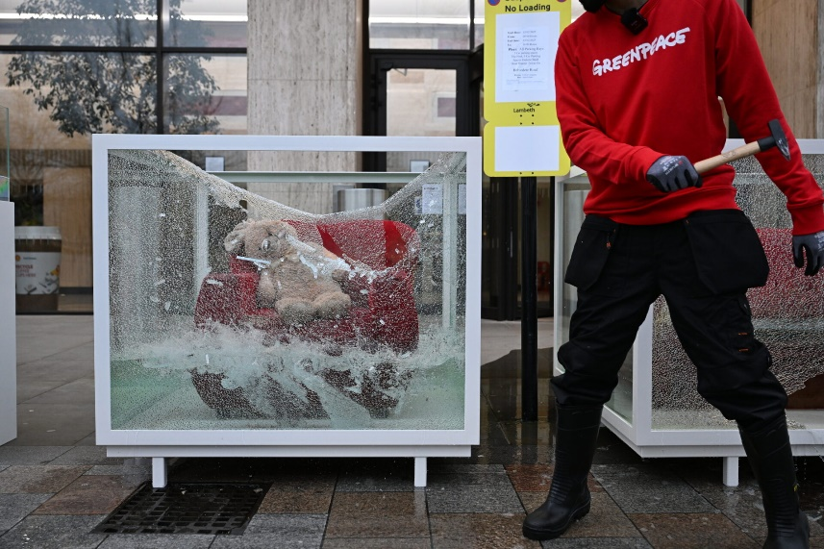
‘A team of 77 activists sets up a protest art installation - titled Breaking Point: Untold Stories of Climate Loss and Damage - around Shell’s London headquarters. The ‘exhibition’ which displays the once-cherished belongings of Filipino communities that were wrecked by climate-charged typhoons that have struck the Philippines aims to highlight how the oil and gas industry is fuelling the climate crisis and intensifying extreme weather events that are destroying lives and livelihoods of ordinary people around the world. © Chris J Ratcliffe / Greenpeace’

Greenpeace:
Greenpeace ‘is an independent global campaigning network, founded in Canada in 1971 by a group of environmental activists’. Greenpeace’s mission is to "ensure the ability of the Earth to nurture life in all its diversity” and they aim to tackle worldwide issues such as climate change. They are a well-established organisation who have performed many protests and created many petitions against key issues, for example they are currently protesting against the US support of Israel through an arms sale by pouring blood red dye into the US Embassy Pond in the UK. This specific movement (outside of Shell HQ London) is against climate change and was displayed through an art installation. The reasoning behind this protest is to highlight how oil and gas companies are fuelling the climate crisis and intensifying extreme weather events that are destroying lives and livelihoods of people around the world. It was also done in order to hold Shell responsible as well as calling for the government to force big polluters to stop drilling and start paying for the devastation they are causing around the world. An example of this is the climate-supercharged typhoons that are hitting the Philippines, causing once-cherished homes and belongings to be destroyed. This protest raised attention for this topic due to the shocking nature of it, this is because it involved activists taking hammers to the exhibition of once-cherished belongings of Filipino communities that were wrecked by typhoons that have struck the Philippines. However, it could be questioned whether this strand of activism is beneficial in any way.
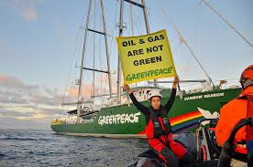
Greenpeace has lots of support worldwide, one reason for this is due to their seemingly reasonable nature, and the impact they have had. It is also important to consider the scale of their work, which is global. Unlike some organisations (such as Just stop oil), Greenpeace is seen as more rational and less extreme. This therefore suggests that they may be successful, however they still face opposition from the media and the governments of the world.
As Greenpeace states in their report of this protest ‘Non-violent direct action is a core Greenpeace principle and our actions have proved essential to the success of campaigns in exposing environmental crimes, confronting unjust activities and stopping environmental destruction’. This shows the aims and reasons behind their approach.
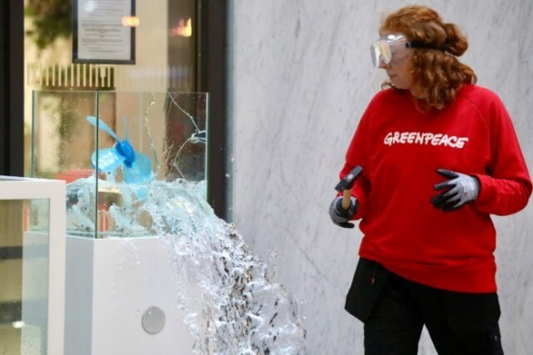
It is incredibly important to listen to the stories of the communities that are experiencing the worst impacts of climate change because they are often ignored. This is why activists at Greenpeace aim to share these stories with the world. In this protest, the items used were owned by people who were affected by the flooding and are therefore damaged. These items included a sofa that was destroyed by Typhoon Gaemi, as well as a guitar, a cupboard and an armchair all destroyed by the same Typhoon. There was also a radio, a TV frame and flask which were all damaged by Typhoon Rai. Finally, there was a portion of a house post based that was altered by Typhoon Yolanda. These items were exhibited in 19 display cases, encircling the Shell Centre, many of which were flooded with water, to show the damage caused by supercharged typhoons. These tanks were then smashed by the activists (in a safe and controlled manor, Greenpeace also ensured that the aftermath was effectively removed in order so that there was no danger to the public). This art installation is incredibly important as it evokes many emotions, due to seeing this horrific state of once loved items, it also clearly shows the damage which is being caused.
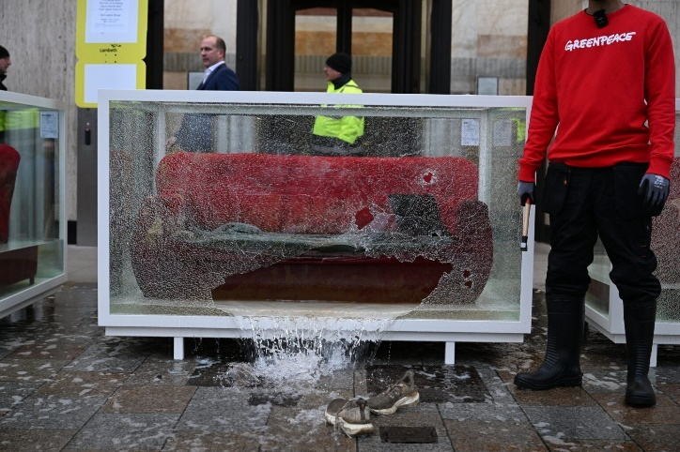
Ronalyn Carbonel, who sent her flood-wrecked sofa to London as part of this Greenpeace protest, said this about the issue at hand: “In the past, it was not like this. When it rained it was minor – the effects were not this severe … Companies like this must be stopped, [they] are only focused on making profit”. This is a clear example of the effect that these issues are causing on the people living in these communities, as well as showing how these changes have happened throughout time and are now becoming more severe.
Fossil fuels are a natural fuel such as coal or gas, formed in the geological past from the remains of living organisms.

There has been growing tensions between these two organisations (Greenpeace and Shell), for a long time due to the difference in beliefs. Shell is a major fossil fuel company and represents everything that Greenpeace is against, due to how they are driving the crisis to continue in order to bank billions and obstruct change. Although Greenpeace is a large organisation, they are not able to work against a multinational company independently due to a lack of funding and lack of support from the world’s governments. Especially as Shell has historically ignored Greenpeace’s efforts and protests relating to the company’s actions. One key example of the tensions between these two organisations was when Shell filed its lawsuit against Greenpeace UK, Greenpeace International and nine activists in February 2023, after the activists had peacefully occupied a moving Shell oil platform. Shell initially threatened the claim could exceed $8 million (c.£6.5 million) in damages. Shell then offered to settle the damages claim if Greenpeace entities, including those not a party to the lawsuit, agreed not to take action at any Shell installation at sea or port, anywhere in the world, ever again. These demands were firmly rejected by Greenpeace and the claim was then later reduced to $1 million in the court filing. This was despite the fact that Shell conceded that other than damaging a padlock (which the Greenpeace defendants denied), the activists caused no damage or delay to the platform during their 13-day occupation.
Shell:

Polluters like Shell have the billions necessary to pay for the damage caused to communities like this, however they don’t pay a penny, but also, while it’s vital to make polluters pay for the damage they’re causing; no amount of compensation will be enough to cover the costs of catastrophic climate change.
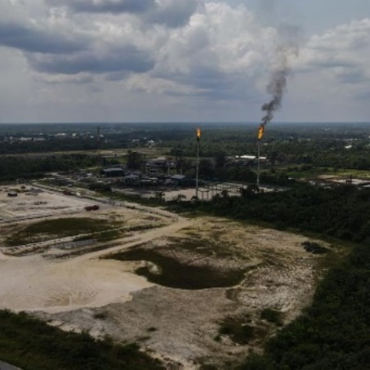
Shell have been known for using environmentally damaging methods in order to harvest gas and oil, despite the causes this has had on communities. For example, as well as playing a part in causing the mass flooding in the Philippines, they have also devastated communities in the Niger Delta area of Nigeria. People in the Niger Delta are living in darkness, while billions worth of oil and energy is being extracted from their land and exported to rich countries in the global north. Jonah Gbemre, (representing the Iwherekan community) says “We don’t have safe water to drink, no roads, no health centres, no social amenities and no jobs. We are suffering. Because of pollution everything has been destroyed”. This is due to Shell’s extraction of fossil fuels in the area. This issue is also continuing the events that will make parts of the planet near uninhabitable and hit those least responsible in the world’s poorest communities the hardest.
Climate Change:
The impacts of climate change caused by the harvesting of fossil fuels are devasting worldwide and if this is allowed to continue by the world’s governments, the effects may become irreversible and will continue to destroy the planet. Another issue is that we do not yet know the full impact that this is having on the environment.
Climate change refers to long-term shifts in temperatures and weather patterns.

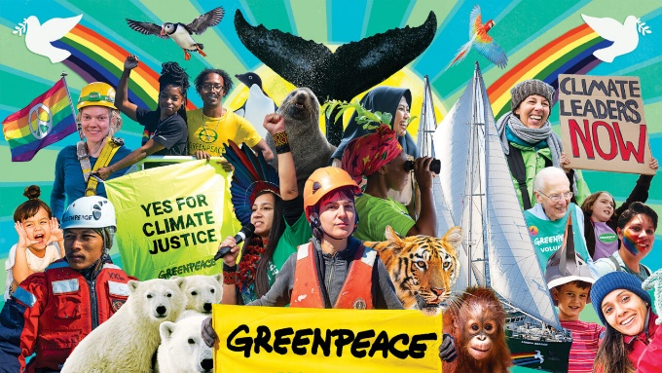
The unfortunate truth is that despite the work of organisations such as Greenpeace and Action Aid, these environmental crimes will continue and will therefore continue to cause climate change, unless the governments of the world interject and place stricter rules in place that also involve harsher punishments. Despite the fact that Greenpeace have had successful movements, and raised awareness to many issues, they have also been unsuccessful at times. For example, they have been subjected to fines, defamation lawsuits and other legal issues. They have even had public relation setbacks, for example they have received criticism about their internal party structure (accused of being undemocratic). However, despite these issues, they have continued to fight for the causes they believe in which displays their dedication which is rather honourable.
It is incredibly important to support the work of organisations that are against climate change, especially the reputable ones. There are many ways to support them, no matter any limitations you have have such as time or money. To support Greenpeace for example, you could: donate on their website or if you cannot afford to do this you could volunteer through the organisation or even just sign petitions which can also be found on their website.
Overall, this protest is a good example of the work of Greenpeace and how hard they are trying to raise awareness for issues such as this, and I’m sure that many in the world will be watching in order to see if Shell will respond.

https://actionaid.org/stories/2020/how-shell-devastating-niger-delta
https://www.greenpeace.org.uk/about-greenpeace/
https://www.greenpeace.org.uk/news/sdsp-breaking-point/
https://www.greenpeace.org.uk/news/typhoons-wrecked-my-belongings-shell-must-pay-climate-damages/
https://www.greenpeace.org.uk/news/shell-settles-multimillion-dollar-slapp-lawsuit-against-greenpeace/

