Cloud-BASED WEB SERVICES
Deian Rhys Treharne
2120039

Table of Contents
Table of Contents 1
Table of Figures 2
Introduction 5
Application 6
How to Run Application Locally Instructions 6
Software Testing 10
Conclusion 39
Video Link Youtube Unlisted 40
References 41

Table of Figures
Figure 1: Directory 9
Figure 2: Nodewebserver files 10
Figure 4:Entering cmd 10
Figure 5: New directory in terminal……………………………………………………………………..10
Figure 6:Nodewebservice packages install 11
Figure 7: Installed files 11
Figure 8: Installing Nodemon Modules 11
Figure 9: Installed Nodemon Modules 11
Figure 10: Web service online 12
Figure 11: Test ID 1 13
Figure 12: Adding film 14
Figure 13:Film added in database 14
Figure 14: Test ID 2 14
Figure 15:All films displaying 15
Figure 16: Test ID 3 15
Figure 17: Movie edited in database 15
Figure 18: Editing process 16
Figure 19: Editing process completed 16
Figure 20:Updated in database 17
Figure 21: Updated in application 17
Figure 22: Test ID 4 17
Figure 23: ID to be deleted 17
Figure 24: Delete Movie Form 17
Figure 25: Submitted Delete Form 18
Figure 26: Movie deleted in application……………………………………………………………….18
Figure 27: Checking database 18
Figure 28: Test ID 5 18
Figure 29: Category Form Table containing movies associated with “Science Fiction”: 19
Figure 30: Display chosen category 19
Figure 31: Test ID 6 20
Figure 32: Add TV show form 20
Figure 33: Submitted TV show form 21
Figure 34: Checking application 21
Figure 35: Checking Database 21
Figure 36: Test ID 7 22
Figure 37: Showing all tv shows 22
Figure 38: Test ID 8 22
Figure 39:Editing form 23
Figure 40:Submitting the form 23
Figure 41:Checking application Database: 24
Figure 42:Test ID 9 24
Figure 43:Delete TV show form 24
Figure 44: Submitting the request 25
Figure 45:Checking application Database: 25
Figure 46: Checking Database 25
Figure 47: Test ID 10 25
Figure 48: Filter category form 25
Figure 49: Display Chosen Category 26
Figure 50: Test ID 11 27
Figure 51:Add Game Form 27
Figure 52: Submitting the form 28
Figure 53: Checking Application 28
Figure 54: Checking Database 28
Figure 55: Test ID 12 29
Figure 56: Viewing all games 29
Figure 57:Test ID 13 30
Figure 58:Editing Games Form 31
Figure 59: Submitting Form 31
Figure 60: Checking Application 31
Figure 61: Checking Database 31
Figure 62: Test ID 14 32
Figure 63: Deleting Games Form 32
Figure 64: Submit Form 33
Figure 65: Checking Application Database: 33
Figure 66:Checking Dataset 33
Figure 67:Test ID 15 33
Figure 68: Filter category form 33
Figure 69: Display selected category 34

Introduction

This report demonstrates the usage of a web application which allows a user to interact with a database through a user interface and to preform basic CRUD (Create, Read, Update and Delete) functions. The designed application will have a RESTful web API which will allow the user to handle information without the need of refreshing the page.
The web application revolves around an entertainment database which includes movies, tv shows and games. The user will be able to create, read, update and delete or known as POST, GET, PATCH and DELETE a movie, tv show and game into the database. The application also allows the user to filter movies, tv shows or games by its assigned category.
This report will show software testing to demonstrate how the code works in the backend and the frontend. This will consist of set tables for each test. Inside the table It’ll show the test description and outcome.
Finally, there will be a video that demonstrates the explanation of the code and the functions of the entertainment application.

Application

As mentioned in the introduction, the application purpose is an entertainment webpage where users can view movies, tv shows and games from a range of different categories. The user will be able to enter movie, tv shows and games records into the database through a form which will then update the database in the background. Users can also edit a record from the database and delete. If the user wished to only look at action movies for example, the user could enter a category name into a form, and the application will only display movies with the category action. This function is also available on tv shows and games.

How to Run Application Locally Instructions
To begin setting up the web service, a directory needs to be created to store all the required files. In this case, the entertainment database runs off these files below. First create a file called express.js, inside the express.js file create the following files:
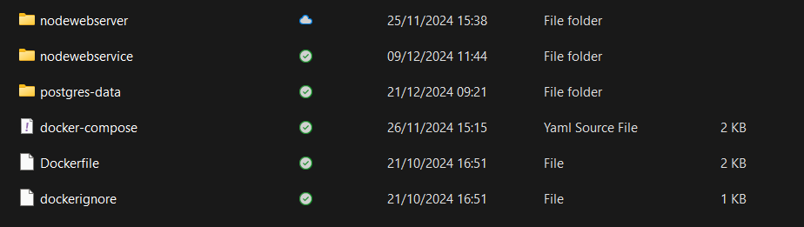
Figure 1: Directory
To create these files, you can go into file explorer (Windows) and create the following files:
- Nodewebserver
- Nodewebservice
- Postgress-data
- Docker files require docker to be installed via Chrome etc
Inside those files listed above, there are additional files that need to be created for this process to work:
Nodewebserver:
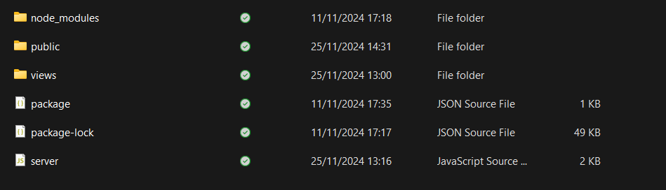
Figure 2: Nodewebserver files
The files you need to create manually are public and views. Inside the folder Public an additional 3 files will need to be created to store file types such as js and html:
- CSS
- Images
- JS
To create the other files such as package, you will need to run the express.js file in terminal to install the remaining files/packages. Highlight the path in file explorer and enter cmd (Windows):
Figure 3: Highlight file path
Figure 4:Entering cmd
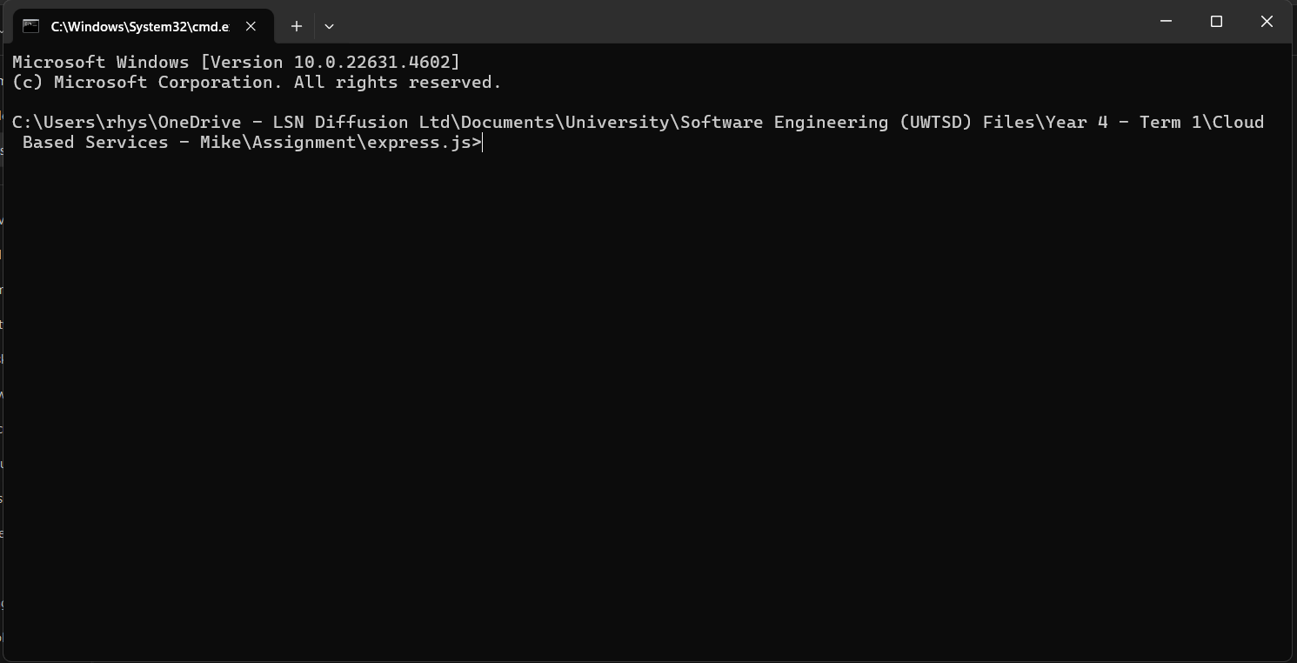
Figure 5: New directory in terminal
As mentioned above, we need to install packages. To begin with, make sure you’re in the nodewebservice directory by entering cd nodewebservice/. Next enter npm init, this command will create the package.json file we need. Once the command has been entered, you may need to press enter a few times then re-enter npm install:
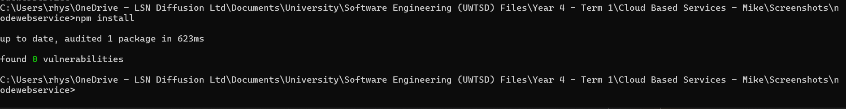
Figure 6:Nodewebservice packages install
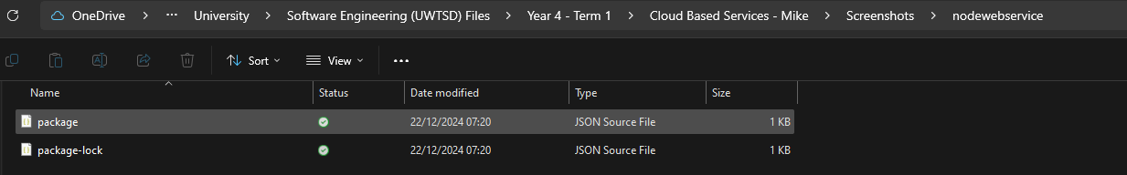
Figure 7: Installed files
Next we need to install the Nodemon within the nodewebservice file, to do so enter in terminal npm install –save-dev nodemon:
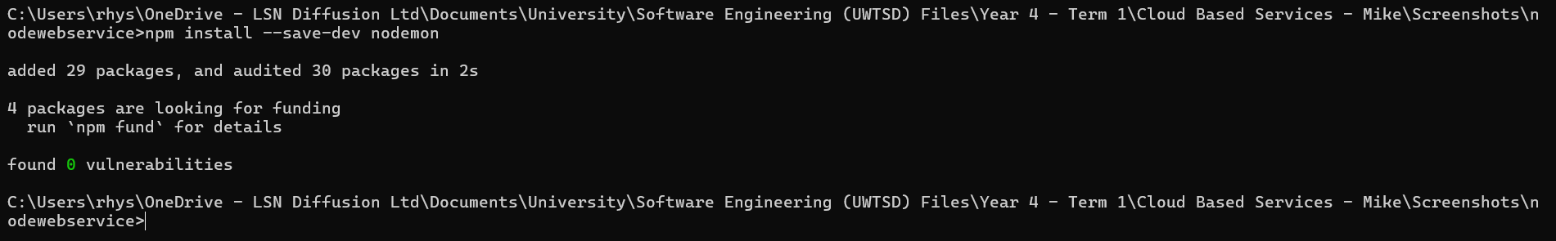
Figure 8: Installing Nodemon Modules
Now all the nodemon files are installed:
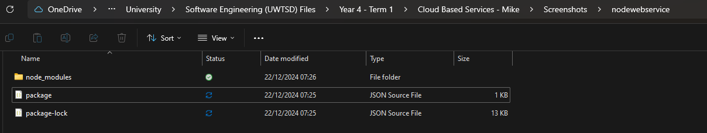
Figure 9: Installed Nodemon Modules

From here you will be able to run your application locally. Once docker files have been added to the express.js folder, you will be able to enter docker-compose up to start the web service:
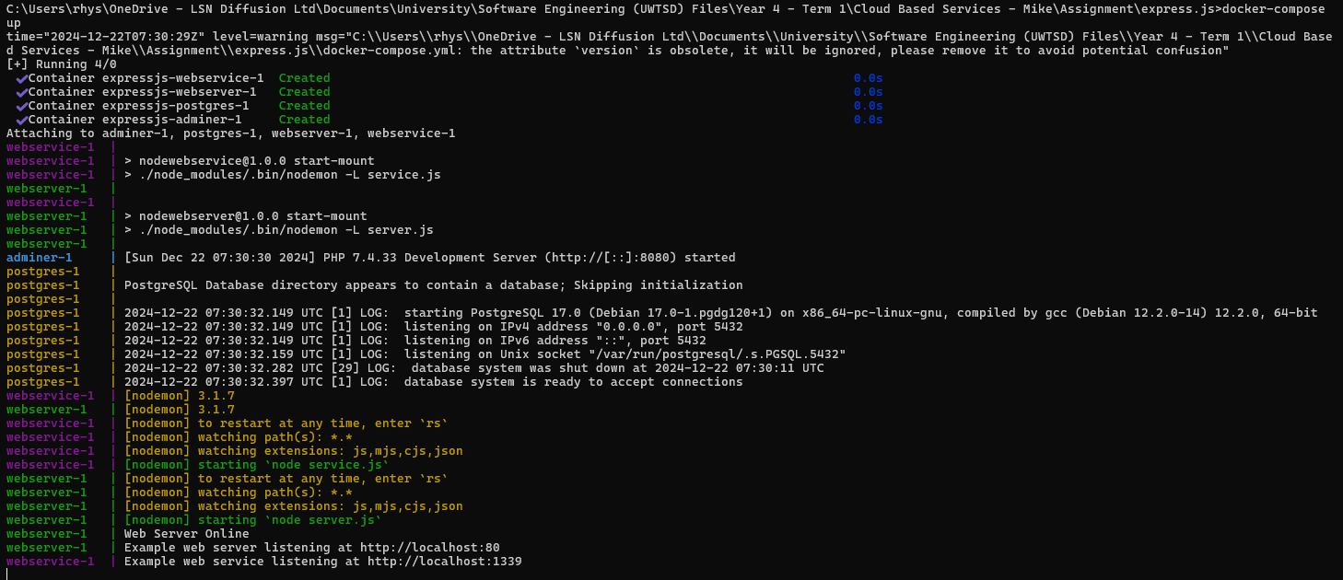
Figure 10: Web service online

Software Testing
This section is to ensure that the web application has been tested thoroughly. Each test will have its own test ID which will be used within the video demonstration. Testing will be conducted through front end (application) to ensure all functions are working as they should be.
Field | Details
Test ID | 1
Test Title | Add Movie into database
Author | Rhys Treharne
Description | The purpose of this test is to ensure a movie is posted into the database
Expected Outcome | The expected outcome of this test is to enter a movie through the add movie form, then the movie should appear in the database with its own unique ID
Actual Outcome | Success, the windows alert states that the movie has been added to the database via the form. This has also been confirmed by checking the database to ensure the new field has been entered
Pass/Fail | Pass
Figure 11: Test ID 1
Evidence:
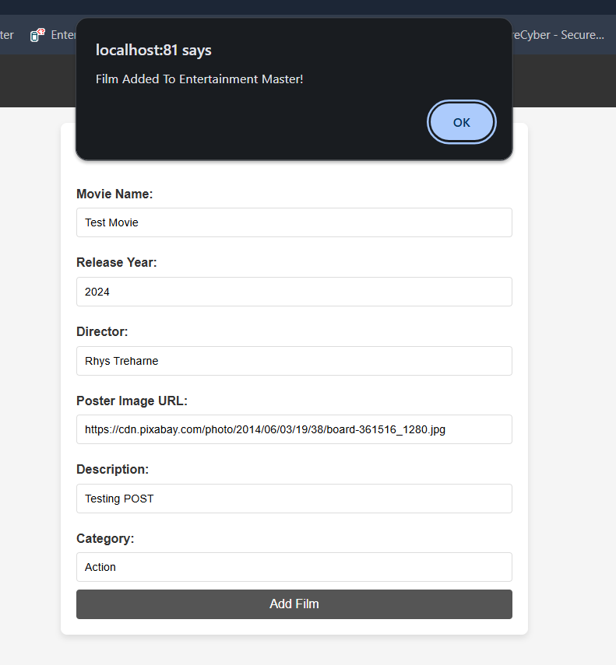
Figure 12: Adding film
Figure 13:Film added in database
Field | Details
Test ID | 2
Test Title | Displaying All Movies from database
Author | Rhys Treharne
Description | The purpose of this test is to ensure all movies are being read and displayed
Expected Outcome | The expected outcome of this test is for all movies inside the database to display on the web page.
Actual Outcome | Success, all movies are displaying on the web page
Pass/Fail | Pass
Figure 14: Test ID 2

Evidence:
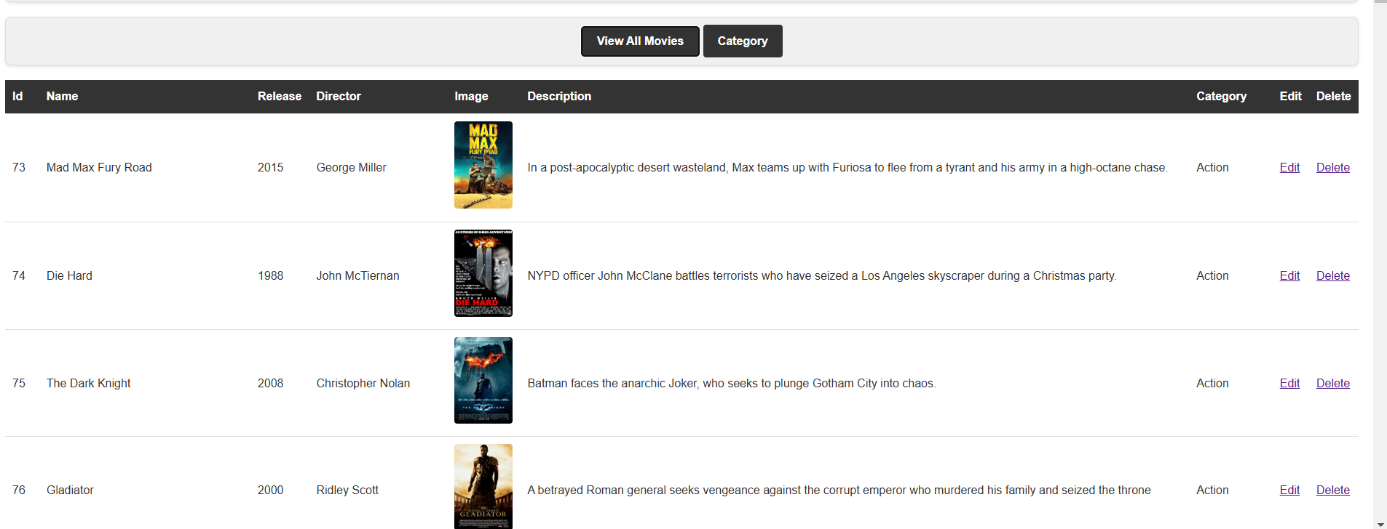
Figure 15:All films displaying
Field | Details
Test ID | 3
Test Title | Edit Movie
Author | Rhys Treharne
Description | The purpose of this test is to ensure when the user is making amends to the chosen movie, it updates the database
Expected Outcome | The expected outcome of this test is for the user to successful make a change to a current movie within the database
Actual Outcome | Success, when making a change to movie ID 147 the database and application is picking up the amendments
Pass/Fail | Pass
Figure 16: Test ID 3
Evidence:
Before edit:
Figure 17: Movie edited in database
Editing process:
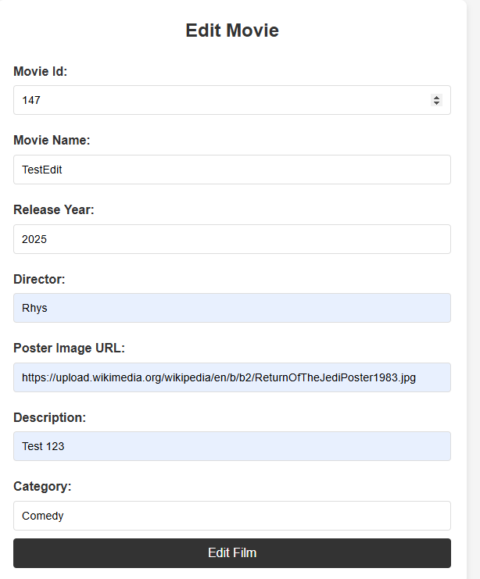
Figure 18: Editing process
Editing process completed:
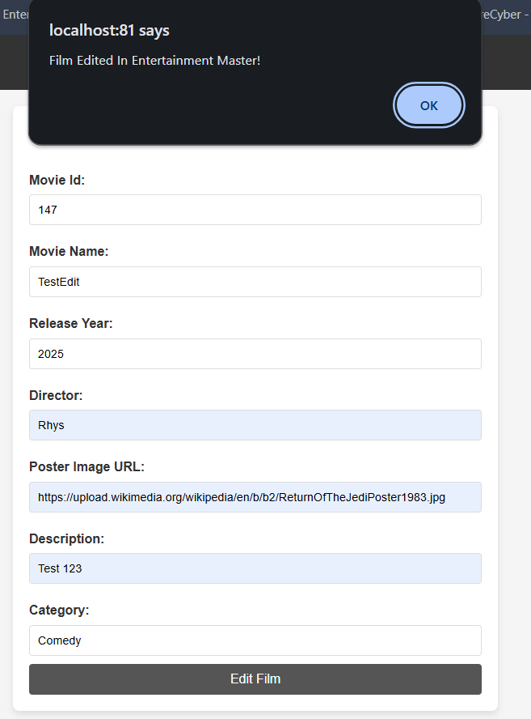
Figure 19: Editing process completed
Table and view all movies updated:
Figure 20:Updated in database

Figure 21: Updated in application
Field | Details
Test ID | 4
Test Title | Delete Movie
Author | Rhys Treharne
Description | The purpose of this test is to ensure that the user can delete a movie from the database via the application
Expected Outcome | The expected outcome of this test is for the user to delete a movie. The user will need to enter the movie Id associated with the movie
Actual Outcome | Success, when the user entered the movie Id into the form, this deleted the movie from the database
Pass/Fail | Pass
Figure 22: Test ID 4
Evidence:
Movie Id to be deleted:
Figure 23: ID to be deleted

Delete movie form:
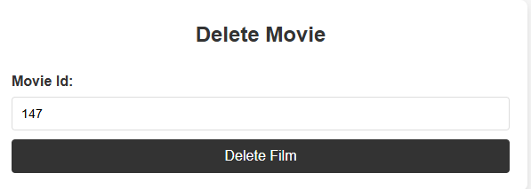
Figure 24: Delete Movie Form
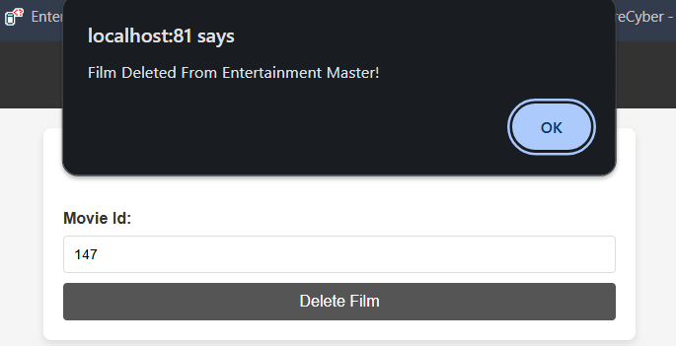
Figure 25: Submitted Delete Form
Checking application:
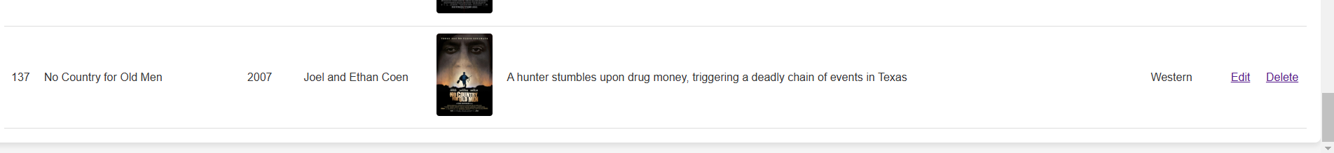
Figure 26: Movie deleted in application
Checking database:
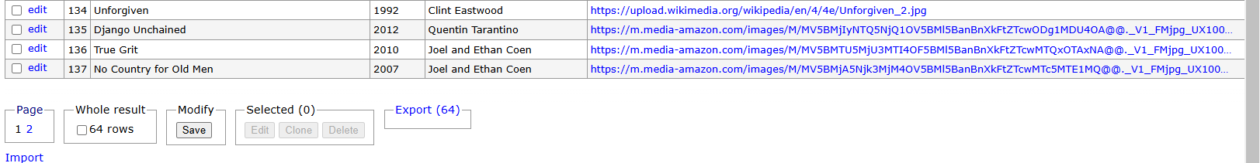
Figure 27: Checking database
Field | Details
Test ID | 5
Test Title | Filter movie by category
Author | Rhys Treharne
Description | The purpose of this test is to ensure that the user can filter movies by category
Expected Outcome | The expected outcome for this test is to display selected movies by categories. The application should display movies assigned to a specific category
Actual Outcome | Success, the user was able to filter all movies by category. The chosen category was Science Fiction, all 5 movies associated with science fiction were displayed
Pass/Fail | Pass
Figure 28: Test ID 5

Evidence:
Entering a category via a form:
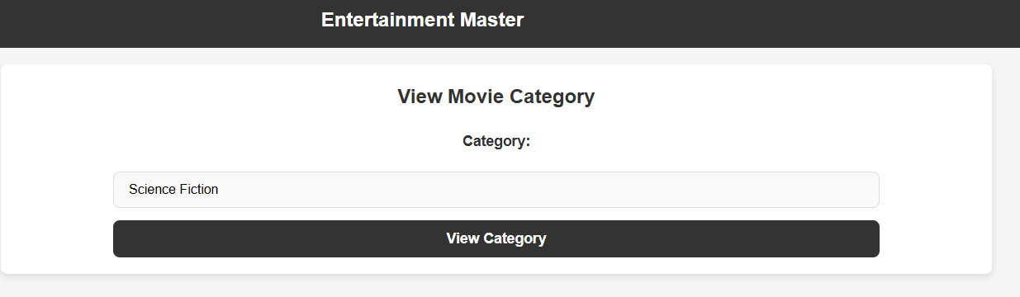
Figure 29: Category Form
Table containing movies associated with “Science Fiction”:
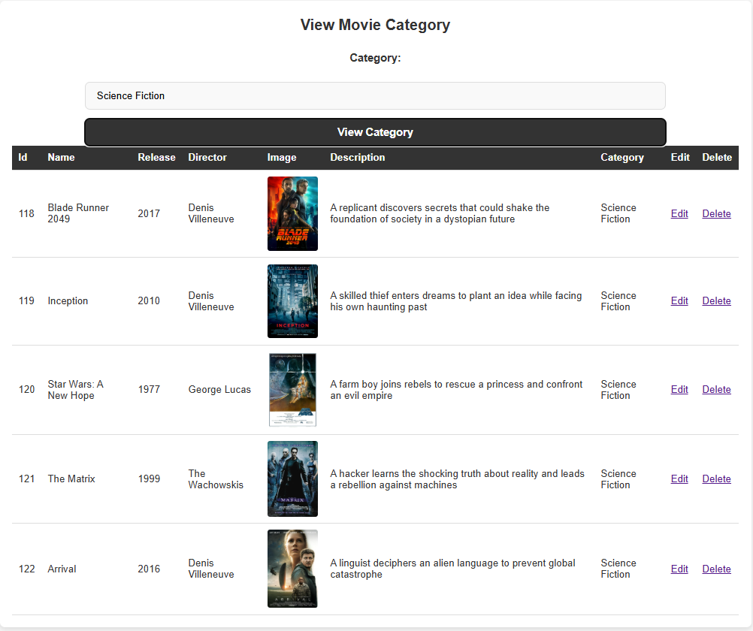
Figure 30: Display chosen category

Field | Details
Test ID | 6
Test Title | Add new TV show
Author | Rhys Treharne
Description | The purpose of this test is to add a new TV show entry into the database via a form
Expected Outcome | The expected outcome is for the user to enter a new TV show into the database through a form
Actual Outcome | Success, the user was able to enter a new TV show into the database. The TV shows table has been updated on application and database ends
Pass/Fail | Pass
Figure 31: Test ID 6
Evidence:
Entering the new TV show details:
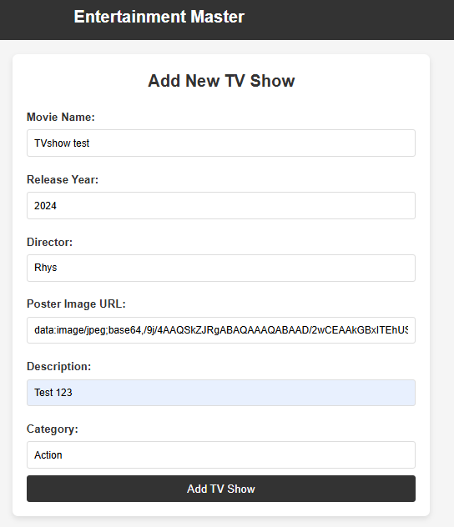
Figure 32: Add TV show form
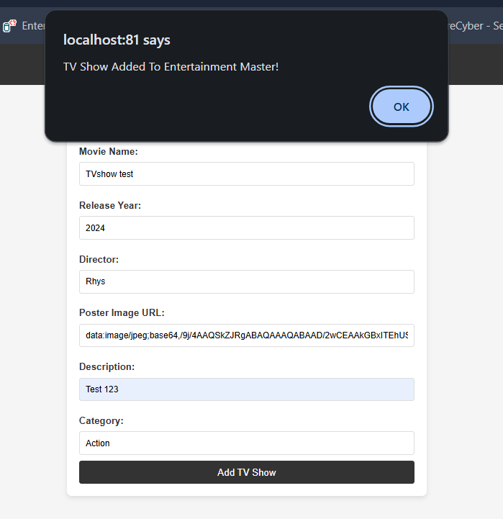
Submitting new TV show:

Figure 33: Submitted TV show form

Checking application:
Figure 34: Checking application
Checking database:
Figure 35: Checking Database
Field | Details
Test ID | 7
Test Title | Reading all TV shows
Author | Rhys Treharne
Description | The purpose of this test is to ensure that all tv shows can be displayed on the application
Expected Outcome | The expected outcome for this test would be for all tv shows to display for the user to view
Actual Outcome | Success, from clicking show all films this will display every tv show within the database
Pass/Fail | Pass
Figure 36: Test ID 7
Evidence:
Clicking show all tv shows:
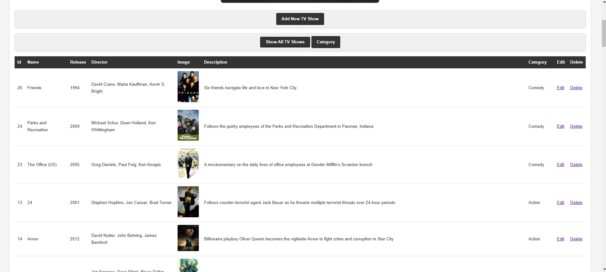
Figure 37: Showing all tv shows

Field | Details
Test ID | 8
Test Title | Editing TV shows
Author | Rhys Treharne
Description | The purpose of this test is to ensure the user can edit a tv show from the application
Expected Outcome | The expected outcome for this test is for the user to select a tv show, enter the Id and edit any field the user requires
Actual Outcome | Success, the editing form was successful on updating tv show Id 86 with its new values
Pass/Fail | Pass
Figure 38: Test ID 8
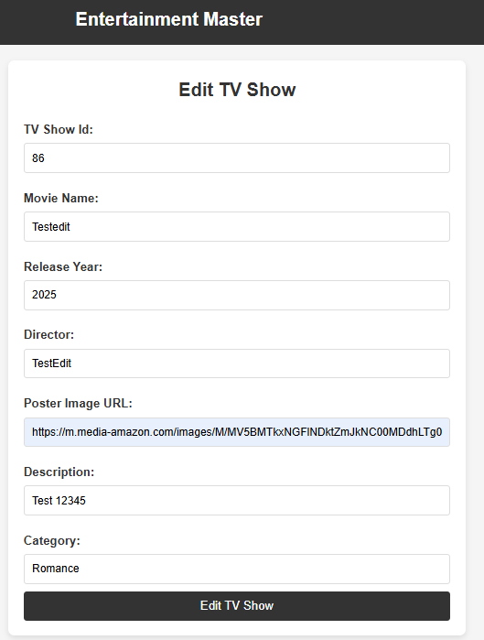
Evidence:
Editing form

Figure 39:Editing form

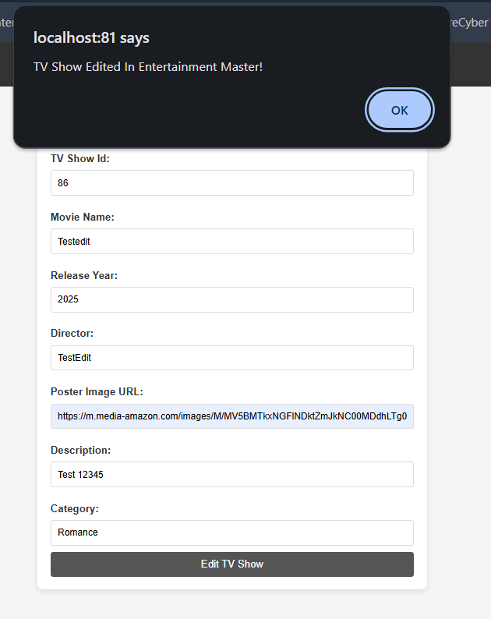
Submitting the edit:

Figure 40:Submitting the form
Checking application and database:
Application:
Figure 41:Checking application
Database:

Field | Details
Test ID | 9
Test Title | Deleting TV shows
Author | Rhys Treharne
Description | The purpose of this test is to ensure the user can delete a record within tv shows through a form
Expected Outcome | The expected outcome for this test is to prove that when entering the tv show Id, the record will be deleted through application and database
Actual Outcome | Success, the tv show was deleted successfully from the application and database
Pass/Fail | Pass
Figure 42:Test ID 9
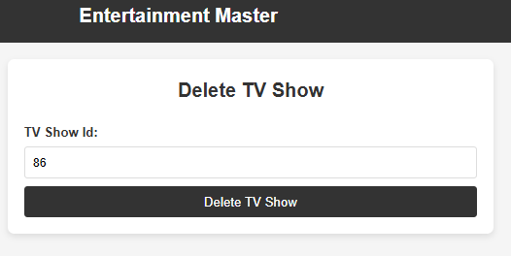
Evidence:
Delete TV show form:

Figure 43:Delete TV show form

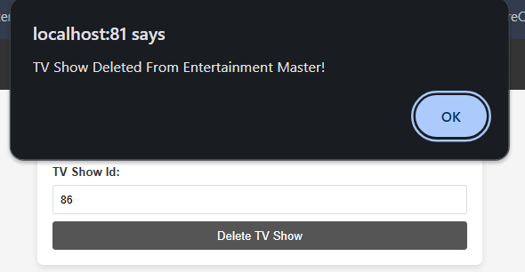
Submitting the delete request:

Figure 44: Submitting the request

Checking application and database:
Application:
Figure 45:Checking application
Database:
Figure 46: Checking Database

Field | Details
Test ID | 10
Test Title | Filtering TV shows by category
Author | Rhys Treharne
Description | The purpose of this test is to ensure the user can filter tv shows by a specific category
Expected Outcome | The expected outcome of this test is to prove the user can enter a category via a form, then the application will display all tv shows associated with the selected category
Actual Outcome | Success, all tv shows associate with the category “Drama” were displayed
Pass/Fail | Pass
Figure 47: Test ID 10
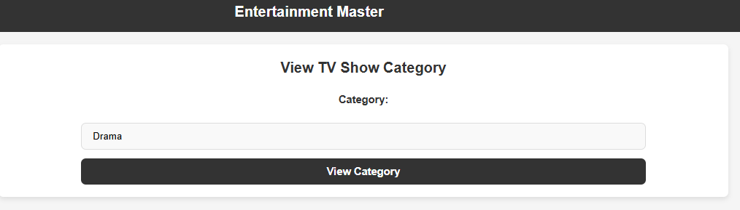
Evidence:
Filter Category Form:
Figure 48: Filter category form

Table displaying tv shows associated with chosen category:
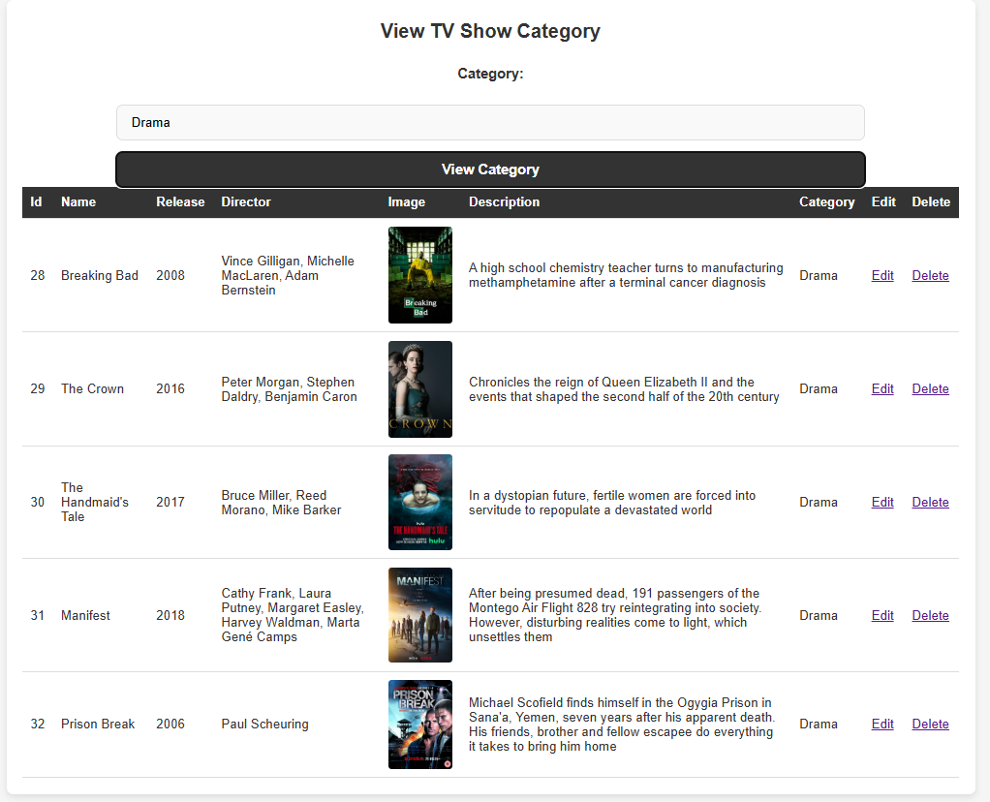
Figure 49: Display Chosen Category

Field | Details
Test ID | 11
Test Title | Adding a new game to the database/application
Author | Rhys Treharne
Description | The purpose of this test is to ensure the user can add a new game into the database through the application via a form
Expected Outcome | The user should be able to enter information regarding a new game and submit it into the database making it available to the application
Actual Outcome | Success, the user was able to enter a new game into the database. The new game entry was successfully displayed and visible in the database
Pass/Fail | Pass
Figure 50: Test ID 1
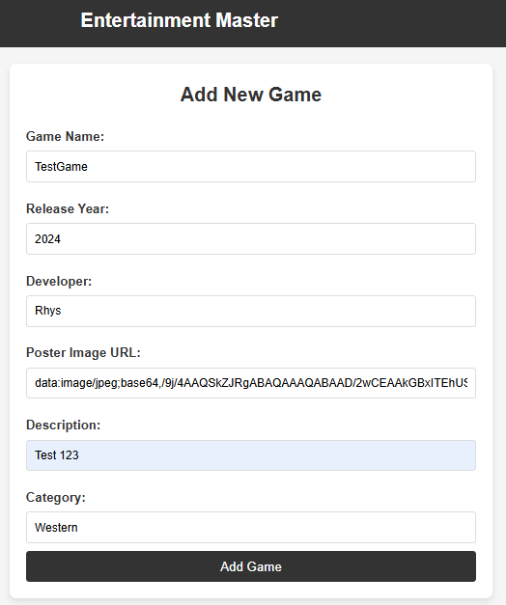
Evidence:
Form to add new game:

Figure 51:Add Game Form
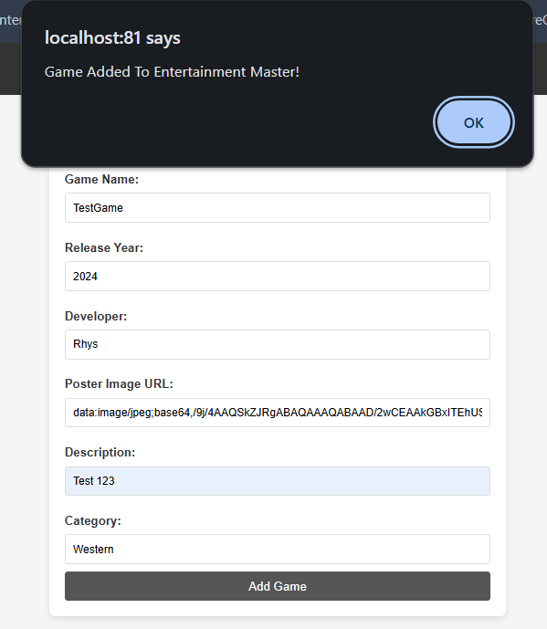
Submitting the form:

Figure 52: Submitting the form
Checking the application and database:
Application:
Figure 53: Checking Application
Database:
Figure 54: Checking Database
Field | Details
Test ID | 12
Test Title | Viewing all games
Author | Rhys Treharne
Description | The purpose of this test is to ensure the user can view all games stored within the database
Expected Outcome | The expected outcome of this test is for the user to be able to read/view all games through the application
Actual Outcome | Success, the user was able to display all games through the application
Pass/Fail | Pass
Figure 55: Test ID 12
Evidence:
Clicking “View all games” to display all games
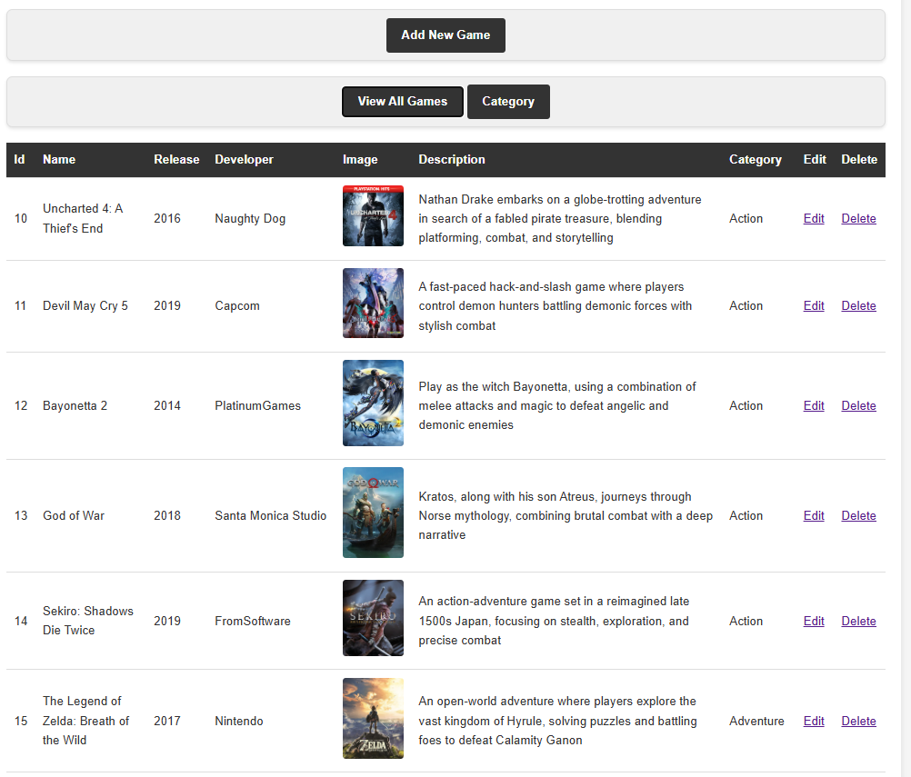
Figure 56: Viewing all games

Field | Details
Test ID | 13
Test Title | Editing game
Author | Rhys Treharne
Description | The purpose of this test is to ensure the user can edit games record already in the database
Expected Outcome | The expected outcome for this test is for the user to be able to edit a record already in the database through a form and display the new changes through the application
Actual Outcome | Success, the user was able to edit a game through the form and submit the changes. This has updated the application and the database
Pass/Fail | Pass
Figure 57:Test ID 13
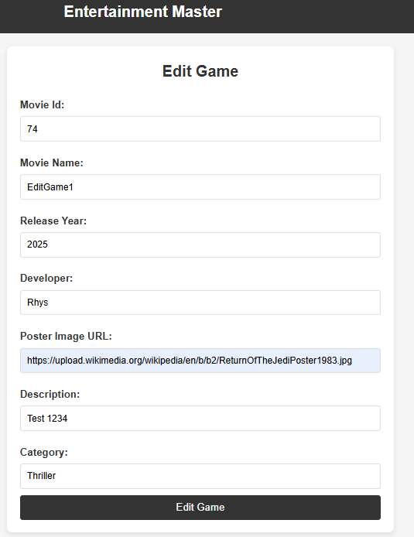
Evidence:
Editing games form:

Figure 58:Editing Games Form
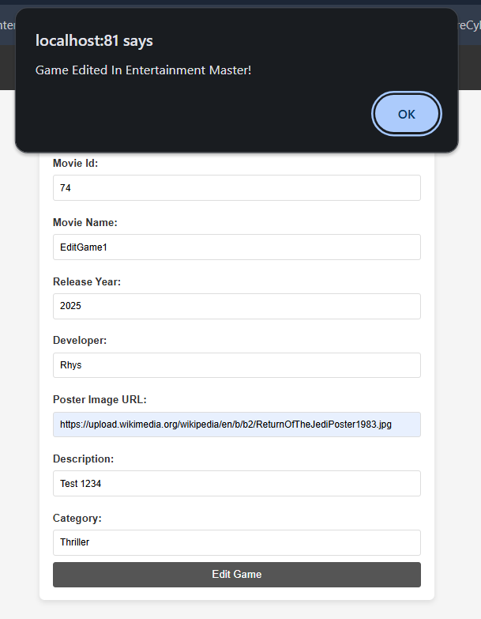
Submitting the form:

Figure 59: Submitting Form
Checking the application and database:
Application:
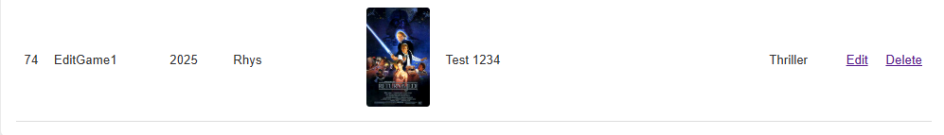
Figure 60: Checking Application
Database:
Figure 61: Checking Database
Field | Details
Test ID | 14
Test Title | Deleting game
Author | Rhys Treharne
Description | The purpose of this test is to prove that the user can delete a game from the application and database through entering the game Id via a form
Expected Outcome | The expected outcome of the test is to allow the user to delete a film from the database. This should delete the game from the application also
Actual Outcome | Success, the user was able to edit a game through the form and submit the changes. This has updated the application and the database
Pass/Fail | Pass
Figure 62: Test ID 14
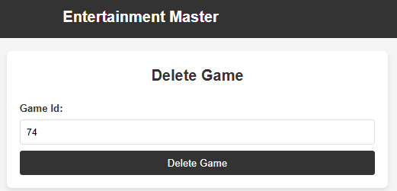
Evidence:
Deleting form:

Figure 63: Deleting Games Form
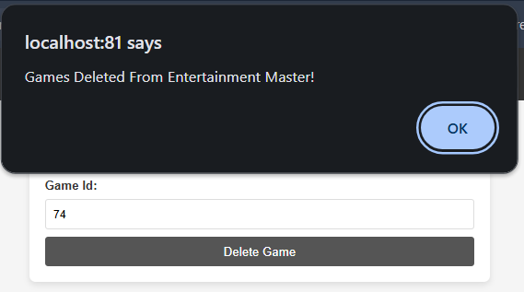
Submit the request:

Figure 64: Submit Form
Checking application and database:
Application:
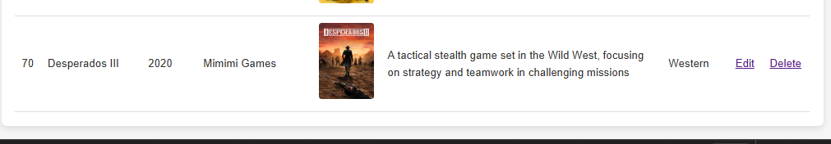
Figure 65: Checking Application
Database:
Figure 66:Checking Dataset

Field | Details
Test ID | 15
Test Title | Filter game by category
Author | Rhys Treharne
Description | The purpose of this test is to prove that the user can filter a game by category. The user will then only be able to see games associated with that specific category
Expected Outcome | The expected outcome of this test is to allow the user to browse games with a specific category
Actual Outcome | Success, the user was able to edit a game through the form and submit the changes. This has updated the application and the database
Pass/Fail | Pass

Figure 67:Test ID 15
Evidence:
Filter category form:
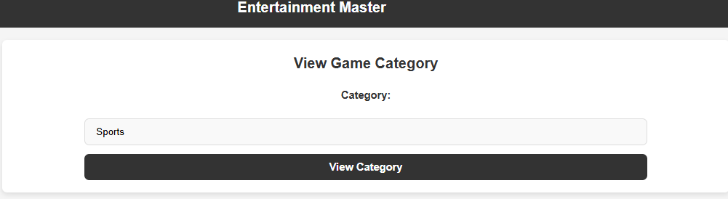
Figure 68: Filter category form

Displaying the chosen category:
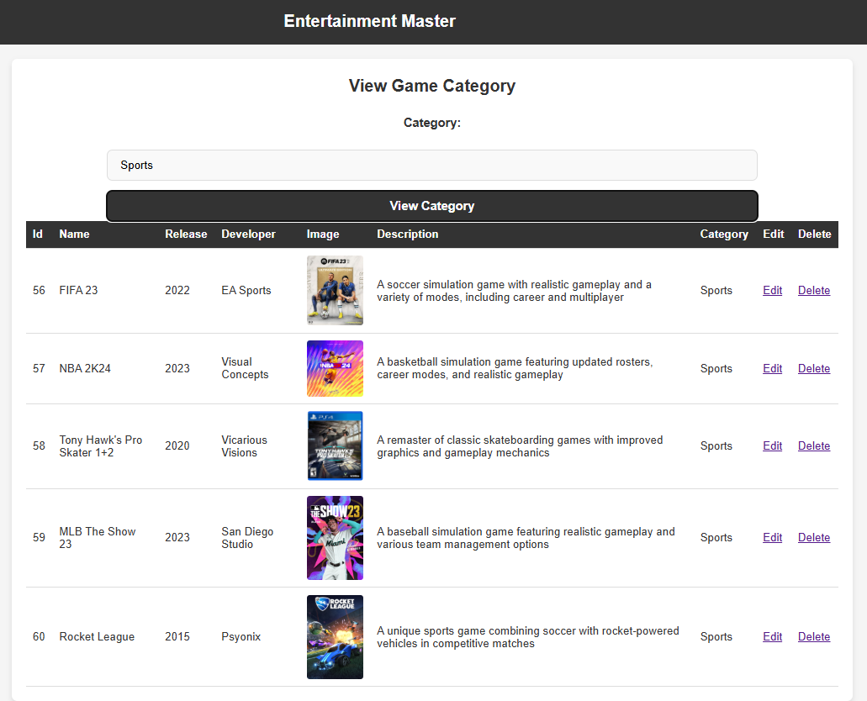
Figure 69: Display selected category

Conclusion
In conclusion, this report thoroughly evaluates the performance of the entertainment application. By conducing many tests to prove the functions work is a very import process [1]. As just mentioned, by conducting software testing it emphasises the need for testing, this can prove that the application works. Software testing is used to identify any bugs within the code and proves all functions work accordingly [2]. This report included a step by step set of instructions to demonstrate how the user can setup their own web service. Getting the setup of the web service correct at the beginning of the process is key, without this step working the whole web service application will not work.

Video Link Youtube Unlisted
https://youtu.be/NB9pV62tQY8

References

[1] | I. C. Society, “The Importance of Software Testing,” IEEE Computer Society , [Online]. Available: https://www.computer.org/resources/importance-of-software-testing#top. [Accessed 22 12 2024].
[2] | M. Fiaz, “Why do we need testing?,” Linkedin, 08 06 2024. [Online]. Available: https://www.linkedin.com/pulse/why-do-we-need-testing-muhammad-fiaz-d2mdf#:~:text=Testing%20is%20crucial%20for%20identifying,quality%2C%20and%20improving%20user%20experience.. [Accessed 22 12 2024].

